## Introduction

**THE AIM** of a linguistic science is to be able to characterize and explain the multitude of linguistic observations circling around us, in conversa- tions, writing, and other media. Part of that has to do with the cognitive side of how humans acquire, produce, and understand language, part of it has to do with understanding the relationship between linguistic utterances and the world, and part of it has to do with understanding the linguistic structures by which language communicates. In order to

RULES approach the last problem, people have proposed that there are ***rules*** which are used to structure linguistic expressions. This basic approach has a long history that extends back at 2000 years, but in this cen- tury the approach became increasingly formal and rigorous as linguists explored detailed grammars that attempted to describe what were formed versus ill-formed utterances of a language.

However, it has become apparent that there is a problem with this con- ception. Indeed it was noticed early on by Edward Sapir, who summed it up in his famous quote “All grammars leak” (Sapir 1921: 38). It is just not possible to provide an exact and complete characterization of formed utterances that cleanly divides them from all other sequences of words, which are regarded as ill-formed utterances. This is because people are always stretching and bending the ‘rules’ to meet their com- municative needs. Nevertheless, it is certainly not the case that the rules are completely ill-founded. Syntactic rules for a language, such as that a basic English noun phrase consists of an optional determiner, some num- ber of adjectives, and then a noun, do capture major patterns within the language. But somehow we need to make things looser, in accounting for the creativity of language use.

This book explores an approach that addresses this problem head on. Rather than starting off by dividing sentences into grammatical and un- grammatical ones, we instead ask, “What are the common patterns that occur in language use?” The major tool which we use to identify these patterns is counting things, otherwise known as statistics, and so the sci- entific foundation of the book is found in probability theory. Moreover, we are not merely going to approach this issue as a scientific question, but rather we wish to show how statistical models of language are built and successfully used for many natural language processing (NLP) tasks. While practical utility is something different from the validity of a the- ory, the usefulness of statistical models of language tends to confirm that there is something right about the basic approach.

Adopting a Statistical NLP approach requires mastering a fair number

of theoretical tools, but before we delve into a lot of theory, this chapter spends a bit of time attempting to situate the approach to natural lan- guage processing that we pursue in this book within a broader context. One should first have some idea about why many people are adopting a statistical approach to natural language processing and of how one should go about this enterprise. So, in this first chapter, we examine some of the philosophical themes and leading ideas that motivate a statistical approach to linguistics and NLP, and then proceed to get our hands dirty by beginning an exploration of what one can learn by looking at statistics over texts.

#### Rationalist and Empiricist Approaches to Language

Some language researchers and many NLP practitioners are perfectly happy to just work on text without thinking much about the relationship between the mental representation of language and its manifestation in written form. Readers sympathetic with this approach may feel like skip- ping to the practical sections, but even practically-minded people have to confront the issue of what prior knowledge to try to build into their model, even if this prior knowledge might be clearly different from what might be plausibly hypothesized for the brain. This section briefly dis- cusses the philosophical issues that underlie this question.

Between about 1960 and 1985, most of linguistics, psychology, artifi- cial intelligence, and natural language processing was completely

**RATIONALIST** by a ***rationalist*** approach. A rationalist approach is characterized

***1 Rationalist and Empiricist Approaches to Language***

by the belief that a significant part of the knowledge in the human mind is not derived by the senses but is fixed in advance, presumably by genetic inheritance. Within linguistics, this rationalist position has come to dom- inate the field due to the widespread acceptance of arguments by Chomsky for an innate language faculty. Within artificial intelligence, rationalist beliefs can be seen as supporting the attempt to create intel- ligent systems by handcoding into them a lot of starting knowledge and reasoning mechanisms, so as to duplicate what the human brain begins with.

Chomsky argues for this innate structure because of what he perceives **POVERTY OF THE** as a problem of the poverty of *stimulus (e.g.,* Chomsky 1986: 7). He **STIMULUS** suggests that it is difficult to see how children can learn something as complex as a natural language from the limited input (of variable quality

and interpretability) that they hear during their early years. The rational- ist approach attempts to dodge this difficult problem by postulating that the key parts of language are innate hardwired in the brain at birth as part of the human genetic inheritance.

**EMPIRICIST An** *empiricist* approach also begins by postulating some cognitive abil- ities as present in the brain. The difference between the approaches is therefore not absolute but one of degree. One has to assume some initial structure in the brain which causes it to prefer certain ways of organiz- ing and generalizing from sensory inputs to others, as no learning is possible from a completely blank slate, a But the thrust of empiricist approaches is to assume that the mind does not begin with detailed sets of principles and procedures specific to the various com- ponents of language and other cognitive domains (for instance, theories of morphological structure, case marking, and the like). Rather, it is as- sumed that a baby’s brain begins with general operations for association, pattern recognition, and generalization, and that these can be applied to the rich sensory input available to the child to learn the detailed structure of natural language. Empiricism was dominant in most of the fields men- tioned above (at least the ones then existing!) between 1920 and 1960, and is now seeing a resurgence. An empiricist approach to suggests that we can learn the complicated and extensive structure of language by specifying an appropriate general language model, and then inducing the values of parameters by applying statistical, pattern recognition, and machine learning methods to a large amount of language use.



Generally in Statistical NLP, people cannot actually work from observ- ing a large amount of language use situated within its context in the

**CORPUS CORPORA**

**A MERICAN**

**STRUCTURALISTS**

**GENERATIVE LINGUISTICS**

**LINGUISTIC COMPETENCE**

**LINGUISTIC PERFORMANCE**

world. So, instead, people simply use texts, and regard the textual context as a surrogate for situating language in a real world context. A body of texts is called a corpus corpus is simply Latin for ‘body,’ and when you have several such collections of texts, you have *corpora.* Adopting such a corpus-based approach, people have pointed to the earlier advocacy of empiricist ideas by the British linguist J.R. Firth, who coined the slogan “You shall know a word by the company it keeps” (Firth 1957: 11). How- ever an empiricist corpus-based approach is perhaps even more clearly seen in the work of American structuralists (the ‘post-Bloomfieldians’), particularly Zellig Harris. For example, (Harris 1951) is an attempt to find discovery procedures by which a language’s structure can be discovered automatically. While this work had no thoughts to computer implemen- tation, and is perhaps somewhat computationally naive, we find here also the idea that a good grammatical description is one that provides a com- pact representation of a corpus of texts.

It is not appropriate to provide a detailed philosophical treatment of scientific approaches to language here, but let us note a few more dif- ferences between rationalist and empiricist approaches. Rationalists and empiricists are attempting to describe different things. Chomskyan (or *generative)* linguistics seeks to describe the language module of the hu- man mind (the I-language) for which data such as texts (the E-language) provide only indirect evidence, which can be supplemented by native speaker intuitions. Empiricist approaches are interested in describing the E-language as it actually occurs. Chomsky (1965: 3-4) thus makes a crucial distinction between *linguistic competence,* which reflects the knowledge of language structure that is assumed to be in the mind of a native speaker, and *linguistic performance* in the world, which is af- fected by all sorts of things such as memory limitations and distracting noises in the environment. Generative linguistics has argued that one can isolate linguistic competence and describe it in isolation, while empiricist approaches generally reject this notion and want to describe actual use of language.

This difference underlies much of the recent revival of interest in em- piricist techniques for computational work. During the second phase of work in artificial intelligence (roughly 1970-1989, say) people were con- cerned with the science of the mind, and the best way to address that was seen as building small systems that attempted to behave intelligently. This approach identified many key problems and approaches that are

* 1. *Scientific Content 7*

still with us today, but the work can be criticized on the grounds that it dealt only with very small (often pejoratively called ‘toy’) problems, and often did not provide any sort of objective evaluation of the general ef- ficacy of the methods employed. Recently, people have placed greater emphasis on engineering practical solutions. Principally, they seek meth- ods that can work on raw text as it exists in the real world, and objective comparative evaluations of how well different methods work. This new emphasis is sometimes reflected in naming the field ‘Language Technol- ogy’ or ‘Language Engineering’ instead of NLP. As we will discuss below, such goals have tended to favor Statistical NLP approaches, because they

**INDUCTION** are better at automatic learning *(knowledge induction),* better at biguation, and also have a role in the science of linguistics.

Finally, Chomskyan linguistics, while recognizing certain notions of **CATEGORICAL** competition between principles, depends on  principles, which sentences either do or do not satisfy. In general, the same was true of

American structuralism. But the approach we will pursue in Statistical NLP draws from the work of Shannon, where the aim is to assign proba- bilities to linguistic events, so that we can say which sentences are ‘usual’ and ‘unusual’. An upshot of this is that while Chomskyan linguists tend to concentrate on categorical judgements about very rare types of sen- tences, Statistical **NLP** practitioners are interested in good descriptions of the associations and preferences that occur in the totality of language use. Indeed, they often find that one can get good real world performance by concentrating on common types of sentences.

#### 1.2 Scientific Content

Many of the applications of the methods that we present in this book have a quite applied character. Indeed, much of the recent enthusiasm for statistical methods in natural language processing derives from people seeing the prospect of statistical methods providing practical solutions to real problems that have eluded solution using traditional NLP methods. But if statistical methods were just a practical engineering approach, an approximation to difficult problems of language that science has not yet been able to figure out, then their interest to us would be rather limited. Rather, we would like to emphasize right at the beginning that there are clear and compelling scientific reasons to be interested in the frequency

with which linguistic forms are used, in other words, statistics, as one approaches the study of language.

1.2.1

**COMPETENCE GRAMMAR**

**GRAMMATICALITY**

Questions that linguistics should answer

What questions does the study of language concern itself with? As a start we would like to answer two basic questions:

* What kinds of things do people say?
* What do these things say/ask/request about the world?

From these two basic questions, attention quickly spreads to issues about how knowledge of language is acquired by humans, and how they actu- ally go about generating and understanding sentences in real time. But let us just concentrate on these two basic questions for now. The first covers all aspects of the structure of language, while the second deals with semantics,  and discourse how to connect utterances with the world. The first question is the bread and butter of corpus lin- guistics, but the patterns of use of a word can act as a surrogate for deep understanding, and hence can let us also address the second question using corpus-based techniques. Nevertheless patterns in corpora more easily reveal the syntactic structure of a language, and so the majority of work in Statistical NLP has dealt with the first question of what kinds of things people say, and so let us begin with it here.

How does traditional  linguistics seek to an- swer this question? It abstracts away from any attempt to describe the kinds of things that people usually say, and instead seeks to describe a competence that is said to underlie the language (and which generative approaches assume to be in the speaker’s head). The extent to which such theories approach the question of what people say is merely to suggest that there is a set of sentences grammatical sentences which are licensed by the competence grammar, and then other strings of words are ungrammatical. This concept of  is meant to be judged purely on whether a sentence is structurally well-formed, and not according to whether it is the kind of thing that people would say or whether it is semantically anomalous. Chomsky gave *Colorless green ideas sleep furiously* as an example of a sentence that is grammatical,

1.2 Scientific 9

though semantically strange and not the kind of thing you would expect people to say. Syntactic grammaticality is a categorical binary 

Now, initially, a distinction between grammatical and ungrammatical sentences does not seem so bad. We immediately notice when a non- native speaker says something really wrong something ungrammatical and we are able to correct such sentences to grammatical ones. In con- trast, except when there are bad speech errors, a native speaker normally produces grammatical sentences. But there are at least two reasons why we should seek more. Firstly, while maintaining a binary split between grammatical and ungrammatical sentences may seem plausible in simple cases, it becomes increasingly far-fetched as we extend our investiga- tion. Secondly, regardless of this, there are many reasons to be interested in the frequency with which different sentences and sentence types are used, and simply dividing sentences into grammatical and ungrammati- cal sentences gives no information about this. For instance, very often non-native speakers say or write things that are not in any way syntac- tically ungrammatical, but just somehow subtly odd. Here’s an example

from a student essay:

(1.1) In addition to this, she insisted that women were regarded as a different existence from men unfairly.

We might respond to this passage by saying that we can understand the message, but it would sound better expressed slightly differently. This

**CONVENTIONALITY** is a statement about the  of certain modes of expression. But a convention is simply a way in which people frequently express or do something, even though other ways are in principle possible.

The fact that sentences do not divide neatly into two sets grammat- ical and ungrammatical ones is well known to anyone who has been in linguistics for a while. For many of the complicated sentences of in- terest to theoretical linguistics, it is difficult for human beings to decide whether they are grammatical or not. For example, try your hand at judg- ing the grammaticality of the following sentences drawn (not at random)

1. Some versions of Chomsky’s 1980s theory, Government-Binding theory  provide a minor degree of gradedness by suggesting that sentences that disobey some constraints are only sort of weird while ones that disobey other constraints are truly horrible, but the formal theory, in GB and elsewhere, provides little support for these notions. Linguists generally rely on an informal system of stars and question marks for initially grading sentences (where * (ungrammatical) ?* ?? ? (questionable)), but these gradations are converted into a binary grammatical/ungrammatical distinction when people try to develop the principles of grammar.

from (van Riemsdijk and Williams 1986) a textbook, not even a research paper before peeking at the answers in the 

(1.2) a.

b.

**C.**



John I believe Sally said Bill believed Sue saw. What did Sally whisper that she had secretly read? John wants very much for himself to win.

(Those are) the books you should read before it becomes difficult to talk about.

* 1. (Those are) the books you should read before talking about becomes difficult.
  2. Who did Jo think said John saw him?

That a serious discussion could arise here of this topic was quite un- expected.

h. The boys read Mary’s stories about each other.

We find that most people disagree with more than one of van Riemsdijk and Williams’s claims about which sentences are grammatical. This re- sult raises real questions about what, if anything, generative linguistics is describing.

This difficulty has led to many statements in the linguistics literature about judgements being difficult, or the facts quite obscure, as if some- how there is a categorical answer to whether each sentence is grammati- cal, but it is hard for human beings to work out what that answer is. Yet, despite these manifest difficulties, most of theoretical linguistics contin- ues to work in a framework that defines such observations to be out of the realm of interest (relegating them to performance effects). We be- lieve that this is unsustainable. On the other hand, it must be noticed that most simple sentences are either clearly acceptable or unacceptable and we would want our theory to be able to account for this observation. Perhaps the right approach is to notice the parallel with other cases of

**CATEGORICAL** *categorical perception* that have been described in the psychological

**PERCEPTION** ature. For instance, although the timing of voicing onset which differenti- ates a  sound from a  sound is a continuous variable (and its typical

1. Answers: a. **OK,** b. bad, c. **OK,** d. **OK, e.** bad, f. **OK, g. OK,** h. bad.

value varies between languages), human beings perceive the results cat- egorically, and this is why a theory of phonology based on categorical phonemes is largely viable, despite all the movements and variations in phonological production occurring in a continuous space. Similarly for syntax, a categorical theory may suffice for certain purposes. Neverthe- less, we would argue that the difficulties in giving grammaticality  ments to complex and convoluted sentences show the implausibility of extending a binary distinction between grammatical and ungrammatical strings to all areas of language use.

Non-categorical phenomena in language

But beyond the above difficulties in giving grammaticality judgements, if we peek into the corners of language, we see clear evidence of failures of categorical assumptions, and circumstances where considerations of fre- quency of use are essential to understanding language. This suggests that

CATEGORICAL VIEW OF while a categorical *view* may be sufficient for many purposes,



LANGUAGE we must see it as an approximation that also has its limitations (just as Newtonian physics is good for many purposes but has its 

One source of data on non-categorical phenomena in language is to look at the history of language change (others are looking at

guistic variation and competing hypotheses during language acquisition). Over time, the words and syntax of a language change. Words will change their meaning and their part of speech. For instance, English while used to be exclusively a noun meaning ‘time,’ a usage that survives mainly in a few fixed phrases such as to a *while,* but changed to be mainly used as a complementizer introducing subordinate clauses *(While you were out,* It doesn’t make sense to say that categorically until some day in 1742 *while* was only a noun and then it became a complementizer even if this claim is only being made for certain speakers rather than the speech community as a whole. Rather, one would expect a gradual change. One hypothesis is that if the frequency of use of a word in vari- ous contexts gradually changes so that it departs from the typical profile of use of words in the category to which it formerly belonged, and rather its profile of use comes to more resemble words of another category, then



1. Readers not familiar with linguistics and NLP may have trouble understanding this section and may wish to skip it, but to return to it after reading chapter 3. The historical examples include various archaic spellings the standardization of English spelling is a relatively modern phenomenon. Reading them aloud is often helpful for decoding them.

it will come to be reanalyzed as a word of that different category. During the period of change, one would expect to see evidence of noncategorical behavior.

Blending of parts of speech:

At first blush it appears that the word can be used either as an adjective as in  or as a preposition 

(1.3) a. We will review that decision in the near future.

b. He lives near the station.

Evidence for as an adjective includes its position between a deter- miner and noun as in  a classic adjective position and the fact that it can form an adverb by adding  ***We nearly lost.*** Evidence for as a preposition includes that it can head the locative phrase com- plements of verbs like ***live*** as in a classic role for prepositions, and that such a phrase can be modified by ***right,*** which is normally restricted to modifying prepositional phrases: He ***lives right the*** (cf. He ***right across the vs. right red cur). So*** far, though,



this data is not that surprising: many words in English seem to have multiple parts of speech. For example, many words are both nouns and verbs, such as ***play: They saw a *** ***vs. They play lacrosse on Thursdays.*** But the interesting thing is that ***near*** can simultaneously show adjective properties and preposition properties, and thus appears to behave as a category blend. This happens in sentences like:

(1.4) a. He has never been nearer the center of the financial establishment.

b. We live nearer the water than you thought.

Realization in the comparative form ***(nearer)*** is a hallmark of adjectives (and adverbs). Other categories do not form comparatives and   On the other hand, grammatical theory tells us that adjectives and nouns do not take direct objects, hence we have to insert prepositions

1. The thoughtful reader might note that some prepositions do have related forms ending in which are perhaps related to comparatives ***(upper, downer,*** *inner, outer),* but we note that none of these prepositions have a superlative that is formed in analogy to regular adjectival superlatives, as ***near*** does (that is, ***nearest),*** and that none of these other forms in can be used in preposition-like uses. We cannot say: *John ***lives*** *inner* ***Sydney than Fred.***

after adjectives and say ***unsure of his beliefs*** or ***convenient for people who work long hours.* In this sense *nearer*** is behaving like a preposition by heading a locative phrase and taking a direct object. Thus in these sentences ***nearer*** is simultaneously showing properties of adjectives and prepositions that are not available to the other category. Hence it is ex- hibiting a blended status somewhere between these two parts of speech, which are normally taken as categorically distinct.

**Language change: *kind of* and *of***

***New*** uses for the word sequences ***kind of*** and sort ***of*** present a convincing example of how different frequencies of use in certain constructions can lead to what is apparently categorical change. In modern English, the expressions ***sort of*** and ***kind of*** have at least two distinct uses. In one, ***sort*** or ***kind*** functions as a noun with ***of* as** a following preposition introducing a prepositional phrase, as in sentences such as ***sort of animal made these trucks?*** But there is another usage in which these expressions can best be thought of as degree modifiers, akin to ***somewhat*** or ***slightly:***

(1.5) a. We are kind of hungry.

b. He sort of understood what was going on.

**We can** tell that ***kind/sort of*** is not behaving as a normal noun preposition sequence here because it is appearing in contexts such as between the subject noun phrase and the verb where normally one cannot insert a noun-preposition sequence (for example, one cannot say ***\*He variety of understood what was going on).***

Historically, ***kind*** and ***sort*** were clearly nouns. Among other things, they could be preceded by a determiner and followed by a PP:

(1.6) a. A nette sent in to the see, and of alle kind of gedrynge. 

b. I knowe that sorte of men ryght well.  15601

Unambiguous degree modifier uses did not appear until the nineteenth century:

(1.7) a. I kind of love you, Sal-I vow.



b. It sort stirs one up to hear about old times. 

It does not appear that this new construction was borrowed from another language. Rather it appears to be a language internal development. How could this innovation have come about?

A plausible hypothesis is to notice that when we have kind/sort of pre- ceding an adjective, then it is actually ambiguous between these two read- ings:

 a.  a [kind]  of  rock]]]

b.  a kind of] dense] rock]



And what one finds is that between the sixteenth and the nineteenth century, there was a significant rise in the use of *kind/sort of* in this [Det *{sort/kind}* of frame:



 a. Their finest and best, is a kind of course red cloth. [c. 

b. But in such questions as the present, a hundred contradictory views may preserve a kind of imperfect analogy. 

(Note that is here a variant spelling of *coarse.)* In this environment, *sort/kind of* fills a slot that could be occupied by a noun head followed by a preposition, but it also fills a slot that could be occupied by a de- gree modifier (with a different syntactic structure). As this usage became more common, *kind/sort of* was more commonly being used in a typical degree modifier slot; in other words, it grew to look syntactically more like a degree modifier. Moreover, the semantics of these particular nouns was such that they could easily be thought of as degree modifiers. This frequency change seems to have driven a change in syntactic category, and in time the use of *kind/sort of* was extended to other contexts such as modifying verb phrases.

The general point here is that while language change can be sudden (due to either external or internal factors), it is generally gradual. The details of gradual change can only be made sense of by examining fre- quencies of use and being sensitive to varying strengths of relationships, and this type of modeling requires statistical, as opposed to categorical, observations.

Although there have only been a few attempts to use Statistical NLP for explaining complex linguistic phenomena, what is exciting about the sub- ject matter of this book from the point of view of theoretical linguistics is that this new way of looking at language may be able to account for

* 1. *Scientific Content*

things such as non-categorical phenomena and language change much better than anything existing today.

1.2.3 Language and cognition as probabilistic phenomena

A more radical argument for probability as part of a scientific under- standing of language is that human cognition is probabilistic and that language must therefore be probabilistic too since it is an integral part of cognition. A frequent response to our previous examples of non- categorical phenomena in language is that they are marginal and rare. Most sentences are either clearly grammatical or clearly ungrammatical. And most of the time, words are used in only one part of speech, without blending. But if language and cognition as a whole are best explained probabilistically, then probability theory must be a central part of an ex- planatory theory of language.

The argument for a probabilistic approach to cognition is that we live in a world filled with uncertainty and incomplete information. To be able to interact successfully with the world, we need to be able to deal with this type of information. Suppose you want to determine whether it is safe to wade through a river. You see that the water is flowing slowly, so probably it won’t drag you away. You are pretty certain that no piranhas or alligators live in this area. You integrate all this information in eval- uating how safe it is to cross the river. Now, if someone tells you, “the water is only knee-deep if you walk towards that tall tree over there”, then this linguistic information will be just one more source of information to incorporate. Processing the words, forming an idea of the overall mean- ing of the sentence, and weighing it in making a decision is no different in principle from looking at the current, forming an idea of the speed of the water, and taking this sensory information into account. So the gist of this argument is that the cognitive processes used for language are identical or at least very similar to those used for processing other forms of sensory input and other forms of knowledge. These cognitive processes are best formalized as probabilistic processes or at least by means of some quantitative framework that can handle uncertainty and incomplete information.

The facts of language often look quite different depending on whether or not one is sympathetic to an important role for quantitative meth- ods in linguistics. A famous example is Chomsky’s dictum that 

**GRAMMATICALITY** ity theory is inappropriate for formalizing the notion of grammaticality.

He argued that computing the probability of sentences from a corpus of utterances would assign the same low probability to all unattested sentences, grammatical and ungrammatical ones alike, and hence not ac- count for linguistic productivity (Chomsky 195 7: 16). This argument only makes sense if one has a bias against probabilistic representation of con- cepts in general. Consider the cognitive representation of the concept Suppose you see a man who is seven feet tall and it is the first per-

son you’ve ever seen of that height. You will easily recognize this person as a man, not as an uncategorizable man. Similarly, it will be easy for you to recognize a person of another unattested height, say four feet, as definitely not In this book, we will look at probabilistic models that can easily learn and represent this type of regularity and make the right judgement for unattested examples. Indeed, a major part of Statis- tical NLP is deriving good probability estimates for unseen events. The premise that all unattested instances will be treated alike in a probabilis- tic framework does not hold.

We believe that much of the skepticism towards probabilistic mod- els for language (and for cognition in general) stems from the fact that the well-known early probabilistic models (developed in the 1940s and 1950s) are extremely simplistic. Because these simplistic models clearly do not do justice to the complexity of human language, it is easy to view probabilistic models in general as inadequate. One of the insights we hope to promote in this book is that complex probabilistic models can be as explanatory as complex non-probabilistic models but with the added advantage that they can explain phenomena that involve the type of un- certainty and incompleteness that is so pervasive in cognition in general and in language in particular.

These issues relate to the treatment of semantics in Statistical NLP. We mentioned earlier that most existing work in Statistical NLP has con- centrated on the lower levels of grammatical processing, and people have sometimes expressed skepticism as to whether statistical approaches can ever deal with meaning. But the difficulty in answering this question is mainly in defining what ‘meaning’ is! It is often useful in practice if ‘mean- ing’ is viewed as symbolic expressions in some language, such as when translating English into a database query language like SQL. This sort of translation can certainly be done using a Statistical NLP system (we discuss the process of translation in chapter *13).* But from a Statistical NLP perspective, it is more natural to think of meaning as residing in the distribution of contexts over which words and utterances are used.

* 1. ***The Ambiguity of Language: Why NLP Is Difficult 17***

Philosophically, this brings us close to the position adopted in the later writings of Wittgenstein (that is, Wittgenstein  where the

**USETHEORYOF** ing of a word is defined by the circumstances of its use (a use  of

**MEANING meaning) see** the quotations at the beginning of the chapter. Under this conception, much of Statistical NLP research directly tackles questions of meaning.

* 1. The Ambiguity of Language: Why NLP Is Difficult

An NLP system needs to determine something of the structure of text normally at least enough that it can answer “Who did what to whom?” Conventional parsing systems try to answer this question only in terms of possible structures that could be deemed grammatical for some choice of words of a certain category. For example, given a reasonable grammar, a standard NLP system will say that sentence (1.10) has 3 syntactic anal- yses, often called parses:

(1.10) Our company is training workers.

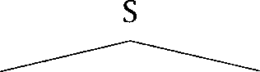The three differing parses might be represented as in (1.11): (1.11) a.

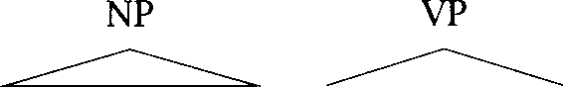

Our ***company*** 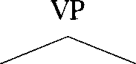

***is*** V

***training workers***

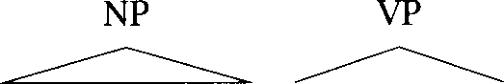b. 

***Our company*** V NP

***is*** 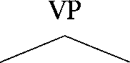

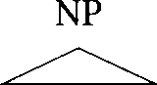V

***training workers***

*Introduction*

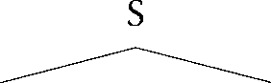**C.**

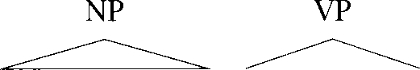

Our *company* V



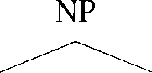*is * N

 

(1.12)

**SELECTIONAL RESTRICTIONS**

*training workers*

There is (a), the one humans perceive, where *is * is the verb group, and two others with *is* as the main verb: in  the rest is a gerund (cf. Our problem *is training workers),* while in  *training* modifies *workers* (cf. Those *are training wheels).* The last two parses are semantically anoma- lous, but in most current systems semantic analysis is done only after syntactic analysis (if at all). This means that, as sentences get longer and grammars get more comprehensive, such ambiguities lead to a terrible multiplication of parses. For instance, Martin et al. (1987) report their system giving 455 parses for the sentence in 

List the sales of the products produced in 1973 with the products pro- duced in 1972.

Therefore, a practical NLP system must be good at making  tion decisions of word sense, word category, syntactic structure, and semantic scope. But the goal of maximizing coverage while minimiz- ing resultant ambiguity is fundamentally inconsistent with symbolic NLP systems, where extending the coverage of the grammar to obscure con- structions simply increases the number of undesired parses for common sentences and vice versa. Furthermore, experience with AI approaches to parsing and disambiguation, which seek models with deep understand- ing, has shown that hand-coded syntactic constraints and preference rules are time consuming to build, do not scale up well, and are brit- tle in the face of the extensive use of metaphor in language (Lakoff 1987). For instance a traditional approach is to use *restrictions,* and say, for example, that a verb like swallow requires an animate being as its subject and a physical object as its object. But such a restriction would disallow common and straightforward metaphorical extensions of the us- age of swallow such as these:

1. See also Church and  for similar examples.
   1. Dirty Hands

(1.13) a. I swallowed his story, hook, line, and sinker.

b. The supernova swallowed the planet.

Disambiguation strategies that rely on manual rule creation and

tuning produce a knowledge acquisition bottleneck, and still perform poorly when evaluated on naturally occurring text.

A Statistical NLP approach seeks to solve these problems by automat- ically learning lexical and structural preferences from corpora. Rather than parsing solely using syntactic categories, such as part of speech la- bels, we recognize that there is a lot of information in the relationships between words, that is, which words tend to group with each other. This collocational knowledge can be exploited as a window onto deeper se- mantic relationships. In particular, the use of statistical models offers a good solution to the ambiguity problem: statistical models are robust, generalize well, and behave gracefully in the presence of errors and new data. Thus Statistical NLP methods have led the way in providing suc- cessful disambiguation in large scale systems using naturally occurring text. Moreover, the parameters of Statistical NLP models can often be esti- mated automatically from text corpora, and this possibility of automatic learning not only reduces the human effort in producing NLP systems, but raises interesting scientific issues regarding human language acquisition.

1.4 Dirty Hands

1.4.1 **Lexical resources**

So much for motivation. How does one actually proceed? Well, first of all, **LEXICAL RESOURCES** one needs to get one’s hands on some lexical *resources:* machine-readable text, dictionaries, thesauri, and also tools for processing them. We will

briefly introduce a few important ones here since we will be referring to them throughout the book. You can consult the for more information on how to actually get your hands on them.

**BROWN CORPUS** The *Brown corpus* is probably the most widely known corpus. It is

a tagged corpus of about a million words that was put together at Brown **BALANCED CORPUS** university in the 1960s and 1970s. It is a balanced *corpus.* That is, an attempt was made to make the corpus a representative sample of Amer-

ican English at the time. Genres covered are press reportage, fiction, scientific text, legal text, and many others. Unfortunately, one has to pay to obtain the Brown corpus, but it is relatively inexpensive for research

**2 0**

**LANCASTER- OSLO- S USANNECORPUS**





**BILINGUALCORPUS PARALLELTEXTS**



**SYNSET**

**1.4.2**

**FUNCTIONWORDS**

***1 Introduction***

purposes. Many institutions with NLP research have a copy available, so ask around. The Lancaster-Oslo-Bergen (LOB) was built as a British English replication of the Brown corpus.

The Susanne is a 130,000 word subset of the Brown corpus, which has the advantage of being freely available. It is also annotated with information on the syntactic structure of sentences the Brown cor- pus only disambiguates on a word-for-word basis. A larger corpus of syntactically annotated (or parsed) sentences is the Penn The text is from the ***Street Journal.*** is more widely used, but not avail- able for free.

The ***Canadian*** the proceedings of the Canadian parliament, are the best known example of a ***bilingual corpus,*** a corpus that contains ***parallel texts*** in two or more languages that are translations of each other. Such parallel texts are important for statistical machine translation and other cross-lingual NLP work. The Hansards are another resource that one has to pay for.

In addition to texts, we also need dictionaries. is an electronic dictionary of English. Words are organized into a hierarchy. Each node consists of a of words with identical (or close to identical) mean- ings. There are also some other relations between words that are defined, such as meronymy or part-whole relations. is free and can be downloaded from the internet.

More details on corpora can be found in chapter 4.

Word counts

Once we have downloaded some text, there are a number of quite inter- esting issues in its low-level representation, classification, and process- ing. Indeed, so many that chapter 4 is devoted to these questions. But for the moment, let us suppose that our text is being represented as a list of words. For the investigation in this section, we will be using Mark Twain’s Tom ***Sawyer.***

There are some obvious first questions to ask. What are the most com- mon words in the text? The answer is shown in table 1.1. Notice how this list is dominated by the little words of English which have important grammatical roles, and which are usually referred to as ***function words,*** such as determiners, prepositions, and complementizers. The one really exceptional word in the list is Tom whose frequency clearly reflects the text that we chose. This is an important point. In general the results one

|  |  |  |
| --- | --- | --- |
| Word | Freq. | Use |
| the | 3332 | determiner (article) |
| and | 2972 | conjunction |
| a | 1775 | determiner |
| to | 1725 | preposition, verbal infinitive marker |
| of | 1440 | preposition |
| was | 1161 | auxiliary verb |
| it | 1027 | (personal/expletive) pronoun |
| in | 906 | preposition |
| that | 877 | complementizer, demonstrative |
| he | 877 | (personal) pronoun |
| I | 783 | (personal) pronoun |
| his | 772 | (possessive) pronoun |
|  | 686 | (personal) pronoun |
| Tom | 679 | proper noun |
| with | 642 | preposition |
|  | Table 1.1 | Common words in ***Tom Sawyer.*** |

**WORD TOKENS**

**WORD TYPES**

gets depends on the corpus or sample used. People use large and var- ied samples to try to avoid anomalies like this, but in general the goal of using a truly ‘representative’ sample of all of English usage is something of a chimera, and the corpus will reflect the materials from which it was constructed. For example, if it includes material from linguistics research papers, then words like *causativize,* and may well oc- cur, but otherwise they are unlikely to be in the corpus at all, no matter how large it is.

How many words are there in the text? This question can be interpreted in two ways. The question about the sheer length of the text is distin- guished by asking how many word *tokens* there are. There are 71,370. So this is a very small corpus by any standards, just big enough to illus- trate a few basic points. Although Sawyer is a reasonable length novel, it is somewhat less than half a megabyte of online text, and for broad coverage statistical grammars we will often seek collections of text that are orders of magnitude larger. How many different words, or in other words, how many word appear in the text? There are 8,018. This is actually quite a small number for a text its size, and presumably reflects the fact that Tom Sawyer is written in a colloquial style for

Introduction

|  |  |
| --- | --- |
| Word Frequency | Frequency of Frequency |
| 1 | 3993 |
| 2 | 1292 |
| 3 | 664 |
| 4 | 410 |
| 5 | 243 |
| 6 | 199 |
| 7 | 172 |
| 8 | 131 |
| 9 | 82 |
| 10 | 91 |
| 11-50 | 540 |
| 51-100 | 99 |
| 100 | 102 |

Table 1.2 Frequency of frequencies of word types in ***Tom Sawyer.***

dren (for instance, a sample of the same size contained slightly

**TOKENS** over 11,000 word types). In general in this way one can talk about

**T Y P E S kens,** individual occurrences of something, and the different things present. One can also calculate the ratio of tokens to types, which is sim- ply the average frequency with which each type is used. For Sawyer, it is 

The above statistics tell us that words in the corpus occur ‘on average’ about 9 times each. But one of the greatest problems in Statistical NLP is that word types have a very uneven distribution. Table 1.2 shows how many word types occur with a certain frequency. Some words are very common, occurring over 700 times and therefore individually account- ing for over 1% of the words in the novel (there are 12 such words in table 1.1). Overall, the most common 100 words account for slightly over half (50.9%) of the word tokens in the text. On the other extreme, note that almost half (49.8%) of the word types occur only once in the corpus.

**LEGOMENA** Such words are referred to as Greek for ‘read only once.’ Even beyond these words, note that the vast majority of word types



1. This ratio is not a valid measure of something like ‘text complexity’ just by itself, since the value varies with the size of the text. For a valid comparison, one needs to normalize the lengths of the texts, such as by calculating the measure over windows of 1,000 words.

cur extremely infrequently: over 90% of the word types occur 10 times or less. Nevertheless, very rare words make up a considerable proportion of the text: 12% of the text is words that occur 3 times or less.

Such simple text counts as these can have a use in applications such as cryptography, or to give some sort of indication of style or author- ship. But such primitive statistics on the distribution of words in a text are hardly terribly linguistically significant. So towards the end of the chapter we will begin to explore a research avenue that has slightly more linguistic interest. But these primitive text statistics already tell us the reason that Statistical NLP is difficult: it is hard to predict much about the behavior of words that you never or barely ever observed in your cor- pus. One might initially think that these problems would just go away when one uses a larger corpus, but this hope is not borne out: rather, lots of words that we do not see at all in Sawyer will occur once or twice in a large corpus. The existence of this long tail of rare words is the basis for the most celebrated early result in corpus linguistics, Zipf’s law, which we will discuss next.

* + 1. Zipf’s laws

In his book Human *Behavior and the Principle * *Effort,* Zipf argues that he has found a unifying principle, the Principle of Least Effort, which underlies essentially the entire human condition (the book even includes some questionable remarks on human sexuality!). The Principle of Least Effort argues that people will act so as to minimize their probable average rate of work (i.e., not only to minimize the work that they would have to do immediately, but taking due consideration of future work that might result from doing work poorly in the short term). The evidence for this theory is certain empirical laws that Zipf uncovered, and his presentation of these laws begins where his own research began, in uncovering certain statistical distributions in language. We will not comment on his general theory here, but will mention some of his empirical language laws.

**The famous law: Zipf’s law**

If we count up how often each word (type) of a language occurs in a large corpus, and then list the words in order of their frequency of occurrence, we can explore the relationship between the frequency of a word  and

**RANK** its position in the list, known as its *r.* Zipf’s law says that:



|  |  |  |  |  |  |  |
| --- | --- | --- | --- | --- | --- | --- |
| Word | Freq. | Rank | Word | Freq. | Rank |  |
| the | 3332 | 1 3332 | turned | 51 | 200 | 10200 |
| and | 2972 | 2 5944 | you’ll | 30 | 300 | 9000 |
| a | 1775 | 3 5235 | name | 21 | 400 | 8400 |
| he | 877 | 10 8770 | comes | 16 | 500 | 8000 |
| but | 410 | 20 8400 | group | 13 | 600 | 7800 |
| be | 294 | 30 8820 | lead | 11 | 700 | 7700 |
| there | 222 | 40 8880 | friends | 10 | 800 | 8000 |
| one | 172 | 50 8600 | begin | 9 | 900 | 8100 |
| about | 158 | 60 9480 | family | 8 | 1000 | 8000 |
| more | 138 | 70 9660 | brushed | 4 | 2000 | 8000 |
| never | 124 | 80 9920 | sins | 2 | 3000 | 6000 |
| Oh | 116 | 90 10440 | Could | 2 | 4000 | 8000 |
| two | 104 | 100 10400 | Applausive | 1 | 8000 | 8000 |

Table *1.3* Empirical evaluation of Zipf’s law on Tom *Sawyer.*

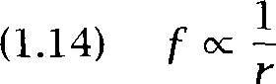

or, in other words:

(1.15) There is a constant *k* such that *f . = k*

For example, this says that the  most common word should occur with three times the frequency of the  most common word. This relationship between frequency and rank appears first to have been no- ticed by Estoup  but was widely publicized by Zipf and continues to bear his name. We will regard this result not actually as a law, but as a roughly accurate characterization of certain empirical facts.

Table 1.3 shows an empirical evaluation of Zipf’s law on the basis of Tom Sawyer. Here, Zipf’s law is shown to approximately hold, but we

note that it is quite a bit off for the three highest frequency words, and further that the product *f .* tends to bulge a little for words of rank

around 100, a slight bulge which can also be noted in many of Zipf’s own studies. Nevertheless, Zipf’s law is useful as a rough description of the frequency distribution of words in human languages: there are a few very common words, a middling number of medium frequency words, and many low frequency words. Zipf saw in this a deep significance.

***1.4 Dirty Hands***

According to his theory both the speaker and the hearer are trying to minimize their effort. The speaker’s effort is conserved by having a small vocabulary of common words and the hearer’s effort is lessened by hav- ing a large vocabulary of individually rarer words (so that messages are less ambiguous). The maximally economical compromise between these competing needs is argued to be the kind of reciprocal relationship be- tween frequency and rank that appears in the data supporting Zipf’s law. However, for us, the main upshot of Zipf’s law is the practical problem that for most words our data about their use will be exceedingly sparse. Only for a few words will we have lots of examples.

The validity and possibilities for the derivation of Zipf’s law is studied extensively by Mandelbrot (1954). While studies of larger corpora some- times show a closer match to Zipf’s predictions than our examples here, Mandelbrot (1954: 12) also notes that “bien que la de Zipf l’allure  des  elle en represente les details [al- though Zipf’s formula gives the general shape of the curves, it is very bad in reflecting the details].” Figure 1.1 shows a rank-frequency plot of the words in one corpus (the Brown corpus) on doubly logarithmic axes. Zipf’s law predicts that this graph should be a straight line with slope 1. Mandelbrot noted that the line is often a bad fit, especially for low and high ranks. In our example, the line is too low for most low ranks and too high for ranks greater than 10,000.



To achieve a closer fit to the empirical distribution of words,

brot derives the following more general relationship between rank and frequency:

(1.16)  = +  or logf = + 



Here P, and are parameters of a text, that collectively measure the richness of the text’s use of words. There is still a hyperbolic distribu- tion between rank and frequency, as in the original equation (1.14). If this formula is graphed on doubly logarithmic axes, then for large values of ***r,*** it closely approximates a straight line descending with slope

just as Zipf’s law. However, by appropriate setting of the other parame- ters, one can model a curve where the predicted frequency of the most frequent words is lower, while thereafter there is a bulge in the curve: just as we saw in the case of Sawyer. The graph in figure 1.2 shows that Mandelbrot’s formula is indeed a better fit than Zipf’s law for our corpus. The slight bulge in the upper left corner and the larger slope

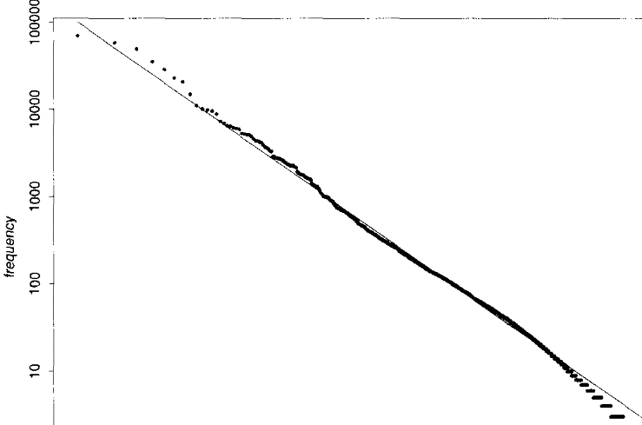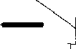

**10 100 **

Figure 1.1 Zipf’s law. The graph shows rank on the X-axis versus frequency on the Y-axis, using logarithmic scales. The points correspond to the ranks and frequencies of the words in one corpus (the Brown corpus). The line is the relationship between rank and frequency predicted by Zipf for k = 100,000, that is  x r = 100,000.

of = 1.15 model the lowest and highest ranks better than the line in figure 1.1 predicted by Zipf.

If we take = 1 and = 0 then Mandelbrot’s formula simplifies to the one given by Zipf (see exercise 1.3). Based on data similar to the cor- pora we just looked at, Mandelbrot argues that Zipf’s simpler formula just is not true in general: “lorsque Zipf essayait de  tout par cette  il essayait d’habiller tout le monde des d’une seule taille [when Zipf tried to represent everything by this (i.e., his) law, he tried to dress everyone with clothes of a single cut]“. Nevertheless, Mandelbrot sees the importance of Zipf’s work as stressing that there are often phenomena in the world that are not suitably modeled by Gaussian (normal) distributions, that is, ‘bell curves,’ but by hyperbolic distribu- tions a fact discovered earlier in the domain of economics by Pareto.

***1.4 Dirty Hands* 27**

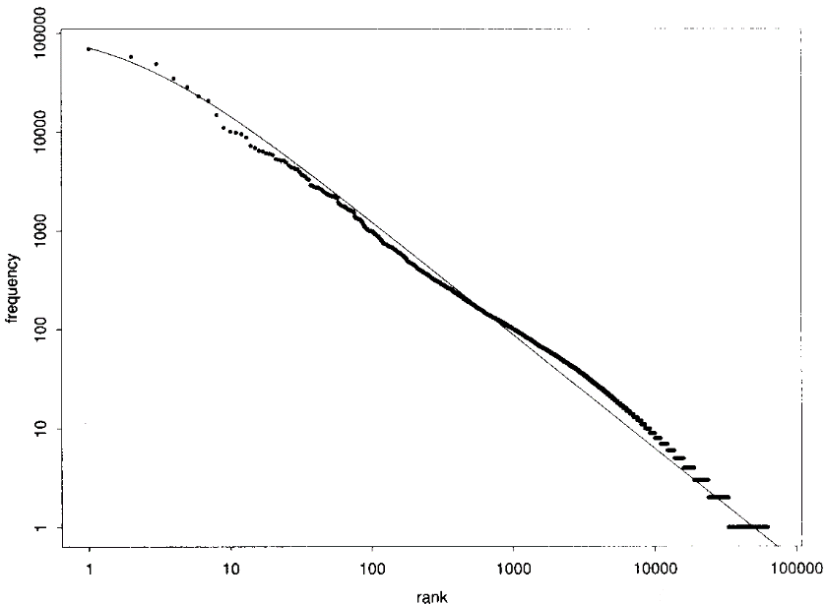

Figure 1.2 Mandelbrot’s formula. The graph shows rank on the X-axis versus frequency on the Y-axis, using logarithmic scales. The points correspond to the ranks and frequencies of the words in one corpus (the Brown corpus). The line is the relationship between rank and frequency predicted by Mandelbrot’s formula for = = 1.15, = 100.



(1.17)

**Other laws**

References to Zipf’s law in the Statistical NLP literature invariably refer to the above law, but Zipf actually proposed a number of other empirical laws relating to language which were also taken to illustrate the Principle of Least Effort. At least two others are of some interest to the concerns of Statistical NLP. One is the suggestion that the number of meanings of a word is correlated with its frequency. Again, Zipf argues that con- servation of speaker effort would prefer there to be only one word with all meanings while conservation of hearer effort would prefer each mean- ing to be expressed by a different word. Assuming that these forces are equally strong, Zipf argues that the number of meanings of a word obeys the law:

*f*



**28** Introduction

or, given the previous law, that:

(1.18)



Zipf finds empirical support for this result (in his study, words of fre- quency rank about 10,000 average about 2.1 meanings, words of rank about 5000 average about 3 meanings, and words of rank about 2000 average about 4.6 meanings).

A second result concerns the tendency of content words to clump. For a word one can measure the number of lines or pages between each oc- currence of the word in a text, and then calculate the frequency of different interval sizes For words of frequency at most 24 in a 260,000 word corpus, Zipf found that the number of intervals of a certain size was inversely related to the interval size where varied be- tween about 1 and 1.3 in Zipf’s studies). In other words, most of the time content words occur near another occurrence of the same word.



The topic of word senses is discussed in chapter 7, while the clumping of content words is discussed in section 15.3.

Other laws of Zipf’s include that there is an inverse relationship be- tween the frequency of words and their length, that the greater the fre- quency of a word or morpheme, the greater the number of different per- mutations (roughly, compounds and morphologically complex forms) it will be used in, and yet further laws covering historical change and the frequency of phonemes.

**The significance of power laws**

As a final remark on Zipf’s law, we note that there is a debate on how surprising and interesting Zipf’s law and ‘power laws’ in general are as a description of natural phenomena. It has been argued that randomly generated text exhibits Zipf’s law (Li 1992). To show this, we construct a generator that randomly  characters from the 26 letters of the alphabet and the blank (that is, each of these 27 symbols has an equal chance of being generated next). Simplifying slightly, the probability of a word of length n being generated is the probability of generating a non-blank character *n* times and the blank after that. One can show that the words generated by such a generator obey a power law of the form Mandelbrot suggested. The key insights are  that there are 26 times more words of length *n* 1 than length *n,* and (ii) that there is a



constant ratio by which words of length are more frequent than words of length n + 1. These two opposing trends combine into the regularity of Mandelbrot’s law. See exercise 1.4.

There is in fact a broad class of probability distributions that obey power laws when the same procedure is applied to them that is used to compute the Zipf distribution: first counting events, then ranking them according to their frequency  et al. 1996). Seen from this angle, Zipf’s law seems less valuable as a characterization of language. But the basic insight remains: what makes frequency-based approaches to lan- guage hard is that almost all words are rare. Zipf’s law is a good way to encapsulate this insight.

* + 1. Collocations

Lexicographers and linguists (although rarely those of a generative bent) COLLOCATION have long been interested in collocations. A collocation is any turn of phrase or accepted usage where somehow the whole is perceived to have

an existence beyond the sum of the parts. Collocations include com- pounds ***(disk drive),*** phrasal verbs ***(make up),*** and other stock phrases (bacon and eggs). They often have a specialized meaning or are idiomatic, but they need not be. For example, at the time of writing, a favorite ex- pression of bureaucrats in Australia is ***international best practice. Now*** there appears to be nothing idiomatic about this expression; it is simply two adjectives modifying a noun in a productive and semantically com- positional way. But, nevertheless, the frequent use of this phrase as a fixed expression accompanied by certain connotations justifies regarding it as a collocation. Indeed, any expression that people repeat because they have heard others using it is a candidate for a collocation.

Collocations are discussed in detail in chapter 5. We see later on that collocations are important in areas of Statistical NLP such as machine translation (chapter 13) and information retrieval (chapter 15). In ma- chine translation, a word may be translated differently according to the collocation it occurs in. An information retrieval system may want to index only ‘interesting’ phrases, that is, those that are collocations.

Lexicographers are also interested in collocations both because they show frequent ways in which a word is used, and because they are tiword units which have an independent existence and probably should appear in a dictionary. They also have theoretical interest: to the extent that most of language use is people reusing phrases and constructions

Frequency Word 1 Word 2

80871 of

58841 in

26430 to

21842 on

21839 for

18568 and

16121 that

15630 at

15494 to

13899 in

13689 of

13361 by

13183 with

12622 from

11428 New

10007 he

9775 as

9231 is

8753 has

8573 for

the the the the the the the the be a

a

the the the

York said a

a

been a

Table *1.4* Commonest  collocations in the New *York Times.*

that they have heard, this serves to de-emphasize the Chomskyan focus on the creativity of language use, and to give more strength to some- thing like a Hallidayan approach that considers language to be insepara- ble from its pragmatic and social context.

Now collocations may be several words long (such as *international best practice)* or they may be discontinuous (such as make *[something] up),* but let us restrict ourselves to the simplest case and wonder how we can au- tomatically identify contiguous two word collocations. It was mentioned above that collocations tend to be frequent usages. So the first idea to try might be simply to find the most common two word sequences in a text. That is fairly easily done, and, for a corpus of text from the New York *Times (see* page  the results are shown in table 1.4. Unfortunately, this method does not seem to succeed very well at capturing the collo- cations present in the text. It is not surprising that these pairs of words

(normally referred to as  occur commonly. They simply rep- resent common syntactic constructions involving individually extremely common words. One problem is that we are not normalizing for the fre- quency of the words that make up the collocation. Given that the,  and *in* are extremely common words, and that the syntax of prepositional and noun phrases means that a determiner commonly follows a preposi- tion, we should expect to commonly see of the and *in the.* But that does not make these word sequences collocations. An obvious next step is to somehow take into account the frequency of each of the words. We will look at methods that do this in chapter 5.

A modification that might be less obvious, but which is very effective, is to *filter* the collocations and remove those that have parts of speech (or syntactic categories) that are rarely associated with interesting collo- cations. There simply are no interesting collocations that have a preposi- tion as the first word and an article as the second word. The two most fre- quent patterns for two word collocations are “adjective noun” and “noun noun” (the latter are called noun-noun compounds). Table 1.5 shows which  are selected from the corpus if we only keep  noun and noun-noun  Almost all of them seem to be phrases that we would want to list in a dictionary with some exceptions like *year* and *year.*

Our excursion into ‘collocation discovery’ illustrates the back and forth in Statistical NLP between modeling and data analysis. Our initial model was that a collocation is simply a frequent  We analyzed the re- sults we got based on this model, identified problems and then came up with a refined model (collocation = frequent  with a particular part-of-speech pattern). This model needs further refinement because of  like *next year* that are selected incorrectly. Still, we will leave our investigation of collocations for now, and continue it in chapter 5.

* + 1. Concordances

As a final illustration of data exploration, suppose we are interested in the syntactic frames in which verbs appear. People have researched how to get a computer to find these frames automatically, but we can also just use the computer as a tool to find appropriate data. For such purposes, people often use a *Key Word In Context * concordancing program

**C ONTEXT** which produces displays of data such as the one in figure 1.3. In such a display, all occurrences of the word of interest are lined up beneath

|  |  |  |  |  |
| --- | --- | --- | --- | --- |
| Frequency | Word 1 | Word 2 | Part-of-speech | pattern |
| 11487 | New | York | AN |  |
| 7261 | United | States | AN |  |
| 5412 | Los | Angeles | NN |  |
| 3301 | last | year | AN |  |
| 3191 | Saudi | Arabia | NN |  |
| 2699 | last | week | AN |  |
| 2514 | vice | president | AN |  |
| 2378 | Persian | Gulf | AN |  |
| 2161 | San | Francisco | NN |  |
| 2106 | President | Bush | NN |  |
| 2001 | Middle | East | AN |  |
| 1942 | Saddam | Hussein | NN |  |
| 1867 | Soviet | Union | AN |  |
| 1850 | White | House | AN |  |
| 1633 | United | Nations | AN |  |
| 1337 | York | City | NN |  |
| 1328 | oil | prices | NN |  |
| 1210 | next | year | AN |  |
| 1074 | chief | executive | AN |  |
| 1073 | real | estate | AN |  |

Table 1.5 Frequent  after filtering. The most frequent  in the New *York Times* after applying a part-of-speech filter.

**could find a target. The librarian "showed off" running hither and thither w elights in. The young lady teachers "showed off" bending sweetly over pupils ingly. The young gentlemen teachers "showed off" with small scoldings and other seeming vexation). The little girls “showed off" in various ways, and the littl n various ways, and the little boys "showed off" with such diligence that the a t genuwyne?" Tom lifted his lip and showed the vacancy. “Well, all right," sai is little finger for a pen. Then he showed Huckleberry how to make an H and an**

1. **face was haggard, and his eyes showed the fear that was upon him. When he**
2. **not overlook the fact that Tom even showed a marked aversion to these inquests**
3. **own. Two or three glimmering lights showed where it lay, peacefully sleeping,**
4. **ird flash turned night into day and** showed **every little grass-blade, separate**
5. **that grew about their feet. And it** showed **three white, startled faces, too. A**
6. **he first thing his aunt said to him showed him that he had brought his sorrows**
7. **p from her lethargy of distress and showed good interest in the proceedings.**
8. **ent a new burst of grief from Becky showed Tom that the thing in his mind had**
9. **shudder quiver all through him. He showed the fragment of candle-wick pe**

Figure 1.3 Key Word In Context display for the word *showed.*

* 1. ***Dirty Hands 33***

NP



showed off

NP*content*

showed

***interest]***

NP*agent*

NP

NP showed



Figure 1.4 Syntactic frames for ***showed*** in ***Tom Sawyer.***

one another, with surrounding context shown on both sides. Commonly, KWIC programs allow you to sort the matches by left or right context. However, if we are interested in syntactic frames, rather than particu- lar words, such sorting is of limited use. The data shows occurrences of the word showed within the novel Torn  There are 5 uses of ***showed off*** (actually all within one paragraph of the text), each in dou- ble quotes, perhaps because it was a neologism at the time, or perhaps because Twain considered the expression slang. All of these uses are in- transitive, although some take prepositional phrase modifiers. Beyond these, there are four straightforward transitive verb uses with just a direct object (6, 8, 11, 12) although there are interesting differences between them with 8 being nonagentive, and 12 illustrating a sense of ‘cause to be visible.’ There is one ditransitive use which adds the person being shown (16). Three examples make who was shown the object NP and express the content either as a that-clause (13, 15) or as a non-finite question-form complement clause (7). One other example has a finite question-form complement clause (10) but omits mention of the person who is shown. Finally two examples have an NP object followed by a prepositional phrase and are quite idiomatic constructions (9, 14): show an ***aversion*** and show ***interest*** But note that while quite idiomatic, they are not completely frozen forms, since in both cases the object noun is productively modified to make a more complex NP. We could systematize the patterns we have found as in figure 1.4.

Collecting information like this about patterns of occurrence of verbs can be useful not only for purposes such as dictionaries for learners of foreign languages, but for use in guiding statistical parsers. A substantial part of the work in Statistical NLP consists (or should consist!) of poring

*34 Introduction*

over large amounts of data, like concordance lines and lists of candidates for collocations. At the outset of a project this is done to understand the important phenomena, later to refine the initial modeling, and finally to evaluate what was achieved.

* 1. Further Reading

Chomsky (1965:  1980:  1986) discusses the distinction be- tween rationalist and empiricist approaches to language, and presents ar- guments for the rationalist position. A recent detailed response to these arguments from an ‘empiricist’ is (Sampson 1997). For people from a gen- erative (computational) linguistics background wondering what Statisti- cal NLP can do for them, and how it relates to their traditional concerns, Abney  is a good place to start. The observation that there must be a preference for certain kinds of generalizations in order to bootstrap induction was pointed out in the machine learning literature by Mitchell  who termed the preference bias. The work of Firth is highly in- fluential within certain strands of the British corpus linguistics tradition, and is thoroughly covered in (Stubbs 1996). References from within the Statistical NLP community perhaps originate in work from AT&T, see for instance (Church and 1993: 1). The Hallidayan approach to lan- guage is presented in (Halliday 1994).

GRAMMATICALITY Thorough discussions of  judgements in linguistics are

found in  1996) and  1997). argues for making use of the judgements of a population of speakers, which is quite com- patible with the approach of this book, and rather against the Chomskyan approach of exploring the grammar of a single speaker. A good entry point to the literature on categorical perception is (Harnad 1987).

Lauer (199Sb: ch. 3) advocates an approach involving probability dis- tributions over meanings. See the Further Reading of chapter 12 for ref- erences to other Statistical NLP work that involves mapping to semantic representations.

The discussion of *kind/sort of* is based on which should be consulted for the sources of the citations used. provides a nectionist model which shows how the syntactic change discussed can be caused by changing frequencies of use. A lot of interesting recent work on gradual syntactic change can be found in the literature on 



(Hopper and Traugott 1993).

***Exercises ***

KWIC

Two proponents of an important role for probabilistic mechanisms in cognition are Anderson (1983, 1990) and Suppes (1984). (Oaksford and Chater 1998) for a recent collection describing different cognitive architectures, including connectionism. The that language is best explained as a cognitive phenomenon is the central tenet of cognitive linguistics (Lakoff 1987; Langacker 1987, 19911, but many cognitive lin- guists would not endorse probability theory as a formalization of cogni- tive linguistics. See also (Schutze 1997).

The novel Tom  is available in the public domain on the internet, currently from sources including the Virginia Electronic Center (see the website).

Zipf’s work began with (Zipf  his doctoral thesis. His two  books are (Zipf 1935) and (Zipf 1949). It is interesting to note that Zipf was reviewed harshly by linguists in his day (see, for instance, (Kent 1930) and (Prokosch 1933)). In part these criticisms correctly on the grandiosity of Zipf’s claims (Kent (1930: writes: “problems of phonol- ogy and morphology are not to be solved en by one grand general formula”), but they also reflected, even then, a certain ambivalence to the application of statistical methods in linguistics. Nevertheless, prominent American structuralists, such as Martin Joos and Morris Swadesh, did be- come involved in data collection for statistical studies, with Joos (1936) emphasizing that the question of whether to use statistical methods in linguistics should be evaluated separately from Zipf’s particular claims.

As well as (Mandelbrot  Mandelbrot’s investigation of Zipf’s law is summarized in (Mandelbrot 1983) see especially chapters 38,

and 42. Mandelbrot attributes the direction of his life’s work (leading to his well known work on fractals and the Mandelbrot set) to reading a review of (Zipf 1949).

Concordances were first constructed by hand for important literary and religious works. Computer concordancing began in the late for the purposes of categorizing and indexing article titles and abstracts. Luhn (1960) developed first computer and coined the term



* 1. Exercises

Exercise 1.1 Requires some knowledge of linguistics]

Try to think of some other cases of noncategorical phenomena in language, per- haps related to language change. For starters, look at the following pairs of

*Introduction*

sentences, and try to work out the problems they raise. (Could these problems be solved simply by assigning the words to two categories, or is there evidence of mixed categoriality?)

(1.19) a. On the weekend the children had *fun.*

b. That’s the  thing we’ve done all holidays.

(1.20) a. Do you get much at work?

b. This morning I had from five clients, all complaining.

**Exercise** 1.2 Probably best attempted after reading chapter 41

Replicate some of the results of section 1.4 on some other piece of text. (Alter- natively, you could use the same text that we did so that you can check your work easily. In this case, you should only expect results similar to ours, since the exact numbers depend on various details of what is treated as a word, how case distinctions are treated, etc.)

**Exercise** 1.3

Show that Mandelbrot’s law simplifies to Zipf’s law for = 1 and = 0.

Exercise 1.4 

Construct a table like table 1.3 for the random character generator described above on page 29 (which generates the letters a through z and blank with equal probability of 27).

Exercise 1.5 

Think about ways of identifying collocations that might be better than the meth- ods used in this chapter.

Exercise 1.6 

If you succeeded in the above exercise, try the method out and see how well it appears to perform.

Exercise 1.7 

Write a program to produce KWIC displays from a text file. Have the user be able to select the word of interest and the size of the surrounding context.

*“In 1786, I found, that in Germany they were engaged in a species of political inquiry, to which they had given the name of Statistics; and though I apply a different idea to that word, for by Statistical is meant in Germany, an inquiry for the purpose of ascertaining the political strength of a country, or questions respecting matters of state; whereas, the idea I annex to the term, is an inquiry into the state of a country, for the purpose*

*of ascertaining the quantum of happiness enjoyed by its inhabitants, and the means of its future improvement; yet, as*

*I thought that a new word might attract more public attention, I resolved on adopting it.*

*(Sir J. Sinclair Statist. Scot. App. p. xiii, 1798)*

## Mathematical Foundations

**THIS CHAPTER** presents some introductory material on probability and information theory, while the next chapter presents some essential know- ledge of linguistics. A thorough knowledge of one or more of the fields of probability and statistics, information theory, and linguistics is desirable, and perhaps even necessary, for doing original research in the field of Sta- tistical **NLP.** We cannot provide a thorough well-motivated introduction to each of these three fields within this book, but nevertheless, we attempt to summarize enough material to allow understanding of everything that follows in the book. We do however assume knowledge of parsing, ei- ther from a computer science or computational linguistics perspective. We also assume a reasonable knowledge of mathematical symbols and techniques, perhaps roughly to the level of a first year undergraduate course, including the basics of such topics as: set theory, functions and relations, summations, polynomials, calculus, vectors and matrices, and logarithms. Mathematical notations that we use are summarized in the Table of Notations.

If you are familiar with one of the areas covered in these two chap- ters, then you should probably just skim the corresponding section. If you’re not familiar with a topic, we think it is probably best to try to read through each section, but you will probably need to reread sections when the techniques in them are put to use. These chapters don’t say much about applications they present the preparatory theory for what follows.

40 *Mathematical Foundations*

**2.1**

**2.1.1**

**PROBABILITY THEORY**

**EXPERIMENT**

**TRIAL**

**BASIC OUTCOMES SAMPLE SPACE**

**DISCRETE**

**EVENT**



**EVENT SPACE**

**PROBABILITY FUNCTION**

**PROBABILITY**

**DISTRIBUTION**

**Elementary Probability Theory**

This section sketches the essentials of probability theory necessary to understand the rest of this book.

Probability spaces

*Probability theory* deals with predicting how likely it is that something will happen. For example, if one tosses three coins, how likely is it that they will all come up heads? Although our eventual aim is to look at language, we begin with some examples with coins and dice, since their behavior is simpler and more straightforward.

The notion of the likelihood of something is formalized through the concept of an *experiment* (or trial) the process by which an observation is made. In this technical sense, tossing three coins is an experiment. All that is crucial is that the experimental protocol is well defined. We assume a collection of *basic outcomes* (or sample points) for our experi- ment, the sample space Sample spaces may either be *discrete,* having at most a countably infinite number of basic outcomes, or *continuous,* hav- ing an uncountable number of basic outcomes (for example, measuring a person’s height). For language applications and in this introduction, we will mainly deal with discrete sample spaces which only contain a finite number of basic outcomes. Let an event *A* be a subset of For example, in the coin experiment, the first coin being a head, and the second and third coming down tails is one basic outcome, while any result of one head and two tails is an example of an event. Note also that represents the certain event, the space of all possible experimental outcomes, and

0 represents the impossible event. We say that an experimental outcome must be an event. The foundations of probability theory depend on the set of events  forming a  a set with a maximal element and arbitrary complements and unions. These requirements are trivially sat- isfied by making the set of events, the event *space,* the power set of the sample space (that is, the set of all subsets of the sample space, often written 

Probabilities are numbers between O and 1, where O indicates impos- sibility and 1 certainty. A *probability function* (also known as a *prob- ability distribution)* distributes a probability mass of 1 throughout the sample space Formally, a discrete probability function is any function

[0,  such that:



***2.1 Elementary Probability Theory 41***





**DISJOINT** Countable additivity: For  sets (i.e., ***= 0*** for

  

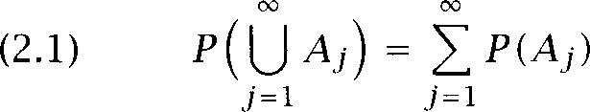

We call ***P(A)*** the probability of the event ***A.*** These axioms say that an event that encompasses, say, three distinct possibilities must have a probability that is the sum of the probabilities of each possibility, and that since an experiment must have some basic outcome as its result, the probability of that is 1. Using basic set theory, we can derive from these axioms a set of further properties of probability functions; see ex- ercise 2.1.

**PROBABILITY SPACE** A well-founded *probability space* consists of a sample space a a-field of events  and a probability function ***P.*** In Statistical NLP applications, we always seek to properly define such a probability space for our mod- els. Otherwise, the numbers we use are merely ad hoc scaling factors, and there is no mathematical theory to help us. In practice, though, corners often have been, and continue to be, cut.

**Example 1:** A fair coin is tossed 3 times. What is the chance of 2 heads’?

**Solution:** The experimental protocol is clear. The sample space is:

= ***{HHH,HHT,HTH, HTT, THH, THT, TTH, TTT}***

Each of the basic outcomes in is equally likely, and thus has probability A situation where each basic outcome is equally likely is called a

**UNIFORM** uniform *distribution.* In a finite sample space with equiprobable basic

**DISTRIBUTION** outcomes, ***P(A) = *** (where is the number of elements in a set ***A).***

The event of interest is:

***A = *** ***HTH, THH}***





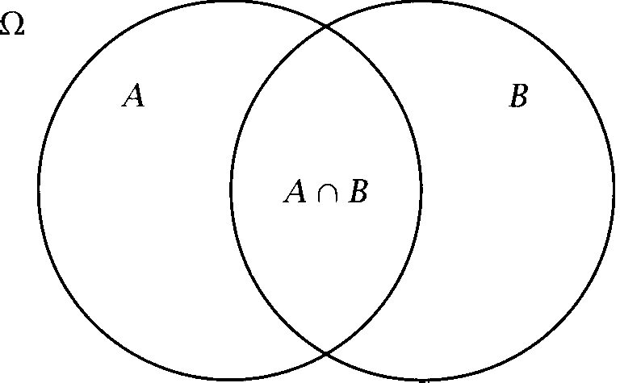**Figure 2.1** A diagram illustrating the calculation of conditional probabil- ity Once we know that the outcome is in *B,* the probability of *A* becomes



n

**2.1.2**

**CONDITIONAL PROBABILITY**

**PRIOR PROBABILITY**

**POSTERIOR PROBABILITY**





Conditional probability and independence

Sometimes we have partial knowledge about the outcome of an experi- ment and that naturally influences what experimental outcomes are pos- sible. We capture this knowledge through the notion of *conditional proba- bility.* This is the updated probability of an event given some knowledge. The probability of an event before we consider our additional knowledge is called the *prior probability* of the event, while the new probability that results from using our additional knowledge is referred to as the pos- *terior probability* of the event. Returning to example 1 (the chance of getting 2 heads when tossing 3 coins), if the first coin has been tossed and is a head, then of the 4 remaining possible basic outcomes, 2 result

in 2 heads, and so the probability of getting 2 heads now becomes  The conditional probability of an event *A* given that an event has occurred

0) is:







Even if P(B) = 0 we have that:

*= * *= * [The multiplication rule]



We can do the conditionalization either way because set intersection is symmetric *(A* n = *A).* One can easily visualize this result by looking at the diagram in figure 2.1.

***2.1 Elementary Probability*** *Theory 43*

The generalization of this rule to multiple events is a central result that

CHAIN RULE will be used throughout this book, the *chain rule:*

*(2.4) . . . * 



The chain rule is used in many places in Statistical NLP, such as working out the properties of Markov models in chapter 9.

INDEPENDENCE Two events *A,* are *independent* of each other if *=*



Unless P(B) = 0 this is equivalent to saying that *P(A) =* (i.e., knowing that is the case does not affect the probability of *A).* This equivalence follows trivially from the chain rule. Otherwise events are

DEPENDENCE *dependent.* We can also say that *A* and are *conditionally independent*

given C = 



INDEPENDENCE

2.1.3 Bayes’ theorem

T H E O R E M  *theorem* lets us swap the order of dependence between events. That is, it lets us calculate  in terms of  This is useful when the former quantity is difficult to determine. It is a central tool that we will use again and again, but it is a trivial consequence of the definition of conditional probability and the chain rule introduced in equations (2.2) and (2.3):

(2.5) *= * *= *

NORMALIZING The righthand side denominator *P(A)* can be viewed as a *normalizing* CONSTANT constant, something that ensures that we have a probability function. If we are simply interested in which event out of some set is most likely

given *A, we* can ignore it. Since the denominator is the same in all cases, we have that:

(2.6) argmax P(A) = ***B***

***B***

However, we can also evaluate the denominator by recalling that:

*=*

= 

*So we* have:

*P(A) =* [additivity]

=

and  serve to split the set A into two disjoint parts (one possibly empty), and so we can evaluate the conditional probability on each, and then sum, using additivity. More generally, if we have some group of sets

**PARTITION** that ***partition A,*** that is, if ***A*** and the are disjoint, then: (2.7) ***P ( A ) ***



This gives us the following equivalent but more elaborated version of Bayes’ theorem:

Bayes’ theorem: If ***A P(A) 0,*** and = 0 for j then:



Example 2: Suppose one is interested in a rare syntactic construction, perhaps parasitic gaps, which occurs on average once in 100,000 sen- tences. Joe Linguist has developed a complicated pattern matcher that attempts to identify sentences with parasitic gaps. It’s pretty good, but it’s not perfect: if a sentence has a parasitic gap, it will say so with proba- bility 0.95, if it doesn’t, it will wrongly say it does with probability 0.005. Suppose the test says that a sentence contains a parasitic gap. What is the probability that this is true?

Solution: Let G be the event of the sentence having a parasitic gap, and let be the event of the test being positive. We want to determine:

 ***=***



***0.95 x*** 0.00001

***0.002***

= 0.95 x 0.00001 + ***0.005 x 0.99999***

Here we use having the construction or not as the partition in the de- nominator. Although Joe’s test seems quite reliable, we find that using it won’t help as much as one might have hoped. On average, only **1** in every 500 sentences that the test identifies will actually contain a parasitic gap. This poor result comes about because the prior probability of a sentence containing a parasitic gap is so low.

Bayes’ theorem is central to the noisy channel model described in sec- tion 22.4.



|  |  |  |  |  |
| --- | --- | --- | --- | --- |
| First |  |  | Second die |  |
| die | 1 | 2 | 3 4 | 5 |

|  |  |  |  |  |  |  |  |  |  |  |  |  |
| --- | --- | --- | --- | --- | --- | --- | --- | --- | --- | --- | --- | --- |
| 6 | | 7 | 8 | 9 | IO | 11 | 12 |  | | | | |
| 5 | | 6 | 7 | 8 | 9 | IO | 11 |
| 4 | | 5 | 6 | 7 | 8 | 9 | IO |
| 3 | | 4 | 5 | 6 | 7 | 8 | 9 |
| 2 | | 3 | 4 | 5 | 6 | 7 | 8 |
| 1 | | 2 | 3 | 4 | 5 | 6 | 7 |
| **X** | = |  | 2 | 3 | 4 | 5 | 67 | 8 | 9 | IO | 111 | 12 |
|  | **36** |  | **12** |  | **36** | **15**  **36** |  | **12** | **18** | **I**  **36** |

Figure 2.2 A random variable X for the sum of two dice. Entries in the body of the table show the value of X given the underlying basic outcomes, while the bottom two rows show the pmf p(x).

**2.1.4**

**RANDOMVARIABLE**

**STOCHASTIC** PROCESS

**INDICATORRANDOM**

**VARIABLE B ERNOULLI TRIAL**

**PROBABILITY MASS**

**FUNCTION**

Random variables

A *random* ***variable*** is simply a function X: (commonly with = I), where is the set of real numbers. Rather than having to work with some irregular event space which differs with every problem we look at, a ran- dom variable allows us to talk about the probabilities of numerical values that are related to the event space. We think of an abstract *stochastic pro- cess* that generates numbers with a certain probability distribution. (The word ***stochastic*** simply means ‘probabilistic’ or ‘randomly generated,’ but is especially commonly used when referring to a sequence of results as- sumed to be generated by some underlying probability distribution.)



A discrete random variable is a function X: where is a count- able subset of If then X is called an *indicator random variable* or a ***Bernoulli trial.***



**Example 3:** Suppose the events are those that result from tossing two dice. Then we could define a discrete random variable X that is the sum of their faces: =   as indicated in figure 2.2.

Because a random variable has a numeric range, we can often do math- ematics more easily by working with the values of a random variable, rather than directly with events. In particular we can define the *probabil- ity mass function* for a random variable X, which gives the

bility that the random variable has different numeric values: (2.9) pmf p(x) =  = = where A, = ***=***



We will write pmfs with a lowercase roman letter (even when they are vari-

ables). If a random variable X is distributed according to the pmf p(x), then we will write X p(x).

Note that p(x) 0 at only a countable number of points (to satisfy the stochastic constraint on probabilities), say ***i*** while p(x) = 0 elsewhere. For a discrete random variable, we have that:





*i i*

Conversely, any function satisfying these constraints can be regarded as a mass function.

Random variables are used throughout the introduction to information theory in section 2.2.

Expectation and variance

**EXPECTATION** The  is the mean or average of a random variable.

**MEAN** If X is a random variable with a pmf p(x) such that p(x) then the expectation is:



(2.10) E(X) = 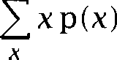

Example 4: If rolling one die and Y is the value on its face, then:

***E(Y) =*** =  y =  

**y=l y=l**

This is the expected average found by totaling up a large number of throws of the die, and dividing by the number of throws.

If Y p(y) is a random variable, any function g(Y) defines a new random variable. If  is defined, then:

(2.11)  =  p(y)

**Y**

For instance, by letting be a linear function g(Y) = +  we see that

***= + b.*** We also have that ***E(X = E(X) + E(Y)*** and if X and Y are independent, then ***=***



**VARIANCE** The variance of a random variable is a measure of whether the values of the random variable tend to be consistent over trials or to vary a lot. One measures it by finding out how much on average the variable’s values deviate from the variable’s expectation:

(2.12) = ***E((X ***

***= *** 

**STANDARD DEVIATION** The commonly used ***standard deviation*** of a variable is the square root of the variance. When talking about a particular distribution or set of data, the mean is commonly denoted as the variance as  and the standard deviation is hence written as

**Example 5:** What is the expectation and variance for the random vari- able introduced in example 3, the sum of the numbers on two dice?

**Solution:** For the expectation, we can use the result in example 4, and the formula for combining expectations in (or below) equation (2.11):

**= *E(Y = E(Y) E(Y) = *** **+ 7**



The variance is given by:

***=*** 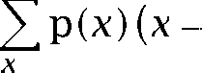 

Because the results for rolling two dice are concentrated around 7, the variance of this distribution is less than for an ‘ll-sided die,’ which re- turns a uniform distribution over the numbers 2-12. For such a uniformly distributed random variable we find that = 10.

Calculating expectations is central to Information Theory, as we will see in section 2.2. Variances are used in section 5.2.

**2.1.6 Notation**

In these sections, we have distinguished between ***P*** as a probability func- tion and p as the probability mass function of a random variable. How- ever, the notations ***P )*** and  do not always refer to the same function. Any time that we are talking about a different probability space, then we are talking about a different function. Sometimes we will denote these

different functions with subscripts on the function to make it clear what we are talking about, but in general people just write ***P*** and rely on con- text and the names of the variables that are arguments to the function to disambiguate. It is important to realize that one equation is often refer- ring to several different probability functions, all ambiguously referred to as ***P.***

2.1.7

**MARGINAL DISTRIBUTION**

Joint and conditional distributions

Often we define many random variables over a sample space giving us a joint (or multivariate) probability distribution. The joint probability mass function for two discrete random variables X, Y is:

 = ***= x, Y = ***

Related to a joint pmf are marginal  which total up the probability masses for the values of each variable separately:

 =   =



**Y**

In general the marginal mass functions do not determine the joint mass function. But if X and Y are independent, then  =



For example, for the probability of getting two sixes from rolling two dice, since these events are independent, we can compute that:

I



There are analogous results for joint distributions and probabilities for the intersection of events. So we can define a conditional pmf in terms of the joint distribution:

**=** 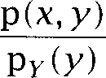 for y such that 0



and deduce a chain rule in terms of random variables, for instance:

 =P P I P YI 



* + 1. Determining

**So** far we have just been assuming a probability function ***P*** and giving it the obvious definition for simple examples with coins and dice. But what

**ESTIMATION**

**RELATIVE FREQUENCY**

**PARAMETRIC**

**NON-PARAMETRIC DISTRIBUTION-FREE**

do we do when dealing with language? What do we say about the proba- bility of a sentence like *The cow chewed its cud?* In general, for language events, unlike dice, is unknown. This means we have to *estimate P.* We do this by looking at evidence about what must be like based on a sam- ple of data. The proportion of times a certain outcome occurs is called the *relative frequency* of the outcome. If  is the number of times an outcome occurs in trials then is the relative frequency of The relative frequency is often denoted Empirically, if one performs a large number of trials, the relative frequency tends to stabilize around some number. That this number exists provides a basis for letting us calculate probability estimates.

Techniques for how this can be done are a major topic of this book, par- ticularly covered in chapter 6. Common to most of these techniques is to estimate by assuming that some phenomenon in language is accept- ably modeled by one of the well-known families of distributions (such as the binomial or normal distribution), which have been widely studied in statistics. In particular a binomial distribution can sometimes be used as an acceptable model of linguistic events. We introduce a couple of families of distributions in the next subsection. This is referred to as a *parametric* approach and has a couple of advantages. It means we have an explicit probabilistic model of the process by which the data was gen- erated, and determining a particular probability distribution within the family only requires the specification of a few parameters, since most of the nature of the curve is fixed in advance. Since only a few parameters need to be determined, the amount of training data required is not great, and one can calculate how much training data is sufficient to make good probability estimates.



But, some parts of language (such as the distributions of words in newspaper articles in a particular topic category) are irregular enough that this approach can run into problems. For example, if we assume our data is binomially distributed, but in fact the data looks nothing like a binomial distribution, then our probability estimates might be wildly wrong.

For such cases, one can use methods that make no assumptions about the underlying distribution of the data, or will work reasonably well for a wide variety of different distributions. This is referred to as a *parametric* or *distribution-free* approach. If we simply empirically esti- mate by counting a large number of random events (giving us a discrete distribution, though we might produce a continuous distribution from

50 *Mathematical Foundations*

such data by interpolation, assuming only that the estimated probability density function should be a fairly smooth curve), then this is a parametric method. However, empirical counts often need to be modified or smoothed to deal with the deficiencies of our limited training data, a topic discussed in chapter 6. Such smoothing techniques usually assume a certain underlying distribution, and so we are then back in the world of parametric methods. The disadvantage of nonparametric methods is that we give our system less prior information about how the data are

 so a great deal of training data is usually needed to compensate for

this.

Non-parametric methods are used in automatic classification when the underlying distribution of the data is unknown. One such method,

est neighbor classification, is introduced in section 16.4 for text rization.

* + 1. Standard distributions

Certain probability mass functions crop up commonly in practice. In particular, one commonly finds the same basic form of a function, but just with different constants employed. Statisticians have long studied these families of functions. They refer to the family of functions as a distribution and to the numbers that define the different members of the

PARAMETEKS family as Parameters are constants when one is talking about a particular pmf, but variables when one is looking at the family. When writing out the arguments of a distribution, it is usual to separate the random arguments from the parameters with a semicolon  In this section, we just briefly introduce the idea of distributions with one example each of a discrete distribution (the binomial distribution), and a continuous distribution (the normal distribution).

**Discrete distributions: The binomial distribution**

BINOMIAL A results when one has a series of trials with only two outcomes (i.e., Bernoulli trials), each trial being independent from all the others. Repeatedly tossing a (possibly unfair) coin is the prototypical example of something with a binomial distribution. Now when looking at linguistic corpora, it is never the case that the next sentence is truly inde- pendent of the previous one, so use of a binomial distribution is always an approximation. Nevertheless, for many purposes, the dependency



*2.1 * *Probability Theory 5*

tween words falls off fairly quickly and we can assume independence. In any situation where one is counting whether something is present or ab- sent, or has a certain property or not, and one is ignoring the  of dependencies between one trial and the next, one is at least implic- itly using a binomial distribution, so this distribution actually crops up quite commonly in Statistical applications. Examples include: look- ing through a corpus to find an estimate of the percent of sentences in English that have the word the in them or finding out how commonly a verb is used transitively by looking through a corpus for instances of a certain verb and noting whether each use is transitive or not.

The family of binomial distributions gives the number of successes out of trials given that the probability of success in any trial is

= 0 w h e r e 0  = 0 *r*

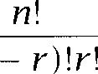

The term  counts the number of different possibilities for choosing objects out of not considering the order in which they are chosen. Examples of some binomial distributions are shown in figure 2.3. The bi-

nomial distribution has an expectation of and a variance of  1



Example 6: Let have as value the number of heads in tosses of a (possibly weighted) coin, where the probability of a head is p.

Then we have the binomial distribution:

 =  =  

(The proof of this is by counting: each basic outcome with heads and

*n* tails has probability and there are  of them.)



The binomial distribution turns up in various places in the book, such as when counting n-grams in chapter 6, and for hypothesis testing in section 8.2.

The generalization of a binomial trial to the case where each of the tri- als has more than two basic outcomes is called a multinomial experiment, and is modeled by the *distribution.* A zcroth order n-gram model of the type we discuss in chapter 6 is a straightforward example of a multinomial distribution.

Another discrete distribution that we discuss and use in this book is the Poisson distribution (section Section 5.3 discusses the Bernoulli distribution, which is simply the special case of the binomial distribution where there is only one trial. That is, we calculate





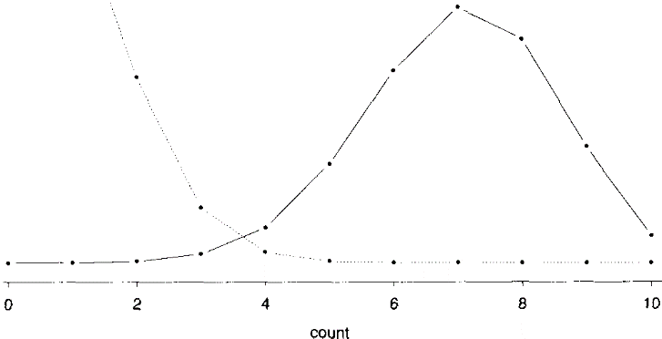

Figure ***2.3*** Two examples of binomial distributions: and





BELL CURVE

NORMAL DISTRIBUTION

**Continuous distributions: The normal distribution**

So far we have looked only at discrete probability distributions and discrete random variables, but many things, such as measurements of heights and lengths, are best understood as having a continuous domain, over the real numbers In this book, we do not outline the mathematics of continuous distributions. Suffice it to say that there are generally anal- ogous results, except with points becoming intervals, and sums becoming integrals. However, we will occasionally have need to refer to continuous probability distributions, so we will give one example here: the normal distribution, which is central to all work in probability and statistics.

For many things in the world, such as the heights or of people, one gets a distribution that is known in the media as a bell curve, but which is referred to in statistics as a normal ***distribution.*** Some normal distribution curves are shown in figure 2.4. The values of the graphed functions, ***probability density functions *** ***do not directly give the*** probabilities of the points along the x-axis (indeed, the probability of a point is always 0 for a continuous distribution). Rather the probability

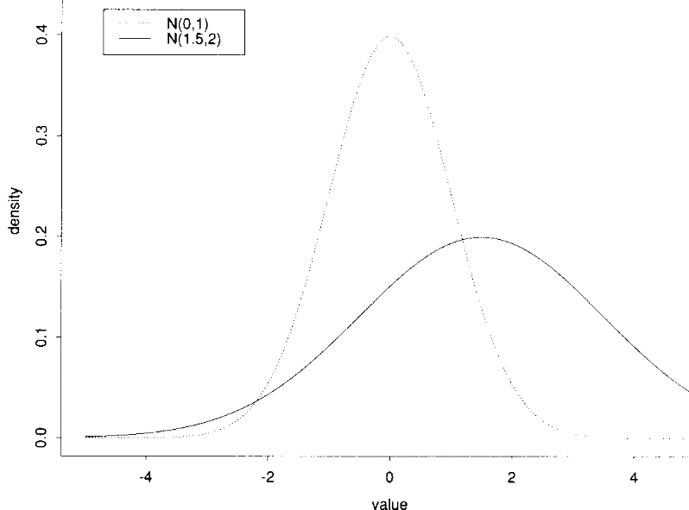

**Figure 2.4** Example normal distribution curves: and



of a result within a certain interval on the x-axis is given by the area delimited by that region, the x-axis and the function curve.

The normal distribution has two parameters for the mean and the standard deviation and the curve is given by:

(2.14) a) = 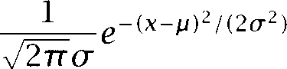

**STANDARD NORMAL** The curve where = 0 and = 1 is referred to as the standard ***normal***

**DISTRIBUTION** *distribution.* A few figures for areas under this curve are given in the appendix.

While it is much better to refer to such a curve as a ‘normal distribution’ than as a ‘bell curve,’ if you really want to fit into the Statistical NLP or pattern recognition communities, you should instead learn to refer to these functions as  and to remark things like, ‘Maybe we could model that using 3 Gaussians’ at appropriate 

1. Carl Friedrich Gauss was the first to use normal curves to model experimental data, using them to model the errors made by astronomers and surveyors in repeated measure- ments of the same quantity, but the normal curve was discovered by Abraham de Moivre.

In much of statistics, the discrete binomial distribution is approxi- mated by the continuous normal distribution one can see the basic similarity in the shapes of the curves by comparing figures 2.3 and 2.4. Such an approximation is acceptable when both basic outcomes have a reasonable probability of occurring or the amount of data is very large (roughly, when 5). But, in natural language, events like oc- currences of the phrase *shade tree mechanics* are so rare, that even if you have a huge amount of text, there will be a significant difference between the appropriate binomial curve and the approximating normal curve, and so use of normal approximations can be unwise.



Gaussians are often used in clustering, as discussed in chapter 14. In particular, here we have only discussed the one-dimensional or univariate normal distribution, while we present there the generalization to many dimensions (the multivariate normal distribution).

Other continuous distributions discussed in this book are the hyper- bolic distributions discussed in section 1.4.3, and the distribution used for hypothesis testing in section 5.3.

**FREQIJENTIST STATISTICS**

**B A Y E S I A N S T A T I S T I C S**

**MAXIMUM LIKELIHOOD**

**ESTIMATE**

**PRIOR BELIEF**

**Bayesian statistics**

**So** far, we have presented a brief introduction to orthodox  *statistics.* Not everyone is agreed on the right philosophical foundations for statistics, and the main rival is a Bayesian approach to statistics. Ac- tually, the Bayesians even argue among themselves, but we are not going to dwell on the philosophical issues here. We want to just briefly intro- duce the Bayesian approach because Bayesian methods are very useful in Statistical NLP, and we will come across them in later chapters.

**Bayesian updating**

Suppose one takes a coin and tosses it 10 times, and gets 8 heads. Then from a frequentist point of view, the result is that this coin comes down heads 8 times out of 10. This is what is called the maximum likelihood es- *timate,* as discussed further in section 62.1. However, if one has looked the coin over, and there doesn’t seem anything wrong with it, one would be very reluctant to accept this estimate. Rather, one would tend to think that the coin would come down equally head and tails over the long run, and getting 8 heads out of 10 is just the kind of thing that happens some- times given a small sample. In other words one has a *prior belief* that

influences one’s beliefs even in the face of apparent evidence against it. Bayesian statistics measure degrees of belief, and are calculated by start- ing with prior beliefs and updating them in the face of evidence, by use of Bayes’ theorem.

For example, let be the model2 that asserts  = Let be a particular sequence of observations yielding *i* heads and tails. Then, for any 0 1:



(2.15)  =  

From a frequentist point of view, we wish to find the MLE:



To do this, we can differentiate the above polynomial, and find its max- imum, which fortunately gives the intuitive answer of  or 0.8 for the case of 8 heads and 2 tails.

But now suppose that one wants to quantify one’s belief that the coin is probably a regular, fair one. One can do that by assuming a prior probability distribution over how likely it is that different models are true. Since one would want most of the probability mass close to one might use something like a Gaussian distribution centered on  but since



polynomials are the only things we can remember how to differentiate, let

us instead assume that one’s prior belief is modeled by the distribution: (2.16)  = 

This polynomial was chosen because its distribution is centered on 

and, conveniently, the area under the curve between 0 and 1 is 1.

When one sees an observation sequence s one wants to know one’s new belief in the fairness of the coin. One can calculate this from (2.15) and (2.16) by Bayes’ theorem:

( 2 . 1 7 ) = 



X

1. By a model we mean whatever theoretical edifices we construct to explain something in the world. A probabilistic model might comprise the specification of a distribution and certain parameter values. Thus, we are introducing some notational sloppiness in equation  since previously we were conditioning on an event, that is, a subset of the event space, and now we are conditioning on a model, but we will allow ourselves that freedom.





**MARGINAL PROBABILITY**

**(2.18)**

Now  is the prior probability of Let us assume for the moment that it does not depend on and therefore that we can ignore it while finding the that maximizes this equation. If we then differentiate the numerator so as find its maximum, we can determine that for the case of 8 heads and 2 tails:

= 

Because our prior was weak (the polynomial is a quite flat curve centered over  we have moved a long way in the direction of believing that the coin is biased, but the important point is that we haven’t moved all the way to 0.8. If we had assumed a stronger prior, we would have a smaller distance from  (See exercise 2.8.)

But what do we make of the denominator P(s)? Well, since we have

just seen one might conclude that this is **1,** but that is not what it means. Rather, it is the marginal *probability* which is obtained by adding up all the weighted by the probability of as we saw earlier in equation (2.8). For the continuous case, we have the integral:



**0**

 **=**

**1**

 (1



**I 0**

This just happens to be an instance of the beta integral, another contin- uous distribution well-studied by statisticians, and so we can look up a book to find out that:

+



*= +*



**NORMALIZATION**

**FACTOR**

**B A Y E S I A N U P D A T I N G**

But the important point is that the denominator is just a *normalization * which ensures that what we calculate for  in (2.17) is ac- tually a probability function.

In the general case where data come in sequentially and we can reason- ably assume independence between them, we start off with an a priori probability distribution, and when a new datum comes in, we can update our beliefs by calculating the maximum of the a posteriori distribution, what is sometimes referred to as the MAP probability. This then becomes the new prior, and the process repeats on each new datum. This process is referred to as *updating.*

**Bayesian decision theory**

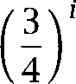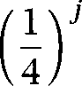But there is another thing that we can do with this new approach: use it to evaluate which model or family of models better explains some data. Suppose that we did not actually see the sequence of coin tosses but just heard the results shouted out over the fence. Now it may be the case, as we have assumed so far, that the results reported truly reflect the results of tossing a single, possibly weighted coin. This is the theory which is a family of models, with a parameter representing the weighting of the coin. But an alternative theory is that at each step someone is tossing two fair coins, and calling out “tails” if *both* of them come down tails, and heads otherwise. Let us call this new theory According to v, ifs is a particular observed sequence of heads and j tails, then:

Note that one of these theories has a free parameter (the weighting of the coin  while the other has no parameters. Let us assume that, a priori, both of these theories are equally likely, for instance:

(2.21) = P(v) = 

We can now attempt to work out which theory is more likely given the data we have seen. We use Bayes’ theorem again, and write down:



The potentially confusing point here is that we have made a quick change in our notation. The quantity we are now describing as  is the quantity that we wrote as just  in (2.19) since at that time we were assuming that theory was true and we were just trying to deter- mine whereas what we are now writing as  is the prior probability of not knowing whether is true or not. With that gotten straight,

**LIKELIHOOD RATIO we** can calculate the ***likelihood ratio*** between these two models. The

terms in the denominators cancel, and we can work out the rest using equations and (2.21):



(2.22) =







10 Results Reported 20 Results Reported

Heads Tails Likelihood ratio Heads Tails Likelihood ratio

|  |  |  |  |  |  |
| --- | --- | --- | --- | --- | --- |
| 0 | 10 | 4.03 x | 0 | 20 | 1.30 x |
| 1 | 9 | 2444.23 | 2 | 18 | 2.07 x |
| 2 | 8 | 244.42 | 4 | 16 | 1.34 x |
| 3 | 7 | 36.21 | 6 |  | 2307.06 |
| 4 | 6 | 7.54 | 8 | 12 | 87.89 |
| 5 | 5 | 2.16 | 10 | 10 | 6.89 |
| 6 | 4 | 0.84 | 12 | 8 | 1.09 |
| 7 | 3 | 0.45 | 14 | 6 | 0.35 |
| 8 | 2 | 0.36 | 16 | 4 | 0.25 |
| 9 | 1 | 0.37 | 18 | 2 | 0.48 |
| 10 | 0 | 0.68 | 20 | 0 | 3.74 |

**Table 2.1** Likelihood ratios between two theories. The left three columns are for a sequence of 10 pieces of data, and the right three columns for a sequence of 20 pieces of data.

**B AYESOPTIMAL**

**DECISION**

If this ratio is greater than 1, we should prefer and otherwise we should prefer (or commonly people take the log of this ratio and see if that value is greater than or less than zero).

We can calculate this ratio for different combinations of heads and tails. Table 2.1 shows likelihood values for sequences of 10 and 20 re- sults. If there are few heads, then the likelihood ratio is greater than one, and the possibly weighted coin theory wins, since it is never strongly in- compatible with any data (because of its free parameter). On the other hand, if the distribution is roughly what we’d expect according to the two fair coins theory (a lot more heads than tails) then the likelihood ratio is smaller than one, and the simpler two fair coins theory wins. As the quantity of data available becomes greater, the ratio of heads needs to be nearer  in order for the two fair coins model to win. If these are the only two theories under consideration, and we choose the one that wins in such a likelihood ratio, then we have made what is called the  *optimal decision.*

If there are more theories, we can compare them all and decide on the

most likely one in the same general manner. An example of this and more general discussion of Bayesian decision theory can be found in our discussion of word sense disambiguation in section 7.2.1.

* 1. Exercises

**Exercise** *2.1*

This exercise indicates the kind of facility with set theory needed for this book, and summarizes a few useful results in probability theory. Use set theory and the axioms defining a probability function to show that:

* + 1. *u = P(A) + P(B)* [the addition rule]



b. P(0) = 0

c.  = 1 -P(A)

1. *A B P(A) P(B)*
2. *-A) = P(B) B)*



**Exercise** *2.2*

Assume the following sample space:

(2.23) = {is-noun, has-plural-s, is-adjective, is-verb]

and the function [0, with the following values:



**X **

|  |  |
| --- | --- |
| is-noun | 0.45 |
| has-plural-s | 0.2 |
| is-adjective | 0.25 |
| is-verb | 0.3 |

Can  be extended to all of  such that it is a well-formed probability distribu- tion? If not, how would you model these data probabilistically?

**Exercise** 2.3

Compute the probability of the event ‘A period occurs after a three-letter word and this period indicates an abbreviation (not an end-of-sentence marker),’ as- suming the following probabilities.

(2.24) P(is-abbreviation] three-letter-word) = 0.8

(2.25) P(three-letter-word) = 0.0003

**Exercise** 2.4

Are and Y as defined in the following table independently distributed?

|  |  |  |  |  |  |
| --- | --- | --- | --- | --- | --- |
| **X** |  |  |  | 1 | 1 |
| Y |  | 0 | 1 | 0 | 1 |
|  | = x, Y = | 0.32 | 0.08 | 0.48 | 0.12 |

Exercise 2.5

In example 5, we worked out the expectation of the sum of two dice in terms of the expectation of rolling one die. Show that one gets the same result if one calculates the expectation for two dice directly.

Exercise 2.6

Consider the set of grades you have received for courses taken in the last two years. Convert them to an appropriate numerical scale. What is the appropriate distribution for modeling them?

Exercise 2.7



Find a linguistic phenomenon that the binomial distribution is a good model for. What is your best estimate for the parameter p?

Exercise 2.8

For *i =* and j = 2, confirm that the maximum of equation (2.15) is at 0.8, and that the maximum of equation (2.17) is 0.75. Suppose our prior belief had instead been captured by the equation:

=



What then would the **MAP** probability be after seeing a particular sequence of 8 heads and 2 tails? (Assume the theory and a prior belief that the coin is fair.)

**2.2 Essential Information Theory**

The field of information theory was developed in the 1940s by Claude Shannon, with the initial exposition reported in (Shannon 1948). Shannon was interested in the problem of maximizing the amount of information that you can transmit over an imperfect communication channel such as a noisy phone line (though actually many of his concerns stemmed from codebreaking in World War II). For any source of ‘information’ and any ‘communication channel,’ Shannon wanted to be able to determine theo- retical maxima for  data compression which turns out to be given by the Entropy (or more fundamentally, by the Kolmogorov complexity  and (ii) the transmission rate which is given by the Channel Capac- ity C. Until Shannon, people had assumed that necessarily, if you send your message at a higher speed, then more errors must occur during the transmission. But Shannon showed that providing that you transmit the information in your message at a slower rate than the Channel Capacity, then you can make the probability of errors in the transmission of your message as small as you would like.

***2.2 Essential Information Theory*** 61

**2.2.1**

ALPHABET

**Entropy**

p(x) be the probability mass function of a random variable X, over a discrete set of symbols (or  X:

p(x) = = x), x x

For example, if we toss two coins and count the number of have a random variable:  = =  p(2) =



heads, we

ENTROPY SELF-INFORMATION

The (or self-information) is the average uncertainty of a single random variable:

**(2.26) Entropy** H(p) = H(X) =



Entropy measures the amount of information in a random variable. It is normally measured in bits (hence the log to the base  but using any other base yields only a linear scaling of results. For the rest of this book, an unadorned log should be read as log to the base 2. Also, for this definition to make sense, we define 0 log 0 = 0.

**Example 7:** Suppose you are reporting the result of rolling an die. Then the entropy is:



1

i=l

H(X) = p(i) = = -log  = log8 = 3 bits

This result is what we would expect. Entropy, the amount of information in a random variable, can be thought of as the average length of the message needed to transmit an outcome of that variable. If we wish to send the result of rolling an eight-sided die, the most efficient way is to simply encode the result as a 3 digit binary message:

|  |  |  |  |  |  |
| --- | --- | --- | --- | --- | --- |
| 1 | 2 | 3 4 | 5 6 | 7 | 8 |
| 001 | 010 | 011 100 | 101 110 | 111 | 000 |

**(2.27)**

The transmission cost of each result is 3 bits, and there is no cleverer way of encoding the results with a lower average transmission cost. In gen- eral, an optimal code sends a message of probability p(i) in  log p(i)  bits.

The minus sign at the start of the formula for entropy can be moved inside the logarithm, where it becomes a reciprocal:

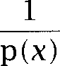 log



People without any statistics background often think about a formula like this as a sum of the quantity p(x) log( p(x)) for each x. While this is mathematically impeccable, it is the wrong way to think about such equations. Rather you should think of  p(x) as an idiom. It says to take a weighted average of the rest of the formula (which will be a function of  where the weighting depends on the probability of each x. Technically, this idiom defines an *expectation,* as we saw earlier. Indeed,

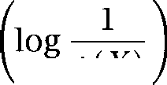

**Example 8: Simplified Polynesian** Simplified Polynesian3 appears to be just a random sequence of letters, with the letter frequencies as shown:

p t k a i u

Then the per-letter entropy is:

H(P) = *P(i) *



= 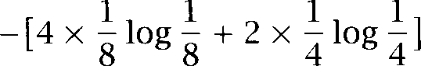

=  bits

This is supported by the fact that we can design a code that on average takes  bits to transmit a letter:

p t k a i u 100 00 101 01 110 111

Note that this code has been designed so that fewer bits are used to send frequent letters, but still so that it can be unambiguously decoded

if a code starts with a 0 then it is of length two, and if it starts with a 1 it is of length 3. There is much work in information theory on the design of such codes, but we will not further discuss them here.

**TWENTY QUESTIONS** One can also think of entropy in terms of the Twenty *Questions* game. If you can ask yes/no questions like ‘Is it a or an a?’ or ‘Is it a conso- nant?’ then on average you will need to ask 2 questions to identify each letter with total certainty (assuming that you ask good questions!). In



1. Polynesian languages, such as Hawai’ian, are well known for their small alphabets.

***2.2 Essential Information Theory* 63**

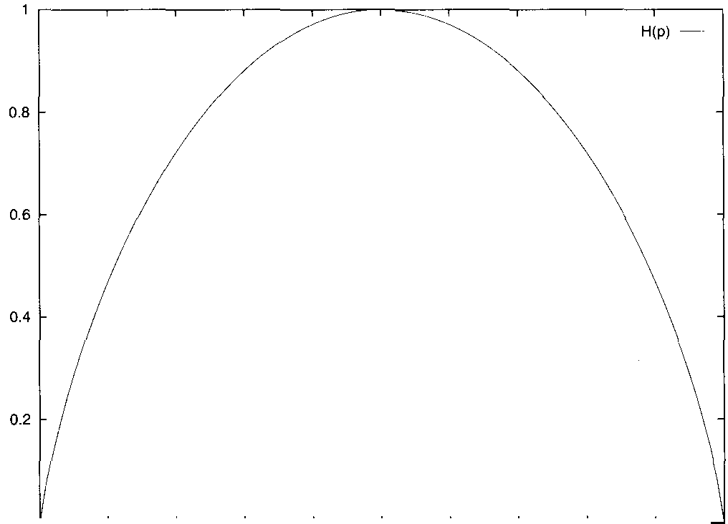

Figure 2.5 The entropy of a weighted coin. The horizontal axis shows the prob- ability of a weighted coin to come up heads. The vertical axis shows the entropy of tossing the corresponding coin once.

other words, entropy can be interpreted as a measure of the size of the ‘search space’ consisting of the possible values of a random variable and its associated probabilities.

Note that: (i) H(X) 0, (ii) H(X) = 0 only when the value of X is determinate, hence providing no new information, and that (iii) entropy increases with the message length. The information needed to transmit the results of tossing a possibly weighted coin depends on the probability that it comes up heads, and on the number of tosses made. The entropy for a single toss is shown in figure 2.5. For multiple tosses, since each is independent, we would just multiply the number in the graph by the

number of tosses.

* + 1. **Joint entropy and conditional entropy**

The joint entropy of a pair of discrete random variables X, Y



is the amount of information needed on average to specify both their values. It is defined as:

  Y) =



The conditional entropy of a discrete random variable Y given an- other X, for X, Y expresses how much extra information you still need to supply on average to communicate Y given that the other party knows X:



( 2 . 3 0 )  =  = 



1



= 

yty

There is also a Chain rule for entropy:

(2.31)  **= ** 

The products in the chain rules for probabilities here become sums be- cause of the log:











 



= +

**Example 9: Simplified Polynesian revisited An** important scientific idea is the distinction between a model and reality. Simplified Polyne- sian isn’t a random variable, but we approximated it (or modeled it) as one. But now let’s learn a bit more about the language. Further fieldwork has revealed that Simplified Polynesian has syllable structure. Indeed, it turns out that all words consist of sequences of CV (consonant-vowel) syllables. This suggests a better model in terms of two random variables C for the consonant of a syllable, and ***V*** for the vowel, whose joint dis- tribution and marginal distributions C, and are as follows:



***2.2 Essential Information Theory*** 6.5

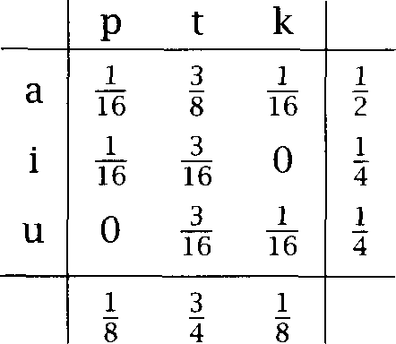(2.32)

Note that here the marginal probabilities are on a per-syllable basis, and are therefore double the probabilities of the letters on a per-letter basis, which would be:

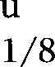(2.33) p t k a i

We can work out the entropy of the joint distribution, in more than one way. Let us use the chain 

H(C) = 2 x x 3

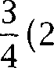

= 9 3 log 3 bits 1.061 bits

 =  =

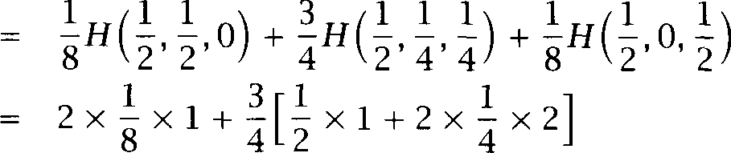

4 2

bits = 1.375 bits



 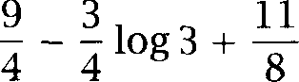

29 3 2.44 bits

9 3



8

1. Within the calculation, we use an informal, but convenient, notation of expressing a finite-valued distribution as a sequence of probabilities, which we can calculate the entropy of.



Note that those 2.44 bits are now the entropy for a whole syllable (which was 2 x  = 5 for the original Simplified Polynesian example). Our better understanding of the language means that we are now much less uncer- tain, and hence less surprised by what we see on average than before.

Because the amount of information contained in a message depends on the length of the message, we normally want to talk in terms of the letter or per-word entropy. For a message of length the per-letter/word

**ENTROPY RATE** entropy, also known as the ***entropy rate, ***

(2.34) = 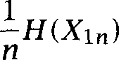 = 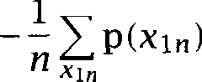

If we then assume that a language is a stochastic process consisting of a sequence of tokens = (Xi), for example a transcription of every word you utter in your life, or a corpus comprising everything that is sent down the to your local paper, then we can define the entropy of a human language as the entropy rate for that stochastic process:

(2.35) = 

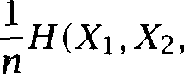

We take the entropy rate of a language to be the limit of the entropy rate

of a sample of the language as the sample gets longer and longer.

* + 1. Mutual information

By the chain rule for entropy,

= H(X) = H(Y) + 



Therefore,

H(X)  = H(Y) 

**MUTUAL** This difference is called the between X and Y. It is the **INFORMATION** reduction in uncertainty of one random variable due to knowing about another, or in other words, the amount of information one random vari-



able contains about another. A diagram illustrating the definition of mu- tual information and its relationship to entropy is shown in figure 2.6 (adapted from Cover and Thomas (1991: 20)).



1. Commonly throughout this book we use two subscripts on something to indicate a sub- sequence. So, here, we use to represent the sequence of random variables (Xi,. . . ,  and similarly = . . , This notation is slightly unusual, but very convenient when sequences are a major part of the domain of discourse. So the reader should re- member this convention and be on the lookout for it.

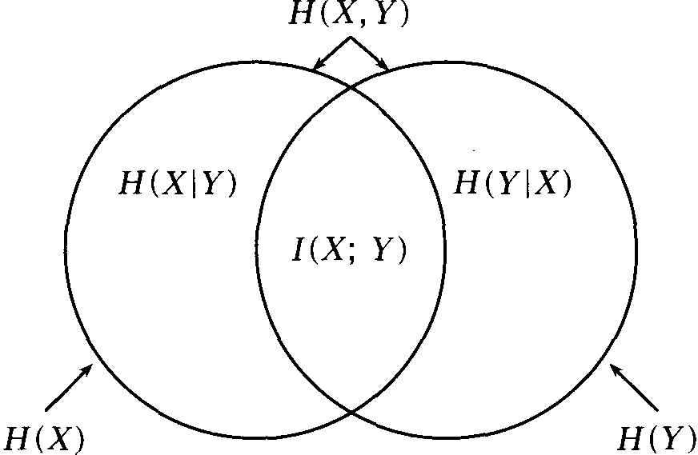***2.2 Essential Information Theory*** 67

**Figure 2.6** The relationship between mutual information and entropy

Mutual information is a symmetric, non-negative measure of the com- mon information in the two variables. People thus often think of mutual information as a measure of dependence between variables. However, it is actually better to think of it as a measure of independence because:

It is 0 only when two variables are independent, but

 For two dependent variables, mutual information grows not only with the degree of dependence, but also according to the entropy of the variables.

Simple arithmetic gives us the following formulas for mutual informa- tion



(2.36) = H(X)

= H(X) H(Y)



= 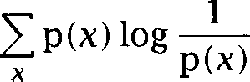 + +

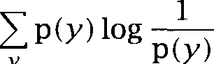

**Y**



log 



Since = 0, note that: H(X) = H(X) =



1. Mutual information is conventionally written with a semi-colon separating the two ar- guments. We are unsure why.



**68 *2 Mathematical Foundations***

This illustrates both why entropy is also called self-information, and how the mutual information between two totally dependent variables is not constant but depends on their entropy.

We can also derive conditional mutual information and a chain rule: (2.37)   =   =  

(2.38)  Y) = . . . . . . . 

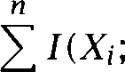

In this section we have defined the mutual information between two

**POINTWISE MUTUAL** random variables. Sometimes people talk about the ***mutual***

**INFORMATION *information*** between two particular points in those distributions:

 Y)

 P(Y)

This has sometimes been used as a measure of association between ele- ments, but there are problems with using this measure, as we will discuss in section 5.4.

Mutual information has been used many times in Statistical NLP, such as for clustering words (section 14.1.3). It also turns up in word sense disambiguation (section 7.2.2).

* + 1. The noisy channel model

Using information theory, Shannon modeled the goal of communicating down a telephone line or in general across any channel in the follow- ing way: The aim is to optimize in terms of throughput and accuracy the communication of messages in the presence of noise in the channel. It is assumed that the output of the channel depends probabilistically on

**COMPRESSION** the input. In general, there is a duality between ***compression,*** which is achieved by removing all redundancy, and transmission accuracy, which

**REDUNDANCY** is achieved by adding controlled redundancy so that the input can be recovered even in the presence of noise. The goal is to encode the mes- sage in such a way that it occupies minimal space while still containing enough redundancy to be able to detect and correct errors. On receipt, the message is then decoded to give what was most likely the original message. This process is shown in figure 2.7.

***2.2 Essential Information Theory*** 69

*W*

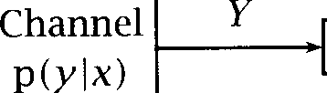

Message from a finite

alphabet

**X**

Input to channel

Decoder

Output from Attempt to

channel reconstruct message based on output

Figure 2.7 The noisy channel model.

***1 - P***

X

***o - o***

P

l - l

***1 - P***

Figure 2.8 A binary symmetric channel. A 1 or a 0 in the input gets flipped on transmission with probability p.

The central concept that characterizes a channel in information theory CAPACITY is its ***capacity.*** The channel capacity describes the rate at which one can transmit information through the channel with an arbitrarily low proba-

bility of being unable to recover the input from the output. For a

less channel, Shannon’s second theorem states that the channel capacity can be determined in terms of mutual information as follows:

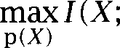

According to this definition, we reach a channel’s capacity if we man- age to design an input code X whose distribution maximizes the mutual information between the input and the output over all possible input distributions p(X) .

As an example, consider the binary symmetric channel in figure 2.8. Each input symbol is either a 1 or a 0, and noise in the channel causes each symbol to be flipped in the output with probability ***p.*** We find that:

  **= H ( Y ) **

**= ** 

Therefore,

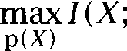 = 1 -H(p)



***2 Mathematical Foundations***



***I***

Noisy Channel

Figure 2.9 The noisy channel model in linguistics.

This last line follows because the mutual information is maximized by maximizing the entropy in the codes, which is done by making the input and hence the output distribution uniform, so their entropy is 1 bit. Since entropy is non-negative, C 1. The channel capacity is 1 bit only if the entropy is zero, that is if = 0 and the channel reliably transmits a 0 as 0 and a 1 as 1, or if = 1 and it always flips bits. A completely noisy binary channel which transmits both and with equal probability as and (i.e., =  has capacity C = 0, since in this case there is

no mutual information between X and Y. Such a channel is useless for

communication.

It was one of the early triumphs of information theory that Shannon was able to show two important properties of channels. First, channel capacity is a well-defined notion. In other words, for each channel there is a smallest upper bound of over possible distributions p(X). Second, in many practical applications it is easy to get close to the opti- mal channel capacity. We can design a code appropriate for the channel that will transmit information at a rate that is optimal or very close to op- timal. The concept of capacity eliminates a good part of the guesswork that was involved in designing communications systems before Shannon. One can precisely evaluate how good a code is for a communication line and design systems with optimal or near-optimal performance.



The noisy channel model is important in Statistical NLP because a sim- plified version of it was at the heart of the renaissance of quantitative natural language processing in the 1970s. In the first large quantitative project after the early quantitative NLP work in the 1950s and  re- searchers at IBM’s T. J. Watson research center cast both speech recogni- tion and machine translation as a noisy channel problem.

Doing linguistics via the noisy channel model, we do not get to con- trol the encoding phase. We simply want to decode the output to give the most likely input, and so we work with the channel shown in fig- ure 2.9. Many problems in NLP can be construed as an attempt to de- termine the most likely input given a certain output. We can determine

|  |  |  |  |  |
| --- | --- | --- | --- | --- |
| Application | Input | output |  | |
| Machine | word | word | ***in a*** | translation |
| Translation | sequences | sequences | language model | model |
| Optical Character | actual text | text with | prob of | model of |
| Recognition (OCR) |  | mistakes | language text | OCR errors |
| Part Of Speech | POS tag | English | prob of |  |
| tagging | sequences | words | sequences |  |
| Speech | word | speech | prob of word | acoustic |
| recognition | sequences | signal | sequences | model |

Table 2.2 Statistical problems as decoding problems.

this as follows, by using Bayes’ theorem, and then noting that the output probability is a constant:

(2.40)  =  = =



i



i *i*

**MODEL** Here we have two probability distributions to consider: p(i) is the lan- guage ***model,*** the distribution of sequences of ‘words’ in the input

**CHANNEL** guage, and  o is the channel probability.



**PROBABILITY** As an example, suppose we want to translate a text from English to French. The noisy channel model for translation assumes that the true text is in French, but that, unfortunately, when it was transmitted to us, it went through a noisy communication channel and came out as English. So the word cow we see in the text was really ***vuche,*** garbled by the noisy channel to cow. All we need to do in order to translate is to recover the

**DECODE** original French or to ***decode*** the English to get the

The validity of the noisy channel model for translation is still giving rise to many a heated debate among NLP researchers, but there is no doubt that it is an elegant mathematical framework that has inspired a significant amount of important research. We will discuss the model in more detail in chapter 13. Other problems in Statistical NLP can also be seen as instantiations of the decoding problem. A selection is shown in table 2.2.

1. The French reader may be sympathetic with the view that English is really a form of garbled French that makes the language of unnecessarily ambiguous!

**RELATIVE ENTROPY**

(2.41)

**K ULLBACK - LEIBLER**

**DIVERGENCE**

(2.42)

**TRIANGLE INEQUALITY**

(2.43 

(2.44)

(2.45

Relative entropy or Kullback-Leibler divergence

For two probability mass functions, p(x), q(x) their relative *entropy* is given by:







where again we define 0 log = 0 and otherwise p log  = The relative entropy, also known as the divergence, is a measure of how different two probability distributions (over the same event space) are. Expressed as an expectation, we have:

log

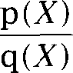

Thus, the KL divergence between p and q is the average number of bits that are wasted by encoding events from a distribution p with a code based on a not-quite-right distribution q.

This quantity is always non-negative, and = 0 iff p = q. For these reasons, some authors use the name ‘KL distance,’ but note that relative entropy is not a metric (in the sense in which the term is used in mathematics): it is not symmetric in p and q (see exercise  and it does not satisfy the *triangle * Hence we will use the name ‘KL divergence,’ but nevertheless, informally, people often think about the relative entropy as the ‘distance’ between two probability distribu- tions: it gives us a measure of how close two pmfs are.



Mutual information is actually just a measure of how far a joint distri- bution is from independence:

  =   

We can also derive conditional relative entropy and a chain rule for relative entropy (Cover and Thomas 1991: 23):

II = log



**Y**

= +



1. The triangle inequality is that for any three



***+***



KL divergence is used for measuring selectional preferences in sec- tion 8.4.

* + 1. The relation to language: Cross entropy

So far we have examined the notion of entropy, and seen roughly how it is a guide to determining efficient codes for sending messages, but how does this relate to understanding language? The secret to this is to return to the idea that entropy is a measure of our uncertainty. The more we know about something, the lower the entropy will be because we are less surprised by the outcome of a trial.

We can illustrate this with the examples used above. Consider again Simplified Polynesian from examples 8 and 9. This language has let- ters. The simplest code is to use 3 bits for each letter of the language. This is equivalent to assuming that a good model of the language (where our ‘model’ is simply a probability distribution) is a uniform model. How- ever, we noticed that not all the letters occurred equally often, and, noting these frequencies, produced a zeroth order model of the language. This had a lower entropy of 2.5 bits per letter (and we showed how this obser- vation could be used to produce a more efficient code for transmitting the language). Thereafter, we noticed the syllable structure of the language, and developed an even better model that incorporated that syllable struc- ture into it. The resulting model had an even lower entropy of 1.22 bits per letter. The essential point here is that if a model captures more of the structure of a language, then the entropy of the model should be lower. In other words, we can use entropy as a measure of the quality of our models.

Alternately, we can think of entropy as a matter of how surprised we will be. Suppose that we are trying to predict the next word in a Sim- plified Polynesian text. That is, we are examining where w is the next word and is the history of words seen so far. A measure of



**SURPRISE** our surprise on seeing the next word can be derived in terms of the con- ditional probability assigned to w by our model m of the distribution of Simplified Polynesian words. Surprise can be measured by what we might

**POINTWISE ENTROPY** term the  *entropy * *= -log, * If the predictor is certain that word w follows a given history and it is correct, then the in- formation supplied to the predictor on seeing w is log, 1 = 0. In other words, the predictor does not experience any surprise at all. On the other hand, if the model thinks that w cannot follow  then = 0 and





so the information supplied to the predictor is infinite  log, 0 =  In this case our model is infinitely surprised, which is normally a very bad thing. Usually our models will predict a probability between these two extremes for each event and so the model will gain some information, or alternatively, be somewhat surprised, when it sees the next word, and the goal is to keep that level of surprise as low as possible. Summing over the surprise of the predictor at each word gives an expression for our total surprise:





 

The second line above follows from the chain rule. Normally, we would want to normalize this measure by the length of the text so our notion of surprise is not dependent on the size of the text. This normalized measure gives the average surprise of the predictor per word.

So far this discussion has been rather informal, but we can formalize it through the notion of relative entropy. Suppose that we have some empirical phenomenon, in Statistical NLP usually utterances in a certain language. Assuming some mapping to numbers, we can represent it via a random variable X. Then we assume that there is some probability distribution over the utterances for instance, you hear ***Thank you*** much more often than ***On you. So we*** take X p(x).

Now, unfortunately we do not know what p  is for empirical phenom- ena. But by looking at instances, for example by looking at a corpus of utterances, we can estimate roughly what p seems to be like. In other words, we can produce a model m of the real distribution, based on our best estimates. In making this model, what we want to do is to mini- mize  II  to have as accurate a probabilistic model as possible. Unfortunately, we normally cannot calculate this relative entropy again, because we do not know what p is. However, there is a related quantity, the cross entropy, which we fortunately can get a handle on.

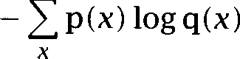**CROSS ENTROPY** The ***cross entropy*** between a random variable X with true probability distribution p(x) and another pmf q (normally a model of  is given by:



=

*2.2 Essential Information Theory* 7.5

(2.47)

(2.48)

(2.49)

(2.50)

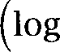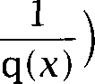

(Proof of this is left to the reader as exercise 2.13.)

Just as we defined the entropy of a language in section 2.2.2, we can define the cross entropy of a language = (Xi) p(x) according to a model m by:

   



We do not seem to be making much progress, because it still seems that we cannot calculate this quantity without knowing p. But if we make certain assumptions that the language is ‘nice,’ then the cross entropy for the language can be calculated as:

=



Using this second form, we can calculate the cross entropy based only on knowing our probability model and having a large body of utterances available. That is, we do not actually attempt to calculate the limit, but approximate it by calculating for a sufficiently large n:

  



This measure is just the figure for our average surprise. Our goal will be to try to minimize this number. Because H(X) is fixed (if unknown), this is equivalent to minimizing the relative entropy, which is a measure of how much our probability distribution departs from actual language use. The only additional requirement is that the text that we use to test the model must be an independent test set, and not part of the training corpus that we used to estimate the parameters of the model. Cross entropy is inversely related to the average probability a model assigns to words in test data. Lower model cross entropy normally leads to better performance in applications, but it need not do so if it is just a matter of improving the magnitude of probability estimates, but not their relative ordering. (See section 6.2.3 for more practical details on calculating the cross entropy of models.)

But what justifies going from equation (2.48) to equation  The formula for language cross entropy has an expectation embedded within it:

(2.51)  = log

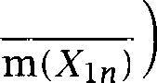

1

Recall that the expectation is a weighted average over all possible se- quences. But in the above formula we are using a limit and looking at longer and longer sequences of language use. Intuitively, the idea is then that if we have seen a huge amount of the language, what we have seen is ‘typical.’ We no longer need to average over all samples of the lan- guage; the value for the entropy rate given by this particular sample will be roughly right.

The formal version of this is to say that if we assume that = (Xi) is a stationary ergodic process, then we can prove the above result. This is a consequence of the Shannon-McMillan-Breiman theorem, also known as the Asymptotic Equipartition Property:

**Theorem:** If is the entropy rate of a finite-valued stationary  process  then:

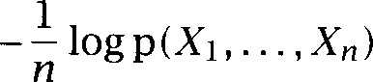 with probability 1

We will not prove this theorem; see Cover and Thomas (1991: ch. 3,

ERGODIC An  process is one that, roughly, cannot get into different states that it will not escape from. An example of a non-ergodic process is one that in the beginning chooses one of two states: one in which it generates 0 forever, one in which it generates 1 forever. If a process is not ergodic, then even looking at one very long sequence will not neces- sarily tell us what its typical behavior is (for example, what is likely to happen when it gets restarted).

STATIONARY A stationary process is one that does not change over time. This is clearly wrong for language: new expressions regularly enter the language while others die out. And so, it is not exactly correct to use this result to allow the calculation of a value for cross entropy for language applica- tions. Nevertheless, for a snapshot of text from a certain period (such as one year’s newswire), we can assume that the language is near enough to unchanging, and so this is an acceptable approximation to truth. At any rate, this is the method regularly used.

The entropy of English

As noted above, English in general is not a stationary ergodic process. But we can nevertheless model it with various stochastic approximations. In

MODELS particular, we can model English with what are known as ***n-gram models***

* 1. ***Essential Information*** Theory 77

**M ARKOVCHAINS** or ***chains.*** These models, which we discuss in detail in chapters 6 and 9, are ones where we assume a limited memory. We assume that the probability of the next word depends only on the previous ***k*** words in the

**M ARKOVASSUMPTION** input. This gives a  order approximation:





If we are working on a character basis, for example, we are trying to guess what the next character in a text will be given the preceding ***k*** characters. Because of the redundancy of English, this is normally fairly easy. For instance, a generation of students have proved this by being able to make do with photocopies of articles that are missing the last character or two of every line.

By adding up counts of letters, letter digraphs (that is, sequences of two letters), and so on in English, one can produce upper bounds for the en- tropy of English.” We assume some such simplified model of English and compute its cross entropy against a text and this gives us an upper bound for the true entropy of English since 0, H(X). Shannon did this, assuming that English consisted of just 27 symbols (the 26 letters of the alphabet and **SPACE** he ignored case distinctions and punctuation). The estimates he derived were:



(2.52) Model Cross entropy (bits)

|  |  |  |
| --- | --- | --- |
| zeroth order | 4.76 | (uniform model, so log 2 7) |
| first order | 4.03 |  |
| second order | 2.8 |  |
| Shannon’s experiment | 1.3 (1.34) | (Cover and Thomas 1991: 140) |

The first three lines show that as the order of the model increases, that is, as information about the frequencies of letters (first order) and digraphs (second order) is used, our model of English improves and the calculated cross entropy drops. Shannon wanted a tighter upper bound on the en- tropy of English, and derived one by human experiments finding out how good at guessing the next letter in a text a human being was. This gave a much lower entropy bound for English. (A later experiment with

1. More strictly, one produces an estimate for the text on which the counts are based, and these counts are good for ‘English only to the extent that the text used is representative of English as a whole. Working at the character level, this is not too severe a problem, but it becomes quite important when working at the word level, as discussed in chapter 4.



more subjects on the same text that Shannon used produced the figure in parentheses, 1.34.)

Of course, the real entropy of English must be lower still: there are doubtless patterns in people’s speech that humans do not pick up on (although maybe not that many!). But at present, the statistical language models that we can construct are much worse than human beings, and so the current goal is to produce models that are as good as English speakers at knowing which English utterances sound normal or common and which sound abnormal or marked.

We return to n-gram models in chapter 6.

* + 1. Perplexity

**PERPLEXITY** In the speech recognition community, people tend to refer to ***perplexity***

rather than cross entropy. The relationship between the two is simple:

(2.53)  m) = 

(2.54) = 



We suspect that speech recognition people prefer to report the larger non-logarithmic numbers given by perplexity mainly because it is much easier to impress funding bodies by saying that “we’ve managed to re- duce perplexity from 950 to only 540” than by saying that “we’ve reduced cross entropy from 9.9 to 9.1 bits.” However, perplexity does also have an intuitive reading: a perplexity of means that you are as surprised on average as you would have been if you had had to guess between *k* equiprobable choices at each step.

* + 1. Exercises

Exercise 2.9 

Take a (short) piece of text and compute the relative frequencies of the letters in the text. Assume these are the true probabilities. What is the entropy of this distribution?

Exercise 2.10

Take another piece of text and compute a second probability distribution over letters by the same method. What is the KL divergence between the two distribu- tions? (You will need to ‘smooth’ the second distribution and replace any zero with a small quantity E.)

* 1. *Further Reading 79*

Exercise 2.11 

Cast the problem of word sense disambiguation as a noisy channel model, in analogy to the examples in table 2.2. Word sense disambiguation is the problem of determining which sense of an ambiguous word is used (e.g., ‘industrial plant’ vs. ‘living plant’ for *plant)* and will be covered in chapter 7.

Exercise 2.12 

Show that the KL divergence is not symmetric by finding an example of two distributions p and q for which



Exercise 2.13  Prove the equality shown in the first two lines of (2.46).

Exercise 2.14 

We arrived at the simplified way of computing cross entropy in equation (2.49) under the premise that the process we are dealing with is ergodic and station- ary. List some characteristics of natural languages that show that these two properties are only approximately true of English.

Exercise 2.15



Reproduce Shannon’s experiment. Write a program that shows you a text one letter at a time. Run it on a text you have not seen. Can you confirm Shannon’s estimate of the entropy of English?

Exercise 2.16 

Repeat the last exercise for one text that is ‘easy’ (e.g., a newsgroup posting) and one text that is ‘hard’ (e.g., a scientific article from a field you don’t know well). Do you get different estimates? If the estimates are different, what difficulties does the experiment raise for interpreting the different estimates of the entropy of English?

#### 2.3 Further Reading

et al. (1986: ch. 4) cover parsing in computer science, and Allen (1995: ch. 3) covers parsing in computational linguistics. Most of the mathematics we use is covered in Part I of  et al.  but not vector spaces and matrices, for which one should consult an introduction to linear algebra such as (Strang 1988).

Many books give good introductions to basic probability theory. A few good ones, listed in approximate order of increasing difficulty are (Moore and McCabe 1989; Freedman et al. 1998; Siegel and Castellan 1988; Groot 1975). Krenn and Samuelsson (1997) is particularly recommended as a much more thorough introduction to statistics aimed at a Statistical



**80 *2 Mathematical Foundations***

NLP audience. Unfortunately most introduction to statistics textbooks follow a very fixed syllabus which is dominated by hypothesis testing as applied in experimental sciences such as biology and psychology. Of- ten these concerns are rather distant from the issues of most relevance to Statistical NLP, and it can be helpful to also look at books covering quantitative methods for machine learning, such as (Mitchell 1997).

The coverage of information theory here barely scratches the surface of that field. Cover and Thomas (1991) provide a thorough introduction. Brown et al. (1992b) present an estimate of 1.75 bits per character for the entropy of English based on predicting the next word, trained on an

enormous corpus of English text.

**3.1**

**SYNTACTIC CATEGORIES**

**GRAMMATICAL**

**CATEGORIES PARTS OF SPEECH**

**NOUN VERB**

**ADJECTIVE SUBSTITUTION TEST**



***Linguistic Essentials***

**THIS CHAPTER** introduces basic linguistic concepts, which are neces- sary for making sense of discussions in the rest of the book. It may partly be a review of things you learned at school, but it will go into more depth for syntactic phenomena like attachment ambiguities and phrase struc- ture that are important in **NLP.** Apart from syntax (sentence structure), we will cover some morphology (word formation) and semantics (mean- ing). The last section will give an overview of other areas of linguistics and pointers to further reading.

#### Parts of Speech and Morphology

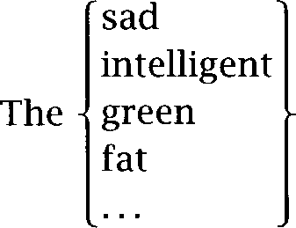Linguists group the words of a language into classes (sets) which show similar syntactic behavior, and often a typical semantic type. These word classes are otherwise called syntactic or ***categories,*** but more commonly still by the traditional name ***parts* (POS).** Three important parts of speech are noun, ***verb,*** and ***adjective.*** typically refer to people, animals, concepts and things. The prototypi- cal ***verb*** is used to express the action in a sentence. ***Adjectives*** describe properties of nouns. The most basic test for words belonging to the same class is the ***substitution test.*** Adjectives can be picked out as words that occur in the frame in (3.1):



one is in the corner.

*82*



**OPEN WORD CLASS LEXICAL CATEGORIES**

**CLOSED WORD CLASS**

**FUNCTIONAL CATEGORIES**

**DICTIONARY**

**LEXICON**

**TAGS**

**MORPHOLOGICAL**

**PROCESSES**

**PLURAL SINGULAR**

*3 Linguistic Essentials*

In sentence (3.21, the noun *children* refers to a group of people (those of young age) and the noun *candy* to a particular type of food:

Children eat sweet candy.

The verb *eat* describes what children do with candy. The adjective *sweet* tells us about a property of candy, namely that it is sweet. Many words have multiple parts of speech: *candy* can also be a verb (as in *much boiling will candy the molasses),* and, at least in British English, *sweet* can be a noun, meaning roughly the same as *candy.* Word classes are normally divided into two. The *open* or *lexical categories* are ones like nouns, verbs and adjectives which have a large number of members, and to which new words are commonly added. The *closed* or *functional egories* are categories such as prepositions and determiners (containing words like  *on, the, a)* which have only a few members, and the mem- bers of which normally have a clear grammatical use. Normally, the vari- ous parts of speech for a word are listed in an online *dictionary,* otherwise known as a *lexicon.*

Traditional systems of parts of speech distinguish about 8 categories,

but corpus linguists normally want to use more fine-grained classifica- tions of word classes. There are well-established sets of abbreviations for naming these classes, usually referred to as POS *tugs.* In this chapter, as we introduce syntactic categories, we will give the abbreviations used in the Brown corpus for the more important categories. For example, ad- jectives are tagged using the code JJ in the Brown corpus. Because of its pioneering role, the Brown corpus tags are particularly widely known.

We briefly describe and compare several well-known tag sets in sec- tion 4.3.2.

Word categories are systematically related by *morphological processes* such as the formation of the  form *(dog-s)* from the *singular* form of the noun *(dog).* Morphology is important in NLP because language is pro- ductive: in any given text we will encounter words and word forms that we haven’t seen before and that are not in our precompiled dictionary. Many of these new words are morphologically related to known words. So if we understand morphological processes, we can infer a lot about the syntactic and semantic properties of new words.

It is important to be able to handle morphology in English, but it’s abso- lutely essential when it comes to highly inflecting languages like Finnish. In English, a regular verb has only 4 distinct forms, and irregular verbs have at most 8 forms. One can accomplish a fair amount without

***3.1 Parts and Morphology 83***

phology, by just listing all word forms. In contrast, a Finnish verb has more than 10,000 forms! For a language like Finnish, it would be tedious and impractical to enumerate all verb forms as an enormous list.

The major types of morphological process are inflection, derivation,

**INFLECTION** and compounding. ***Inflections*** are the systematic modifications of a ***root***

**ROOT FORM PREFIXES SUFFIXES**

 by means of prefixes and  to indicate grammatical

tions like singular and plural. Inflection does not change word class or meaning significantly, but varies features such as tense, number, and plurality. All the inflectional forms of a word are often grouped as

**LEXEME** festations of a single

**DERIVATION *Derivation*** is less systematic. It usually results in a more radical change of syntactic category, and it often involves a change in meaning. An ex- ample is the derivation of the adverb ***widely*** from the adjective ***wide*** (by appending the suffix  ***Widely*** in a phrase like ***it is widely believed*** means ***among a large we//-dispersed group *** a shift from the core meaning of ***wide (extending over a vast urea).*** Adverb formation is also less systematic than plural inflection. Some adjectives like ***old*** or ***difficult*** don’t have adverbs:  and  are not words of English. Here are some other examples of derivations: the suffix ***-en*** transforms adjec- tives into verbs ***(weak-en, soft-en),*** the suffix transforms verbs into adjectives ***(understand-able, accept-able),*** and the suffix transforms verbs into nouns ***(teacher,***

**COMPOUNDING *Compounding*** refers to the merging of two or more words into a new word. English has many noun-noun compounds, nouns that are

nations of two other nouns. Examples are ***tea kettle, disk drive,*** or college ***degree.*** While these are (usually) written as separate words, they are pro- nounced as a single word, and denote a single semantic concept, which one would normally wish to list in the lexicon. There are also other compounds that involve parts of speech such as adjectives, verbs, and prepositions, such as ***downmarket, (to) overtake,*** and ***cow disease.***

We will now introduce the major parts of speech of English.

3.1.1 Nouns and **pronouns**

Nouns typically refer to entities in the world like people, animals, and things. Examples are:

(3.3) dog, tree, person, hat, speech, idea, philosophy

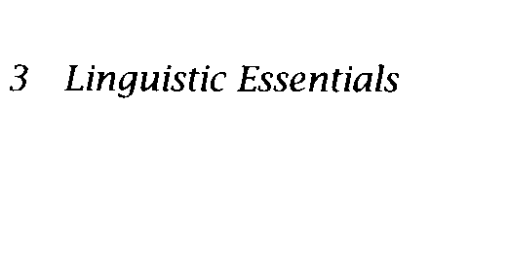***84***

Type of inflection Instances number singular, plural

gender feminine, masculine, neuter

case nominative, genitive, dative, accusative

Table 3.1 Common inflections of nouns.

English, which is morphologically impoverished compared to many other languages, has only one inflection of the noun, the plural form. It is usually formed by appending the suffix Here are some nouns with their singular and plural forms.

|  |  |  |  |  |
| --- | --- | --- | --- | --- |
| (3.4) | dog | dogs | tree trees | person persons |
|  | hat  idea | hats  ideas | speech speeches  philosophy philosophies | woman women child children |

The plural suffix has three pronunciations,  as in hats,  as in boys, and /as/ as in speeches, the last case being represented by insertion of an e in the writing system. A few forms like women don’t follow the

**IRREGULAR** regular pattern, and are termed ***irregular.***

Number (singular and plural) is one common grammatical distinction that is marked on the noun. Two other types of inflection that are com- mon for nouns across languages are gender and case as shown in ta- ble 3.1.

English does not have a system of gender inflections, but it does have different gender forms for the third person singular pronoun: he (mas- culine), ***she*** (feminine), and (neuter). An example of gender inflection of nouns from Latin is the endings -a for feminine and for masculine. Examples:  ‘son, male child’;  ‘daughter, female child.’ In some languages, grammatical gender is closely correlated with the sex of the person referred to as it is for these two Latin words (female feminine, male masculine, neither neuter), but in other languages gender is a largely arbitrary grammatical category. An example linguists are fond of is the German word for girl,  which is neuter.

In some languages, nouns appear in different forms when they have different functions (subject, object, etc.) in a sentence, and these forms

**CASE** are called ***cases.*** For example, the Latin for ‘son’ is  when the subject, but  when the object of a verb. Many languages have a rich array of case inflections, with cases for instrumentals, etc. English

***3.1 Parts of Speech and Morphology***

has no real case inflections. The only case relationship that is systemati- cally indicated is the genitive. The genitive describes the possessor. For example, the phrase the woman’s house indicates that the woman owns the house. The genitive is usually written  but just as after words that end in which includes most plural nouns such as in the ***students’ grievances.*** Although initially looks like a case inflection, it is

**CLITIC** ally what is termed a ***clitic,*** also known as a phrasal  because it can appear not only attached to nouns, but after other words that modify a noun, as in ***the person you met’s house was broken into.***

**PRONOUN *Pronouns*** are a separate small class of words that act like variables in that they refer to a person or thing that is somehow salient in the discourse context. For example, the pronoun ***she*** in sentence (3.5) refers to the most salient person (of feminine gender) in the context of use, which is Mary.

(3.5) After  arrived in the village, ***she*** looked for a bed-and-breakfast.

As well as distinguishing the number of their antecedent, they also mark person (1st = speaker, 2nd = hearer, or 3rd = other discourse enti- ties). They are the only words in English which appear in different forms when they are used as the subject and the object of a sentence. We call

**NOMINATIVE** these forms the ***nominative*** or ***subject case*** and ***accusative*** or ***object case***

**SUBJECT CASE** personal pronouns, respectively. Pronouns also have special forms,

**ACCUSATIVE**

**OBJECT CASE**

***sessive pronouns,*** for when they are a possessor, as in my cur, which we

**POSSESSIVE PRONOUNS** can view as genitive case forms. Somewhat oddly, English pronouns have another possessive form, often called the ‘second’ possessive personal pronoun, used when the object of the preposition of describes the

**REFLEXIVE PRONOUNS** sessor: a ***friend*** Finally, there are ***reflexive pronouns,*** which are used similarly to ordinary (personal) pronouns except that they always refer to a nearby antecedent in the same sentence, normally the subject of the sentence. For example, ***herself*** in sentence must refer to Mary whereas ***her*** in sentence cannot refer to Mary (that is, Mary saw a woman other than herself in the mirror).



(3.6) a. Mary saw herself in the mirror.

b. Mary saw her in the mirror.

Reflexive pronouns (and certain other expressions like *each other)* are **ANAPHORS** often referred to as  and must refer to something very nearby in the text. Personal pronouns also refer to previously discussed people



|  |  |  |  |  |
| --- | --- | --- | --- | --- |
| Nominative | Accusative | Possessive | 2nd Possessive | Reflexive |
| PPS |  |  |  | PPL |
| PPSS |  |  |  | (PPLS for |
| I | me | my your | mine  yours | myself  yourself |
| **M A S C** h e | him | his | his | himself |
| 3SG **FEM** she | her | her | hers | herself |
| 3SG **NEUT** it | it | its | its | itself |
| **we** | **us** | our | ours | ourselves |
|  |  | your | yours | yourselves |
| they | them | their | theirs | themselves |

Table 3.2 Pronoun forms in English. Second person forms do not distinguish number, except in the reflexive, while third person singular forms distinguish gender.

and things, but at a slightly greater distance. All the forms for pronouns, and their Brown tags are summarized in table 3.2.

Brown tags. NN is the Brown tag for singular nouns *(candy, woman).*

The Brown tag set also distinguishes two special types of nouns, *proper*

**PROPER NAMES** (or *proper names),* and *adverbial nouns.* Proper nouns are names **ADVERBIAL NOUNS** like Smith, or *United States* that refer to particular persons or things. Proper nouns are usually capitalized. The tag for proper nouns is

Adverbial nouns (tag NR) are nouns like home, *west* and *tomorrow* that can be used without modifiers to give information about the circum- stances of the event described, for example the time or the location. They have a function similar to *adverbs (see* below). The tags mentioned so far have the following plural equivalents: NNS (plural nouns), NNPS (plural proper nouns), and NRS (plural adverbial nouns). Many also have posses- sive or genitive extensions: NN$ (possessive singular nouns), NNS$ (pos- sessive plural nouns), NNP$ (possessive singular proper nouns), (possessive plural proper nouns), and (possessive adverbial nouns). The tags for pronouns are shown in table 3.2.

1. Actually, the Brown tag for proper nouns was NP, but we follow the Penn in **substituting** NNP, so that NP can maintain its conventional meaning within linguistics of a noun phrase (see below). We also follow the Penn in using a doubled N in the related tags mentioned subsequently.

*3 . 1 Parts of Speech and Morphology 87*

**3.1.2**

**DETERMINER**

**ARTICLE**

**DEMONSTRATIVES**

**ADJECTIVE**

(3.7)

**ATTRIBUTIVE ADNOMINAL PREDICATIVE**

(3.8)

**AGREEMENT**

**COMPARATIVE SUPERLATIVE**

**PERIPHRASTIC FORMS**

**POSITIVE**



Words that accompany nouns: Determiners and adjectives

Several other parts of speech most commonly appear accompanying nouns. *Determiners* describe the particular reference of a noun. A sub- type of determiners is *articles.* The article the indicates that we’re talking about someone or something that we already know about or can uniquely determine. We say the *tree* if we have already made reference to the tree or if the reference is clear from context such as when we are standing next to a tree and it is clear we are referring to it. The article a (or an) indicates that the person or thing we are talking about was not previously mentioned. If we say a *tree,* then we are indicating that we have not men- tioned this tree before and its identity cannot be inferred from context. Other determiners include the *demonstrutives,* such as *this* and *that.*

*Adjectives* are used to describe properties of nouns. Here are some adjectives (in italics):

a *red* rose, this  journey, many *intelligent* children, a very *trendy*

magazine

Uses such as these modifying a noun are called *attributive* or Adjectives also have a *predicative* use as a complement of be:

The rose is *red.* The journey will be long.

Many languages mark distinctions of case, number, and gender on ar- ticles and adjectives as well as nouns, and we then say that the article or adjective *agrees* with the noun, that is, they have the same case, number, and gender. In English, the morphological modifications of adjectives are the derivational endings like  which we covered earlier, and the for- mation of *comparative (richer, trendier),* and *superlative (richest, trendi- est)* forms. Only some, mainly shorter, adjectives form morphological comparatives and superlatives by suffixing *-er* and *-est.* For the rest,  *forms* are used *(more intelligent, most intelligent).* Periphrastic forms are formed with the auxiliary words, in this case *more* and

The basic form of the adjective *(rich, trendy, intelligent)* is called the posi- *tive* when contrasted with comparative and superlative. Comparative and superlative forms compare different degrees to which the property de- scribed by the adjective applies to nouns. The following example should be self-explanatory:

John is rich, Paul is richer, Mary is richest.



**QUANTIFIER**

**INTERROGATIVE**

**PRONOUNS INTERROGATIVE DETERMINERS**

3.1.3

**BASE FORM**

**PRESENT TENSE**

(3.10)

**Brown tags.** The Brown tag for adjectives (in the positive form) is JJ, for comparatives JJR, for superlatives JJT. There is a special tag, JJS, for the ‘semantically’ superlative adjectives chief, main, and top. Num- bers are subclasses of adjectives. The cardinals, such as one, two, and  have the tag CD. The ordinals, such as first, second, tenth, and ***mid-twentieth*** have the tag OD.

The Brown tag for articles is AT. Singular determiners, like ***this, that,*** have the tag DT; plural determiners (these, those) DTS; determiners that can be singular or plural (some, any) DTI, and ‘double conjunction’ deter- miners ***(either, neither)*** DTX.

 are words that express ideas like ‘all,’ ‘many,’ ‘some.’ The determiners and any can function as quantifiers. Other parts of speech that correspond to quantifiers have the tags ABN (pre-quantifier: many) and PN (nominal pronoun: ***one, something, anything, some- body).*** The tag for there when used to express existence at the beginning

of a sentence is EX.

A final group of words that occur with or instead of nouns are the ***in- terrogative pronouns*** and ***determiners*** which are used for questions and relative clauses. Their tags are WDT (wh-determiner: what, ***which),*** (possessive wh-pronoun: whose), WPO (objective  whom, ***which, that),*** and WPS (nominative wh-pronoun: who, ***which, that).***

Verbs

Verbs are used to describe actions (She threw the ***stone),*** activities (She ***walked along the river)*** and states (I have $50). A regular English verb has the following morphological forms:

the root or ***base form: walk***

* the third singular present tense: ***walks***

the gerund and present participle: ***walking***

* the past tense form and past/passive participle: ***walked***

Most of these forms do duty in several functions. The base form is used for the ***present tense.***

I walk. You walk. We walk. You (guys) walk. They walk.

The third singular person has a different present tense form:

*3 . 1* ***Parts of Speech and Morphology***

(3.11) She walks. He walks. It walks.

**INFINITIVE** The base form is also used for the ***infinitive*** with to: (3.12) She likes to walk. She has to walk. ***To walk*** is fun.

and after modals and in the bare infinitive: (3.13) She shouldn’t ***walk.*** She helped me ***walk.***

**PROGRESSIVE** The form is used for the ***progressive*** (indicating that an action is in

progress):

(3.14) She is walking. She was walking. She will be walking.

**GERUND** and as the gerund, a derived form where the verb gains some or all of the properties of nouns:

(3.15) This is the most vigorous ***walking*** I’ve done in a long time. ***Walking*** is fun.

The form serves as past tense indicating an action that took place in the past:

(3.16) She walked.

**PRESENT PERFECT** It also functions as the past participle in the formation of present perfect: (3.17) She has walked.

**PAST PERFECT** and past  (3.18) She had walked.

**IRREGULAR** A number of verbs are ***irregular*** and have different forms for past tense and past participle. Examples are ***drive*** and ***take:***

(3.19) a. She ***drove*** the car. She has never ***driven*** a car.

b. She ***rook off*** on Monday. She had already ***off*** on Monday.

Just as nouns are commonly marked for features like number and case, verbs are also commonly marked for certain features. Table 3.3 summarizes grammatical features that are commonly indicated on verbs across languages. These features can be indicated either morphologically

**S Y N T H E T I C F O R M S** (also called  as in the case of the English endings



***3 Linguistic Essentials***

Feature Category

subject number subject person tense

aspect

mood/modality participles voice

Instances singular, plural

first ***walk),*** second (you ***walk),*** third (she ***walks)*** present tense, past tense, future tense progressive, perfect

possibility, subjunctive, irrealis

present participle ***(walking),*** past participle ***(walked)***

active, passive, middle

Table 3.3 Features commonly marked on verbs,

**AUXILIARIES** and  or by means of ***auxiliaries,*** words that accompany verbs in a

**VERB GROUP verb group** (also called ***analytically).*** English uses the auxiliaries ***have,***

**ANALYTIC FORMS *be,*** and (and others) to express aspect, mood, and some tense

The present and past perfect are formed with ***have*** as we saw in sentences (3.17) and (3.18). The progressive is formed with ***be*** (3.14). Forms that are built using auxiliaries, as opposed to direct inflection as

**FORMS** in the case of the English past tense, are referred to as ***periphrustic forms.* MODAL AUXILIARIES** In English, there is a class of verbs with special properties: the modal ***auxiliaries*** or Modals lack some of the forms of ordinary verbs

(no infinitive, no progressive form), and always come first in the verb group. They express modalities like possibility (may, can) or obligation ***(should)*** as illustrated in the following examples:

(3.20) a. With her abilities, she can do whatever she wants to.

1. He ***may*** or not come to the meeting.
2. You ***should*** spend more time with your family.

In English, the formation of the future tense with the auxiliary ***will*** is in all ways parallel to that of other modalities:

(3.21) She ***will*** come. She ***will*** not come.

**Brown tags.** The Brown tag set uses VB for the base form ***(take),*** VBZ for the third person singular ***(takes),*** for the past tense ***(took),*** VBG for gerund and present participle ***(taking),*** and VBN for the past participle ***(taken).*** The tag for modal auxiliaries (can, ***may, must, could, might,***



is MD. Since ***be, have,*** and ***do*** are important in forming tenses and moods,

* 1. *1* ***Parts of Speech and Morphology* 91**

the Brown tag set has separate tags for all forms of these verbs. We omit them here, but they are listed in table 4.6.

3.1.4 **Other parts of speech**

**Adverbs, prepositions, and particles**

We have already encountered adverbs as an example of morphological

**ADVERB** derivation. ***Adverbs*** modify a verb in the same way that adjectives modify nouns. Adverbs specify place, time, manner or degree:

(3.22) a. She often travels to Las Vegas.

1. She allegedly committed 
2. She started her career off very ***impressively.***

Some adverbs, such as ***often,*** are not derived from adjectives and lack the suffix 

Some adverbs can also modify adjectives  and  and other adverbs 

(3.23) a. a very unlikely event

1. a ***shockingly*** frank exchange
2. She started her career off very impressively.

Certain adverbs like very are specialized to the role of modifying

**DEGREE ADVERBS** jectives and adverbs and do not modify verbs. They are called degree adverbs. Their distribution is thus quite distinct from other adverbs, and

**QUALIFIER** they are sometimes regarded as a separate part of speech called 

**P R E P O S I T I O N *Prepositions*** are mainly small words that prototypically express spatial relationships:

(3.24) ***in*** the glass, ***on*** the table, ***over*** their heads, an interesting idea,

***concerning*** your recent invention

**PARTICLE** Most prepositions do double duty as particles. ***Particles*** are a subclass of prepositions that can enter into strong bonds with verbs in the

**PHRASAL VERBS** tion of so-called  ***verbs.*** We can best think of a phrasal verb as a separate lexical entry with syntactic and semantic properties different from the verb it was formed from. Here are some examples:



(3.25) a. The plane took  at Sam.

b. Don’t give *in* to him.

**C.** It is time to take *on* new responsibilities.

d. He was put off by so much rudeness.

Sometimes these constructions can occur with the preposition separated from the verb:

(3.26) a. I didn’t want to rake that responsibility *on* right now.

b. He *put* me 

These phrasal verbs have particular meanings that are quite specialized, and unpredictable from the verb and particle that make them up.

Sometimes we need to know the meaning of a sentence to be able to distinguish particles and prepositions: *up* is a preposition in and a particle in  Note the meaning shift from the literal meaning of running on an incline in (3.2 7a) to the figurative meaning of building up a large bill in 

(3.27) a. She ran up a hill.

b. She ran up a bill.

Brown tags. The tags for adverbs are RB (ordinary adverb: *simply, lute, well, little),* RBR (comparative adverb: *later, better, less),* RBT (superlative adverb: *latest, best, least), (not),* QL (qualifier: very, *extremely),* and QLP (post-qualifier: *enough, indeed).* Two tags stand for parts of speech that have both adverbial and interrogative functions: WQL (wh-qualifier:

and WRB (wh-adverb: how, *when, where).*

The Brown tag for prepositions is IN, while particles have the tag RP.

Conjunctions and complementizers

The remaining important word categories are coordinating and

**COORDINATING** nating conjunctions. *Coordinating conjunctions* ‘conjoin’ or *coordinate*

**CONJUNCTION** two words or phrases of (usually) the same category:

**COORDINATION**

 husband *and* wife [nouns]

* 1. *Phrase Structure*

**CLAUSE SUBORDINATING**

**CONJUNCTION**

(3.28)

**COMPLEMENTIZERS**

#### 3.2

**WORD ORDER**

**PHRASES SYNTAX**

**CONSTITIJENT**

z She bought leased the car. [verbs]

the green triangle and the blue square [noun phrases]

z She bought her car, *but* she also considered leasing it. [sentences]

One function of coordinating conjunctions is to link two sentences (or *clauses)* as shown in the last example. This can also be done by *subordi- nating conjunctions.* In the examples below, the subordinating conjunc- tion is shown in italics.

1. She said he would be late. [proposition]
2. She complained *because* he was late. [reason]
3. I won’t wait *if* he is late. [condition]
4. She thanked him *although* he was late. [concession]
5. She left *before* he arrived. [temporal]

Cases of subordinating conjunctions like *that* in or use of *for* which introduce arguments of the verb are often alternatively regarded as  The difference between coordination and subordi- nation is that, as the terms suggest, coordination joins two sentences as equals whereas subordination attaches a secondary sentence to a pri- mary sentence. The secondary sentence often expresses a proposition, a reason, a condition, a concession or a temporally related event.

Brown tags. The tag for conjunctions is CC. The tag for subordinating conjunctions is CS.

#### Phrase Structure

Words do not occur in just any old order. Languages have constraints on word order. But it is also the case that the words in a sentence are not just strung together as a sequence of parts of speech, like beads on a necklace. Instead, words are organized into *phrases,* groupings of words that are clumped. as a unit. *Syntax* is the study of the regularities and constraints of word order and phrase structure.

One fundamental idea is that certain groupings of words behave as

*constituents.* Constituents can be detected by their being able to occur

in various positions, and showing uniform syntactic possibilities for ex- pansion. The examples in (3.29) and (3.30) show evidence from position- ing and phrasal expansion for a constituent that groups nouns and their modifiers:

* 1. I put the bagels in the freezer.
  2. The bagels, put in the freezer.

C. I put in the fridge the  (that John had given me)

She him



the woman the man

*(3.30)*

the tall woman the very tall woman

the tall woman with sad eyes

saw

the short man the very short man

the short man with red hair

 

**PARADIGMATIC RELATIONSHIP**

**PARADIGM SYNTAGMATIC RELATIONSHIP SYNTAGMA**

**COLLOCATIONS**

This is the notion of a *paradigmatic relationship* in Saussurean linguis- tics. All elements that can be replaced for each other in a certain syntactic position (like the noun phrase constituent above) are members of one *paradigm.* In contrast, two words bear a *relationship* if they can form a phrase (or  like sewed clothes or sewed a *dress.* An important class of syntagmatically related words are *collocations* (chap- ter 5).

In this section we will briefly mention some of the major phrase types,

and then introduce techniques linguists use to model phrase structure.

(3.31)

The upshot will be to suggest that English sentences typically have an overall phrase structure that looks as follows:

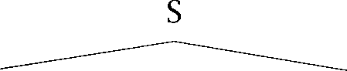

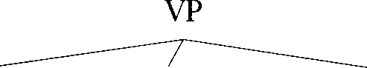

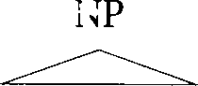

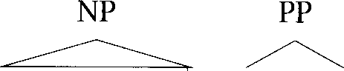*That man* VBD



*caught the butterfly* IN NP



*with net*

A whole sentence is given the category S. A sentence as a subject noun phrase and a verb phrase.

normally rewrites

*3.2 Phrase Structure 95*

**PHRASE Noun phrases.** A noun is usually embedded in a phrase a syn- tactic unit of the sentence in which information about the noun is 

**HEAD** ered. The noun is the head of the noun phrase, the central constituent that determines the syntactic character of the phrase. Noun phrases are usually the *arguments* of verbs, the participants in the action, activity or state described by the verb. Noun phrases normally consist of an op- tional determiner, zero or more adjective phrases, a noun head, and then perhaps some post-modifiers, such as prepositional phrases or clausal modifiers, with the constituents appearing in that order. Clausal

**RELATIVE CLAUSES** ifiers of nouns are referred to as *relative clauses.* Here is a large noun phrase that indicates many of these possibilities:

(3.32) The homeless old man in the park that I tried to help yesterday

**PREPOSITIONAL Prepositional phrases.** *Prepositional phrases* are headed by a **PHRASES** preposition and contain a noun phrase complement. They can appear within all the other major phrase types. They are particularly common

in noun phrases and verb phrases where they usually express spatial and temporal locations and other attributes.

**Verb phrases.** Analogous to the way nouns head noun phrases, the verb **VERB PHRASE** is the head of the *verb phruse* (VP). In general, the verb phrase organizes all elements of the sentence that depend syntactically on the verb (ex-

cept that in most syntactic theories the verb phrase does not contain the subject noun phrase). Some examples of verb phrases appear in (3.33):

(3.33) a. *Getting to school on time* was a struggle.

1. He was *trying to keep his temper.*
2. That woman *quickly showed me the to hide.*

**ADJECTIVE PHRASES Adjective phrases.** Complex *adjective phrases* are less common, but encompass examples like the phrases shown in bold in these sen- tences: *She is very sure of herself; He seemed a man who quite certain* **to succeed.**

**32.1 Phrase structure grammars**

A syntactic analysis of a sentence tells us how to determine the meaning of the sentence from the meaning of the words. For example, it will tell us who does what to whom in the event described in a sentence. Compare:

(3.34) Mary gave Peter a book. (3.35) Peter gave Mary a book.

Sentences (3.34) and (3.35) use the same words, but have different mean- ings. In the first sentence, the book is transferred from Mary to Peter, in the second from Peter to Mary. It is the word order that allows us to infer who did what to whom.

Some languages like Latin or Russian permit many different ways of ordering the words in a sentence without a change in meaning, and in- stead use case markings to indicate who did what to whom. This type of

**FREE WORD ORDER** language is called a *free word order* language, meaning that word order isn’t used to indicate who the doer is word order is then usually used mainly to indicate discourse structure. Other languages such as English are more restrictive in the extent to which words can move around in a sentence. In English, the basic word order is Subject Verb Object:

(3.36) The *children* (subject) should (auxiliary verb) eat spinach (object).

In general, this order is modified only to express particular ‘mood’

**INTERROGATIVES** egories. In *interrogatives* (or questions), the subject and first auxiliary

**INVERTED** verb are *inverted:*

(3.37) Should (auxiliary verb) the *children* (subject) eat *spinach* (object)?

If the statement would involve no auxiliary, a form of do appears in the

**IMPERATIVES** initial position (Did he cry?). In *imperatives* (commands or requests), there is no subject (it is inferred to be the person who is addressed):

(3.38) Eat spinach!

**DECLARATIVES** Basic sentences are called when contrasted with interroga- tives and imperatives.

**REWRITE RULES** The regularities of word order are often captured by means of *rewrite rules.* A rewrite rule has the form ‘category category*’ and states that the symbol on the left side can be rewritten as the sequence of symbols on the right side. To produce a sentence of the language, we start with

**START SYMBOL** the *start symbol* ‘S’ (for sentence). Here is a simple set of rewrite rules:

 NPVP

AT NNS



AT ***the***

***children***

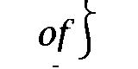

NP AT NN NP PP VP PP

VP VBD

VBD NP

P IN NP

**NNS**

VBD IN

***students mountains slept***

***ate saw in***

**cake**

The rules on the righthand side rewrite one of the syntactic categories (or part of speech symbols) introduced in the previous sections into a word of the corresponding category. This part of the grammar is often

**LEXICON** separated off as the *lexicon.* The nature of these rules is that a certain

syntactic category can be rewritten as one or more other syntactic cat- egories or words. The possibilities for rewriting depend solely on the category, and not on any surrounding context, so such phrase structure

**CONTEXT-FREE** grammars are commonly referred to as *context-free* ***grammars.***

**GRAMMARS** With these rules, we can derive sentences. Derivations (3.40) and (3.41) are two simple examples.

(3.40) s





(3.41) s

NPVP

AT NNS VBD

***The children slept***

NPVP

AT NNS NP

AT NNS VBD AT NN

***The children ate the cake***

The more intuitive way to represent phrase structure is as a tree. We refer

**TERMINAL NODES** to the leaf nodes of the tree as ***terminal nodes*** and to internal nodes as

**NONTERMINAL NODES *nonterminal nodes.*** In such a tree each nonterminal node and its

**LOCAL TREE** ate daughters, otherwise known as a ***local tree*** corresponds to the appli- cation of a rewrite rule. The order of daughters generates the word order of the sentence, and the tree has a single root node, which is the start symbol of the grammar. Trees (3.42) and (3.43) correspond to

(3.42)

tions (3.40) and (3.41). Each node in the tree shows something that we are hypothesising to be a constituent.



VP



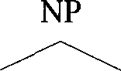AT NNS VBD

  

***The children slept***

***(3.43)***

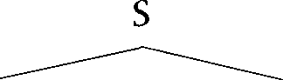

 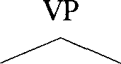

AT NNS VBD NP

   

***The children ate*** AT NN

***the cake***

**BRACKETING** A third and final way to show constituency is via a ***(labeled) bracketing.*** Sets of brackets delimit constituents and may be labeled to show the category of the nonterminal nodes. The labeled bracketing for (3.43) is (3.44):

        **[AT**



A property of most formalizations of natural language syntax in terms **RECURSIVITY** of rewrite rules is  the fact that there are constellations in which rewrite rules can be applied an arbitrary number of times. In our

example grammar, a PP contains an NP which can in turn contain an- other PP. Thus we can get recursive expansions as in the example in figure **3.1.** Here, the sequence of prepositional phrases is generated by multiple application of the rewrite rule cycle “NP NP PP; PP IN NP.” The derivation applies the cycle twice, but we could apply it three, four, or a hundred times.

Recursivity makes it possible for a single nonterminal symbol like VP or NP to be expanded to a large number of words. (For example, in figure 3.1 the symbol VP is expanded to nine words: ***ate the cake of the children in***

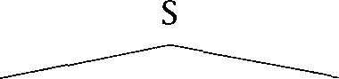

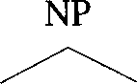 

DT NNS VBD

*the students ate*

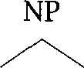

DT NN IN

  

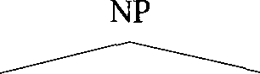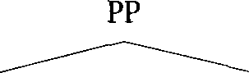

*the cake of*

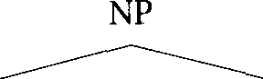

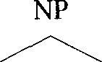 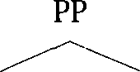

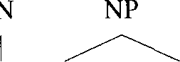DT NN I

N

 

*the children in* DT NN

*the mountains*

Figure 3.1 An example of recursive phrase structure expansion.

the mountains.) One consequence is that two words that were gener- ated by a common rewrite rule and are syntactically linked can become separated by intervening words as the derivation of a sentence proceeds.

**NON-LOCAL** These types of phenomena are called *non-local dependencies* because two

**DEPENDENCIES** words can be syntactically dependent even though they occur far apart in a sentence.

**SUBJECT-VERB** One example of a dependency that can be non-local is subject-verb **AGREEMENT** *agreement,* the fact that the subject and verb of a sentence agree in num- ber and person. We have She *He walks, It* versus I *walk, You*

*We walk, They* That is, the verb has the ending indicating third person singular if and only if the subject is in the third person sin- gular. Subject and verb agree even if other words and phrases intervene as in the following example.

(3.45) The **women** who found the wallet were given a reward.

If we looked only at immediate neighbors it would seem that we would have to say *wallet was. Only* a complete syntactic analysis of the sentence reveals that The *women* is the subject and the form of to be has to be in the plural.

**LONG-DISTANCE DEPENDENCIES**

**WH-EXTRACTION**

*(3.46)*

**EMPTY NODES**

*(3.47)*

Another important case of non-local dependencies is the class known as long-distance *dependencies,* such as *wh-extraction.\** The name is based on the theory that phrases such as *which book* in  are moved (or extracted) from an underlying position (after the verb as in  to their “surface” position (the beginning of the sentence as in 

* 1. Should Peter buy book?
  2. *Which book* should Peter buy?

Without making any commitment to such a movement theory, it is clear that we have to recognize a long distance dependency between buy and *which book.* Otherwise we would not be able to tell that *book* is an argu- ment of buy.

Non-local phenomena are a challenge for some Statistical NLP approa- ches like n-grams that model local dependencies. An n-gram model would predict that the word after *wallet* in (3.45) is not were. These issues are further discussed at the beginning of chapter 11.

A final feature of many versions of phrase structure grammar is empty nodes. Empty nodes occur when a nonterminal may be rewritten as noth- ing. For example, noting that one can also say *the cake!* without a subject NP, one might suggest adding a rule NP 0. An NP nonterminal is then allowed to be rewritten as nothing. This is often represented by putting a 0 or an e under the node in the tree. Using this notation, the tree in  could be given the structure in (3.47):

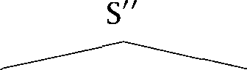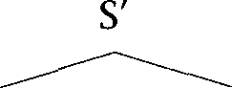

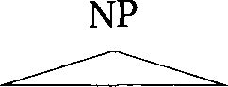*Which book* M D



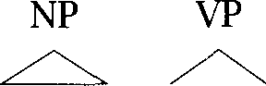*should*

N P

*Peter* VB NP

 

*buy e*

1. In the speech literature, the term ‘long-distance dependencies’ regularly refers to any- thing beyond the range of a  model. We have termed such effects ‘non-local depen- dencies,’ and have reserved the term ‘long-distance dependencies’ for its usual linguistic meaning of a dependency that appears to be able to cross any number of nodes in a phrase structure tree.

The simple model of phrase structure that we have developed here **CONTEXT-FREE** adopts a context-free view of language. For example, once we have ex- panded ‘VP’ to ‘VBD NP’ and then to ‘sewed NP,’ we can replace NP with

whatever noun phrase we please. The context provided by the verb sewed is inaccessible when we decide how to expand NP. This inaccessibility of context is the key property of a context-free grammar. We could expand VP to a natural phrase like sewed clothes, but we can as easily choose a nonsensical expansion like sewed ***wood blocks.***

How to include necessary dependencies is a central topic in probabilis- tic parsing, which we discuss in chapter 12.

3.2.2 Dependency: Arguments and adjuncts

**DEPENDENCY** Another important organizing notion is the concept of ***dependents.*** In a sentence like:

(3.48) Sue watched the man at the next table.

Sue and ***the*** are dependents of a watching event. We will say that they are the two arguments of the verb ***watch.*** The PP ***the next table*** is a dependent of man. It modifies ***man.***

Most commonly, noun phrases are arguments of verbs. The arguments of verbs can be described at various levels. One can classify the

**SEMANTIC ROLES** ments via ***semantic roles.*** The ***agent*** of an action is the person or thing

**AGENT PATIENT**

that is doing something, the ***patient*** is the person or thing that is having something done to it, and other roles like ***instrument*** and goal describe yet other classes of semantic relationships. Alternatively, one can de- scribe the syntactic possibilities for arguments in terms of grammatical

**SUBJECT** relations. All English verbs take a ***subject,*** which is the noun phrase that **OBJECT** appears before the verb. Many verbs take an ***object*** noun phrase, which normally appears immediately after the verb. Pronouns are in the sub-

ject case when they are subjects of a verb, and in the object case when they are objects of a verb. In our earlier example, here repeated as sen- tence (3.491, ***children*** is the subject of ***eat*** (the children are the agents of the action of eating), and ***sweet candy*** is the object of eat (the sweet candy is the thing being acted upon, the patient of the action):

(3.49) Children eat sweet candy.

***(3.50)***

**INDIRECT OBJECT**

**RECIPIENT DIRECT OBJECT**

(3.51)

***(3.52***

**ACTIVE VOICE PASSIVE VOICE**

***(3.53)***

Note that the morphological form of candy does not change. In English, pronouns are the only nouns that change their forms when used in the object case.

Some verbs take two object noun phrases after the verb, both in the object case:

She gave him the book.

In this sentence, ***him*** is the ***indirect object*** (describing the ***recipient,*** the one who indirectly gets something) and the book is the direct object (de- scribing the patient). Other such verbs are verbs of sending and verbs of communication:

1. She sent her mother the book.
2. She him the letter.

Such verbs often allow an alternate expression of their arguments where the recipient appears in a prepositional phrase:

She sent the book to her mother.

Languages with case markings normally distinguish these and ex- press patients in the accusative case and recipients in the dative case.

There are systematic associations between semantic roles and gram- matical functions, for example agents are usually subjects, but there are also some dissociations. In ***Bill received package from the mailman,*** it is the mailman who appears to be the agent. The relationships between semantic roles and grammatical functions are also changed by voice al- ternations (the one feature in table 3.3 which we did not discuss earlier). Many language make a distinction between active voice and passive voice (or simply ***active*** and ***passive).*** Active corresponds to the default way of expressing the arguments of a verb: the agent is expressed as the subject, the patient as the object:

Children eat sweet candy.

In the passive, the patient becomes the subject, and the agent is demoted to an oblique role. In English this means that the order of the two argu- ments is reversed, and the agent is expressed by means of a prepositional by-phrase. The passive is formed with the auxiliary ***be*** and the past par- ticiple:

(3.54) Candy is eaten by children.

In other languages, the passive alternation might just involve changes in case marking, and some morphology on the verb.

**Subcategorization**

As we have seen, different verbs differ in the number of entities (persons, animals, things) that they relate. One such difference is the contrast

**TRANSITIVE** tween and *intransitive* verbs. Transitive verbs have a (direct)

**INTRANSITIVE** object, intransitive verbs don’t: (3.55) a. She brought a bottle of whiskey.

b. She walked (along the river).

In sentence a bottle *ofwhiskey* is the object of brought. We cannot use the verb *bring* without an object: we cannot say She *brought.* The verb *walk* is an example of an intransitive verb. There is no object in sentence (3.55). There is, however, a prepositional phrase expressing the location of the activity.

Syntacticians try to classify the dependents of verbs. The first distinc- tion they make is between arguments and adjuncts. The subject, object,

**ARGUMENTS** and direct object are arguments. In general,  express entities that are centrally involved in the activity of the verb. Most arguments are expressed as  but they may be expressed as or as clauses:



**(3.56)** a. We deprived him  

b. John knows *that he is losing.*

Arguments are divided into the subject, and all non-subject arguments

**COMPLEMENTS** which are collectively referred to as *complements.*

**ADJUNCTS** *Adjuncts* are phrases that have a less tight link to the verb. Adjuncts are always optional whereas many complements are obligatory (for ex- ample, the object of *bring* is obligatory). Adjuncts can also move around more easily than complements. Prototypical examples of adjuncts are phrases that tell us the time, place, or manner of the action or state that the verb describes as in the following examples:

(3.5 7) a. She saw a Woody Allen movie yesterday.

1. She saw a Woody Allen movie *in Paris.*
2. She saw the Woody Allen movie with ***great interest.***
3. She saw a Woody Allen movie ***with a couple***



**SUBORDINATE *Subordinate clauses*** (sentences within a sentence) can also be either **CLAUSES** adjuncts or subcategorized arguments, and can express a variety of rela- tionships to the verb. In the examples we saw earlier in  (a) involves

an argument clause, while the rest are adjuncts.

Sometimes, it’s difficult to distinguish adjuncts and complements. The prepositional phrase on ***the table*** is a complement in the first sentence (it is subcategorized for by ***put*** and cannot be omitted), an adjunct in the second (it is optional):

(3.58) She put the book on ***the table.***

***(3.59)*** He gave his presentation on ***the stage.***

The traditional argument/adjunct distinction is really a reflection of the categorical basis of traditional linguistics. In many cases, such as the following, one seems to find an intermediate degree of selection:

(3.60) a. I straightened the nail with a ***hammer.***

b. He will retire ***in Florida.***

is not clear whether the in italics should be regarded as being cen- trally involved in the event described by the verb or not. Within a Sta- tistical NLP approach, it probably makes sense to talk instead about the degree of association between a verb and a dependent.

We refer to the classification of verbs according to the types of

**SUBCATEGORIZATION** plements they permit as ***subcategorization.*** We say that a verb

***gorizes for*** a particular complement. For example, ***bring*** subcategorizes for an object. Here is a list of subcategorized arguments with example sentences.

**Subject. *The children*** eat candy.

**Object.** The children eat candy.

**Prepositional phrase.** She put the book on ***the table.***

**Predicative adjective.** We made the man angry.

**Bare infinitive.** She helped me ***walk.***

*3.2 Phrase Structure*

**Infinitive with *to.*** She likes *to walk.*

**Participial phrase.** She stopped singing *tune* eventually.

**That-clause. She** thinks *it will ruin tomorrow.* The *that* can usu- ally be omitted: She thinks *will ruin tomorrow.*

**Question-form clauses.** She is wondering why *it is ruining in August.*

She asked me *what book I was reading.*

While most of these complements are phrasal units that we have already seen, such as and  the final entries are not, in that they are a unit bigger than an S. The clause why *ruining in August* consists of a whole sentence *is ruining in August* plus an additional constituent out front. Such a “large clause” is referred to as an S’ (pronounced “S Bar”) constituent. Relative clauses and main clause questions are also analyzed as S’ constituents.



Often verbs have several possible patterns of arguments. A particular **SUBCATEGORIZATION** set of arguments that a verb can appear with is referred to as a  **FRAME** *rizution frame.* Here are some subcategorization frames that are common

in English.

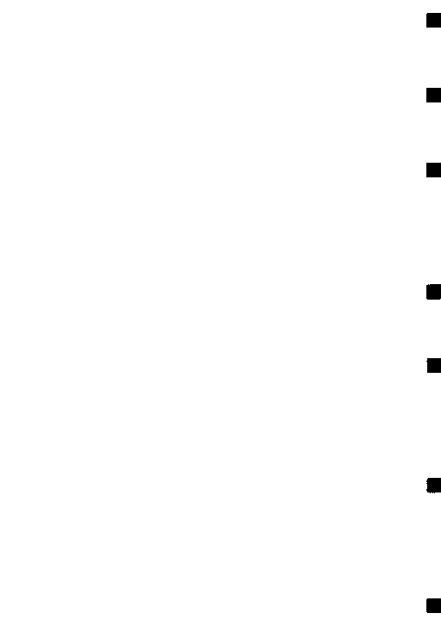**Intransitive verb.** The *womun walked.*

**Transitive verb.** *John loves Mary.*



**Ditransitive verb.** object], object].



*Mary gave Peter flowers.*

**Intransitive with PP.** NP[subject], PP. *rent in Puddington.*

**Transitive with PP. NP[subject],** PP. She *the book on the table.*

**Sentential complement. clause.** *know (that) she likes you.*

**Transitive with sentential complement. clause.** *She told me that Gary is coming on Tuesday.*



Subcategorization frames capture *syntactic* regularities about  **SELECTIONAL** ments. There are also *semantic* regularities which are called *selectional* **RESTRICTIONS** *restrictions* or *selectional preferences.* For example, the verb *bark* prefers

**SELECTIONAL**

**PREFERENCES**

dogs as subjects. The verb *eat* prefers edible things as objects:

(3.61)

(3.62)

(3.63)

3.2.3

**HEAD**

**SPECIFIER**

(3.64)

*The* Chihuahua barked all night. I eat *vegetables* every day.

Sentences that violate selectional preferences sound odd:

1. *cut* barked all night.
2. I eat philosophy every day.

Selectional preferences are further discussed in section 8.4.

X’ **theory**

Phrase structure rules as presented above do not predict any  ity in the way that phrases in natural languages are made, nor any reg- ularities for the appearance of different kinds of dependents in clauses. However, modern syntax has stressed that there are a lot of such regu- larities. An important idea is that a word will be the head of a phrase. The reason why we talk about noun phrases and prepositional phrases is because they are a constituent consisting of a noun or preposition re- spectively, and all their dependents. The noun or preposition heads the  Linguists have further argued that there is a broad systematicity in the way dependents arrange themselves around a head in a phrase. A head forms a small constituent with its complements. This constituent can be modified by adjuncts to form a bigger constituent, and finally this constituent can combine with a *specifier,* a subject or something like a determiner to form a maximal phrase. An example of the general picture is shown in (3.64):

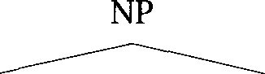

Det



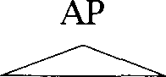*the*

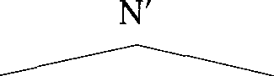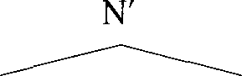

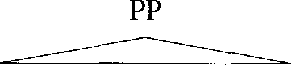*definitive N*



study ofsubcategorization

1. Recall, however, that verb phrases, as normally described, are slightly anomalous, since they include all the complements of the verb, but not the subject.
   1. *Phrase Structure 107*

**ADJUNCTION**

3.2.4

**GENERATION**

**PARSING**

**PARSE**

**SYNTACTIC AMBIGUITY**

**ATTACHMENT AMBIGUITY**

(3.65)

The intermediate constituents are referred to as N’ nodes (pronounced “N bar nodes”). This is basically a two bar level theory (where we think of XP as X”), but is complicated by the fact that recursive  of modifiers is allowed at the N’ level to express that a noun can have any number of adjectival phrase modifiers. Sometimes people use theories with more or fewer bar levels.

The final step of the argument is that while there may be differences in word order, this general pattern of constituency is repeated across phrase types. This idea is referred to as X’ theory, where the X is taken to represent a variable across lexical categories.

Phrase structure ambiguity

**So** far we have used rewrite rules to generate sentences. It is more com- mon to use them in parsing, the process of reconstructing the deriva- tion(s) or phrase structure tree(s) that give rise to a particular sequence of words. We call a phrase structure tree that is constructed from a sen- tence a parse. For example, the tree in (3.43) is a parse of sentence (3.41). In most cases, there are many different phrase structure trees that could all have given rise to a particular sequence of words. A parser based on a comprehensive grammar of English will usually find hundreds of parses for a sentence. This phenomenon is called phrase structure ambiguity or syntactic ambiguity. We saw an example of a syntactically ambiguous sentence in the introduction, example (1.10): *company is * *workers.* One type of syntactic ambiguity that is particularly

frequent is *attachment ambiguity.*

Attachment ambiguities occur with phrases that could have been gen- erated by two different nodes. For example, according to the grammar in there are two ways to generate the prepositional phrase *with a spoon* in sentence (3.65):

The children ate the cake with a spoon.

It can be generated as a child of a verb phrase, as in the parse tree shown in figure 3.2 (a), or as a child of one of the noun phrases, as in the parse tree shown in figure 3.2 (b).

Different attachments have different meanings. The ‘high’ attachment to the verb phrase makes a statement about the instrument that the chil- dren used while eating the cake. The ‘low’ attachment to the noun phrase tells us which cake was eaten (the cake with a spoon, and not, say, the

 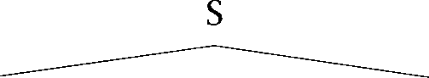

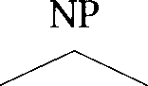 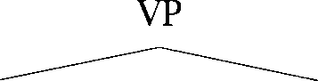

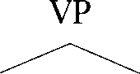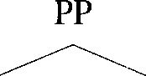AT NNS

 I

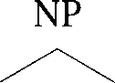***The children*** VBD NP IN

I  

ate AT NN ***with*** AT NN

***the cake a spoon***

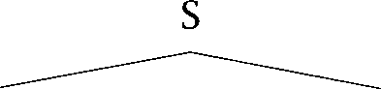

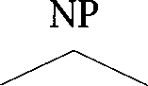 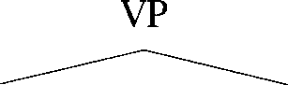

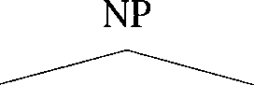AT NNS VBD

***The children ate*** 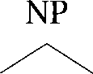 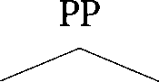

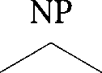AT NN IN

I I

***the cake with*** AT NN

***a spoon***

Figure 3.2 An example of a prepositional phrase attachment ambiguity.

cake with icing). So resolving attachment ambiguities can be important for finding the correct semantic interpretation.

A much-studied subclass of syntactic ambiguity is the phenomenon **GARDEN PATHS** of ***garden *** A garden path sentence leads you along a path that suddenly turns out not to work. For example, there might turn out to be

additional words in the sentence that do not seem to belong there: (3.66) The horse raced past the barn fell.

Sentence (3.66) from (Bever 1970) is probably the most famous example of a garden path sentence. By the time most people get to the word ***barn,*** they have constructed a parse that roughly corresponds to the meaning

‘The horse ran past the barn.’ But then there is an additional word fell that cannot be incrementally added to this parse. We have to backtrack to ***raced*** and construct a completely different parse, corresponding to the meaning The horse fell ***after it had been the burn.*** Garden  is the phenomenon of first being tricked into adopting a spurious parse and then having to backtrack to try to construct the right parse.



Garden-path sentences are rarely a problem in spoken language. Se- mantic preferences, the generosity of speakers in following communica- tive maxims, and intonational patterns all usually prevent us from garden  (MacDonald et al. 1994; Tanenhaus and Trueswell 1995). We can see this in sentence (3.66) where an intonational break between horse and ***raced*** would tip the hearer off that ***raced*** introduces a reduced relative clause, not the verb of the main clause. However, garden-pathing can be a real problem when reading complex sentences of written English.

We have seen examples of sentences with more than one parse due to syntactic ambiguity. Most sentences are of this type. But it is also possible that a sentence will have no parse at all. The reason could be that a rule was used in the generation of the sentence that is not covered by

**UNGRAMMATICAL** the grammar. The other possibility is that the sentence is  or not syntactically well-formed. Here is an example of an ungrammatical sentence.

(3.67)  children the.

It is important to distinguish ungrammaticality from semantic abnormal- ity. Sentences like the following are odd, but they are jarring because their semantic interpretation is incoherent whereas (3.67) does not have an interpretation at all.

(3.68) a. Colorless green ideas sleep furiously.

b. The cat barked.

People often use a hash mark  to indicate semantic, pragmatic, or cul- tural oddness, as opposed to the marks we introduced earlier for syntac- tic illformedness.

#### Semantics and Pragmatics

Semantics is the study of the meaning of words, constructions, and utter- ances. We can divide semantics into two parts, the study of the meaning

**LEXICAL SEMANTICS**

**HYPERNYMY**

**HYPONYMY HYPERONYM**

**ANTONYMS**

**MERONYMY**

**HOLONYM SYNONYMS HOMONYMS**

**SENSES POLY SEME**

**AMBIGUITY**

**HOMOPHONY**

**COMPOSITIONALITY**

*(3.69)*

of individual words (or *lexical semantics)* and the study of how meanings of individual words are combined into the meaning of sentences (or even larger units).

One way to approach lexical semantics is to study how word meanings are related to each other. We can organize words into a lexical hierarchy, as is the case, for example, in which defines  and A hypernym or is a word with a more general sense, for example, animal is a hypernym of cat. A hyponym is a word with a more specialized meaning: *cut* is a hyponym of animal. (In general, if  is a hypernym of  then  is a hyponym of  *Antonyms* are words with opposite meanings: and or long and *short.* The whole relationship is called *meronymy.* The word *tire* is a meronym of



and  is a meronym of tree. The whole corresponding to a part is called a 

*Synonyms* are words with the same meaning (or very similar meaning): and are synonyms. *Homonyms* are words that are written

the same way, but are (historically or conceptually) really two different words with different meanings which seem unrelated. Examples are suit (‘lawsuit’ and ‘set of garments’) and bunk (‘river bank’ and ‘financial insti- tution’). If a word’s meanings (or senses) are related, we call it a  The word brunch is polysemous because its senses (‘natural subdivision of a plant’ and ‘a separate but dependent part of a central organization’) are related. Lexical *ambiguity* can refer to both homonymy and polysemy. The of homonymy where the two words are not only written the same way, but also have identical pronunciation, is called *homophony. So* the words buss for a species of fish and for a low-pitched sound are homonyms, but they are not homophones.

Disambiguating word senses is the topic of chapter 7.

Once we have the meanings of individual words, we need to assemble them into the meaning of the whole sentence. That is a hard problem because natural language often does not obey the principle of   by which the meaning of the whole can be strictly predicted from the meaning of the parts. The word *white* refers to very different colors in the following expressions:

white paper, white hair, white skin, white wine

White hair is grey, a white skin really has a rosy color, and white wine

1. The latter is prescriptively correct. The former is more commonly used.

**COLLOCATIONS**

**IDIOM**

**SCOPE**

is actually yellow (but yellow wine doesn’t sound very appealing). The groupings white *hair, white skin,* and *white wine* are examples of colloca- *tions.* The meaning of the whole is the sum of the meanings of the part plus some additional semantic component that cannot be predicted from the parts.

Collocations are the topic of chapter 5.

If the relationship between the meaning of the words and the meaning of the phrase is completely opaque, we call the phrase an *idiom.* For ex- ample, the idiom *to kick the bucket* describes a process, dying, that has nothing to do with kicking and buckets. We may be able to explain the historical origin of the idiom, but in today’s language it is completely non-compositional. Another example is the noun-noun compound *cur- riuge return* for the character that marks the end of a line. Most younger speakers are not aware of its original meaning: returning the carriage of a typewriter to its position on the left margin of the page when starting a new line.

There are many other important problems in assembling the meanings of larger units, which we will not discuss in detail here. One example is the problem of scope. Quantifiers and operators have a scope which extends over one or more phrases or clauses. In the following sentence, we can either interpret the quantifier everyone as having scope over the negative not (meaning that not one person went to the movie), or we can interpret the negation as having scope over the quantifier (meaning that at least one person didn’t go to the movie):

*3.70)* Everyone didn’t go to the movie.

In order to derive a correct representation of the meaning of the sentence, we need to determine which interpretation is correct in context.

The next larger unit to consider after words and sentences is a *dis- course.* Studies of discourse seek to elucidate the covert relationships between sentences in a text. In a narrative discourse, one can seek to describe whether a following sentence is an example, an elaboration, a restatement, etc. In a conversation one wants to model the relationship between turns and the kinds of speech acts involved (questions, state-

**DISCOURSE ANALYSIS**

**ANAPHORIC RELATIONS**

**(3.71)**

ments, requests, acknowledgments, etc.). A central problem in *discourse analysis* is the resolution of  *relations.*

* 1. Mary helped *Peter* get out of the cab. *He* thanked her.

**INFORMATION EXTRACTION**

(3.72)



* 1. Mary helped *the other passenger* out of the cab. *The man* had asked her to help him because of his foot injury.

Anaphoric relations hold between noun phrases that refer to the same person or thing. The noun phrases Peter and He in sentence  and *the other passenger* and *The man* in sentence  refer to the same person. The resolution of anaphoric relations is important for *informa- tion extraction.* In information extraction, we are scanning a text for a specific type of event such as natural disasters, terrorist attacks or cor- porate acquisitions. The task is to identify the participants in the event and other information typical of such an event (for example the purchase price in a corporate merger). To do this task well, the correct identi- fication of anaphoric relations is crucial in order to keep track of the participants.

Hurricane Hugo destroyed 20,000 Florida homes. At an estimated cost of one billion dollars, the disaster has been the most costly in the state’s history.

If we identify *Hurricane Hugo* and *the disaster* as referring to the same entity in mini-discourse  we will be able to give Hugo as an an- swer to the question: *Which hurricanes caused more than a billion dollars worth of damage?*

Discourse analysis is part of  the study of how knowledge about the world and language conventions interact with literal meaning. Anaphoric relations are a pragmatic phenomenon since they are con- strained by world knowledge. For example, for resolving the relations in discourse  it is necessary to know that hurricanes are disasters. Most areas of pragmatics have not received much attention in Statistical NLP, both because it is hard to model the complexity of world knowledge with statistical means and due to the lack of training data. Two areas that are beginning to receive more attention are the resolution of anaphoric relations and the modeling of speech acts in dialogues.

#### Other Areas

Linguistics is traditionally subdivided into phonetics, phonology, mor- phology, syntax, semantics, and pragmatics. Phonetics is the study of the physical sounds of language, phenomena like consonants, vowels and in- tonation. The subject of phonology is the structure of the sound systems

* 1. *Further Reading 113*

in languages. Phonetics and phonology are important for speech recogni- tion and speech synthesis, but since we do not cover speech, we will not cover them in this book. We will introduce the small number of phonetic and phonological concepts we need wherever we first refer to them.

In addition to areas of study that deal with different levels of language, there are also subfields of linguistics that look at particular aspects of

**SOCIOLINGUISTICS** language.  studies the interactions of social organization **HISTORICAL** and language. The change of languages over time is the subject of **LINGUISTICS** *linguistics.* Linguistic  looks at how languages make different

use of the inventory of linguistic devices and how they can be classified into groups based on the way they use these devices. Language acquisi- tion investigates how children learn language. Psycholinguistics focuses on issues of real-time production and perception of language and on the way language is represented in the brain. Many of these areas hold rich possibilities for making use of quantitative methods. Mathematical linguistics is usually used to refer to approaches using non-quantitative mathematical methods.

#### Further Reading

In-depth overview articles of a large number of the subfields of linguistics can be found in (Newmeyer 1988). In many of these areas, the influence of Statistical NLP can now be felt, be it in the widespread use of corpora, or in the adoption of quantitative methods from Statistical NLP.

De Saussure 1962 is a landmark work in structuralist linguistics. An excellent in-depth overview of the field of linguistics for non-linguists is provided by the Cambridge Encyclopedia of Language (Crystal 1987). See also (Pinker 1994) for a recent popular book. (1969) presents an extremely thorough study of the possibilities for word derivation in English. Quirk et al. (1985) provide a comprehensive grammar of English. Finally, a good work of reference for looking up syntactic (and many mor- phological and semantic) terms is (Trask 1993).

Good introductions to speech recognition and speech synthesis are: (Waibel and Lee 1990; Rabiner and Juang 1993; Jelinek 1997).

3.6

**(3.73)**

**(3.74)**

**(3.75)**

**(3.76)**

**(3.77)**

**(3.78)**

#### Exercises

**Exercise 3.1 **

What are the parts of speech of the words in the following paragraph?

The lemon is an essential cooking ingredient. Its sharply fragrant juice and tangy rind is added to sweet and savory dishes in every cuisine. This enchanting book, written by cookbook author John Smith, offers a wonderful array of recipes celebrating this internationally popular, intensely flavored fruit.

**Exercise** 3.2

Think of five examples of noun-noun compounds.

**Exercise** 3.3

Identify subject, direct object and indirect object in the following sentence. He baked her an apple pie.

Exercise 3.4  What is the difference in meaning between the following two sentences?

1. Mary defended her.
2. Mary defended herself.

**Exercise** 3.5

What is the standard word order in the English sentence (a) for   for imperatives,  for interrogatives?

**Exercise** 3.6 

What are the comparative and superlative forms for the following adjectives and adverbs?

good, well, effective, big, curious, bad

Exercise 3.7 

Give base form, third singular present tense form, past tense, past participle, and present participle for the following verbs.

throw, do, laugh, change, carry, bring, dream

Exercise 3.8  Transform the following sentences into the passive voice.

1. Mary carried the suitcase up the stairs.
2. Mary gave John the suitcase.
   1. ***Exercises***

**Exercise 3.9**

What is the difference between a preposition and a particle? What grammatical function does ***in*** have in the following sentences?

(3.79) a. Mary lives in London.

* 1. When did Mary move in?
  2. She puts in a lot of hours at work.
  3. She put the document in the wrong folder.

**Exercise** 3.10

Give three examples each of transitive verbs and intransitive verbs.

**Exercise** 3.11

What is the difference between a complement and an adjunct? Are the itali- cized phrases in the following sentences complements or adjuncts? What type of complements or adjuncts?

(3.80) a. She goes to Church on ***Sundays.***

1. She went ***to London.***
2. Peter relies ***on Mary*** for help with his homework.
3. The book is lying ***on the table.***
4. She watched him ***with a telescope.***

**Exercise** 3.12

The italicized phrases in the following sentences are examples of attachment ambiguity. What are the two possible interpretations?

(3.81) Mary saw the man ***with the telescope.***

(3.82) The company experienced growth in classified advertising ***and preprinted inserts.***

**Exercise** 3.13

Are the following phrases compositional or non-compositional?

(3.83) to beat around the bush, to eat an orange, to kick butt, to twist somebody’s arm, help desk, computer program, desktop publishing, book publishing, the publishing industry

Exercise 3.14 

Are phrasal verbs compositional or non-compositional?

Exercise 3.15 

In the following sentence, either a few ***actors*** or ***everybody*** can take wide scope over the sentence. What is the difference in meaning?

(3.84) A few actors are liked by everybody.

### Corpus-Based Work

**THIS CHAPTER** begins with some brief advice on getting set up to do corpus-based work. The main requirements for Statistical **NLP** work are computers, corpora, and software. Many of the details of computers and corpora are subject to rapid change, and so it does not make sense to dwell on these. Moreover, in many cases, one will have to make do with the computers and corpora at one V local establishment, even if they are not in all respects ideal. Regarding software, this book does not attempt to teach programming skills as it goes, but assumes that a reader inter- ested in implementing any of the algorithms described herein can already program in some programming language. Nevertheless, we provide in this section a few pointers to languages and tools that may be generally useful.

After that the chapter covers a number of interesting issues concerning the formats and problems one encounters when dealing with Uaw data plain text in some electronic form. A very important, if often neglected, issue is the low-level processing which is done to the text before the real work of the research project begins. As we will see, there are a number of difficult issues in determining what is a word and what is a sentence. In practice these decisions are generally made by imperfect heuristic meth- ods, and it is thus important to remember that the inaccuracies of these methods affect all subsequent results.

Finally the chapter turns to marked up data, where some process often a human being has added explicit markup to the text to indicate something of the structure and semantics of the document. This is often helpful, but raises its own questions about the kind and content of the markup used. We introduce the rudiments of **SGML** markup (and thus

*118* 4 Corpus-Based *Work*

also **XML)** and then turn to substantive issues such as the choice of tag sets used in corpora marked up for part of speech.

#### Getting Set Up

* + 1. Computers

Text corpora are usually big. It takes quite a lot of computational re- sources to deal with large amounts of text. In the early days of comput- ing, this was the major limitation on the use of corpora. For example in the earliest years of work on constructing the Brown corpus (the  just sorting all the words in the corpus to produce a word list would take 17 hours of (dedicated) processing time. This was because the computer (an IBM 7070) had the equivalent of only about 40 kilobytes of memory, and so the sort algorithm had to store the data being sorted on tape drives. Today one can sort this amount of data within minutes on even a modest computer.

As well as needing plenty of space to store corpora, Statistical NLP methods often consist of a step of collecting a large number of counts from corpora, which one would like to access speedily. This means that one wants a computer with lots of hard disk space, and lots of memory. In a rapidly changing world, it does not make much sense to be more pre- cise than this about the hardware one needs. Fortunately, all the change is in a good direction, and often all that one will need is a decent personal computer with its RAM cheaply expanded (whereas even a few years ago, a substantial sum of money was needed to get a suitably fast computer with sufficient memory and hard disk space).

* + 1. Corpora

A selection of some of the main organizations that distribute text cor- pora for linguistic purposes are shown in table 4.1. Most of these orga- nizations charge moderate sums of money for  If your budget does not extend to this, there are now numerous sources of free text, ranging from and web pages, to the many books and 

1. Prices vary enormously, but are normally in the range of per CD for academic and nonprofit organizations, and reflect the considerable cost of collecting and processing material.



Linguistic Data Consortium (LDC)



European Language Resources Association (ELRA)

International Computer Archive of Modern English   Oxford Text Archive <http://ota.ahds.ac.uk/>

Child Language Data Exchange System  

**Table** 4.1 Major suppliers of electronic corpora with contact

that are available free on the web. Such free sources will not bring you linguistically-marked-up corpora, but often there are tools that can do the task of adding markup automatically reasonably well, and at any rate, working out how to deal with raw text brings its own challenges. Further resources for online text can be found on the

When working with a corpus, we have to be careful about the valid- ity of estimates or other results of statistical analysis that we produce. A corpus is a special collection of textual material collected according to a certain set of criteria. For example, the Brown corpus was designed as a representative sample of written American English as used in 1961 (Francis and 1982: S-6). Some of the criteria employed in its construction were to include particular texts in amounts proportional to actual publication and to exclude verse because Lt presents special linguistic problems (p. 5).

As a result, estimates obtained from the Brown corpus do not neces- sarily hold for British English or spoken American English. For example, the estimates of the entropy of English in section 2.2.7 depend heavily on the corpus that is used for estimation. One would expect the entropy of poetry to be higher than that of other written text since poetry can flout semantic expectations and even grammar. So the entropy of the Brown corpus will not help much in assessing the entropy of poetry. A more mundane example is text categorization (see chapter 16) where the per- formance of a system can deteriorate significantly over time because a sample drawn for training at one point can lose its representativeness after a year or two.

**REPRESENTATIVE** The general issue is whether the corpus is a ***represenrutive sample*** of

**SAMPLE** the population of interest. A sample is representative if what we find for the sample also holds for the general population. We will not dis- cuss methods for determining representativeness here since this issue is dealt with at length in the corpus linguistics literature. We also refer

**BALANCEDCORPUS** the reader to this literature for creating ***balanced*** corpora, which are put together so as to give each subtype of text a share of the corpus that is proportional to some predetermined criterion of importance. In Statis- tical NLP, one commonly receives as a corpus a certain amount of data from a certain domain of interest, without having any say in how it is constructed. In such cases, having more training text is normally more useful than any concerns of balance, and one should simply use all the text that is available.

In summary, there is no easy way of determining whether a corpus is representative, but it is an important issue to keep in mind when doing Statistical NLP work. The minimal questions we should attempt to answer when we select a corpus or report results are what type of text the corpus is representative of and whether the results obtained will transfer to the domain of interest.

The effect of corpus variability on the accuracy of part-of-speech tag- ging is discussed in section 10.3.2.

* + 1. **Software**

There are many programs available for looking at text corpora and ana- lyzing the data that you see. In general, however, we assume that readers will be writing their own software, and so all the software that is really needed is a plain text editor, and a compiler or interpreter for a lan- guage of choice. However, certain other tools, such as ones for searching through text corpora can often be of use. We briefly describe some such tools later.

**Text editors**

**You** will want a plain text editor that shows fairly literally what is actually in the file. Fairly standard and cheap choices are **Emacs** for Unix (or Windows), for Windows, and for Macintosh.

**Regular expressions**

In many places and in many programs, editors, etc., one wishes to find certain patterns in text, that are often more complex than a simple match against a sequence of characters. The most general widespread notation

**REGULA R EXPRESSIONS** for such matches are regular ***expressions*** which can describe patterns

REGULAR LANGUAGE that are a regular  the kind that can be recognized by a finite state machine. If you are not already familiar with regular expressions, you will want to become familiar with them. Regular expressions can be used in many plain text editors (Emacs, Nisus, with many tools (such as grep and sed), and as built-ins or libraries in many programming languages (such as Pet-l, C, Introductions to regular expressions can be found in (Hopcroft and Ullman 1979; Sipser 1996; Fried1 1997).



Programming languages

Most Statistical NLP work is currently done in C/C++. The need to deal with large amounts of data collection and processing from large texts means that the efficiency gains of coding in a language like C/C++ are generally worth it. But for a lot of the ancillary processing of text, there are many other languages which may be more economical with human labor. Many people use for general text preparation and reformat- ting. Its integration of regular expressions into the language syntax is particularly powerful. In general, interpreted languages are faster for these kinds of tasks than writing everything in C. Old timers might still use awk rather than even though what you can do with it is rather more limited. Another choice, better liked by programming purists is Python, but using regular expressions in Python just is not as easy as Perl. One of the authors still makes considerable use of Prolog. The

in database facilities and easy handling of complicated data structures makes Prolog excel for some tasks, but again, it lacks the easy access to regular expressions available in There are other languages such as or Icon developed for text computing, and which are

liked by some in the humanities computing world, but their use does not seem to have permeated into the Statistical NLP community. In the last few years there has been increasing uptake of Java. While not as fast as C, Java has many other appealing features, such as being  oriented, providing automatic memory management, and having many useful libraries.

Programming techniques

This section is not meant as a substitute for a general knowledge of com- puter algorithms, but we briefly mention a couple of useful tips.



Coding words. Normally Statistical NLP systems deal with a large num- ber of words, and programming languages like  provide only quite limited facilities for dealing with words. A method that is commonly used in Statistical NLP and Information Retrieval is to map words to numbers on input (and only back to words when needed for output). This gives a lot of advantages because things like equality can be checked more easily and quickly on numbers. It also maps all tokens of a word to its type, which has a single number. There are various ways to do this. One good way is to maintain a large hash table (a hash function maps a set of ob- jects into a specificed range of integers, for example, **[0, .** A hash table allows one to see efficiently whether a word has been seen before, and if so return its number, or else add it and assign a new number. The numbers used might be indices into an array of words (especially effec- tive if one limits the application to 65,000 or fewer words, so they can be stored as 16 bit numbers) or they might just be the address of the canonical form of the string as stored in the hashtable. This is especially convenient on output, as then no conversion back to a word has to be done: the string can just be printed.



There are other useful data structures such as various kinds of trees. See a book on algorithms such as  et al. 1990) or (Frakes and Baeza-Yates 1992).

Collecting count data. For a lot of Statistical NLP work, there is a first step of collecting counts of various observations, as a basis for estimating probabilities. The seemingly obvious way to do that is to build a big data structure (arrays or whatever) in which one counts each event of interest. But this can often work badly in practice since this model requires a huge memory address space which is being roughly randomly accessed. Unless your computer has enough memory for all those tables, the program will end up swapping a lot and will run very slowly. Often a better approach is for the data collecting program to simply emit a token representing each observation, and then for a follow on program to sort and then count these tokens. Indeed, these latter steps can often be done by existing system utilities (such as sort and **uniq** on Unix systems). Among other places, such a strategy is very successfully used in the CMU-Cambridge Statistical Language Modeling toolkit which can be obtained from the web (see website).



* 1. **Looking at Text**

Text will usually come in either a raw format, or marked up in some **MARKUP** way.  is a term that is used for putting codes of some sort into a computer file, that are not actually part of the text in the file, but explain something of the structure or formatting of that text. Nearly all computer

systems for dealing with text use mark-up of some sort. Commercial word processing software uses markup, but hides it from the user by employing WYSIWYG (What You See Is What You Get) display. Normally, when dealing with corpora in Statistical NLP, we will want explicit markup that we can see. This is part of why the first tool in a corpus linguist V toolbox is a plain text editor.

There are a number of features of text in human languages that can make them difficult to process automatically, even at a low level. Here we discuss some of the basic problems that one should be aware of. The discussion is dominated by, but not exclusively concerned with, the most fundamental problems in *English* text.

* + 1. Low-level formatting issues

**Junk formatting/content**

Depending on the source of the corpus, there may be various formatting and content that one cannot deal with, and is just junk that needs to be filtered out. This may include: document headers and separators, type- setter codes, tables and diagrams, garbled data in the computer file, etc.

OCR If the data comes from *OCR* (Optical Character Recognition), the OCR pro- cess may have introduced problems such as headers, footers and floating material (tables, figures, and footnotes) breaking up the paragraphs of the text. There will also usually be OCR errors where words have been misrecognized. If your program is meant to deal with only connected En- glish text, then other kinds of content such as tables and pictures need to be regarded as junk. Often one needs a filter to remove junk content before any further processing begins.

**Uppercase and lowercase**

The original Brown corpus was all capitals (a before a letter was used to indicate a capital letter in the original source text). All uppercase text is

124 *4 Corpus-Based Work*

rarely seen these days, but even with modern texts, there are questions of how to treat capitalization. In particular, if we have two tokens that are identical except that one has certain letters in uppercase, should we treat them as the same? For many purposes we would like to treat the, The, and THE as the same, for example if we just want to do a study of the usage of definite articles, or noun phrase structure. This is easily done by converting all words to upper- or lowercase, but the problem is that at the same time we would normally like to keep the two types of Brown in Brown and brown *paint* distinct. In many circumstances it is

**PROPER NAMES** easy to distinguish names and hence to keep this distinction, but

sometimes it is not. A simple heuristic is to change to lowercase letters capital letters at the start of a sentence (where English regularly capi- talizes all words) and in things like headings and titles when there is a series of words that are all in capitals, while other words with capital let- ters are assumed to be names and their uppercase letters are preserved. This heuristic works quite well, but naturally, there are problems. The first problem is that one has to be able to correctly identify the ends of sentences, which is not always easy, as we discuss later. In certain gen- res (such as *Winnie the Pooh),* words may be capitalized just to stress that they are making a Very Important Point, without them indicating a proper name. At any rate, the heuristic will wrongly lowercase names that ap- pear sentence initially or in all uppercase sequences. Often this source of error can be tolerated (because regular words are usually more common than proper names), but sometimes this would badly bias estimates. One can attempt to do better by keeping lists of proper names (perhaps with further information on whether they name a person, place, or company), but in general there is not an easy solution to the problem of accurate proper name detection.

* + 1. What is a word?

Normally, an early step of processing is to divide the input text into units

**TOKENS** called tokens where each is either a *word* or something else like a number

**WORD TOKENIZATION**

or a punctuation mark. This process is referred to as The treatment of punctuation varies. While normally people want to keep sen- tence boundaries (see section 4.2.4 below), often sentence-internal punc- tuation has just been stripped out. This is probably unwise. Recent work has emphasized the information contained in all punctuation. No mat- ter how imperfect a representation, punctuation marks like commas and

dashes give some clues about the macro structure of the text and what is likely to modify what.

The question of what counts as a word is a vexed one in linguistics, and often linguists end up suggesting that there are words at various lev- els, such as phonological words versus syntactic words, which need not all be the same. What is a humble computational linguist meant to do?

**GRAPHIC WORD** and Francis (1967) suggested the practical notion of a graphic word which they define as D string of contiguous alphanumeric charac- ters with space on either side; may include hyphens and apostrophes, but no other punctuation marks. But, unfortunately, life is not that simple, even if one is just looking for a practical, workable definition.

and Francis seem in practice to use intuition, since they regard as words numbers and monetary amounts like $22.50 which do not strictly seem to obey the definition above. And things get considerably worse. Especially if using online material such as newsgroups and web pages for data, but even if sticking to newswires, one finds all sorts of oddities that should presumably be counted as words, such as references to  or the web company  net, or the various forms of smilies made out of punctu- ation marks, such as Even putting aside such creatures, working out word tokens is a quite difficult affair. The main clue used in English is



**WHITESPACE** the occurrence of *whitespace* a space or tab or the beginning of a new line between words but even this signal is not necessarily reliable. What are the main problems?

**Periods**

Words are not always surrounded by white space. Often punctuation marks attach to words, such as commas, semicolons, and periods (full stops). It at first seems easy to remove punctuation marks from word tokens, but this is problematic for the case of periods. While most peri- ods are end of sentence punctuation marks, others mark an abbreviation such as in etc. or  These abbreviation periods presumably should remain as part of the word, and in some cases keeping them might be im- portant so that we can distinguish Wash., an abbreviation for the state of Washington, from the capitalized form of the verb Note especially that when an abbreviation like etc. appears at the end of the sentence, then only one period occurs, but it serves both functions of the period, simultaneously! An example occurred with  earlier in this

**HAPLOLOGY** graph. Within morphology, this phenomenon is referred to as 

*126 4 Corpus-Based Work*

The issue of working out which punctuation marks do indicate the end of a sentence is discussed further in section 42.4.

**Single apostrophes**

It is a difficult question to know how to regard English contractions such as or These count as one graphic word according to the definition above, but many people have a strong intuition that we really have two words here as these are contractions for I *will* and *is not.* Thus some processors (and some corpora, such as the Penn Treebank) split such contractions into two words, while others do not. Note the impact that not splitting them has. The traditional first syntax rule:



NP VP

stops being obviously true of sentences involving contractions such as I P *right.* On the other hand, if one does split, there are then funny words like and in your data.

Phrases such as the dog V and *the child* V*,* when not abbreviations for the dog *is* or *the dog has,* are commonly seen as containing dog V as the genitive or possessive case of dog. But as we mentioned in section 3.1.1,

CLITIC this is not actually correct for English where is a *clitic* which can at- tach to other elements in a noun phrase, such as in The house *rented yesterday* V *garden is really big.* Thus it is again unclear whether to re- gard *dog* V as one word or two, and again the Penn opts for the latter. Orthographic-word-final single quotations are an especially tricky case. Normally they represent the end of a quotation and so should not be part of a word, but when following an they may represent an (unpro- nounced) indicator of a plural possessive, as in *the boys toys* and then should be treated as part of the word, if other possessives are being so treated. There is no easy way for a tokenizer to determine which function is intended in many such cases.

**Hyphenation: Different forms representing the same word**

Perhaps one of the most difficult areas is dealing with hyphens in the input. Do sequences of letters with a hyphen in between count as one word or two? Again, the intuitive answer seems to be sometimes one, sometimes two. This reflects the many sources of hyphens in texts.

*4.2 Looking at Text*

One source is typographical. Words have traditionally been broken and hyphens inserted to improve justification of text. These line-breaking hy- phens may be present in data if it comes from what was actually typeset. It would seem to be an easy problem to just look for hyphens at the end of a line, remove them and join the part words at the end of one line and the beginning of the next. But again, there is the problem of haplology. If there is a hyphen from some other source, then after that hyphen is regarded as a legitimate place to break the text, and only one hyphen appears not two. So it is not always correct to delete hyphens at the end of a line, and it is difficult in general to detect which hyphens were line-breaking hyphens and which were not.

Even if such line-breaking hyphens are not present (and they usually are not in truly electronic texts), difficult problems remain. Some things with hyphens are clearly best treated as a single word, such as e-mail or *co-operate* or *A-l-plus* (as in *A-l * *commercial paper,* a financial rating). Other cases are much more arguable, although we usually want to regard them as a single word, for example, *non-lawyer, * and *so-culled.* The hyphens here might be termed lexical hyphens. They are  inserted before or after small word formatives, sometimes for the purpose of splitting up vowel sequences.

The third class of hyphens is ones inserted to help indicate the cor- rect grouping of words. A common copy-editing practice is to hyphenate compound pre-modifiers, as in the example earlier in this sentence or in examples like these:

*(4.1)* a. the once-quiet study of superconductivity

* 1. a tough regime of business-conduct rules
  2. the aluminum-export ban
  3. a text-based medium

And hyphens occur in other places, where a phrase is seen as in some sense quotative or as expressing a quantity or rate:

(4.2) a. the idea of a child-as-required-yuppie-possession must be motivating them

b. a final Wake-it-or-leave-it offer

**C.** the raise

**128** 4 Corpus-Based Work

d. the 

In these cases, we would probably want to treat the things joined by hy- phens as separate words. In many corpora this type of hyphenation is very common, and it would greatly increase the size of the word vocab- ulary (mainly with items outside a dictionary) and obscure the syntactic structure of the text if such things were not split apart into separate



A particular problem in this area is that the use of hyphens in many such cases is extremely inconsistent. Some texts and authorities use ***cooperate,*** while others use As another example, in the Dow Jones newswire, one can find all **of data-base and *base*** (the first and third are commonest, with the former appearing to domi- nate in software contexts, and the third in discussions of company assets, but without there being any clear semantic distinction in usage). Closer to home, look back at the beginning of this section. When we initially drafted this chapter, we (quite accidentally) used all of markup, ***murk-up*** and ***up.*** A careful copy editor would catch this and demand con- sistency, but a lot of the text we use has never been past a careful copy editor, and at any rate, we will commonly use texts from different sources which often adopt different conventions in just such matters. Note that this means that we will often have multiple forms, perhaps some treated as one word and others as two, for what is best thought of as a single

**LEXEME** (a single dictionary entry with a single meaning).

Finally, while British typographic conventions put spaces between dashes and surrounding words, American typographic conventions nor- mally have a long dash butting straight up against the words-like this. While sometimes this dash will be rendered as a special character or as multiple dashes in a computer file, the limitations of traditional com- puter character sets means that it can sometimes be rendered just as a hyphen, which just further compounds the difficulties noted above.

**The same form representing multiple Zords’**

In the main we have been collapsing distinctions and suggesting that one may wish to regard variant sequences of characters as really the

1. One possibility is to split things apart, but to add markup, as discussed later in this chapter, which records that the original was hyphenated. In this way no information is lost.

***4.2 Looking at Text 129***

same word. It is important to also observe the opposite problem, where one might wish to treat the identical sequence of characters as different

**HOMOGRAPHS** words. This happens with ***homographs,*** where two lexemes have overlap- ping forms, such as saw as a noun for a tool, or as the past tense of the verb see. In such cases we might wish to assign occurrences of saw to two different lexemes.

Methods of doing this automatically are discussed in chapter 7.

**Word segmentation in other languages**

Many languages do not put spaces in between words at all, and so the basic word division algorithm of breaking on whitespace is of no use at all. Such languages include major East-Asian languages/scripts, such as Chinese, Japanese, and Thai. Ancient Greek was also written by Ancient Greeks without word spaces. Spaces were introduced (together with

**WORD SEGMENTATION** cent marks, etc.) by those who came afterwards. In such languages, ***word segmentation*** is a much more major and challenging task.

While maintaining most word spaces, in German compound nouns are written as a single word, for example 

 Oife insurance company employee. In many ways this makes

linguistic sense, as compounds a single word, at least phonologically. But for processing purposes one may wish to divide such a compound, or at least to be aware of the internal structure of the word, and this becomes a limited word segmentation task. While not the rule, joining of compounds sometimes also happens in English, especially when they are common and have a specialized meaning. We noted above that one finds both ***base*** and ***database.*** As another example, while ***hard disk*** is more common, one sometimes finds in the computer press.

**Whitespace not indicating a word break**

Until now, the problems we have dealt with have mainly involved splitting apart sequences of characters where the word divisions are not shown by whitespace. But the opposite problem of wanting to lump things together also occurs. Here, things are separated by whitespace but we may wish to regard them as a single word. One possible case is the reverse of the German compound problem. If one decides to treat ***database*** as one word, one may wish to treat it as one word even when it is written as ***base.*** More common cases are things such as phone numbers, where we

may wish to regard 9365 *1873* as a single Zord, or in the cases of

part names such as New York or San *Francisco. An* especially difficult case is when this problem interacts with hyphenation as in a phrase like this one:

*(4.3)* the New York-New Haven railroad

Here the hyphen does not express grouping of just the immediately ad- jacent graphic words treating York-New as a semantic unit would be a big mistake.

Other cases are of more linguistic interest. For many purposes, one would want to regard phrasal verbs (make up, work out) as a single

eme (section  but this case is especially tricky since in many cases the particle is separable from the verb *couldn* W *work the answer out),* and so in general identification of possible phrasal verbs will have to be left to subsequent processing. One might also want to treat as a single lexeme certain other fixed phrases, such as *in spite * *in order to,* and be- cause  but typically a tokenizer will regard them as separate words. A partial implementation of this approach occurs in the LOB corpus where

certain pairs of words such as because of are tagged with a single part of

**TAGS** speech, here preposition, by means of using so-called *ditto tugs.*

**Variant coding of information of a certain semantic type**

Many readers may have felt that the example of a phone number in the previous section was not very recognizable or convincing because *their* phone numbers are written as 812-4374, or whatever. However, even if one is not dealing with multilingual text, any application dealing with text from different countries or written according to different stylistic conventions has to be prepared to deal with typographical differences. In particular, some items such as phone numbers are clearly of one seman- tic sort, but can appear in many formats. A selection of formats for phone numbers with their countries, all culled from advertisements in one issue of the magazine The *Economist,* is shown in table 4.2. Phone numbers var- iously use spaces, periods, hyphens, brackets, and even slashes to group digits in various ways, often not consistently even within one country. Additionally, phone numbers may include international or national long distance codes, or attempt to show both (as in the first three UK entries in the table), or just show a local number, and there may or may not be explicit indication of this via other marks such as brackets and plus

*4.2 Looking at Text*

|  |  |  |  |
| --- | --- | --- | --- |
| Phone number | Country | Phone number | Country |
| 01713780647 | UK |  | Denmark |
| (44.171) 1007 | UK | 95-51-279648 | Pakistan |
| (0) 1225 753678 | UK | 3797 | Switzerland |
| 01256468551 | UK | (94-l) 866854 | Sri Lanka |
| (202) 522-2230 | USA | 69 136-2 98 05 | Germany |
| l-925-225-3000 | USA | 33134433226 | France |
| 212. 995.5402 | USA |  | The Netherlands |

Table 4.2 Different formats for telephone numbers appearing in an issue of

*The Economist.*

signs. Trying to deal with myriad formats like this is a standard  **INFORMATION** lem in information *extraction.* It has most commonly been dealt with by building carefully handcrafted regular expressions to match formats, but

given the brittleness of such an approach, there is considerable interest in automatic means for learning the formatting of semantic types.

We do not cover information extraction extensively in this book, but there is a little further discussion in section 10.6.2.

**Speech corpora**

Our discussion has concentrated on written text, but the transcripts of speech corpora provide their own additional challenges. Speech corpora normally have more contractions, various sorts of more phonetic rep- resentations, show pronunciation variants, contain many sentence frag- ments, and include fillers like and Example (4.4) from the Switch- board corpus available from the LDC shows a typical extract from a speech transcript:

(4.4) Also I [cough] not convinced that the, at least the kind of people that I work with, I P not convinced that that V really, uh, doing much for the progr-, for the, uh, drug problem.

* + 1. **Morphology**

Another question is whether one wants to keep word forms like *sit, sits* and *sat* separate or to collapse them. The issues here are similar to those in the discussion of capitalization, but have traditionally been regarded

as more linguistically interesting. At first, grouping such forms together and working in terms of lexemes feels as if it is the right thing to do.

**STEMMING** ing this is usually referred to in the literature as *stemming* in reference to a process that strips off affixes and leaves you with a stem. Alternatively,

**LEMMATIZATION** the process may be referred to as where one is attempting

**LEMMA** to find the lemma or of which one is looking at an inflected form. These latter terms imply disambiguation at the level of lexemes, such as whether a use of *lying* represents the verb lie-lay Wo prostrate oneself or *lie-lied* Wo fib.’

Extensive empirical research within the Information Retrieval (IR) com- munity has shown that doing stemming does not help the performance of classic IR systems when performance is measured as an average over queries  1989; Hull 1996). There are always some queries for which stemming helps a lot. But there are others where performance goes down. This is a somewhat surprising result, especially from the viewpoint of lin- guistic intuition, and so it is important to understand why that is. There are three main reasons for this.

One is that while grouping the various forms of a stem seems a good thing to do, it often costs you a lot of information. For instance, while *operating* can be used in a periphrastic tense form as in *is operating*

(section  it is usually used in noun- and adjective-like uses such as *operating systems* or *operating costs.* It is not hard to see why a search for *operating systems* will perform better if it is done on inflected words than if one instead searches for all paragraphs that contain

and Or to consider another example, if someone enters *business* and the stemmer then causes retrieval of documents with busy in them, the results are unlikely to be beneficial.

Secondly, morphological analysis splits one token into several. How- ever, often it is worthwhile to group closely related information into chunks, notwithstanding the blowout in the vocabulary that this causes. Indeed, in various Statistical NLP domains, people have been able to im- prove system performance by regarding frequent multiword units as a single distinctive token. Often inflected words are a useful and effective chunk size.

Thirdly, most information retrieval studies have been done on English although recently there has been increasing multilingual work. English has very little morphology, and so the need for dealing intelligently with morphology is not acute. Many other languages have far richer systems

of inflection and derivation, and then there is a pressing need for

4.2 *Looking at Texf*

**FULL-FORM LEXICON** phological analysis. A  lexicon for such languages, one that sepa- rately lists all inflected forms of all words, would simply be too large. For instance, Bantu languages (spoken in central and southern Africa) display rich verbal morphology. Here is a form from  (Tanzania). Note the prefixes for subject and object agreement, and tense:

(4.5)



a-ka-b&mu-ha



, gave them to him.’

For historical reasons, some Bantu language orthographies write many of these morphemes with whitespace in between them, but in the lan- guages with Fonjunctive orthographies, morphological analysis is badly needed. There is an extensive system of pronoun and tense markers ap- pearing before the verb root, and quite a few other morphemes that can

appear after the root, yielding a large system of possibili- ties. Finnish is another language famous for millions of inflected forms for each verb.

One might be tempted to conclude from the paragraphs above that, in languages with rich morphology, one would gain by stripping inflec- tional morphology but not derivational morphology. But this hypothesis remains to be carefully tested in languages where there is sufficient in- flectional morphology for the question to be interesting.

It is important to realize that this result from IR need not apply to any or all Statistical NLP applications. It need not even apply to all of IR. Morphological analysis might be much more useful in other applications. Stemming does not help in the non-interactive evaluation of IR systems, where a query is presented and processed without further input, and the results are evaluated in terms of the appropriateness of the set of docu- ments returned. However, principled morphological analysis is valuable in in an interactive context, the context in which should really be evaluated. A computer does not care about weird stems like busy from business, but people do. They do not understand what is going on when *business* is stemmed to *busy* and a document with *busy* in it is returned.

It is also the case that nobody has systematically studied the possi- bility of letting people interactively influence the stemming. We believe that this could be very profitable, for cases like saw (where you want to stem for the sense Vee, but not for the sense Futting implement ), or derivational cases where in some cases you want the stems 

from  but in some you do not (busy from *business).* But the suggestion that human input may be needed does show the difficulties of doing automatic stemming in a knowledge-poor environment of the sort that has often been assumed in Statistical NLP work (for both ideological and practical reasons).

Stemming and IR in general are further discussed in chapter 15.

* + 1. Sentences

**What is a sentence?**

The first answer to what is a sentence is Vomething ending with a



or We have already mentioned the problem that only some periods mark the end of a sentence: others are used to show an abbreviation, or for both these functions at once. Nevertheless, this basic heuristic gets one a long way: in general about 90% of periods are sentence boundary indicators (Riley 1989). There are a few other pitfalls to be aware of. Sometimes other punctuation marks split up what one might want to regard as a sentence. Often what is on one or the other or even both sides of the punctuation marks colon, semicolon, and dash and might best be thought of as a sentence by itself, as in this example:



(4.6) The scene is written with a combination of unbridled passion and handed control: In the exchanges of the three characters and the rise and fall of emotions, Mr. Weller has captured the heartbreaking inexorability of separation.

Related to this is the fact that sometimes sentences do not nicely follow in sequence, but seem to nest in awkward ways. While normally nested things are not seen as sentences by themselves, but clauses, this classi- fication can be strained for cases such as the quoting of direct speech, where we get subsentences:

(4.7) <ou remind me, she remarked, Rf your mother.”

A second problem with such indirect speech is that it is standard type- setting practice (particularly in North America) to place quotation marks after sentence final punctuation. Therefore, the end of the sentence is not after the period in the example above, but after the close quotation mark that follows the period.

The above remarks suggest that the essence of a heuristic sentence division algorithm is roughly as in figure 4.1. In practice most systems

* 1. *Looking at Text 135*
     + - Place putative sentence boundaries after all occurrences of (and maybe



* + - * Move the boundary after following quotation marks, if any.
      * Disqualify a period boundary in the following circumstances:

it is preceded by a known abbreviation of a sort that does not nor- mally occur word finally, but is commonly followed by a capitalized proper name, such as Prof. or vs.

If it is preceded by a known abbreviation and not followed by an uppercase word. This will deal correctly with most usages of ab- breviations like *etc.* or which can occur sentence medially or finally.

* + - * Disqualify a boundary with a ? or if:

It is followed by a lowercase letter (or a known name).

* + - * Regard other putative sentence boundaries as sentence boundaries.

Figure *4.1* Heuristic sentence boundary detection algorithm.

have used heuristic algorithms of this sort. With enough effort in their

development, they can work very well, at least within the textual domain for which they were built. But any such solution suffers from the same problems of heuristic processes in other parts of the tokenization pro- cess. They require a lot of hand-coding and domain knowledge on the part of the person constructing the tokenizer, and tend to be brittle and domain-specific.

There has been increasing research recently on more principled meth- ods of sentence boundary detection. Riley (1989) used statistical clas- sification trees to determine sentence boundaries. The features for the classification trees include the case and length of the words preceding and following a period, and the a priori probability of different words to occur before and after a sentence boundary (the computation of which requires a large quantity of labeled training data). Palmer and Hearst (1994; 1997) avoid the need for acquiring such data by simply using the part of speech distribution of the preceding and following words, and using a neural network to predict sentence boundaries. This yields a

robust, largely language independent boundary detection algorithm with high performance (about 98-99% correct). Reynar and Ratnaparkhi (1997) and Mikheev (1998) develop Maximum Entropy approaches to the prob- lem, the latter achieving an accuracy rate of 99.25% on sentence boundary

Sentence boundary detection can be viewed as a classification problem. We discuss classification, and methods such as classification trees and maximum entropy models in chapter 16.

**What are sentences like?**

In linguistics classes, and when doing traditional computational linguis- tics exercises, sentences are generally short. This is at least in part be- cause many of the parsing tools that have traditionally been used have a exponential in the sentence length, and therefore become im- practical for sentences over twelve or so words. It is therefore important to realize that typical sentences in many text genres are rather long. In newswire, the modal (most common) length is normally around 23 words. A chart of sentence lengths in a sample of text is shown in ta- ble 4.3.

* 1. Marked-up Data

While much can be done from plain text corpora, by inducing the struc- ture present in the text, people have often made use of corpora where some of the structure is shown, since it is then easier to learn more. This markup may be done by hand, automatically, or by a mixture of these two methods. Automatic means of learning structure are covered in the remainder of this book. Here we discuss the basics of markup. Some texts mark up just a little basic structure such as sentence and paragraph boundaries, while others mark up a lot, such as the full syntac- tic structure in corpora like the Penn and the Susanne corpus. However, the most common grammatical markup that one finds is a cod- ing of words for part of speech, and so we devote particular attention to that.

1. ***Accuracy*** as a technical term is defined and discussed in section 8.1. However, the definition corresponds to one V intuitive understanding: it is the percent of the time that one is correctly classifying items.

|  |  |  |  |
| --- | --- | --- | --- |
| Length | Number | Percent | Cum. % |
| l-5 | 1317 | 3.13 | 3.13 |
| 6-10 | 3215 | 7.64 | 10.77 |
| 11-15 | 5906 | 14.03 | 24.80 |
| 16-20 | 7206 | 17.12 | 41.92 |
| 21-25 | 7350 | 17.46 | 59.38 |
| 26-30 | 6281 | 14.92 | 74.30 |
| 31-35 | 4740 | 11.26 | 85.56 |
| 36-40 | 2826 | 6.71 | 92.26 |
| 41-45 | 1606 | 3.82 | 96.10 |
| 46-50 | 858 | 2.04 | 98.14 |
| 51-100 | 780 | 1.85 | 99.99 |
|  | 6 | 0.01 | 100.00 |

Table 4.3 Sentence lengths in text. Column 3ercent shows the per- centage in each range, column &um. shows the cumulative percentage below a certain length.

* + 1. Markup schemes

Various schemes have been used to mark up the structure of text. In the early days, these were developed on an ad hoc basis, as needs arose. One of the more important early examples was the COCOA format, which was used for including header information in texts (giving author, date, title, etc.). This information was enclosed within angle brackets with the first letter indicating the broad semantics of the field. Some other ad hoc systems of this sort are still in quite common use. The most common form of grammatical markup, which we discuss in great detail below, is indicating the part of speech of words by adding a part of speech tag to each word. These tags are commonly indicated by devices such as following each word by a slash or underline and then a short code naming the part of speech. The Penn uses a form of Lisp-like bracketing to mark up a tree structure over texts.

However, currently by far the most common and supported form of

**S TANDARD** markup is to use SGML (the Generalized  *Language).*

SGML is a general language that lets one define a grammar for texts, in

**L ANGUAGE**

particular for the type of markup they contain. The now-ubiquitous HTML is an instance of an SGML encoding. The Text Encoding Initiative  was

**a** major attempt to define SGML encoding schemes suitable for marking up various kinds of humanities text resources ranging from poems and novels to linguistic resources like dictionaries. Another acronym to be

**XML** aware of is **XML. XML** defines a simplified subset of **SGML** that was partic- ularly designed for web applications. However, the weight of commercial support behind **XML** and the fact that it avoids some of the rather arcane, and perhaps also archaic, complexities in the original **SGML** specification means that the **XML** subset is likely to be widely adopted for all other purposes as well.

This book does not delve deeply into **SGML.** We will give just the rudi- mentary knowledge needed to get going. **SGML** specifies that each

**DOCUMENT TYPE** ument type should have a Type Definition **(DTD),** which is a **DEFINITION** grammar for legal structures for the document. For example, it can state **DTD** rules that a paragraph must consist of one or more sentences and nothing

else. An **SGML** parser verifies that a document is in accordance with this **DTD,** but within Statistical **NLP** the **DTD** is normally ignored and people just process whatever text is found. An **SGML** document consists of one or more elements, which may be recursively nested. Elements normally begin with a begin tag and end with an end tag, and have document con- tent in between. Tags are contained within angle brackets, and end tags begin with a forward slash character. As well as the tag name, the begin tag may contain additional attribute and value information. A couple of examples of **SGML** elements are shown below:

(4.8) a.  **then he **

**did not say another **

**b. **  **is an ugly**

The structure tagging shown in  where the tag s is used for sen- tences and p for paragraphs, is particularly widespread. Example  shows a tag with attributes and values. An element may also consist of just a single tag (without any matching end tag). In **XML,** such empty ele- ments must be specially marked by ending the tag name with a forward slash character.

In general, when making use of SGML-encoded text in a casual way, one will wish to interpret some tags within angle brackets, and to simply ignore others. The other SGML syntax that one must be aware of is char- acter and entity references. These begin with an ampersand and end with

**a** semicolon. Character references are a way of specifying characters not available in the standard ASCII character set (minus the reserved SGML markup characters) via their numeric code. Entity references have sym- bolic names which were defined in the DTD (or are one of a few predefined entities). Entity references may expand to any text, but are commonly used just to encode a special character via a symbolic name. A few exam- ples of character and entity references are shown in (4.9). They might be rendered in a browser or when printed as shown in (4.10).

(4.9) a.  **is the less than symbol**

**b. r&eacute;sum&eacute;**

**This chapter was written on &docdate;.**

(4.10) a. is the less than symbol

1. resume
2. This chapter was written on January 21, 1998.

There is much more to know about SGML, and some references appear in the Further Reading below, but this is generally enough for what the XML community normally terms the 'esperate Hacker to get by.

* + 1. Grammatical tagging

A common first step of analysis is to perform automatic grammatical tagging for categories roughly akin to conventional parts of speech, but often considerably more detailed (for instance, distinguishing compara- tive and superlative forms of adjectives, or singular from plural nouns). This section examines the nature of tag sets. What tag sets have been used? Why do people use different ones? Which one should you choose?

How tagging is done automatically is the subject of chapter 10.

Tag sets

Historically, the most influential tag sets have been the one used for

 the American Brown corpus (the **Brown tug set)** and the series of tag sets developed at the University of Lancaster, and used for tagging the Lancaster-Oslo-Bergen corpus and more recently the British National

Sentence she

was told that the

journey might kill

her



PNP VBD WN

AT0

VMO WI PNP PUN

Brown

BEDZ VBN

cs AT NN MD VB

Penn

PRP VBD VBN IN DT NN MD

VB PRP

ICE







CONJUNC(subord)











Figure 4.2 A sentence as tagged according to several different tag sets.

Tag set Basic size Total tags

|  |  |  |
| --- | --- | --- |
| Brown | 87 | 179 |
| Penn | 45 |  |
|  | 132 |  |
| CLAWS2 | 166 |  |
| CLAWS | 62 |  |
| London-Lund | 197 |  |

Table 4.4 Sizes of various tag sets.

Corpus (CLAWS1 through CLAWS5; CLAWS5 is also referred to as the

**tag set).** Recently, the Penn ***tag set*** has been the one most **SET** widely used in computational work. It is a simplified version of the Brown tag set. A brief summary of tag set sizes is shown in table 4.4. An ex-

ample sentence shown tagged via several different tag sets is shown in figure 4.2. These tag sets are all for English. In general, tag sets incorpo- rate morphological distinctions of a particular language, and so are not directly applicable to other languages (though often some of the design ideas can be transferred). Many tag sets for other languages have also been developed.

An attempt to align some tag sets, roughly organized by traditional parts of speech appears in tables 4.5 and 4.6, although we cannot guar- antee that they are accurate in every detail. They are mostly alphabetical, but we have deviated from alphabetical order a little so as to group

Category Adjective

Adjective, ordinal number Adjective, comparative Adjective, superlative

Adjective, superlative, semantically

Examples

happy, bad sixth,  last happier, worse happiest, worst chief, top

Claws Brown

JJ



ORD



JJ

Adjective, cardinal number Adjective, cardinal number, one Adverb

Adverb, negative Adverb, comparative Adverb, superlative Adverb, particle Adverb, question

Adverb, degree question Adverb, degree

Adverb, degree, postposed Adverb, nominal Conjunction, coordination Conjunction, subordinating Conjunction, complementizer Determiner

Determiner, pronoun Determiner, pronoun, plural Determiner, prequalifier Determiner, prequantifier

Determiner, pronoun or double  Determiner, pronoun or double  Determiner, article

Determiner, postdeterminer Determiner, possessive Determiner, possessive, second Determiner, question

Determiner, possessive question Noun

Noun, singular Noun, plural

Noun, proper, singular Noun, proper, plural Noun, adverbial

Noun, adverbial, plural Pronoun, nominal (indefinite) Pronoun, personal, subject Pronoun, personal, subject, 3SG Pronoun, personal, object Pronoun, reflexive

Pronoun, reflexive, plural Pronoun, question, subject Pronoun, question, object Pronoun, existential there

3, fifteen one

often, particularly not, n W

faster fastest

up, off, out when, how, why how, however very, so, too enough, indeed here, there, now and, or although, when that

this, each, another any, some

these, those quite

all, half both

either, neither the, a, an many, same their, your mine, yours

which, whatever whose

aircraft, data woman, book women, books London, Michael

Australians, Methodists tomorrow, home Sundays, weekdays none, everything, one you, we

she, he, it you, them, me

herself, myself themselves, ourselves who, whoever

who, whoever there

CRD PNI AVO

AVO AVO AVP

AVO AVO AVO

DTO DTO DTO DTO DTO DTO DTO AT0 DTO DPS DPS

NNO

NN2 NPO NPO NNO NN2 PNI PNP PNP PNP PNX PNX

EXO

CD CD RB

RBR RBT RP WRB



RN

c c cs cs DT DTI DTS ABL ABN ABX DTX AT AP



WDT



NN NN NNS NP NPS NR NRS PN





PPL





EX

CD CD RB RB RBR RBS RP

WRB WRB RB

RB RB

cc IN IN DT DT DT PDT PDT

DT (CC)

DT (CC)



PRP WDT



NN NN NNS NNP

NNPS NN NNS NN

PRP PRP PRP PRP PRP





EX

Table 4.5 Comparison of different tag sets: adjective, adverb, conjunction, de- terminer, noun, and pronoun tags.

Category

Examples Claws c5 Brown

Penn

Verb, base present form (not infinitive) Verb, infinitive

Verb, past tense

Verb, present participle Verb, past/passive participle Verb, present 3SG form Verb, auxiliary ***do,*** base Verb, auxiliary ***do,*** infinitive Verb, auxiliary ***do,*** past

Verb, auxiliary ***do,*** present part. Verb, auxiliary do, past part.

Verb, auxiliary ***do,*** present 3SG Verb, auxiliary ***have,*** base Verb, auxiliary have, infinitive Verb, auxiliary ***have,*** past

Verb, auxiliary have, present part. Verb, auxiliary ***have,*** past part.

Verb, auxiliary ***have,*** present 3SG Verb, auxiliary be, infinitive Verb, auxiliary ***be,*** past

Verb, auxiliary ***be,*** past, 3SG Verb, auxiliary ***be,*** present part. Verb, auxiliary ***be,*** past part.

Verb, auxiliary ***be,*** present, 3SG Verb, auxiliary be, present, Verb, auxiliary be, present Verb, modal

Infinitive marker Preposition, to Preposition Preposition, of Possessive

Interjection (or other isolate) Punctuation, sentence ender Punctuation, semicolon Punctuation, colon or ellipsis Punctuation, comma Punctuation, dash Punctuation, dollar sign Punctuation, left bracket Punctuation, right bracket

Punctuation, quotation mark, left Punctuation, quotation mark, right Foreign words (not in English lexicon) Symbol

Symbol, alphabetical Symbol, list item

take, live WB

take, live W I

took, lived W D taking, living WG taken, lived W N

takes, lives w z

do VDB

do VDB

did VDD

doing VDG

done VDN

does VDZ

have VHB

have VHI

had VHD

having VHG

had VHN

has VHZ

be VBI

were VBD

was VBD

being VBG

been VBN

is, VBZ

am, P VBB

are, Ue VBB can, could, 11 VMO to TOO

to PRP

for, above PRP

of PRF





oh, yes, mmm

.!? PUN

PUN PUN PUN PUN PUN





PUR

 



UNC



A, d zzo A A. First

VB VB VBD VBG VBN VBZ DO DO DOD VBG VBN DOZ HV HV HVD HVG HVN



BE BED BEDZ BEG BEN BEZ BEM BER MD TO IN

IN IN



UH

not



not not



not

VBP VB VBD VBG VBN VBZ VBP VB VBD VBG VBN VBZ VBP VB VBD VBG VBN VBZ



VBD VBD VBG VBN VBZ VBP VBP MD TO TO IN IN



UH



FW SYM



Table 4.6 Comparison of different tag sets: Verb, preposition, punctuation and symbol tags. An entry of Qot means an item was ignored in tagging, or was not separated off as a separate token.

egories that are sometimes collapsed. In this categorization, we use an elsewhere convention where the least marked category is used in all cases where a word cannot be placed within one of the more precise subclassi- fications. For instance, the plain Adjective category is used for adjectives that aren W comparatives, superlatives, numbers, etc. The complete Brown tag set was made larger by two decisions to augment the tag set. Normal tags could be followed by a hyphen and an attribute like TL (for a ti- tle word), or in the case of foreign words, the FW foreign word tag was followed by a hyphen and a part of speech assignment. Secondly, the Brown tag scheme makes use of Fombined tags for graphic words that one might want to think of as multiple lexemes, such as  Normally such items were tagged with two tags joined with a plus sign, but for negation one just adds to a tag. So isn W is tagged and is tagged PPS+MD. Additionally, possessive forms like ***children* V** are tagged with a tag ending in Normally, these tags are transparently derived from a base non-possessive tag, for instance, in this case. These techniques of expanding the tag set are ignored in the comparison.

Even a cursory glance will show that the tag sets are very different. Part of this can be attributed to the overall size of the tag set. A larger tag set will obviously make more fine-grained distinctions. But this is not the only difference. The tag sets may choose to make distinctions in different areas. For example, the tag set is larger overall than the Penn

tag set, and it makes many more distinctions in some areas, but in other areas it has chosen to make many fewer. For instance, the Penn tag set distinguishes 9 punctuation tags, while makes do with only 4. Pre- sumably this indicates some difference of opinion on what is considered important. Tag sets also disagree more fundamentally in how to classify certain word classes. For example, while the Penn tag set simply regards subordinating conjunctions as prepositions (consonant with work in gen- erative linguistics), the tag set keeps them separate, and moreover implicitly groups them with other types of conjunctions. The notion of implicit grouping referred to here is that all the tag sets informally show relationships between certain sets of tags by having them begin with the same letter or pair of letters. This grouping is implicit in that although it is obvious to the human eye, they are formally just distinct symbolic

1. Compare the discussion above. This is also done in some other corpora, such as the London-Lund corpus, but the recent trend seems to have been towards dividing such graphic words into two for the purposes of tagging.

tags, and programs normally make no use of these families. However, in some other tag sets, such as the one for the International Corpus of English (Greenbaum  an explicit system of high level tags with at- tributes for the expression of features has been adopted. There has also been some apparent development in people V ideas of what to encode. The early tag sets made very fine distinctions in a number of areas such as the treatment of certain sorts of qualifiers and determiners that were relevant to only a few words, albeit common ones. More recent tag sets have generally made fewer distinctions in such areas.

**The design of a tag set**

What features should guide the design of a tag set? Standardly, a tag set encodes both the target feature of classification, telling the user the use- ful information about the grammatical class of a word, and the predictive features, encoding features that will be useful in predicting the behavior of other words in the context. These two tasks should overlap, but they are not necessarily identical.

**PART OF SPEECH** The notion of part of speech is actually complex, since parts of speech can be motivated on various grounds, such as semantic (commonly called notional) grounds, syntactic distributional grounds, or morphological grounds. Often these notions of part of speech are in conflict. For the purposes of prediction, one would want to use the definition of part of speech that best predicts the behavior of nearby words, and this is pre- sumably strictly distributional tags. But in practice people have often used tags that reflect notional or morphological criteria. For example one of the uses of English present participles ending in  is as a gerund where they behave as a noun. But in the Brown corpus they are quite regularly tagged with the VBG tag, which is perhaps better reserved for verbal uses of participles. This happens even within clear noun com- pounds such as this one:

(4.11) FUltOn/NP-TL



Ideally, we would want to give distinctive tags to words that have dis- tinctive distributions, so that we can use that information to help pro- cessing elsewhere. This would suggest that some of the tags in, for ex- ample, the Penn tag set are too coarse to be good predictors. For instance, the complementizer *that* has a very distinct distribution from regular prepositions, and degree adverbs and the negative have

* 1. ***Further Reading 145***

very different distributions from regular adverbs, but neither of these distinctions show up in the tag set. People have frequently made changes to add or remove distinctions according to their intuitions for exam- ple, Charniak (1996) questions the decision of the Penn to tag auxiliaries with the same tags as other verbs, given that auxiliary verbs have a very distinctive distribution, and proceeds to retag them with an AUX tag. In general, the predictive value of making such changes in the set of distinctions in part of speech systems has not been very system- atically evaluated. So long as the same tag set is used for prediction and classification, making such changes tends to be a two-edged sword: splitting tags to capture useful distinctions gives improved information for prediction, but makes the classification task  For this reason, there is not necessarily a simple relationship between tag set size and the performance of automatic taggers.

* 1. **Further Reading**

The Brown corpus (the Brown University Standard Corpus of Present-Day American English) consists of just over a million words of written Amer- ican English from 1961. It was compiled and documented by W. Nelson Francis and Henry Kucera (Francis and Kucera 1964; Kucera and Fran- cis 1967; Francis and Kucera 1982). The details on early processing of the Brown corpus are from an from Henry Kucera (posted to the corpora mailing list by Katsuhide Sonoda on 26 Sep 1996). The LOB (Lancaster-Oslo-Bergen) corpus was built as a British-English replication of the Brown Corpus during the 1970s (Johansson et al. 1978; Garside et al. 1987).

Identifying proper names is a major issue in Information Extraction. See 1997) for an introduction.

A carefully designed and experimentally tested set of tokenization rules is the set used for the Susanne corpus (Sampson 1995: 52-59).

 (1990) provides a linguistic perspective on the importance of **PUNCTUATION punctuation. An** introductory discussion of what counts as a word in linguistics can be found in (Crowley et al. 1995: 7-9). Lyons (1968: 194-

206) provides a more thorough discussion. The examples in the section on hyphenation are mainly real examples from the Dow Jones newswire.

1. This is unless one category groups two very separate distributional clusters, in which case splitting the category can actually sometimes make classification easier.

Others are from e-mail messages to the corpora list by Robert Amsler and Mitch Marcus, 1996, and are used with thanks.

There are many existing systems for morphological analysis available, and some are listed on the effective method of doing stem- ming in a knowledge-poor way can be found in Kay and



(1993). Sproat (1992) contains a good discussion of the problems mor- phology presents for NLP and is the source of our German compound example.

The COCOA  and Concordance on Atlas) format was used in corpora from and in related software such as LEXA  1993).

SGML and XML are described in various books (Herwijnen 1994; Grath 1997; St. Laurent  and a lot of information, including some short readable introductions, is available on the web (see website).

The guidelines of the Text Encoding initiative (1994 P3 version) are published as  and Burnard  and include a very readable introduction to SGML in chapter 2. In general, though, rather than read the actual guidelines, one wants to look at tutorials such as Ide and

nis  or on the web, perhaps starting at the sites listed on the

site. The full complexity of the TEI overwhelmed all but the most dedi- cated standard bearers. Recent developments include  which tries to pare the original standard down to a human-usable version, and the Corpus Encoding Standard, a TEI-conformant SGML instance especially designed for language engineering corpora.

Early work on CLAWS (Constituent-Likelihood Automatic Word-tagging System) and its tag set is described in (Garside et al. 1987). The more re- cent tag set presented above is taken from (Garside 1995). The Brown tag set is described in (Francis and 1982) while the Penn tag set is described in (Marcus et al.  and in more detail in (Santorini 1990).

This book is not an introduction to how corpora are used in linguistic studies (even though it contains a lot of methods and algorithms useful for such studies). However, recently there has been a flurry of new texts

CORPUS LINGUISTICS on linguistics  and Wilson 1996; Stubbs 1996; Biber et al. 1998; Kennedy 1998; Barnbrook 1996). These books also contain much more discussion of corpus design issues such as sampling and balance than we have provided here. For an article specifically addressing the problem of designing a representative corpus, see (Biber 1993).

More details about different tag sets are collected in Appendix B of (Garside et al. 1987) and in the web pages of the AMALGAM project (see website). The AMALGAM also has a description of the tokenizing

* 1. ***Exercises***

rules that they use, which can act as an example of a heuristic sentence di- vider and tokenizer. Grefenstette and Tapanainen (1994) provide another discussion of tokenization, showing the results of experiments employ- ing simple knowledge-poor heuristics.

#### 4.5 Exercises

Exercise 4.1 

As discussed in the text, it seems that for most purposes, we G want to treat some hyphenated things as words (for instance, ***co-worker, Asian-American),*** but not others (for instance, ***ain* W*-it-great-to-be-a-Texan,***

***possession).*** Find hyphenated forms in a corpus and suggest some basis for which forms we would want to treat as words and which we would not. What are the reasons for your decision? (Different choices may be appropriate for different needs.) Suggest some methods to identify hyphenated sequences that should be broken up e.g., ones that only appear as non-final elements of compound nouns:

 ***syndrome]***

Exercise 4.2  For linguists]

Take some linguistic problem that you are interested in (non-constituent coordi- nation, ellipsis, idioms, heavy NP shift, pied-piping, verb class alternations, etc.). Could one hope to find useful data pertaining to this problem in a general cor- pus? Why or why not? If you think it might be possible, is there a reasonable way to search for examples of the phenomenon in either a raw corpus or one that shows syntactic structures? If the answer to both these questions is yes, then look for examples in a corpus and report on anything interesting that you find.

Exercise 4.3 

Develop a sentence boundary detection algorithm. Evaluate how successful it is. (In the construction of the ***Wall Street Journal*** section of the CD-ROM (Church and Liberman  a rather simplistic sentence boundary detection algorithm was used, and the results were not hand corrected, so many errors remain. If this corpus is available to you, you may want to compare your results with the sentence boundaries marked in the corpus. With luck, you should be able to write a system that performs considerably better!)

**P A R T**

**Words**

*"When I say, for instance, 'I had a good breakfast this morning,' it is clear that I am not in the throes of laborious thought, that what I have to transmit is hardly more than a pleasurable*

*memory symbolically rendered in the grooves of habitual expression. It is somewhat as though a dynamo capable o f*

*generating enough power to run an elevator were operated almost exclusively to feed an electric doorbell."*

*(Sapir 1921: 14)*

***Collocations***

A CO LL OCAT I ON is an expression consisting of two or more words that correspond to some conventional way of saying things. Or in the words of Firth (1957: 181): "Collocations of a given word are statements of the habitual or customary places of that word." Collocations include noun phrases like *strong tea* and *weapons of mass destruction,* phrasal verbs like *to make up,* and other stock phrases like *the rich and powerful.* Par- ticularly interesting are the subtle and not-easily-explainable patterns of word usage that native speakers all know: why we say *a stiffbreeze* but not *??a stiffwind * either *a strong breeze* or *a strong wind* is okay), or why we speak of *broad daylight* (but not *?bright daylight* or *??narrow darkness).*

Collocations are characterized by limited *compositionality.* We call a natural language expression compositional if the meaning of the expres- sion can be predicted from the meaning of the parts. Collocations are not fully compositional in that there is usually an element of meaning added to the combination. In the case of *strong tea, strong* has acquired the meaning *rich in some active agent* which is closely related, but slightly different from the basic sense *having great physical strength.* Idioms are the most extreme examples of non-compositionality. Idioms like *to kick the bucket* or *to hear it through the grapevine* only have an indirect his- torical relationship to the meanings of the parts of the expression. We are not talking about buckets or grapevines literally when we use these idioms. Most collocations exhibit milder forms of non-compositionality, like the expression *international best practice* that we used as an exam- ple earlier in this book. It is very nearly a systematic composition of its parts, but still has an element of added meaning. It usually refers to ad- ministrative efficiency and would, for example, not be used to describe a

TERM TERM TERMINOLOGICAL

PHRASE TERMINOLOGY EXTRACTION



cooking technique although that meaning would be compatible with its literal meaning.

There is considerable overlap between the concept of *collocation* and notions like *term, technical term,* and *terminological phrase.* As these names suggest, the latter three are commonly used when collocations are extracted from technical domains (in a process called *terminology extraction).* The reader should be warned, though, that the word *term* has a different meaning in information retrieval. There, it refers to both words and phrases. So it subsumes the more narrow meaning that we will use in this chapter.

Collocations are important for a number of applications: natural lan- guage generation (to make sure that the output sounds natural and mis- takes like *powerful tea* or *to take a decision* are avoided), computational lexicography (to automatically identify the important collocations to be listed in a dictionary entry), parsing (so that preference can be given to parses with natural collocations), and corpus linguistic research (for in- stance, the study of social phenomena like the reinforcement of cultural stereotypes through language  1996)).

There is much interest in collocations partly because this is an area that has been neglected in structural linguistic traditions that follow Saussure and Chomsky. There is, however, a tradition in British linguistics, asso- ciated with the names of Firth, Halliday, and Sinclair, which pays close attention to phenomena like collocations. Structural linguistics concen- trates on general abstractions about the properties of phrases and sen- tences. In contrast, Firth's *Contextual Theory of Meaning* emphasizes the importance of context: the context of the social setting (as opposed to the idealized speaker), the context of spoken and textual discourse (as opposed to the isolated sentence), and, important for collocations, the context of surrounding words (hence Firth's famous dictum that a word is characterized by the company it keeps). These contextual features easily get lost in the abstract treatment that is typical of structural linguistics.

A good example of the type of problem that is seen as important in this contextual view of language is Halliday's example of strong vs. pow- erful tea (Halliday 1966: 150). It is a convention in English to talk about *strong tea,* not *powerful tea,* although any speaker of English would also understand the latter unconventional expression. Arguably, there are no interesting structural properties of English that can be gleaned from this contrast. However, the contrast may tell us something interesting about attitudes towards different types of substances in our culture (whydo we

*5.1* ***Frequency 153***

use ***powerful*** for drugs like heroin, but not for cigarettes, tea and coffee?) and it is obviously important to teach this contrast to students who want to learn idiomatically correct English. Social implications of language use and language teaching are just the type of problem that British linguists following a Firthian approach are interested in.

In this chapter, we will introduce a number of approaches to finding collocations: selection of collocations by frequency, selection based on mean and variance of the distance between focal word and collocating word, hypothesis testing, and mutual information. We will then return to the question of what a collocation is and discuss in more depth differ- ent definitions that have been proposed and tests for deciding whether a phrase is a collocation or not. The chapter concludes with further readings and pointers to some of the literature that we were not able to include.

The reference corpus we will use in examples in this chapter consists of four months of the ***New York Times*** newswire: from August through November of 1990. This corpus has about 115 megabytes of text and roughly 14 million words. Each approach will be applied to this corpus to make comparison easier. For most of the chapter, the ***New York Times*** examples will only be drawn from fixed two-word phrases (or bigrams). It is important to keep in mind, however, that we chose this pool for convenience only. In general, both fixed and variable word combinations can be collocations. Indeed, the section on mean and variance looks at the more loosely connected type.

**5.1 Frequency**

Surely the simplest method for finding collocations in a text corpus is counting. If two words occur together a lot, then that is evidence that they have a special function that is not simply explained as the function that results from their combination.

Predictably, just selecting the most frequently occurring  is not very interesting as is shown in table 5.1. The table shows the  (sequences of two adjacent words) that are most frequent in the corpus and their frequency. Except for ***New York,*** all the  are pairs of function words.

There is, however, a very simple heuristic that improves these results a lot (Justeson and Katz  pass the candidate phrases through a



|  |  |  |
| --- | --- | --- |
|  | | the |
| 58841 | in | the |
| 26430 | to | the |
| 21842 | on | the |
| 21839 | for | the |
| 18568 | and | the |
| 16121 | that | the |
| 15630 | at | the |
| 15494 | to | be |
| 13899 | in | a |
| 13689 | of | a |
| 13361 | by | the |
| 13183 | with | the |
| 12622 | from | the |
| 11428 | New | York |
| 10007 | he | said |
| 9775 | as | a |
| 9231 | is | a |
| 8753 | has | been |
| 8573 | for | a |

**Table 5.1** Finding Collocations: Raw Frequency. is the frequency of some- thing in the corpus.

Tag Pattern Example

A N *linear function*

N N *regression coefficients*

A A N *Gaussian variable*

A N N *cumulative distribution function*

N A N *mean squared error*

N N N *class probability function*

N P N *degrees of freedom*

**Table 5.2** Part of speech tag patterns for collocation filtering. These patterns were used by Justeson and Katz to identify likely collocations among frequently occurring word sequences.

* 1. ***Frequency***

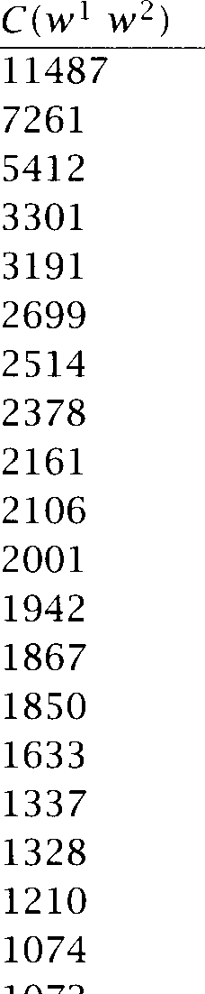

|  |  |  |
| --- | --- | --- |
|  | | Tag Pattern |
| New | York | AN |
| United | States | AN |
| Los | Angeles | N N |
| last | year | AN |
| Saudi | Arabia | N N |
| last | week | AN |
| vice | president | AN |
| Persian | Gulf | AN |
| San | Francisco | N N |
| President | Bush | N N |
|  | East | AN |
|  | Hussein | N N |
| Soviet | Union | AN |
|  | House | AN |
| United | Nations | AN |
| York | City | N N |
| oil | prices | N N |
| next | year | AN |
| chief | executive | AN |
| real | estate | AN |

**Table 5.3** Finding Collocations: Justeson and Katz' part-of-speech filter.

part-of-speech filter which only lets through those patterns that are likely to be  Justeson and Katz  17) suggest the patterns in table 5.2. Each is followed by an example from the text that they use as a test set. In these patterns A refers to an adjective, P to a preposition, and N to a noun.

Table ***5.3*** shows the most highly ranked phrases after applying the fil- ter. The results are surprisingly good. There are only **3 ** that we would not regard as non-compositional phrases: ***last year, last week,*** and ***first time. York City*** is an artefact of the way we have implemented the Justeson and Katz filter. The full implementation would search for the longest sequence that fits one of the part-of-speech patterns and would thus find the longer phrase ***New City,*** which contains ***York City.***

The twenty highest  phrases containing ***strong*** and ***powerful*** all



1. Similar ideas can be found in (Ross and Tukey 1975) and (Kupiec et al. 1995).



***w***

***w***

***w***

***w***

support ***50*** force 13

safety sales

opposition showing

sense message defense gains evidence criticism possibility feelings

demand challenges challenge case

supporter signal

man

computers position

men

computer man symbol

tary machines country weapons post people

nation forces chip

Germany senators neighbor magnet

**Table** 5.4 The nouns ***w*** occurring most often in the patterns ***'strong*** w' and

***'powerfulw.'***

have the form A N (where A is either ***strong*** or ***powerful).*** We have listed them in table 5.4.

Again, given the simplicity of the method, these results are surpris- ingly accurate. For example, they give evidence that ***strong challenge*** and ***powerful computers*** are correct whereas ***powerful challenge*** and ***strong computers*** are not. However, we can also see the limits of a  based method. The nouns ***man*** and ***force*** are used with both adjectives ***(strong force*** occurs further down the list with a frequency of 4). A more sophisticated analysis is necessary in such cases.

Neither ***strong tea*** nor ***powerful tea*** occurs in our ***New York Times*** cor- pus. However, searching the larger corpus of the World Wide Web we find 799 examples of ***strong tea*** and 17 examples of ***powerful tea*** (the latter mostly in the computational linguistics literature on collocations),which

indicates that the correct phrase is ***strong***

Justeson and Katz' method of collocation discovery is instructive in that it demonstrates an important point. A simple quantitative technique (the frequency filter in this case) combined with a small amount of lin- guistic knowledge (theimportance of parts of speech) goes a long way. In the rest of this chapter, we will use a stop list that excludes words whose most frequent tag is not a verb, noun or adjective.

Exercise 5.1 

Add part-of-speech patterns useful for collocation discovery to table 5.2, includ- ing patterns longer than two tags.

Exercise 5.2 

Pick a document in which your name occurs (an  a university transcript or a letter). Does Justeson and Katz's filter identify your name as a collocation?

Exercise 5.3 

We used the World Wide Web as an auxiliary corpus above because neither

***tea*** nor ***powerful tea*** occurred in the ***New York Times.*** Modify Justeson and Katz's method so that it uses the World Wide Web as a resource of last resort.

* 1. Mean and Variance

Frequency-based search works well for fixed phrases. But many colloca- tions consist of two words that stand in a more flexible relationship to one another. Consider the verb ***knock*** and one of its most frequent argu- ments, ***door.*** Here are some examples of knocking on or at a door from our corpus:

(5.1) a. she knocked on his door

1. they knocked at the door
2. 100 women knocked on Donaldson's door
3. a man knocked on the metal front door

The words that appear between ***knocked*** and ***door*** vary and the distance between the two words is not constant so a fixed phrase approach would not work here. But there is enough regularity in the patterns to allow us to determine that ***knock*** is the right verb to use in English for this situation, not ***hit, beat*** or ***rap.***

--

1. This search was performed on on March 28, 1998.

Sentence: ***Stocks crash as rescue plan teeters *** ***stocks crash stocks as stocks rescue***

***crash as crash rescue crash plan***

***as rescue as plan as teeters***

***rescue plan rescue teeters***

***plan teeters***

**Figure 5.1** Using a three word collocational window to capture  at a distance.

A short note is in order here on collocations that occur as a fixed phrase versus those that are more variable. To simplify matters we only look at fixed phrase collocations in most of this chapter, and usually at just  But it is easy to see how to extend techniques applicable to  to  at a distance. We define a collocational window (usu- ally a window of **3** to 4 words on each side of a word), and we enter ***every*** word pair in there as a collocational  as in figure 5.1. We then proceed to do our calculations as usual on this larger pool of 

However, the mean and variance based methods described in this sec- tion by definition look at the pattern of varying distance between two words. If that pattern of distances is relatively predictable, then we have evidence for a collocation like ***knock*** .. . ***door*** that is not necessarily a fixed phrase. We will return to point and a more in-depth discussion of what a collocation is towards the end of this chapter.

One way of discovering the relationship between ***knocked*** and ***door*** is to MEAN compute the ***mean*** and ***variance*** of the offsets (signed distances) between the two words in the corpus. The mean is simply the average offset. For

the examples in we compute the mean offset between ***knocked*** and as follows:

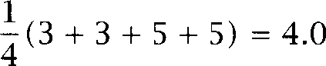

assumes a tokenization of ***Donaldson's*** as three words ***Donaldson,*** apostrophe, and ***s,*** which is what we actually did.) If there was an oc- currence of ***door*** before ***knocked,*** then it would be entered as a negative number. For example, ***- 3*** for ***the door that she knocked on.*** We restrict our analysis to positions in a window of size 9 around the focal word ***knocked.***

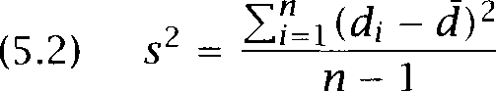The variance measures how much the individual offsets deviate from the mean. We estimate it as follows.

where *n* is the number of times the two words co-occur,  is the offset for co-occurrence *i,* and d is the sample mean of the offsets. If the offset is the same in all cases, then the variance is zero. If the offsets are randomly distributed (which will be the case for two which occur together by chance, but not in a particular relationship), then the variance will be

**SAMPLE DEVIATION ** As is customary, we use the *sample deviation* =  the square root of the variance, to assess how variable the offset between two words is. The deviation for the four examples of *knocked * *door* in the above case is 1.15:



The mean and deviation characterize the distribution of distances be- tween two words in a corpus. We can use this information to discover collocations by looking for pairs with low deviation. A low deviation means that the two words usually occur at about the same distance. Zero deviation means that the two words always occur at exactly the same distance.

We can also explain the information that variance gets at in terms of peaks in the distribution of one word with respect to another. Figure 5.2 shows the three cases we are interested in. The distribution of *strong* with respect to *opposition* has one clear peak at position -1 (corresponding to the phrase *strong opposition).* Therefore the variance of *strong* with respect to *opposition* is small *(s* = *0.67).* The mean of -1.15 indicates that *strong* usually occurs at position -1 (disregarding the noise introduced by one occurrence at *- 4).*

We have restricted positions under consideration to a window of size 9 centered around the word of interest. This is because collocations are essentially a local phenomenon. Note also that we always get a count of at position when we look at the relationship between two different

words. is because, for example, *strong* cannot appear in position in contexts in which that position is already occupied by *opposition.*

Moving on to the second diagram in figure 5.2, the distribution of *strong* with respect to *support* is drawn out, with several negative po- sitions having large counts. For example, the count of approximately *20*

frequency of *strong*

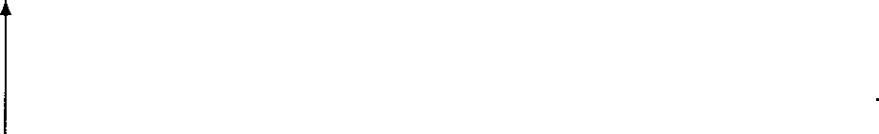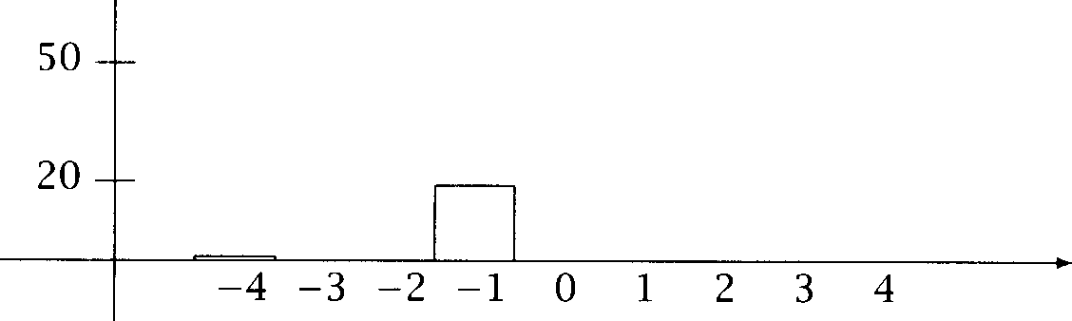

I Position of *strong* with respect to *opposition* = -1.15, *s* = 0.67).

= 1.07).

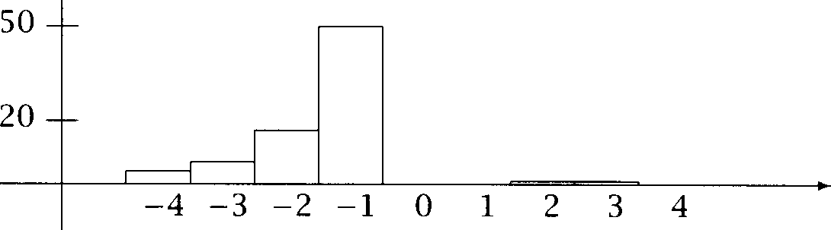

frequency of *strong*

Position of *strong* with respect to *support* =

**A**

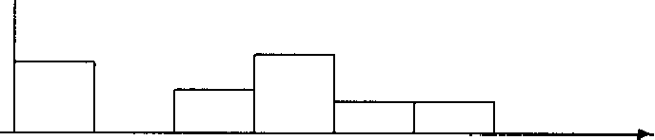

frequency of *strong*

50

20 --

0 1 2 3 4

Position of *strong* with respect to *for* = - 1.12, *s*

= 2.15).

**Figure** 5.2 Histograms of the position of *strong* relative to three words.

***Mean and Variance***

|  |  |  |  |  |
| --- | --- | --- | --- | --- |
| ***d*** | | Count | Word 1 | Word 2 |
| 0.43 | 0.97 | 11657 | New | York |
| 0.48 | 1.83 | 24 | previous | games |
| 0.15 | 2.98 | 46 | minus | points |
| 0.49 | 3.87 | 131 | hundreds | dollars |
| 4.03 | 0.44 | 36 | editorial | Atlanta |
| 4.03 | 0.00 | 78 | ring | New |
| 3.96 | 0.19 | 119 | point | hundredth |
| 3.96 | 0.29 | 106 | subscribers | by |
| 1.07 | 1.45 | 80 | strong | support |
| 1.13 | 2.57 | 7 | powerful | organizations |
| 1.01 | 2.00 | 112 | Richard |  |
| 1.05 | 0.00 | 10 | Garrison | said |

**Table 5.5** Finding collocations based on mean and variance. Sample deviation and sample mean d of the distances between 12 word pairs.

at position -2 is due to uses like ***strong leftist support*** and ***strong busi- ness support.*** Because of this greater variability we get a higher ***s*** (1.07) and a mean that is between positions -1 and -2 (-1.45).

Finally, the occurrences of ***strong*** with respect to ***for*** are more evenly distributed. There is tendency for ***strong*** to occur before ***for*** (hence the negative mean of  but it can pretty much occur anywhere around ***for.*** The  deviation of = 2.15 indicates this variability. This indi- cates that ***for*** and ***strong*** don't form interesting collocations.

The word pairs in table 5.5 indicate the types of collocations that can be found by approach. If the mean is close to 1.0 and the devia- tion low, as is the case for ***New York,*** then we have the type of phrase that Justeson and Katz' frequency-based approach will also discover. If the mean is much greater than 1.0, then a low deviation indicates an in- teresting phrase. The pair ***previous*** / ***games*** (distance 2) corresponds to phrases like ***in the previous 10 games*** or ***in the previous 15 games; minus points*** corresponds to phrases like ***minus*** 2 ***percentage points, minus***

***3 percentage points*** etc; ***hundreds *** ***dollars*** corresponds to ***hundreds of billions of dollars*** and ***hundreds of millions of dollars.***

High deviation indicates that the two words of the pair stand in no interesting relationship as demonstrated by the four high-variance exam- ples in table 5.5. Note that means tend to be close to zero here as one

*Collocations*

would expect for a uniform distribution. More interesting are the cases in between, word pairs that have large counts for several distances in their collocational distribution. We already saw the example of *strong * *business * *support* in figure 5.2. The alternations captured in the other three medium-variance examples are *powerful * *lobbying * *organizations, Richard * *M.* and *Garrison said * *said Garrison* (remember that we tokenize *Richard* as four tokens: *Richard,* .,



The method of variance-based collocation discovery that we have in- troduced in this section is due to Smadja. We have simplified things somewhat. In particular, Smadja *(1993)* uses an additional constraint that filters out 'flat' peaks in the position histogram, that is, peaks that are not surrounded by deep valleys (an example is at - 2 for the combi- nation *strong * *for* in figure 5.2). Smadja *(1993)*shows that the method is quite successful at terminological extraction (with an estimated accu- racy of *80%)*and at determining appropriate phrases for natural language generation (Smadja and *1990).*

Smadja's notion of collocation is less strict than many others'. The combination *knocked * *door* is probably not a collocation we want to classify as terminology - although it may be very useful to identify for the purpose of text generation. Variance-based collocation discovery is the appropriate method if we want to find this type of word combination, combinations of words that are in a looser relationship than fixed phrases and that are variable with respect to intervening material and relative position.

* 1. **Hypothesis Testing**

One difficulty that we have glossed over so far is that high frequency and low variance can be accidental. If the two constituent words of a frequent  like *new companies* are frequently occurring words (as *new* and *companies* are), then we expect the two words to co-occur a lot just by chance, even if they do not form a collocation.

What we really want to know is whether two words occur together more often than chance. Assessing whether or not something is a chance event is one of the classical problems of statistics. It is usually couched in terms

**HYPOTHESIS** of hypothesis testing. We formulate a *null hypothesis * that there is no association between the words beyond chance occurrences, compute the probability *p* that the event would occur if were true, and then reject

**SIGNIFICANCE LEVEL ** if is too low (typically if beneath a *significance level* of *p* 0.05, 0.01, 0.005, or 0.001) and retain as possible 

It is important to note that this is a mode of data analysis where we look at two things at the same time. As before, we are  for partic- ular patterns in the data. But we are also taking into account how much data we have seen. Even if there is a remarkable pattern, we will discount it if we haven't seen enough data to be certain that it couldn't be due to chance.

How can we apply the methodology of hypothesis testing to the prob- lem of finding collocations? We first need to formulate a null hypothesis which states what should be true if two words do not form a colloca- tion. For such a free combination of two words we will assume that each of the words  and  is generated completely independently of the other, and so their chance of coming together is simply given by:

 = 

The model implies that the probability of co-occurrence is just the prod- uct of the probabilities of the individual words. As we discuss at the end of this section, this is a rather simplistic model, and not empirically accurate, but for now we adopt independence as our null hypothesis.

* + 1. The t test

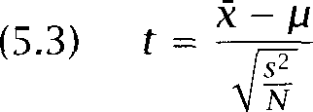Next we need a statistical test that tells us how probable or improbable it is that a certain constellation will occur. A test that has been widely used for collocation discovery is the *t* test. The *t* test looks at the mean and variance of a sample of measurements, where the null hypothesis is that the sample is drawn from a distribution with mean The test looks at the difference between the observed and expected means, scaled by the variance of the data, and tells us how likely one is to get a sample of that mean and variance (or a more extreme mean and variance) assuming that the sample is drawn from a normal distribution with mean To deter- mine the probability of getting our sample (or a more extreme sample), we compute the *t* statistic:

1. Significance at a level of 0.05 is the weakest evidence that is normally accepted in the experimental sciences. The large amounts of data commonly available for Statistical NLP tasks means that we can often expect to greater levels of significance.

where R is the sample mean, *s2* is the sample variance, is the sample size, and is the mean of the distribution. If the t statistic is large enough we can reject the null hypothesis. We can find out exactly how large it has to be by  up the table of the t distribution we have compiled in the appendix (or by using the better tables in a statistical reference book, or by using appropriate computer software).

Here's an example of applying the t test. Our null hypothesis is that the mean height of a population of men is We are given a sample of 200 men with = 169 and *s2* = 2600 and want to know whether this sample is from the general population (the null hypothesis) or whether it is from a different population of smaller men. This gives us the following t according to the above formula:

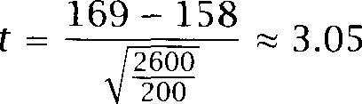

If you look up the value of t that corresponds to a confidence level of

= 0.005, you will find  Since the t we got is larger than 2.576, we can reject the null hypothesis with 99.5%confidence. So we can say that the sample is not drawn from a population with mean and our probability of error is less than 0.5%.

To see how to use the t test for finding collocations, let us compute the t value for *new companies.* What is the sample that we are measuring the mean and variance of? There is a standard way of extending the t test for use with proportions or counts. We think of the text corpus as a long sequence of and the samples are then indicator random variables that take on the value 1 when the  of interest occurs, and are otherwise.



Using maximum likelihood estimates, we can compute the probabilities of *new* and *companies* as follows. In our corpus, *new* occurs 15,828 times, *companies* 4,675 times, and there are 14,307,668 tokens overall.

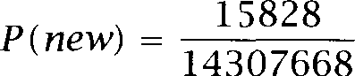

*P (companies)* = 4675

14307668

1. **A** sample of 200 means 199 degress of freedom, which corresponds to about the same

***t*** as degrees of freedom. This is the row of the table where we looked up 2.576.

The null hypothesis is that occurrences of ***new*** and ***companies*** are inde- pendent.

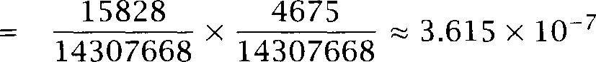: ***P(new companies)*** = ***P (companies)***

If the null hypothesis is true, then the process of randomly generating  of words and assigning 1 to the outcome ***new companies*** and to any other outcome is in effect a Bernoulli trial with ***p*** = 3.615 ***x*** for the probability of ***new company*** turning up. The mean for this

distribution is = 3.615 x and the variance is = - (see



section which is approximately ***p.*** The approximation = p -

 ***p*** holds since for most  ***p*** is small.

It turns out that there are actually 8 occurrences of ***new companies***

among the 14,307,668  in our corpus. So, for the sample, we have that the sample mean is: = - 5.591 x Now we have

-

everything we need to apply the ***t*** test:

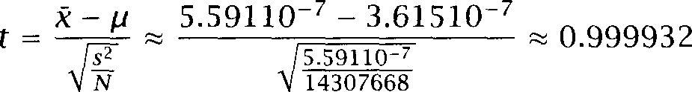

This *t* value of 0.999932 is not larger than 2.576, the critical value for

= 0.005. So we cannot reject the null hypothesis that ***new*** and ***compa- nies*** occur independently and do not form a collocation. That seems the right result here: the phrase ***new companies*** is completely compositional and there is no element of added meaning here that would justify elevat- ing it to the status of collocation. (The ***t*** value is suspiciously close to 1.0, but that is a coincidence. See exercise 5.5.)

Table 5.6 shows ***t*** values for ten that occur exactly 20 times in the corpus. For the top five we can reject the null hypothesis that the component words occur independently for = 0.005, so these are good candidates for collocations. The bottom five  fail the test for significance, so we will not regard them as good candidates for collocations.



Note that a frequency-based method would not be able to rank the ten  since they occur with exactly the same frequency. Looking at the counts in table 5.6, we can see that the ***t*** test takes into account the num- ber of co-occurrences of the  relative to the frequencies of the component words. If a high proportion of the occurrences of both words ***(Ayatollah Ruhollah, videocassette recorder)*** or at least a very high





|  |  |
| --- | --- |
| w | w |
| Ayatollah | Ruhollah |
| Bette  Agatha | Midler  Christie |
| videocassette | recorder |
| unsalted | butter |
| first  over | made  many |
| into | them |
| like | people |
| time | last |

**Table 5.6** Finding collocations: The test applied to 10  that occur with frequency 20.

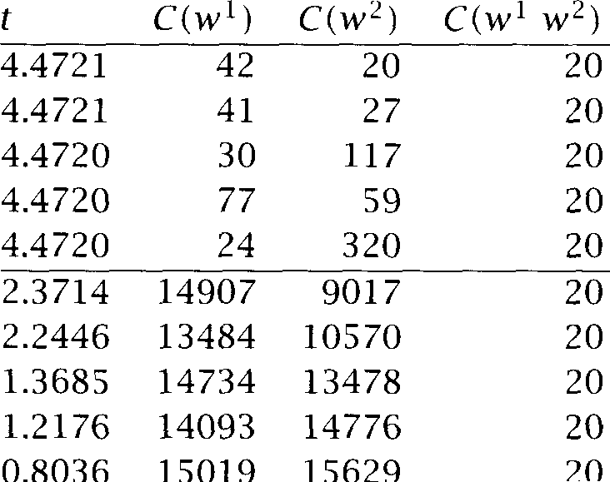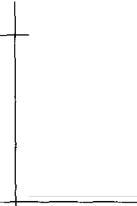

proportion of the occurrences of one of the words ***(unsalted)***occurs in the  then its ***t*** value is high. This criterion makes intuitive sense.

Unlike most of this chapter, the analysis in table 5.6 includes some stop words - without stop words, it is actually hard to find examples that fail significance. It turns out that most  attested in a corpus occur significantly more often than chance. For 824 out of the 831  that occurred 20 times in our corpus the null hypothesis of independence can be rejected. But we would only classify a fraction as true collocations. The reason for this surprisingly high proportion of possibly dependent   0.99) is that language - if compared with a random word generator - is very regular so that few completely unpredictable events happen. Indeed, this is the basis of our ability to perform tasks like word sense disambiguation and probabilistic parsing that we discuss in other chapters. The t test and other statistical tests are most useful as a method for ***ranking*** collocations. The level of significance itself is less useful. In fact, in most publications that we cite in this chapter, the level of significance is never looked at. All that is used is the scores and the resulting ranking.

* + 1. Hypothesis testing of differences

The ***t*** test can also be used for a slightly different collocation discovery problem: to find words whose co-occurrence patterns best distinguish

***5.3 Hypcthesis Testing 167***

***t*** Word



3.1622 933 0 10 computers computer symbol machines Germany nation chip

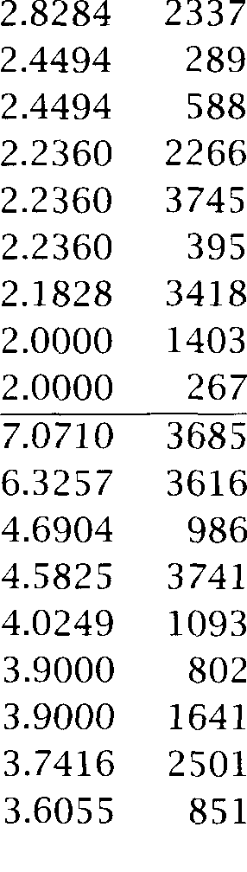

force

friends neighbor support enough safety

sales

opposition showing

sense

defense gains criticism

**Table 5.7** Words that occur significantly more often with ***powerful*** (thefirst ten words) and ***strong*** (thelast ten words).

between two words. For example, in computational lexicography we may want to find the words that best differentiate the meanings of ***strong*** and ***powerful.*** This use of the t test was suggested by Church and Hanks (1989). Table 5.7 shows the ten words that occur most significantly more often with ***powerful*** than with ***strong*** (first ten words) and most signif- icantly more often with ***strong*** than with ***powerful*** (second set of ten words).

The t scores are computed using the following extension of the ***t*** test to the comparison of the means of two normal populations:

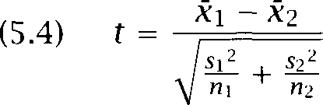

Here the null hypothesis is that the average difference is 0  =  so we

have =   -  = In the denominator we add the variances of the two populations since the variance of the difference of two random variables is the sum of their individual variances.



Now we can explain table 5.7. The t values in the table were computed assuming a Bernoulli distribution (as we did for the basic version of the t test that we introduced first). If w is the collocate of interest  computers or symbol) and and v2 are the words we are comparing powerful and strong), then we have =  =  w), =  =



We again use the approximation s 2 = p - p2 p:

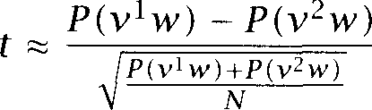

We can simplify this as follows.

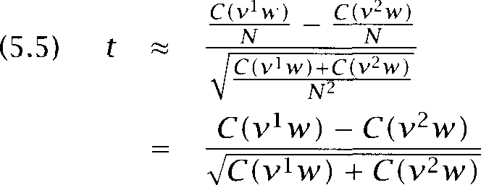

where  is the number of times x occurs in the corpus.

The application suggested by Church and Hanks (1989) for this form of the t test was lexicography. The data in table 5.7 are useful to a lex- icographer who wants to write precise dictionary entries that bring out the difference between strong and powerful. Based on significant collo- cates, Church and Hanks analyze the difference as a matter of intrinsic vs. extrinsic quality. For example, strong support from a demographic group means that the group is very committed to the cause in question, but the group may not have any power. So strong describes an intrinsic quality. Conversely, a powerful supporter is somebody who actually has the power to move things. Many of the collocates we found in our cor- pus support Church and Hanks' analysis. But there is more complexity to the difference in meaning between the two words since what is extrinsic and intrinsic can depend on subtle matters like cultural attitudes. For ex- ample, we talk about strong tea on the one hand and powerful drugs on the other, a difference that tells us more about our attitude towards tea and drugs than about the semantics of the two adjectives (Church et al. 1991: 133).

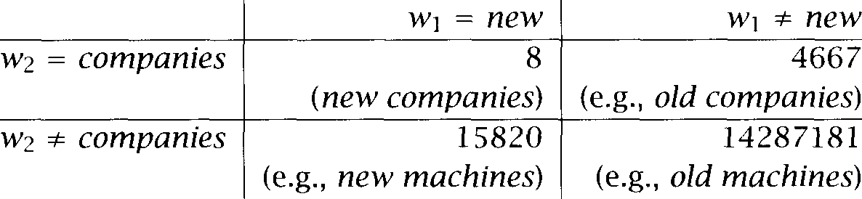

**Table** 5.8 A 2-by-2 table showing the dependence of occurrences of *new* and *companies.* There are 8 occurrences of *new companies* in the corpus, 4,667 grams where the second word is *companies,* but the first word is not *new,* 15,820  with the first word *new* and a second word different from *companies,* and 14,287,181  that contain neither word in the appropriate position.

* + 1. Pearson's chi-square test

Use of the test has been criticized because it assumes that probabili- ties are approximately normally distributed, which is not true in general (Church and Mercer 1993: 20). An alternative test for dependence which does not assume normally distributed probabilities is the  test (pro- nounced 'chi-square test'). In the simplest case, the  test is.applied to 2-by-2 tables like table 5.8. The essence of the test is to compare the observed frequencies in the table with the frequencies expected for inde- pendence. If the difference between observed and expected frequencies is large, then we can reject the null hypothesis of independence.

Table 5.8 shows the distribution of *new* and *companies* in the refer- ence corpus that we introduced earlier. Recall that  = 15,828,  = 4,675, *new companies)* = 8, and that there are 14,307,668 tokens in the corpus. That means that the number of

grams with the first token not being *new* and the second token being *companies* is 4667 = 4675 - 8. The two cells in the bottom row are computed in a similar way.

The  statistic sums the differences between observed and expected values in all squares of the table, scaled by the magnitude of the expected values, as follows:

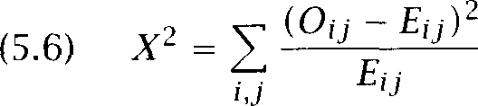

where i ranges over rows of the table, j ranges over columns,  is the observed value for cell and is the expected value.

One can show that the quantity asymptotically distributed. In



other words, if the numbers are large, then  has a  distribution. We will return to the issue of how good this approximation is later.

The expected frequencies  are computed from the marginal proba- bilities, that is, from the totals of the rows and columns converted into proportions. For example, the expected frequency for cell  (new companies) would be the marginal probability of new occurring as the first part of a  times the marginal probability of companies occur- ring as the second part of a  (multiplied by the number of  in the corpus):

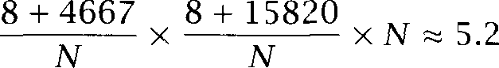

That is, if new and companies occurred completely independently of each other we would expect 5.2 occurrences of new companies on average for a text of the size of our corpus.

The  test can be applied to tables of any size, but it has a simpler form for 2-by-2 tables: (see exercise 5.9)



This formula gives the following  value for table 5.8:



 up the  distribution in the appendix, we find that at a proba- bility level of = 0.05 the critical value is  3.841 (the statistic has one degree of freedom for a 2-by-2 table). So we cannot reject the null hypothesis that new and companies occur independently of each other. Thus new companies is not a good candidate for a collocation.

This result is the same as we got with the t statistic. In general, for the problem of finding collocations, the differences between the t statistic and the  statistic do not seem to be large. For example, the 20  with the highest t scores in our corpus are also the 20  with the highest  scores.

However, the  test is also appropriate for large probabilities, for which the normality assumption of the t test fails. This is perhaps the reason that the  test has been applied to a wider range of problems in collocation discovery.

One of the early uses of the test in Statistical NLP was the



***COW COW***

***vache*** 59 6

***vache 8*** 570934

**Table** 5.9 Correspondence of *vache* and *cow* in an aligned corpus. By applying the  test to this table one can determine whether *vache* and *cow* are transla- tions of each other.

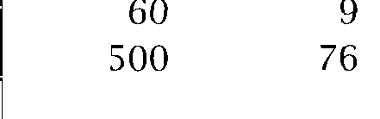

corpus 1 corpus 2

***word 1 word word 3***

124

20

**Table** 5.10 Testing for the independence of words in different corpora using  This test can be used as a metric for corpus similarity.

cation of translation pairs in aligned corpora (Church and Gale  The data in table 5.9 (from a hypothetical aligned corpus) strongly sug- gest that ***vache*** is the French translation of English ***cow.*** Here, 59 is the number of aligned sentence pairs which have ***cow*** in the English sentence and ***vache*** in the French sentence etc. The  value is very high here:  = 456400. So we can reject the null hypothesis that ***cow*** and ***vache*** occur independently of each other with high confidence. This pair is a good candidate for a translation pair.

An interesting application of  as a metric for corpus similarity (Kilgarriff and Rose 1998). Here we compile an n-by-two table for a large for example n = 500. The two columns correspond to the two corpora.

Each row corresponds to a particular word. This is schematically shown in table 5.10. If the ratio of the counts are about the same (as is the case in table 5.10, each word occurs roughly 6 times more often in corpus 1 than in corpus 2), then we cannot reject the null hypothesis that both corpora are drawn from the same underlying source. We can interpret this as a  degree of similarity. On the other hand, if the ratios vary wildly, then the  score will be high and we have evidence for a high degree of dissimilarity.



1. They actually use a measure they call  which is  multiplied by N. They do this since they are only interested in  translation pairs, so that assessment of signifi- cance is not important.

 

 N

 )



P I )



out of

are

**Table 5.11** How to compute Dunning's likelihood ratio test. For example, the likelihood of hypothesis is the product of the last two lines in the rightmost column.

Just as application of the t test is problematic because of the under- lying normality assumption, so is application of  in cases where the numbers in the 2-by-2 table are small. Snedecor and Cochran (1989: 127) advise against using  if the total sample size is smaller than 20 or if it is between 20 and 40 and the expected value in any of the cells is 5 or less.

LIKELIHOOD **RATIO**

**Likelihood ratios**

Likelihood ratios are another approach to hypothesis testing. We will see below that they are more appropriate for sparse data than the  test. But they also have the advantage that the statistic we are computing, a **likelihood** ratio, is more interpretable than the statistic. It simply a number that tells us how much more likely one hypothesis is than the other.

In applying the likelihood ratio test to collocation discovery, we ex- amine the following two alternative explanations for the occurrence fre- quency of a  w2 (Dunning 1993):

**Hypothesis 1. ** = p = 

**Hypothesis 2. ** = = 

Hypothesis 1 is a formalization of independence (the occurrence of w2 is independent of the previous occurrence of  Hypothesis 2 is a formal- ization of dependence which is good evidence for an interesting colloca- tion."



1. **We assume that if Hypothesis** 2 **is true. The case is rare and we will ignore it here.**

We use the usual maximum likelihood estimates for p, and and write and for the number of occurrences of w2 and w w2 in the corpus:

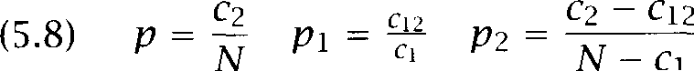

Assuming a binomial distribution:

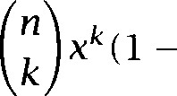

the likelihood of getting the counts for  w2 and w2 that we actually observed is then  =   - N -  for Hypothe- sis 1 and  =    for Hypothesis 2. Ta- ble 5.11 summarizes discussion. One obtains the likelihoods  and  just given by multiplying the last two lines, the likelihoods of the specified number of occurrences of w1w2 and  respectively.

The log of the likelihood ratio A is then as follows:

(5.10)  log-



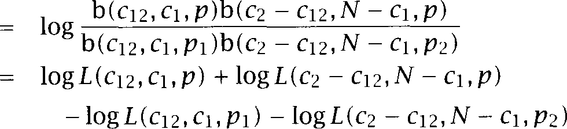)

where =  



Table 5.12 shows the twenty  of powerful which are highest ranked according to the likelihood ratio when the test is applied to the New York Times corpus (for which N = 14,307,668). We will explain below why we show the quantity - 2  instead of A. We consider all occurring  here, including rare ones that occur less than six times, since this test works well for rare  For example, powerful cudgels, which occurs 2 times, is identified as a possible collocation.

One advantage of likelihood ratios is that they have a clear intuitive in- terpretation. For example, the powerful computers is =

1.3 x times more likely under the hypothesis that computers is more likely to follow powerful than its base rate of occurrence would suggest.

This number is easier to interpret than the scores of the t test or the test we have to look up in a table.

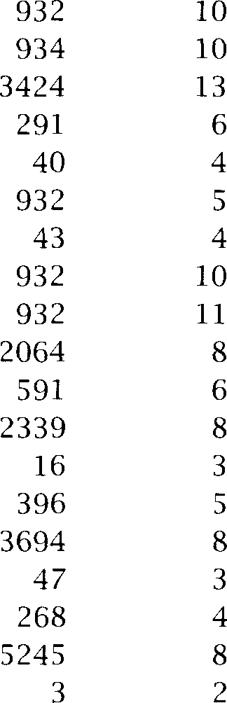most politically powerful powerful powerful powerful economically powerful

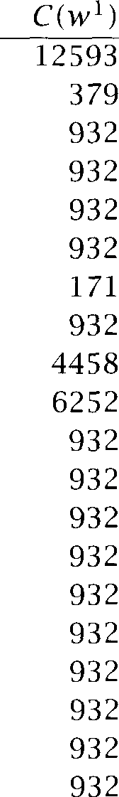

1291.42

99.31

82.96

80.39

57.27 51.66 51.52 51.05 50.83 50.75 49.36 48.78 47.42 43.23 43.10 40.45 36.36 36.15

35.24

34.15

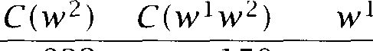

less very

powerful powerful powerful powerful powerful powerful powerful powerful powerful powerful

w powerful powerful

computers force symbol lobbies powerful magnet powerful powerful position machines computer magnets chip

men

486

neighbor political cudgels

**Table 5.12**

likelihood ratio test.

of ***powerful*** with the highest scores according to Dunning's

But the likelihood ratio test also has the advantage that it can be more appropriate for sparse data than the  test. HOW do we use the likeli- hood ratio for hypothesis testing? If is a likelihood ratio of a particular form, then the quantity -2 log is asymptotically  distributed (Mood et al. 1974: 440). So we can use the values in table 5.12 to test the null hypothesis  against the alternative hypothesis  For example, we can look up the value of 34.15 for ***powerful cudgels*** in the table and reject

for this  on a confidence level of = 0.005. (The critical value (for one degree of freedom) is 7.88. See the table of the  distribution in the appendix.)

The particular form of the likelihood ratio that is required here is that of a ratio between the maximum likelihood estimate over a subpart of the parameter space and the maximum likelihood estimate over the

tire parameter space. For the likelihood ratio in  the entire



is the space of pairs for the probability of w2 occurring when w preceded  and w 2 occurring when a different word preceded  We get the maximum likelihood for the data we observed if we assume the maximum likelihood estimates that we computed in (5.8). The  is the subset of cases for which = Again, the estimate in (5.8) gives us the maximum likelihood over the  given the data we ob- served. It can be shown that if A is a ratio of two likelihoods of this type (one being the maximum likelihood over the subspace, the other over the entire space), then - 2log A is asymptotically  distributed. 'Asymptot- ically' roughly means 'if the numbers are large enough'. Whether or not the numbers are large enough in a particular case is hard to determine, but Dunning has shown that for small counts the approximation to



is better for the likelihood ratio in (5.11) than, for example, for the

statistic in (5.6). Therefore, the likelihood ratio test is in general more appropriate than Pearson's  test for collocation 

**Relative frequency ratios.** So far we have looked at evidence for

RELATIVE cations within one corpus. Ratios of relative frequencies between two or more different corpora can be used to discover collocations that are char- acteristic of a corpus when compared to other corpora  1993). Although ratios of relative frequencies do not fit well into the hypothe- sis testing paradigm, we treat them here since they can be interpreted as likelihood ratios.

Table 5.13 shows ten  that occur exactly twice in our reference corpus (the 1990 New York Times corpus). The  are ranked ac- cording to the ratio of their relative frequencies in our 1990 reference corpus versus their frequencies in a 1989 corpus (again drawn from the months August through November). For example, Obeid occurs 68 times in the 1989 corpus. So the relative frequency ratio is:

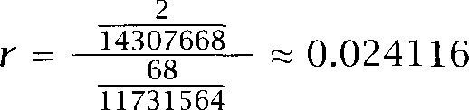

The  in table 5.13 are mostly associated with news items that were more prevalent in 1989 than in 1990: The Muslim cleric Sheik Abdul



1. However, even - 2 log is not approximated well by  if the expected values in the

2-by-2 contingency table are less than 1.0 (Read and Cressie 1988; Pedersen 1996).



|  |  |  |  |
| --- | --- | --- | --- |
| Ratio |  |  | *w* |
| 0.0241 |  | Karim | Obeid |
| 0.0372 |  | East | Berliners |
| 0.0372 |  | Miss | Manners |
| 0.0399 |  | 17 | earthquake |
| 0.0409 |  | HUD |  |
| 0.0482 |  | EAST | GERMANS |
| 0.0496 |  | Muslim | cleric |
| 0.0496 |  |  | Le |
| 0.0512 |  | Prague | Spring |
| 0.0529 |  | Among | individual |

**Table 5.13** Damerau's frequency ratio test. Ten  that occurred twice in the 1990 *New* York *Times* corpus, ranked according to the (inverted) ratio of relative frequencies in 1989 and 1990.

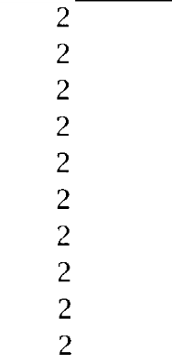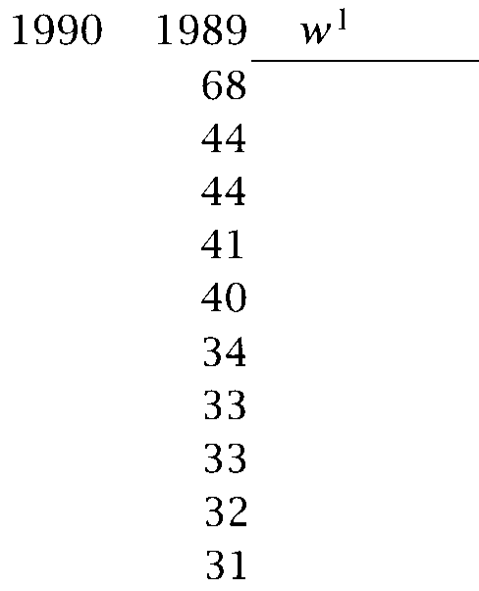

Karim Obeid (who was abducted in  the disintegration of commu- nist Eastern Europe *(East Berliners, EAST GERMANS, Prague Spring),* the novel *The Russia House* by *John Le * a scandal in the Department of Housing and Urban Development (HUD), and the October 17 earthquake in the San Francisco Bay Area. But we also find artefacts like *Miss Manners* (whose column the *New York Times* stopped carrying in 1990) and *Among individual.* The reporter Phillip H.  liked to use the latter phrase for his stock market reports *(Among individual Big Board issues..* .), but he stopped writing for the *Times* in 1990.

The examples show that frequency ratios are mainly useful to find *subject-specific* collocations. The application proposed by Damerau is to compare a general text with a subject-specific text. Those words and phrases that on a relative basis occur most often in the subject-specific text are likely to be part of the vocabulary that is specific to the domain.

**Exercise 5.4**



Identify the most significantly non-independent  according to the *t* test in *a* corpus of your choice.

**Exercise 5.5 **

It is a coincidence that the t value for *new companies* is close to 1.0. Show this by computing the *t* value of *new companies* for *a* corpus with the following counts.

= 30,000,  = 9,000, *companies)* = *20,* and corpus size *N* = 15,000,000.

* 1. Hypothesis Testing

**Exercise 5.6** *

We can improve on the method in section 5.2 by taking into account variance. In fact, Smadja does this and the algorithm described in (Smadja 1993) therefore bears some similarity to the *t* test.

Compute the t statistic in equation **(5.3)** for possible collocations by substituting mean and variance as computed in section 5.2 for and and (a) assuming

= 0, and  assuming = round(%)t,hat is, the closest integer. Note that we are not testing for here, but for collocations of word pairs that occur at any fixed small distance.



**Exercise 5.7**



As we pointed out above, almost all  occur significantly more often than chance if a stop list is used for prefiltering. Verify that there is a large proportion of  that occur less often than chance if we do not filter out function words.

**Exercise 5.8**



Apply the t test of differences to a corpus of your choice. Work with the follow- ing word pairs or with word pairs that are appropriate for your corpus: man / woman, blue  green, lawyer  doctor.

**Exercise 5.9 **

Derive equation (5.7) from equation (5.6).

**Exercise 5.10**

Find terms that distinguish best between the first and second part of a corpus of your choice.

**Exercise 5.11**

Repeat the above exercise with random selection. Now you should find that fewer terms are significant. But some still are. Why? Shouldn't there be no differences between corpora drawn from the same source? Do this exercise for different significance levels.

**Exercise 5.12**



Compute a measure of corpus similarity between two corpora of your choice.

**Exercise 5.13**

Kilgarriff and Rose's corpus similarity measure can also be used for assessing corpus homogeneity. This is done by constructing a series of random divisions of the corpus into a pair of subcorpora. The test is then applied to each pair. If most of the tests indicated similarity, then it is a homogeneous corpus. Apply this test to a corpus of your choice.

|  |  |  |  |  |  |
| --- | --- | --- | --- | --- | --- |
|  | | | |  | *w* |
| 18.38 | 42 | 20 | 20 | Ayatollah | Ruhollah |
| 17.98 | 41 | 27 | 20 | Bette | Midler |
|  |
| 16.31 | 30 | 117 | 20 | Agatha | Christie |
| 15.94 | 77 | 59 | 20 | videocassette | recorder |
| 15.19 | 24 | 320 | 20 | unsalted | butter |
| 1.09 | 14907 | 9017 | 20 | first | made |
| 1.01 | 13484 | 10570 | 20 | over | many |
| 0.53 | 14734 | 13478 | 20 | into | them |
| 0.46 | 14093 | 14776 | 20 | like | people |
| 0.29 | 15019 | 15629 | 20 | time | last |

**Table 5.14** Finding collocations: Ten  that occur with frequency 20,

ranked according to mutual information.







**INFORMATION**

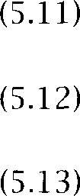

###### Mutual Information

An information-theoretically motivated measure for discovering inter- esting collocations is *pointwise mutual information* (Church et al. 1991; Church and Hanks 1989; Hindle 1990). (1961: 27-28) originally de- fined mutual information between particular events x' and y', in our case the occurrence of particular words, as follows:

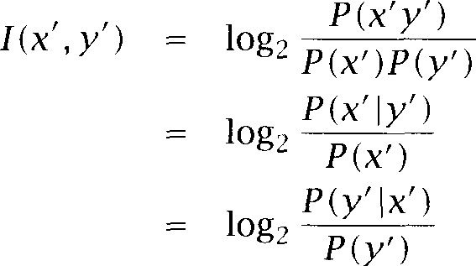

This type of mutual information, which we introduced in section 2.2.3, is roughly a measure of how much one word tells us about the other, a notion that we will make more precise shortly.

In information theory, mutual information is more often defined as holding between *random variables,* not *values o f random variables* as we have defined it here (see the standard definition in section 2.2.3). We will see below that these two types of mutual information are quite different creatures.

When we apply this definition to the 10 collocations from table 5.6, we

* 1. *Mutual Information*

|  |  |  |  |  |
| --- | --- | --- | --- | --- |
|  | chambre | chambre | MI |  |
| house | 31,950 | 12,004 |  |
| house | 4793  communes | 848,330  communes | 4.1 | 553610 |
| house | 4974 | 38,980 |  |  |
| house | 441 | 852,682 | 4.2 | 88405 |

**Table 5.15** Correspondence of *chambre* and *house* and *communes* and *house*

in the aligned Hansard corpus. Mutual information gives a higher score to

while the  test gives a higher score to the correct translation

pair

get the same ranking as with the test (see table 5.14). As usual, we use maximum likelihood estimates to compute the probabilities, for example:

20

Ruhollah) =  14307668 18.38



14307668

So what exactly is (pointwise)mutual information, a measure of? writes about definition (5.12):



The amount of information provided by the occurrence of the event represented by  about the occurrence of the event represented by  is defined as 

For example, the mutual information measure tells us that the amount of information we have about the occurrence of Ayatollah at position i in the corpus increases by 18.38 bits if we are told that Ruhollah occurs at

position i + 1. Or, since (5.12) and 3) are equivalent, it also tells us

that the amount of information we have about the occurrence of Ruhollah at position i + 1 in the corpus increases by 18.38 bits if we are told that

Ayatollah occurs at position i. We could also say that our uncertainty is reduced by 18.38 bits. In other words, we can be much more certain that Ruhollah will occur next if we are told that Ayatollah is the current word.

Unfortunately, this measure of 'increased information' is in many cases not a good measure of what an interesting correspondence between two events is, as has been pointed out by many authors. (We base our dis- cussion here mainly on (Church and Gale  and (Maxwell Consider the two examples in table 5.15 of counts of word correspon- dences between French and English sentences in the Hansard corpus, an

aligned corpus of debates of the Canadian parliament (the table is simi- lar to table 5.9). The reason that *house* frequently appears in translations of French sentences containing *chambre* and *communes* is that the most common use of *house* in the Hansard is the phrase *House o f Commons* which corresponds to *Chambre de communes* in French. But it is easy to see that *communes* is a worse match for *house* than *chambre* since most occurrences of *house* occur without *communes* on the French side. As shown in the table, the  test able to infer the correct correspon- dence whereas mutual information gives preference to the incorrect pair *(communes,house).*

We can explain the difference between the two measures easily if we look at definition (5.12) of mutual information and compare the quanti- ties I*(chambre,house)* and *I (communes,house)*:

*chambre)* 31950



*P house)*



, 0.87

*house)*



 0.92 4974 *P communes)*



*P house)*

log *P house) P house)*

The word *communes* in the French makes it more likely that *house* oc-

curred in the English than *chambre* does. The higher mutual information value for *communes* reflects the fact that *communes* causes a larger de- crease in uncertainty here. But as the example shows decrease in uncer- tainty does not correspond well to what we want to measure. In contrast, the  a direct test of probabilistic dependence, in this context we can interpret as the degree of association between two words and hence as a measure of their quality as translation pairs and collocations. Table 5.16 shows a second problem with using mutual information for finding collocations. We show ten  that occur exactly once in the first documents of the reference corpus and their mutual infor- mation score based on the documents. The right half of the table shows the mutual information score based on the entire reference corpus

(about 23,000 documents).

The larger corpus of 23,000 documents makes some better estimates possible, which in turn leads to a slightly better ranking. The  *marijuana growing* and *new converts* (arguably collocations) have moved up and *Reds* (definitely not a collocation) has moved down. How- ever, what is  is that even after going to a 10 times larger corpus 6 of the  still only occur once and, as a consequence, have in- accurate maximum likelihood estimates and artificially inflated mutual

* 1. *Information 181*

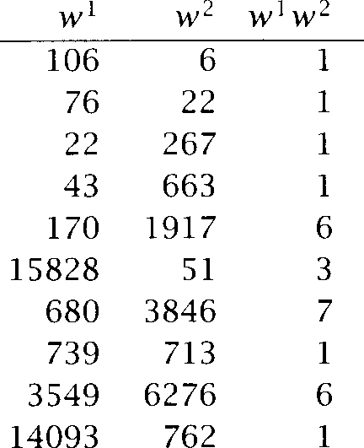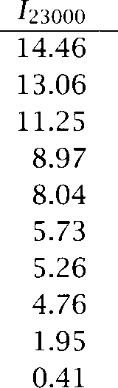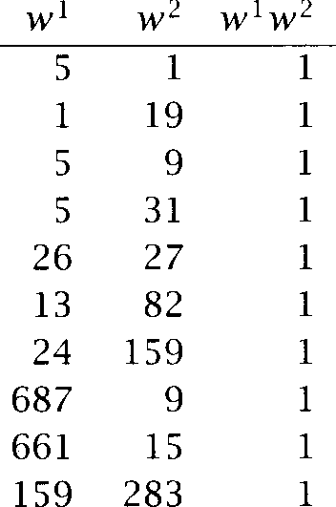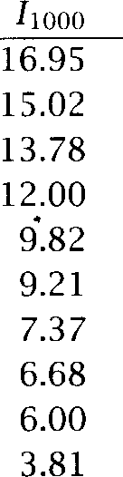

Schwartz eschews fewest visits

FIND GARDEN

Indonesian pieces Reds survived marijuana growing doubt whether new converts

like offensive must think

Schwartz eschews

FIND GARDEN

fewest visits Indonesian pieces marijuana growing new converts doubt whether Reds survived must think

like offensive

**Table 5.16** Problems for Mutual Information from data sparseness. The table shows ten  that occurred once in the first documents in the ref- erence corpus ranked according to mutual information score in the first documents (left half of the table) and ranked according to mutual information score in the entire corpus (right half of the table). These examples illustrate that a large proportion of  are not well characterized by corpus data (evenfor large corpora) and that mutual information is particularly sensitive to estimates that are inaccurate due to sparseness.

information scores. All 6 are not collocations and we would prefer a measure which ranks them accordingly.

None of the measures we have seen works very well for low-frequency events. But there is evidence that sparseness is a particularly difficult problem for mutual information. To see why, notice that mutual infor- mation is a log likelihood ratio of the probability of the



and the product of the probabilities of the individual words P P

Consider two extreme cases: perfect dependence of the occurrences of the two words (they only occur together) and perfect independence (the occurrence of one does not give u s any information about the occurrence of the other). For perfect dependence we have:

1



= = log --

-

That is, among perfectly dependent  as they get rarer, their mu- tual information *increases.*

For perfect independence we have:



|  |  |  |  |  |
| --- | --- | --- | --- | --- |
| Symbol | Definition | Current use |  | |
| ***(X ;***Y) | ***E*** log | pointwise mutual information mutual information | mutual information average | of MI |

**Table 5.17** Different definitions of *mutual information* in (Cover and Thomas



1991) and 1961).

We can say that mutual information is a good measure of independence. Values close to indicate independence (independent of frequency). But it is a bad measure of dependence because for dependence the score depends on the frequency of the individual words. Other things being equal,  composed of low-frequency words will receive a higher score than  composed of high-frequency words. That is the oppo- site of what we would want a good measure to do since higher frequency means more evidence and we would prefer a higher rank for  for whose interestingness we have more evidence. One solution that has been proposed for this is to use a cutoff and to only look at words with a fre- quency of at least **3.** However, such a move does not solve the underlying problem, but only ameliorates its effects.

Since pointwise mutual information does not capture the intuitive no- tion of an interesting collocation very well, it is often not used when it is made available in practical applications (Fontenelle et al. 1994: 81) or it is redefined as  ***w 2 )*** to compensate for the bias of the origi- nal definition in favor of low-frequency events (Fontenelle et al. 1994: 72, Hodges et al. 1996).

As we mentioned earlier, the definition of mutual information used here is common in corpus linguistic studies, but is less common in Infor- mation Theory. Mutual information in Information Theory refers to the

**EXPECTATION** expectation of the quantity that we have used in this section:

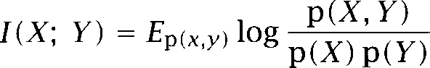

The definition we have used in chapter is an older one, termed  wise mutual information (see section 2.2.3, 1961: 28, and  1968). Table 5.17 summarizes the older and newer naming conventions. One quantity is the expectation of the other, so the two types of mutual information are quite different.

The example of mutual information demonstrates what should be

* 1. *The Notion o f Collocation 183*

evident: it is important to check what a mathematical concept is a for- malization of. The notion of pointwise mutual information that we have used here (log  measures the reduction of uncertainty about

the occurrence of one word when we are told about the occurrence of the

other. As we have seen, such a measure is of limited utility for acquiring the types of linguistic properties we have looked at in this section.

**Exercise 5.14**

Justeson and Katz's part-of-speech filter in section 5.1 can be applied to any of the other methods of collocation discovery in this chapter. Pick one and modify it to incorporate a part-of-speech filter. What advantages does the modified method have?

**Exercise 5.1 5 **

Design and implement a collocation discovery tool for a translator's workbench. Pick either one method or a combination of methods that the translator can choose from.

**Exercise 5.16** *

Design and implement a collocation discovery tool for a lexicographer's work- bench. Pick either one method or a combination of methods that the lexicogra- pher can choose from.

**Exercise 5.17 **

Many news services tag references to companies in their news stories. For ex- ample, all references to the *General Electric Company* would be tagged with the same tag regardless of which variant of the name is used  *GE, General Elec- tric,* or *General Electric Company).* Design and implement a collocation discovery tool for finding company names. How could one partially automate the process of identifying variants?

**5.5 The Notion of Collocation**

The notion of collocation may be confusing to readers without a back- ground in linguistics. We will devote this section to discussing in more detail what a collocation is.

There are actually different definitions of the notion of collocation. Some authors in the computational and statistical literature define a col- location as two or more *consecutive* words with a special behavior, for example Choueka (1988):

[A collocation is defined as] a sequence of two or more consecutive words, that has characteristics of a syntactic and semantic unit,

and whose exact and unambiguous meaning or connotation cannot be derived directly from the meaning or connotation of its compo- nents.

Most of the examples we have presented in this chapter also assumed adjacency of words. But in most linguistically oriented research, a phrase can be a collocation even if it is not consecutive (as in the example ***knock***

... ***door).*** The following criteria are typical of linguistic treatments of

collocations (see for example Benson (1989)and Brundage et al.  non-compositionality being the main one we have relied on here.

**Non-compositionality.** The meaning of a collocation is not a straight- forward composition of the meanings of its parts. Either the meaning is completely different from the free combination (as in the case of id- ioms like ***kick the bucket)*** or there is a connotation or added element of meaning that cannot be predicted from the parts. For example, ***white wine, white hair*** and ***white woman*** all refer to slightly different colors, so we can regard them as collocations.

**Non-substitutability.** We cannot substitute other words for for the components of a collocation even if, in context, they have the same meaning. For example, we can't say ***yellow wine*** instead of ***white wine*** even though ***yellow*** is as good a description of the color of white wine as ***white*** is (it is kind of a yellowish white).

**Non-modifiability.** Many collocations cannot be freely modified with additional lexical material or through grammatical transformations. This is especially true for frozen expressions like idioms. For example, we can't modify ***frog*** in ***to get a frog in one's throat*** into ***to get an ugly frog in one's throat*** although usually nouns like ***frog*** can be modified by adjectives like ***ugly.*** Similarly, going from singular to plural can make an idiom ill-formed, for example in ***people as poor as church mice.***

**A** nice way to test whether a combination is a collocation is to translate it into another language. If we cannot translate the combination word by word, then that is evidence that we are dealing with a collocation. For example, translating ***make a decision*** into French one word at a time we get  ***une decision*** which is incorrect. In French we have to say ***prendre une decision.*** So that is evidence that ***make a decision*** is a collocation in English.

* 1. ***The Notion of Collocation***

strength



-

to build up to find

-

-

to save

-

to sap somebody's brute

-

tensile -

the - to [do

staff was] at full -

on the of [your recommendation]



power

-

to assume emergency

-

-

-discretionary

over [several provinces]

supernatural - to turn off the - the - to [do

the balance of -

fire -

**Table** 5.18 Collocations in the BBI Combinatory Dictionary of English for the words ***strength*** and ***power.***

Some authors have generalized the notion of collocation even further and included cases of words that are strongly associated with each other, but do not necessarily occur in a common grammatical unit and with a particular order, cases like ***doctor*** - ***nurse*** or ***plane*** - ***airport.*** It is prob- ably best to restrict collocations to the narrower sense of grammatically

**ASSOCIATION** bound elements that occur in a particular order and use the terms

**CO-OCCURRENCE *ation*** and ***co-occurrence*** for the more general phenomenon of words that are likely to be used in the same context.

It is instructive to look at the types of collocations that a purely lin- guistic analysis of text will discover if plenty of time and person power is available so that the limitations of statistical analysis and computer technology need be of no concern. An example of such a purely linguistic analysis is the BBI Combinatory Dictionary of English (Bensonet al. 1993). In table 5.18, we show some of the collocations (or combinations as the dictionary prefers to call them) of ***strength*** and ***power*** that the diction- ary  We can see immediately that a wider variety of grammatical patterns is considered here (in particular patterns involving prepositions and particles). Naturally, the quality of the collocations is also higher than computer-generated lists - as we would expect from a manually produced compilation.

We conclude our discussion of the concept of collocation by going

through some subclasses of collocations that deserve special mention.



1. We cannot show collocations of ***strong*** and ***powerful*** because these adjectives are not listed as entries in the dictionary.

*186 Collocations*

**LIGHT VERBS** Verbs with little semantic content like *make, take* and *do* are called *light verbs* in collocations like *make a decision* or *do a favor.* There is hardly anything about the meaning of *make, take* or *do* that would explain why we have to say *make a decision* instead of *take a decision* and *do a fa- vor* instead of *make a favor,* but for many computational purposes the correct light verb for combination with a particular noun must be deter- mined and thus acquired from corpora if this information is not available in machine-readable dictionaries. Dras and Johnson *(1996)*examine one approach to this problem.

**VERB PARTICLE** *Verb particle constructions* or *phrasal verbs* are an especially important part of the lexicon of English. Many verbs in English like *to tell off* and

**PHRASAL VERBS** *to go down* consist of a combination of a main verb and a particle. These verbs often correspond to a single lexeme in other languages *(repriman- der, descendre* in French). This type of construction is a good example of a collocation with often non-adjacent words.

**PROPER NAMES** *Proper nouns* (also called *proper names)* are usually included in the category of collocations in computational work although they are quite different from lexical collocations. They are most amenable to ap- proaches that look for fixed phrases that reappear in exactly the same form throughout a text.

**TERMINOLOGICAL** *Terminological expressions* or phrases refer to concepts and objects in technical domains. Although they are often fairly compositional  *hy- draulic oil filter),* it is still important to identify them to make sure that they are treated consistently throughout a technical text. For example, when translating a manual, we have to make sure that all instances of *hydraulic oil filter* are translated by the same term. If two different trans- lations are used (even if they have the same meaning in some sense), the reader of the translated manual could get confused and think that two different entities are being described.

As a final example of the wide range of phenomena that the term col- location is applied to, let us point to the many different degrees of in- variability that a collocation can show. At one extreme of the spectrum we have usage notes in dictionaries that describe subtle differences in us- age between near-synonyms like *answer* and *reply (diplomaticanswer* vs. *stinging reply).* This type of collocation is important for generating text that sounds natural, but getting a collocation wrong here is less likely to lead to a fatal error. The other extreme are completely frozen ex- pressions like proper names and idioms. Here there is just one way of saying things and any deviation will completely change the meaning of

what is said. Luckily, the less compositional and the more important a collocation, the easier it is to acquire it automatically.

###### Further Reading

See (Stubbs 1996) for an in-depth discussion of the British tradition of 'empiricist' linguistics.

The t test is in most general statistics books. Standard ref- erences are (Snedecor and Cochran 1989: 53) and (Moore and

1989: 541).  and  (1990: 306) and Ramsey and Schafer (1997) are more accessible fcr students with less mathematical back- ground. These books also cover the  test, but not some of the other more specialized tests that we discuss here.

One of the first publications on the discovery of collocations was (Church and Hanks  later expanded to (Church et al. 1991). The au- thors drew attention to an emerging type of corpus-based dictionary  clair 1995) and developed a program of computational lexicography that combines corpus evidence, computational methods and human judge- ment to build more comprehensive dictionaries that better reflect actual language use.

There are a number of ways lexicographers can benefit from automated processing of corpus data. A lexicographer writes a dictionary entry after looking at a potentially large number of examples of a word. If the ex- amples are automatically presorted according to collocations and other criteria (for example, the topic of the text), then this process can be made much more efficient. For example, phrasal verbs are sometimes neglected in dictionaries because they are not separate words. A corpus-based ap- proach will make their importance evident to the lexicographer. In addi- tion, a balanced corpus will reveal which of the uses are most frequent and hence most important for the likely user of a dictionary. Difference tests like the t test are useful for writing usage notes and for writing ac- curate definitions that reflect differences in usage between words. Some of these techniques are being used for the next generation of dictionaries (Fontenelle et al. 1994).

Eventually, a new form of dictionary could emerge from this work, a kind of dictionary-cum-corpus in which dictionary entry and corpus evidence support each other and are organized in a coherent whole. The COBUILD dictionary already has some of these characteristics (Sinclair

*5 Collocations*

1995). Since space is less of an issue with electronic dictionaries plenty of corpus examples can be integrated into a dictionary entry for the in- terested user.

What we have said about the value of statistical corpus analysis for monolingual dictionaries applies equally to bilingual dictionaries, at least if an aligned corpus is available (Smadja et al. 1996).

Another important application of collocations is Information Retrieval Accuracy of retrieval can be improved if the similarity between a

user query and a document is determined based on common collocations phrases) instead of common words  1989; Evans et al. 1991; Strzalkowski 1995; Mitra et al. 1997). See Lewis and Jones (1996) and Krovetz (1991) for further discussion of the question of using colloca- tion discovery and NLP in Information Retrieval and Nevill-Manning et al. (1997) for an alternative non-statistical approach to using phrases in IR. Steier and Belew (1993) present an interesting study of how the treat- ment of phrases (for example, for phrase weighting) should change as we move from a subdomain to a general domain. For example, *invasive procedure* is completely compositional and a less interesting collocation

in the subdomain of medical articles, but becomes interesting and compositional when 'exported' to a general collection that is a mixture of many specialized domains.

Two other important applications of collocations, which we will just mention, are natural language generation (Smadja 1993) and language information retrieval (Hull and Grefenstette 1

An important area that we haven't been able to cover is the discovery of proper nouns, which can be regarded as a of collocation. Proper nouns cannot be exhaustively covered in dictionaries since new people, places, and other entities come into existence and are named all the time. Proper nouns also present their own set of challenges: co-reference (How can we tell that IBM and International Business Machines refer to the same entity?), disambiguation (When does refer to the American Exchange, when to American Express?), and classification (Is this new en- tity that the text refers to the name of a person, a location or a company?). One of the earliest studies on topic is (Coates-Stephens 1993). Mc- Donald (1995) focuses on lexicosemantic patterns that can be used as cues for proper noun detection and classification. and

(1995) and Paik et al. (1995) propose ways of classifying proper nouns

according to type.

One frequently used measure for interestingness of collocations that

z **SCORE** we did not cover is the z score, a close relative of the test. It is used in several software packages and workbenches for text analysis (Fontenelle et al. 1994; Hawthorne 1994). The z score should only be applied when the variance is known, which arguably is not the case in most Statistical NLP applications.

Fisher's exact test is another statistical test that can be used for judging how unexpected a set of observations is. In contrast to the t test and the  test, it is appropriate even for very small counts. However, it is hard to compute, and it is not clear whether the results obtained in practice are much different from, for example, the  test (Pedersen 1996).

Yet another approach to discovering collocations is to search for points in the word stream with either or high uncertainty as to what the next (or previous) word will be. Points with  uncertainty are likely to be phrase boundaries, which in turn are candidates for points where a col- location may start or end, whereas points with low uncertainty are likely to be located within a collocation. See (Evans and Zhai 1996) and  hata et al. 1997) for two approaches that use this type of information for finding phrases and collocations.



## Statistical Inference: n-gram Models over Sparse Data

**STATISTICAL NLP** aims to do statistical inference for the field of

**STATISTICAL** ral language. *Statistical inference* in general consists of taking some data (generated in accordance with some unknown probability distribution) and then making some inferences about this distribution. For example, we might look at lots of instances of prepositional phrase attachments in a corpus, and use them to try to predict prepositional phrase attach- ments for English in general. The discussion in this chapter divides the problem into three areas (although they tend to overlap considerably): di- viding the training data into equivalence classes, finding a good statistical estimator for each equivalence class, and combining multiple estimators. As a running example of statistical estimation, we will examine the

**LANGUAGE MODELING** classic task of language *modeling,* where the problem is to predict the

next word given the previous words. This task is fundamental to speech or optical character recognition, and is also used for spelling correction, handwriting recognition, and statistical machine translation. This sort of

**S H A N N O N G A M E** task is often referred to as a Shannon game following the presentation of the task of guessing the next letter in a text in (Shannon 1951). This problem has been well-studied, and indeed many estimation methods were first developed for this task. In general, though, the methods we develop are not specific to this task, and can be directly used for other tasks like word sense disambiguation or probabilistic parsing. The word prediction task just provides a clear easily-understood problem for which the techniques can be developed.

**6.1**

**6.1.1**

**TARGET FEATURE CLASSIFICATORY**

**FEATURES**

**INDEPENDENCE ASSUMPTIONS**

**BINS**

**RELIABILITY**

**6.12**



**HISTORY**

**Bins: Forming Equivalence Classes**

Reliability vs. discrimination

Normally, in order to do inference about one feature, we wish to find other features of the model that predict it. Here, we are assuming that past behavior is a good guide to what will happen in the future (that is, that the model is roughly stationary). This gives us a classification task: we try to predict the feature on the basis of various classificatory *features.* When doing this, we effectively divide the data into equivalence classes that share values for certain of the classificatory features, and use this equivalence classing to help predict the value of the target feature on new pieces of data. This means that we are tacitly making ***indepen- dence*** the data either does not depend on other features, or the dependence is sufficiently minor that we hope that we can neglect it without doing too much harm. The more classificatory features (of some relevance) that we identify, the more finely conditions that determine the unknown probability distribution of the target feature can potentially be teased apart. In other words, dividing the data into many bins gives us greater Going against this is the problem that if we use a lot of bins then a particular bin may contain no or a very small number of training instances, and then we will not be able to do statistically ***reliable*** estimation of the target feature for that bin. Finding equivalence classes that are a good compromise between these two criteria is our first goal.

n-gram models

The task of predicting the next word can be stated as attempting to esti- mate the probability function P:



In such a stochastic problem, we use a classification of the previous words, the  to predict the next word. On the basis of having looked at a lot of text, we know which words tend to follow other words.

For this task, we cannot possibly consider each textual history sepa- rately: most of the time we will be listening to a sentence that we have never heard before, and so there is no previous identical textual history on which to base our predictions, and even if we had heard the begin- ning of the sentence before, it might end differently this time. And so we



**M A R K O V A S S U M P T I O N**



**FOUR-GRAM**





**PARAMETERS**

need a method of grouping histories that are similar in some way so as to give reasonable predictions as to which words we can expect to come next. One possible way to group them is by making a *assumption* that only the prior local context the last few words affects the next word. If we construct a model where all histories that have the same last

1 words are placed in the same equivalence class, then we have an order Markov model or an n-gram word model (the last word of



the n-gram being given by the word we are predicting).

Before continuing with model-building, let us pause for a brief inter- lude on naming. The cases of n-gram models that people usually use are for *n =* and these alternatives are usually referred to as a  a and a *four-gram* model, respectively. Revealing this will surely be enough to cause any Classicists who are reading this book to stop, and to leave the field to uneducated engineering sorts: is a Greek root and so should be put together with Greek number prefixes. Shannon actually *did* use the term  but with the declining levels of educa- tion in recent decades, this usage has not survived. As non-prescriptive linguists, however, we think that the curious mixture of English, Greek, and Latin that our colleagues actually use is quite fun. So we will not try to stamp it 

Now in principle, we would like the of our n-gram models to be fairly large, because there are sequences of words like:

Sue swallowed the large green

where *swallowed* is presumably still quite strongly influencing which word will come next pill or perhaps *frog* are likely continuations, but *tree, cur* or *mountain* are presumably unlikely, even though they are in general fairly natural continuations after *the large green* However, there is the problem that if we divide the data into too many bins, then there are a lot of parameters to estimate. For instance, if we conser- vatively assume that a speaker is staying within a vocabulary of 20,000 words, then we get the estimates for numbers of parameters shown in table



1. Rather than ***four-gram,*** some people do make an attempt at appearing educated by saying ***quadgram,*** but this is not really correct use of a Latin number prefix (which would give ***quadrigram,*** cf. ***quadrilateral),*** let alone correct use of a Greek number prefix, which would give us “a ***tetragram*** model.”
2. Given a certain model space (here word n-gram models), the parameters are the num- bers that we have to specify to determine a particular model within that model space.

Model Parameters

1 st order  model): 20,000 x 19,999 = 400 million

2nd order  model): 20,000’ x 19,999 = 8 trillion 3th order (four-gram model): 20,000” x 19,999 = 1.6 x 

Table ***6.1*** Growth in number of parameters for n-gram models.

So we quickly see that producing a five-gram model, of the sort that we thought would be useful above, may well not be practical, even if we have what we think is a very large corpus. For this reason, n-gram systems currently usually use  or  (and often make do with a smaller vocabulary).

One way of reducing the number of parameters is to reduce the value of but it is important to realize that n-grams are not the only way of forming equivalence classes of the history. Among other operations

**STEMMING** of equivalencing, we could consider stemming (removing the inflectional endings from words) or grouping words into semantic classes (by use of a pre-existing thesaurus, or by some induced clustering). This is ef- fectively reducing the vocabulary size over which we form n-grams. But we do not need to use n-grams at all. There are myriad other ways of forming equivalence classes of the history it’s just that they’re all a bit more complicated than n-grams. The above example suggests that know- ledge of the predicate in a clause is useful, so we can imagine a model that predicts the next word based on the previous word and the previ- ous predicate (no matter how far back it is). But this model is harder to implement, because we first need a fairly accurate method of identifying the main predicate of a clause. Therefore we will just use n-gram models in this chapter, but other techniques are covered in chapters 12 and 14.

For anyone from a linguistics background, the idea that we would choose to use a model of language structure which predicts the next word simply by examining the previous two words with no reference to the structure of the sentence seems almost preposterous. But, actually, the

Since we are assuming nothing in particular about the probability distribution, the num- ber of parameters to be estimated is the number of bins times one less than the number of values of the target feature (one is subtracted because the probability of the last target value is automatically given by the stochastic constraint that probabilities should sum to one).

lexical co-occurrence, semantic, and basic syntactic relationships that ap- pear in this very local context are a good predictor of the next word, and such systems work surprisingly well. Indeed, it is difficult to beat a  model on the purely linear task of predicting the next word.

6.1.3 Building n-gram models

In the final part of some sections of this chapter, we will actually build some models and show the results. The reader should be able to recreate our results by using the tools and data on the accompanying The text that we will use is Jane Austen’s novels, and is available from the This corpus has two advantages:  it is freely available through

the work of Project Gutenberg, and (ii) it is not too large. The small size of the corpus is, of course, in many ways also a disadvantage. Because of the huge number of parameters of n-gram models, as discussed above, n-gram models work best when trained on enormous amounts of data. However, such training requires a lot of CPU time and diskspace, so a small corpus is much more appropriate for a textbook example. Even so, you will want to make sure that you start off with about 40Mb of free diskspace before attempting to recreate our examples.

As usual, the first step is to preprocess the corpus. The Project Guten- berg Austen texts are very clean plain ASCII files. But nevertheless, there are the usual problems of punctuation marks attaching to words and so on (see chapter 4) that mean that we must do more than simply split on whitespace. We decided that we could make do with some very simple search-and-replace patterns that removed all punctuation leaving

space separated words (see the for details). We decided to use ***Emma, Mansfield Park, Northanger Abbey, Pride and Prejudice,*** and ***Sense and Sensibility*** as our corpus for building models, reserving ***Persuasion*** for testing, as discussed below. This gave us a (small) training corpus of N = 617,091 words of text, containing a vocabulary ***V*** of 14,585 word types.

By simply removing all punctuation as we did, our file is literally a long sequence of words. This isn’t actually what people do most of the time. It is commonly felt that there are not very strong dependencies between sentences, while sentences tend to begin in characteristic ways. So people mark the sentences in the text most commonly by surrounding them with the SGML tags and  The probability calculations at the

start of a sentence are then dependent not on the last words of the pre- ceding sentence but upon a ‘beginning of sentence’ context. We should additionally note that we didn’t remove case distinctions, so capitalized words remain in the data, imperfectly indicating where new sentences begin.

#### 6.2 Statistical Estimators

Given a certain number of pieces of training data that fall into a certain bin, the second goal is then finding out how to derive a good probabil- ity estimate for the target feature based on these data. For our running example of n-grams, we will be interested in and the predic- tion Since:



(6.3)  



estimating good conditional probability distributions can be reduced to having good solutions to simply estimating the unknown probability dis- tribution of 

Let us assume that the training text consists of words. If we append 1 dummy start symbols to the beginning of the text, we can then also

say that the corpus consists of n-grams, with a uniform amount of conditioning available for the next word in all cases. Let be the number of bins (equivalence classes). This will be  where ***V*** is the vocabulary size, for the task of working out the next word and for the task of estimating the probability of different n-grams. Let be the frequency of a certain n-gram in the training text, and let us say that there are n-grams that appeared ***r*** times in the training text (i.e., =



 These frequencies of frequencies are very commonly used in the estimation methods which we cover below. This notation is summarized in table 6.2.



1. However, when smoothing, one has a choice of whether to smooth the n-gram proba- bility estimates, or to smooth the conditional probability distributions directly. For many methods, these do not give equivalent results since in the latter case one is separately smoothing a large number of conditional probability distributions (which normally need to be themselves grouped into classes in some way).

*6.2 Statistical Estimators 197*

**N** Number of training instances

*B* Number of bins training instances are divided into An n-gram in the training text



**. ** Frequency of n-gram in training text



Frequency of an n-gram

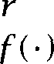 Frequency estimate of a model

 Number of bins that have *r* training instances in them  Total count of n-grams of frequency in further data *h* ‘History’ of preceding words

Table 6.2 Notation for the statistical estimation chapter.

* + 1. Maximum Likelihood Estimation (MLE)

MLE **estimates from relative frequencies**

Regardless of how we form equivalence classes, we will end up with bins that contain a certain number of training instances. Let us assume a  model where we are using the two preceding words of context to predict the next word, and let us focus in on the bin for the case where the two preceding words were comes In a certain corpus, the authors found 10 training instances of the words comes and of those, 8 times they were followed by once by and once by a. The question at this point is what probability estimates we should use for estimating the next word.

The obvious first answer (at least from a frequentist point of view) is

**RELATIVE FREQUENCY** to suggest using the *relative frequency* as a probability estimate:

 = 0.8

 = 0.1

*P(a) =* 0.1

 = 0.0 for x not among the above 3 words

**MAXIMUM LIKELIHOOD** This estimate is called the *maximum likelihood estimate*

**ESTIMATE**



*.*

**(6.4)** *. . =*





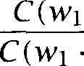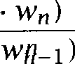

If one fixes the observed data, and then considers the space of all pos- sible parameter assignments within a certain distribution (here a 

**LIKELIHOOD** model) given the data, then statisticians refer to this as a *likelihood * **FUNCTION** The maximum likelihood estimate is so called because it is the choice of parameter values which gives the highest probability to the

training  The estimate that does that is the one shown above. It does not waste any probability mass on events that are not in the train- ing corpus, but rather it makes the probability of observed events as high as it can subject to the normal stochastic constraints.

But the MLE is in general unsuitable for statistical inference in NLP. The problem is the sparseness of our data (even if we are using a large corpus). While a few words are common, the vast majority of words are very uncommon and longer n-grams involving them are thus much rarer again. The MLE assigns a zero probability to unseen events, and since the probability of a long string is generally computed by multiplying the probabilities of subparts, these zeroes will propagate and give us bad (zero probability) estimates for the probability of sentences when we just happened not to see certain n-grams in the training text.” With respect to the example above, the MLE is not capturing the fact that there are other words which can follow comes for example *the* and some.

As an example of data sparseness, after training on 1.5 million words from the IBM Laser Patent Text corpus, Bahl et al. (1983) report that 23% of the  tokens found in further test data drawn from the same corpus were previously unseen. This corpus is small by modern stan- dards, and so one might hope that by collecting much more data that the problem of data sparseness would simply go away. While this may ini- tially seem hopeful (if we collect a hundred instances of we will probably find instances with it followed by *the* and some), in practice it is never a general solution to the problem. While there are a limited number of frequent events in language, there is a seemingly never



1. This is given that the occurrence of a certain n-gram is assumed to be a random variable with a binomial distribution (i.e., each n-gram is independent of the next). This is a quite untrue (though usable) assumption: firstly, each n-gram overlaps with and hence partly determines the next, and secondly, content words tend to clump (if you use a word once in a paper, you are likely to use it again), as we discuss in section 15.3.
2. Another way to state this is to observe that if our probability model assigns zero prob-

ability to any event that turns out to actually occur, then both the cross-entropy and the KL divergence with respect to (data from) the real probability distribution is infinite. In other words we have done a maximally bad job at producing a probability function that is close to the one we are trying to model.

6.2 *Statistical Estimators 199*

**RARE EVENTS** ing tail to the probability distribution of rarer and rarer events, and we can never collect enough data to get to the end of the  For instance could be followed by any number, and we will never see ev-



ery number. In general, we need to devise better estimators that allow for the possibility that we will see events that we didn’t see in the training text.

All such methods effectively work by somewhat decreasing the proba- bility of previously seen events, so that there is a little bit of probability mass left over for previously unseen events. Thus these methods are

**DISCOUNTING** quently referred to as discounting methods. The process of discounting is **SMOOTHING** often referred to as smoothing, presumably because a distribution with- out zeroes is smoother than one with zeroes. We will examine a number

of smoothing methods in the following sections.

**Using** MLE **estimates for n-gram models of Austen**

Based on our Austen corpus, we made n-gram models for different values of n. It is quite straightforward to write one’s own program to do this, by totalling up the frequencies of n-grams and l)-grams, and then dividing to get MLE probability estimates, but there is also software to do it on the



In practical systems, it is usual to not actually calculate n-grams for all words. Rather, the n-grams are calculated as usual only for the most common words, and all other words are regarded as Out-Of-Vocabulary  items and mapped to a single token such as Commonly, this will be done for all words that have been encountered only once in the

**LEGOMENA** training corpus A useful variant in some domains is to notice the obvious semantic and distributional similarity of rare numbers and to have two out-of-vocabulary tokens, one for numbers and one for everything else. Because of the Zipfian distribution of words, cutting out low frequency items will greatly reduce the parameter space (and the memory requirements of the system being built), while not appreciably affecting the model quality  legomena often constitute half of the types, but only a fraction of the tokens).



We used the conditional probabilities calculated from our training cor- pus to work out the probabilities of each following word for part of a



1. Cf. Zipf’s law the observation that the relationship between a word’s frequency and the rank order of its frequency is roughly a reciprocal curve as discussed in section 1.4.3.

***6 Statistical Inference: n-gram Models over Sparse Data***



 

      



    

**Table 6.3** Probabilities of each successive word for a clause from ***Persuasion.*** The probability distribution for the following word is calculated by Maximum Likelihood Estimate n-gram models for various values of ***n.*** The predicted likeli- hood rank of different words is shown in the first column. The actual next word is shown at the top of the table in italics, and in the table in bold.



|  |  |  |  |  |  |  |  |  |  |  |  |  |
| --- | --- | --- | --- | --- | --- | --- | --- | --- | --- | --- | --- | --- |
| **In**  ***person***  l-gram | *she* |  |  |  | inferior |  |  |  | *both* |  | | |
|  | the* | 0.034 | the | 0.034 | the | 0.034 | the | *0.034* | the | *0.034* | the | 0.034 |
|  | to | 0.032 | to | 0.032 | to | 0.032 |  | *0.032* | to | *0.032* | to | 0.032 |
|  | and | 0.030 | and | 0.030 | and | 0.030 |  |  | and | *0.030* | and | 0.030 |
|  | of | 0.029 | of | 0.029 | of | 0.029 |  |  | of | 0.029 | of | 0.029 |
|  | was | 0.015 | was | 0.015 | was | 0.015 |  |  | was | 0.015 | was | 0.015 |
| 13 | she | 0.011 |  |  | she | 0.011 |  |  | she | 0.011 | she | 0.01 I |
| *2 5 4* |  |  |  |  | both | 0.0005 |  |  | both | 0.0005 | both | 0.0005 |
| 435 |  |  |  |  | sisters | 0.0003 |  |  |  |  | sisters | 0.0003 |
| 1701 |  |  |  |  | inferior | 0.00005 |  |  |  |  |  |  |
| Z-gram |  |  |  |  |  |  | *P* | *inferior)* |  |  |  |  |
| 1 | and | 0.099 | had | 0.141 | not | 0.065 |  | *0.2* 12 | be | 0.111 | of | 0.066 |
| 2 | who | 0.099 | was | 0.122 | a | 0.052 |  |  | the | 0.057 | to | 0.041 |
| 3 | to | 0.076 |  |  | the | 0.033 |  |  | her | 0.048 | in | 0.038 |
| 4 | in | 0.045 |  |  | to | 0.031 |  |  | have | 0.027 | and | 0.025 |
| 23 | she | 0.009 |  |  |  |  |  |  | Mrs | 0.006 | she | 0.009 |
| 41 |  |  |  |  |  |  |  |  | what | 0.004 | sisters | 0.006 |
| 293 |  |  |  |  |  |  |  |  |  | 0.0004 |  |  |
|  |  |  |  |  | inferior | 0 |  |  |  |  |  |  |
| **UNSEEN** did 0.5 not *0.057* **UNSEEN** the *0.286 0.222* | | | | | | | | | | | | |
| 2 | was | | | 0.5 |  | *0.038* | Maria | | | 0.143 | Chapter | 0.111 |
|  |  | | |  | in | 0.030 | cherries | | | 0.143 | Hour | 0.111 |
| 4 |  | | |  | to | 0.026 | her | | | 0.143 | Twice | 0.111 |
|  |  | | |  | inferior | 0 | both | | | 0 | sisters | 0 |
| **UNSEEN** | | | **UNSEEN** | | in | 1.0 | **UNSEEN** | | **UNSEEN** | | **UNSEEN** | |
|  | | |  | | inferior | 0 |  | |  | |  | |

sentence from our test corpus *Persuasion.* We will cover the issue of test corpora in more detail later, but it is vital for assessing a model that we try it on different data otherwise it isn’t a fair test of how well the model allows us to predict the patterns of language. Extracts from these probability distributions including the actual next word shown in bold are shown in table 6.3. The unigram distribution ignores context en- tirely, and simply uses the overall frequency of different words. But this is not entirely useless, since, as in this clause, most words in most sen- tences are common words. The  model uses the preceding word to help predict the next word. In general, this helps enormously, and gives us a much better model. In some cases the estimated probability of the word that actually comes next has gone up by about an order of magnitude (was, to, *sisters).* However, note that the  model is not guaranteed to increase the probability estimate. The estimate for she has actually gone down, because she is in general very common in Austen novels (being mainly books about women), but somewhat unexpected af- ter the noun *person* although quite possible when an adverbial phrase is being used, such as In *person* here. The failure to predict *inferior* after

was shows problems of data sparseness already starting to crop up.

When the  model works, it can work brilliantly. For example, it gives us a probability estimate of 0.5 for was following *person she.* But in general it is not usable. Either the preceding  was never seen be- fore, and then there is no probability distribution for the following word, or a few words have been seen following that  but the data is so sparse that the resulting estimates are highly unreliable. For example, the  to both was seen 9 times in the training text, twice followed by to, and once each followed by 7 other words, a few of which are shown in the table. This is not the kind of density of data on which one can sensibly build a probabilistic model. The four-gram model is entirely useless. In general, four-gram models do not become usable until one is training on several tens of millions of words of data.

Examining the table suggests an obvious strategy: use higher order n-gram models when one has seen enough data for them to be of some use, but back off to lower order n-gram models when there isn’t enough data. This is a widely used strategy, which we will discuss below in the section on combining estimates, but it isn’t by itself a complete solution to the problem of n-gram estimates. For instance, we saw quite a lot of words following in the training data 9409 tokens of 1481 types but *inferior* was not one of them. Similarly, although we had seen quite

***6 Statistical Inference: n-gram Models over Sparse Data***



a lot of words in our training text overall, there are many words that did not appear, including perfectly ordinary words like decides or wart. So regardless of how we combine estimates, we still definitely need a way to give a non-zero probability estimate to words or n-grams that we happened not to see in our training text, and so we will work on that problem first.

* + 1. Laplace’s law, Lidstone’s law and the Jeffreys-Perks law Laplace’s law

The manifest failure of maximum likelihood estimation forces us to ex- amine better estimators. The oldest solution is to employ Laplace’s law (1814; 1995). According to this law,

(6.6) ***N + B***

ADDING ONE This process is often informally referred to as ***adding*** one, and has the effect of giving a little bit of the probability space to unseen events. But rather than simply being an unprincipled move, this is actually the Bayesian estimator that one derives if one assumes a uniform prior on events (i.e., that every n-gram was equally likely).

However, note that the estimates which Laplace’s law gives are depen- dent on the size of the vocabulary. For sparse sets of data over large vocabularies, such as n-grams, Laplace’s law actually gives far too much of the probability space to unseen events.

Consider some data discussed by Church and Gale in the con- text of their discussion of various estimators for Their corpus of 44 million words of Associated Press (AP) yielded a vocab- ulary of 400,653 words (maintaining case distinctions, splitting on hy- phens, etc.). Note that this vocabulary size means that there is a space of 1.6 x possible and so a ***priori*** barely any of them will actually occur in the corpus. It also means that in the calculation of

***B*** is far larger than N, and Laplace’s method is completely unsatisfactory in such circumstances. Church and Gale used half the corpus (22 million

EXPECTED FREQUENCY words) as a training text. Table 6.4 shows the expected frequency

ESTIMATES mates of various methods that they discuss, and Laplace’s law estimates that we have calculated. Probability estimates can be derived by divid- ing the frequency estimates by the number of n-grams, N = 22 million. For Laplace’s law, the probability estimate for an n-gram seen times is

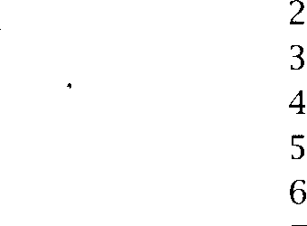=  empirical  fdel 

|  |  |  |  |  |  |  |
| --- | --- | --- | --- | --- | --- | --- |
| 0 | 0.000027 | 0.000137 | 0.000037 | 0.000027 | 74 671 100 000 | 2 019 |
|  | 0.448 | 0.000274 | 0.396 | 0.446 | 2 018 046 | 903 206 |
|  | 1.25 | 0.000411 | 1.24 | 1.26 | 449 721 | 564 153 |
|  | 2.24 | 0.000548 | 2.23 | 2.24 | 188 933 | 424 015 |
|  | 3.23 | 0.000685 | 3.22 | 3.24 | 105 668 | 341 099 |
|  | 4.21 | 0.000822 | 4.22 | 4.22 | 68 379 | 287 776 |
|  | 5.23 | 0.000959 | 5.20 | 5.19 | 48 190 | 251951 |
|  | 6.21 | 0.00109 | 6.21 | 6.21 | 35 709 | 221 693 |
| 8 | 7.21 | 0.00123 | 7.18 | 7.24 | 27 710 | 199 779 |
| 9 | 8.26 | 0.00137 | 8.18 | 8.25 | 22 280 | 183 971 |

Table 6.4 Estimated frequencies for the AP data from Church and Gale

The first five columns show the estimated frequency calculated for a  that actually appeared times in the training data according to different estimators: is the maximum likelihood estimate,  uses validation on the test set,  is the ‘add one’ method,  is deleted interpolation (two-way cross valida- tion, using the training data), and  is the Good-Turing estimate. The last two columns give the frequencies of frequencies and how often of a certain

frequency occurred in further text.

 so thefrequencyestimate becomes  =  These estimated frequencies are often easier for humans to interpret than probabilities, as one can more easily see the effect of the discount- ing.

Although each previously unseen  has been given a very low probability, because there are so many of them, of the probability space has actually been given to unseen  This is far too much, and it is done at the cost of enormously reducing the probability esti- mates of more frequent events. How do we know it is far too much? The second column of the table shows an empirically determined estimate (which we discuss below) of how often unseen n-grams actually appeared in further text, and we see that the individual frequency of occurrence of previously unseen n-grams is much lower than Laplace’s law predicts, while the frequency of occurrence of previously seen n-grams is much higher than  In particular, the empirical model finds that only

of the  in further text were previously unseen.

1. This is calculated as x *=* x = 0.465.
2. It is a bit hard dealing with the astronomical numbers in the table. A smaller example which illustrates the same point appears in exercise 6.2.



Lidstone’s law and the Jeffreys-Perks law

Because of this overestimation, a commonly adopted solution to the prob- lem of multinomial estimation within statistical practice is Lidstone’s law of succession, where we add not one, but some (normally smaller) posi- tive value



***+ A***

This method was developed by the actuaries Hardy and Lidstone, and Johnson showed that it can be viewed as a linear interpolation (see below) between the MLE estimate and a uniform prior. This may be seen by setting = + ***Bh):***

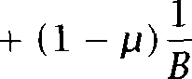



N



**E STIMATION**

The most widely used value for A is  This choice can be theoretically justified as being the expectation of the same quantity which is maxi- mized by MLE and so it has its own names, the Jeffreys-Perks law, or Expected ***Likelihood Estimation*** (Box and Tiao 1973: 34-36).

In practice, this often helps. For example, we could avoid the objection above that two much of the probability space was being given to unseen events by choosing a small But there are two remaining objections:  we need a good way to guess an appropriate value for A in advance, and

(ii) discounting using Lidstone’s law always gives probability estimates linear in the MLE frequency and this is not a good match to the empirical distribution at low frequencies.

Applying these methods to Austen

Despite the problems inherent in these methods, we will nevertheless try applying them, in particular ELE, to our Austen corpus. Recall that up until now the only probability estimate we have been able to derive for the test corpus clause ***she was inferior to both sisters*** was the unigram estimate, which (multiplying through the bold probabilities in the top part of table 6.3) gives as its estimate for the probability of the clause



3.96 x For the other models, the probability estimate was either zero or undefined, because of the sparseness of the data.

Let us now calculate a probability estimate for this clause using a gram model and Following the word ***was,*** which appeared 9409

|  |  |  |  |  |
| --- | --- | --- | --- | --- |
| *6.2 Statistical Estimators* |  |  |  | **205** |
| Rank | Word | MLE | ELE |  |
| 1 | not | 0.065 | 0.036 |  |
| 2 | a | 0.052 | 0.030 |  |
| 3 | the | 0.033 | 0.019 |  |
| 4 | to | 0.031 | 0.017 |  |
|  | inferior | 0 | 0.00003 |  |

Table 6.5 Expected Likelihood Estimation estimates for the word following *was.*

times, not appeared 608 times in the training corpus, which overall con- tained 14589 word types. So our new estimate for  is (608

14589 x 0.5) = 0.036. The estimate for  has thus been discounted (by almost half!). If we do similar calculations for the other words, then we get the results shown in the last column of ta- ble 6.5. The ordering of most likely words is naturally unchanged, but the probability estimates of words that did appear in the training text are discounted, while non-occurring words, in particular the actual next word, inferior, are given a non-zero probability of occurrence. Continu- ing in this way to also estimate the other  probabilities, we find that this language model gives a probability estimate for the clause of



6.89 x  Unfortunately, this probability estimate is actually lower than the MLE estimate based on unigram counts reflecting how greatly all the MLE probability estimates for seen n-grams are discounted in the construction of the ELE model. This result substantiates the slogan used in the titles of (Gale and Church  poor estimates of context are worse than none. Note, however, that this does not mean that the model that we have constructed is entirely useless. Although the probability estimates it gives are extremely low, one can nevertheless use them to rank alternatives. For example, the model does correctly tell us that she was inferior to *both sisters* is a much more likely clause in English than *inferior to was both she sisters,* whereas the unigram estimate gives them both the same probability.

* + 1. Held out estimation

How do we know that giving 46.5% of the probability space to unseen events is too much? One way that we can test this is empirically. We

**HELD OUT ESTIMATOR**



can take further text (assumed to be from the same source) and see how often  that appeared ***r*** times in the training text tend to turn up in the further text. The realization of this idea is the held out ***estimator*** of Jelinek and (1985).

**The held out estimator**

For each n-gram, let:



  **=** frequency of in training data



**. . . =** frequency of in held out data



and recall that  is the number of  with frequency (in the training text). Now let:

 ***= *** **. . . **



That is,  is the total number of times that all n-grams that appeared times in the training text appeared in the held out data. Then the aver- age frequency of those n-grams is  and so an estimate for the proba-

bility of one of these n-grams is:

(6.10)   where



**TRAINING DATA**

**OVERTRAINING**

**TEST DATA**

**Pots of data for developing and testing models**

A cardinal sin in Statistical NLP is to test on your ***training data.*** But why is that? The idea of testing is to assess how well a particular model works. That can only be done if it is a ‘fair test’ on data that has not been seen before. In general, models induced from a sample of data have a tendency to be ***overtrained,*** that is, to expect future events to be like the events on which the model was trained, rather than allowing sufficiently for other possibilities. (For instance, stock market models sometimes suffer from this failing.) So it is essential to test on different data. A particular case of this is for the calculation of cross entropy (section 22.6). To calculate cross entropy, we take a large sample of text and calculate the per-word entropy of that text according to our model. This gives us a measure of the quality of our model, and an upper bound for the entropy of the language that the text was drawn from in general. But all that is only true if the test is independent of the training data, and large enough

to be indicative of the complexity of the language at hand. If we test on the training data, the cross entropy can easily be lower than the real entropy of the text. In the most blatant case we could build a model that has memorized the training text and always predicts the next word with probability 1. Even if we don’t do that, we will find that MLE is an excellent language model if you are testing on training data, which is not the right result.

So when starting to work with some data, one should always separate it immediately into a training portion and a testing portion. The test data is normally only a small percentage (510%) of the total data, but has to be sufficient for the results to be reliable. You should always eyeball the training data you want to use your human pattern-finding abilities to get hints on how to proceed. You shouldn’t eyeball the test data that’s cheating, even if less directly than getting your program to memorize it.

Commonly, however, one wants to divide both the training and test data into two again, for different reasons. For many Statistical NLP meth- ods, such as held out estimation of n-grams, one gathers counts from one lot of training data, and then one smooths these counts or estimates certain other parameters of the assumed model based on what turns up

**HELD OUT DATA** in further held or *validation* data. The held out data needs to be

**VALIDATION DATA ** of both the primary training data and the test data. Normally the stage using the held out data involves the estimation of many fewer pa- rameters than are estimated from counts over the primary training data, and so it is appropriate for the held out data to be much smaller than the primary training data (commonly about 10% of the size). Nevertheless, it is important that there is sufficient data for any additional parameters of the model to be accurately estimated, or significant performance losses can occur (as Chen and Goodman (1996: 317) show).

A typical pattern in Statistical NLP research is to write an algorithm, train it, and test it, note some things that it does wrong, revise it and then to repeat the process (often many times!). But, if one does that a lot, not only does one tend to end up seeing aspects of the test set, but just repeatedly trying out different variant algorithms and looking at their performance can be viewed as subtly probing the contents of the test set. This means that testing a succession of variant models can again lead to

**DEVELOPMENT TEST** overtraining. So the right approach is to have two test sets: a *development*

**SET** *test set* on which successive variant methods are and a final *test* **FINAL TEST SET** *set* which is used to produce the final results that are published about the performance of the algorithm. One should expect performance on

the final test set to be slightly lower than on the development test set (though sometimes one can be lucky).

The discussion so far leaves open exactly how to choose which parts of the data are to be used as testing data. Actually here opinion divides into two schools. One school favors selecting bits (sentences or even grams) randomly from throughout the data for the test set and using the rest of the material for training. The advantage of this method is that the testing data is as similar as possible (with respect to genre, register, writer, and vocabulary) to the training data. That is, one is training from as accurate a sample as possible of the type of language in the test data. The other possibility is to set aside large contiguous chunks as test data. The advantage of this is the opposite: in practice, one will end up using any NLP system on data that varies a little from the training data, as language use changes a little in topic and structure with the passage of time. Therefore, some people think it best to simulate that a little by choosing test data that perhaps isn’t quite stationary with respect to the training data. At any rate, if using held out estimation of parameters, it is best to choose the same strategy for setting aside data for held out data as for test data, as this makes the held out data a better simulation of the test data. This choice is one of the many reasons why system results can be hard to compare: all else being equal, one should expect slightly worse performance results if using the second approach.

While covering testing, let us mention one other issue. In early work, it

was common to just run the system on the test data and present a single performance figure (for perplexity, percent correct or whatever). But this

**VARIANCE** isn’t a very good way of testing, as it gives no idea of the ***variance*** in

the performance of the system. A much better way is to divide the test data into, say 20, smaller samples, and work out a test result on each of them. From those results, one can work out a mean performance figure, as before, but one can also calculate the variance that shows how much performance tends to vary. If using this method together with continuous chunks of training data, it is probably best to take the smaller testing samples from different regions of the data, since the testing lore tends to be full of stories about certain sections of data sets being “easy,” and so it is better to have used a range of test data from different sections of the corpus.

If we proceed this way, then one system can score higher on average than another purely by accident, especially when within-system variance is high. So just comparing average scores is not enough for meaningful



|  |  |  |
| --- | --- | --- |
|  | System 1 | System 2 |
| scores | 71, 61, 55, 60, 68, 49, | 42, 55, 75, 45, 54, 51 |
|  | 42, 72, 76, 55, 64 | 55, 36, 58, 55, 67 |
| total | 609 | 526 |
|  | 11 | 11 |
| mean | 55.4 | 47.8 |
|  |  |  |
| df | 10 | 10 |

Pooled 130.2



**55.4-47.8**







**Table 6.6 Using** the test for comparing the performance of two systems. Since we calculate the mean for each data set, the denominator in the calculation of variance and the number of degrees of freedom is (11 1) (11 1) = 20. The data do not provide clear support for the superiority of system Despite the clear difference in mean scores, the sample variance is too high to draw any definitive conclusions.

system comparison. Instead, we need to apply a statistical test that takes into account both mean and variance. Only if the statistical test rejects the possibility of an accidental difference can we say with confidence that one system is better than the other.”

**TEST** An example of using the test (which we introduced in section 5.3.1) for comparing the performance of two systems is shown in table 6.6 (adapted from (Snedecor and Cochran 1989: 92)). Note that we use a pooled estimate of the sample variance  here under the assumption that the variance of the two systems is the same (which seems a reason- able assumption here: 609 and 526 are close enough). Looking up the distribution in the appendix, we find that, for rejecting the hypothesis that the system 1 is better than system 2 at a probability level of = 0.05, the critical value is 1.72 5 (using a one-tailed test with 20 degrees of freedom). Since we have 1.56 1.725, the data fail the significance test. Although the averages are fairly distinct, we cannot conclude supe-

riority of system 1 here because of the large variance of scores.



1. Systematic discussion of testing methodology for comparing statistical and machine learning algorithms can be found in (Dietterich 1998). A good case study, for the example of word sense disambiguation, is (Mooney 1996).

210 ***Statistical Inference: n-gram Models over Sparse Data***

**Using held out estimation on the test data**

**So** long as the frequency of an n-gram is the only thing that we are using to predict its future frequency in text, then we can use held out estimation performed on the test set to provide the correct answer of what the discounted estimates of probabilities should be in order to max- imize the probability of the test set data. Doing this empirically measures how often n-grams that were seen ***r*** times in the training data actually do occur in the test text. The empirical estimates in table 6.4 were found by randomly dividing the 44 million in the whole AP cor- pus into equal-sized training and test sets, counting frequencies in the



22 million word training set and then doing held out estimation using the test set. Whereas other estimates are calculated only from the 22 million words of training data, this estimate can be regarded as an em- pirically determined gold standard, achieved by allowing access to the test data.

* + 1. **Cross-validation (deleted estimation)**

The  estimates discussed immediately above were constructed by looking at what actually happened in the test data. But the idea of held out estimation is that we can achieve the same effect by dividing the training data into two parts. We build initial estimates by doing counts on one part, and then we use the other pool of held out data to refine those estimates. The only cost of this approach is that our initial training data is now less, and so our probability estimates will be less reliable.

Rather than using some of the training data only for frequency counts and some only for smoothing probability estimates, more efficient schemes are possible where each part of the training data is used both as initial training data and as held out data. In general, such methods in

**CROSS-VALIDATION** statistics go under the name ***cross-validation.***

Jelinek and (1985) use a form of two-way cross-validation that **DELETED ESTIMATION** they call ***deleted estimation.*** Suppose we let  be the number of n-grams occurring times in the  part of the training data, and  be the total

occurrences of those  from part a in the  part. Now depending on which part is viewed as the basic training data, standard held out estimates would be either:

where **. . . =**



The more efficient deleted interpolation estimate does counts and smoothing on both halves and then does a weighted average of the two according to the proportion of words in versus

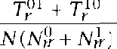(6.11  where



On large training corpora, doing deleted estimation on the training data works better than doing held-out estimation using just the training data, and indeed table 6.4 shows that it produces results that are quite close to the empirical gold standard. It is nevertheless still some way off for low frequency events. It overestimates the expected frequency of unseen objects, while underestimating the expected frequency of objects that were seen once in the training data. By dividing the text into two parts like this, one estimates the probability of an object by how many times it was seen in a sample of size  assuming that the probability of a token seen *r* times in a sample of size  is double that of a token seen *r* times in a sample of size However, it is generally true that as the size of the training corpus increases, the percentage of unseen n-grams that one encounters in held out data, and hence one’s probability estimate for unseen n-grams, decreases (while never becoming negligible). It is for this reason that collecting counts on a smaller training corpus has the effect of overestimating the probability of unseen n-grams.

There are other ways of doing cross-validation. In particular Ney et al. LEAVING-ONE-OUT (1997) explore a method that they call Leaving-One-Out where the pri- mary training corpus is of size N 1 tokens, while 1 token is used as

held out data for a sort of simulated testing. This process is repeated N times so that each piece of data is left out in turn. The advantage of this training regime is that it explores the effect of how the model changes if any particular piece of data had not been observed, and Ney et al. show strong connections between the resulting formulas and the widely-used Good-Turing method to which we turn



1. Remember that, although the empirical gold standard was derived by held out esti- mation, it was held out estimation based on looking at the test data! Chen and Goodman (1998) find in their study that for smaller training corpora, held out estimation outper- forms deleted estimation.
2. However, Chen and Goodman (1996: 314) suggest that leaving one word out at a

time is problematic, and that using larger deleted chunks in deleted interpolation is to be preferred.

Good-Turing estimation

**The Good-Turing estimator**

Good (1953) attributes to Turing a method for determining frequency or probability estimates of items, on the assumption that their distribution is binomial. This method is suitable for large numbers of observations of data drawn from a large vocabulary, and works well for n-grams, despite the fact that words and n-grams do not have a binomial distribution. The probability estimate in Good-Turing estimation is of the form  = where can be thought of as an adjusted frequency. The theorem un- derlying Good-Turing methods gives that for previously observed items:

(6.12) ***=***

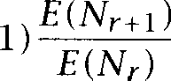

where ***E*** denotes the expectation of a random variable (see (Church and Gale  Gale and Sampson 1995) for discussion of the derivation of this formula). The total probability mass reserved for unseen objects is then ***(see*** exercise 6.5).

Using our empirical estimates, we can hope to substitute the observed  for  However, we cannot do this uniformly, since these empir- ical estimates will be very unreliable for high values of In particular, the most frequent n-gram would be estimated to have probability zero, since the number of n-grams with frequency one greater than it is zero! In practice, one of two solutions is employed. One is to use Good-Turing reestimation only for frequencies ***r k*** for some constant ***k (e.g.,*** 10). Low frequency words are numerous, so substitution of the observed fre- quency of frequencies for the expectation is quite accurate, while the MLE estimates of high frequency words will also be quite accurate and so one doesn’t need to discount them. The other is to fit some function S through the observed values of (Y,  and to use the smoothed values S(r) for the expectation (this leads to a family of possibilities depend- ing on exactly which method of curve fitting is employed Good (1953) discusses several smoothing methods). The probability mass  given to unseen items can either be divided among them uniformly, or by some more sophisticated method (see under Combining Estimators, below). So using this method with a uniform estimate for unseen events, we have:

**Good-Turing Estimator:** If ***. . . = 0,***



(6.13) N



***+*** + 1)





If  . . . w,) = 0,

(6.14)  



**1**



**RENORMALIZATION**

**COUNT-COUNTS**

Gale and Sampson (1995) present a simple and effective approach, Sim- ple Good-Turing, which effectively combines these two approaches. As a smoothing curve they simply use a power curve =  (with -1 to give the appropriate hyperbolic relationship), and estimate ***A*** and by simple linear regression on the logarithmic form of this equation log = a log (linear regression is covered in section  or in all introductory statistics books). However, they suggest that such a simple curve is probably only appropriate for high values of For low values of ***r,*** they use the measured directly. Working up through frequencies, these direct estimates are used until for one of them there isn’t a signifi- cant difference between values calculated directly or via the smoothing function, and then smoothed estimates are used for all higher   Simple Good-Turing can give exceedingly good estimators, as can be seen by comparing the Good-Turing column  in table 6.4 with the empirical gold standard.

Under any of these approaches, it is necessary to all the estimates to ensure that a proper probability distribution results. This can be done either by adjusting the amount of probability mass given to unseen items (as in equation (6.14)) or, perhaps better, by keeping the estimate of the probability mass for unseen items as  and



 all the estimates for previously seen items (as Gale and Sampson

(1995) propose).

**Frequencies of frequencies Austen**

To do Good-Turing, the first step is to calculate the frequencies of differ- ent frequencies (also known as count-counts). Table 6.7 shows extracts from the resulting list of frequencies of frequencies for  and trigrams. (The numbers are reminiscent of the Zipfian distributions of

1. An estimate of is deemed significantly different if the difference exceeds 1.65 times the standard deviation of the Good-Turing estimate, which is given by:

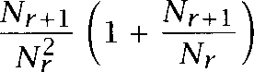

***+***





 

|  |  |  |  |  |  |  |  |
| --- | --- | --- | --- | --- | --- | --- | --- |
| ***r*** |  | | | | | | |
| 1 | 138741 | 28 |  | 1 | 404211 | 28 | 35 |
| 2 | 25413 | 29 | 120 | 2 | 32514 | 29 | 32 |
| 3 | 10531 | 30 | 86 | 3 | 10056 | 30 | 25 |
| 4 | 5997 | 31 | 98 | 4 | 4780 | 31 | 18 |
| 5 | 3565 | 32 | 99 | 5 | 2491 | 32 | 19 |
| 6 | 2486 |  |  | 6 | 1571 |  |  |
| 7 | 1754 | 1264 | 1 | 7 | 1088 | 189 | 1 |
| 8 | 1342 | 1366 | 1 | 8 | 749 | 202 | 1 |
| 9 | 1106 | 1917 | 1 | 9 | 582 | 214 | 1 |
| 10 | 896 | 2233 | 1 | 10 | 432 | 366 | 1 |
|  |  | 2507 | 1 |  |  | 378 | 1 |

Table ***6.7*** Extracts from the frequencies of frequencies distribution for and in the Austen corpus.

section 1.4.3 but different in the details of construction, and more exag- gerated because they count sequences of words.) Table 6.8 then shows the reestimated counts and corresponding probabilities for 

For the  the mass reserved for unseen = = 0.2248. The space of  is the vocabulary squared, and we saw 199,252  so using uniform estimates, the probability estimate for each unseen  is:



199252) = 1.058 x  If we now wish to work out conditional prob- ability estimates for a  model by using Good-Turing estimates for  probability estimates, and MLE estimates directly for unigrams, then we begin as follows:



Continuing in this way gives the results in table 6.9, which can be com- pared with the  estimates in table 6.3. The estimates in general seem quite reasonable. Multiplying these numbers, we come up with a probability estimate for the clause of 1.278 x  This is at least much higher than the ELE estimate, but still suffers from assuming a uniform distribution over unseen

  

|  |  |  |
| --- | --- | --- |
|  | 0.0007 |  |
| 1 | 0.3663 | 5.982 x10-7 |
| 2 | 1.228 | 2.004 x |
| 3 | 2.122 | 3.465 |
| 4 | 3.058 | 4.993 x |
| 5 | 4.015 | 6.555 |
| 6 | 4.984 | 8.138 x |
| 7 | 5.96 | 9.733 x |
| 8 | 6.942 | 1.134 x |
| 9 | 7.928 | 1.294 x |
| 10 | 8.916 |  |
| 28 | 26.84 | 4.383 x10-5 |
| 29 | 27.84 |  |
| 30 | 28.84 | 4.709x |
| 31 | 29.84 | 4.872 x |
| 32 | 30.84 | 5.035 x |
| 1264 | 1263 | 0.002062 |
| 1366 | 1365 | 0.002228 |
| 1917 | 1916 | 0.003128 |
| 2233 | 2232 | 0.003644 |
| 2507 | 2506 | 0.004092 |

Table 6.8 Good-Turing estimates for  Adjusted frequencies and prob- abilities. Smoothed using the software on the

 0.0055

 0.1217

 *6.9 x*

*inferior)* 0.1806



*both 0.0003956*



*both)* 0.003874



Table 6.9 Good-Turing  frequency estimates for the clause from *Persua- sion.*

**62.6 Briefly noted**

**Ney** and Essen (1993) and Ney et al. (1994) propose two discounting mod- els: in the absolute discounting model, all non-zero MLE frequencies are discounted by a small constant amount and the frequency so gained is uniformly distributed over unseen events:

**Absolute discounting:** If **. . =**



(6.15)   **=**



otherwise





(6.16)

(Recall that is the number of bins.) In the linear discounting method, the non-zero MLE frequencies are scaled by a constant slightly less than one, and the remaining probability mass is again distributed across novel events:

**discounting:** If C ***. . . = r,***

**(1** if ***r 0***



 otherwise

These estimates are equivalent to the frequent engineering move of mak- ing the probability of unseen events some small number instead of zero and then  the other probabilities so that they still sum to one the choice between them depending on whether the other proba- bilities are scaled by subtracting or multiplying by a constant. Looking again at the figures in table 6.4 indicates that absolute discounting seems like it could provide a good estimate. Examining the  figures there, it seems that a discount of 0.77 would work well except for  that have only been seen once previously (which would be un- derestimated). In general, we could use held out data to estimate a good value for 6. Extensions of the absolute discounting approach are very successful, as we discuss below. It is hard to justify linear discounting. In general, the higher the frequency of an item in the training text, the more accurate an unadjusted MLE estimate is, but the linear discounting method does not even approximate this observation.

A shortcoming of Lidstone’s law is that it depends on the number of

bins in the model. While some empty bins result from sparse data prob- lems, many more may be principled gaps. Good-Turing estimation is one

**N ATURAL ** **OF**

**S UCCESSION**

method where the estimates of previously seen items do not depend on the number of bins. Ristad (1995) explores the hypothesis that natu- ral sequences use only a subset of the possible bins. He derives various forms for a *Natural Law * including the following probability estimate for an n-gram with observed frequency



**(6.17) **  **= **



otherwise

The central features of this law are: (i) it reduces to Laplace’s law if some- thing has been seen in every bin, (ii) the amount of probability mass assigned to unseen events decreases quadratically in the number of trials, and (iii) the total probability mass assigned to unseen events is independent of the number of bins so there is no penalty for large vocabularies.

#### 6.3 Combining Estimators

So far the methods we have considered have all made use of nothing but the raw frequency of an n-gram and have tried to produce the best es- timate of its probability in future text from that. But rather than giving the same estimate for all n-grams that never appeared or appeared only rarely, we could hope to produce better estimates by looking at the fre- quency of the (n l)-grams found in the n-gram. If these  l)-grams are themselves rare, then we give a low estimate to the n-gram. If the (n 1)-grams are of moderate frequency, then we give a higher probabil- ity estimate for the n-gram. Church and Gale  present a detailed study of this idea, showing how probability estimates for unseen  can be estimated in terms of the probabilities of the unigrams that com- pose them. For unseen  they calculate the joint-if-independent probability  ), and then group the  into bins based on this quantity. Good-Turing estimation is then performed on each bin to give corrected counts that are normalized to yield probabilities.



1. **But** if the are of very high frequency, then we may actually want to lower the estimate again, because the non-appearance of the n-gram is then presumably indicative of a principled gap.

But in this section we consider the more general problem of how to combine multiple probability estimates from various different models. If we have several models of how the history predicts what comes next, then we might wish to combine them in the hope of producing an even better model. The idea behind wanting to do this may either be smoothing, or simply combining different information sources.

For n-gram models, suitably combining various models of different or- ders is in general the secret to success. Simply combining MLE n-gram estimates of various orders (with some allowance for unseen words) us- ing the simple linear interpolation technique presented below results in a quite good language model (Chen and Goodman 1996). One can do bet- ter, but not by simply using the methods presented above. Rather one needs to combine the methods presented above with the methods for combining estimators presented below.

6.3.1

**LINEAR INTERPOLATION**

**MIXTURE MODELS**

**DELETED INTERPOLATION**

(6.18)

Simple linear interpolation

One way of solving the sparseness in a  model is to mix that model with  and unigram models that suffer less from data sparseness. In any case where there are multiple probability estimates, we can make a linear combination of them, providing only that we weight the contri- bution of each so that the result is another probability function. Inside Statistical NLP, this is usually called linear interpolation, but elsewhere the name (finite) mixture models is more common. When the functions being interpolated all use a subset of the conditioning information of the most discriminating function (as in the combination of



gram and unigram models), this method is often referred to as ***deleted interpolation.*** For interpolating n-gram language models, such as deleted interpolation from a  model, the most basic way to do this is:

  **+ ** 

where 0 1 and = 1.



While the weights may be set by hand, in general one wants to find the combination of weights that works best. This can be done automatically by a simple application of the Expectation Maximization (EM) algorithm, as is discussed in section 9.2.1, or by other numerical algorithms. For instance, Chen and Goodman (1996) use Powell’s algorithm, as presented in (Press et al. 1988). Chen and Goodman (1996) show that this simple

model (with just slight complications to deal with previously unseen his- tories and to reserve some probability mass for out of vocabulary items) works quite well. They use it as the baseline model (see section 7.1.3) in their experiments.

6.32 Katz’s backing-off

BACK-OFF MODELS In ***back-off models,*** different models are consulted in order depending on their specificity. The most detailed model that is deemed to provide sufficiently reliable information about the current context is used. Again, back-off may be used to smooth or to combine information sources.

Back-off n-gram models proposed by Katz (1987). The estimate for an n-gram is allowed to back off through progressively shorter histo- ries:



(6.19)  ***. .***

***k***





otherwise



if



If the n-gram of concern has appeared more than ***k*** times is normally set to 0 or  then an n-gram estimate is used, as in the first line. But the **MLE** estimate is discounted a certain amount (represented by the function ***so*** that some probability mass is reserved for unseen n-grams whose probability will be estimated by backing off. The MLE estimates need to be discounted in some manner, or else there would be no probability mass to distribute to the lower order models. One possibility for calcu- lating the discount is the Good-Turing estimates discussed above, and this is what Katz actually used. If the n-gram did not appear or appeared ***k*** times or less in the training data, then we will use an estimate from a shorter n-gram. However, this back-off probability has to be multiplied by a normalizing factor so that only the probability mass left over in the discounting process is distributed among n-grams that are estimated by backing off. Note that in the particular case where the in the immediately preceding history was unseen, the first line is inapplica- ble for any choice of and the back-off factor takes on the value 1. If



the second line is chosen, estimation is done recursively via an

gram estimate. This recursion can continue down, so that one can start

with a four-gram model and end up estimating the next word based on unigram frequencies.

While backing off in the absence of much data is generally reasonable, it can actually work badly in some circumstances. If we have seen the gram many times, and is a common word, but we have never seen the then at some point we should actually conclude that this is significant, and perhaps represents a ‘grammatical zero,’ rather than routinely backing off and estimating via the  esti- mate  Rosenfeld and Huang (1992) suggest a more complex back-off model that attempts to correct for this.



Back-off models are sometimes criticized because their probability es- timates can change suddenly on adding more data when the back-off al- gorithm selects a different order of n-gram model on which to base the estimate. Nevertheless, they are simple and in practice work well.

* + 1. General linear interpolation

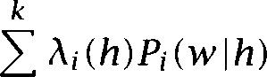In simple linear interpolation, the weights were just a single number, but one can define a more general and powerful model where the weights are a function of the history. For ***k*** probability functions the general form for a linear interpolation model is:

(6.20)

 

i=l

where  0 1 and  = 1.



Linear interpolation is commonly used because it is a very general way to combine models. Randomly adding in dubious models to a linear in- terpolation need not do harm providing one finds a good weighting of the models using the EM algorithm. But linear interpolation can make bad use of component models, especially if there is not a careful par- titioning of the histories with different weights used for different sorts of histories. For instance, if the  are just constants in an interpola- tion of n-gram models, the unigram estimate is always combined in with the same weight regardless of whether the  estimate is very good (because there is a lot of data) or very poor.

In general the weights are not set according to individual histories. Training a distinct  for each is not in general fe- licitous, because it would worsen the sparse data problem. Rather one

wants to use some sort of equivalence classing of the histories. Bahl et al. (1983) suggest partitioning the into bins according to  and tying the parameters for all histories with the same frequency.

Chen and Goodman  show that rather than this method of put- ting the A parameters into bins, a better way is to group them according to the average number of counts per non-zero element:

(6.21)



That is, we take the average count over non-zero counts for n-grams We presume that the reason this works is that, be-



cause of the syntax of language, there are strong structural constraints on which words are possible or normal after certain other words. While it is central to most Statistical NLP language models that any word is al- lowed after any other and this lets us deal with all possible disfluencies nevertheless in many situations there are strong constraints on what can normally be expected due to the constraints of grammar. While some n-grams have just not been seen, others are ‘grammatical zeroes,’ to coin a phrase, because they do not fit with the grammatical rules of the lan- guage. For instance, in our Austen training corpus, both of the  great deal and of occur 178 times. But of that is followed in the corpus by 115 different words, giving an average count of 1.55, reflecting the fact that any adverb, adjective, or noun can felicitously follow within a noun phrase, and any capitalized word starting a new sentence is also a possibility. There are thus fairly few grammatical zeroes (mainly just verbs and prepositions). On the other hand, great deal is followed by only 36 words giving an average count of 4.94. While a new sentence start is again a possibility, grammatical possibilities are otherwise pretty much limited to conjunctions, prepositions, and the comparative form of adjectives. In particular, the preposition of follows 38% of the time. The higher average count reflects the far greater number of grammatical ze- roes following this  and so it is correct to give new unseen words

a much lower estimate of occurrence in this context.

Finally, note that back-off models are actually a special case of the gen- eral linear interpolation model. In back-off models, the functions  are chosen so that their value is 0 for a history except for the coefficient of the model that would have been chosen using a back-off model, which has the value 1.

* + 1. Briefly noted

Bell et al. (1990) and and Bell (1991) introduce a number of smoothing algorithms for the goal of improving text compression. Their “Method is normally referred to as *smoothing* and has been used for smoothing speech language models. The idea is to model the probability of a previously unseen event by estimating the probability of seeing such a new (previously unseen) event at each point as one proceeds through the training corpus. In particular, this probability is worked out relative to a certain history. So to calculate the probability of seeing a new word after, say, sat *in* one is calculating from the training data how often one saw a new word after sat *in,* which is just the count of the num- ber of  types seen which begin with sat ***in.*** It is thus an instance of generalized linear interpolation:

*(6.22)*

*(6.23)*

**L INEAR S UCCESSIVE**

**A BSTRACTION**

*(6.24)*





where the probability mass given to new n-grams is given by:

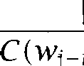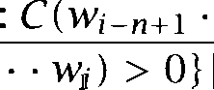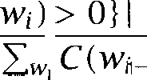

*.*

*n+*





*= ,*

However, Chen and Goodman’s (1998) results suggest that this method is not as good a smoothing technique for language models as others that we discuss in this section (performing particularly poorly when used on small training sets).

Samuelsson (1996) develops *Linear Successive Abstraction,* a method of

determining the parameters of deleted interpolation style models without the need for their empirical determination on held out data.

son’s results suggest similar performance within a part-of-speech tagger to that resulting from conventional deleted interpolation; we are unaware of any evaluation of this technique on word n-gram models.

Another simple but quite successful smoothing method examined by Chen and Goodman (1996) is the following.  and Peto (1990) argue for a smoothed distribution of the form:

     



***.***

***+***

where represents the number of counts added, in the spirit of stone’s law, but distributed according to the lower order distribution.



Model

|  |  |
| --- | --- |
| Cross-entropy | Perplexity |
| 7.98 bits | 252.3 |
| 7.90 bits | 239.1 |
| 7.95 bits | 247.0 |







**Table 6.10** Back-off language models with Good-Turing estimation tested on

***Persuasion.***

Chen and Goodman (1996) suggest that the number of added counts should be proportional to the number of words seen exactly once, and suggest taking:



where . . . . . .  =  and then opti- mizing  and on held out data.

Kneser and Ney (1995) develop a back-off model based on an exten- sion of absolute discounting which provides a new more accurate way of estimating the distribution to which one backs off. Chen and Goodman (1998) find that both this method and an extension of it that they propose provide excellent smoothing performance.



* + 1. Language models for Austen

With the introduction of interpolation and back-off, we are at last at the point where we can build first-rate language models for our Austen cor- pus. Using the CMU-Cambridge Statistical Language Modeling Toolkit (see the  we built back-off language models using Good-Turing estimates, following basically the approach of Katz  We then calculated the cross-entropy (and perplexity) of these language models on our test set, ***Persuasion.*** The results appear in table 6.10. The esti- mated probabilities for each following word, and the n-gram size used to estimate it for our sample clause is then shown in table 6.11. Our prob- ability estimates are at last pleasingly higher than the unigram estimate with which we began!

While overall the  model outperforms the  model on the test data, note that on our example clause, the  model actually

1. The version of Good-Turing smoothing that the package implements only discounts low frequencies words that occurred fewer than 7 times.

      Product

|  |  |  |  |  |  |  |  |
| --- | --- | --- | --- | --- | --- | --- | --- |
| Unigram | 0.011 | 0.015 | 0.00005 | 0.032 | 0.0005 | 0.0003 | 3.96 x |
|  | 0.00529 | 0.1219 | 0.0000159 | 0.183 | 0.000449 | 0.00372 | 3.14 x |
| ***n*** used | 2 | 2 | 1 | 2 | 2 | 2 |  |
| ***n*** used | 0.00529  2 | 0.0741  3 | 0.0000162  1 | 0.183  2 | 0.000384  2 | 0.00323  2 | 1.44 x |

Table 6.11 Probability estimates of the test clause according to various lan- guage models. The unigram estimate is our previous MLE unigram estimate. The other two estimates are back-off language models. The last column gives the overall probability estimate given to the clause by the model.



signs a higher probability. Overall, the model performs slightly worse than the model. This is expected given the small amount of training data. Back-off models are in general not perfectly successful at simply ignoring inappropriately long contexts, and the models tend to deteriorate if too large n-grams are chosen for model building relative to the amount of data available.

#### Conclusions

A number of smoothing methods are available which often offer similar and good performance figures. Using Good-Turing estimation and linear interpolation or back-off to circumvent the problems of sparse data rep- resent good current practice. Chen and Goodman (1996, 1998) present extensive evaluations of different smoothing algorithms. The conclusions of (Chen and Goodman 1998) are that a variant of Kneser-Ney

off smoothing that they develop normally gives the best performance. It is outperformed by the Good-Turing smoothing method explored by Church and Gale when training models on more than 2 million words of text, and one might hypothesize that the same would be true of models trained on a couple of orders of magnitude more text. But in all other circumstances, it seems to perform as well or better than other methods. While simple smoothing methods may be ap- propriate for exploratory studies, they are best avoided if one is hoping to produce systems with optimal performance. Active research continues on better ways of combining probability models and dealing with sparse data.

* 1. ***Further Reading 225***

#### Further Reading

Important research studies on statistical estimation in the context of lan- guage modeling include (Katz  (Jelinek  (Church and Gale  (Ney and Essen  and (Ristad 1995). Other discussions of es- timation techniques can be found in (Jelinek 1997) and (Ney et al. 1997). Gale and Church (1994) provide detailed coverage of the problems with “adding one.” An approachable account of Good-Turing estimation can be found in (Gale and Sampson 1995). The extensive empirical compar- ison of various smoothing methods in (Chen and Goodman 1996, 1998) are particularly recommended.

The notion of maximum likelihood across the values of a parameter was first defined in (Fisher 1922). See (Ney et al. 1997) for a proof that the relative frequency really is the maximum likelihood estimate.

Recently, there has been increasing use of maximum entropy methods for combining models. We defer coverage of maximum entropy models until chapter 16. See Lau et al. (1993) and Rosenfeld (1994, 1996) for applications to language models.

The early work cited in section 6.2.2 appears in: (Lidstone  (John- son  and (Jeffreys 1948). See (Ristad 1995) for discussion. Good (1979: 395-396) covers Turing’s initial development of the idea of

Turing smoothing. This article is reprinted with amplification in (Britton 1992).

#### Exercises

Exercise 6.1

Explore figures for the percentage of unseen n-grams in test data (that differs from the training data). Explore varying some or all of: the order of the model (i.e., (ii) the size of the training data, (iii) the genre of the training data, and

(iv) how similar in genre, domain, and year the test data is to the training data.

Exercise 6.2

As a smaller example of the problems with Laplace’s law, work out probability estimates using Laplace’s law given that 100 samples have been seen from a potential vocabulary of 1000 items, and in that sample 9 items were seen 10 times, 2 items were seen 5 times and the remaining 989 items were unseen.

**Exercise *6.3***

Show that using ELE yields a probability function, in particular that

**=**



**Exercise 6.4**

Using the word and  frequencies within the Austen test corpus given be- low, confirm the ELE estimate for the test clause ***she was inferior to both sisters*** given in section 6.2.2 (using the fact that the word before ***she*** in the corpus was ***person).***



|  |  |  |  |
| --- | --- | --- | --- |
| **W** |  | | |
| person | 223 | person she | 2 |
| she | 6,917 | she was | 843 |
| was | 9,409 | was inferior | 0 |
| inferior | 33 | inferior to | 7 |
| to | 20,042 | to both | 9 |
| both | 317 | both sisters | 2 |

**Exercise 6.5**

Show that Good-Turing estimation is well-founded. I.e., you want to show:



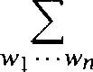

**Exercise 6.6**

We calculated a Good-Turing probability estimate for ***she was inferior to both sisters*** using a  model with a uniform estimate of unseen  Make sure you can recreate these results, and then try doing the same thing using a  model. How well does it work?

**Exercise 6.7**

Build language models for a corpus using the software pointed to on the

site (or perhaps build your own). Experiment with what options give the best language model, as measured by cross-entropy.

**Exercise 6.8**

Get two corpora drawn from different domains, and divide each into a training and a test set. Build language models based on the training data for each domain. Then calculate the cross-entropy figures for the test sets using both the language model trained on that domain, and the other language model. How much do the cross-entropy estimates differ?

***6.6 Exercises*** 227

**Exercise 6.9**

Write a program that learns word n-gram models of some text (perhaps doing smoothing, but it is not really necessary for this exercise). Train separate models on articles from several newsgroups or other text from different genres and then generate some random text based on the models. How intelligible is the output for different values of Is the different character of the various newsgroups clearly preserved in the generated text?

**Exercise 6.10**

Write a program that tries to identify the language in which a short segment of text is written, based on training itself on text written in known languages. For instance, each of the following lines is text in a different language:

is ondubbelzinnig uit pretendre un emploi uscirono fuori solo alcune look into any little problem

If you know a little about European languages, you can probably identify what language each sample is from. This is a classification task, in which you should usefully be able to use some of the language modeling techniques discussed in this chapter. (Hint: consider letter n-grams vs. word n-grams.) (This is a problem that has been investigated by others; see in particular (Dunning 1994). The contains pointers to a number of existing language identification systems including one that was originally done as a solution to this exercise!)

## Word Sense Disambiguation

**THIS CHAPTER** gives an overview of work on word sense  tion within Statistical NLP. It introduces a few of the most important word sense disambiguation algorithms, and describes their resource re- quirements and performance.

What is the idea of word sense disambiguation? The problem to be

**SENSES** solved is that many words have several meanings or senses. For such **AMBIGUITY** words given out of context, there is thus ambiguity about how they are to be interpreted. As a first example of ambiguity, consider the word

*bank* and two of the senses that can be found in Webster’s New Collegiate Dictionary (Woolf 1973):

* the rising ground bordering a lake, river, or sea
* an establishment for the custody, loan exchange, or issue of money, for the extension of credit, and for facilitating the transmission of funds

**DISAMBIGUATION** The task of disambiguation is to determine which of the senses of an ambiguous word is invoked in a particular use of the word. This is done by looking at the context of the word’s use.

This is how the problem has normally been construed in the word sense disambiguation literature. A word is assumed to have a finite number of discrete senses, often given by a dictionary, thesaurus, or other reference source, and the task of the program is to make a forced choice between these senses for the meaning of each usage of an ambiguous word, based on the context of use. However, it is important to realize at the outset that there are a number of reasons to be quite unhappy with such a statement of the task. The word ***bank*** is perhaps the most famous example of an ambiguous word, but it is really quite atypical. A more typical situation

230 *7 Word Sense Disambiguation*

is that a word has various somewhat related senses, and it is unclear whether to and where to draw lines between them. For example, consider the word *title.* Some senses that we found in a dictionary were:

Name/heading of a book, statute, work of art or music, etc.









**S Y N E C D O C H E** 

Material at the start of a film

The right of legal ownership (of land)

The document that is evidence of this right

An appellation of respect attached to a person’s name

A written work [by  i.e., putting a part for the whole]

One approach is simply to define the senses of a word as the meanings given to it in a particular dictionary. However, this is unsatisfactory from a scientific viewpoint because dictionaries often differ greatly in the num- ber and kind of senses they list, not only because comprehensive dictio- naries can be more complete, but fundamentally in the way word uses are gathered into senses. And often these groupings seem quite arbi- trary. For example, the above list of senses distinguishes as two senses a right of legal title to property and a document that shows that right. However, this pattern of sense extension between a concept and some- thing that shows the concept is pervasive and could have been, but was not, distinguished for other uses. For example the same ambiguity exists when talking about the title of a painting. For instance, one might remark in a gallery:

(7.1) This work doesn’t have a title.

That sentence could mean either that the work was not given a title by the author, or simply that the little placard giving the title, which usually appears by paintings in a gallery, is missing. It is also somewhat unclear why books, statutes and works of art or music are grouped together while films are separated out. The second definition could be seen as a special case of the first definition. It is quite common in many dictionaries for senses to be listed that are really special cases of another sense, if this sense is frequently and distinctively used in texts. These difficulties sug- gest that, for most words, the usages and hence the sense definitions are not to be thought of as like five kinds of cheese, among which one must

***231***

choose, but more like a casserole which has some pieces of clearly dis- tinct identifiable content, but a lot of stuff of uncertain and mixed origin in between.

Notwithstanding these philosophical objections, the problem of disam- biguation is of clear importance in many applications of natural language processing. A system for automatic translation from English to German needs to translate ***bank*** as  for the first sense given above (‘ground bordering a lake or river’), and as ***Bank*** for the second sense (‘financial institution’). An information retrieval system answering a query about ‘financial banks’ should return only documents that use ***bank*** in the sec- ond sense. Whenever a system’s actions depend on the meaning of the text being processed, disambiguation is beneficial or even necessary.

There is another kind of ambiguity, where a word can be used as differ- ent parts of speech. For example, butter may be used as a noun, or as a verb, as in You ***should butter your toast.*** Determining the usage of a word

**TAGGING** in terms of part of speech is referred to as ***tagging,*** and is discussed in chapter 10. How do these two notions relate? Using a word as a verb instead of as a noun is clearly a different usage, with a different meaning involved, and so this could be viewed as a word sense disambiguation problem. Conversely, differentiating word senses could be viewed as a tagging problem, but using semantic tags rather than part of speech tags. In practice, the two topics have been distinguished, partly because of dif- ferences between the nature of the problem, and partly because of the methods that have been used to approach them. In general, nearby struc- tural cues are most useful for determining part of speech (e.g., is the preceding word a determiner?), but are almost useless for determining semantic sense within a part of speech. Conversely, quite distant content words are often very effective for determining a semantic sense, but are of little use for determining part of speech. Consequently, most part of speech tagging models simply use local context, while word sense disam- biguation methods often try to use content words in a broader context.

The nature of ambiguity and disambiguation changes quite a bit de- pending on what material is available for training a word sense disam- biguation system. After an initial section about methodology, this chap- ter has three main sections dealing with different types of training ma- terial. Section 7.2 describes ***supervised disambiguation,*** disambiguation based on a labeled training set. Section 7.3 describes ***dictionary-based disambiguation,*** disambiguation that is based on lexical resources such as dictionaries and thesauri. Section 7.4 deals with ***unsupervised disam-***

***232 7 Word Sense Disamhiguation***

 the case in which only unlabeled text corpora are available for training. We conclude with an in-depth discussion of the notion of sense and pointers to further reading.

**7.1 Methodological Preliminaries**

Several important methodological issues come up in the context of word sense disambiguation. They are of general relevance to NLP, but have received special attention in this context. These are: supervised vs. unsu- pervised learning; the use of artificial evaluation data, known in the word sense disambiguation context as ***pseudowords;*** and the development of upper and lower bounds for the performance of algorithms, so that their success can be meaningfully interpreted.

*7.1.1* Supervised and unsupervised learning

A lot of algorithms are classified as to whether they involve supervised or unsupervised learning  and Hart 1973: 45). The distinction is that

**SUPERVISED LEARNING** with ***supervised learning we know*** the actual status (here, sense label) for

**UNSUPERVISED** each piece of data on which we train, whereas with ***unsupervised***

**LEARNING ing we** do not know the classification of the data in the training sample.

**CLIJSTERING** Unsupervised learning can thus often be viewed as a ***clustering*** task (see **CLASSIFICATION** chapter while supervised learning can usually be seen as a ***classifica- tion*** task (see chapter or equivalently as a function-fitting task where

one extrapolates the shape of a function based on some data points. However, in the Statistical NLP domain, things are often not this sim-

ple. Because the production of labeled training data is expensive, people will often want to be able to learn from unlabeled data, but will try to give

**KNOWLEDGE SOURCES** their algorithms a head start by making use of various ***knowledge sources,*** such as dictionaries, or more richly structured data, such as aligned bilin- gual texts. In other methods, the system is seeded with labeled training data, but this data is augmented by further learning from unlabeled data. Rather than trying to force different methods on to a procrustean bed, it usually makes most sense to simply give a precise answer to the question: ***What knowledge sources are needed for use of this method?*** As we will see, sometimes there are alternative combinations of knowledge sources that can give similar information (e.g., using either aligned bilingual texts, or monolingual texts and a bilingual dictionary).

* 1. ***Methodological Preliminaries*** 233

Pseudowords

In order to test the performance of disambiguation algorithms on a nat- ural ambiguous word, a large number of occurrences has to be biguated by hand a time-intensive and laborious task. In cases like this in which test data are hard to come by, it is often convenient to gener- ate artificial evaluation data for the comparison and improvement of text processing algorithms. In the case of word sense disambiguation these

**PSEUDOWORDS** artificial data are called 

Gale et al.  and show how pseudowords, i.e., artificial ambiguous words, can be created by conflating two or more nat- ural words. For example, to create the pseudoword banana-door, one replaces all occurrences of *banana* and *door* in a corpus by the artifi- cial word ***banana-door.*** Pseudowords make it easy to create large-scale training and test sets for disambiguation while obviating the need for hand-labeling: we regard the text with pseudowords as the ambiguous source text, and the original as the text with the ambiguous words ambiguated.



* + 1. Upper and lower bounds on performance

While it is important to measure the performance of one’s algorithm, nu- merical evaluation by itself is meaningless without some discussion of how well the algorithm performs *relative to the difficulty of the task.* For example, whereas 90% accuracy is easy to achieve for part-of-speech tag- ging of English text, it is beyond the capacity of any existing machine translation system. The estimation of upper and lower bounds for the performance of an algorithm is a way to make sense of performance fig- ures (Gale et al. It is a good idea for many tasks in NLP, especially if there are no standardized evaluation sets for comparing systems.

**UPPER BOUND** The upper *bound* used is usually human performance. In the case of word sense disambiguation, if human judges disagree on the correct sense assignment for a particular context, then we cannot expect an auto- matic procedure to do better. Determining upper bounds is particularly interesting if the disambiguation algorithm uses a limited representation of contexts, for example just looking at the three words on each side of the ambiguous word. In such a situation, the reason for poor per- formance may just be that the contextual representations are not very informative so that even humans would not be able to disambiguate very

well based on the same information. We can evaluate this by looking at human performance when based on the same limited contextual 

An upper bound for word sense disambiguation was established by Gale et al. (1992a). Gale et al. performed tests with the following task: Subjects were given pairs of occurrences and had to decide whether they were instances of the same sense. The task resulted in upper bounds between 97% and 99%. However, most of the words in Gale et test set have few and clearly distinct senses. In contrast, there are many am- biguous words (in particular, high-frequency ones) that are similar to our example title, i.e., their senses are interrelated and overlapping.

judge agreement depends on the type of ambiguity: it is higher for words with clearly distinct senses (95% and higher) and lower for polysemous words with many related senses (perhaps as low as 65% to  The task is also easier when viewed as a yes/no decision task than as an arbitrary clustering task.

This means that we have to look at the properties of an individual am- biguous word to determine whether a disambiguation algorithm does a good job for it. For a word like *bank we* should aim for performance in the ninety percent range, whereas less stringent criteria should be ap- plied to fuzzier cases like  side, and way.

**LOWER BOUND** The lower bound or *baseline* is the performance of the simplest  **BASELINE** ble algorithm, usually the assignment of all contexts to the most frequent sense. A baseline should always be given because raw performance num-

bers make it impossible to assess how hard disambiguation is for a par- ticular word. An accuracy of 90% is an excellent result for an ambiguous word with two equiprobable senses. The same accuracy for a word with two senses in a 9 to 1 frequency ratio is trivial to achieve by always selecting the most frequent sense.

Upper and lower bounds are most relevant when we are dealing with a classification task and the evaluation measure is accuracy. Section 8.1 discusses other evaluation measures, in particular, precision and recall.

* + - 1. Although, for limited artificial contexts like this, it is of course possible that computers might be able to be more successful than human beings at extracting useful predictive information.
      2. See (Jorgensen 1990). To be able to correctly compare the extent of inter-judge agree- ment across tasks, we need to correct for the expected chance agreement (which depends on the number of senses being distinguished). This is done by the kappa statistic (Siegel and Castellan 1988; Carletta 1996).
  1. ***Supervised Disambiguation***

Symbol Meaning

***W*** an ambiguous word

senses of the ambiguous word w



*. . . .* contexts of w in a corpus

words used as contextual features for disambiguation

**Table 7.1** Notational conventions used in this chapter.

7.2 Supervised Disambiguation

In supervised disambiguation, a disambiguated corpus is available for training. There is a training set of exemplars where each occurrence of the ambiguous word w is annotated with a semantic label (usually its contextually appropriate sense  This setting makes supervised biguation an instance of statistical classification, the topic of chapter 16. The task is to build a classifier which correctly classifies new cases based on their context of use This notation, which we will use throughout the remainder of the chapter, is shown in table 7.1.

We have selected two of the many supervised algorithms that have been applied to word sense disambiguation that exemplify two impor- tant theoretical approaches in statistical language processing: Bayesian classification (the algorithm proposed by Gale et al.  and Informa- tion Theory (the algorithm proposed by Brown et al.  They also demonstrate that very different sources of information can be employed successfully for disambiguation. The first approach treats the context of occurrence as a bag of words without structure, but it integrates infor- mation from many words in the context window. The second approach looks at only one informative feature in the context, which may be sen- sitive to text structure. But this feature is carefully selected from a large number of potential ‘informants.’

* + 1. Bayesian classification

The idea of the Bayes classifier which we will present for word senses is that it looks at the words around an ambiguous word in a large context window. Each content word contributes potentially useful information about which sense of the ambiguous word is likely to be used with it. The classifier does no feature selection. Instead it combines the evidence

**B AYES ** **B AYESDECISIONRULE**





from all features. The specific formalization we describe is due to Gale et al.  The supervised training of the classifier assumes that we have a corpus where each use of ambiguous words is labeled with its correct sense.

A  *classifier* applies the  *decision rule* when choosing a class, the rule that minimizes the probability of error  and Hart 1973: 43):

Bayes decision rule

Decides’ if for s’



The Bayes decision rule is optimal because it minimizes the probability of error. This is true because for each individual case it chooses the class (or sense) with the highest conditional probability and hence the smallest error rate. The error rate for a sequence of decisions (for example, ambiguating all instances of w in a multi-page text) will therefore also be as small as possible.

We usually do not know the value of but we can compute it using  *rule* as in section 2.1.10:



 *=*



**PRIORPROBABILITY**

**POSTERIOR PROBABILITY**

*(7.3)*

 is the *prior * of sense the probability that we have an instance of if we do not know anything about the context.  is updated with the factor  which incorporates the evidence which we have about the context, and results in the *posterior probability P*

If all we want to do is choose the correct class, we can simplify the classification task by eliminating  (which is a constant for all senses and hence does not influence what the maximum is). We can also use logs of probabilities to make the computation simpler. Then, we want to assign w to the sense s’ where:





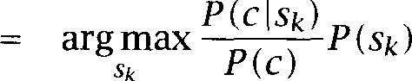



  



***7.2 Supervised Disambiguation 237***

N AIVE 

Gale et classifier is an instance of a particular kind of Bayes clas- sifier, the ***Naive Bayes*** classifier. Naive Bayes is widely used in machine learning due to its efficiency and its ability to combine evidence from a large number of features (Mitchell 1997: ch. 6). It is applicable if the state of the world that we base our classification on is described as a series of attributes. In our case, we describe the context of w in terms of the words that occur in the context.

N AIVE The ***Naive *** ***assumption*** is that the attributes used for description

ASSUMPTION are all conditionally independent:

***(7.4)* Naive Bayes assumption**

BAG OF WORDS



In our case, the Naive Bayes assumption has two consequences. The first is that all the structure and linear ordering of words within the con- text is ignored. This is often referred to as a bug of words  The other is that the presence of one word in the bag is independent of an- other. This is clearly not true. For example, ***president*** is more likely to occur in a context that contains ***election*** than in a context that contains poet. But, as in many other cases, the simplifying assumption makes it possible to adopt an elegant model that can be quite effective despite its shortcomings. Obviously, the Naive Bayes assumption is inappropri- ate if there are strong conditional dependencies between attributes. But there is a surprisingly large number of cases in which it does well, partly because the decisions made can still be optimal even if the probability es- timates are inaccurate due to feature dependence (Domingos and Pazzani 1997).

With the Naive Bayes assumption, we get the following modified deci-

sion rule for classification:

**Decision rule for Naive Bayes**

Decide if =



and are computed via Maximum-Likelihood estimation, perhaps with appropriate smoothing, from the labeled training corpus:







* + - 1. A bag is like a set, but allows repeated elements (we use ‘in’ rather than  in equa- tion (7.4) because we are treating c as a 

238 ***7 Word Sense***

Sense

**comment:** Training

**for** all senses of w **do**

3 **for** all words in the vocabulary **do**



4 

5 **end**

6 **end**

7 **for** all senses of w **do**



8  =

**end**

**comment:** Disambiguation ii **for** all senses of w **do**

***12 *** 

***13* for** all words in the context window c **do**



***14 *** 

***15* end end**

**choose s’ =** arg max,,

Figure 7.1 Bayesian disambiguation.

Clues for sense

medication illegal substance

Table ***7.2***

***prices, prescription, patent, increase, consumer, pharmaceutical abuse, paraphernalia, alcohol, cocaine, traffickers***

Clues for two senses of ***drug*** used by a Bayesian classifier. Adapted

from (Gale et al. 1992b: 419).





where is the number of occurrences of in a context of sense in the training corpus, the number Of occurrences Of in the training corpus, and  is the total number of occurrences of the

ambiguous word w. Figure 7.1 summarizes the algorithm.



Gale, Church and Yarowsky  1992c) report that a  tion system based on this algorithm is correct for about 90% of occur- rences for six ambiguous nouns in the Hansard corpus: ***duty,*** drug, land, ***language, position,*** and ***sentence.***

Table 7.2 gives some examples of words that are good clues for two



* 1. ***Supervised Disambiguation 2.39***

Ambiguous word Indicator prendre object

vouloir tense

Examples: value sense

***to take de’cision to make***

present ***to want***

conditional ***to like***

cent word to the left per %

number c. [money]

**Table 7.3** Highly informative indicators for three ambiguous French words.

senses of ***drug*** in the Hansard corpus. For example, ***prices*** is a good clue for the ‘medication’ sense. This means that  ‘medication’) is large and  substance’) is small and has the effect that a context of ***drug*** containing ***prices*** will have a higher score for ‘medication’ and a lower score for ‘illegal substance’ (as computed on line 14 in figure 7.1).

* + 1. An information-theoretic approach

The Bayes classifier attempts to use information from all words in the context window to help in the disambiguation decision, at the cost of a somewhat unrealistic independence assumption. The information theo- retic algorithm which we turn to now takes the opposite route. It tries to find a single contextual feature that reliably indicates which sense of the ambiguous word is being used. Some of Brown et examples of indicators for French ambiguous words are listed in table 7.3. For the verb ***prendre,*** its object is a good indicator: ***prendre une*** trans- lates as ***to take a measure, prendre une de’cision*** as ***to make a decision.*** Similarly, the tense of the verb ***vouloir*** and the word immediately to the left of ***cent*** are good indicators for these two words as shown in table 7.3. In order to make good use of an informant, its values need to be cat- egorized as to which sense they indicate, e.g., indicates ***to take, de’cision*** indicates ***to make.*** Brown et al. use the ***Flip-Flop algorithm*** for this purpose. Let **.** be the translations of the ambiguous word, and xi the possible values of the indicator. Figure 7.2 shows the Flip-Flop algorithm for this case. The version of the algorithm described here only disambiguates between two senses. See Brown et al. for an extension to more than two senses. Recall the definition of mutual



***240 7 Word Sense Disambiguation***

find random partition P = of 



**while** (improving) **do**

**3** find partition Q = of



**4** that maximizes



5  =  of 

**7** that maximizes



**8 end**

**Figure 7.2** The Flip-Flop algorithm applied to finding indicators for biguation.

information from section 2.2.3:

   log



It can be shown that each iteration of the Flip-Flop algorithm increases the mutual information monotonically, so a natural stopping cri- terion is that does not increase any more or only insignificantly.



As an example, assume we want to translate ***prendre*** based on its object and that we have ***make, rise, speak]*** and



**, ** **= *note, exemple, parole}*** (cf. (Brown et al. 267)). The initial partition of the senses might be ***= ***



***rise}*** and ***= (make, speak}.*** Which partition Q of the indicator values would give us maximum ***Q)?*** Obviously, the answer depends on the particular data we are working with. But let us assume that ***prendre*** is translated by ***take*** when occurring with the objects note, and exemple (corresponding to the phrases ***take a measure, take notes,*** and ***take an example),*** and translated by ***make, speak,*** and ***rise*** when occurring with  and ***parole*** (corresponding to the phrases ***make a decision, make a speech*** and ***rise to speak).***

Then the partition that will maximize is  =  note, exemple} and  =  parole} since this division of the indicator values gives us the most information for distinguishing the translations in  from the translations in  We only make an incorrect decision when ***prendre parole*** is translated as ***rise to speak,*** but this cannot be avoided since ***rise*** and ***speak*** are in two different partition groups.



The next two steps of the algorithm then repartition as ***= *** and = ***rise, speak}*** and Q as before. This partition is always correct for ***take.*** We would have to consider more than two ‘senses’ if we

also wanted to distinguish between the other translations ***make, rise*** and

***speak.***

A simple exhaustive search for the best partition of the French transla- tions and the best possible indicator values would take exponential time. The Flip-Flop algorithm is an efficient linear-time algorithm for comput- ing the best partition of values for a particular indicator, based on the splitting theorem (Breiman et al. 1984). We run the algorithm for all pos- sible indicators and then choose the indicator with the highest mutual information. Brown et al. found that this was the accusative object for ***prendre,*** tense for and the preceding word for cent as shown in table ***7.3.***

Once an indicator and a particular partition of its values has been de-

termined, disambiguation is simple:

1. For the occurrence of the ambiguous word, determine the value of the indicator.
2. If is in  assign the occurrence to sense 1, if is in  assign the occurrence to sense 2.

Brown et al.  report a 20% improvement in the performance of a machine translation system (from 37 to 45 sentences correct out of

100) when the information-theoretic algorithm is incorporated into the system.

We call the algorithm ***supervised*** because it requires a labeled training set. However in Brown et work, each occurrence of, say, French ***cent*** is ‘labeled’ not with its sense but by its corresponding English translation. These class labels are not the senses. For example, some of the labels of the French word cent are (English) ***per*** and the numbers 0, one, 2, and 8. The algorithm groups the labels into two classes,  =



{per} and  =  0, one,  which are then interpreted as the two senses of cent, corresponding to the English translations % (percent sign) and cent (with the variants c. and  There is thus a many-to-one mapping from labels to senses.

#### Dictionary-Based Disambiguation

If we have no information about the sense categorization of specific in- stances of a word, we can fall back on a general characterization of the senses. This section describes disambiguation methods that rely on the



**242** *7 Word Sense Disambiguation*

definition of senses in dictionaries and thesauri. Three different types of information have been used. Lesk (1986) exploits the sense defini- tions in the dictionary directly. Yarowsky (1992) shows how to apply the semantic categorization of words (derived from the categories in Ro- get’s thesaurus) to the semantic categorization and disambiguation of contexts. In Dagan and Itai’s method  translations of the different senses are extracted from a bilingual dictionary and their distribution in a foreign language corpus is analyzed for disambiguation. Finally, we will see how a careful examination of the distributional properties of senses can lead to significant improvements in disambiguation. Commonly, am- biguous words are only used with one sense in any given discourse and with any given collocate (the one sense per discourse and one sense per

hypotheses).

* + 1. Disambiguation based on sense definitions

Lesk (1986) starts from the simple idea that a word’s dictionary defini- tions are likely to be good indicators for the senses they  Suppose that two of the definitions of cone are as follows:

a mass of ovule-bearing or pollen-bearing scales or in trees of the pine family or in cycads that are arranged usually on a somewhat elongated axis,

something that resembles a cone in shape: as a crisp cone-shaped wafer for holding ice cream.

either *tree* or *ice* occur in the same context as cone, then chances are that the occurrence belongs to the sense whose definition contains that word: sense 1 for *tree,* sense 2 for *ice.*

Let be the dictionary definitions of the senses of the ambiguous word w, represented as the bag of words occurring in the definition, and  the dictionary definition of a word occurring in the context of use c of w, represented as the bag of words occurring in the definition of (If are the senses of then  *=* We simply ignore sense distinctions for the words that occur in the context of w.) Then Lesk’s algorithm can be described as shown in figure 7.3. For the overlap function, we can just count the number of common words in



1. Lesk credits Margaret Millar and Lawrence Urdang with the original proposal of the algorithm.

comment: Given: context c 2 for all senses of w do

*3 * *=*



*4* end

5 choose = argmax,, 



Figure 7.3 Lesk’s dictionary-based disambiguation algorithm. is the set of words occurring in the dictionary definition of sense is the set of words occurring in the dictionary definition of word (that is, the union of all the sense definitions of 



Sense Definition

tree a tree of the olive family

burned stuff the solid residue left when combustible material

is burned

Table 7.4 Two senses of ***ash.***

Scores Context

**0** 1 This cigar burns slowly and creates a stiff ash.

1 0 The ash is one of the last trees to come into leaf.

Table 7.5 Disambiguation of ***ash*** with Lesk’s algorithm. The score is the num- ber of (stemmed) words that are shared by the sense definition and the context. The first sentence is disambiguated as ‘burned stuff! because one word is shared with the definition of sense ***burn,*** and there are no common words for the other sense. In the second example, the word shared with the definition of (‘tree’) is ***tree.***

the definition of sense and the union  ***E,,*** of the definitions of the words in the context. Or we could use any of the similarity functions which we present in table 8.7.

One of Lesk’s examples is the word ash with the senses in table 7.4. The two contexts in table 7.5 are correctly disambiguated when scored on the number of words common with the different sense definitions.

By itself, information of this sort derived from a dictionary is insuffi- cient for high quality word sense disambiguation. Lesk reports accuracies between 50% and 70% when the algorithm is applied to a sample of am- biguous words. He suggests various optimizations that could improve

performance. For example, one could run several iterations of the algo- rithm on a text. Instead of using the union of all words  occurring in the definition of one could only use the words in the definitions of the contextually appropriate senses as determined in the previous iteration of the algorithm. One would hope that the iterated algorithm eventually settles on the correct sense of each word in the text. Pook and Catlett (1988) suggest another improvement: to expand each word in the context with a list of synonyms from a thesaurus. Such an algorithm combines elements of dictionary-based and thesaurus-based disambiguation.

* + 1. Thesaurus-based disambiguation

Thesaurus-based disambiguation exploits the semantic categorization provided by a thesaurus like Roget’s (Roget 1946) or a dictionary with subject categories like Longman’s (Procter 1978). The basic inference in thesaurus-based disambiguation is that the semantic categories of the words in a context determine the semantic category of the context as a whole, and that this category in turn determines which word senses are used.

The following simple thesaurus-based algorithm was proposed by Walker (1987: 254). The basic information used is that each word is assigned one or more subject codes in the dictionary. If the word is as- signed several subject codes, then we assume that they correspond to the different senses of the word. Let  be the subject code of sense of ambiguous word w occurring in context c. Then w can be disambiguated by counting the number of words for which the thesaurus lists  as a possible topic. We then choose the sense with the highest count as shown in figure 7.4.

Black (1988: 187) achieved only moderate success when applying Walker’s algorithm to a sample of five ambiguous words: accuracies around 50%. However, the test words were difficult and highly ambigu- ous: interest, point, power, state and

One problem with the algorithm is that a general categorization of words into topics is often inappropriate for a particular domain. For example, mouse may be listed as both a mammal and an electronic de- vice in a thesaurus, but in a computer manual it will rarely be evidence for the thesaurus category ‘mammal.’ A general topic categorization may also have a problem of coverage. We will not find Navratilova in a the- saurus from the 1960s (and we may not find any proper nouns). Yet

I comment: Given: context c

**for** all senses of w **do 3 =**



**4 end**

choose s’ = argmax,, 



Figure ***7.4*** Thesaurus-based disambiguation. is the subject code of sense and  **1** iff is one of the subject codes of and otherwise. The score is the number of words that are compatible with the subject code of’



sense

the occurrence of ***Navratilova*** is an excellent indicator of the category ‘sports.’

The algorithm in figure 7.5 for the adaptation of a topic classification to a corpus was proposed by Yarowsky (1992). The algorithm adds words to a category if they occur more often than chance in the contexts of

in the corpus. For example, ***Navratilova*** will occur more often in sports contexts than in other contexts, so it will be added to the sports category. Yarowsky’s algorithm in figure 7.5 uses the Bayes classifier introduced in section 7.2.1 for both adaptation and disambiguation. First we com- pute a score for each pair of a context in the corpus and a thesaurus category For example, context (7.6) would get a high score for the thesaurus category ‘sports,’ assuming that the thesaurus lists ***tennis*** as a

‘sports’ word. In Yarowsky’s experiments, a context is simply a window centered around the ambiguous word.

(7.6) It is amazing that Navratilova, who turned 33 earlier this year, continues to play great tennis.

Making a Naive Bayes assumption, we can compute this as where  is computed as follows.



***( 7 . 7 )***

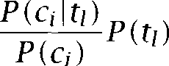

**I**



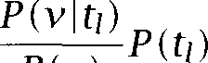

We then use a threshold in line 7 to determine which thesaurus cat- egories are salient in a context. A fairly large value for this threshold should be chosen so that only contexts with good evidence for a category are assigned.

***1*** comment: Categorize contexts based on categorization of words

***2* for** all contexts in the corpus do

***3* for** all thesaurus categories do



***4 ***  ***=***

***5*** end

***6*** end

***7 ***  

***8*** comment: Categorize words based on categorization of contexts

***9*** for all words in the vocabulary do



***10*** *Vj* in ***C }***

end

***12*** for all topics do

***13 *** =  

***14*** end

***15*** for all words all topics do



***16 ***   

***17*** end

***18*** for all topics do



***19 ***   



***20*** end

***21*** comment: Disambiguation

***22*** for all senses of occurring in c do

***23***



***24*** end

***25*** choose s.t. = argmax,, score(&)

Figure 7.5 Adaptive thesaurus-based disambiguation. Yarowsky’s algorithms for adapting a semantic categorization of words and for thesaurus-based biguation. on line 16 is estimated as the proportion of contexts of topic



that contain word

Now we can adjust the semantic categorization in the thesaurus to our corpus (represented as the set of contexts  On line 16, we estimate

as the proportion of contexts of that are in category If



is covered in the thesaurus, then this will adapt  semantic categories to the corpus (for example, stylus may get a high score as a computer term even though the thesaurus only lists it in the category ‘writing’). If is not covered, then it will be added to the appropriate categories (the

|  |  |  |  |
| --- | --- | --- | --- |
| Word | Sense | Roget category | Accuracy |
| *bass* | musical senses | **MUSIC** | 99% |
|  | fish | **ANIMAL, INSECT** | 100% |
| *star* | space object | **UNIVERSE** | 96% |
|  | celebrity | **ENTERTAINER** | 95% |
|  | star shaped object | **INSIGNIA** | 82% |
| *interest* | curiosity | **REASONING** | 88% |
|  | advantage | **INJUSTICE** | 34% |
|  | financial | **DEBT** | 90% |
|  | share | **PROPERTY** | 38% |

Table 7.6 Some results of thesaurus-based disambiguation. The table shows the senses of three ambiguous words, the Roget categories they correspond to, and the accuracy of the algorithm in figure 7.5. Adapted from (Yarowsky 1992).

**TOPIC-INDEPENDENT**

**DISTINCTIONS**

case of *Navratilova).* The prior probability of is simply computed as its relative frequency, adjusted for the fact that some contexts will have no semantic categories and others more than one (line 19).

The values computed on line 16 are then used for  tion in analogy to the Bayesian algorithm we discussed earlier (see fig- ure 7.1). Yarowsky (1992) recommends smoothing for some of the maxi- mum likelihood estimates (see chapter 6).



Table 7.6 shows some results from (Yarowsky 1992). The method achieves high accuracy when thesaurus categories and senses align well with topics as in the case of *bass* and *star.* When a sense is spread out over several topics, the algorithm fails. Yarowsky calls these  *independent distinctions* between senses. For example, the sense ‘advan- tage’ of *interest* (as in *self-interest)* is not topic-specific. Self-interest can occur in music, entertainment, space exploration, finance, etc. Therefore, a topic-based classification does not do well on this sense.

Disambiguation based on translations in a second-language corpus

The third dictionary-based algorithm makes use of word corresponden- ces in a bilingual dictionary (Dagan et al. 1991; Dagan and Itai 1994). We will refer to the language of application (the one for which we want

Sense 1 Sense 2

Definition legal share attention, concern

Translation *Beteiligung Interesse* English collocation *acquire an interest show interest* Translation *Beteiligung erwerben Interesse zeigen*

Table *7.7* How to disambiguate *interest* using a second-language corpus.

to do disambiguation) as the *first language* and the target language in the bilingual dictionary as the *second language.* For example, if we want to disambiguate English based on a German corpus, then English is the first language, German is the second language, and we need an  German dictionary (one with English headwords and German entries).

The basic idea of Dagan and Itai’s algorithm is best explained with the example in table 7.7. English *interest* has two senses with two different translations in German. Sense 1 translates as *Beteiligung (legal share,* as in “a 50% interest in the company”) and Sense 2 translates as *Interesse (attention, concern,* as in “her interest in mathematics”). (There are other senses of *interest* which we will ignore here.) In order to disambiguate an occurrence of *interest* in English, we identify the phrase it occurs in and search a German corpus for instances of the phrase. If the phrase occurs with only one of the translations of *interest* in German, then we assign the corresponding sense whenever *interest* is used in this phrase.

As  suppose *interest* is used in the phrase *showed interest.* The German translation of *show,* ‘zeigen,’ will only occur with *Interesse* since “legal shares” are usually not shown. We can conclude that *interest* in the phrase *to show interest* belongs to the sense *attention, concern.* On the other hand, the only frequently occurring translation of the phrase *acquired interest* is *eine Beteiligung,* since *interest* in the sense ‘attention, concern’ is not usually acquired. This tells us that a use of *interest* as the object of *acquire* corresponds to the second sense, “legal share.”

A simple implementation of this idea is shown in figure 7.6. For the above example the relation *R* is ‘is-object-of’ and the goal would be to ambiguate *interest* in *R (interest, show).* To do this, we count the number of times that translations of the two senses of *interest* occur with trans- lations of *show* in the second language corpus. The count of

*zeigen)* would be higher than the count of *R * *zeigen), so we*



**comment:** Given: a context c in which w occurs in relation *R v)*

**for** all senses of w **do**

***3 *** ***= T ( V ) : ***



***4* end**

***5*** choose = argmax,, 

Figure 7.6 Disambiguation based on a second-language corpus. is the second-language corpus,  is the set of possible translations of sense

and T(v) is the set of possible translations of v. The score of a sense is the number of times that one of its translations occurs with translations of v in the second-language corpus.

would choose the sense ‘attention, concern,’ corresponding to The algorithm used by Dagan and Itai is more complex: it

biguates only if a decision can be made reliably. Consider the example of Hebrew which has two possible English translations, and head. Dagan and Itai found 10 examples of the relation stand at head and 5 examples of the relation ***stand at*** in their English second-language corpus. This suggests that *stand head* is more likely to translate the Hebrew phrase correctly. However, we can expect “stand at head” to be incorrect in a large proportion of the translations (approxi- mately  0.33). In many cases, it is better to avoid a decision than to make an error with high probability. In a large system in which each com- ponent has a certain error rate, an accuracy of about 0.67 as in the above example is unacceptable. If a sentence passes through five components, each with an error rate of 0.33, then overall system accuracy could be as low as 14%: (1 0.14. Dagan and Itai show how the probability of error can be estimated. They then make decisions only when the level of confidence is 90% or higher.



* + 1. One sense per discourse, one sense per collocation

The dictionary-based algorithms we have looked at so far process each occurrence separately. But there are constraints between different occur- rences that can be exploited for disambiguation. This section discusses work by Yarowsky (1995) which has on two such constraints:

**One sense per discourse.** The sense of a target word is highly consis- tent within any given document.

**2.50**

Discourse Initial label

 living living

***7 Word Sense Disambiguation***

Context

the existence of plant and animal life classified as either  or animal

Although bacterial and plant cells are enclosed

 living contains a varied plant and animal life living the most common  life

living slight within Arctic plant species

factory are protected by plant parts remaining from

Table ***7.8*** Examples of the one sense per discourse constraint. The table shows contexts from two different documents,  and  One context in  lacks suffi- cient local information for disambiguation  Local information is misleading for the last context in  The one sense per discourse constraint can be used to counteract lacking or misleading information in such cases. It will correctly assign the unclassified and the misclassified contexts to ‘living.’ Adapted from  1995).

 **One sense per collocation.** Nearby words provide strong and con- sistent clues to the sense of a target word, conditional on relative distance, order and syntactic relationship.

an example for the first constraint consider the word  The constraint captures the intuition that if the first occurrence of plant is a use of the sense ‘living being,’ then later occurrences are likely to refer to living beings too. Table 7.8 shows two examples. This constraint is especially usable when the material to be disambiguated is a collection of small documents, or can be divided into short ‘discourses’ by the kind of method discussed in section 15.5. Then, this simple property of word senses can be used quite effectively as we will see below.

The second constraint makes explicit the basic assumption that most work on statistical disambiguation relies on: that word senses are strongly correlated with certain contextual features like other words in the same phrasal unit. Yarowsky’s (1995) approach is similar to Brown et information-theoretic method, which we introduced in section 7.2.2, in that he selects the strongest collocational feature for a particular context and disambiguates based only on this feature.



features are ranked according to the following ratio:

(7.8)



* 1. ***Dictionary-Based Disambiguation 2.51***

which basically is the ratio of the number of occurrences of sense with collocation  divided by the number of occurrences of sense with col- location  (again, smoothing is important if the collocation and/or senses occur infrequently, see Yarowsky (1994)).

Relying on only the strongest feature has the advantage that no inte- gration of different sources of evidence is necessary. Many statistical methods, such as the Naive Bayes method used in section or the dictionary-based methods presented earlier in this section, assume inde- pendence when evidence is combined. Since independence rarely holds, it is sometimes better to avoid the need for combining evidence altogether, and to rely on just one reliable piece of evidence. The more complex alternative is to accurately model the dependencies between sources of evidence (see chapter 16).

Figure 7.7 is a schematic description of an algorithm proposed by Yarowsky that combines both constraints. The algorithm iterates build- ing two interdependent sets for each sense contains characteristic collocations.  is the set of contexts of the ambiguous word w that are currently assigned to



On 3,  is initialized from the dictionary definition of or from another source (for example, a set of collocations entered manually by a lexicographer or a set of collocations from a small hand-labeled training set).  is initially empty.

The iteration begins by assigning all contexts with a characteristic col- location (line 11). For example, all Of



in which is the object of the verb ***show*** would be assigned to if “is the object of ***show”*** is one of the collocations in The set of characteristic collocations is then recomputed



by selecting those collocations that are most characteristic of the just up- dated (line 14).

After this part of the algorithm has been completed, the constraint “one sense per discourse” is applied. All instances of the ambiguous word w are assigned to the majority sense in a document or discourse (line 20). Table 7.8 gave two examples of this process.

Yarowsky demonstrates that this algorithm is highly effective. Differ- ent versions achieve between 90.6% and 96.5% accuracy. The error rate is reduced by 27% when the discourse constraint (lines 18-21) is incorpo- rated. This is a surprisingly good performance given that the algorithm does not need a labeled set of training examples.



*252* ***7 Word Sense Disambiguation***

***1* comment:** Initialization

***2* for** all senses of w **do**

***3 =* the** set of collocations in dictionary definition

***4* end**

***5* for all senses of w do**

***6* =**

***7* end**

***8* comment:** One sense per collocation

***9*** while (at least one changed in the last iteration) **do**

***10* for all senses of w do**

***11 ***

***12* end**

***13* for all senses of w do**

***14* = **



***15* end**

***16* end**

***17* comment:** One sense per discourse

***18* for all documents do**

***19* determine the majority sense of w in**

***20* assign all occurrences of in to**

***21* end**

**Figure 7.7** Disambiguation based on “one sense per collocation” and sense per discourse.”

#### Unsupervised Disambiguation

All that the methods discussed in the last section require for  tion are basic lexical resources, a small training set, or a few collocation Although this seems little to ask for, there are situations in which

even such a small amount of information is not available. In particular, this is often the case when dealing with information from specialized domains, for which there may be no available lexical  For example, information retrieval systems must be able to deal with text collections from any subject area. General dictionaries are less useful for domain-specific collections. A data base of chemical abstracts mostly

1. However, there are specialized dictionaries in some fields, such as for medical and scientific terms.

contains documents that belong to the category “chemistry” in a generic semantic classification. A generic thesaurus-based disambiguation algo- rithm would therefore be of little use. One cannot expect the user of an information retrieval system to define the senses of ambiguous words or to provide a training set for a new text collection. With the surge in on- line material in recent years, there is an increasing number of scenarios where outside sources of information are not available for  tion.

Strictly speaking, completely unsupervised disambiguation is not

**SENSE TAGGING** sible if we mean tagging: an algorithm that labels occurrences as belonging to one sense or another. Sense tagging requires that some characterization of the senses be provided. However, sense *discrimina- tion* can be performed in a completely unsupervised fashion: one can cluster the contexts of an ambiguous word into a number of groups and discriminate between these groups without labeling them. Several such sense discrimination algorithms have been proposed. We will describe

**CONTEXT-GROUP** one of them here, *context-group discrimination,* largely following

 Note also the similarity to Brown et al.‘s approach described in section 7.22. Brown et al.  cluster *translations* of an ambiguous word, which can be thought of as a type of prelabeling of the occurrences of the ambiguous word w. Here, we will look at a completely unsuper- vised algorithm that clusters unlabeled occurrences.

The probabilistic model is the same as that developed by Gale et al. (section 7.2.1). For an ambiguous word w with senses . . , . . ,

we estimate the conditional probability of each word occurring in a context where w is being used in a particular sense that is,  

In contrast to Gale et Bayes classifier, parameter estimation in un-

supervised disambiguation is not based on a labeled training set. Instead, we start with a random initialization of the parameters The are then reestimated by the EM algorithm (see section 14.2.2). After the random initialization, we compute for each context of w the probability that it was generated by sense We can use this preliminary categorization of the contexts as our training data and then reestimate the parameters **so** as to maximize the likelihood of the data given the model. The algorithm is developed in figure 7.8.



The EM algorithm is guaranteed to increase the log likelihood of the

1. For consistency we reuse the probabilistic model introduced in section 7.2.1 and sec- tion 7.3.2, instead of
   1. ***7 Word Sense Disambiguation***
      1. Initialize the parameters of the model randomly. The parameters are  1 1 ***k K,*** and 1 ***k K.***



Compute the log of the likelihood of the corpus C given the model as the product of the probabilities of the individual contexts (where  *=*



*K*



***K***

i=l



k=l

While is improving repeat:



* + - 1. E-step. For 1 ***k K,*** 1 estimate  the posterior probabil- ity that generated *Ci,* as follows:



To compute *we* make the by now familiar Naive Bayes as- sumption:





 M-step. Re-estimate the parameters and  by way of maximum likelihood estimation:





where sums over all contexts in which occurs and  =



 is a normalizing

Recompute the probabilities of the senses as follows:



Figure ***7.8 An*** EM algorithm for learning a word sense clustering. ***K*** is the num- ber of desired senses; are the contexts of the ambiguous word in the corpus; and are the words being used as disambiguating features.



model given the data in each step. Therefore, the stopping criterion for the algorithm is to stop when the likelihood (computed in step 1) is no longer increasing significantly.

Once the parameters of the model have been estimated, we can

biguate contexts of w by computing the probability of each of the senses based on the words occurring in the context. Again, we make the Naive Bayes assumption and use the Bayes decision rule (7.5):

Decide ifs’ =

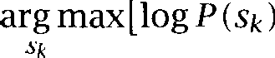

*v, EC*

The granularity of the sense classification of an ambiguous word can be chosen by running the algorithm for a range of values for K, the number of senses. The more senses there are, the more structure the model has, and therefore it will be able to explain the data better. As a result the best possible log likelihood of the model given the data will be higher with each new sense added. However, one can examine by how much the log likelihood increases with each new sense. If it increases strongly because the new sense explains an important part of the data, then this suggests that the new number of senses is justified. If the log likelihood increases only moderately, then the new sense only picks up random variation in the data and it is probably not 

A simpler way to determine the number of senses is to make it de- pendent on how much training material is available. This approach is justified for an information retrieval application by Schiitze and Pedersen (1995).

An advantage of unsupervised disambiguation is that it can be eas- ily adapted to produce distinctions between usage types that are more fine-grained than would be found in a dictionary. Again, information re- trieval is an application for which this is useful. The distinction between physical banks in the context of bank robberies and banks as abstract corporations in the context of corporate mergers can be highly relevant even if it is not reflected in dictionaries.

If the unsupervised algorithm is run for a large number of senses, say ***K =*** 20, then it will split dictionary senses into fine-grained contextual variants. For example, the sense ‘lawsuit’ of ***suit*** could be split into ‘civil suit, ‘criminal suit,’ etc. Usually, the induced clusters do not line up well with dictionary senses. Infrequent senses and senses that have few

7. One could choose the optimal number of senses automatically by testing on validation data, as discussed in chapter 6.

Word Sense Accuracy

|  |  |  |  |
| --- | --- | --- | --- |
| *suit* | lawsuit | 95 | 0 |
|  | the suiytou wear | 96 | 0 |
| *motion* | physical movement | 85 | 1 |
|  | proposal for action | 88 | 13 |
| *train* | line of railroad cars | 79 | 19 |
|  | to teach | 55 | 31 |

Table 7.9 Some results of unsupervised disambiguation. The table shows the mean and standard deviation for ten experiments with different initial conditions for the EM algorithm. Data are from 1998: 110).

collocations are hard to isolate in unsupervised disambiguation. Senses like the use of *suit* in the sense ‘to be appropriate for’ as in *This suits me fine* are unlikely to be discovered. However, such hard to identify senses often carry less content than senses that are tied to a particular subject area. For an information retrieval system, it is probably more important to make the distinction between usage types like ‘civil suit’ vs. ‘criminal suit’ than to isolate the verbal sense ‘to suit.’

Some results of unsupervised disambiguation are shown in table 7.9. We need to take into account the variability that is due to different ini- tializations here (Step 1 in figure 7.8). The table shows both the average accuracy and the standard deviation over ten trials. For senses with a clear correspondence to a particular topic, the algorithm works well and variability is low. The word *suit* is an example. But the algorithm fails for words whose senses are topic-independent such as ‘to teach’ for *train* this failure is not unlike other methods that work with topic information only. In addition to the low average performance, variability is also quite high for topic-independent senses. In general, performance is 5% to 10% lower than that of some of the dictionary-based algorithms as one would expect given that no lexical resources for training or defining senses are used.

##### 7.5 What Is a Word Sense?

Now that we have looked at a wide range of different approaches to word sense disambiguation, let us revisit the question of what precisely a word

***What Is a Word Sense? 2.57***

**SKEWED DISTRIBUTION**

sense is. It would seem natural to define senses as the mental representa- tions of different meanings of a word. But given how little is known about the mental representation of meaning, it is hard to design experiments that determine how senses are represented by a subject. Some studies ask subjects to cluster contexts. The subject is given a pile of index cards, each with a sentence containing the ambiguous word, and instruc- tions to sort the pile into coherent subgroups. While these experiments have provided many insights (for example, for research on the notion of semantic similarity, see Miller and Charles  it is not clear how well they model the use of words and senses in actual language comprehen- sion and production. Determining linguistic similarity is not a task that people are confronted with in natural situations. Agreement between clusterings performed by different subjects is low (Jorgensen 1990).

Another problem with many psychological experiments on ambiguity is that they rely on introspection and whatever folk meaning a subject as- sumes for the word ‘sense.’ It is not clear that introspection is a valid methodology for getting at the true mental representations of senses since it fails to elucidate many other phenomena. For example, peo- ple tend to rationalize non-rational economic decisions (Kahneman et al. 1982).

The most frequently used methodology is to adopt the sense defini- tions in a dictionary and then to ask subjects to label instances in a cor- pus based on these definitions. There are different opinions on how well this technique works. Some researchers have reported high agreement between judges (Gale et al. 1992a) as we discussed above. High average agreement is likely if there are many ambiguous words with a skewed distribution, that is, one sense that is used in most of the occurrences. Sanderson and van Rijsbergen (1998) argue that such skewed distribu- tions are typical of ambiguous words.

However, randomly selecting ambiguous words as was done in (Gale et al. 1992a) introduces a bias which means that their figures may not reflect actual inter-judge agreement. Many ambiguous words with the highest disagreement rates are high-frequency words. So on a per-token basis inter-judge disagreement can be high even if it is lower on a

type basis. In a recent experiment, Jean Veronis  1998) found that there was not a single instance of the frequent French words ***correct,*** and  with complete agreement among



judges. The main reasons Veronis found for inter-judge disagreement were vague dictionary definitions and true ambiguity in the corpus.



Can we write dictionaries that are less vague? Fillmore and Atkins (1994) discuss such issues from a lexicographic perspective. Some au- thors argue that it is an inherent property of word meaning that several

**CO-ACTIVATION** senses of a word can be used simultaneously or co-activated (Kilgarriff 1993; Schutze 1997; Kilgarriff  which entails high rates of

judge disagreement. Of course, there are puns like (7.9) in which multiple senses are used in a way that seems so special that it would be acceptable for an NLP system to fail:

(7.9) In AI, much of the I is in the beholder.

But Kilgarriff (1993) argues that such simultaneous uses of senses are quite frequent in ordinary language. An example is (7.10) where arguably two senses of  are invoked: ‘the act of competing’ and ‘the competitors.’

(7.10) For better or for worse, this would bring competition to the licensed trade.

**SYSTEMATIC** Many cases of ‘coactivation’ are cases of systematic polysemy,

**POLYSEMY** semantic rules that apply to a class of words and systematically change or extend their meaning. (See (Apresjan  (Pustejovsky  (Lakoff (Ostler and Atkins and Zaenen  and  take and Briscoe 1995) for theoretical work on systematic polysemy and (Buitelaar 1998) for a recent computational study.) The word competi- *tion* is a case in point. A large number of English words have the same meaning alternation between ‘the act of X’ vs. ‘the people doing X’. For example, *organization, administration,* and *formation* also exhibit it.



A different type of systematic ambiguity that cannot be neglected in practice is that almost all words can also be used as proper nouns, some of them frequently. Examples are *Brown, Bush,* and *Army.*

One response to low inter-judge agreement and the low performance of disambiguation algorithms for highly ambiguous words is to only con- sider coarse-grained distinctions, for example only those that manifest themselves across languages (Resnik and Yarowsky 1998). Systematic polysemy is likely to be similar in many languages, so we would not dis- tinguish the two related senses of *competition* (‘the act of competing’ and ‘the competitors’) even if a monolingual dictionary lists them as differ- ent. This strategy is similar to ones used in other areas of NLP, such as parsing, where one defines an easier problem, shallow parsing, and does

* 1. *What Is a Word Sense? 2.59*

not attempt to solve the hardest problem, the resolution of attachment ambiguities.

Clustering approaches to word sense disambiguation (such as

group disambiguation) adopt the same strategy. By definition, automatic clustering will only find groups of usages that can be successfully distin- guished. This amounts to a restriction to a subpart of the problem that can be solved. Such solutions with a limited scope can be quite useful. Many translation ambiguities are coarse, so that a system restricted to coarse sense distinctions is sufficient. Context-group disambiguation has been successfully applied to information retrieval  and Pedersen 1995).

Such application-oriented notions of sense have the advantage that it is easy to evaluate them as long as the application that disambiguation is embedded in can be evaluated (for example, translation accuracy for machine translation, the measures of recall and precision introduced in chapter 8 for information retrieval). Direct evaluation of  tion accuracy and comparison of different algorithms is more difficult, but will be easier in the future with the development of standard evalu- ation sets. See Mooney (1996) for a comparative evaluation of a number of machine learning algorithms and Towel1 and Voorhees (1998) for the evaluation of a disambiguator for three highly ambiguous words ***(hard, serve,*** and line). A systematic evaluation of algorithms was undertaken as part of the project (unfortunately, after the writing of this chapter). See the

Another factor that influences what notion of sense is assumed, al- beit implicitly, is the type of ***information*** that is used in disambiguation: co-occurrence (the bag-of-words model), relational information (subject, object, etc.), other grammatical information (such as part-of-speech), col- locations (one sense per collocation) and discourse (one sense per dis- course). For example, if only co-occurrence information is used, then only ‘topical’ sense distinctions are recognized, senses that are associ- ated with different domains. The inadequacy of the bag-of-words model for many sense distinctions has been emphasized by Justeson and Katz (1995a). et al. (1998) look at the combination of topical and locational information and achieve optimal results when both are used. Choueka and Lusignan (1985) show that humans do surprisingly well at sense discrimination if only a few words of adjacent context are shown

giving more context contributes little to human disambiguation perfor- mance. However, that does not necessarily mean that wider context is

useless for the computer. Gale et al. (1992b) show that there is addi- tional useful information in the context out to about 50 words on either side of the ambiguous word (using their algorithm), and that there is de- tectable information about sense distinctions out to a very large distance (thousands of words).

Different types of information may be appropriate to different degrees for different parts of speech. Verbs are best disambiguated by their ar- guments (subjects and objects), which implies the importance of local information. Many nouns have topically distinct word senses (like *suit* and ***bank) so*** that a wider context is more likely to be helpful.

Much research remains to be done on word sense disambiguation. In particular, it will become necessary to evaluate algorithms on a represen- tative sample of ambiguous words, an effort few researchers have made so far. Only with more thorough evaluation will it be possible to fully un- derstand the strengths and weaknesses of the disambiguation algorithms introduced in this chapter.

#### 7.6

**SENTENCE BOUNDARY IDENTIFICATION**

#### Further Reading

An excellent recent discussion of both statistical and non-statistical work on word sense disambiguation is (Ide and 1998). See also (Guthrie et al. 1996). An interesting variation of word sense disambiguation is sen- *tence boundary identification* (section 4.2.4). The problem is that periods in text can be used either to mark an abbreviation or to mark the end of a sentence. Palmer and Hearst (1997) show how the problem can be cast as the task of disambiguating two ‘senses’ of the period: ending an abbreviation vs. ending a sentence or both.

The common thread in this chapter has been the amount and type of lexical resources used by different approaches. In these remarks, we will first mention a few other methods that fit under the rubrics of su- pervised, dictionary-based, and unsupervised disambiguation, and then work that did not fit well into our organization of the chapter.

Two important supervised disambiguation methods are *k* nearest neighbors  also called memory-based learning (see page 295) and loglinear models. A nearest neighbor disambiguator is introduced in (Dagan et al. 1994, 1997b). The authors stress the benefits of ap- proaches for sparse data. See also (Ng and Lee 1996) and (Zavrel and Daelemans 1997). Decomposable models, a type of loglinear model, can

* 1. *Further Reading 261*

be viewed as a generalization of Naive Bayes. Instead of treating all features as independent, features are grouped into mutually dependent subsets. Independence is then assumed only between features in dif- ferent subsets, not for all pairs of features as is the case in the Naive Bayes classifier. Bruce and Wiebe (1994) apply decomposable models to disambiguation with good results.

Other disambiguation algorithms that rely on lexical resources are (Karov and Edelman  (Guthrie et al.  and et al. 1998). Karov and Edelman (1998) present a formalism that takes advantage of evidence both from a corpus and a dictionary, with good  tion results. Guthrie et al. (1991) use the subject field codes in (Procter 1978) in a way similar to the thesaurus classes in (Yarowsky 1992).

et al. (1998) apply transformation-based learning (see section 10.4.1) to tag ambiguous words with thesaurus categories.

Papers that use clustering include (Pereira et al. 1993; Zernik  Dolan 1994; Pedersen and Bruce 1997; Chen and Chang 1998). Pereira et al, (1993) cluster contexts of words in a way similar to



but based on a different formalization of clustering. They do not di- rectly describe a disambiguation algorithm based on the clustering result, but since in this type of unsupervised method assignment to clusters is equivalent to disambiguation, this would be a straightforward extension. See section 14.1.4 for the clustering algorithm they use. Chen and Chang (1998) and Dolan (1994) are concerned with constructing representations for senses by combining several subsenses into one ‘supersense.’ This type of clustering of subsenses is useful for constructing senses that are coarser than those a dictionary may provide and for relating sense defi- nitions between two dictionaries.

An important issue that comes up in many different approaches to disambiguation is how to combine different types of evidence  1992). See (Cottrell 1989; Hearst 1991; Alshawi and Carter 1994; Wilks and Stevenson 1998) for different proposals.

Although we only cover statistical approaches here, work on word sense disambiguation has a long tradition in Artificial Intelligence and Computational Linguistics. Two often-cited contributions are (Kelly and Stone  a hand-constructed rule-based disambiguator, and (Hirst  who exploits selectional restrictions for disambiguation. An ex- cellent overview of non-statistical work on disambiguation can be found in the above-mentioned (Ide and 1998).

#### Exercises

**Exercise** *7.1*

The lower bound of disambiguation accuracy depends on how much information is available. Describe a situation in which the lower bound could be lower than the performance that results from classifying all occurrences of a word as in- stances of its most frequent sense. (Hint: What knowledge is needed to calculate that lower bound?)

**Exercise** 7.2

Supervised word sense disambiguation algorithms are quite easy to devise and train. Either implement one of the models discussed above, or design your own and implement it. How good is the performance? Training data are available from the Linguistic Data Consortium (the DSO corpus) and from the

project (semcor). See the for links to both.

**Exercise 7.3**

Create an artificial training and test set using pseudowords. Evaluate one of the supervised algorithms on it.

**Exercise 7.4**

Download a version of Roget’s thesaurus from the web (see the website), and implement and evaluate a thesaurus-based algorithm.

**Exercise 7.5**

The two supervised methods differ on two different dimensions: the number of features used (one vs. many) and the mathematical methodology (informa- tion theory vs. Bayesian classification). How would one design a Bayes classifier that uses only one feature and an information-theoretic method that uses many features?

**Exercise 7.6**

In light of the discussion on closely related and ‘co-activated’ senses, discuss to what extent pseudowords model ambiguity well.

Exercise 7.7 

Lesk’s algorithm counts how many words are shared between sense definition and context. This is not optimal since reliance on “nondescript” or stop words like or *especially* can result in misclassifications. Try to come up with refine- ments of Lesk’s algorithm that would weight words according to their expected value in discrimination.

**Exercise 7.8**

Two approaches use only one feature: information-theoretic disambiguation and Yarowsky’s (1995) algorithm. Discuss differences and other similarities between the two approaches.

*7.7 Exercises* 263

Exercise 7.9 

Discuss the validity of the “one sense per discourse” constraint for different types of ambiguity (types of usages, homonyms etc.). Construct examples where the constraint is expected to do well and examples where it is expected to do poorly.

Exercise 7.10 

Evaluate the one sense per discourse constraint on a corpus. Find sections or articles with multiple uses of an ambiguous word, and work out how often they have different senses.

Exercise 7.11 

The section on unsupervised disambiguation describes criteria for determining the number of senses of an ambiguous word. Can you think of other criteria? Assume (a) that a dictionary is available (but the word is not listed in it);  that a thesaurus is available (but the word is not listed in it).

Exercise 7.12 

For a pair of languages that you are familiar with, find three cases of an ambigu- ous word in the first language for which the senses translate into different words and three cases of an ambiguous words for which at least two senses translate to the same word.

Exercise 7.13 

Is it important to evaluate unsupervised disambiguation on a separate test set or does the unsupervised nature of the method make a distinction between training and test set unnecessary? (Hint: It can be important to have a separate test set. Why? See  1998: 1081.)

Exercise 7.14 

Several of the senses of discussed in the beginning of the chapter are related by systematic polysemy. Find other words with the same systematic polysemy.

Exercise 7.15 

Pick one of the disambiguation algorithms and apply it to sentence boundary identification.



***“There is one, yt is called in the tongue Durion, and is so good that.. it doth in savour all others that euer they had seene, or tasted.***

***(Parke tr. Mendoza’s Hist. China 393,***

*Lexical Acquisition*

THE TOPIC of chapter 5 was the acquisition of *collocations,* phrases and other combinations of words that have a specialized meaning or some other special behavior important in NLP. In this chapter, we will cast our net more widely and look at the acquisition of more complex syntactic

**LEXICAL ACQUISITION** and semantic properties of words. The general goal of lexical acquisition is to develop algorithms and statistical techniques for filling the holes in existing machine-readable dictionaries by looking at the occurrence patterns of words in large text corpora. There are many lexical acquisi- tion problems besides collocations: selectional preferences (for example, the verb eat usually takes food items as direct objects), subcategorization frames (for example, the recipient of *contribute* is expressed as a preposi- tional phrase with *to),* and semantic categorization (what is the semantic category of a new word that is not covered in our dictionary?). While we discuss simply the ability of computers to learn lexical information from online texts, rather than in any way attempting to model human language acquisition, to the extent that such methods are successful, they tend to undermine the classical Chomskyan arguments for an innate language faculty based on the perceived poverty of the stimulus.

Most properties of words that are of interest in NLP are not fully cov- ered in machine-readable dictionaries. This is because of the productivity of natural language. We constantly invent new words and new uses of old words. Even if we could compile a dictionary that completely covered the language of today, it would inevitably become incomplete in a matter of months. This is the reason why lexical acquisition is so important in Statistical NLP.

**LEXICAL** A brief discussion of what we mean by *lexical* and the *lexicon* is in

**LEXICON** order. Trask (1993: 159) defines the lexicon as:

**LEXICAL ENTRIES** That part of the grammar of a language which includes the *lexical* entries for all the words and/or morphemes in the language and which may also include various other information, depending on the particular theory of grammar.

The first part of the definition (“the lexical entries for all the words”) suggests that we can think of the lexicon as a kind of expanded diction- ary that is formatted so that a computer can read it (that is,

readable). The trouble is that traditional dictionaries are written for the needs of human users, not for the needs of computers. In particular, quantitative information is completely missing from traditional dictio- naries since it is not very helpful for the human reader. So one important task of lexical acquisition for Statistical NLP is to augment traditional dictionaries with quantitative information.

The second part of the definition (“various other information, depend- ing on the particular theory of grammar”) draws attention to the fact that there is no sharp boundary between what is lexical information and what is non-lexical information. A general syntactic rule like S NP VP is definitely non-lexical, but what about ambiguity in the attachment of prepositional phrases? In a sense, it is a syntactic problem, but it can be resolved by looking at the lexical properties of the verb and the noun that compete for the prepositional phrase as the following example shows:

(8.1) a. The children ate the cake with their hands.

b. The children ate the cake with blue icing.

We can learn from a corpus that eating is something you can do with your hands and that cakes are objects that have icing as a part. After acquiring these lexical dependencies between ate and hands and cake and *icing, we* can correctly resolve the attachment ambiguities in example **(8.1)** such that *with hands* attaches to *ate* and *with blue icing* attaches to *cake.*

In a sense, almost all of Statistical NLP involves estimating parameters tied to word properties, so a lot of statistical NLP work has an element of lexical acquisition to it. In fact, there are linguistic theories claim- ing that all linguistic knowledge is knowledge about words (Dependency Grammar (Mel’?uk  Categorial Grammar (Wood  Tree Adjoin- ing Grammar (Schabes et al. 1988; ‘Radical Lexicalism’  tunen 1986)) and all there is to know about a language is the lexicon, thus completely dispensing with grammar as an independent entity. In gen- eral, those properties that are most easily conceptualized on the level



***8.1 Evaluation Measures*** 267

of the individual word are covered under the rubric ‘lexical acquisition.’ We have devoted separate chapters to the acquisition of collocations and word sense disambiguation simply because these are self-contained and warrant separate treatment as central problems in Statistical NLP. But they are as much examples of lexical acquisition as the problems covered in this chapter.

The four main areas covered in this chapter are verb subcategorization (the syntactic means by which verbs express their arguments), attach- ment ambiguity (as in example  selectional preferences (the seman- tic characterization of a verb’s arguments such as the fact that things that get eaten are usually food items), and semantic similarity between words. However, we first begin by introducing some evaluation measures which are commonly used to evaluate lexical acquisition methods and various other Statistical NLP systems, and conclude with a more in-depth discussion of the significance of lexical acquisition in Statistical NLP and some further readings.

#### 8.1 Evaluation Measures

An important recent development in NLP has been the use of much more rigorous standards for the evaluation of systems. It is generally agreed that the ultimate demonstration of success is showing improved performance at an application task, be that spelling correction, summa- rizing job advertisements, or whatever. Nevertheless, while developing systems, it is often convenient to assess components of the system on some artificial performance score (such as perplexity), improvements in which one can expect to be reflected in better performance for the whole system on an application task.

Evaluation in Information Retrieval (IR) makes frequent use of the no- tions of precision and recall, and their use has crossed over into work on evaluating Statistical NLP models, such as a number of the systems discussed in this chapter. For many problems, we have a set of targets (for example, targeted relevant documents, or sentences in which a word has a certain sense) contained within a larger collection. Our system then decides on a selected set (documents that it thinks are relevant, or sen- tences that it thinks contain a certain sense of a word, etc.). This situation is shown in figure 8.1. The selected and target groupings can be thought

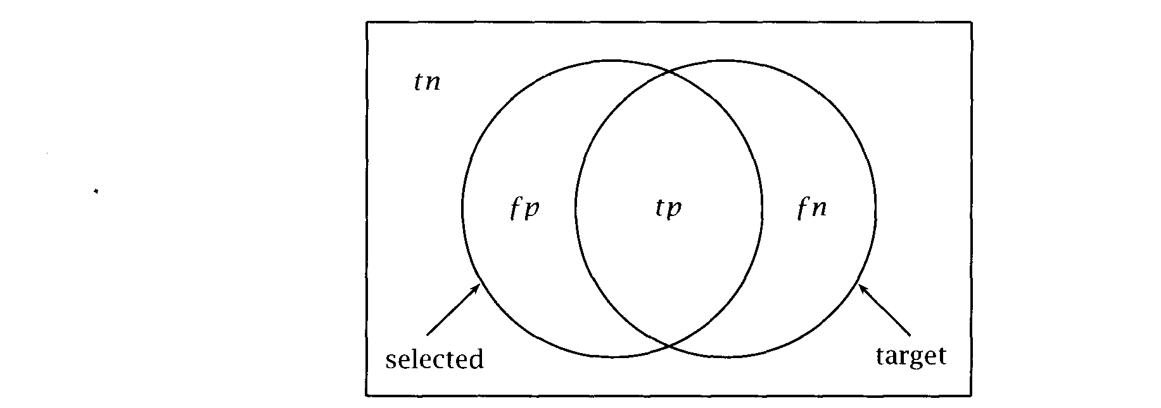

**Figure 8.1** A diagram motivating the measures of precision and recall. The areas counted by the figures for true and false positives and true and false negatives are shown in terms of the target set and the selected set. Precision is the proportion of target (or correct) items in the selected (or retrieved) set. Recall is the proportion of target items that were selected. In turn, = ***tp + fp,*** and  = ***tp + fn).***



of as indicator random variables, and the joint distribution of the two variables can be expressed as a 2x2 contingency matrix:

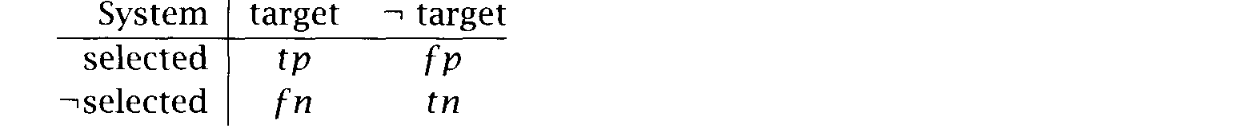

The numbers in each box show the frequency or count of the number of **TRUE POSITIVES** items in each region of the space. The cases accounted for by ***(true* TRUE NEGATIVES positives)** and ***(true negatives)*** are the cases our system got right. The **FALSE POSITIVES** wrongly selected cases in  are called  positives,  acceptances **T YPE II ERRORS** or Type ***errors.*** The cases in *f* that failed to be selected are called

**FALSE NEGATIVES TYPE ERRORS PRECISION**

***negatives, false rejections*** or ***Type I errors.***

Precision is defined as a measure of the proportion of selected items that the system got right:

(8.3) precision =



***+***

**RECALL *Recall*** is defined as the proportion of the target items that the system

8.1 Evaluation Measures

selected:

*(8.4)* recall =



In applications like IR, one can generally trade off precision and re- call (one can select every document in the collection and get 100% recall but very low precision, etc.). This tradeoff can be plotted in a  recall curve, as we illustrate in section 15.1.2. Sometimes such a tradeoff doesn’t make as much sense in NLP applications, but in any situation where there are some items that one is more sure of than others (such as in subcategorization frame learning in section  the same opportuni- ties for trading off precision vs. recall exist.

For this reason it can be convenient to combine precision and recall into

***F* MEASURE** a single measure of overall performance. One way to do this is the *F*

**MEASURE** *sure,* a variant of the *measure* introduced by van Rijsbergen (1979: where *F = E.* The *F* measure is defined as follows:

(8.5) *F =* 1



**(1**

where is precision, *R* is recall and is a factor which determines the weighting of precision and recall. A value of = 0.5 is often chosen for equal weighting of and *R.* With this value, the *F* measure simplifies to



A good question to ask is: “Wait a minute, in the table in



is the number of things I got right, and is the number of things I got wrong. Why don’t we just report the percentage of things right or the percentage of things wrong. One can do that, and these measures



**ACCURACY** are known as *accuracy* and *error.* But it turns out that these often aren’t **ERROR** good measures to use because in most of the kinds of problems we look at the number of non-target, non-selected things, is huge, and dwarfs

all the other numbers. In such contexts, use of precision and recall has three advantages:

* Accuracy figures are not very sensitive to the small, but interesting numbers and fn, whereas precision and recall are. One can get extremely high accuracy results by simply selecting nothing.



* Other things being equal, the measure prefers results with more true positives, whereas accuracy is sensitive only to the number of errors. This bias normally reflects our intuitions: We are interested in finding things, even at the cost of also returning some junk.



|  |  |  |  |  |  |  |  |
| --- | --- | --- | --- | --- | --- | --- | --- |
|  | | | *t n* |  |  | ***F*** |  |
| 25 | 0 | 125 | 99,850 | 1.000 | 0.167 | 0.286 | 0.9988 |
| 50 | 100 | 100 | 99,750 | 0.333 | 0.333 | 0.333 | 0.9980 |
| 75 | 150 | 75 | 99,700 | 0.333 | 0.500 | 0.400 | 0.9978 |
| 125 | 225 | 25 | 99,625 | 0.357 | 0.833 | 0.500 | 0.9975 |
| 150 | 275 | 0 | 99,575 | 0.353 | 1.000 | 0.522 | 0.9973 |
| 50 | 0 | 100 | 99,850 | 1.000 | 0.333 | 0.500 | 0.9990 |
| 75 | 25 | 75 | 99,825 | 0.750 | 0.500 | 0.600 | 0.9990 |
| 100 | 50 | 50 | 99,800 | 0.667 | 0.667 | 0.667 | 0.9990 |
| 150 | 100 | 0 | 99,750 | 0.600 | 1.000 | 0.750 | 0.9990 |

**Table 8.1** The measure and accuracy are different objective functions. The table shows precision, recall, measure (with = 0.5) and accuracy scores for certain selections of some number of items from out of a collection of 100,000 items of which 150 are genuine targets. The upper series (a) shows increasing measure values, but decreasing accuracy. The lower series  shows identical accuracy scores, but again increasing measure values. The bias of the mea- sure is towards maximizing the true positives, while accuracy is sensitive only

to the number of classification errors.

Using precision and recall, one can give a different cost to missing target items versus selecting junk.

Table 8.1 provides some examples which illustrate how accuracy and the

***F*** measure (with = 0.5) evaluate results differently.

**FALLOUT** A less frequently used measure is  the proportion of targeted items that were mistakenly selected.

fallout =



Fallout is sometimes used as a measure of how hard it is to build a sys- tem that produces few false positives. If the number of non-targeted items is very large, then low precision due to large *fp* may be unavoid- able because with a large background population of non-targeted items,

it is unavoidable that some will be miscategorized.

In some fields of engineering recall-fallout trade-offs are more

ROC **CURVE** mon than precision-recall trade-offs. One uses a so-called ***ROC*** (for *receiver * *characteristic)* to show how different levels of fallout (false positives as a proportion of all non-targeted events) influence recall

Frame

NP NP NP S NP INF

NPNPS NP NP INF NP NP NP

Functions Verb

subject, object greet

subject, clause hope

subject, infinitive hope

subject, object, clause tell

subject, object, infinitive tell subject, (direct) object, indirect object give

Example

 greeted

 hopes he will attend.  hopes to attend.

 told he will attend.

 told  to attend.

 gave  the book.

Table 8.2 Some subcategorization frames with example verbs and sentences. (adapted from (Brent 1993: 247)).

or sensitivity (true positives as a proportion of all targeted events). Think of a burglar alarm that has a knob for regulating its sensitivity. The ROC curve will tell you, for a certain rate of false positives, what the expected rate of true positives is. For example, for a false positives rate of being woken up once in a hundred nights with no burglars, one might achieve an expected rate of true positives of 95% (meaning 5% of burglaries will not be detected).

Evaluation measures used in probabilistic parsing are discussed in sec- tion 12.1.8, and evaluation in IR is further discussed in section

#### 8.2

**SUBCATEGORIZE FOR**

**SUBCATEGORIZATION**

**FRAME**

#### Verb Subcategorization

Verbs  for different syntactic categories as we discussed in section 3.2.2. That is, they express their semantic arguments with differ- ent syntactic means. A particular set of syntactic categories that a verb can appear with is called a ***subcategorization *** Examples of egorization frames are given in table 8.2. English verbs always  rize for a subject, so we sometimes omit subjects from subcategorization frames.

The phenomenon is called subcategorization because we can think of the verbs with a particular set of ***semantic*** arguments as one category. Each such category has several ***subcategories*** that express these seman- tic arguments using different ***syntactic*** means. For example, the class of verbs with semantic arguments ***theme*** and ***recipient*** has a subcategory that expresses these arguments with an object and a prepositional phrase (for example, ***donate*** in He ***donated a large sum of money to rhe church),***

and another subcategory that in addition permits a double-object con- struction (for example, give in He gave the church a large sum



Knowing the possible subcategorization frames for verbs is important for parsing. The contrast in (8.7) shows why.

(8.7) a. She told the man where Peter grew up.

b. She found the place where Peter grew up.

If we know that *tell* has the subcategorization frame NP NP S (subject, object, clause), and that find lacks that frame, but has the  rization frame NP NP (subject, object), we can correctly attach the

clause to in the first sentence (as shown in  and to place in the second sentence (as shown in 

(8.8) a. She told [the man] [where Peter grew up].

b. She found [the place [where Peter grew up]].

Unfortunately, most dictionaries do not contain information on egorization frames. Even if we have access to one of the few dictionaries that do (e.g.,  19741, the information on most verbs is incomplete. According to one account, up to 50% of parse failures can be due to miss- ing subcategorization frames The most comprehensive source of categorization information for English is probably (Levin 1993). But even this excellent compilation does not cover all subcategorization frames and it does not have quantitative information such as the relative fre- quency of different subcategorization frames for a verb. And the need to cope with the productivity of language would make some form of acqui- sition from corpora necessary even if there were better sources available.

A simple and effective algorithm for learning some subcategorization frames was proposed by Brent (19931, implemented in a system called Suppose we want to decide based on corpus evidence whether

verb v takes frame  Lerner makes this decision in two steps.

Cues. Define a regular pattern of words and syntactic categories which indicates the presence of the frame with high certainty. Certainty is formalized as probability of error. For a particular cue  we define a probability of error that indicates how likely we are to make a mistake if we assign frame  to verb v based on cue 

1. John Carroll, “Automatic acquisition of subcategorization frames and selectional pref- erences from corpora,” talk given at the workshop “Practical Acquisition of Large-Scale Lexical Information” at CSLI, Stanford, on April 23, 1998.

**Hypothesis testing.** The basic idea here is that we initially assume that the frame is not appropriate for the verb. This is our null hy- pothesis  We reject this hypothesis if the cue  indicate with high probability that our  is wrong.

**Cues.** Here is the regular pattern that Brent (1993: 247) uses as the cue for the subcategorization frame “NP NP” (transitive verbs):

(8.9) Cue for frame “NP NP”:

CAP) (PUNC  CC)



where OBJ stands for personal pronouns that are necessarily accusative (or objective) like me and him,  stands for personal pronouns that can be both subjects and objects like you and it, CAP is any cap- italized word, PUNC is a punctuation mark, and CC is a subordinating conjunction like *if, before* or as.

This pattern is chosen because it is only likely to occur when a verb indeed takes the frame “NP NP.” Suppose we have a sentence like (8.10) which matches the instantiation “CAP PUNC” of pattern (8.9).

(8.10) [.  greet-V Peter-CAP ,-PUNC 

One can imagine a sentence like (8.11) where this pattern occurs and the verb does not allow the frame. (The matching pattern in (8.11) is came-V Thursday-CAP ,-PUNC.) But this case is very unlikely since a verb followed by a capitalized word that in turn is followed by a punctuation mark will almost always be one that takes objects and does not require any other syntactic arguments (except of course for the subject). So the probability of error is very low when we posit the frame ‘NP NP’ for a verb that occurs with cue (8.9).

(8.11) I came Thursday, before the storm started.

Note that there is a tradeoff between how reliable a cue is and how of- ten it occurs. The pattern “OBJ CC” is probably even less likely to be a misleading cue than “CAP PUNC.” But if we narrowed (8.9) down to one reliable instantiation, we might have to sift through hundreds of occur- rences of a verb to find the first occurrence with a cue, which would make the test applicable only to the most frequent verbs. This is a problem which we will return to later.

**Hypothesis testing.** Once the cues for the frames of interest have been defined, we can analyze a corpus, and, for any verb-frame combination, count the number of times that a cue for the frame occurs with the verb. Suppose that verb  occurs a total of times in the corpus and that there are occurrences with a cue for frame  Then we can reject the null hypothesis  that  does not permit  with the following probability of error:



*0*

*(8.12) = * **=** *= * 



where = 0 is shorthand for ‘Verb  does not permit frame  is the number of times that  occurs with cue  and is the

error rate for cue  that is, the probability that we find cue for a particular occurrence of the verb although the frame is not actually used. Recall the basic idea of hypothesis testing (chapter 5, page 162): is the probability of the observed data if the null hypothesis  is correct. If is small, then we reject  because the fact that an unlikely event occurred indicates assuming  was wrong. Our probability of error in



this reasoning is

In equation  we assume a binomial distribution (section 21.9). Each occurrence of the verb is an independent coin flip for which the cue doesn’t work with probability (that is, the cue occurs, but the frame doesn’t), and for which it works correctly with probability l-•j (either the cue occurs and correctly indicates the frame or the cue doesn’t occur and thus doesn’t mislead  It follows that an incorrect rejection of  has probability if we observe *m* or more cues for the frame. We will reject the null hypothesis if for an appropriate level of significance



for example, = 0.02. For we will assume that verb  does not permit frame 



An experimental evaluation shows that Lerner does well as far as pre- cision is concerned. For most subcategorization frames, close to 100% of the verbs assigned to a particular frame are correctly assigned (Brent 1993: 255). However, Lerner does less well at recall. For the six frames covered by Brent  recall ranges from 47% to  but these num- bers would probably be appreciably lower if a random sample of verb types had been selected instead of a random sample of verb tokens,



1. Lerner has a third component that we have omitted here: a way of determining for each frame. The interested reader should consult (Brent 1993).

a sampling method that results in a small proportion of low-frequency verbs.” Since low-frequency verbs are least likely to be comprehensively covered in existing dictionaries, they are arguably more important to get right than high-frequency verbs.

Manning (1993) addresses the problem of low recall by using a tagger and running the cue detection (that is, the regular expression matching for patterns like (8.9)) on the output of the tagger. It may seem worrying that we now have two error-prone systems, the tagger and the cue detec- tor, which are combined, resulting in an even more error-prone system. However, in a framework of hypothesis testing, this is not necessarily problematic. The basic insight is that it doesn’t really matter how reliable a cue is as an indicator for a subcategorization frame. Even an unreliable indicator can help us determine the subcategorization frame of a verb reliably if it occurs often enough and we do the appropriate hypothesis testing. For example, if cue  with error rate = 0.25 occurs 11 out of 80 times, then we can still reject the null hypothesis that  does not permit  with 0.011 0.02 despite the low reliability of

Allowing low-reliability cues and additional cues based on tagger out-

put increases the number of available cues significantly. As a result, a much larger proportion of verb occurrences have cues for a given frame. But more importantly, there are many subcategorization frames that have no high-reliability cues, for example, subcategorization for a preposition such as on in he on relatives or *with* in she *compared the results*

*findings.* Since most prepositions occurring after verbs are not subcategorized for, there is simply no reliable cue for verbs  rizing for a preposition. Manning’s method can learn a larger number of subcategorization frames, even those that have only low-reliability cues.

Table 8.3 shows a sample of Manning’s results. We can see that preci- sion is high: there are only three errors. Two of the errors are preposi- tional phrases to *bridge between* and to *retire in.* It is often difficult to decide whether prepositional phrases are arguments (which are categorized for) or adjuncts (which aren’t). One could argue that *retire* subcategorizes for the PP in in a sentence like John *retires in*

*ibu* since the verb and the PP-complement enter into a closer relationship than mere adverbial modification. (For example, one can infer that John ended up living in Malibu for a long time.) But the OALD does not list

1. Each occurrence of a verb in the Brown corpus had an equal chance of appearing in the sample which biases the sample against low-frequency verbs.



*8 Lexical Acquisition*

|  |  |  |  |
| --- | --- | --- | --- |
| Verb | Correct | Incorrect | OALD |
| *bridge* | 1 | 1 | 1 |
| *burden* | *2* |  | *2* |
| *depict* | *2* |  | *3* |
| *emanate* | 1 |  | 1 |
| *leak* | 1 |  | 5 |
|  | 1 |  | 3 |
| *remark* | 1 | 1 | *4* |
| *retire* | *2* | 1 | 5 |
| *shed* | 1 |  | 2 |
| *troop* | *0* |  | *3* |

Table 8.3 Some subcategorization frames learned by Manning’s system. For each verb, the table shows the number of correct and incorrect subcategoriza- tion frames that were learned and the number of frames listed in the Oxford Advanced Learner’s Dictionary  1974). Adapted from (Manning 1993).

in-PP” as a subcategorization frame, and this was what was used as the gold standard for evaluation.

The third error in the table is the incorrect assignment of the intransi- tive frame to *remark.* This is probably due to sentences like (8.13) which look like *remark* is used without any arguments (except the subject).

(8.13) “And here we are 10 years later with the same problems,” Mr. Smith re- marked.

Recall in table 8.3 is relatively low. Recall here is the proportion of categorization frames listed in the OALD that were correctly identified. High precision and low recall are a consequence of the hypothesis testing framework adopted here. We only find subcategorization frames that are well attested. Conversely, this means that we do not find subcategoriza- tion frames that are rare. An example is the transitive use of *leak* as in *he leaked the new,* which was not found due to an insufficient number of occurrences in the corpus.

Table 8.3 is only a sample. Precision for the complete set of 40 verbs was  recall was 43%. One way to improve these results would be to incorporate prior knowledge about a verb’s subcategorization frame. While it is appealing to be able to learn just from raw data, without any help from a lexicographer’s work, results will be much better if we take

prior knowledge into account. The same pattern can be strong evidence for a new, unlisted subcategorization frame for one verb but evidence for a different frame with another verb. This is particularly true if we continue in the direction of more structured input to the  tion detector and use a parser instead of just a tagger. The simplest way of specifying prior knowledge would be to stipulate a higher prior for subcategorization frames listed in the dictionary.

As an example of how prior knowledge would improve accuracy, sup- pose we analyze a particular syntactic pattern (say, V NP  and find two possible subcategorization frames  (subject, object) and  (subject, object, clause) with a slightly higher probability for  This is our exam- ple (8.8). A parser could choose  (subject, object) for a verb for which both frames have the same prior and  (subject, object, clause) for a verb for which we have entered a bias against  using some prior knowledge. For example, if we know that is a verb of communication like tell, we may want to disfavor frames without clauses, and the parser would correctly choose frame  (subject, object, clause) for *my boss where I had put the file with the slide presentation.* Such a system based on an incomplete subcategorization dictionary would make better use of a corpus than the systems described here and thus achieve better results.



Exercise 8.1 

A potential problem with the inclusion of low-reliability cues is that they ‘wa- ter down’ the effectiveness of high-reliability cues if we combine all cues in one regular expression pattern, resulting in lower recall. How can we modify the hypothesis test to address this problem? Hint: Consider a multinomial distribu- tion.

Exercise 8.2 

Suppose a subcategorization frame for a verb is very rare. Discuss the difficulty of detecting such a frame with Brent and Manning’s methods.

Exercise 8.3 

Could one sharpen the hypothesis test for a low-frequency subcategorization frame  by taking as the event space the set of occurrences of the verb that could potentially be instances of the subcategorization frame? Consider a verb that is mostly used transitively (with a direct object NP), but that has some oc- currences that subcategorize only for a PP. The methods discussed above would count transitive uses as evidence against the possibility of any intransitive use. With an appropriately reduced event space, this would no longer be true. Discuss advantages and disadvantages of such an approach.

Exercise 8.4 

A difficult problem in an approach using a fixed significance level = 0.02 in Brent’s work) and a categorical classification scheme (the verb takes a particular frame, yes/no) is to determine the threshold such that as many  tion classifications as possible are correct (high precision), but not too many frames are missed (high recall). Discuss how this problem might be alleviated in a probabilistic framework in which we determine  instead of making a binary decision.

Exercise 8.5 

In an approach to subcategorization acquisition based on parsing and priors, how would you probabilistic parses and priors into a posterior estimate of the probability of subcategorization frames? Assume that the priors are given in the form and that parsing a corpus gives you a number of estimates of the form (the probability of sentence ***k*** given that verb in the sentence occurs with frame 



#### 8.3 Attachment Ambiguity

A pervasive problem in parsing natural language is resolving attachment ambiguities. When we try to determine the syntactic structure of a sen- tence, a problem that we consider in general in chapter 12, there are often phrases that can be attached to two or more different nodes in the tree, and we have to decide which one is correct. PP attachment is the attachment ambiguity problem that has received the most attention in the Statistical NLP literature. We saw an example of it in chapter 3 example  here repeated as (8.14):

(8.14) The children ate the cake with a spoon.

Depending on where we attach the prepositional phrase with a ***spoon,*** the sentence can either mean that the children were using a spoon to eat the cake (the PP is attached to ate), or that of the many cakes that they could have eaten the children ate the one that had a spoon attached (the PP is attached to cake). This latter reading is anomalous with this PP, but would be natural for the PP with ***frosting.*** See figure 3.2 in chapter 3 for the two different syntactic trees that correspond to the two attach- ments. This type of syntactic ambiguity occurs in every sentence in which a prepositional phrase follows an object noun phrase. The reason why the sentence in (1.12) had so many parses was because there were a lot of (and participial relative clauses) which can attach at various places syntactically. In this section, we introduce a method for determining the



*8.3 Attachment Ambiguity* 279

attachment of *prepositional phrases* based on lexical information that is due to Hindle and Rooth (1993).

How are such ambiguities to be resolved? While one could imagine textualizing a discourse where *with a spoon* was used as a differentiator of cakes, it was natural in the above example to see it as a tool for eating, and thus to choose the verb attachment. This seems to be true for many naturally occurring sentences:

(8.15) a. Moscow sent more than 100,000 soldiers into Afghanistan

b. Sydney Water breached an agreement with **NSW** Health..

In these examples, only one attachment results in a reasonable interpre- tation. In  the PP *into Afghanistan* must attach to the verb phrase headed by send, while in  the PP *with Health* must attach to the NP headed by *agreement.* In cases like these, lexical preferences can be used to disambiguate. Indeed, it turns out that, in most cases, simple lexical statistics can determine which attachment is the correct one. These simple statistics are basically co-occurrence counts between the verb and the preposition on the one hand, and between the noun and the preposition on the other. In a corpus, we would find lots of cases where *into* is used with send, but only a few where *into* is used with sol- *dier. So we* can be reasonably certain that the PP headed by *into* in  attaches to send, not to *soldiers.*

A simple model based on this information is to compute the following likelihood ratio A (cf. section 5.3.4 on likelihood ratios).

( 8 . 1 6 ) = 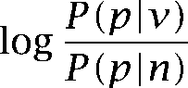

where  is the probability of seeing a PP with after the verb v and  is the probability of seeing a PP with after the noun *n.* We can then attach to the verb for  *n, 0* and to the noun for



The trouble with this model is that it ignores the fact that other things being equal, there is a preference for attaching phrases “low” in the parse tree. For PP attachment, the lower node is the NP node. For example, the tree in figure 3.2  attaches the PP *with the spoon* to the lower NP node, the tree in figure 3.2 (a) attaches it to the higher VP node. One can explain low attachments with a preference for local operations. When we process the PP, the NP is still fresh in our mind and so it is easier to attach the PP to it.



***W***

***C ( w )***

***w i t h )***

*end* 5156 607

*venture* 1442 155

Table 8.4 An example where the simple model for resolving PP attachment ambiguity fails.

(8.17)

8.3.1

The following example from the New York *Times* shows why it is im- portant to take the preference for attaching low into account:

Chrysler confirmed that it would end its troubled venture with Maserati.

The preposition *with* occurs frequently after both *end (e.g., the show ended with a song)* and *venture (e.g., the venture with* The data from the New York *Times* corpus in table 8.4,” when plugged into equation  predict attachment to the verb:

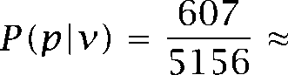 0.118 0.107 =

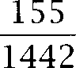

But that is the wrong decision here. The model is wrong because equa- tion (8.16) ignores a bias for low attachment in cases where a preposition is equally compatible with the verb and the noun. We will now develop a probabilistic model for PP attachment that formalizes this bias.

Hindle and Rooth (1993)

In setting up the probabilistic model that is due to Hindle and Rooth  we first define the event space. We are interested in sentences that are potentially ambiguous with respect to PP attachment. So we define the event space to consist of all clauses that have a transitive verb (a verb with an object noun phrase), an NP following the verb (the object noun phrase) and a PP following the  Our goal is to resolve the PP attachment ambiguity in these cases.

In order to reduce the complexity of the model, we limit our attention to one preposition at a time (that is, we are not modeling possible inter- actions between headed by different prepositions, see exercise



1. We used the subset of texts from chapter 5.
2. Our terminology here is a little bit sloppy since the PP is actually part of the NP when it attaches to the noun, so, strictly speaking, it does not follow the NP. So what we mean here when we say “NP” is the base NP chunk without complements and adjuncts.

*8.3 Attachment Ambiguity 281*

and, if there are two with the same preposition in sequence, then we will only model the behavior of the first (see exercise 8.9).

To simplify the probabilistic model, we will not directly ask the ques- tion about whether a certain preposition is attached to a certain verb or noun. Rather, we will estimate how likely it is in general for a preposition to attach to a verb or noun. We will look at the following two questions, formalized by the sets of indicator random variables VA, and NA,:

VA,: Is there a PP headed by and following the verb which attaches to (VA, = 1) or not (VA,, = O)?

NA,: Is there a PP headed by and following the noun which attaches to (NA, = 1) or not (NA, = O)?

Note that we are referring to any occurrence of the preposition here rather than to a particular instance. So it is possible for both NA, and VA, to be 1 for some value of For instance, this is true for = on in the sentence:

(8.18) He put the book [on World War II] [on the table].

For a clause containing the sequence PP,” we wish to calcu- late the probability of the PP headed with preposition attaching to the verb v and the noun conditioned on v and



(8.19)  =   n)

(8.20) = 

In  we assume conditional independence of the two attachments that is, whether a PP occurs modifying *n* is independent of whether one occurs modifying v. In  we assume that whether the verb is modified by a PP does not depend on the noun and whether the noun is

modified by a PP does not depend on the verb.

That we are treating attachment of a preposition to a verb and to a noun (i.e., VA, and NA,) as independent events seems counterintuitive at first since the problem as stated above posits a binary choice between noun and verb attachment. So, rather than being independent, attachment to the verb seems to imply non-attachment to the noun and vice versa. But we already saw in (8.18) that the definitions of VA, and NA, imply that both can be true. The advantage of the independence assumption is that it is easier to derive empirical estimates for the two variables separately

rather than estimating their joint distribution. We will see below how we can estimate the relevant quantities from an unlabeled corpus.

Now suppose that we wish to determine the attachment of a PP that is immediately following an object noun. We can compute an estimate in terms of model (8.20) by computing the probability of NA, = 1.

P(Attach(p) =  =  = 0 v VA, = l/v) x  = 

= 1.0 x  = 

=  = 

So we do not need to consider whether VA, = 0 or VA, = 1, since while there could be other in the sentence modifying the verb, they are immaterial to deciding the status of the PP immediately after the noun head.

In order to see that the case VA, = 1 and NA, = 1 does not make Attach(P) = v true, let’s look at what these two premises entail. First, there must be two prepositional phrases headed by a preposition of type This is because we assume that any given PP can only attach to one

phrase, either the verb or the noun. Second, the first of these two must attach to the noun, the second to the verb. If it were the other way round, then we would get crossing brackets. It follows that VA, = 1 and NA, = 1 implies that the first PP headed by is attached to the noun, not to the verb. So Attach(p) v holds in this case.

In contrast, because there cannot be crossing lines in a phrase structure tree, in order for the first PP headed by the preposition to attach to the verb, both VA, = 1 and NA, 0 must hold. Substituting the appropriate values in model (8.20) we get:

P(Attach(p) =  n) =  =  = 

=  =  = 

We can again assess  =  and  = via a likeli- hood ratio

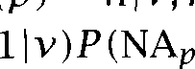

=

= log,

=

=

=



noun attach- for values of

We choose verb attachment for large positive values of and ment for large negative values. We can also make decisions

closer to zero (verb attachment for positive A and noun attachment for negative A), but there is a higher probability of error.

How do we estimate the probabilities  = 1  and  = 1 In) that we need for equation  The simplest method is to rely on maximum likelihood estimates of the familiar form:

 = l(v) =



= = C(n)

where  and C(n) are the number of occurrences of v and in the corpus, and and are the number of times that *p* attaches to v and *p* attaches to *n.* remaining difficulty is to determine the attachment counts from an unlabeled corpus. In some sentences the attachment is obvious.



(8.22) a. The road *London* is long and winding.

b. She sent him *into the nursery* to gather up his toys.

The prepositional phrase in italics in  must attach to the noun since there is no preceding verb, and the italicized PP in (8.2213) must attach to the verb since attachment to a pronoun like *him* is not possi- ble. So we can bump up our counts for  to) and  *into)* by one based on these two sentences. But many sentences are ambiguous. That, after all, is the reason why we need an automatic procedure for the resolution of attachment ambiguity.

Hindle and Rooth (1993) propose a heuristic for determining  and from unlabeled data that has essentially three steps.



1. Build an initial model by counting all unambiguous cases (examples like  and 
2. Apply the initial model to all ambiguous cases and assign them to the appropriate count if A exceeds a threshold (for example, 2.0 for verb attachment and -2.0 for noun attachment).



1. Divide the remaining ambiguous cases evenly between the counts (that is, increase both and by 0.5 for each ambiguous case).



Sentence  here repeated as  may serve as an example of how the method is applied (Hindle and Rooth 1993: 109-110).

*(8.23)* Moscow sent more than 100,000 soldiers into Afghanistan..

First we estimate the two probabilities we need for the likelihood ratio. The count data are from Hindle and Rooth’s test corpus.

 = 1  into)



 *send)*

86

*=* 1742.5

*0.049*

=  *soldiers)*



*= soldiers, into)*

*=* 1

*1478*

*0.0007*

The fractional count is due to the step of the heuristic that divides the hardest ambiguous cases evenly between noun and verb. We also have:

(8.24)   *=* 1 = 1  *0.9993*



Plugging these numbers into formula  we get the following like- lihood ratio.

*A (send, soldiers, into)* log, 0.049 x 0.9993

*0.0007*

So attachment to the verb is much more likely  70 times more likely), which is the right prediction here. In general, the procedure is accurate in about 80% of cases if we always make a choice (Hindle and Rooth 1993: 115). We can trade higher precision for lower recall if we only make a decision for values of A that exceed a certain threshold. For example, Hindle and Rooth (1993) found that precision was 91.7% and recall was 55.2% for A = 3.0.

8.32 General remarks on PP attachment

Much of the early psycholinguistic literature on parsing emphasized the use of structural heuristics to resolve ambiguities, but they clearly don’t help in cases like the PP attachments we have been looking at. For identi- cal sequences of word classes, sometimes one parse structure is correct, and sometimes another. Rather, as suggested by Ford et al.  lexical preferences seem very important here.

There are several major limitations to the model presented here. One is that it only considers the identity of the preposition and the noun and verb to which it might be attached. Sometimes other information is important (studies suggest human accuracy improves by around 5% when they see more than just a v, triple). In particular, in sentences like those in  the identity of the noun that heads the NP inside the PP is clearly crucial:



$27 a share] [at its monthly meetingl.

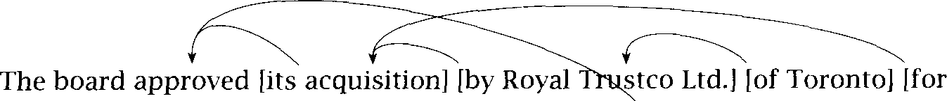

Figure 8.2 Attachments in a complex sentence.

**(8.25)** a. I examined the man with a stethoscope

b. I examined the man with a broken leg

Other information might also be important. For instance Hindle and Rooth (1993) note that a superlative adjective preceding the noun highly biased things towards an NP attachment (in their data). This condition- ing was probably omitted by Hindle and Rooth because of the infrequent occurrence of superlative adjectives. However, a virtue of the likelihood ratio approach is that other factors can be incorporated in a principled manner (providing that they are assumed to be independent). Much other work has used various other features, in particular the identity of the head noun inside the PP (Resnik and Hearst 1993; Brill and Resnik 1994; Ratnaparkhi et al. 1994; Zavrel et al. 1997; Ratnaparkhi 1998). Franz (1996) is able to include lots of features within a loglinear model ap- proach, but at the cost of reducing the most basic association strength parameters to categorical variables.

A second major limitation is that Hindle and Rooth (1993) consider only the most basic case of a PP immediately after an NP object which is modifying either the immediately preceding noun or verb. But there are many more possibilities for PP attachments than this. Gibson and Pearlmutter (1994) argue that psycholinguistic studies have been greatly biased by their overconcentration on this one particular case. A PP sep- arated from an object noun by another PP may modify any of the noun inside the preceding PP, the object noun, or the preceding verb. Figure 8.2 shows a variety of the distant and complex attachment patterns that oc- cur in texts. Additionally, in a complex sentence, a PP might not modify just the immediately preceding verb, but might modify a higher verb. See Franz (1997) for further discussion, and exercise 8.9.

**Other attachment issues**

Apart from prepositional phrases, attachment ambiguity also occurs with various kinds of adverbial and participial phrases and clauses, and in

NOUN COMPOIJNDS noun compounds. The issue of the scope of in parsing is also rather similar to an attachment decision, but we will not consider it further here.

A noun phrase consisting of a sequence of three or more nouns either has the left-branching structure or the right-branching structure [N [N N]]. For example, door *manufacturer* is left-branching: *[[door bell] manufacturer].* It’s a manufacturer of door bells, not a manufac- turer of bells that somehow has to do with doors. The phrase



*aid worker* is an example of a right-branching NP: [woman *worker]].* The phrase refers to an aid worker who is female, not a worker working for or on woman *aid.* The left-branching case roughly corresponds to at- tachment of the PP to the verb  N  while the right-branching case corresponds to attachment to the noun



We could directly apply the formalism we’ve developed for preposi- tional phrases to noun compounds. However, data sparseness tends to be a more serious problem for noun compounds than for prepositional phrases because prepositions are high-frequency words whereas most nouns are not. For this reason, one approach is to use some form of semantic generalization based on word classes in combination with at- tachment information. See Lauer (1995a) for one take on the problem (use of semantic classes for the PP attachment problem was explored by Resnik and Hearst (1993) with less apparent success). A different exam- ple of class-based generalization will be discussed in the next section.



As a final comment on attachment ambiguity, note that a large pro- portion of prepositional phrases exhibit ‘indeterminacy’ with respect to attachment (Hindle and Rooth 1993: *112).* Consider the PP *with them* in (b.26):

(8.26) We have not signed a settlement agreement *with them.*

When you sign an agreement with person X, then in most cases it is an agreement with X, but you also do the signing with X. It is rather unclear whether the PP should be attached to the verb or the noun or whether we should rather say that a PP like *with them* in sentence (8.26) should attach to *both* verb and noun. Lauer (1995a) found that a significant proportion of noun compounds also had this type of attachment indeterminacy. This

is an example of a possibly important insight that came out of Statisti- cal NLP work. Before Hindle and Rooth’s study, computational linguists were not generally aware of how widespread attachment indeterminacy is (though see Church and Patil(l982) for a counterexample).

After becoming aware of this fact, we could just say that it doesn’t mat- ter how we attach in indeterminate cases. But the phenomenon might also motivate us to explore new ways of determining the contribution a prepositional phrase makes to the meaning of a sentence. The phe- nomenon of attachment indeterminacy suggests that it may not be a good idea to require that PP meaning always be mediated through a noun phrase or a verb phrase as current syntactic formalisms do.

Exercise *8.6 *

As is usually the case with maximum likelihood estimates, they suffer in accuracy if data are sparse. Modify the estimation procedure using one of the procedures suggested in chapter 6. Hindle and Rooth (1993) use an ‘Add One’ method in their experiments.

Exercise 8.7 [*I

Hindle and Rooth (1993) used a partially parsed corpus to determine and C( p). Discuss whether we could use an unparsed corpus and what additional problems we would have to grapple with.



Exercise 8.8 

Consider sentences with two headed by two different prepositions, for ex- ample, “He put the book on Churchill in his backpack.” The model we developed could attach *on Churchill* to *put* when applied to the preposition *on* and *in his backpack* to *book* when applied to the preposition *in.* But that is an incorrect parse tree since it has crossing brackets. Develop a model that makes consistent decisions for sentences with two headed by different prepositions.

Exercise 8.9 

Develop a model that resolves the attachment of the second PP in a sequence of the form: V . . N . PP PP. There are three possible cases here: attachment to the verb, attachment to the noun and attachment to the noun in the first PP.

Exercise 8.10 

Note the following difference between a) the acquisition methods for attachment ambiguity in this section and  those for subcategorization frames in the last section and those for collocations in chapter 5. In the case of PP attachment, we are interested in what is *predictable.* We choose the pattern that best fits what we would predict to happen from the training corpus. (For example, a PP headed by *in* after *send.)* In the case of subcategorization and collocations, we are interested in what is *unpredictable,* that is, patterns that shouldn’t occur if our model was right. Discuss this difference.

***288*** *Lexical Acquisition*

#### Selectional Preferences

Most verbs prefer arguments of a particular type. Such regularities are **SELECTIONAL** called preferences or ***restrictions.*** Examples are that **PREFERENCES** the objects of the verb tend to be food items, the subjects of think **RESTRICTIONS** tend to be people, and the subjects of ***bark*** tend to be dogs. These

***tic*** constraints on arguments are analogous to the ***syntactic*** constraints we looked at earlier, subcategorization for objects,  infinitives etc. We use the term ***preferences*** as opposed to ***rules*** because the preferences can be overridden in metaphors and other extended meanings. For exam- ple, ***eat*** takes non-food arguments in ***eating one’s words*** or ***fear eats the soul.***

The acquisition of selectional preferences is important in Statistical **NLP** for a number of reasons. If a word like *duriun* is missing from our machine-readable dictionary, then we can infer part of its meaning from selectional restrictions. In the case of sentence  we can infer that a *duriun* is a type of food.

(8.27) Susan had never eaten a fresh durian before.

Another important use of selectional preferences is for ranking the possible parses of a sentence. We will give higher scores to parses where the verb has ‘natural’ arguments than to those with atypical arguments, a strategy that allows us to choose among parses that are equally good on syntactic criteria. Scoring the semantic wellformedness of a sentence based on selectional preferences is more amenable to automated lan- guage processing than trying to understand the meaning of a sentence more fully. This is because the semantic regularities captured in selec- tional preferences are often quite strong and, due to the tight syntactic link between a verb and its arguments, can be acquired more easily from corpora than other types of semantic information and world knowledge. We will now introduce the model of selectional preferences proposed by Resnik (1993, 1996). In principle, the model can be applied to any class of words that imposes semantic constraints on a grammatically de- pendent phrase: verb-subject, verb-direct object, verb-prepositional phrase, adjective-noun, noun-noun (in noun-noun compounds). But

we will only consider the case ‘verb-direct object’ here, that is, the case

of verbs selecting a semantically restricted class of direct object noun phrases.

The model formalizes selectional preferences using two notions: selec-

**SELECTIONAL PREFERENCE STRENGTH**

tional preference strength and selectional association. ***prefer- ence strength*** measures how strongly the verb constrains its direct object. It is defined as the KL divergence between the prior distribution of direct objects (the distribution of direct objects for verbs in general) and the distribution of direct objects of the verb we are trying to characterize.

We make two assumptions to simplify the model. First, we only take the head ***noun*** of the direct object into account (for example, apple in Susan ate the green ***apple)*** since the head is the crucial part of the noun phrase that determines compatibility with the verb. Second, instead of dealing with individual nouns, we will instead look at ***classes*** of nouns. As usual, a class-based model facilitates generalization and parameter estimation. With these assumptions, we can define selectional preference strength  as follows:

***(8.28) *** 

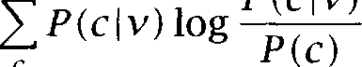

C

**SELECTIONAL ASSOCIATION**

where ***P(C)*** is the overall probability distribution of noun classes and  is the probability distribution of noun classes in the direct object position of v. We can take the noun classes from any lexical resource that groups nouns into classes. Resnik (1996) uses

Based on selectional preference strength, we can define



***sociation*** between a verb v and a class c as follows:

***(8.29) *** ***=***



That is, the association between a verb and a class is defined as the pro- portion that its summand ***P (c v)*** log  contributes to the overall pref- erence strength S(v).

Finally, we need a rule for assigning association strength to nouns (as opposed to noun classes). If the noun is in only one class c, then we simply define ***c).*** If the noun is a member of several classes, then we define its association strength as the highest association strength of any of its classes.



***(8.30) =***



m a x

A noun like ***chair*** in (8.3 1) is in several classes because it is polysemous (or ambiguous).

***(8.31)*** Susan interrupted the chair.

*Lexical Acquisition*

|  |  |  |  |  |  |
| --- | --- | --- | --- | --- | --- |
| Noun class | c |  | | | |
| people | | 0.25 | 0.01 | 0.25 | 0.33 |
| furniture | | 0.25 | 0.01 | 0.25 | 0.33 |
| food | | 0.25 | 0.97 | 0.25 | 0.33 |
| action | | 0.25 | 0.01 | 0.25 | 0.01 |
|  | |  | 1.76 | 0.00 | 0.35 |

Table 8.5 Selectional Preference Strength The argument distributions and selectional preference strengths of three verbs for a classification of nouns with four classes (based on hypothetical data).

In the case of *chair, we* have two candidate classes, ‘furniture’ and ‘peo- ple’ (the latter in the sense ‘chairperson’). Equating with the



**DISAMBIGUATION** *A* amounts to disambiguating the noun. In sentence (8.3 1) we will base the association strength  *chair)* on the class ‘peo- ple’ since interrupting people is much more common than interrupting pieces of furniture, that is:



*A( interrupt,* people) *A * furniture) Hence:

*A( interrupt, chair) =* max *A( interrupt,*

= *A( interrupt,* people)

So we can disambiguate *chair* as a by-product of determining the associ- ation of *interrupt* and *chair.*

The hypothetical data in table 8.5 (based on (Resnik 1996: 139)) may serve as a further illustration of the model. The table shows the prior dis- tribution of object over noun classes (assuming that there are only the four classes shown) and posterior distributions for three verbs. The verb eat overwhelmingly prefers food items as arguments; see’s distri- bution is not very different from the prior distribution since all physical objects can be seen; find has a uniform distribution over the first three classes, but ‘disprefers’ actions since actions are not really the type of entities that are found.

The selectional preference strengths of the three verbs are shown in the row ‘SPS.’ The numbers conform well with our intuition about the three verbs: eat is very specific with respect to the arguments it can take, find is less specific, and see has no selectional preferences (at least in

our hypothetical data). Note that there is a clear interpretation of SPS as the amount of information we gain about the argument after learning about the verb. In the case of eat, SPS is 1.76, corresponding to almost 2 binary questions. That is just the number of binary questions we need to get from four classes (people, furniture, food, action) to one, namely the class ‘food’ that eat selects. (Binary logarithms were used to compute SPS and association strength.)

Computing the association strengths between verbs and noun classes, we find that the class ‘food‘ is strongly preferred by eat (8.32) whereas the class ‘action’ is dispreferred by find (8.33). This example shows that the model formalizes selectional ‘dispreferences’ (negative numbers) as well as selectional preferences (positive numbers).

(8.32)  food) = 1.08

(8.33)  = -0.13

The association strengths between see and all four noun classes are zero, corresponding to the intuition that see does not put strong constraints on its possible arguments.

The remaining problem is to estimate the probability that a direct ob- ject in noun class c occurs given a verb v, =  The maximum likelihood estimate for  is the relative frequency of v with respect to all verbs. Resnik (1996) proposes the following estimate



for



(8.34) = 

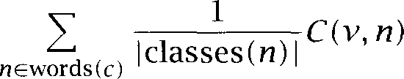

where is the total number of verb-object pairs in the corpus, words(c) is the set of all nouns in class c, classes(n) is the number of noun classes that contain as a member and is the number of verb-object pairs with v as the verb and as the head of the object NP. This way of estimating bypasses the problem of disambiguating nouns. If a noun that is a member of two classes and occurs with v, then we assign half of this occurrence to and half to



***So*** far, we have only presented constructed examples. Table 8.6 shows some actual data from experiments on the Brown corpus (Resnik 1996: 142). The verbs and nouns were taken from a psycholinguistic study (Holmes et al. 1989). The nouns in the left and right halves of the table are ‘typical’ and ‘atypical’ objects, respectively. For most verbs,

*Lexical Acquisition*

|  |  |  |  |  |  |  |
| --- | --- | --- | --- | --- | --- | --- |
| Verb v | Noun ***n*** |  | Class | Noun ***n*** |  | Class |
| ***answer*** | ***request*** |  | speech act | ***tragedy*** | 3.88 | communication |
| ***find*** | ***label*** | 1.10 | abstraction | ***fever*** | 0.22 | psych. feature |
| ***hear*** | ***story*** | 1.89 | communication | ***issue*** | 1.89 | communication |
| ***remember*** | ***reply*** | 1.31 | statement | ***smoke*** | 0.20 | article of commerce |
| ***repeat*** | ***comment*** | 1.23 | communication | ***journal*** | 1.23 | communication |
| ***read*** | ***article*** | 6.80 | writing | ***fashion*** | -0.20 | activity |
| ***see*** | ***friend*** | 5.79 | entity | ***method*** | -0.01 | method |
| ***write*** | ***letter*** | 7.26 | writing | ***market*** | 0.00 | commerce |

Table 8.6 Association strength distinguishes a verb’s plausible and implausible objects. The left half of the table shows typical objects, the right half shows atypical objects. In most cases, association strength is a good predictor of object typicality.



**IMPLICIT OBJECT ALTERNATION**

(8.35)

association strength accurately predicts which object is typical. For ex- ample, it correctly predicts that ***friend*** is a more natural object for see than ***method.*** Most errors the model makes are due to the fact that it performs a form of disambiguation, by choosing the highest association strength among the possible classes of the noun (cf. the example of ***chair we*** discussed earlier). Even if a noun is an atypical object, if it has a rare interpretation as a plausible object, then it will be rated as typical. An example of this is ***hear.*** Both ***story*** and ***issue*** can be forms of commu- nication, but this meaning is rarer for ***issue.*** Yet the model chooses the rare interpretation because it makes more sense for the verb ***hear.***

Apart from the specific question of selectional preference, Resnik also investigates how well the model predicts whether or not a verb has the so-called ***implicit object alternation*** (or ***unspecified object alternation, see*** Levin (1993: 33)). An example is the alternation between sentences

and The verb ***eat*** alternates between explicitly naming what was eaten  and leaving the thing eaten implicit 

1. Mike ate the cake.
2. Mike ate.

The explanation Resnik offers for this phenomenon is that the more constraints a verb puts on its object, the more likely it is to permit the implicit-object construction. The intuition is that for a verb like ***eat*** with a strong selectional preference, just knowing the verb gives us so much

formation about the direct object that we don’t have to mention it. Resnik finds evidence that selectional preference strength is a good predictor of the permissibility of the implicit-object alternation for verbs.

We can now see why Resnik’s model defines selectional preference strength (SPS) as the primary concept and derives association strength from it. SPS is seen as the more basic phenomenon which explains the occurrence of implicit objects as well as association strength.

An alternative is to define association strength directly as  or as if we don’t want to go through an intermediate class represen- tation. Approaches to computing include distributional clustering (the work by Pereira et al. (1993) described in chapter **14)** and methods for computing the similarity of nouns. If a measure of the similarity of nouns is available, then can be computed from the distribution of nouns similar to ***n*** that are found in the argument slot of v. See the next section for more on this approach.



**Exercise** 8.11

As we pointed out above, we can use a model of selectional preferences for ambiguating nouns by computing the association strengths for different senses of the noun. This strategy assumes that we know what the senses of the noun are and which classes they are members of. How could one use selectional pref- erences to discover senses of nouns whose senses we don’t know?

**Exercise** 8.12

Verbs can also be ambiguous as in the case of fire in these two sentences.

(8.36) a. The president fired the chief financial officer.

b. Mary fired her gun first.

How can the model be used to disambiguate verbs? Consider two scenarios, one in which we have a training set in which verb senses are labeled, one in which we don’t.

**Exercise 8.13**

The model discussed in this section assigns the noun sense with the maximum association strength. This approach does not take prior probabilities into ac- count. We may not want to choose an extremely rare sense of a noun even if it is the best fit as the object NP of a verb.

Example: The noun ***shot*** has the rare meaning ‘marksman’ as in ***John was reputed be a crack shot. So,*** theoretically, we could choose this sense for ***shot*** in the sentence ***John fired a shot,*** corresponding to the meaning ***John laid off a***

***marksman.***

How could prior probabilities be used to avoid such incorrect inferences?

**Exercise 8.14**

In the approach developed above, is treated as a flat set of noun classes, but it is actually a hierarchy. How could one make use of the information present in the hierarchy (for example, the fact, that the class ‘dog’ is a subclass of ‘animal’ which in turn is a subclass of ‘entity’)?

**Exercise 8.15**

Verbs can be organized into a hierarchy too. How could one use hierarchical information about verbs for better parameter estimation?

**Exercise 8.16**

One assumption of the model is that it is the head noun that determines the compatibility of an object NP with the selectional preferences of the verb. How- ever, as pointed out by Resnik (1996:  that is not always the case. Examples include negation (you ***can’t eat stones),*** and certain adjectival modifiers (he ***ate a chocolate firetruck; the tractor beam pulled the ship closer);*** neither stones nor firetrucks are compatible with the selectional preferences of ***eat,*** but these sentences are still well-formed. Discuss this problem.

**Exercise 8.17**

Hindle and Rooth (1993) go through several iterations of estimating initial pa- rameters of their model, disambiguating some ambiguous attachments and estimating parameters based on disambiguated instances. How could this ap- proach be used to estimate the prior probabilities of noun classes in  The goal would be to improve on the uniform distribution over possible classes assumed in the equation.

**Exercise 8.18**

Resnik’s model expresses association strength as a proportion of selectional preference strength. This leads to interesting differences from an approach based on formalizing selectional preference as Compare two noun-verb pairs with equal that is, ***=*** If the selectional prefer- ence strength of vi is much larger than that of then we get  ***So*** the two models make different predictions here. Discuss these



differences.

#### Semantic Similarity

The holy grail of lexical acquisition is the acquisition of meaning. There are many tasks (like text understanding and information retrieval) for which Statistical NLP could make a big difference if we could automati- cally acquire meaning. Unfortunately, how to represent meaning in a way that can be operationally used by an automatic system is a largely un- solved problem. Most work on acquiring semantic properties of words

*8.5 Semantic Similarity* ***295***

**SEMANTIC SIMILARITY** has therefore focused on *semantic similarity.* Automatically acquiring a relative measure of how similar a new word is to known words (or how dissimilar) is much easier than determining what the meaning actually is. Despite its limitations, semantic similarity is still a useful measure to

**GENERALIZATION**

have. It is most often used for ***generalization*** under the assumption that semantically similar words behave similarly. An example would be the problem of selectional preferences that we discussed in the previous section. Suppose we want to find out how appropriate *durian* is as an argument of in sentence (8.37) (our previous example (8.27)):

***(8.37)*** Susan had never eaten a fresh durian before.

Suppose further that we don’t have any information about ***durian*** except that it’s semantically similar to apple, banana, and *mango,* all of which perfectly fit the selectional preferences of ***eat.*** Then we can generalize from the behavior of ***apple, banana,*** and ***mango*** to the semantically sim- ilar ***duriun*** and hypothesize that ***duriun*** is also a good argument of ***eat.*** This scheme can be implemented in various ways. We could base our treatment of ***duriun*** only on the closest semantic neighbor (say, ***mango),*** or we could base it on a combination of evidence from a fixed number of nearest neighbors, a combination that can be weighted according to how semantically similar each neighbor is to ***duriun.***

**CLASS-BASED GENERALIZATION**

*k* **NEAREST NEIGHBORS**

KNN

Similarity-based generalization is a close relative of class-based gener- alization. In similarity-based generalization we only consider the closest neighbors in generalizing to the word of interest. In class-based general- ization, we consider the whole class of elements that the word of interest is most likely to be a member of. (See exercise 8.20.)

Semantic similarity is also used for query expansion in information re- trieval. A user who describes a request for information in her own words may not be aware of related terms which are used in the documents that the user would be most interested in. If a user describes a request for documents on Russian space misions using the word ***astronaut,*** then a query expansion system can suggest the term ***cosmonaut*** based on the semantic similarity between ***astronaut*** and ***cosmonaut.***

Another use of semantic similarity is for so-called ***nearest neighbors***

(or  classification, see section 16.4). We first need a training set of elements that are each assigned to a category. The elements might be words and the categories might be topic categories as they are used by

services (‘financial,’ ‘agriculture,’ ‘politics’ etc.). In KNN

**SEMANTIC DOMAIN**

**TOPIC**

**CONTEXTUAL INTERCHANGEABILITY**



**DOCUMENT SPACE**

**WORD SPACE**

we assign a new element to the category that is most prevalent among its nearest neighbors.

Before delving into the details of how to acquire measures of semantic similarity, let us remark that semantic similarity is not as intuitive and clear a notion as it may seem at first. For some, semantic similarity is an extension of synonymy and refers to cases of near-synonymy like the pair *dwelling/abode.* Often semantic similarity refers to the notion that two words are from the same *semantic domain* or *topic.* On this understand- ing of the term, words are similar if they refer to entities in the world that are likely to co-occur like doctor, fever, and *intravenous,* words that can refer to quite different entities or even be members of different syntactic categories.

One attempt to put the notion of semantic similarity on a more solid footing is provided by Miller and Charles  who show that  ments of semantic similarity can be explained by the degree of contextual *interchangeability* or the degree to which one word can be substituted for another in context.

Note that ambiguity presents a problem for all notions of semantic similarity. If a word is semantically similar to one sense of an ambiguous word, then it is rarely semantically similar to the other sense. For exam- ple, *litigation* is similar to the legal sense of *suit,* but not to the ‘clothes’ sense. When applied to ambiguous words, semantically similar usually means ‘similar to the appropriate sense’.



Vector space measures

A large class of measures of semantic similarity are best conceptualized as measures of vector similarity. The two words whose semantic similar- ity we want to compute are represented as vectors in a multi-dimensional space. Figures 8.3, 8.4, and 8.5 give (constructed) examples of such multi- dimensional spaces (see also figure 15.5).

The matrix in figure 8.3 represents words as vectors in *document space.* Entry contains the number of times word j occurs in document *i.* Words are deemed similar to the extent that they occur in the same doc- uments. In document space, *cosmonaut* and *astronaut* are dissimilar (no shared documents); *truck* and *cur* are similar since they share a docu- ment: they co-occur in 

The matrix in figure 8.4 represents words as vectors in *word space.*

Entry contains the number of times word j co-occurs with word *i.*

*8.5 Semantic Similarity*



|  |  |  |  |  |
| --- | --- | --- | --- | --- |
| cosmonaut | astronaut | moon | car | truck |
|  | 0 | 1 | 1 | 0 |
|  | 1 | 1 | 0 | 0 |
| 1 | 0 | 0 | 0 | 0 |
| 0 | 0 | 0 | 1 | 1 |
|  | 0 | 0 | 1 | 0 |
|  | 0 | 0 | 0 | 1 |

Figure 8.3 A document-by-word matrix *A.*

|  |  |  |  |  |  |
| --- | --- | --- | --- | --- | --- |
|  | cosmonaut | astronaut | moon | car | truck |
| cosmonaut | 2 | 0 | 1 | 1 | 0 |
| astronaut | 0 | 1 | 1 | 0 | 0 |
| moon | 1 | 1 | 2 | 1 | 0 |
| car | 1 | 0 | 1 | 3 | 1 |
| truck | 0 | 0 | 0 | 1 | 2 |

Figure 8.4 A word-by-word matrix *B.*

|  |  |  |  |  |  |
| --- | --- | --- | --- | --- | --- |
|  | cosmonaut | astronaut | moon | car | truck |
| Soviet | 1 | 0 | 0 | 1 | 1 |
| American | 0 | 1 | 0 | 1 | 1 |
| spacewalking | 1 | 1 | 0 | 0 | 0 |
| red | 0 | 0 | 0 | 1 | 1 |
| full | 0 | 0 | 1 | 0 | 0 |
| old | 0 | 0 | 0 | 1 | 1 |

Figure 8.5 A modifier-by-head matrix C. The nouns (or heads of noun phrases)

in the top row are modified by the adjectives in the left column.

Co-occurrence can be defined with respect to documents, paragraphs or other units. Words are similar to the extent that they co-occur with the same words. Here, cosmonaut and *astronaut* are more similar than before since they both co-occur with *moon.*

We have defined co-occurrence in figure 8.4 with respect to the doc- uments in figure 8.3. In other words, the following relationship holds:

**TRANSPOSE = ** (Here is the transpose, where we swap the rows and columns

**SO** that  

The matrix in figure 8.5 represents nouns (interpreted as heads of noun





**MODIFIER SPACE**

**TOPICAL SIMILARITY**

**BINARY VECTORS**

***8 Lexical Acquisition***

phrases) as vectors in *modifier space.* Entry contains the number of times that head is modified by modifier *i.* Heads are similar to the ex- tent that they are modified by the same modifiers. Again, cosmonaut and astronaut are similar. But, interestingly is dissimilar from cosmo- naut and astronaut here, in contrast to the document space in figure 8.3 and the word space in figure 8.4. This contrast demonstrates that differ- ent spaces get at different types of semantic similarity. The type of un- differentiated co-occurrence information in document and word spaces captures  similarity (words pertaining to the same topic domain). Head-modifier information is more fine-grained. Although *astronaut* and are part of the same domain (‘space exploration’), they are obvi-

ously entities with very different properties (a human being versus a celestial body). Different properties correspond to different modifiers, which explains why the two words come out as dissimilar on the modifier metric.”

The three matrices also have an interesting interpretation if we look at the similarity of instead of the similarity of columns (or, equiv- alently, look at the similarity of columns of the transposed matrices). Looking at the matrices this way, *A* defines similarity between docu- ments. This is the standard way of defining similarity among documents and between documents and queries in information retrieval. Matrix C defines similarity between modifiers when transposed. For example, *red*

and *old* are similar (they share cur and *truck),* suggesting that they are

used to modify the same types of nouns. Matrix is symmetric, so looking at similarity of rows is no different from looking at similarity of columns.

So far we have appealed to an intuitive notion of vector similarity. Ta- ble 8.7 defines several measures that have been proposed to make this notion precise (adapted from (van Rijsbergen 1979: 39)). At first, we only consider *binary vectors,* that is, vectors with entries that are either 0 or 1. The simplest way to describe a binary vector is as the set of dimensions on which it has non-zero values. So, for example, the vector for cosmo- naut in figure 8.5 can be represented as the set *{Soviet, * Having done this, we can calculate similarities using set operations, as in table 8.7.

1. ***See*** Grefenstette (1996) and and Pedersen (1997) for a discussion of the pros and cons of measuring word similarity based on associations versus head-modifier rela- tionships.

*8.5 Semantic Similarity*

Similarity measure Definition matching coefficient

Dice coefficient



Jaccard (or Tanimoto) coefficient Overlap coefficient



cosine 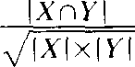 Table 8.7 Similarity measures for binary vectors.

**MATCHING** The first similarity measure, the *matching coefficient,* simply counts the **COEFFICIENT** number of dimensions on which both vectors are non-zero. In contrast to the other measures, it does not take into account the length of the

vectors and the total number of non-zero entries in 

**D ICE COEFFICIENT** The *Dice coefficient* normalizes for length by dividing by the total num- ber of non-zero entries. We multiply by 2 so that we get a measure that ranges from 0.0 to 1.0 with 1.0 indicating identical vectors.

**J ACCARD COEFFICIENT** The *coefficient* penalizes a small number of shared entries (as a proportion of all non-zero entries) more than the Dice coefficient does. Both measures range from 0.0 (no overlap) to 1.0 (perfect overlap), but the Jaccard coefficient gives lower values to low-overlap cases. For example, two vectors with ten non-zero entries and one common entry get a Dice

The Jaccard coefficient is frequently used in chemistry as a measure of similarity between chemical compounds (Willett and Winterman

The Overlap *coefficient* has the flavor of a measure of inclusion. It has

a value of 1.0 if every dimension with a non-zero value for the first vector is also non-zero for the second vector or vice versa (in other words if X Y or Y



**COSINE** The *cosine* is identical to the Dice coefficient for vectors with the same number of non-zero entries (see exercise  but it penalizes less in cases where the number of non-zero entries is very different. For ex- ample, if we compare one vector with one non-zero entry and another vector with 1000 non-zero entries and if there is one shared entry, then

1. This can be desirable to reflect our confidence in the similarity judgement. Hindle (1990) recommends a measure for noun similarity with this property.

**8** *Lexical Acquisition*



**VECTOR SPACE**

(8.38)

**LENGTH OF A VECTOR**

(8.39)

(8.40)

**NORMALIZED CORRE- LATION COEFFICIENT**

we get a Dice coefficient of 2 x  1 1000) 0.002 and a cosine of

 0.03. This property of the cosine is important in Statisti- cal **NLP** since we often compare words or objects that we have different amounts of data for, but we don’t want to say they are dissimilar just because of that.

So far we have looked at binary vectors, but binary vectors only have one bit of information on each dimension. A more powerful represen- tation for linguistic objects is the real-valued *vector space.* We will not give a systematic introduction to linear algebra here, but let us briefly review the basic concepts of vector spaces that we need in this book. A real-valued vector of dimensionality is a sequence of real num- bers, where denotes the  component of (its value on dimension *i).* The components of a vector are properly written as a column:



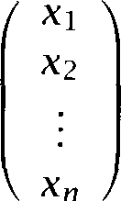

However, we sometimes write vectors horizontally within paragraphs. We write for the vector space of real-valued vectors with dimensionality so we have In a Euclidean vector space, the length *vector*

is defined as follows.

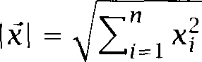

Finally, the dot product between two vectors is defined as  =



The cosine, the last similarity measure we introduced for binary vec- tors, is also the most important one for real-valued vectors. The cosine measures the cosine of the angle between two vectors. It ranges from 1.0

= 1.0) for vectors pointing in the same direction over 0.0 for or- thogonal vectors = 0.0) to 1 .O for vectors pointing in opposite directions  = -1.0).

For the general case of two n-dimensional vectors and  in a valued space, the cosine measure can be calculated as follows:

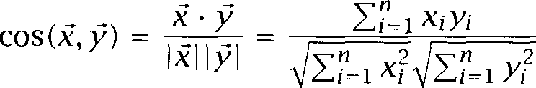

This definition highlights another interpretation of the cosine, the inter- pretation as the *normalized coefficient.* We compute how well

8.5 Semantic ***Similarity* 301**

NORMALIZATION

(8.41)

(8.42)

EUCLIDEAN DISTANCE

(8.43)

(8.44)

the and the correlate and then divide by the (Euclidean) length of the two vectors to scale for the magnitude of the individual and

We call a vector ***normalized*** if it has unit length according to the Eu- clidean norm:



 = = 1

For normalized vectors, the cosine is simply the dot product:

=



The ***Euclidean distance*** between two vectors measures how far apart they are in the vector space:

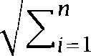

An interesting property of the cosine is that, if applied to normalized vectors, it will give the same ranking of similarities as Euclidean distance does. That is, if we only want to know which of two objects is closest to a third object, then cosine and Euclidean distance give the same answer for normalized vectors. The following derivation shows why ranking ac- cording to cosine and Euclidean distance comes out to be the same:





i=l

2



i=l i=l i=l



1 2

i=l

=

Finally, the cosine has also been used as a similarity measure of prob- ability distributions (Goldszmidt and Sahami 1998). Two distributions  and  are first transformed into and  Taking the cosine of the two resulting vectors gives the measure ***D =***



which can be interpreted as the sum over the geometric means of the

 and 

Table 8.8 shows some cosine similarities computed for the New ***York Times*** corpus described in chapter 5. We compiled a  ma- trix similar to the word-by-word matrix in figure 8.4. As rows we selected

Focus word ***garlic fallen***

***engineered Alfred simple***

Nearest neighbors

***sauce pepper s a l t*** cup

***fell decline rise drop genetically drugs research d r u g named Robert William W something things Y o u always***

Table 8.8 The cosine as a measure of semantic similarity. For each of the five words in the left column, the table shows the words that were most similar according to the cosine measure when applied to a word-by-word co-occurrence matrix. For example, ***sauce*** is the word that is most similar to ***garlic.*** The cosine between the vectors of ***sauce*** and ***garlic*** is 0.732.



the 20,000 most frequent words, as columns the 1,000 most frequent words (after elimination of the 100 most frequent words in both cases). Instead of raw co-occurrence counts, we used the logarithmic weighting function f(x) = 1 log(x) for non-zero counts (see section 15.2.2). A occurrence event was defined as two words occurring within 25 words of each other. The table shows cosine similarities between rows of the matrix.

For some word pairs, cosine in word space is a good measure of se- mantic similarity. The neighbors of ***garlic*** are generally close in meaning to garlic (with the possible exception of cup). The same is true for ***fallen.*** Note, however, that grammatical distinctions are not reflected because co-occurrence information is insensitive to word order and grammatical dependencies (the past participle ***fallen*** and the past tense ***fell*** are near- est neighbors of each other). The word engineered shows the dependency of the similarity measure. In the New ***York Times,*** the word is often used in the context of genetic engineering. A corpus of automo- bile magazine articles would give us a very different set of neighbors of engineered. Finally, the words ***Alfred*** and simple show us the limits of the chosen similarity measure. Some of the neighbors of ***Alfred*** are also names, but this is a case of part-of-speech similarity rather than seman- tic similarity. The neighbors of ***simple*** seem completely random. Since ***simple*** is frequently used and its occurrences are distributed throughout the corpus, co-occurrence information is not useful here to characterize the semantics of the word.

The examples we have given demonstrate the advantage of vector

* 1. *Semantic Similarity*

spaces as a representational medium: their simplicity. It is easy to visu- alize vectors in a two-dimensional or three-dimensional space. Equating similarity with the extent to which the vectors point in the same direction is equally intuitive. In addition, vector space measures are easy to com- pute. Intuitive simplicity and computational efficiency are probably the main reasons that vector space measures have been used for a long time in information retrieval, notably for word-by-document matrices  1969; Qiu and Frei 1993). Work on using vector measures for word-by-word and modifier-by-head matrices is more recent  stette  Schutze  See (Grefenstette  and (Burgess and Lund 1997) for research demonstrating that vector-based similarity mea- sures correspond to psychological notions of semantic similarity such as



PRIMING the degree to which one word primes another.

8.5.2 **Probabilistic measures**

The problem with vector space based measures is that, except for the cosine, they operate on binary data (yes or no). The cosine is the only vector space measure that accommodates quantitative information, but it has its own problems. Computing the cosine assumes a Euclidean space. This is because the cosine is defined as the ratio of the lengths of two sides of a triangle. So we need a measure of length, the Euclidean met- ric. But a Euclidean space is not a well-motivated choice if the vectors we are dealing with are vectors of probabilities or counts which is what most representations for computing semantic similarity are based on. To see this observe that the Euclidean distance between the probabilities 0.0 and 0.1 is the same as the distance between the probabilities 0.9 and 1.0. But in the first case we have the difference between impossibility and a chance of 1 in 10 whereas in the second there is only a small differ- ence of about 10%. The Euclidean distance is appropriate for normally distributed quantities, not for counts and probabilities.

Matrices of counts like those in figures 8.3, 8.4, and 8.5 can be easily transformed into matrices of conditional probabilities by dividing each element in a row by the sum of all entries in the row (this amounts to using maximum likelihood estimates). For example, in the matrix in fig- ure 8.5, the entry for *(American, astronaut)* would be transformed into

*= * *= 0.5.* The question of semantic similarity can then be recast as a question about the similarity (or dissimilarity) of two probability distributions.

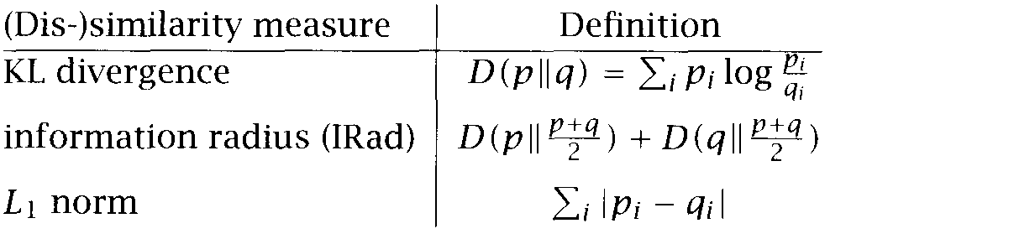

Table 8.9 Measures of between probability distributions.

Table 8.9 shows three measures of dissimilarity between probability distributions investigated by Dagan et al. (1997b). We are already familiar

KL **DIVERGENCE** with the KL divergence from section 2.2.5. It measures how well distribu- tion approximates distribution p; or, more precisely, how much infor- mation is lost if we assume distribution when the true distribution is ***p.*** The KL divergence has two problems for practical applications. First, we get a value of if there is a ‘dimension’ with = 0 and 0 (which will happen often, especially if we use simple maximum likelihood estimates). Secondly, KL divergence is asymmetric, that is,

The intuitive notion of semantic similarity and most other types of sim- ilarity we are interested in is symmetric, so the following should hold:

=



**INFORMATION RADIUS** The second measure in table 8.9, ***information radius*** (or total diver- gence to the average as Dagan et al. (1997b) call it), overcomes both these problems. It is symmetric = and there is no problem with infinite values since 0 if either 0 or 0.

The intuitive interpretation of is that it answers the question: How much information is lost if we describe the two words (or random vari- ables in the general case) that correspond to ***p*** and 9 with their average distribution? ranges from 0 for identical distributions to 2 log 2 for maximally different distributions (see exercise 8.26). As usual we assume  = 0.

**NORM** A third measure considered by Dagan et al. (1997b) is the (or

**M ANHATTANNORM *norm.*** It also has the desirable properties of being symmetric and well-defined for arbitrary p and 9. We can interpret it as a measure of the ***expected proportion of different events,*** that is, as the expected

1. Note that in clustering, asymmetry can make sense since we are comparing two differ- ent entities, the individual word that we need to assign to a cluster and the representation of the cluster. The question here is how well the cluster represents the word which is

different from similarity in the strict sense of the word. See (Pereira et al. 1993).



tion of events that are going to be different between the distributions and is because = 1 and



is the expected proportion of trials with the same

As an example consider the following conditional distributions com- puted from the data in figure 8.5.

=  = 0.5

= 0

***= P *** ***cosmonaut) =*** 0.5

**41 =**

**= *= 0.5***

**93 = ** ***0.5***

Here we have:

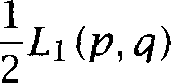 = 1 0.5 0.5



**i**

**So** if we looked at the sets of adjectives that occurred with a large number of uses of cosmonaut and ***astronaut*** in a corpus, then the overlap of the two sets would be expected to be 0.5, corresponding to the proportion of occurrences of  with each noun.

Dagan et al. (1997b) compared the three dissimilarity measures (KL,  and  on a task similar to the selectional preferences problem in section 8.4. Instead of looking at the fit of nouns as argument of verbs, they looked at the fit of verbs as predicates for nouns. For example, given a choice of the verbs ***make*** and ***take*** the similarity measures were used to determine that ***make*** is the right verb to use with ***plans (make plans)*** and ***take*** is the right verb to use with ***actions (take actions).***



1. The following derivation shows that 9) = 1









*= * *9i*







Note that this also shows that 0 *2* since 9) 0.



Here is how the similarity measure is used to compute the conditional probability  which Dagan et al.  use as a measure of ‘goodness of fit:’

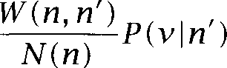

Here, v is the verb, is the noun, S(M ) is the set of nouns closest to *n* according to the similarity measure,  *n’)* is a similarity measure derived from the dissimilarity measure and N(n) is a normalizing factor: *N(n) = * *W(n, n’).*

This formulation makes it necessary to transform the dissimilarity measure (KL, or  into the similarity measure *W.* The following three transformations were used.

*(8.46)*

*(8.47)*

*(8.48)*

 = =

*= * 



The parameter  can be tuned for optimal performance.

Dagan et al.  show that consistently performs better than KL and  Consequently, they recommend as the measure that is best to use in general.

This concludes our brief survey of measures of semantic similarity and dissimilarity. Vector space measures have the advantage of conceptual simplicity and of producing a similarity value that can be directly used for generalization. But they lack a clear interpretation of the computed measure. Probabilistic dissimilarity measures are on a more solid footing theoretically, but require an additional transformation to get to a mea- sure of similarity that can be used for nearest neighbor generalization. Ei- ther approach is valuable in acquiring semantic properties of words from corpora by using similarity to transfer knowledge from known words to those that are not covered in the lexicon.

Exercise 8.19

Similarity-based generalization depends on the premise that similar things be- have similarly. This premise is unobjectionable if the two uses of the word *simi- lar* here refer to the same notion. But it is easy to fall into the trap of interpreting

1. For the experiments, *S(n)* was chosen to be the entire set of nouns, but one can limit the words considered to those closest to the target word.

them differently. In that case, similarity-based generalization can give inaccurate results.

Find examples of such potentially dangerous cases, that is, examples where words that are similar with respect to one aspect behave very differently with respect to another aspect.

Exercise 8.20 

Similarity-based and class-based generalization are more closely related than it may seem at first glance. Similarity-based generalization looks at the closest neighbors and weights the input from these neighbors according to their sim- ilarity. Class-based generalization looks at the most promising class and, in the simplest case, generalizes the novel word to the average of that class. But class-based generalization can be made to look like similarity-based generaliza- tion by integrating evidence from all classes and weighting it according to how well the element fits into each class. Similarity-based generalization looks like class-based generalization if we view each element as a class.

Discuss the relationship between the two types of generalization. What role do efficiency considerations play?

Exercise 8.2 1 

Co-occurrence matrices like the one in figure 8.3 represent different types of in- formation depending on how co-occurrence is defined. What types of words would you expect *fire* to be similar to for the following definitions of occurrence: co-occurrence within a document; co-occurrence within a sentence; co-occurrence with words at a maximum distance of three words to the right; co-occurrence with the word immediately adjacent to the right. (See Finch and Chater (1994) and Schutze (1995) for two studies that show how the latter type of immediate co-occurrence can be used to discover syntactic categories.)

**Exercise** 8.22

The measures we have looked at compare simple objects like vectors and proba- bility distributions. There have also been attempts to measure semantic similar- ity between more complex objects like trees (see (Sheridan and Smeaton 1992) for one example). How could one measure the (semantic?) similarity between trees? How might such an approach lead to a better measure of semantic simi- larity between words than ‘flat’ structures?

**Exercise 8.23**

Select two words heading columns in figure 8.3 and compute  similar- ities using each of the measures in table 8.7 for each of the three matrices in figures 8.3 through 8.5.

**Exercise 8.24**

Show that dice and cosine coefficients are identical if the two vectors compared have the same number of non-zero entries.

**Exercise 8.2 5**

Semantic similarity can be context-dependent. For example, electrons and tennis balls are similar when we are talking about their form (both have a round shape) and dissimilar when we are talking about their sizes.

Discuss to what extent similarity is context-dependent and when this can hinder correct generalization.

**Exercise 8.26**

Show that divergence to the average  is bounded by 2 log 2.

**Exercise 8.2 7**

Select two words heading columns in figure 8.3 and compute the three measures of dissimilarity in table 8.9 for each of the matrices in figures 8.3 through 8.5. You will have to smooth the probabilities for KL divergence. Are the dissimilarity measures asymmetric for KL divergence?

**Exercise 8.28**

Both the norm and the Euclidean norm are special cases of the Minkowski norm



 ***=***



***i***

In this context, the Euclidean norm is also referred to as ***So*** the norm can be seen as a more appropriate version of the Euclidean norm for probability distributions.

Another norm that has been used for vectors is that is  for et al. 1983). What well-known function does correspond to?



**Exercise 8.29**

Does a dissimilarity measure of 0 on one of the measures in table 8.9 imply that the other two measures are 0 too?

**Exercise 8.30**

If two probability distributions are maximally dissimilar according to one mea- sure in table 8.9 (e.g., ***=*** 2 log does that imply that they are maxi- mally dissimilar according to the other two?



#### The Role of Lexical Acquisition in Statistical NLP

Lexical acquisition plays a key role in Statistical NLP because available lex- ical resources are always lacking in some way. There are several reasons for this.



*8.6 The Role* ***of*** *Lexical Acquisition* ***in Statistical*** *NLP*

One reason is the cost of building lexical resources manually. For many types of lexical information, professional lexicographers will collect more accurate and comprehensive data than automatic procedures. But often manually constructed dictionaries are not available due to the cost of their construction. One estimate for the average time it takes to create a lexical entry from scratch is half an hour  et al. 1993; obviously it depends on the complexity of the entry), so manual resource construction can be quite expensive.

There is one type of data that humans, including lexicographers, are notoriously bad at collecting: quantitative information. So the quantita- tive part of lexical acquisition almost always has to be done automati- cally, even if excellent manually constructed lexical resources are avail- able for qualitative properties.

More generally, many lexical resources were designed for human con- sumption. The flip side of quantitative information being missing (which may be less important for people) is that the computer has no access to contextual information that is necessary to interpret lexical entries in conventional dictionaries. This is expressed aptly by (1993): “one cannot learn a new language by reading a bilingual dictionary.” An ample is the irregular plural postmen which is not listed as an exception in the lexical entry of postman in some dictionaries because it is obvious to a human reader that the plural of postman is formed in analogy to the plural of man. The best solution to problems like these is often the augmentation of a manual resource by automatic means.

Despite the importance of these other considerations motivating au- tomated lexical acquisition, the main reason for its importance is the inherent productivity of language. Natural language is in a constant state of flux, adapting to the changing world by creating names and words to refer to new things, new people and new concepts. Lexical resources have to be updated to keep pace with these changes. Some word classes are more likely to have coverage gaps than others. Most documents will men- tion proper nouns that we have not encountered before whereas there will hardly ever be newly created auxiliaries or prepositions. But the cre- ativity of language is not limited to names. New nouns and verbs also occur at a high rate in many texts. Words that are covered in the diction- ary may still need the application of lexical acquisition methods because they develop new senses or new syntactic usage patterns.

How can we quantify the amount of lexical information that has to be learned automatically, even if lexical resources are available? For a rough



Type of coverage problem Example proper noun ***Caramello,***

foreign word ***perestroika***

code

mathematical object

non-standard English ***havin***

abbreviation ***NLP***

hyphenated word ***non-examination***

hyphen omitted ***bedclothes***

negated adjective ***unassailable***

adverbs ***ritualistically***

technical vocabulary ***normoglycaemia***

plural of mass noun ***estimations***

other cases ***deglutition, affinitizes***

Table 8.10 Types of words occurring in the LOB corpus that were not covered by the OALD dictionary.

assessment, we can consult Zipf’s law and other attempts to estimate the proportion of as yet unseen words and uses in text (see chapter 6 and, for example,  and Sproat 1996) and  1991)).

A more detailed analysis is provided in (Sampson 1989). Sampson **LEXICAL COVERAGE** tested the coverage of a dictionary with close to 70,000 entries (the OALD,  1974) for a 45,000 word subpart of the LOB corpus. (Numbers

were not counted as words.) He found that about 3% of tokens were not listed in the dictionary. It is instructive to look at the different types of words that are the cause of coverage problems. Table 8.10 lists the major types found by Sampson and some examples.

More than half of the missing words were proper nouns. The other half is due to the other categories in the table. Some of the coverage problems would be expected not to occur in a larger dictionary (some frequent proper nouns and words like ***unassailable).*** But based on Samp- son’s findings, one would expect between one and two percent of tokens in a corpus to be missing from even a much larger dictionary. It is also im- portant to note that this type of study only gets at character strings that are entirely missing from the dictionary. It is much harder to estimate at what rate known words are used with new senses or in novel syntactic constructions. Finally, the one to two percent of unknown words tend to

* 1. *The Role of Lexical Acquisition in Statistical NLP*

be among the most important in a document: the name of the person pro- filed in an article or the abbreviation for a new scientific phenomenon. So even if novel words constitute only a small percentage of the text, having an operational representation for their properties is paramount.

It took a long time until the limitations of dictionaries and hand-crafted knowledge bases for successful language processing became clear to NLP researchers. A common strategy in early NLP research was to focus on a small subdomain to attack what seemed to be the two most fundamental problems: parsing and knowledge representation. As a result of this focus on small subdomains, this early research “provided nothing for general use on large-scale texts” and “work in computational linguistics was largely inapplicable to anything but to sub-languages of very limited semantic and syntactic scope” (Ide and Walker 1992).

Problems of lexical coverage started to take center stage in the late eighties when interest shifted from subdomains to large corpora and ro- bust systems, partly due to the influence of speech recognition research. One of the earliest pieces of work on lexical acquisition from corpora was done for the FORCE4 system developed by Walker and Amsler (1986) at SRI International. Since then, lexical acquisition has become one of the most active areas of Statistical NLP.

What does the future hold for lexical acquisition? One important trend is to look harder for sources of prior knowledge that can constrain the process of lexical acquisition. This is in contrast to earlier work that tried to start ‘from scratch’ and favored deriving everything from the corpus. Prior knowledge can be *discrete* as is the case when a lexical hierarchy like is used or *probabilistic,* for example, when a prior distribution

over object noun classes is derived from a verb’s dictionary entry and this prior distribution is then refined based on corpora. Much of the hard work of lexical acquisition will be in building interfaces that admit easy specification of prior knowledge and easy correction of mistakes made in automatic learning.

One important source of prior knowledge should be linguistic theory, which has been surprisingly underutilized in Statistical NLP. In addition to the attempts we have discussed here to constrain the acquisition pro- cess using linguistic insights, we refer the reader to Pustejovsky et al.  Boguraev and Pustejovsky  and Boguraev (1993) for work that takes linguistic theory as the foundation of acquisition. The last two articles summarize the important work on computational lexicogra- phy done at Cambridge University (described in detail in (Boguraev and

Briscoe  which, although mostly non-statistical, contains impor- tant insights on how to combine theoretical linguistics and empirical ac- quisition from lexical resources

Dictionaries are only one source of information that can be important in lexical acquisition in addition to text corpora. Other sources are en- cyclopedias, thesauri, gazeteers, collections of technical vocabulary and any other reference work or data base that is likely to contribute to a characterization of the syntactic and semantic properties of uncommon words and names.

The reader may have wondered why we have limited ourselves to tex- tual sources. What about speech, images, video? Lexical acquisition has focused on text because words are less ambiguous descriptors of content than features that can be automatically extracted from audio and visual data. But we can hope that, as work on speech recognition and image understanding progresses, we will be able to ground the linguistic rep- resentation of words in the much richer context that non-textual media provide. It has been estimated that the average educated person reads on the order of one million words in a year, but hears ten times as many words spoken. If we succeed in emulating human acquisition of language by tapping into this rich source of information, then a breakthrough in the effectiveness of lexical acquisition can be expected.

#### Further Reading

There are several books and special issues of journals on lexical acqui- sition: (Zernik  (Ide and Walker  (Church and



and (Boguraev and Pustejovsky 1995). More recent work is covered in later issues of *Computational Linguistics, Natural Language Engineering,* and *Computers and the Humanities.* In what follows, we point the reader to some of the work on lexical acquisition we were not able to cover.

Other approaches to the resolution of attachment ambiguity include transformation-based learning (Brill and Resnik 1994) and loglinear mod- els (Franz 1997). Collins and Brooks (1995) used a back-off model to address data sparseness issues. Attachment ambiguity in noun phrases also occurs in Romance languages. See (Bourigault 1993) for French and  et al. 1997) for Italian.

An alternative to Resnik’s information-theoretic approach to the acqui- sition of selectional preferences is work by Li and Abe (1995) that uses a

***8.7 Further Reading***

Minimum Description Length framework. In (Li and Abe  this work is extended to take into account the dependency between two or more arguments of a verb. For example, drive can take ***cm*** as a subject (This drives  but only if there is no object. This type of regularity

can only be discovered we we look at all arguments of the verb simulta- neously. See also (Velardi and Pazienza 1989) and (Webster and Marcus 1989) for early (non-probabilistic, but corpus-based) work on selectional preferences.

Once we have acquired information about the selectional preferences of a verb, we can exploit this knowledge to acquire subcategorization frames, the first problem we looked at in this chapter. Poznanski and Sanfilippo (1995) and and McKee (1995) take this approach. For example, a verb that takes an NP of type ‘beneficiary’ or ‘recipient’ is likely to subcategorize for a to-PP.

Apart from semantic similarity, the automatic enhancement of hierar- chies has been another focus in the area of acquiring semantics. Hearst and (1995) and Hearst (1992) describe systems that insert new words into an existing semantic hierarchy and Coates-Stephens (1993) and Paik et al. (1995) do the same for proper nouns. Riloff and Shep- herd (1997) and Roark and Charniak (1998) assign words to categories assuming a flat category structure (which can be regarded as a simplified semantic hierarchy).

Two other important types of semantic information that attempts have been made to acquire from corpora are antonyms (Justeson and Katz 1991) and metaphors (Martin 1991).

We suggested above that non-textual data are a worthwhile source of information to exploit. There are some research projects that investigate how lexical acquisition could take advantage of such data once the prob- lem of how to automatically build a representation of the context of an utterance has been solved. Suppes et al. (1996) stress the importance of action-oriented matching between linguistic forms and their contextual meaning (as opposed to acquiring word meaning from passive percep- tion). Siskind (1996) shows that even if the contextual representation is highly ambiguous (as one would expect in a realistic learning situation), lexical acquisition can proceed successfully.

As a last source of information for acquiring meaning, we mention work on exploiting morphology for this purpose. An example of a mor- phological regularity that implies a particular type of meaning is the pro- gressive tense. In English, only non-stative verbs occur in the progressive



tense. Oversimplifying somewhat, we can infer from the fact that we find he running in a corpus, but not he *knowing* that *know* is stative and

is non-stative. See (Dorr and Olsen  (Light 1996) and

et al. 1996) for work along these lines. While none of these papers take a statistical approach, such morphological information could be a fertile ground for applying statistical methods.

We conclude these bibliographic remarks by pointing the reader to two important bodies of non-statistical work that warrant careful study by anybody interested in lexical acquisition. They are of great poten- tial importance either because they suggest ways of combining statisti- cal approaches with symbolic approaches (as in the regular-expression post-filtering of collocations in (Justeson and Katz  or because the insights they offer can often be expressed in a statistical framework as well as in a non-statistical framework, making them a valuable source for future statistical work.

The first area is the work on building syntactic and semantic know- ledge bases from machine-readable dictionaries described by Boguraev and Briscoe (1989) and Jensen et al. (1993). These two books are a good starting point for those who want to learn about the strengths and weaknesses of dictionaries for lexical acquisition. We have focused on corpus-based acquisition here because that has been the bias in Statisti- cal NLP, but we believe that most future work will combine corpus-based and dictionary-based acquisition.

The second area is the application of regular expression matching to natural language processing. (See (Appelt et al.  (Jacquemin (Voutilainen  (Sproat et al.  and (Jacquemin et al. 1997) for examples.) There are phenomena and processing steps in lexical acqui- sition that deal with purely symbolic information and that can be well modeled in terms of regular languages. (Tokenization of English is an example.) In such cases, the speed and simplicity of finite state automata cannot be matched by other methods  and Schabes 1997; Levine et al. 1992).

**PART** III

# Grammar

  

**H IDDEN M ARKOV M ODELS ** havebeenthemainstayofthe sta- tistical modeling used in modern speech recognition systems. Despite their limitations, variants of are still the most widely used tech- nique in that domain, and are generally regarded as the most successful. In this chapter we will develop the basic theory of touch on their applications, and conclude with some pointers on extending the basic **HMM** model and engineering practical implementations.

**HMM An** is nothing more than a probabilistic function of a Markov pro- cess. We have already seen an example of Markov processes in the n-gram

**M ARKOVMODEL** models of chapters 2 and 6. were first developed by A. Markov (a student of Chebyshev). Their first use was actually for a linguistic purpose modeling the letter sequences in works of Russian literature (Markov 1913) but Markov models were then developed as a general statistical tool. We will refer to vanilla Markov



**V ISIBLE M ARKOV** models as ***Visible Models*** when we want to be careful to

**M ODELS** distinguish them from

We have placed this chapter at the beginning of the Jrammar part of the book because working on the order of words in sentences is a start at understanding their syntax. We will see that this is what a VMM does. operate at a higher level of abstraction by postulating additional

Kidden structure, and that allows us to look at the order of categories

of words. After developing the theory of in this chapter, we look at the application of to part-of-speech tagging. The last two chapters in this part then deal with the probabilistic formalization of core notions of grammar like phrase structure.

#### 9.1

**M ARKOV ASSUMPTION**









#### Markov Models

Often we want to consider a sequence (perhaps through time) of random variables that independent, but rather the value of each variable depends on previous elements in the sequence. For many such systems, it seems reasonable to assume that all we need to predict the future ran- dom variables is the value of the present random variable, and we don W need to know the values of all the past random variables in the sequence. For example, if the random variables measure the number of books in the university library, then, knowing how many books were in the library today might be an adequate predictor of how many books there will be to- morrow, and we don W really need to additionally know how many books the library had last week, let alone last year. That is, future elements of the sequence are conditionally independent of past elements, given the present element.



taking

Suppose X = (XI,...,  is a sequence of random variables values in some finite set S =  the state space. Then the *Properties* are:



**Limited Horizon:**

 **= ** **= **



**Time invariant (stationary):**

**= =**

X is then said to be a Markov chain, or to have the Markov property. One can describe a Markov chain by a stochastic transition matrix *A:*



Here, 0, *Vi, j* and = 1,

Additionally one needs to specify  the probabilities of different initial states for the Markov chain:





Here, 1. The need for this vector can be avoided by specifying that the Markov model always starts off in a certain extra initial state, and then using transitions from that state contained within the matrix **A**

to specify the probabilities that used to be recorded in

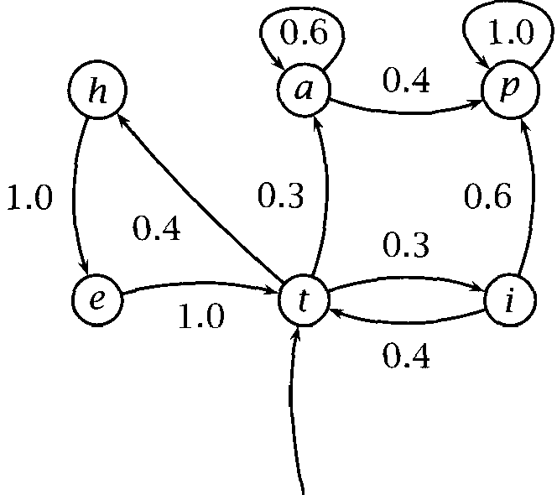

***start***

**Figure 9.1** A Markov model.

From this general description, it should be clear that the word n-gram models we saw in chapter 6 are Markov models. Markov models can be used whenever one wants to model the probability of a linear sequence of events. For example, they have also been used in NLP for modeling valid phone sequences in speech recognition, and for sequences of speech acts in dialog systems.

Alternatively, one can represent a Markov chain by a state diagram as in figure 9.1. Here, the states are shown as circles around the state name, and the single start state is indicated with an incoming arrow. Possible transitions are shown by arrows connecting states, and these arcs are la- beled with the probability of this transition being followed, given that you are in the state at the tail of the arrow. Transitions with zero probability are omitted from the diagram. Note that the probabilities of the outgoing arcs from each state sum to 1. From this representation, it should be clear that a Markov model can be thought of as a (nondeterministic) fi- nite state automaton with probabilities attached to each arc. The Markov properties ensure that we have a finite state automaton. There are no long distance dependencies, and where one ends up next depends simply on what state one is in.

In a visible Markov model, we know what states the machine is passing

through, so the state sequence or some deterministic function of it can be regarded as the output.

The probability of a sequence of states (that is, a sequence of random variables) Xi, *. . . ,* is easily calculated for a Markov chain. We find that we need merely calculate the product of the probabilities that occur on the arcs or in the stochastic matrix:

**= ** 



**= ** 

T-l



So, using the Markov model in figure 9.1, we have:

= *= = * *= = * *=*



*=* 1.0 x 0.3 x 0.6

= 0.18

Note that what is important is whether we encode a process as a Markov process, not whether we most naturally do. For example, recall the n-gram word models that we saw in chapter 6. One might think that, for 3, such a model is not a Markov model because it violates the Limited Horizon condition we are looking a little into earlier history. But we can reformulate any n-gram model as a visible Markov model by simply encoding the appropriate amount of history into the state space (states are then l)-grams, for example (was, *walking, down)* would be a state in a  model). In general, any fixed finite amount of history can always be encoded in this way by simply elaborating the state space as a crossproduct of multiple previous states. In such cases, we sometimes talk of an  *order* Markov model, where is the number of previous states that we are using to predict the next state. Note, thus, that an n-gram model is equivalent to an order Markov model.



Exercise 9.1 

Build a Markov Model similar to figure 9.1 for one of the types of phone numbers in table 4.2.

#### 9.2 Hidden Markov Models

In an HMM, you don W know the state sequence that the model passes through, but only some probabilistic function of it.



***0.7* 0.5**

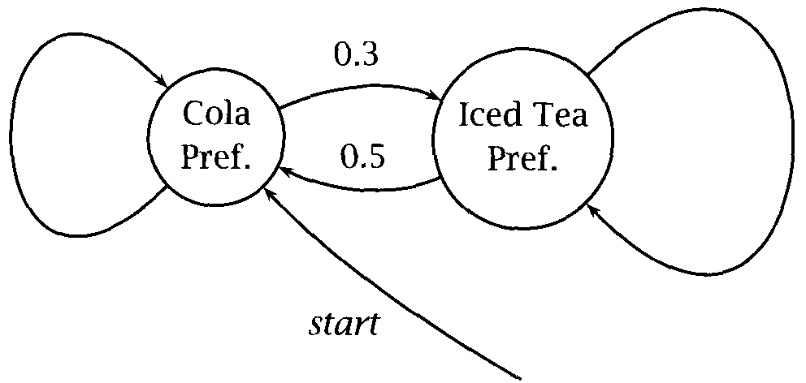

Figure 9.2 The crazy soft drink machine, showing the states of the machine and the state transition probabilities.

**EMISSION PROBABILITY**



**Example 1:** Suppose you have a crazy soft drink machine: it can be in two states, cola preferring  and iced tea preferring (IP), but it switches between them randomly after each purchase, as shown in figure 9.2.

Now, if, when you put in your coin, the machine always put out a cola if it was in the cola preferring state and an iced tea when it was in the iced tea preferring state, then we would have a visible Markov model. But instead, it only has a tendency to do this. So we need symbol emission *probabilities* for the observations:





For this machine, the output is actually independent of and so can be described by the following probability matrix:

Output probability given From state



cola iced tea

lemonade

CP 0.6

IP 0.1

0.1

0.7

0.3

0.2

What is the probability of seeing the output sequence {lem,  if the machine always starts off in the cola preferring state?

**Solution:** We need to consider all paths that might be taken through the HMM, and then to sum over them. We know that the machine starts in state CP. There are then four possibilities depending on which of the two states the machine is in at the other two time instants. So the total

probability is:

0.7 x 0.3 x 0.7 x 0.1 + 0.7 x 0.3 x 0.3 x 0.1

0.3 x 0.3 x 0.5 x 0.7 0.3 x 0.3 x 0.5 x 0.7 = 0.084

**Exercise 9.2**

What is the probability of seeing the output sequence if the machine always starts off in the ice tea preferring state?

Why use

are useful when one can think of underlying events   generating surface events. One widespread use of this is tagging assigning parts of speech (or other classifiers) to the words in a text. We think of there being an underlying Markov chain of parts of speech from which the actual words of the text are generated. Such models are

discussed in chapter 10.

When this general model is suitable, the further reason that are very useful is that they are one of a class of models for which there exist efficient methods of training through use of the Expectation Maximiza- tion (EM) algorithm. Given plenty of data that we assume to be generated by HMM where the model architecture is fixed but not the proba- bilities on the arcs this algorithm allows us to automatically learn the model parameters that best account for the observed data.

Another simple illustration of how we can use is in generating parameters for linear interpolation of n-gram models. We discussed in chapter 6 that one way to estimate the probability of a sentence:

 drank her beer before the meal arrived)

was with an n-gram model, such as a  model, but that just using an n-gram model with fixed tended to suffer because of data sparse- ness. Recall from section 6.3.1 that one idea of how to smooth n-gram

**LINEAR** estimates was to use linear interpolation of n-gram estimates for various

**INTERPOLATION** for example:



This way we would get some idea of how likely a particular word was, even if our coverage of  is sparse. The question, then, is how to set the parameters While we could make reasonable guesses as to

* 1. ***Hidden Models***

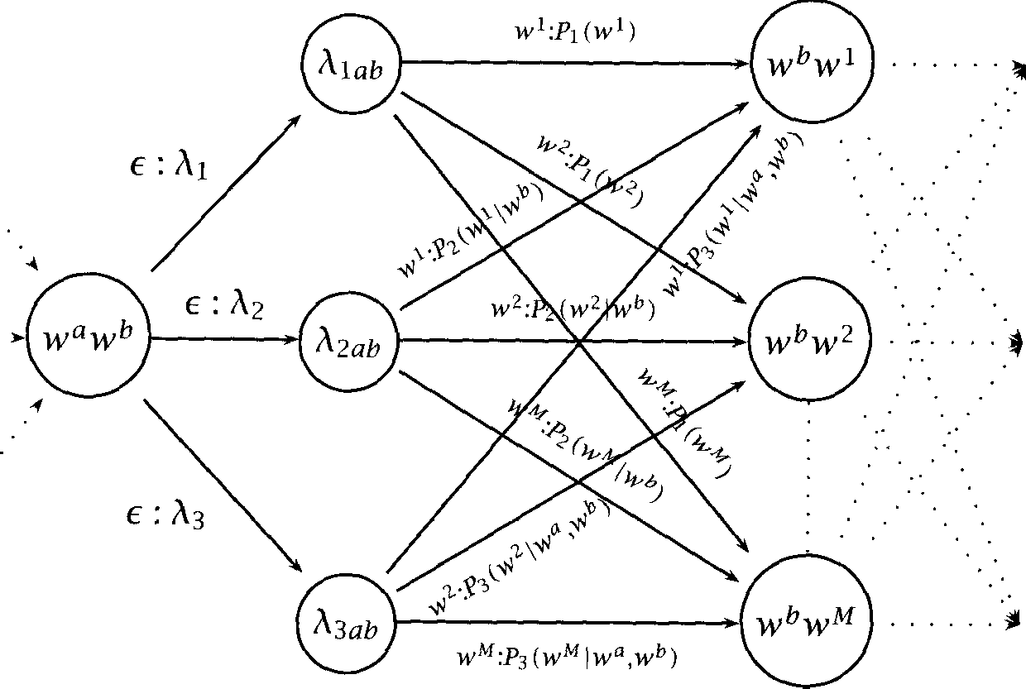

**Figure 9.3** A section of an **HMM** for a linearly interpolated language model. The notation o on arcs means that this transition is made with probability and that an o is output when this transition is made (with probability **1).**



what parameter values to use (and we know that together they must obey the stochastic constraint =  it seems that we should be able to find the optimal values automatically. And, indeed, we can (Jelinek 1990). The key insight is that we can build an HMM with hidden states that represent the choice of whether to use the unigram,  or  probabilities. The HMM training algorithm will determine the optimal weight to give to the arcs entering each of these hidden states, which in turn represents the amount of the probability mass that should be



determined by each n-gram model via setting the parameters  above.

Concretely, we build an HMM with four states for each word pair, one for the basic word pair, and three representing each choice of n-gram model for calculating the next transition. A fragment of the HMM is shown in figure 9.3. Note how this HMM assigns the same probabilities as the earlier equation: there are three ways for to follow  and the total probability of seeing next is then the sum of each of the n-gram probabilities that adorn the arcs multiplied by the corresponding param- eter hi. The HMM training algorithm that we develop in this chapter can

*9 Markov Models*

Set of states Output alphabet

= 

*K = =*



Intial state probabilities II



State transition probabilities *A*



Symbol emission probabilities = j *k K*

State sequence x = : V



Output sequence 0 =  *K*



Table 9.1 Notation used in the **HMM** chapter.

then be applied to this network, and used to improve initial estimates for the parameters  There are two things to note. This conversion works

**TR A NS I T I O N S** by adding *epsilon transitions* that is transitions that we wish to say do not produce an output symbol. Secondly, as presented, we now have separate parameters  for each word pair. But we would not want to adjust these parameters separately, as this would make our sparse data problem worse not better. Rather, for a fixed *i, we* wish to keep all (or at least classes of) the  parameters having the same value, which we do by using *states.* Discussion of both of these extensions to the basic HMM model will be deferred to section 9.4.

9.2.2 General form of an HMM

An HMM is specified by a five-triple  *K, II, A, * where and *K* are the set of states and the output alphabet, and II, *A,* and are the probabilities for the initial state, state transitions, and symbol emissions, respectively. The notation that we use in this chapter is summarized in table 9.1. The random variables  map from state names to corresponding integers. In the version presented here, the symbol emitted at time depends on both the state at time and at time 1. This is sometimes called a



**ARC-EMISSION HMM** *arc-emission* because we can think of the symbol as coming off the

**HMM** arc, as in figure 9.3. An alternative formulation is a *state-emission*

where the symbol emitted at time depends just on the state at time The HMM in example 1 is a state-emission HMM. But we can also regard it as a arc-emission HMM by simply setting up the  parameters so that    This is discussed further in section 9.4.

Given a specification of an HMM, it is perfectly straightforward to

1;



Start in state with probability (i.e.,  = 

1. **forever do**
2. Move from state to state with probability (i.e.,  = 



1. Emit observation symbol = k with probability 6

***7* end**

**Figure 9.4** A program for a Markov process.

late the running of a Markov process, and to produce an output sequence. One can do it with the program in figure 9.4. However, by itself, doing this is not terribly interesting. The interest in comes from

ing that some set of data was generated by a HMM, and then being able to calculate probabilities and probable underlying state sequences.

#### The Three Fundamental Questions for

There are three fundamental questions that we want to know about an HMM:

* + 1. Given a model = *(A, B,* how do we efficiently compute how likely a certain observation is, that is 
    2. Given the observation sequence 0 and a model how do we choose a state sequence  . . . ,  that best explains the observations?
    3. Given an observation sequence 0, and a space of possible models found by varying the model parameters = *(A, B, * how do we find the model that best explains the observed data?

Normally, the problems we deal with are not like the soft drink machine. We don W know the parameters and have to estimate them from data. That V the third question. The first question can be used to decide be- tween models which is best. The second question lets us guess what path was probably followed through the Markov chain, and this hidden path can be used for classification, for instance in applications to part of speech tagging, as we see in chapter 10.

* + 1. Finding the probability of an observation

Given the observation sequence 0 =  and a model = *(A, II), we* wish to know how to efficiently compute the prob- ability of the observation given the model. This process is often referred



**DECODING** to as *decoding.*

For any state sequence X = (Xl,. . . , 

( 9 . 6 )  =

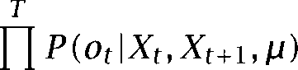

and,

 **. . . **

       

Now,



Therefore,

( 9 . 9 1  = 

**X**



This derivation is quite straightforward. It is what we did in exam- ple 1 to work out the probability of an observation sequence. We simply summed the probability of the observation occurring according to each possible state sequence. But, unfortunately, direct evaluation of the re- sulting expression is hopelessly inefficient. For the general case (where one can start in any state, and move to any other at each step), the calcu- lation requires 1) multiplications.

Exercise 9.3 Confirm this claim.



**DYNAMIC** The secret to avoiding this complexity is the general technique of *dy-* **PROGRAMMING** or by which we remember partial re- **MEMOIZATION** sults rather than recomputing them. This general concept crops up in many other places in computational linguistics, such as chart parsing,



and in computer science more generally (see  et al. 1990: ch. 16) for a general introduction). For algorithms such as the dynamic

**TRELLIS** programming problem is generally described in terms of ***trellises*** (also **LATTICE** called ***lattices).*** Here, we make a square array of states versus time, and compute the probabilities of being at each state at each time in terms

of the probabilities for being in each state at the preceding time instant. This is all best seen in pictures see figures 9.5 and 9.6. A trellis can record the probability of all initial  of the **HMM** that end in a cer- tain state at a certain time. The probability of longer  can then be worked out in terms of one shorter subpaths.

**The forward procedure**

**PROCEDURE** The form of caching that is indicated in these diagrams is called the for- ward ***procedure.*** We describe it in terms of forward variables:

(9.10) **. . .**



The forward variable (t) is stored at in the trellis and expresses the total probability of ending up in state at time (given that the obser- vations were seen). It is calculated by summing probabilities for all incoming arcs at a trellis node. We calculate the forward variables in the trellis left to right using the following procedure:



* + - 1. Initialization

1 ***i***



* + - 1. Induction

   

* + - 1. Total



**N**

 

**i=l**

1 1 j N

 1)



**i=l**

This is a much cheaper algorithm that requires only  multiplica- tions.





State



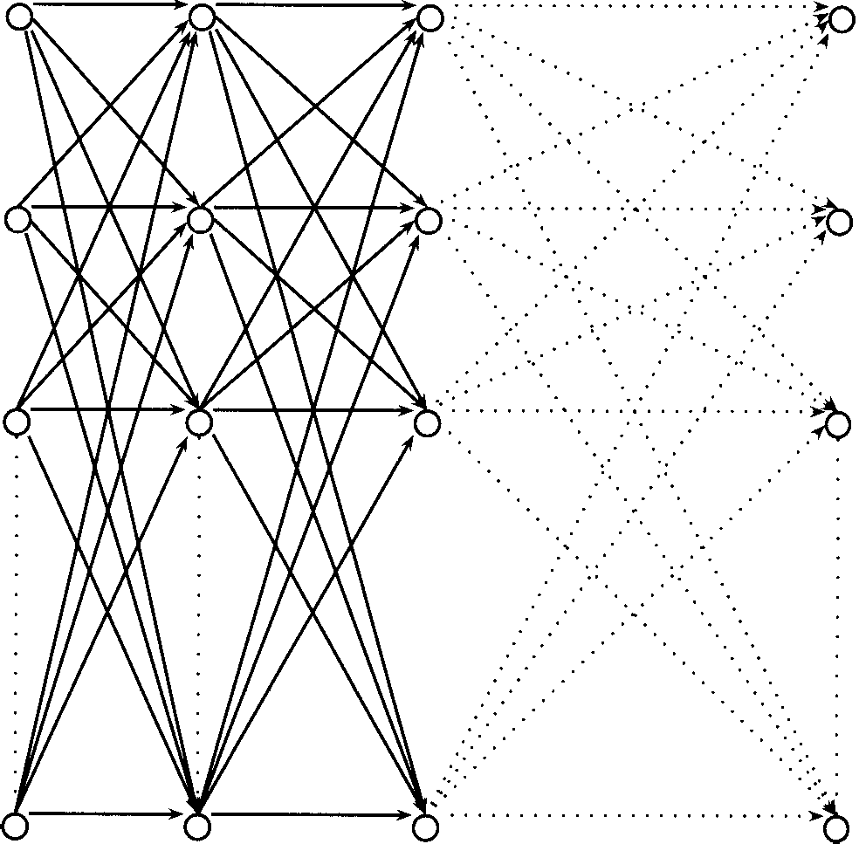1 2 3

Time,

Figure 9.5 Trellis algorithms. The trellis is a square array of states versus times. A node at can store information about state sequences which in- clude = ***i.*** The lines show the connections between nodes. Here we have a fully interconnected **HMM** where one can move from any state to any other at each step.



**The backward procedure**

It should be clear that we do not need to cache results working forward through time like this, but rather that we could also work backward. The

BACKWARD procedure computes backward variables which are the total PROCEDURE probability of seeing the rest of the observation sequence given that we were in state at time The real reason for introducing this less intu-

itive calculation, though, is because use of a combination of forward and backward probabilities is vital for solving the third problem of parameter

***9.3 The Three Fundamental Questions for HMMS***



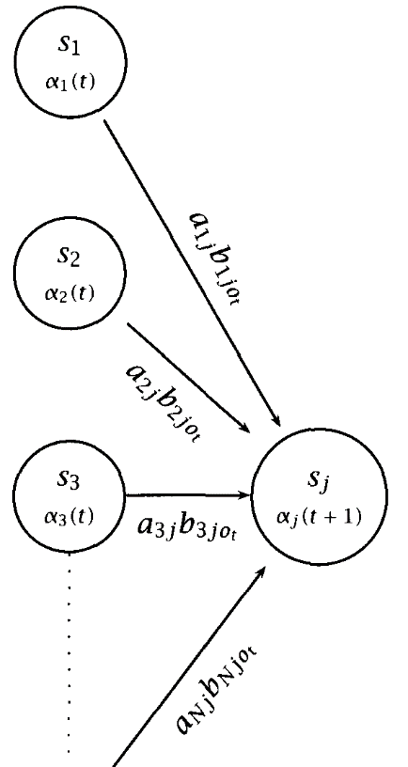

0

**Figure 9.6** Trellis algorithms: Closeup of the computation of forward probabil- ities at one node. The forward probability 1) is calculated by summing the product of the probabilities on each incoming arc with the forward probability of the originating node.

reestimation.



Define backward variables

(9.11) *. .*



Then we can calculate backward variables working from right to left through the trellis as follows:

|  |  |  |  |  |  |  |  |  |  |
| --- | --- | --- | --- | --- | --- | --- | --- | --- | --- |
| Time | (t): | 1 | lem | | output    2 3 | | cola | | 4 |
|  | | 1.0 | | 0.21 | | 0.0462 | | 0.021294 | |
|  | | 0.0 | | 0.09 | | 0.0378 | | 0.010206 | |
| **. .** | | 1.0 | | 0.3 | | 0.084 | | 0.0315 | |
|  | | 0.0315 | | 0.045 | | 0.6 | | 1.0 | |
| 0.029 | | 0.245 | | 0.1 | | 1.0 | |
| 0.0315 | |  | |  | |  | |
|  | | 1.0 | | 0.3 | | 0.88 | | 0.676 | |
| 0.0 | | 0.7 | | 0.12 | | 0.324 | |
|  | | IP | |  | |  | |
|  | | 1.0 | | 0.21 | | 0.0315 | | 0.01323 | |
| 0.0 | | 0.09 | | 0.0315 | | 0.00567 | |
|  | |  | | IP | |  | |
|  | |  | | IP | |  | |
|  | | IP | |  | |  | |
| 0.019404 | |  | |  | |  | |

Table 9.2 Variable calculations for 0 = (lem, cola).

1. Initialization



1. Induction

 ***+ *** 



1. Total





**i=l**

Table 9.2 shows the calculation of forward and backward variables, and other variables that we will come to later, for the soft drink machine from example 1, given the observation sequence 0 = (lem, cola).

***9.3 The Three Fundamental Questions for*** *331*

Combining them

More generally, in fact, we can use any combination of forward and back- ward caching to work out the probability of an observation sequence. Observe that:

 *= * *= * *. . . = *

***= ***  *= * *. . . *

*= . * *= *

 *. . . * *. . * *= *

*= * *. * *= * *. . * *= *

Therefore:

    



The previous equations were special cases of this one.

**9.32 Finding the best state sequence**

7he second problem was worded somewhat vaguely as Iinding the state sequence that best explains the observations. That is because there is more than one way to think about doing this. One way to proceed would be to choose the states individually. That is, for each t, 1 1, we would find that maximizes 



Let

(9.13) *P(Xt*

 *=*











The individually most likely state  is: (9.14)  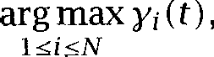 1 1



This quantity maximizes the expected number of states that will be

guessed correctly. However, it may yield a quite unlikely state sequence.

Therefore, this is not the method that is normally used, but rather the Viterbi algorithm, which efficiently computes the most likely state se- quence.

**Viterbi algorithm**

Commonly we want to find the most likely complete path, that is:



**X**

To do this, it is sufficient to maximize for a fixed 0:



**X**

**V ITERBIALGORITHM An** efficient trellis algorithm for computing this path is the ***al- gorithm.*** Define:

 = max **. . **  **= **





This variable stores for each point in the trellis the probability of the most probable path that leads to that node. The corresponding variable  then records the node of the incoming arc that led to this most probable path. Using dynamic programming, we calculate the most probable path through the whole trellis as follows:

1. Initialization

 **1 **

1. Induction

 **1**



Store backtrace

 **1) 1** j



1. Termination and path readout (by backtracking). The most likely state sequence is worked out from the right backwards:

**= 1)**



 **=**

In these calculations, one may get ties. We assume that in that case one path is chosen rantiomly. In practical applications, people commonly want to work out not only the best state sequence but the n-best se- quences or a graph of likely paths. In order to do this people often store the *n* best previous states at a node.



Table 9.2 above shows the computation of the most likely states and state sequence under both these interpretations for this example, they prove to be identical.

9.3.3 The third problem: Parameter estimation

Given a certain observation sequence, we want to find the values of the model parameters = ***(A,*** which best explain what we observed. Using Maximum Likelihood Estimation, that means we want to find the values that maximize



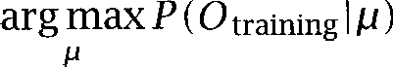

There is no known analytic method to choose to maximize (0 But we can locally maximize it by an iterative hill-climbing algorithm. This

**2 RWARD-BACKWARD** algorithm is the or *Forward-Backward algorithm,* which is a **ALGORITHM** special case of the Expectation Maximization method which we will cover **EM ALGORITHM** in greater generality in section 14.2.2. It works like this. We don W know



what the model is, but we can work out the probability of the observa- tion sequence using some (perhaps randomly chosen) model. Looking at that calculation, we can see which state transitions and symbol emissions were probably used the most. By increasing the probability of those, we can choose a revised model which gives a higher probability to the ob- servation sequence. This maximization process is often referred to as

**TRAINING** *twining* the model and is performed on *training data.*

**TRAINING DATA** Define *(i, * 1 1 *i, j* as shown below. This is the prob- ability of traversing a certain arc at time given observation sequence 0; see figure 9.7.



**= =** *=*

 *= =*

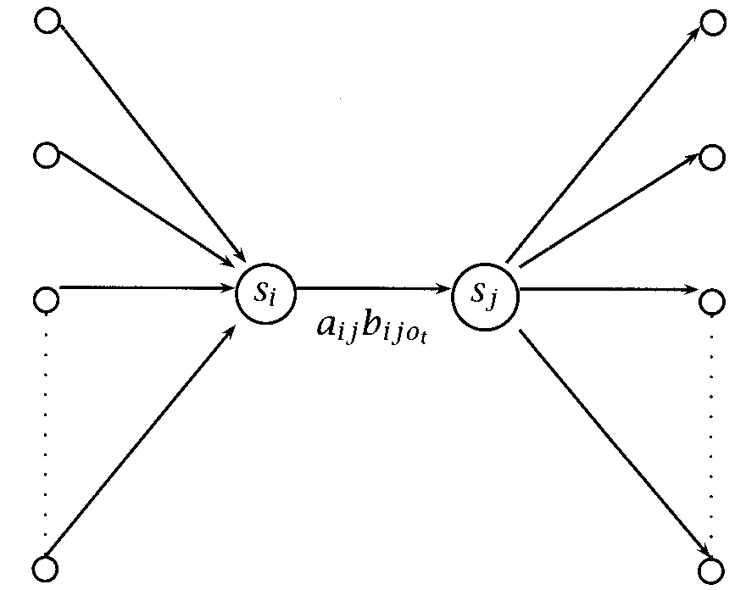



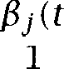

Figure 9.7 The probability of traversing an arc. Given an observation sequence and a model, we can work out the probability that the Markov process went from state to at time





Note that  *=*

*Now,* if we sum over the time index, this gives us expectations (counts):



expected number of transitions from state in 0



*T*

= expected number of transitions from state ***i*** to  in 0



we begin with some model (perhaps preselected, perhaps just cho- sen randomly). We then run 0 through the current model to estimate the expectations of each model parameter. We then change the model to

maximize the values of the paths that are used a lot (while still respect- ing the stochastic constraints). We then repeat this process, hoping to converge on optimal values for the model parameters

The reestimation formulas are as follows:

(9.17)  = expected frequency in state at time = **1**

(9.18) expected number of transitions from state *i* to j

expected number of transitions from state *i*



(9.19) expected number of transitions from *i* to j with *k* observed

expected number of transitions from *i* to j



Thus, from = ***(A, B, we*** derive  = I?). Further, as proved by Baum, we have that:





This is a general property of the EM algorithm (see section 14.2.2). There- fore, iterating through a number of rounds of parameter reestimation will improve our model. Normally one continues reestimating the pa- rameters until results are no longer improving significantly. This process of parameter reestimation does not guarantee that we will find the best

**LOCAL MAXIMUM** model, however, because the reestimation process may get stuck in a

*maximum* (or even possibly just at a saddle point). In most problems of interest, the likelihood function is a complex nonlinear surface and there are many local maxima. Nevertheless, Baum-Welch reestimation is usually effective for

To end this section, let us consider reestimating the parameters of the crazy soft drink machine HMM using the Baum-Welch algorithm. If we let the initial model be the model that we have been using so far, then train- ing on the observation sequence (lem,  cola) will yield the following values for *(i, j):*

 Time (and 

1 2 3

IP IP IP



0.3 0.7 1.0 0.28 0.02 0.3 0.616 0.264 0.88

IP 0.0 0.0 0.0 0.6 0.1 0.7 0.06 0.06 0.12

and so the parameters will be reestimated as follows:

|  |  |  |  |  |  |  |
| --- | --- | --- | --- | --- | --- | --- |
|  | Original | | Reestimated | | | |
| 1.0 | | 1.0 | | | |
| IP | 0.0 | | 0.0 | | | |
|  |  | IP |  |  | IP |  |
| ***A*** CP | 0.7 | 0.3 |  | 0.5486 | 0.4514 |  |
| IP | 0.5 | 0.5 |  | 0.8049 | 0.1951 |  |
|  | cola |  | lem | cola |  | lem |
| ***B*** CP | 0.6 | 0.1 | 0.3 | 0.4037 | 0.1376 | 0.4587 |
|  | 0.1 | 0.7 | 0.2 | 0.1363 | 0.8537 | 0.0 |

Exercise 9.4

If one continued running the Baum-Welch algorithm on this HMM and this train- ing sequence, what value would each parameter reach in the limit? Why?

The reason why the Baum-Welch algorithm is performing so strangely here should be apparent: the training sequence is far too short to accurately rep- resent the behavior of the crazy soft drink machine.

Exercise 9.5

Note that the parameter that is zero in stays zero. Is that a chance occurrence? What would be the value of the parameter that becomes zero in ***B*** if we did an- other iteration of Baum-Welch reestimation? What generalization can one make about Baum-Welch reestimation of zero parameters?

#### Implementation, Properties, and Variants

**Implementation**

Beyond the theory discussed above, there are a number of practical is- sues in the implementation of HMMS. Care has to be taken to make the implementation of HMM tagging efficient and accurate. The most obvious issue is that the probabilities we are calculating consist of keeping on multiplying together very small numbers. Such calculations Will rapidly

* 1. ***Implementation, Properties, and Variants* 337**

underflow the range of floating point numbers on a computer (even if you store them as Gouble !).

The Viterbi algorithm only involves multiplications and choosing the largest element. Thus we can perform the entire Viterbi algorithm work- ing with logarithms. This not only solves the problem with floating point underflow, but it also speeds up the computation, since additions are much quicker than multiplications. In practice, a speedy implementa- tion of the Viterbi algorithm is particularly important because this is the

algorithm, whereas training can usually proceed slowly offline.

However, in the Forward-Backward algorithm as well, something still has to be done to prevent floating point underflow. The need to perform summations makes it difficult to use logs. A common solution is to

SCALING ploy auxiliary scaling coefficients, whose values grow with the time



COEFFICIENTS that the probabilities multiplied by the scaling coefficient remain within the floating point range of the computer. At the end of each iteration, when the parameter values are reestimated, these scaling factors cancel out. Detailed discussion of this and other implementation issues can be found in (Levinson et al.  (Rabiner and Juang 1993:  (Cutting et al.  and (Dermatas and Kokkinakis 1995). The main al- ternative is to just use logs anyway, despite the fact that one needs to sum. Effectively then one is calculating an appropriate scaling factor at the time of each addition:

(9.21) **funct**



if x log big) then y

**elsif y** log big)

then x

**else** y) + log(exp(x y)))



fi.

where ***big*** is a suitable large constant like  For an algorithm like this where one is doing a large number of numerical computations, one also has to be careful about round-off errors, but such concerns are well outside the scope of this chapter.

Variants

There are many variant forms of that can be made without funda- mentally changing them, just as with finite state machines. One is to



**338 *9 Markov Models***

low some arc transitions to occur without emitting any symbol, so-called

**EPSILON TRANSITIONS** *epsilon* or *transitions* et al. 1983). Another commonly used

**NULL TRANSITIONS** ant is to make the output distribution dependent just on a single state, rather than on the two states at both ends of an arc as you traverse an arc, as was effectively the case with the soft drink machine. Under this model one can view the output as a function of the state chosen, rather than of the arc traversed. The model where outputs are a function of the state has actually been used more often in Statistical NLP, because it corresponds naturally to a part of speech tagging model, as we see in chapter 10. Indeed, some people will probably consider us perverse for having presented the arc-emission model in this chapter. But we chose the arc-emission model because it is trivial to simulate the state-emission model using it, whereas doing the reverse is much more difficult. As sug- gested above, one does not need to think of the simpler model as having the outputs coming off the states, rather one can view the outputs as still coming off the arcs, but that the output distributions happen to be the same for all arcs that start at a certain node (or that end at a certain node, if one prefers).

This suggests a general strategy. A problem with HMM models is the

large number of parameters that need to be estimated to define the model, and it may not be possible to estimate them all accurately if not much data is available. A straightforward strategy for dealing with this situation is to introduce assumptions that probability distributions on certain arcs or at certain states are the same as each other. This is

**PARAMETER TYING** ferred to as *parameter tying,* and one thus gets *tied* or *tied*

**TIED STATES TIED ARCS**

Another possibility for reducing the number of parameters of the model is to decide that certain things are impossible (i.e., they have probability zero), and thus to introduce structural zeroes into the model. Making some things impossible adds a lot of structure to the model, and so can greatly improve the performance of the parameter reestimation al- gorithm, but is only appropriate in some circumstances.

* + 1. Multiple input observations

We have presented the algorithms for a single input sequence. How does one train over multiple inputs? For the kind of HMM we have been as- suming, where every state is connected to every other state (with a

**ERGODIC MODEL** zero transition probability) what is sometimes called an  *model*

there is a simple solution: we simply concatenate all the observation

* 1. *Further Reading 339*

sequences and train on them as one long input. The only real disadvan- tage to this is that we do not get sufficient data to be able to reestimate the initial probabilities successfully. However, often people use **HMM** models that are not fully connected. For example, people sometimes use

**FORWARD MODEL** a model where there is an ordered set of states and one can only proceed at each time instant to the same or a higher numbered state. If the **HMM** is not fully connected it contains structural zeroes or if we do want to be able to reestimate the initial probabilities, then we need to extend the reestimation formulae to work with a sequence of inputs. Provided that we assume that the inputs are independent, this is straight- forward. We will not present the formulas here, but we do present the analogous formulas for the **PCFG** case in section 11.3.4.



* + 1. Initialization of parameter values

The reestimation process only guarantees that we will find a local max- imum. If we would rather find the global maximum, one approach is to try to start the **HMM** in a region of the parameter space that is near the global maximum. One can do this by trying to roughly estimate good val- ues for the parameters, rather than setting them randomly. In practice, good initial estimates for the output parameters =  turn out to be particularly important, while random initial estimates for the parameters *A* and are normally satisfactory.

9.5 Further Reading

The Viterbi algorithm was first described in (Viterbi 1967). The mathe- matical theory behind Hidden Markov Models was developed by Baum and his colleagues in the late sixties and early seventies (Baum et al.  and advocated for use in speech recognition in lectures by Jack Ferguson from the Institute for Defense Analyses. It was applied to speech processing in the 1970s by Baker at CMU (Baker  and by Jelinek and colleagues at IBM (Jelinek et al. 1975; Jelinek  and then later found its way at IBM and elsewhere into use for other kinds of lan- guage modeling, such as part of speech tagging.

There are many good references on HMM algorithms (within the context of speech recognition), including (Levinson et al. 1983; Knill and Young 1997; Jelinek 1997). Particularly well-known are (Rabiner 1989; Rabiner

340 ***9 Markov Models***

and Juang 1993). They consider continuous (where the output is real valued) as well as the discrete we have considered here, con- tain information on applications of to speech recognition and may also be consulted for fairly comprehensive references on the develop- ment and the use of Our presentation of is however most closely based on that of Paul (1990).

Within the chapter, we have assumed a fixed HMM architecture, and have just gone about learning optimal parameters for the HMM within that architecture. However, what size and shape of HMM should one choose for a new problem? Sometimes the nature of the problem de- termines the architecture, as in the applications of to tagging that we discuss in the next chapter. For circumstances when this is not the case, there has been some work on learning an appropriate HMM struc- ture on the principle of trying to find the most compact HMM that can adequately describe the data (Stolcke and Omohundro 1993).

are widely used to analyze gene sequences in bioinformatics. See for instance  and Brunak 1998; Durbin et al. 1998). As linguists, we find it a little hard to take seriously problems over an alphabet of four symbols, but bioinformatics is a well-funded domain to which you can apply your new skills in Hidden Markov Modeling!

1. ***Part-of-Speech Tagging***

THE ULTIMATE GOAL of research on Natural Language Processing is to parse and understand language. As we have seen in the preceding chapters, we are still far from achieving this goal. For this reason, much research in NLP has on intermediate tasks that make sense of some of the structure inherent in language without requiring complete

**TAGGING** understanding. One such task is part-of-speech tagging, or simply tug- ging. Tagging is the task of labeling (or tagging) each word in a sentence with its appropriate part of speech. We decide whether each word is a noun, verb, adjective, or whatever. Here is an example of a tagged sen- tence:

(10.1) The-AT representative-NN put-VBD chairs-NNS on-IN the-AT table-NN.

The part-of-speech tags we use in this chapter are shown in table 10.1, and generally follow the Brown/Penn tag sets (see section 4.3.2). Note that another tagging is possible for the same sentence (with the rarer sense for *put* of an *option to*

(10.2) The-AT representative-JJ put-NN chairs-VBZ on-IN the-AT table-NN.

But this tagging gives rise to a semantically incoherent reading. The tag- ging is also syntactically unlikely since uses of *put* as a noun and uses of chairs as an intransitive verb are rare.

This example shows that tagging is a case of limited syntactic disam- biguation. Many words have more than one syntactic category. In tagging, we try to determine which of these syntactic categories is the most likely for a particular use of a word in a sentence.

Tagging is a problem of limited scope: Instead of constructing a com- plete parse, we just fix the syntactic categories of the words in a sentence.



AT BEZ IN JJ



MD NN NNP NNS

PERIOD

PN RB RBR TO VB VBD VBG VBN VBP VBZ

WDT

Part Of Speech article

the word *is* preposition adjective

comparative adjective modal

singular or mass noun singular proper noun plural noun

.:?!

personal pronoun adverb

comparative adverb the word to

verb, base form verb, past tense

verb, present participle, gerund verb, past participle

verb, non-3rd person singular present verb, 3rd singular present

determiner (what, *which)*

Table **10.1** Some part-of-speech tags frequently used for tagging English.

For example, we are not concerned with finding the correct attachment of prepositional phrases. As a limited effort, tagging is much easier to solve than parsing, and accuracy is quite high. Between 96% and 97% of tokens are disambiguated correctly by the most successful approaches. However, it is important to realize that this impressive accuracy figure is not quite as good as it looks, because it is evaluated on a per-word basis. For instance, in many genres such as newspapers, the average sentence is over twenty words, and on such sentences, even with a tagging accuracy of 96% this means that there will be on average over one tagging error per sentence.

Even though it is limited, the information we get from tagging is still quite useful. Tagging can be used in information extraction, question

* 1. *The Information* ***Sources in Tagging 343***

swering, and shallow parsing. The insight that tagging is an intermediate layer of representation that is useful and more tractable than full parsing is due to the corpus linguistics work that was led by Francis and

at Brown University in the 1960s and 70s (Francis and 1982).

The following sections deal with Markov Model taggers, Hidden Markov Model taggers and transformation-based tagging. At the end of the chap- ter, we discuss levels of accuracy for different approaches to tagging. But first we make some general comments on the types of information that are available for tagging.

#### The Information Sources in Tagging

How can one decide the correct part of speech for a word used in a con- text? There are essentially two sources of information. One way is to look at the tags of other words in the context of the word we are interested in. These words may also be ambiguous as to their part of speech, but the essential observation is that some part of speech sequences are common, such as AT JJ NN, while others are extremely unlikely or impossible, such as AT JJ VBP. Thus when choosing whether to give an NN or a tag to the word play in the phrase a we should obviously choose



**SYNTAGMATIC** the former. This type of *syntagmatic* structural information is the most obvious source of information for tagging, but, by itself, it is not very successful. For example, Greene and an early deterministic rule-based tagger that used such information about syntagmatic patterns correctly tagged only 77% of words. This made the tagging problem look quite hard. One reason that it looks hard is that many content words in English can have various parts of speech. For example, there is a very productive process in English which allows almost any noun to be turned into a verb, for example, *Next, you * *the pan,* or, to web *annual report.* This means that almost any noun should also be listed in a dictionary as a verb as well, and we lose a lot of constraining information needed for tagging.



These considerations suggest the second information source: just knowing the word involved gives a lot of information about the correct tag. Although  can be used as a verb, an occurrence of  is much more likely to be a noun. The utility of this information was conclusively demonstrated by Charniak et al.  who showed that a Gumb tagger



that simply assigns the most common tag to each word performs at the surprisingly high level of 90%  This made tagging look quite easy at least given favorable conditions, an issue to which we shall return. As

a result of this, the performance of such a Gumb tagger has been used to

give a baseline performance level in subsequent studies. And all modern taggers in some way make use of a combination of syntagmatic informa- tion (looking at information about tag sequences) and lexical information (predicting a tag based on the word concerned).

Lexical information is so useful because the distribution of a word V us-

ages across different parts of speech is typically extremely uneven. Even for words with a number of parts of speech, they usually occur used as one particular part of speech. Indeed, this distribution is usually so marked that this one part of speech is often seen as basic, with others be- ing derived from it. As a result, this has led to a certain tension over the way the term Sart of speech has been used. In traditional grammars, one often sees a word in context being classified as something like D noun be- ing used as an adjective, which confuses what is seen as the Easic part of speech of the lexeme with the part of speech of the word as used in the current context. In this chapter, as in modern linguistics in general, we are concerned with determining the latter concept, but nevertheless, the distribution of a word across the parts of speech gives a great deal of additional information. Indeed, this uneven distribution is one reason why one might expect statistical approaches to tagging to be better than deterministic approaches: in a deterministic approach one can only say that a word can or cannot be a verb, and there is a temptation to leave out the verb possibility if it is very rare (since doing so will probably lift the level of overall performance), whereas within a statistical approach, we can say that a word has an extremely high priori probability of being a noun, but there is a small chance that it might be being used as a verb, or even some other part of speech. Thus syntactic disambiguation can be argued to be one context in which a framework that allows quantitative information is more adequate for representing linguistic knowledge than a purely symbolic approach.



* + 1. The general efficacy of this method was noted earlier by (1987).
  1. Markov Model Taggers

102.1 **The probabilistic model**

In Markov Model tagging, we look at the sequence of tags in a text as a Markov chain. As discussed in chapter 9, a Markov chain has the follow- ing two properties:

**Limited horizon. = ** ***. . ***

 **Time invariant (stationary). *= *** ***= = ***

That is, we assume that a word V tag only depends on the previous tag (limited horizon) and that this dependency does not change over time (time invariance). For example, if a finite verb has a probability of 0.2 to occur after a pronoun at the beginning of a sentence, then this probability will not change as we tag the rest of the sentence (or new sentences). As with most probabilistic models, the two Markov properties only approxi- mate reality. For example, the Limited Horizon property does not model long-distance relationships like this was in fact the core of Chomsky V famous argument against using Markov Models for natural language.

**Exercise 10.1**

What are other linguistic phenomena that are not modeled correctly by Markov chains? Which general property of language is common to these phenomena?

**Exercise 10.2**

Why is Time Invariance problematic for modeling language?

Following (Charniak et al.  we will use the notation in table 10.2. We use subscripts to refer to words and tags in particular positions of the sentences and corpora we tag. We use superscripts to refer to word types in the lexicon of words and to refer to tag types in the tag set. In this compact notation, we can state the above Limited Horizon property as follows:





We use a *training set* of manually tagged text to learn the regularities of tag sequences. The maximum likelihood estimate of tag  following

*346* ***0 Part-of-Speech Tagging***

the word at position in the corpus the tag of

the words occurring at positions ***i*** through ***i +***

(alternative notations: ***, *** the tags for



***W’*** the  word in the lexicon  the  tag in the tag set

the number of occurrences of  in the training set the number of occurrences of  in the training set the number of occurrences of  followed by 



*:* the number of occurrences of  that are tagged as 

*T* number of tags in tag set

*W* number of words in the lexicon

***n*** sentence length

Table 10.2 Notational conventions for tagging.

 is estimated from the relative frequencies of different tags following a certain tag as follows:

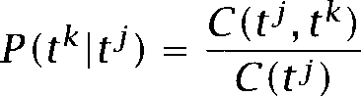

For instance, following on from the example of how to tag a *new * *we* would expect to find that Indeed, on the Brown corpus,  0.45 and  0.0005.

With estimates of the probabilities *we* can compute the prob- ability of a particular tag sequence. In practice, the task is to find the most probable tag sequence for a sequence of words, or equivalently, the most probable state sequence for a sequence of words (since the states of the Markov Model here are tags). We incorporate words by having the Markov Model emit words each time it leaves a state. This is similar to the symbol emission probabilities  in from chapter 9:





The difference is that we can directly observe the states (or tags) if we have a tagged corpus. Each tag corresponds to a different state. We

can also directly estimate the probability of a word being emitted by a particular state (or tag) via Maximum Likelihood Estimation:

 



***(10.3)***

Now we have everything in place to find the best tagging  for a sen- tence Applying Bayes rule, we can write:

= argmax









We now reduce this expression to parameters that can be estimated from the training corpus. In addition to the Limited Horizon assumption  we make two assumptions about words:

* words are independent of each other  and
* a word V identity only depends on its tag (10.5)

   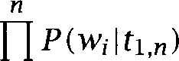

(10.5)

**i=l**

    





(10.6)

 **x **  x

 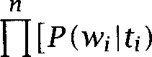  



**i=l**



(We define 1.0 to simplify our notation.)



Exercise ***10.3***

These are simplifying assumptions. Give two examples each of phenomena where independence of words (10.4) and independence from previous and fol- lowing tags (10.5) don W hold.

So the final equation for determining the optimal tags for a sentence

is:

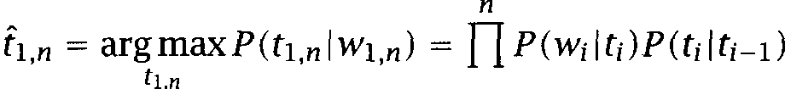

**i=l**

**for all tags do**

**for all tags do**





**end end**

**for all tags do**

**for all words ** **do**

 



**end**

**end**

Figure 10.1 Algorithm for training a Visible Markov Model Tagger. In most implementations, a smoothing method is applied for estimating the and



|  |  |  |  |  |  |
| --- | --- | --- | --- | --- | --- |
| First tag | AT | BEZ | **Second tag**  IN NN | | PERIOD |
| AT | 0 | 0 | 0 | 48636 | 0 19 |
| BEZ | 1973 | 0 | 426 | 187 | 0 38 |
| IN | 43322 | 0 | 1325 | 17314 | 0 185 |
| NN | 1067 | 3720 | 42470 | 11773 | 614 21392 |
|  | 6072 | 42 | 4758 | 1476 | 129 1522 |
| PERIOD | 8016 | 75 | 4656 | 1329 | 954 0 |

Table 10.3 Idealized counts of some tag transitions in the Brown Corpus. For example, NN occurs 48636 times after AT.

The algorithm for training a Markov Model tagger is summarized in figure 10.1. The next section describes how to tag with a Markov Model tagger once it is trained.

Exercise 10.4

Given the data in table 10.3, compute maximum likelihood estimates as shown in figure 10.1 for



and *P* (PERIOD NN). Assume that the total number of occurrences of tags can be obtained by umming over the numbers in a row (e.g., for BEZ).

Exercise 10.5

Given the data in table 10.4, compute maximum likelihood estimates as shown in figure 10.1 for



and Take the total number of occurrences of tags from table 10.3.



***10.2 Markov Model Taggers***

|  |  |  |  |  |  |
| --- | --- | --- | --- | --- | --- |
|  | AT | BEZ | IN | NN | PERIOD |
| ***bear*** | **0** | 0 | 0 | 10 43 | 0 |
| ***is*** | **0** | 10065 | 0 | 0 0 | 0 |
| ***move*** | **0** | 0 | 0 | 36 133 | 0 |
| ***on*** | **0** | 0 | 5484 | 0 0 | 0 |
| ***president*** | **0** | 0 | 0 | 382 0 | 0 |
| ***progress*** | **0** | 0 | 0 | 108 4 | 0 |
| ***the*** | 69016 | 0 | 0 | 0 0 | 0 |
|  | 0 | 0 | 0 | 0 0 | 48809 |

Table 10.4 Idealized counts for the tags that some words occur with in the Brown Corpus. For example, 36 occurrences of ***move*** are with the tag NN.

Exercise 10.6  Compute the following two probabilities:

 NN BEZ IN AT ***The bear is on the move.)***

NN BEZ IN AT ***The bear is on the move.)***

* + 1. The Viterbi algorithm

We could evaluate equation (10.7) for all possible taggings  of a sen- tence of length ***n,*** but that would make tagging exponential in the length of the input that is to be tagged. An efficient tagging algorithm is the Viterbi algorithm from chapter 9. To review, the Viterbi algorithm has three steps:  initialization, (ii) induction, and (iii) termination and  readout. We compute two functions  (j), which gives us the probability of being in state j tag  at word ***i,*** and (j), which gives us the most likely state (or tag) at word ***i*** given that we are in state j at word ***i +*** 1. The reader may want to review the discussion of the Viterbi algorithm in section before reading on. Throughout, we will refer to states as tags in this chapter because the states of the model correspond to tags. (But note that this is only true for a  tagger.)

The initialization step is to assign probability 1.0 to the tag PERIOD:

 1.0

= 0.0 for PERIOD



That is, we assume that sentences are delimited by periods and we pend a period in front of the first sentence in our text for convenience.

**comment:** Given: a sentence of length *n*

**comment:** Initialization

***3 *** = 1.0

**4 ** **=** 0.0 for PERIOD



***5* comment:** Induction



**for all tags do**

**7**

**8**



X

***9***

***10* end end**

***12* comment:** Termination and path-readout  =



**14**

**15 ** 

**end**

***17 *** 



Figure **10.2** Algorithm for tagging with a Visible Markov Model Tagger.

The induction step is based on equation  where =  and =  ***tj):***

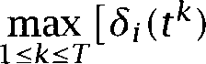   1 j



***X *** ***X *** 1 j

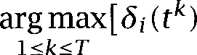

Finally, termination and read-out steps are as follows, where  . .  are the tags we choose for words . . ,





 1 *i n* 1

 ***. . *** ***= *** ***(tj)***

Tagging with a Visible Markov Model tagger is summarized in figure 10.2.

**Exercise 10.7**

Based on the probability estimates from the previous set of exercises, tag the following sentence using the Viterbi algorithm.

***10.2 Markov Model Taggers 351***

**(10.8)** The bear is on the move.

Exercise 10.8

Some larger data sets of tag sequence probabilities and some suggested exercises are available on the

Terminological note: Markov Models vs. Hidden Markov Models. The reader may have noticed that for the purposes of tagging, the Markov Models in this chapter are treated as Hidden Markov Models. This is because we can observe the states of the Markov Model in training (the tags of the labeled corpus), but we only observe words in applying the Markov Model to the tagging task. We could say that the formalism used in Markov Model tagging is really a mixed formalism. We construct 9isi- ble Markov Models in training, but treat them as Hidden Markov Models when we put them to use and tag new corpora.

* + 1. Variations

**Unknown words**

We have shown how to estimate word generation probabilities for words that occur in the corpus. But many words in sentences we want to tag will not be in the training corpus. Some words will not even be in the dictionary. We discussed above that knowing the a priori distribution of the tags for a word (or at any rate the most common tag for a word) takes you a great deal of the way in solving the tagging problem. This means that unknown words are a major problem for taggers, and in practice, the differing accuracy of different taggers over different corpora is often mainly determined by the proportion of unknown words, and the smarts built into the tagger that allow it to try to guess the part of speech of unknown words.

The simplest model for unknown words is to assume that they can be of any part of speech (or perhaps only any open class part of speech that is nouns, verbs, etc., but not prepositions or articles). Unknown words are given a distribution over parts of speech corresponding to that of the lexicon as a whole. While this approach is serviceable in some cases, the loss of lexical information for these words greatly lowers the accuracy of the tagger, and so people have tried to exploit other features of the word and its context to improve the lexical probability estimates for unknown words. Often, we can use morphological and other cues to

*10 Part-of-Speech Tagging*

|  |  |  |  |  |  |  |
| --- | --- | --- | --- | --- | --- | --- |
| Feature | Value | NNP | NN | NNS | VBG | VBZ |
| unknown word | yes | 0.05 | 0.02 | 0.02 | 0.005 | 0.005 |
|  | no | 0.95 | 0.98 | 0.98 | 0.995 | 0.995 |
| capitalized | yes | 0.95 | 0.10 | 0.10 | 0.005 | 0.005 |
|  | no | 0.05 | 0.90 | 0.90 | 0.995 | 0.995 |
| ending | -s | 0.05 | 0.01 | 0.98 | 0.00 | 0.99 |
|  |  | 0.01 | 0.01 | 0.00 | 1.00 | 0.00 |
|  |  | 0.05 | 0.10 | 0.00 | 0.00 | 0.00 |
|  | other | 0.89 | 0.88 | 0.02 |  | 0.01 |

Table 10.5 Table of probabilities for dealing with unknown words in tagging. For example, word = = 0.05 and = *=* 1.0.

make inferences about a word V possible parts of speech. For example, words ending in are likely to be past tense forms or past participles. Weischedel et al. (1993) estimate word generation probabilities based on three types of information: how likely it is that a tag will generate an unknown word (this probability is zero for some tags, for example PN, personal pronouns); the likelihood of generation of uppercase/lowercase words; and the generation of hyphens and particular suffixes:

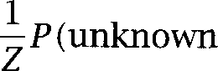

where Z is a normalization constant. This model reduces the error rate for unknown words from more than 40% to less than 20%.

Charniak et al. (1993) propose an alternative model which depends both on roots and suffixes and can select from multiple morphological analyses (for example, do-es (a verb form) vs. doe-s (the plural of a noun)). Most work on unknown words assumes independence between fea- tures. Independence is often a bad assumption. For example, capitalized words are more likely to be unknown, so the features Xnknown word’ and Fapitalized in Weischedel et model are not really independent.

Franz (1996; 1997) develops a model for unknown words that takes **MAINEFFECTS** pendence into account. He proposes a loglinear model that models *main* **INTERACTIONS effects** (the effects of a particular feature on its own) as well as *interac-*

*tions* (such as the dependence between Xnknown word and Fapitalized ).

For an approach based on Bayesian inference see Samuelsson (1993).

***10.2 Markov Model Taggers*** 3.53

Exercise 10.9

Given the (made-up) data in table 10.5 and Weischedel et model for un- known words, compute



and As-

sume that NNP, NN, NNS, VBG, and VBZ are the possible tags. Do the estimates seem intuitively correct? What additional features could be used for better results?

**Exercise** 10.10

Compute better estimates of the probabilities in table 10.5 from the data on the web site.

 **taggers**

The basic Markov Model tagger can be extended in several ways. In the model developed so far, we make predictions based on the preceding tag.

TAGGER This is called a  *tugger* because the basic unit we consider is the preceding tag and the current tag. We can think of tagging as selecting the most probable word probabilities).



We would expect more accurate predictions if more context is taken into account. For example, the tag RB (adverb) can precede both a verb in the past tense  and a past participle (VBN). So a word sequence like clearly marked is inherently ambiguous in a Markov Model with a

TAGGER Pemory that reaches only one tag back. A *tugger* has a

tag memory and lets us disambiguate more cases. For example, *is clearly marked* and he  *marked* suggest VBN and VBD, respectively, be- cause the  %EZ RB VBN is more frequent than the %EZ RB VBD and because 3N RB VBD is more frequent than RB VBN.”



A  tagger was described in (Church  which is probably the most cited publication on tagging and got many NLP researchers inter- ested in the problem of part-of-speech tagging.

**Interpolation and variable memory**

Conditioning predictions on a longer history is not always a good idea. For example, there are usually no short-distance syntactic dependen- cies across commas. So knowing what part of speech occurred before a comma does not help in determining the correct part of speech af- ter the comma. In fact, a  tagger may make worse predictions than a  tagger in such cases because of sparse data problems

3.54 *Part-of-Speech Tagging*

 transition probabilities are estimated based on rarer events, so the chances of getting a bad estimate are higher.

One way to address this problem is linear interpolation of unigram,  and  probabilities:

   + 

This method of linear interpolation was covered in chapter 6 and how to estimate the parameters  using an HMM was covered in chapter 9.

Some researchers have selectively augmented a low-order Markov model based on error analysis and prior linguistic knowledge. For ex- ample, Kupiec  observed that a first order HMM systematically mistagged the sequence Whe bottom of as $T JJ IN. He then extended the order-one model with a special network for this construction so that the improbability of a preposition after a $T JJ sequence could be learned. This method amounts to manually selecting higher-order states for cases where an order-one memory is not sufficient.

A related method is the Variable Memory Markov Model   and Singer 1994). have states of mixed Oength instead of the fixed-length states of  and  taggers. A VMMM tagger can go from a state that remembers the last two tags (corresponding to a  to a state that remembers the last three tags (corresponding to a fourgram) and then to a state without memory (corresponding to a unigram). The number of symbols to remember for a particular sequence is determined in training based on an information-theoretic criterion. In contrast to linear interpolation, VMMMs condition the length of mem- ory used for prediction on the current sequence instead of using a fixed weighted sum for all sequences. VMMMs are built top-down by splitting states. An alternative is to build this type of model bottom-up by way of

MODEL MERGING model *merging* (Stolcke and Omohundro 1994a; Brants 1998).

The hierarchical non-emitting Markov model is an even more powerful model that was proposed by Ristad and Thomas (1997). By introduc- ing non-emitting transitions (transitions between states that do not emit a word or, equivalently, emit the empty word  this model can store dependencies between states over arbitrarily long distances.

**Smoothing**

Linear interpolation is a way of smoothing estimates. We can use any of the other estimation methods discussed in chapter 6 for smoothing. For

* 1. Markov Model *Taggers 355*

example, Charniak et al. (1993) use a method that is similar to Adding One (but note that, in general, it does not give a proper probability distri- bution 





+

Smoothing the word generation probabilities is more important than smoothing the transition probabilities since there are many rare words that will not occur in the training corpus. Here too, Adding One has been used (Church 1988). Church added 1 to the count of all parts of speech listed in the dictionary for a particular word, thus guaranteeing a

zero probability for all parts of speech  that are listed as possible for

 



where  is the number of possible parts of speech of 

**Exercise** 10.11

Recompute the probability estimates in exercises 10.4 and 10.5 with Adding One.

Reversibility

We have described a Markov Model that Gecodes (or tags) from left to right. It turns out that decoding from right to left is equivalent. The following derivation shows why this is the case:

  **= ** **. **



**.**





Assuming that the probability of the initial and last states are the same (which is the case in tagging since both correspond to the tag PERIOD), Iorward and Eackward probability are the same. So it doesn W matter which direction we choose. The tagger described here moves from left to right. Church V tagger takes the opposite direction.

Maximum Likelihood: Sequence vs. tag by tag

As we pointed out in chapter 9, the Viterbi Algorithm finds the most likely sequence of states (or tags). That is, we maximize We

could also maximize  for all which amounts to summing over different tag sequences.

As an example consider sentence (10.10): (10.10) Time flies like an arrow.

Let us assume that, according to the transition probabilities we Ye gath- ered from our training corpus, and are likely taggings (assume probability is an unlikely tagging (assume proba- bility and that is impossible because transition probabil- ity is 0.0.



(10.11) a. NN VBZ RB AT NN. = 0.01

1. NN NNS VB AT NN. = 0.01
2. NN NNS RB AT NN. = 0.001
3. NN VBZ VB AT NN. = 0

For this example, we will obtain taggings and as the equally most likely sequences  But we will obtain if we maximize for all This is because = Time flies ***like an arrow) =*** 0.011 = P(b) + ***P(c)*** 0.01 = P(a) = ***=***



***flies like arrow)*** and = ***Time flies like an arrow) =*** 0.011 = P(a) + 0.01 = ***P(b) = = VB Time flies like an arrow).***



Experiments conducted by Merialdo (1994: 164) suggest that there is no large difference in accuracy between maximizing the likelihood of in- dividual tags and maximizing the likelihood of the sequence. Intuitively, it is fairly easy to see why this might be. With Viterbi, the tag transi- tions are more likely to be sensible, but if something goes wrong, we will sometimes get a sequence of several tags wrong; whereas with tag by tag, one error does not affect the tagging of other words, and so one is more likely to get occasional dispersed errors. In practice, since incoherent se- quences (like 1N NNS RB AT NN above) are not very useful, the Viterbi algorithm is the preferred method for tagging with Markov Models.

* 1. Hidden Markov Model Taggers

Markov Model taggers work well when we have a large tagged training set. Often this is not the case. We may want to tag a text from a special- ized domain with word generation probabilities that are different from

those in available training texts. Or we may want to tag text in a foreign language for which training corpora do not exist at all.

* + 1. Applying to POS tagging

If we have no training data, we can use an **HMM** to learn the regularities of tag sequences. Recall that an **HMM** as introduced in chapter 9 consists of the following elements:

a set of states

an output alphabet initial state probabilities

state transition probabilities symbol emission probabilities

As in the case of the Visible Markov Model, the states correspond to tags.

The output alphabet consists either of the words in the dictionary or classes of words as we will see in a moment.

We could randomly initialize all parameters of the **HMM,** but this would leave the tagging problem too unconstrained. Usually dictionary infor- mation is used to constrain the model parameters. If the output alphabet consists of words, we set word generation  symbol emission) proba- bilities to zero if the corresponding word-tag pair is not listed in the dictionary (e.g., JJ is not listed as a possible part of speech for ***book). Al-*** ternatively, we can group words into word equivalence classes so that all words that allow the same set of tags are in the same class. For example, we could group bottom and top into the class JJ-NN if both are listed with just two parts of speech, JJ and NN. The first method was proposed by Jelinek  the second by Kupiec  We write for the prob- ability that word (or word class) is emitted by tag This means that as in the case of the Visible Markov Model the Rutput of a tag does not depend on which tag  state) is next.



  method.





where the sum is over all words in the dictionary and

0 if  is not a part of speech allowed for 

=

**1** otherwise

T o

where  is the number of tags allowed for 

Jelinek V method amounts to initializing the HMM with the maximum likelihood estimates for assuming that words occur equally likely with each of their possible tags.



**Kupiec V method.** First, group all words with the same possible parts of speech into Petawords Here is a subset of the integers from 1 to where ***T*** is the number of different tags in the tag set:

=  allowed for  1,



For example, if NN =  and JJ =  then will contain all words for which the dictionary allows tags NN and JJ and no other tags.

We then treat these metawords the same way we treated words in Jelinek V 

=



where C(  is the number of occurrences of words from the sum in the denominator is over all metawords and

***0 ***

***=***

 otherwise

where  is the number of indices in

The advantage of Kupiec V method is that we don W fine-tune a

rate set of parameters for each word. By introducing equivalence classes, the total number of parameters is reduced substantially and this smaller set can be estimated more reliably. This advantage could turn into a disadvantage if there is enough training material to accurately estimate parameters word by word as Jelinek V method does. Some experiments

1. The actual initialization used by Kupiec is a variant of what we present here. We have tried to make the similarity between Jelinek V and Kupiec V methods more transparent.

DO maximum likelihood estimates from a tagged training corpus correct ordering only of lexical probabilities

D2 lexical probabilities proportional to overall tag probabilities D3 equal lexical probabilities for all tags admissible for a word

TO maximum likelihood estimates from a tagged training corpus equal probabilities for all transitions

**Table 10.6** Initialization of the parameters of an HMM. DO, and D3 are initializations of the lexicon, and TO and are initializations of tag transitions investigated by Elworthy.



conducted by Merialdo (1994) suggest that unsupervised estimation of a separate set of parameters for each word introduces error. This ar- gument does not apply to frequent words, however. Kupiec therefore does not include the 100 most frequent words in equivalence classes, but treats them as separate one-word classes.

**Training.** Once initialization is completed, the Hidden Markov Model is trained using the Forward-Backward algorithm as described in chapter 9.

**Tagging.** As we remarked earlier, the difference between VMM tagging and HMM tagging is in how we the model, not in how we tag. The formal object we end up with after training is a Hidden Markov model in both cases. For this reason, there is no difference when we apply the model in tagging. We use the Viterbi algorithm in exactly the same man- ner for Hidden Markov Model tagging as we do for Visible Markov Model tagging.

10.32 The effect of initialization on HMM training

The Flean (i.e., theoretically well-founded) way of stopping training with the Forward-Backward algorithm is the log likelihood criterion (stop when the log likelihood no longer improves). However, it has been shown that, for tagging, this criterion often results in overtraining. This issue was investigated in detail by Elworthy (1994). He trained from the dif- ferent starting conditions in table 10.6. The combination of DO and TO corresponds to Visible Markov Model training as we described it at the beginning of this chapter. orders the lexical probabilities correctly



**CLASSICAL**

**EARLY MAXIMUM**

**INITIAL MAXIMUM**

*10 Part-of-Speech Tagging*

(for example, the fact that the tag VB is more likely for make than the tag NN), but the absolute values of the probabilities are randomized. gives the same ordering of parts of speech to all words (for example, for the most frequent tag  *we* would have is greater than



for all other tags  D3 preserves only information about which tags are possible for a word, the ordering is not necessarily correct. initializes the transition probabilities to roughly equal 

Elworthy (1994) finds three different patterns of training for different combinations of initial conditions. In the *classical* pattern, performance on the test set improves steadily with each training iteration. In this case the log likelihood criterion for stopping is appropriate. In the early

pattern, performance improves for a number of iterations (most often for two or three), but then decreases. In the *initial maximum* pat- tern, the very first iteration degrades performance.

The typical scenario for applying is that a dictionary is available, but no tagged corpus as training data (conditions D3 (maybe  and For this scenario, training follows the early maximum pattern. That means that we have to be careful in practice not to overtrain. One way to achieve this is to test the tagger on a held-out validation set after each iteration and stop training when performance decreases.

Elworthy also confirms Merialdo V finding that the Forward-Backward algorithm degrades performance when a tagged training corpus (of even

moderate size) is available. That is, if we initialize according to DO and TO, then we get the initial maximum pattern. However, an interesting twist is that if training and test corpus are very different, then a few iterations do improve performance (the early maximum pattern). This is a case that occurs frequently in practice since we are often confronted with types of text for which we do not have similar tagged training text.

In summary, if there is a sufficiently large training text that is fairly similar to the intended text of application, then we should use Visible Markov Models. If there is no training text available or training and test text are very different, but we have at least some lexical information, then we should run the Forward-Backward algorithm for a few iterations. Only when we have no lexical information at all, should we train for a larger number of iterations, ten or more. But we cannot expect good 

1. Exactly identical probabilities are generally bad as a starting condition for the EM algo- rithm since they often correspond to suboptimal local optima that can easily be avoided. We assume that D3 and refer to approximately equal probabilities that are slightly perturbed to avoid ties.

in this case. This failure is not a defect in the forward-backward algorithm, but reflects the fact that the forward-backward algorithm is only maximizing the likelihood of the training data by adjusting the pa- rameters of an HMM. The changes it is using to reduce the cross entropy may not be in accord with our true objective function getting words assigned tags according to some  tag set. Therefore it is not capable of optimizing performance on that task.

Exercise 10.12

when introducing **HMM** tagging above, we said that random initialization of the model parameters (without dictionary information) is not a useful starting point for the EM algorithm. Why is this the case? what would happen if we just had the following eight parts of speech: preposition, verb, adverb, adjective, noun, article, conjunction, and auxiliary; and randomly initialized the HMM. Hint: The EM algorithm will concentrate on high-frequency events which have the highest impact on log likelihood (the quantity maximized).

How does this initialization differ from

Exercise 10.13

The EM algorithm improves the log likelihood of the model given the data in each iteration. How is this compatible with Elworthy V and Merialdo V results that tagging accuracy often decreases with further training?

**Exercise** 10.14

The crucial bit of prior knowledge that is captured by both Jelinek V and Kupiec V methods of parameter initialization is which of the word generation probabilities should be zero and which should not. The implicit assumption here is that a generation probability set to zero initially will remain zero during training. Show that this is the case referring to the introduction of the Forward-Backward algorithm in chapter 9.

**Exercise** 10.15

Get the Xerox tagger (see pointer on and tag texts from the web site.

#### 10.4 Transformation-Based Learning of Tags

In our description of Markov models we have stressed at several points that the Markov assumptions are too for many properties of nat- ural language syntax. The question arises why we do not adopt more sophisticated models. We could condition tags on preceding words (not just preceding tags) or we could use more context than  taggers by going to  or even higher order taggers.

This approach is not feasible because of the large number of param- eters we would need. Even with taggers, we had to smooth and interpolate because maximum likelihood estimates were not robust enough. This problem would be exacerbated with models more complex than the Markov models introduced so far, especially if we wanted to condition transition probabilities on words.

We will now turn to transformation-based tagging. One of the strengths of this method is that it can exploit a wider range of lexical and syn- tactic regularities. In particular, tags can be conditioned on words and on more context. Transformation-based tagging encodes complex terdependencies between words and tags by selecting and sequencing transformations that transform an initial imperfect tagging into one with fewer errors. The training of a transformation-based tagger requires an order of magnitude fewer decisions than estimating the large number of parameters of a Markov model.

Transformation-based tagging has two key components:

* a specification of which Hrror-correcting transformations are admis- sible
* the learning algorithm

As input data, we need a tagged corpus and a dictionary. We first tag each word in the training corpus with its most frequent tag that is what we need the dictionary for. The learning algorithm then constructs a ranked list of transformations that transforms the initial tagging into a tagging that is close to correct. This ranked list can be used to tag new text, by again initially choosing each word V most frequent tag, and then applying the transformations. We will now describe these components in more detail.

10.4.1 **Transformations**

A transformation consists of two parts, a triggering environment and a rewrite rule. Rewrite rules have the form meaning Ueplace tag by tag Brill (1995a) allows the triggering environments shown in table 10.7. Here the asterisk is the site of the potential rewriting and the boxes denote the locations where a trigger will be sought. For example, line 5 refers to the triggering environment 7ag occurs in one of the



three previous positions.”

Schema



1 *

2 * I

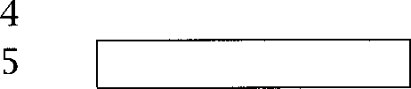

3 *

* -

*

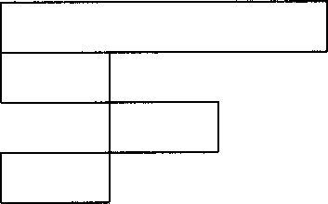6

7

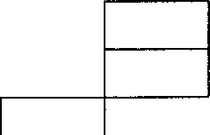

8

9

Table 10.7 Triggering environments in transformation-based tagger. amples: Line 5 refers to the triggering environment 7ag occurs in one of the three previous positions ; Line 9 refers to the triggering environment 7ag occurs two positions earlier and tag occurs in the following position.”

Source tag Target tag Triggering environment NN VB previous tag is TO

VBP VB one of the previous three tags is MD RBR next tag is JJ

VBP VB one of the previous two words is

Table 10.8 Examples of some transformations learned in transformation-based tagging.

Examples of the type of transformations that are learned given these triggering environments are shown in table 10.8. The first transforma- tion specifies that nouns should be retagged as verbs after the tag TO. Later transformations with more specific triggers will switch some words back to NN (e.g., school in go to school). The second transformation in table 10.8 applies to verbs with identical base and past tense forms like *cut* and put. A preceding modal makes it unlikely that they are used in the past tense. An example for the third transformation is the retagging of in valuable player.

The first three transformations in table 10.8 are triggered by tags. The fourth one is triggered by a word. (In the Penn words like don W and shouldn W are split up into a modal and  Similar to the second transformation, this one also changes a past tense form to a base form. A preceding makes a base form more likely than a past tense form.

I  := corpus with each word tagged with its most frequent tag

***3* for := 0 step** 1 **do**

4 ***v :=*** the transformation that minimizes 

6 if then break



***7 *** 

8 ***:=***

end

**. . . , **



**Figure 10.3** The learning algorithm for transformation-based tagging. refers to the tagging of the corpus in iteration ***i. E*** is the error rate.

Word-triggered environments can also be conditioned on the current word and on a combination of words and tags ( Whe current word is

and the following tag is 

There is also a third type of transformation in addition to tag-triggered and word-triggered transformations.  transforma- tions offer an elegant way of integrating the handling of unknown words into the general tagging formalism. Initially, unknown words are tagged as proper nouns (NNP) if capitalized, as common nouns (NN) otherwise. Then morphology-triggered transformations like 5eplace NN by NNS if the unknown word V suffix is correct errors. These transformations are learned by the same learning algorithm as the tagging transforma- tions proper. We will now describe this learning algorithm.

10.42 The learning algorithm

The learning algorithm of transformation-based tagging selects the best transformations and determines their order of application. It works as shown in figure 10.3.

Initially we tag each word with its most frequent tag. In each iteration of the loop, we choose the transformation that reduces the error rate most (line  where the error  is measured as the number of words that are mistagged in tagged corpus  We stop when there is no trans- formation left that reduces the error rate by more than a  threshold This procedure is a greedy search for the optimal sequence of transformations.

We also have to make two decisions about how to apply the

 that is, how exactly to compute First, we are going to stipulate that transformations are applied from left to right to the input. Secondly, we have to decide whether transformations should have an im- mediate or delayed effect. In the case of immediate effect, applications of the same transformation can influence each other. Brill implements delayed-effect transformations, which are simpler. This means that a transformation $ B if the preceding tag is A will transform AAAA to ABBB. would be transformed to ABAB if transformations took effect immediately.



An interesting twist on this tagging model is to use it for ***unsuper- vised*** learning as an alternative to HMM tagging. As with HMM tagging, the only information available in unsupervised tagging is which tags are allowable for each word. We can then take advantage of the fact that many words only have one tag and use that as the scoring function for selecting transformations. For example, we can infer that the tagging of can in The can as NN is correct if most unambiguous words in the environment $T _ BEZ are nouns with this tag. Brill (1995b) de-



scribes a system based on this idea that achieves tagging accuracies of up to  a remarkable result for an unsupervised method. What is particularly interesting is that there is no overtraining in sharp contrast to which are very prone to overtraining as we saw above. This is a point that we will return to presently.

* + 1. Relation to other models Decision trees

Transformation-based learning bears some similarity to decision trees (see section 16.1). We can view a decision tree as a mechanism that labels all leaves that are dominated by a node with the majority class label of that node. As we descend the tree we relabel the leaves of a child node if its label differs from that of the parent node. This way of looking at a decision tree shows the similarity to transformation-based learning where we also go through a series of relabelings, working on smaller and smaller subsets of the data.

In principle, transformation-based learning is strictly more powerful than decision trees as shown by Brill (1995a). That is, there exist clas- sification tasks that can be solved using transformation-based learning that cannot be solved using decision trees. However, it is not clear that

this Hxtra power of transformation-based learning is used in NLP appli- cations.

The main practical difference between the two methods is that the training data are split at each node in a decision tree and that we ap- ply a different sequence of Wransformations for each node (the sequence corresponding to the decisions on the path from the root to that node). In transformation-based learning, each transformation in the learned trans- formation list is applied to all the data (leading to a rewriting when the triggering environment is met). As a result, we can directly minimize on the figure of merit that we are most interested in (number of tagging er- rors in the case of tagging) as opposed to indirect measures like entropy that are used for and decision trees. If we directly minimized tag- ging errors in decision tree learning, then it would be easy to achieve 100% accuracy for each leaf node. But performance on new data would be poor because each leaf node would be formed based on arbitrary proper- ties of the training set that don W generalize. Transformation-based learn- ing seems to be surprisingly immune to this form of overfitting (Ramshaw and Marcus 1994). This can be partially explained by the fact that we always learn on the whole data set.

One price we pay for this robustness is that the space of transforma- tion sequences we have to search is huge. A naive implementation of transformation-based learning will therefore be quite inefficient. How- ever, there are ways of searching the space more intelligently and effi- ciently (Brill 199 

**Probabilistic models in general**

In comparison to probabilistic models (including decision trees), trans- formation based learning does not make the battery of standard methods available that probability theory provides. For example, no extra work is necessary in a probabilistic model for a N-best tagging a tagging mod- ule that passes a number of tagging hypotheses with probabilities on to the next module downstream (such as the parser).

It is possible to extend transformation-based tagging to N-best tagging by allowing rules of the form Ddd tag A to B if that some words



will be tagged with multiple tags. However, the problem remains that we don W have an assessment of how likely each of the tags is. The first tag could be 100 times more likely than the next best one in one situation

and all tags could be equally likely in another situation. This type of knowledge could be critical for constructing a parse.

An important characteristic of learning methods is the way prior know- ledge can be encoded. Transformation-based tagging and probabilistic approaches have different strengths here. The specification of templates for the most appropriate triggering environments offers a powerful way of biasing the learner towards good generalizations in

based learning. The templates in table 10.7 seem obvious. But they seem obvious only because of what we know about syntactic regularities. A large number of other templates that are obviously inappropriate are conceivable (e.g., Whe previous even position in the sentence is a noun ). In contrast, the probabilistic Markov models make it easier to encode precisely what the prior likelihood for the different tags of a word are (for example, the most likely tag is ten times as likely or just one and a half times more likely). The only piece of knowledge we can give the learner

in transformation-based tagging is which tag is most likely.

* + 1. Automata

The reader may wonder why we describe transformation-based tagging in this textbook even though we said we would not cover rule-oriented approaches. While transformation-based tagging has a rule component, it also has a quantitative component. We are somewhat loosely using Statistical NLP in the sense of any corpus-based or quantitative method that uses counts from corpora, not just those that use the framework of probability theory. Transformation-based tagging clearly is a Statistical **NLP** method in this sense because transformations are selected based on a quantitative criterion.

However, the quantitative evaluation of transformations (by how much they improve the error rate) only occurs during training. Once learning is complete, transformation-based tagging is purely symbolic. That means that a transformation-based tagger can be converted into another sym- bolic object that is equivalent in terms of tagging performance, but has other advantageous properties like time efficiency.

This is the approach taken by and Schabes (1995). They convert **FINITE STATE** a transformation-based tagger into an equivalent ***finite state* transducer, TRANSDUCER** a finite-state automaton that has a pair of symbols on each arc, one input symbol and one output symbol (in some cases several symbols can be

output when an arc is traversed). A finite-state transducer passes over an

input string and converts it into an output string by consuming the input symbols on the arcs it traverses and outputting the output symbols on the same arcs.

The construction algorithm proposed by Roche and Schabes has four steps. First, each transformation is converted into a finite-state

LOCAL EXTENSION Second, the transducer is converted into its local extension. Simply

put, the local extension  of a transducer  is constructed such that run- ning  on an input string in one pass has the same effect as running  on each position of the input string. This step takes care of cases like the following. Suppose we have a transducer that implements the transfor- mation Ueplace A by B if one of the two preceding symbols is C. This transducer will have one arc with the input symbol A and the output sym- bol B. So for an input sequence like &AA we have to run it twice (at the second and third position) to correctly transduce &M to &BB. The local extension is constructed such that one pass will do this conversion. In the third step, we compose all transducers into one single trans- ducer whose effect is the same as running the individual transducers in sequence. This single transducer is generally non-deterministic. When- ever this transducer has to keep an event (like & occurred at position  in memory it will do this by launching two paths one assuming that a tag affected by a preceding C will occur later, one assuming that no such tag will occur. The appropriate path will be pursued further, the inappropriate path will be Nilled off at the appropriate position in the string. This type of indeterminism is not efficient, so the fourth step is to convert the non-deterministic transducer into a deterministic one. This is not possible in general since non-deterministic transducers can keep events in memory for an arbitrary long sequence, which cannot be done by deterministic transducers. However, Roche and Schabes show that the transformations used in transformation-based tagging do not give rise to transducers with this property. We can therefore always transform a

transformation-based tagger into a deterministic finite-state transducer. The great advantage of a deterministic finite-state transducer is speed. A transformation-based tagger can take elementary steps to tag a text where *R* is the number of transformations, ***K*** is the length of the triggering environment, and ***n*** is the length of the input text (Roche and Schabes 1995: 231). In contrast, finite-state transducers are linear in the length of the input text with a much smaller constant. Basically, we only hop from one state to the next as we read a word, look up its most likely tag (the initial state) and output the correct tag. This makes speeds of

several tens of thousands of words per second possible. The speed of Markov model taggers can be an order of magnitude lower. This means that transducer-based tagging adds a very small overhead to operations like reading the input text from disk and its time demands are likely to be negligible compared to subsequent processing steps like parsing or message understanding.

There has also been work on transforming Hidden Markov models into finite state transducers (Kempe 1997). But, in this case, we cannot achieve complete equivalence since automata cannot perfectly mimic the floating point operations that need to be computed for the Viterbi algorithm.

* + 1. Summary

The great advantage of transformation-based tagging is that it can condi- tion tagging decisions on a richer set of events than the probabilistic models we looked at earlier. For example, information from the left and right can be used simultaneously and individual words (not just their tags) can influence the tagging of neighboring words. One rea- son transformation-based tagging can accommodate this richer set of triggering environments is probably that it primarily deals with binary information, which is less complex than probabilities.

It has also been claimed that transformations are easier to understand and modify than the transition and word generation probabilities in prob- abilistic tagging. However, it can be quite hard to foresee the effect of changing one transformation in a sequence, since complex interactions can occur when several dozen transformations are applied in sequence and each depends on the output of the previous one.

Work on the theoretical foundations of transformation-based tagging is still on-going. For example, the fact that transformation-based learning seems remarkably resistant to overfitting is so far an empirical result that is not well understood.

Even so, both learning and tagging are remarkably simple and intuitive in transformation-based tagging. Whether this simplicity is the principal criterion for choosing between a transformation-based or a probabilis- tic tagger, or whether the strength of probabilistic models in dealing with uncertainty and certain types of prior knowledge are more important con- siderations will depend on many factors such as what type of system the tagger is a component of and whether those working on this system are more comfortable with rule-based or probabilistic approaches.

***10 Part-of-Speech Tagging***

Apart from tagging, transformation-based learning has also been ap- plied to parsing (Brill  prepositional phrase attachment (Brill and Resnik  and word sense disambiguation  et al. 1998).

Exercise 10.16 

Transformation-based learning is a form of greedy search. Is greedy search ex- pected to find the optimal sequence of transformations? What would be alterna- tives?

Exercise 10.17 

Most of the triggering environments in Brill  refer to preceding context. Why? Would you expect the same tendency for languages other than English?

Exercise 10.18 

The set of possible triggering environments for words and tags is different in (Brill 1995a). For example, Rne of the three preceding tags is is admissible as a triggering environment, but not Rne of the three preceding words is X. What might be the reason for this difference? Consider the differences between the sizes of the search spaces for words and tags.

Exercise 10.19 

Apart from choosing the most frequent tag as initialization, we can also assign all words to the same tag (say, NN) or use the output of another tagger which the transformation-based tagger can then improve. Discuss relative advantages of different initializations.

Exercise 10.20  Get the Brill tagger (see pointer on  and tag texts from the

#### Other Methods, Other Languages

* + 1. Other approaches to tagging

Tagging has been one of the most active areas of research in NLP in the last ten years. We were only able to cover three of the most important ap- proaches here. Many other probabilistic and quantitative methods have been applied to tagging, including all the methods we cover in chap- ter 16: neural networks (Benello et al.  decision trees



memory-based learning (or nearest neighbor approaches) (Daelemans et al.  and maximum entropy models (Ratnaparkhi 

1. Ratnaparkhi V tagger, one of the nighest performing statistical taggers, is publicly avail- able. See the

There has also been work on how to construct a tagged corpus with a minimum of human effort (Brill et al. 1990). This problem poses itself when a language with as yet no tagged training corpus needs to be tackled or when in the case of already tagged languages we encounter text that is so different as to make existing tagged corpora useless.

Finally, some researchers have explored ways of constructing a tag set automatically in order to create syntactic categories that are appropri- ate for a language or a particular text sort  1995; and Smith 1996).

* + 1. Languages other than English

We have only covered part-of-speech tagging of English here. It turns out that English is a particularly suitable language for methods that try to infer a word V grammatical category from its position in a sequence of words. In many other languages, word order is much freer, and the surrounding words will contribute much less information about part of

speech. However, in most such languages, the rich inflections of a word contribute more information about part of speech than happens in En- glish. A full evaluation of taggers as useful preprocessors for high-level multilingual NLP tasks will only be possible after sufficient experimental results from a wide range of languages are available.

Despite these reservations, there exist now quite a number of tagging studies, at least for European languages. These studies suggest that the accuracy for other languages is comparable with that for English  and Kokkinakis 1995; Kempe  although it is hard to make

such comparisons due to the incomparability of tag sets (tag sets are not universal, but all encode the particular functional categories of individual languages).

* 1. Tagging Accuracy and Uses of Taggers

**10.6.1 Tagging accuracy**

Accuracy numbers currently reported for tagging are most often in the range of 95% to  when calculated over all words. Some authors give accuracy for ambiguous words only, in which case the accuracy figures are of course lower. However, performance depends considerably on fac- tors such as the following.

**The amount of training data available.** In general, the more the better.



**The tag set.** Normally, the larger the tag set, the more potential am- biguity, and the harder the tagging task (but see the discussion in sec- tion 4.32). For example, some tag sets make a distinction between the preposition to and the infinitive marker to, and some don W. Using the latter tag set, one can W tag wrongly.

**The difference between training corpus and dictionary on the one hand and the corpus of application on the other.** If training and ap- plication text are drawn from the same source (for example, the same time period of a particular newspaper), then accuracy will be high. Nor- mally the only results presented for taggers in research papers present results from this situation. If the application text is from a later time period, from a different source, or even from a different genre than the training text (e.g., scientific text vs. newspaper text), then performance can be 

**Unknown words.** A special case of the last point is coverage of the dictionary. The occurrence of many unknown words will greatly de- grade performance. The percentage of words not in the dictionary can be very high when trying to tag material from some technical domain.

change in any of these four conditions will impact tagging accuracy, sometimes dramatically. If the training set is small, the tag set large, the test corpus significantly different from the training corpus, or we are confronted with a larger than expected number of unknown words, then performance can be far below the performance range cited above. It is important to stress that these types of external conditions often have a stronger influence on performance than the choice of tagging method especially when differences between methods reported are on the order of half a percent.

The influence of external factors also needs to be considered when we evaluate the surprisingly high performance of a Gumb tagger which always chooses a word V most frequent tag. Such a tagger can get an ac- curacy of about 90% in favorable conditions (Charniak et al. 1993). This high number is less surprising when we learn that the dictionary that was used in (Charniak et al. 1993) is based on the corpus of application, the

1. See Elworthy (1994) and Samuelsson and Voutilainen (1997) for experiments looking at performance for different degrees of similarity to the training set.

Brown corpus. Considerable manual effort went into the resources that make it now easy to determine what the most frequent tag for a word in the Brown corpus is. So it is not surprising that a tagger exploiting this dictionary information does well. The automatic tagger that was origi- nally used to preprocess the Brown corpus only achieved 77% accuracy (Greene and 1971). In part this was due to its non-probabilistic nature, but in large part this was due to the fact that it could not rely on a large dictionary giving the frequency with which words are used in different parts of speech that was suitable for the corpus of application.

Even in cases where we have a good dictionary and the  tag strategy works well, it is still important how well a tagger does in the range from 90% correct to 100% correct. For example, a tagger with 97% accuracy has a 63% chance of getting all tags in a sentence right, compared to 74% for a tagger with 98% accuracy. So even small improvements can make a significant difference in an application.

One of the best-performing tagging formalisms is non-quantitative: EngCG ***Grammar),*** developed at the University of



**G RAMMAR** Helsinki. Samuelsson and Voutilainen (1997) show that it performs bet- ter than Markov model taggers, especially if training and test corpora are not from the same  In EngCG, hand-written rules are compiled into finite-state automata (Karlsson et al. 1995; Voutilainen 1995). The basic idea is somewhat similar to transformation-based learning, except that a human being (instead of an algorithm) iteratively modifies a set of tagging rules so as to minimize the error rate. In each iteration, the current rule set is run on the corpus and an attempt is made to mod- ify the rules so that the most serious errors are handled correctly. This methodology amounts to writing a small expert system for tagging. The claim has been made that for somebody who is familiar with the method- ology, writing this type of tagger takes no more effort than building an **HMM** tagger (Chanod and Tapanainen  though it could be argued that the methodology for **HMM** tagging is more easily accessible.

We conclude our remarks on tagging accuracy by giving examples of

some of the most frequent errors. Table 10.9 shows some examples of common error types reported by Kupiec (1992b). The example phrases and fragments are all ambiguous, demonstrating that semantic context,

1. The accuracy figures for EngCG reported in the paper are better than 99% vs. better than 95% for a Markov Model tagger, but comparison is difficult since some ambiguities are not resolved by EngCG. EngCG returns a set of more than one tag in some cases.

|  |  |  |
| --- | --- | --- |
| Correct tag | Tagging error | Example |
| noun singular | adjective | ***an executive order*** |
| adjective | adverb | ***important issues*** |
| preposition | particle | ***He ran up a big*** |
| past tense | past participle | ***loan*** needed ***to meet*** |
| past participle | past tense | ***loan needed to meet*** |

Table 10.9 Examples of frequent errors of probabilistic taggers.

or more syntactic context is necessary than a Markov model has access to. Syntactically, the word ***executive*** could be an adjective as well as a noun. The phrase ***important issues*** could refer to a larger number of important issues or to issues that are more important. The word ***up*** is used as a preposition in ***running up a hill,*** as a particle in ***running up a*** bill. Finally, depending on the embedding, ***needed*** can be a past participle or a past tense form as the following two sentences from (Kupiec  show:

(10.12) a. The loan needed to meet rising costs of health care.

b. They cannot now handle the loan needed to meet rising costs of health care.

**CONFUSION MATRIX** Table 10.10 shows a portion of a ***confusion matrix*** for the tagger de- scribed in (Franz 1995). Each row shows the percentage of the time words of a certain category were given different tags by the tagger. In a way the results are unsurprising. The errors occur in the cases where multiple class memberships are common. Particularly to be noted, however, is the low accuracy of tagging particles, which are all word types that can also act as prepositions. The distinction between particles and prepositions, while real, is quite subtle, and some people feel that it is not made very accurately even in hand-tagged 

10.62 Applications of tagging

The widespread interest in tagging is founded on the belief that many NLP applications will benefit from syntactically disambiguated text. Given this

1. Hence, as we shall see in chapter 12, it is often ignored in the evaluation of probabilistic parsers.

|  |  |  |  |  |  |  |  |  |
| --- | --- | --- | --- | --- | --- | --- | --- | --- |
| Correct  Tags | DT | IN | Tags  JJ | assigned  NN | by the  RB | tagger  RP | VB | VBG |
| DT | 99.4 |  |  |  |  |  |  |  |
| IN |  | 97.5 |  |  | 1.5 |  |  |  |
| JJ |  |  | 93.9 | 1.8 |  |  |  |  |
| NN |  |  | 2.2 | 95.5 |  |  |  |  |
| RB |  | 2.4 | 2.2 |  | 93.2 | 1.2 |  |  |
| RP |  | 24.7 |  | 1.1 | 12.6 | 61.5 |  |  |
| VB |  |  |  | 1.4 |  |  | 96.0 |  |
| VBG |  |  | 2.5 | 4.4 |  |  |  | 93.0 |

**Table 10.10** A portion of a confusion matrix for part of speech tagging. For each tag, a row of the table shows the percentage of the time that the tagger assigned tokens of that category to different tags. (Thus, in the full confusion matrix, the percentages in each row would add to but do not do so here, because only a portion of the table is shown.). Based on (Franz 1995).

ultimate motivation for part-of-speech tagging, it is surprising that there seem to be more papers on stand-alone tagging than on applying tagging to a task of immediate interest. We summarize here the most important applications for which taggers have been used.

Most applications require an additional step of processing after

RTIAL PARSING ging: *partial parsing.* Partial parsing can refer to various levels of detail of syntactic analysis. The simplest partial parsers are limited to finding the noun phrases of a sentence. More sophisticated approaches assign grammatical functions to noun phrases (subject, direct object, indirect object) and give partial information on attachments, for example, Whis noun phrase is attached to another (unspecified) phrase to the right .

There is an elegant way of using Markov models for noun phrase recognition (see (Church 19881, but a better description can be found in (Abney 1996a)). We can take the output of the tagger and form a sequence of tag  For example, NN VBZ RB AT NN would be transformed into NN-VBZ VBZ-RB RB-AT AT-NN. This sequence of tag  is then tagged with five symbols: noun-phrase-beginning,

phrase-end, noun-phrase-interior, noun-phrase-exterior (that is, this tag  is not part of a noun phrase), and between-noun-phrases (that is, at the position of this tag  there is a noun phrase immediately to the right and a noun phrase immediately to the left). The noun phrases

376 *Part-of-Speech Tagging*

are then all sequences of tags between a noun-phrase-beginning symbol (or a between-noun-phrases symbol) and a noun-phrase-end symbol (or a between-noun-phrases symbol), with noun-phrase-interior symbols in between.

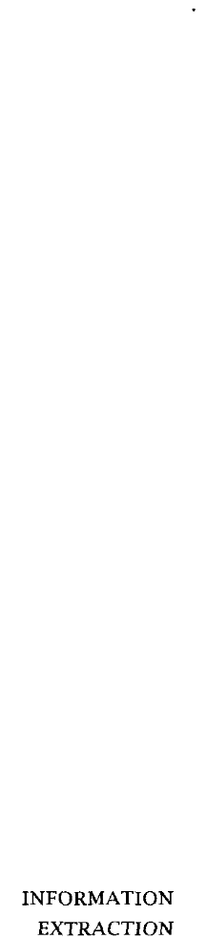

The best known approaches to partial parsing are Fidditch, developed in the early eighties by Hindle  and an approach called Sarsing by chunks developed by Abney (1991). These two systems do not use tag- gers because they predate the widespread availability of taggers. See also (Grefenstette 1994). Two approaches that are more ambitious than cur- rent partial parsers and attempt to bridge the gap between shallow and full parsing are the XTAG system  et al. 1994) and chunk tagging (Brants and Skut 1998; Skut and Brants 1998).

In many systems that build a partial parser on top of a tagger, partial parsing is accomplished by way of regular expression matching over the output of the tagger. For example, a simple noun phrase may be defined as a sequence of article (AT), an arbitrary number of adjectives (JJ) and a singular noun (NN). This would correspond to the regular expression $T NN. Since these systems focus on the final application, not on partial parsing we cover them in what follows not under the rubric Sartial pars- ing, but grouped according to the application they are intended for. For an excellent overview of partial parsing (and tagging) see (Abney  One important use of tagging in conjunction with partial parsing is for

lexical *acquisition.* We refer the reader to chapter 8.

Another important application is *information extraction* (which is also referred to as message understanding, data extraction, or text data min- ing). The goal in information extraction is to find values for the  fined slots of a template. For example, a template for weather report- ing might have slots for the type of weather condition (tornado, snow storm), the location of the event (the San Francisco Bay Area), the time of the event (Sunday, January 11,  and what the effect of the event was (power outage, traffic accidents, etc.). Tagging and partial parsing help identify the entities that serve as slot fillers and the relationships between them. A recent overview article on information extraction is  1997). In a way one could think of information extraction as like tagging except that the tags are semantic categories, not grammati- cal parts of speech. However, in practice quite different techniques tend to be employed, because local sequences give less information about se- mantic categories than grammatical categories.

Tagging and partial parsing can also be applied to finding good

***10.7 Further Reading 377***

dexing terms in information retrieval. The best unit for matching user queries and documents is often not the individual word. Phrases like ***United States of America*** and ***secondary education lose*** much of their meaning if they are broken up into words. Information retrieval per- formance can be improved if tagging and partial parsing are applied to noun phrase recognition and query-document matching is done on more meaningful units than individual terms  1987; Smeaton 1992; Strzalkowski 1995). A related area of research is phrase normalization in which variants of terms are normalized and represented as the same basic unit (for example, book ***publishing*** and ***publishing of books). See*** (Jacquemin et al. 1997).

ANSWERING Finally, there has been work on so-called ***question answering*** systems

which try to answer a user query that is formulated in the form of a ques- tion by returning an appropriate noun phrase such as a location, a person, or a date (Kupiec  Burke et al. 1997). For example, the question Who ***President Kennedy?*** might be answered with the noun phrase ***Oswald*** instead of returning a list of documents as most information re- trieval systems do. Again, analyzing a query in order to determine what type of entity the user is looking for and how it is related to other noun phrases mentioned in the question requires tagging and partial parsing.

We conclude with a negative result: the best lexicalized probabilistic parsers are now good enough that they perform better starting with un- tagged text and doing the tagging themselves, rather than using a tagger as a preprocessor (Charniak 1997a). Therefore, the role of taggers ap- pears to be as a fast lightweight component that gives sufficient informa- tion for many application tasks, rather than as a desirable preprocessing stage for all applications.

#### Further Reading

Early work on modeling natural language using Markov chains had been largely abandoned by the early sixties, partially due to Chomsky V criti- cism of the inadequacies of Markov models (Chomsky 1957: ch. 3). The lack of training data and computing resources to pursue an Hmpirical’ approach to natural language probably also played a role. Chomsky V criticism still applies: Markov chains cannot fully model natural lan- guage, in particular they cannot model many recursive structures (but cf. Ristad and Thomas (1997)). What has changed is that approaches that

378 *10 Part-of-Speech Tagging*

emphasize technical goals such as solving a particular task have become acceptable even if they are not founded on a theory that fully explains language as a cognitive phenomenon.

The earliest Waggers were simply programs that looked up the category

of words in a dictionary. The first well-known program which attempted to assign tags based on syntagmatic contexts was the rule-based pro- gram presented in (Klein and Simmons  though roughly the same idea is present in  and Thorpe 1962). Klein and Simmons use the

terms Wags and Wagging, though apparently interchangeably with Fodes’ and Foding. The earliest probabilistic tagger known to us is (Stolz et al.

1965). This program initially assigned tags to some words (including all function words) via use of a lexicon, morphology rules, and other ad-hoc rules. The remaining open class words were then tagged using condi- tional probabilities calculated from tag sequences. Needless to say, this wasn W a well-founded probabilistic model.

Credit has to be given to two groups, one at Brown University, one at the University of Lancaster, who spent enormous resources to tag two large corpora, the Brown corpus and the Lancaster-Oslo-Bergen (LOB) cor- pus. Both groups recognized how invaluable a corpus annotated with tag information would be for further corpus research. Without these two tagged corpora, progress on part-of-speech tagging would have been hard if not impossible. The availability of a large quantity of tagged data is no doubt an important reason that tagging has been such an active area of research.

The Brown corpus was automatically pre-tagged with a rule-based tag- ger, TAGGIT (Greene and 1971). This tagger used lexical

tion only to limit the tags of words and only applied tagging rules when words in the surrounding context were unambiguously tagged. The out- put of the tagger was then manually corrected in an effort that took many years and supplied the training data for a lot of the quantitative work that was done later.

One of the first Markov Model taggers was created at the University of Lancaster as part of the LOB tagging effort (Garside et al. 1987; Mar- shall 1987). The heart of this tagger was the use of  tag sequence probabilities, with limited use of higher order context, but the differing probabilities of assigning a word to different parts of speech were han- dled by ad hoc discounting factors. The type of Markov Model tagger that tags based on both word probabilities and tag transition probabilities was introduced by Church (1988) and (1988).

* 1. ***Exercises***

During the beginning of the resurgence of quantitative methods in NLP, the level of knowledge of probability theory in the NLP community was so low that a frequent error in early papers is to compute the probability of the next tag in a Markov model as (10.14) instead of (10.13). At first sight, (10.14) can seem more intuitive. After all, we are looking at a word and want to determine its tag, so it is not far-fetched to assume the word as given and the tag as being conditioned on the word.

(10.13)

(10.14)

  

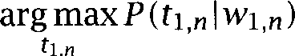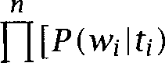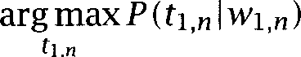i=l

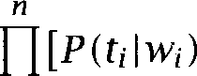

i=l

But, actually, equation (10.14) is not correct, and use of it results in lower performance (Charniak et al. 1993).

While the work of Church and was key in the resurgence of statistical methods in computational linguistics, work on hidden Markov model tagging had actually begun much earlier at the IBM research cen- ters in New York state and Paris. Jelinek (1985) and Derouault and

(1986) are widely cited. Earlier references are Bahl and (1976) and Baker  who attributes the work to Elaine Rich. Other early work in probabilistic tagging includes (Eeg-Olofsson 1985; Foster 1991).

{NOMINAL VERBS A linguistic discussion of the conversion of nouns to verbs  ***verbs)*** and its productivity can be found in Clark and Clark (1979). Huddleston (1984: ch. 3) contains a good discussion of the traditional definitions of parts of speech, their failings, and the notion of part of

speech or word class as used in modern structuralist linguistics.

#### 10.8 Exercises

Exercise 10.2 1

Usually, the text we want to tag is not segmented into sentences. An algorithm for identifying sentence boundaries is introduced in chapter 4, together with a general overview of the nitty-gritty of corpus processing.

Could we integrate sentence-boundary detection into the tagging methods intro- duced in this chapter? What would we have to change? How effective would you expect sentence-boundary detection by means of tagging to be?

380 *Part-of-Speech Tagging*

**Exercise** *10.22*

Get the MULTEXT tagger (see the  and tag some non-English text from the

***Probabilistic Context Free Grammars***

**PEOPLE WRITE** and say lots of different things, but the way people say things even in drunken casual conversation has some structure and regularity. The goal of syntax within linguistics is to try to isolate that structure. Until now, the only form of syntax we have allowed ourselves is methods for describing the ordering and arrangement of words, either directly in terms of the words, or in terms of word categories. In this chapter, we wish to escape the linear tyranny of these n-gram models and **HMM** tagging models, and to start to explore more complex notions of grammar.

Even in the most traditional forms of grammar, syntax is meant to show something more that just linear order. It shows how words group together and relate to each other as heads and dependents. The dominant method used for doing this within the last 50 or so years has been to place tree structures over sentences, as we saw in chapter 3. Language has a complex recursive structure, and such tree-based models unlike Markov models allow us to capture this. For instance Kupiec  notes that his HMM-based tagger has problems with constructions like:

(11.1) The velocity of the seismic waves rises to

because a singular verb (here, rises) is unexpected after a plural noun. Kupiec V solution is to augment the HMM model so it can recognize a rudimentary amount of NP structure, which in his model is encoded as a higher-order context extension glued on to his basic first order HMM. Leaving aside the technical details of the solution, the essential observa- tion about verb agreement is that it is reflecting the hierarchical structure of the sentence, as shown in  and not the linear order of words.

(11.2)

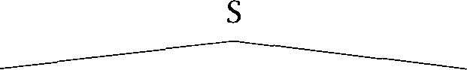

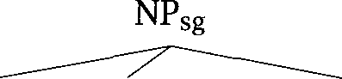 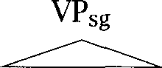

DT NN ***rises to***

 

***The velocity*** IN



***of the seismic waves***

The verb agrees in number with the noun ***velocity*** which is the head of the preceding noun phrase, and not with the noun that linearly precedes it.

PCFG The simplest probabilistic model for recursive embedding is a ***PCFG,***

**PROBABILISTIC** a ***Probabilistic*** (sometimes also called ***Stochastic) Context Free Grammar***

**_** which is simply a CFG with probabilities added to the rules, indicating

**G RAMMAR**

how likely different rewritings are. We provide a detailed discussion of PCFGs in this chapter for a number of reasons: PCFGs are the simplest and most natural probabilistic model for tree structures, the mathemat- ics behind them is well understood, the algorithms for them are a natural development of the algorithms employed with and PCFGs pro- vide a sufficiently general computational device that they can simulate various other forms of probabilistic conditioning (as we describe in sec- tion 12.1.9). Nevertheless, it is important to realize that PCFGs are only one of many ways of building probabilistic models of syntactic structure, and in the next chapter we study the domain of probabilistic parsing more generally.

A PCFG G consists of:

 ***V***

z A set of nonterminals,  ***i =*** 1,. . . ,

* A designated start symbol, 
* A set of rules,  (where  is a sequence of terminals and nonterminals)



* A corresponding set of probabilities on rules such that: (11.3) ***Vi =*** 1



Notation G



Meaning Grammar (PCFG)

Language (generated or accepted by a grammar) Parse tree

Nonterminal vocabulary  is start symbol) Terminal vocabulary



Sentence to be parsed

Nonterminal  spans positions through in string Outside probabilities (11.15)

Inside probabilities (11.14)

Table 11.1 Notation for the PCFG chapter.

Note that when we write  in this chapter, we always mean  That is, we are giving the probability distribution of the daughters for a certain head. Such a grammar can be used either to parse or generate sentences of the language, and we will switch between these terminologies quite freely.



Before parsing sentences with a PCFG, we need to establish some no- tation. We will represent the sentence to be parsed as a sequence of words and use to denote the subsequence We denote a single rewriting operation of the grammar by a single arrow



If as a result of one or more rewriting operations we are able to rewrite a nonterminal  as a sequence of words then we will say



**DOMINATION** that  dominates the words and write either ***. .***



or  = This situation is illustrated in (11.4): a



tree with root nonterminal  dominating all and only the words from in the string:



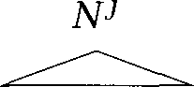( 1 1

. 4 )



To say that a nonterminal  spans positions a through in the string, but not to specify what words are actually contained in this subsequence, we will write  This notation is summarized in table 11.1.

The probability of a sentence (according to a grammar  is given by: (11.5) **=** where is a parse tree of the sentence



S-N PVP **1.0**

PP PNP **1.0**

VP-VNP 0.7 VP VP PP 0.3 P 1.0



V ***saw*** 1.0

NP NP PP 0.4

NP ***astronomers* 0.1**

NP ***ears* 0.18**

NP saw 0.04

NP ***stars* 0.18**

NP ***telescopes*** 0.1

Table 11.2 A simple Probabilistic Context Free Grammar (PCFG). The

are S, NP, PP, VP, P, V. We adopt the common convention whereby the start symbol is denoted by S. The terminals are the words in italics. The table shows the grammar rules and their probabilities. The slightly unusual NP rules have been chosen so that this grammar is in Chomsky Normal Form, for use as an example later in the section.





Moreover, it is easy to find the probability of a tree in a PCFG model. One just multiplies the probabilities of the rules that built its local subtrees.

**(11.6)**

**(11.7)**

**(11.8)**

Example 1: Assuming the grammar in table 11.2, the sentence ***as- tronomers saw stars with ears*** has two parses with probabilities as shown in figure 11.1.

What are the assumptions of this model? The conditions that we need are:

Place invariance. The probability of a does not depend on where in the string the words it dominates are  is like time invari- ance in 

 is the same



Context-free. The probability of a does not depend on words not dominated by the

P outside ***k*** through =



Ancestor-free. The probability of a does not depend on nodes in the derivation outside the

anY ancestor nodes outside =



 



 

**I **

*astronomers*

 







astronomers

*saw*





**I**

stars





 

*with ears*





 

 **NP0.18 ** **NP0.18**

*saw stars with ears*

=

= 0.0009072

= 1.0 x 0.1 x 0.3 x 0.7 x 1.0 x 0.18 x 1.0 x 1.0 x 0.18

= 0.0006804

**=** 0.0015876



**Figure 11.1** The two parse trees, their probabilities, and the sentence probabil- ity. This is for the sentence ***astronomers saw stars with ears,*** according to the grammar in table 11.2. Nonterminal nodes in the trees have been subscripted with the probability of the local tree that they head.

Using these conditions we can justify the calculation of the probability of a tree in terms of just multiplying probabilities attached to rules. But to show an example, we need to be able to distinguish tokens of a

nal. Therefore, let the upper left index in  be an arbitrary identifying index for a particular token of a nonterminal. Then,

***P***

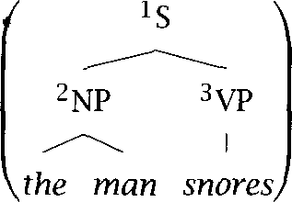

the ***man snores***

***= ***  



***= ***      

=      

***=*** NP the ***snores)***

where, after expanding the probability by the chain rule, we impose first the context-freeness assumption, and then the position-invariant as- sumption.

11.1

**INDUCTION IDENTIFICATION IN**

**THE LIMIT EGATIVE EVIDENCE**

**Some Features of** PCFGs

Here we give some reasons to use a PCFG, and also some idea of their limitations:

As grammars expand to give coverage of a large and diverse corpus of text, the grammars become increasingly ambiguous. There start to be many structurally different parses for most word sequences. A PCFG gives some idea of the plausibility of different parses.

A PCFG does not give a very good idea of the plausibility of different parses, since its probability estimates are based purely on structural factors, and do not factor in lexical co-occurrence.

PCFGs are good for induction. Gold (1967) showed that cannot be learned (in the sense of ***identification in the limit*** that is, whether one can identify a grammar if one is allowed to see as much data produced by the grammar as one wants) without the use of neg- ***ative evidence*** (the provision of ungrammatical examples). But PCFGs

* 1. ***Some Features of PCFGs*** 387

can be learned from positive data alone (Horning 1969). (However, do- ing grammar induction from scratch is still a difficult, largely unsolved problem, and hence much emphasis has been placed on learning from bracketed corpora, as we will see in chapter 12.)

Robustness. Real text tends to have grammatical mistakes,

 and errors. This problem can be avoided to some extent with a PCFG by ruling out nothing in the grammar, but by just giving implau- sible sentences a low probability.

PCFGs give a probabilistic language model for English (whereas a CFG does not).

The predictive power of a PCFG as measured by entropy tends to be greater than that for a finite state grammar (i.e., an HMM) with the same number of parameters. (For such comparisons, we compute the number of parameters as follows. A *V* terminal, nonterminal PCFG has + parameters, while a *K* state output HMM has *+ MK* parameters. While the exponent is higher in the PCFG case, the number of nonterminals used is normally quite small. See Lari and Young (1990) for a discussion of this with respect to certain artificial grammars.)

In practice, a PCFG is a worse language model for English than an gram model (for 1). An n-gram model takes some local lexical context into account, while a PCFG uses none.



PCFGs are not good models by themselves, but we could hope to com- bine the strengths of a PCFG and a  model. An early experiment that conditions the rules of a PCFG by word  (and some addi- tional context sensitive knowledge of the tree) is presented in  man and Marcus (1991) and  and Weir (1992). Better solu- tions are discussed in chapter 12.

PCFGs have certain biases, which may not be appropriate. All else be- ing equal, in a PCFG, the probability of a smaller tree is greater than a larger tree. This is not totally wild it is consonant with Frazier V (1978) Minimal Attachment heuristic but it does not give a sensible model of actual sentences, which peak in frequency at some interme- diate length. For instance, table 4.3 showed that the most frequent length for Street Journal sentences is around 23 words. A PCFG

**5OBABILITY MASS OF**

**RULES**

(11.9)

(11.10)

**INCONSISTENT**

**IMPROPER**

**11.2**

gives too much of the probability mass to very short sentences. Sim- ilarly, all else being equal, nonterminals with a small number of ex- pansions will be favored over nonterminals with many expansions in PCFG parsing, since the individual rewritings will have much higher probability (see exercise 12.3).

The one item here that deserves further comment is the claim that PCFGs define a language model. Initially, one might suspect that providing that the rules all obey equation then  =  = 1. But actually this is only true if the probability of ***rules*** is accumulating in finite derivations. For instance, consider the grammar:

S rhubarb =  s - s s 

This grammar will generate all strings rhubarb.. rhubarb. However, we find that the probability of those strings is:

***rhubarb* 1**

***rhubarb rhubarb *** ***rhubarb rhubarb rhubarb*** 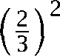 ***x*** 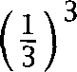 ***x 2 = ***



The probability of the language is the sum of this infinite series  +  + + . . . . which turns out to be  Thus half the probability mass has disappeared into infinite trees which do not generate strings of the lan- guage! Such a distribution is often termed ***inconsistent*** in the probability literature, but since this word has a rather different meaning in other fields related to NLP, we will term such a distribution ***improper.*** In prac- tice, improper distributions are not much of a problem. Often, it doesn W really matter if probability distributions are improper, especially if we are mainly only comparing the magnitude of different probability estimates.

Moreover, providing we estimate our PCFG parameters from parsed train- ing corpora (see chapter Chi and (1998) show that one always gets a proper probability distribution.

**Questions for** PCFGs

Just as for there are three basic questions we wish to answer:

* 1. *Questions for* 389

What is the probability of a sentence according to a grammar G: What is the most likely parse for a sentence:  *G)?*



How can we choose rule probabilities for the grammar G that maxi- mize the probability of a sentence, arg *G)?*



In this chapter, we will only consider the case of Chomsky Normal Form

**F ORM** grammars, which only have unary and binary rules of the form:



(11.11)

(11.12)

**PROBABILISTIC**

The parameters of a PCFG in Chomsky Normal Form are:

G) If nonterminals, an  matrix of parameters If *V* terminals, parameters



For  = 1,.



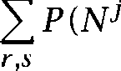*=* 1



***k***

This constraint is seen to be satisfied for the grammar in table 11.2 (un- der the convention whereby all probabilities not shown are zero). Any CFG can be represented by a weakly equivalent CFG in Chomsky Normal Form.’

To see how we might efficiently compute probabilities for PCFGs, let us work from to probabilistic regular *grammars,* and then from there to PCFGS. Consider a probabilistic regular grammar (PRG), which has rules of the form:

or and start state 



This is similar to what we had for an HMM. The difference is that in an HMM there is a probability distribution over strings of a certain length:

*=* 1



1. **Two** grammars  and  are weakly ***equivalent*** if they both generate the same lan- guage (with the same probabilities on sentences for stochastic equivalence). Two gram- mars are ***strongly equivalent*** if they additionally assign sentences the same tree structures

(with the same probabilities, for the stochastic case).

F i n0i s h

0



HMM

**Figure 11.2** A Probabilistic Regular Grammar

whereas in a PCFG or a PRG, there is a probability distribution over the set of all strings that are in the language generated by the grammar:

*=* 1



To see the difference, consider:

*decided to bake a)*

This would have a high probability in an HMM, since this is a quite likely beginning to a sentence, but a very low probability in a PRG or a PCFG, because it isn W a complete utterance.

We can think of a PRG as related to an HMM roughly as in figure 11.2. We add a start state and the transitions from it to the states of the HMM mirror the initial probabilities To represent ending the string, we

**SINK STATE** join to the HMM a finish state, often called a *sink state,* which one never leaves once one has entered it. From each HMM state one can continue in the basic HMM or shift to the sink state, which we interpret as the end of string in the PRG.

This gives the basic idea of how are related to We can implement the PRG as an HMM where the states are nonterminals and the terminals are the output symbols, as follows:

States: NP N N N sink state

Outputs: *the big brown box*

Recall how for an HMM we were able to efficiently do calculations in terms of forward and backward probabilities:

Forward probability =  *=*

Backward probability *=*



* 1. *Questions for PCFGs*

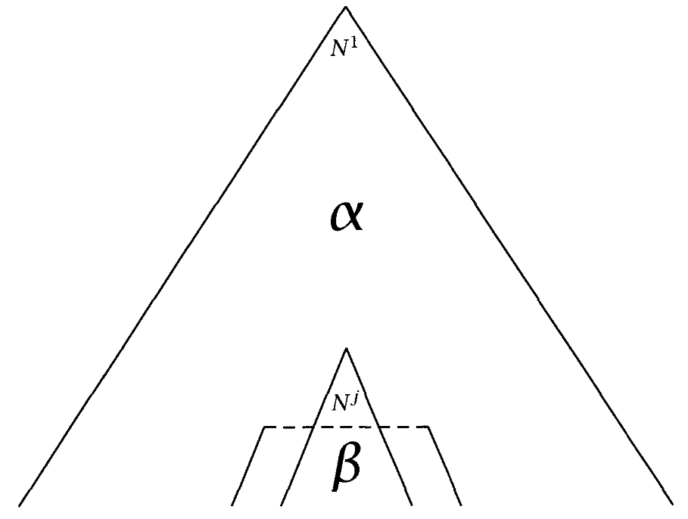

**. . .**

*wq*

**Figure 11.3** Inside and outside probabilities in PCFGs.

But now consider the parse again, drawn as a tree:

(11.13)

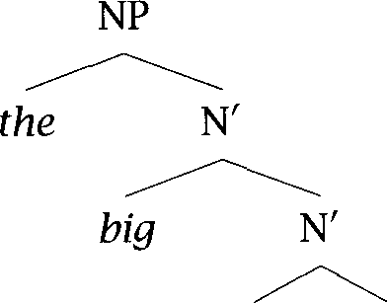

*brown*



In the tree, the forward probability corresponds to the probability of ev- erything above and including a certain node, while the backward proba- bility corresponds to the probability of everything below a certain node (given the node). This suggests an approach to dealing with the more general case of PCFGs. We introduce Inside and Outside probabilities, as indicated in figure 11.3, and defined as follows:

***(11.14)*** Outside probability  =



(11.15) Inside probability =



The inside probability  ***(p, *** is the total probability of generating words given that one is starting off with the nonterminal  The



outside probability is the total probability of beginning with the start symbol and generating the nonterminal  and all the words outside



#### The Probability of a String

* + 1. **Using inside probabilities**

In general, we cannot efficiently calculate the probability of a string by simply summing the probabilities of all possible parse trees for the string, as there will be exponentially many of them. An efficient way to

**INSIDE ALGORITHM** late the total probability of a string is by the ***inside algorithm,*** a dynamic programming algorithm based on the inside probabilities:

(11.16) ***= ***

(11.17) = IN:,, =



The inside probability of a substring is calculated by induction on the length of the string subsequence:

**Base case:** We want to find  (k, (the probability of a rule



=  

**Induction:** We want to find for ***p*** As this is the inductive step using a Chomsky Normal Form grammar, the first rule must be of the form  so we can proceed by induction, dividing the string in two in various places and summing the result:



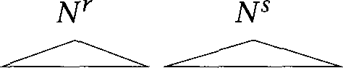



***11.3 The Probability of a String***



Then,  1









***q-1***

***= *** 

***d=p***





***d=p***



***=* + **



***d=p***



Above, we first divided things up using the chain rule, then we made use of the context-free assumptions of and then rewrote the re- sult using the definition of the inside probabilities. Using this recurrence relation, inside probabilities can be efficiently calculated bottom up.

Example 2: The above equation looks scary, but the calculation of in- side probabilities is actually relatively straightforward. We Ue just trying to find all ways that a certain constituent can be built out of two smaller constituents by varying what the labels of the two smaller constituents are and which words each spans. In table 11.3, we show the computations of inside probabilities using the grammar of table 11.2 and the sentence

**PARSE TRIANGLE** explored in figure 11.1. The computations are shown using a parse ***tri- angle*** where each box records nodes that span from the row index to the column index.

Further calculations using this example grammar and sentence are left to the reader in the Exercises.

|  |  |  |  |  |  |
| --- | --- | --- | --- | --- | --- |
|  | 1 | 2 | 3 | 4 | 5 |
|  | = 0.1 |  | = 0.0126 |  | = 0.0015876 |
| 2 |  | = 0.04  = 1.0 | = 0.126 |  | = 0.015876 |
| 3 |  |  | = 0.18 |  | = 0.01296 |
| 4 |  |  |  | = 1.0 | = 0.18 |
| 5 |  |  |  |  | = 0.18 |
|  | ***astronomers*** | ***saw*** | ***stars*** | ***with*** | ***ears*** |

Table 11.3 Calculation of inside probabilities. Table cell shows non-zero probabilities  calculated via the inside algorithm. The recursive com- putation of inside probabilities is done starting along the diagonal, and then moving in diagonal rows towards the top right corner. For the simple gram- mar of table 11.2, the only non-trivial case is cell (2, which we calculate as:



* + 1. Using outside probabilities

We can also calculate the probability of a string via the use of the outside probabilities. For any *k,* 1 *k*



*= *

*j*

*= *

*j*



(11.19) 

The outside probabilities are calculated top down. As we shall see, the inductive calculation of outside probabilities requires reference to inside probabilities, so we calculate outside probabilities second, using

**OUTSIDE ALGORITHM** the outside algorithm.

**Base Case:** The base case is the probability of the root of the tree being nonterminal  with nothing outside it:

 = 1

*= 0* for j 1



***11.3 The Probability of a String 3 9 5***

(11.20)



with

**case:** In terms of the previous step of the derivation, a node which we are concerned might be on the left:



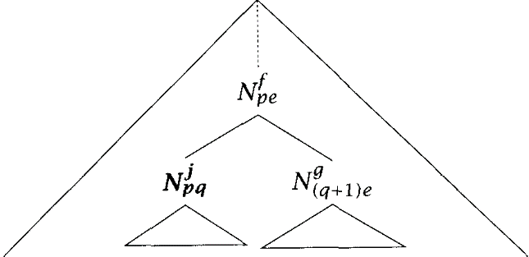

(11.21)

or right branch of the parent node:



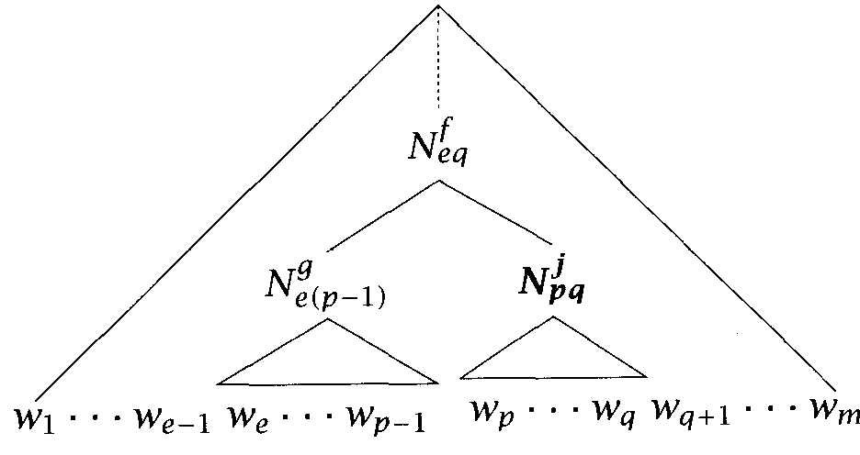

We sum over both possibilities, but restrict the first sum to j so as not to double count in the case of rules of the form X



***[***



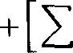

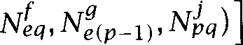

***[***

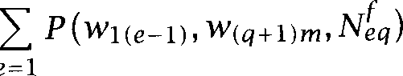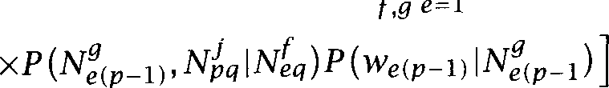

      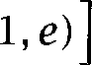



***+***



As with an HMM, we can form a product of the inside and the outside probabilities:



*= *

But this time, the fact that we postulate a nonterminal node is important (whereas in the HMM case it is trivial that we are in some state at each point in time). Therefore, the probability of the sentence ***and*** that there is some constituent spanning from word to 9 is given by:



However, we know that there will always be some nonterminal spanning the whole tree and each individual terminal (in a Chomsky Normal Form grammar). The nonterminal nodes whose only daughter is a single

**PRETERMINAL** minal node are referred to as  nodes. Just in these cases this gives us the equations in (11  and (11.19) for the total prob- ability of a string. Equation (11.17) is equivalent to  and makes use of the root node, while equation (11.19) is equivalent to and makes use of the fact that there must be some



preterminal above each word

* + 1. Finding the most likely parse for a sentence

A Viterbi-style algorithm for finding the most likely parse for a sentence can be constructed by adapting the inside algorithm to find the element of the sum that is maximum, and to record which rule gave this maxi- mum. This works as in the HMM case because of the independence as- sumptions of PCFGs. The result is an  PCFG parsing algorithm.

The secret to the Viterbi algorithm for is to define accumulators

 (t) which record the highest probability of a path through the trellis that leaves us at state  at time Recalling the link between and PCFGs through looking at this time we wish to find the highest

***11.3 The Probability of a*** *397*

probability partial parse tree spanning a certain substring that is rooted with a certain nonterminal. We will retain the name and use accumula- tors:

= the highest inside probability parse of a



Using dynamic programming, we can then calculate the most probable parse for a sentence as follows. The initialization step assigns to each unary production at a leaf node its probability. For the inductive step, we again know that the first rule applying must be a binary rule, but this time we find the most probable one instead of summing over all such rules, and record that most probable one in the variables, whose values are a list of three integers recording the form of the rule application which had the highest probability.

1. Initialization



1. Induction

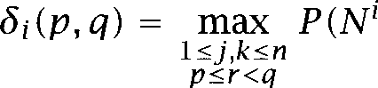

Store backtrace

=    



1. Termination and path readout (by backtracking). Since our grammar has a start symbol  then by construction, the probability of the most likely parse rooted in the start symbol 

(11.23)  =



We want to reconstruct this maximum probability tree  We do this by regarding  as a set of nodes  and showing how to construct this

2. We could alternatively find the highest probability node of any category that dominates the entire sentence as:



Probabilistic ***Context Free Grammars***

set. Since the grammar has a start symbol, the root node of the tree must be  We then show in general how to construct the left and right daughter nodes of a nonterminal node, and applying this process recursively will allow us to reconstruct the entire tree. If =  is in the Viterbi parse, and  9) = then:



left(&) = 

right(&) = 

Note that where we have written Drgmax above, it is possible for there not to be a unique maximum. We assume that in such cases the parser just chooses one maximal parse at random. It actually makes things con- siderably more complex to preserve all ties.

* + 1. Training a PCFG

The idea of training a PCFG is grammar learning or grammar induction, but only in a certain limited sense. We assume that the structure of the grammar in terms of the number of terminals and nonterminals, and the name of the start symbol is given in advance. We also assume the set of rules is given in advance. Often one assumes that all possible rewriting rules exist, but one can alternatively assume some pre-given structure in the grammar, such as making some of the nonterminals dedicated preterminals that may only be rewritten as a terminal node. Training the grammar comprises simply a process that tries to find the optimal probabilities to assign to different grammar rules this architecture. As in the case of we construct an EM training algorithm, the

**INSIDE- OUTSIDE** *Inside-Outside algorithm,* which allows us to train the parameters of a

**ALGORITHM** PCFG on unannotated sentences of the language. The basic assumption is that a good grammar is one that makes the sentences in the training corpus likely to occur, and hence we seek the grammar that maximizes the likelihood of the training data. We will present training first on the basis of a single sentence, and then show how it is extended to the more realistic situation of a large training corpus of many sentences, by assum- ing independence between sentences.

To determine the probability of rules, what we would like to calculate

is:



* 1. ***The Probability of a String*** *399*

where is the count of the number of times that a particular rule is used. If parsed corpora are available, we can calculate these probabilities directly (as discussed in chapter 12). If, as is more common, a parsed training corpus is not available, then we have a hidden data problem: we wish to determine probability functions on rules, but can only directly see the probabilities of sentences. As we don W know the rule probabilities,



we cannot compute relative frequencies, so we instead use an iterative algorithm to determine improving estimates. We begin with a certain grammar topology, which specifies how many terminals and

nals there are, and some initial probability estimates for rules (perhaps just randomly chosen). We use the probability of each parse of a training sentence according to this grammar as our confidence in it, and then sum the probabilities of each rule being used in each place to give an expecta- tion of how often each rule was used. These expectations are then used to refine our probability estimates on rules, so that the likelihood of the training corpus given the grammar is increased.

Consider:

=      

We have already solved how to calculate let us call this probability Then:



and the estimate for how many times the nonterminal  is used in the derivation is:



(11.24)  is used in the derivation) =

In the case where we are not dealing with a preterminal, we substitute the inductive definition of  into the above probability and then s, ***p***







Therefore, the estimate for how many times this particular rule is used in the derivation can be found by summing over all ranges of words that

(11.25)

(11.26)

(11.27)

the node could dominate:

 *Nj* used)



Now for the maximization step, we want:

*_ NY*

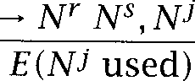

So, the reestimation formula is:

 = 







*9)*

Similarly for preterminals,

*P(Nj *  *=*





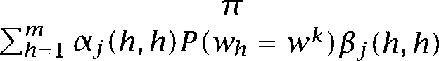



The  *= * above is, of course, either 0 or 1, but we express things in the second form to show maximal similarity with the preceding case. Therefore,

_



Unlike the case of this time we cannot possibly avoid the prob- lem of dealing with multiple training instances one cannot use con- catenation as in the HMM case. Let us assume that we have a set of training sentences = with *Wi = . . .* Let



and  be the common from before for use of a nonterminal at a branching node, at a preterminal node, and anywhere respectively, now calculated from sentence 

(11.28) 





 



 



* 1. Problems with *the* Inside-Outside Algorithm 401

If we assume that the sentences in the training corpus are independent, then the likelihood of the training corpus is just the product of the prob- abilities of the sentences in it according to the grammar. Therefore, in the reestimation process, we can sum the contributions from multiple sentences to give the following reestimation formulas. Note that the de- nominators consider all expansions of the nonterminal, as terminals or nonterminals, to satisfy the stochastic constraint in equation (11.3) that a nonterminal V expansions sum to 1.

(11.29)

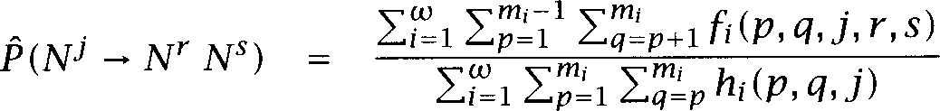

and

(11.30)

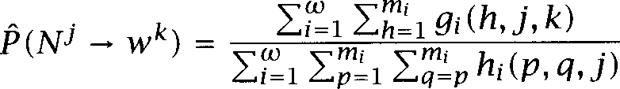

The Inside-Outside algorithm is to repeat this process of parameter reestimation until the change in the estimated probability of the training corpus is small. If  is the grammar (including rule probabilities) in the  iteration of training, then we are guaranteed that the probability of the corpus according to the model will improve or at least get no worse:

**11.4**

**LOCAL MAXIMA**





#### Problems with the Inside-Outside Algorithm

However, the PCFG learning algorithm is not without problems:

1. Compared with linear models like HMMS, it is slow. For each sentence, each iteration of training is  where is the length of the sentence, and n is the number of nonterminals in the grammar.
2. Local *maxima* are much more of a problem. Charniak (1993) reports that on each of 300 trials of PCFG induction (from randomly initialized parameters, using artificial data generated from a simple English-like PCFG) a different local maximum was found. Or in other words, the algorithm is very sensitive to the initialization of the parameters. This might perhaps be a good place to try another learning method. (For instance, the process of simulated annealing has been used with some success with neural nets to avoid problems of getting stuck in local

maxima (Kirkpatrick et al. 1983; Ackley et al. 19851, but it is still per- haps too compute expensive for large-scale PCFGs.) Other partial so- lutions are restricting rules by initializing some parameters to zero or performing grammar minimization, or reallocating nonterminals away from Jreedy terminals. Such approaches are discussed in Lari and Young (1990).

1. Based on experiments on artificial languages, Lari and Young (1990) suggest that satisfactory grammar learning requires many more terminals than are theoretically needed to describe the language at hand. In their experiments one typically needed about ***3n***

nals to satisfactorily learn a grammar from a training text generated by a grammar with *n* nonterminals. This compounds the first problem.

1. While the algorithm is guaranteed to increase the probability of the training corpus, there is no guarantee that the nonterminals that the algorithm learns will have any satisfactory resemblance to the kinds of nonterminals normally motivated in linguistic analysis (NP, VP, etc.). Even if one initializes training with a grammar of the sort familiar to linguists, the training regime may completely change the meaning of nonterminal categories as it thinks best. As we have set things up, the only hard constraint is that  must remain the start symbol. One option is to impose further constraints on the nature of the grammar. For instance, one could specialize the nonterminals so that they each only generate terminals nonterminals. Using this form of grammar would actually also simplify the reestimation equations we presented above.

Thus, while grammar induction from unannotated corpora is possible in principle with PCFGs, in practice, it is extremely difficult. In different ways, many of the approaches of the next chapter address various of the limitations of using vanilla PCFGs.

#### Further Reading

A comprehensive discussion of topics like weak and strong equivalence, Chomsky Normal Form, and algorithms for changing arbitrary into various normal forms can be found in (Hopcroft and Ullman 1979). Stan- dard techniques for parsing with in NLP can be found in most AI and NLP textbooks, such as (Allen 1995).

* 1. *Further Reading 403*

Probabilistic were first studied in the late 1960s and early  and initially there was an outpouring of work. Booth and Thomson  following on from Booth  define a PCFG as in this chap- ter (modulo notation). Among other results, they show that there are probability distributions on the strings of context free languages which cannot be generated by a PCFG, and derive necessary and sufficient con- ditions for a PCFG to define a proper probability distribution. Other work from this period includes: (Grenander  (Suppes  (Huang and Fu  and several theses (Horning 1969; Ellis 1969; Hutchins 1970). Tree structures in probability theory are normally referred to as

BRANCHING  *processes,* and are discussed in such work as (Harris 1963) and  1971).

During the  work on stochastic formal languages largely died out, and PCFGs were really only kept alive by the speech community, as an occasionally tried variant model. The Inside-Outside algorithm was intro- duced, and its convergence properties formally proved by Baker (1979). Our presentation essentially follows (Lari and Young 1990). This paper includes a proof of the algorithmic complexity of the Inside-Outside al- gorithm. Their work is further developed in (Lari and Young 1991).

For the extension of the algorithms presented here to arbitrary PCFGs, see (Charniak 1993) or (Kupiec 1991,  Jelinek et al. (1990) and Jelinek et al. (1992a) provide a thorough introduction to PCFGs. In par- ticular, these reports, and also Jelinek and Lafferty (1991) and Stolcke  present incremental left-to-right versions of the Inside and Viterbi algorithms, which are very useful in contexts such as language models for speech recognition.

In the section on training a PCFG, we assumed a fixed grammar archi- tecture. This naturally raises the question of how one should determine this architecture, and how one would learn it automatically. There has been a little work on automatically determining a suitable architecture

MODEL using  *model merging,* a *Minimum Description Length* approach (Stolcke and Omohundro 1994b; Chen  but at present this task is

M INIMUM

LE N G T H

still normally carried out by using the intuitions of a linguist.



3. For anyone familiar with chart parsing, the extension is fairly straightforward: in a chart we always build maximally binary Wraversals as we move the dot through rules. We can use this virtual grammar, with appropriate probabilities to parse arbitrary PCFGs (the rule that completes a constituent can have the same probability as the original rule, while all others have probability 1).

**404 *11 Probabilistic Context Free Grammars***

have also been used in bioinformatics (e.g., Sakakibara et al.  but not nearly as much as **HMMS.**

#### Exercises

Exercise **11.1**

Consider the probability of a (partial) syntactic parse tree giving part of the struc- ture of a sentence:

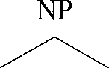***P*** Det N’ Adj N\I

In general, as the  gets large, we cannot accurately estimate the probabil- ity of such trees from any existing training corpus (a data sparseness problem).

As we saw, **PCFGS** approach this problem by estimating the probability of a tree like the one above from the joint probabilities of local subtrees:

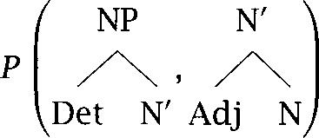

However, how reasonable is it to assume independence between the probability distributions of these local (which is the assumption that licenses us to estimate the probability of a as the product of the probability of each local tree it contains)?

Use a parsed corpus (e.g., the Penn Treebank) and find for some common sub- trees whether the independence assumption seems justified or not. If it is not, see if you can find a method of combining the probabilities of local in such a way that it results in an empirically better estimate of the probability of a larger

**Exercise 11.2**

Using a parse triangle as in figure 11.3, calculate the outside probabilities for the sentence ***astronomers saw stars with ears*** according to the grammar in table **11.2.** Start at the top righthand corner and work towards the diagonal.

**Exercise 11.3**

Using the inside and outside probabilities for the sentence ***astronomers saw stars with ears*** worked out in figure **11.3** and exercise **11.2,** reestimate the proba- bilities of the grammar in table 11.2 by working through one iteration of the Inside-Outside algorithm. It is helpful to first link up the inside probabilities shown in figure 11.3 with the particular rules and used to obtain them.

***11.6 Exercises 405***

What would the rule probabilities converge to with continued iterations of the Inside-Outside algorithm? Why?

Exercise **11.4 **

Recording possible spans of nodes in a parse triangle such as the one in fig- ure 11.3 is the essence of the Cocke-Kasami-Younger (CKY) algorithm for pars- ing (Younger 1967;  and 1979). Writing a CKY PCFG parser is quite straightforward, and a good exercise. One might then want to extend the parser from Chomsky Normal Form grammars to the more general case of context-free grammars. One way is to work out the general case oneself, or to consult the appropriate papers in the Further Reading. Another way is to write a grammar transformation that will take a and convert it into a Chomsky Normal Form CFG by introducing specially-marked additional nodes where nec- essary, which can then be removed on output to display parse trees as given by the original grammar. This task is quite easy if one restricts the input CFG to one that does not contain any empty nodes (nonterminals that expand to give nothing).

Exercise **11.5 **

Rather than simply parsing a sequence of words, if interfacing a parser to a speech  one often wants to be able to parse a word lattice, of the sort shown in figure 12.1. Extend a PCFG parser so it works with word lattices. (Because the of a PCFG parser is dependent on the number of words in the word lattice, a PCFG parser can be impractical when dealing with large speech lattices, but our keep getting faster every year!)

## Probabilistic Parsing

**THE PRACTICE** of parsing can be considered as a straightforward

**CHUNKING** plementation of the idea of  recognizing higher level units of structure that allow us to compress our description of a sentence. One way to capture the regularity of chunks over different sentences is to learn a grammar that explains the structure of the chunks one finds. This

**AR INDUCTION** is the problem of grammar *induction.* There has been considerable work

on grammar induction, because it is exploring the empiricist question of how to learn structure from unannotated textual input, but we will not cover it here. Suffice it to say that grammar induction techniques are reasonably well understood for finite state languages, but that induction is very difficult for context-free or more complex languages of the scale needed to handle a decent proportion of the complexity of human lan- guages. It is not hard to induce some form of structure over a corpus of text. Any algorithm for making chunks such as recognizing com- mon subsequences will produce some form of representation of sentences, which we might interpret as a phrase structure tree. How- ever, most often the representations one finds bear little resemblance to the kind of phrase structure that is normally proposed in linguistics and

**NLP.**

**Now,** there is enough argument and disagreement within the field of syntax that one might find who has proposed syntactic struc- tures similar to the ones that the grammar induction procedure which you have sweated over happens to produce. This can and has been taken as evidence for that model of syntactic structure. However, such an ap- proach has more than a whiff of circularity to it. The structures found depend on the implicit inductive bias of the learning program. This sug- gests another tack. We need to get straight what structure we expect our

Kennedy

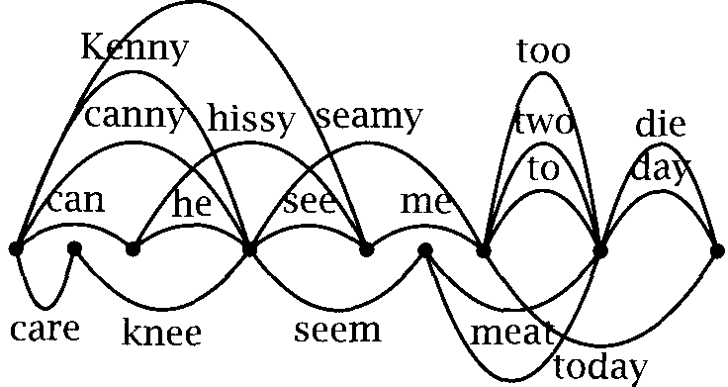meet

Figure 12.1 A word lattice (simplified).

model to find *before we* start building it. This suggests that we should begin by deciding what we want to do with parsed sentences. There are various possible goals: using syntactic structure as a first step towards semantic interpretation, detecting phrasal chunks for indexing in an IR system, or trying to build a probabilistic parser that outperforms n-gram models as a language model. For any of these tasks, the overall goal is to produce a system that can place a provably useful structure over

**PARSER** trary sentences, that is, to build a parser. For this goal, there is no need to insist that one begins with a If one just wants to do a good job at producing useful syntactic structure, one should use all the prior information that one has. This is the approach that will be adopted in this chapter.



The rest of this chapter is divided into two parts. The first introduces some general concepts, ideas, and approaches of broad general relevance, which turn up in various places in the statistical parsing literature (and a couple which should turn up more often than they do). The second then looks at some actual parsing systems that exploit some of these ideas, and at how they perform in practice.

12.1 Some Concepts

* + 1. **Parsing for disambiguation**

There are at least three distinct ways in which one can use probabilities in a parser:

*12.1 Some Concepts*



* + - * **Probabilities for determining the sentence.** One possibility is to use WORD LATTICE a parser as a language model over a *word* lattice in order to determine what sequence of words running along a path through the lattice has

highest probability. In applications such as speech  the actual input sentence is uncertain, and there are various hypotheses, which are normally represented by a word lattice as in figure  The job of the parser here is to be a language model that tries to de- termine what someone probably said. A recent example of using a parser in this way is (Chelba and Jelinek 1998).

* + - * **Probabilities for speedier parsing. A second** goal is to use probabil- ities to order or prune the search space of a parser. The task here is to enable the parser to find the best parse more quickly while not harming the quality of the results being produced. A recent study of effective methods for achieving this goal is (Caraballo and Charniak 1998).

**. Probabilities for choosing between parses.** The parser can be used to choose from among the many parses of the input sentence which ones are most likely.

In this section, and in this chapter, we will concentrate on the third use of probabilities over parse trees: using a statistical parser for  tion.

Capturing the tree structure of a particular sentence has been seen as key to the goal of disambiguation the problem we discussed in chap- ter 1. For instance, to determine the meaning of the sentence in  we need to determine what are the meaningful units and how they relate. In particular we need to resolve ambiguities such as the ones represented in whether the correct parse for the sentence is  or



or  or even 

(12.1) The post office will hold out discounts and service concessions as incen- tives.

1. Alternatively, they may be represented by an n-best *list,* but that has the unfortunate effect of multiplying out ambiguities in what are often disjoint areas of uncertainty in the signal.

**(12.2) a.** S

 X VP

AU

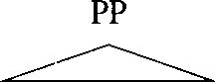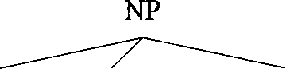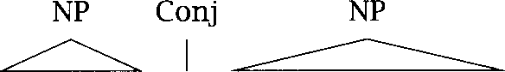

***The post office will*** V

I

ut NP Conj

holdo ***as incentives***

***discounts and service concessions***

b. S

Au

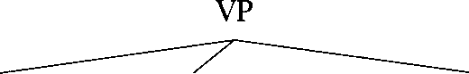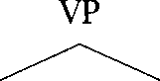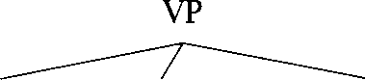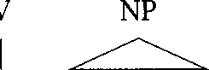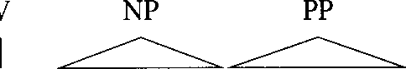

Conj

V

***and*** V

x

***The post office will***

***hold out discounts service concessions as incentives***

**C.**

Au

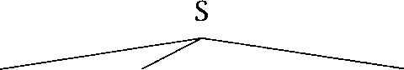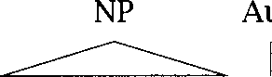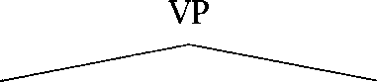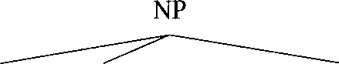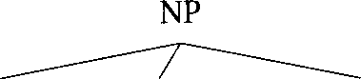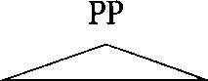

x

***The post office will*** V

***hold out*** NP

Conj

***discounts and N***

***N***



***service concessions as incentives***

d. S

VP

***The post office will*** V

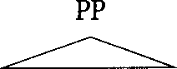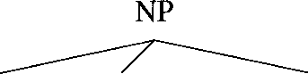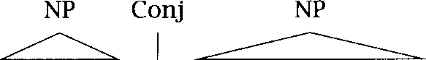

***hold*** P ***as incentives***

***out***

NP Conj

***discounts and service concessions***

One might get the

***out discounts service concessions as incentives***

impression from computational linguistics books

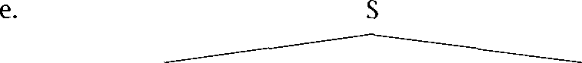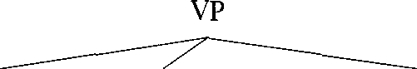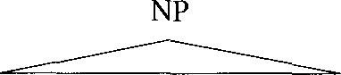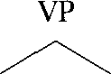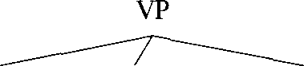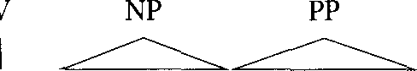

***The post office will hold***

NP ***and*** V

I A

that such ambiguities are rare and artificial, because most books contain the same somewhat unnatural-sounding examples (ones about pens and boxes, or seeing men with telescopes). But that V just because simple short examples are practical to use. Such ambiguities are actually ubi- quitous. To provide some freshness in our example  we adopted the following approach: we randomly chose a Street Journal article, and used the first sentence as the basis for making our point. Finding ambiguities was not  If you are still not convinced about the severity of the disambiguation problem, then you should immediately do exercise 12.1 before continuing to read this chapter.

What is one to do about all these ambiguities? In classical categorical approaches, some ambiguities are seen as genuine syntactic ambiguities, and it is the job of the parser to return structures corresponding to all of these, but other weird things that one V parser spits out are seen as faults of the grammar, and the grammar writer will attempt to refine the grammar, in order to generate less crazy parses. For instance, the grammar writer might feel that  should be ruled out, because hold needs an object noun phrase, and enforce that by a subcategorization frame placed on the verb hold. But actually that would be a mistake, because then the parser would not be able to handle a sentence such as: ***The flood waters reached a height of 8 but the sandbags held.***

In contrast, a statistically-minded linguist will not be much interested in how many parses his parser produces for a sentence. Normally there is still some categorical base to the grammar and so there is a fixed finite

1. We refrained from actually ***using*** the sentence, since like so many sentences in newspapers, it was rather long. It would have been difficult to fit trees for a 38 word sentence on the page. But for reference, here it is: ***Postmaster General Anthony Frank, in a speech to a mailers* F*onvention today, is expected to set a goal of having computer-readable***

***bar codes on all business mail by 1995, holding out discounts and service concessions as incentives.***

number of parses, but statistically-minded linguists can afford to be quite licentious about what they allow into their grammar, and so they usually are. What is important is the probability distribution over the parses gen- erated by the grammar. We want to be able to separate out the few parses that are likely to be correct from the many that are syntactically possible, but extremely unlikely. In many cases, we are just interested in Whe best parse, which is the one deemed to be most likely to be correct. Statistical parsers generally disambiguate and rate how likely different parses are as they parse, whereas in conventional parsers, the output trees would normally be sent to downstream models of semantics and world know- ledge that would choose between the parses. A statistical parser usually disambiguates as it goes by using various extended notions of word and category collocation as a surrogate for semantic and world knowledge. This implements the idea that the ways in which a word tends to be used gives us at least some handle on its meaning.

* + 1. Treebanks

We mentioned earlier that pure grammar induction approaches tend not to produce the parse trees that people want. A fairly obvious approach to this problem is to give a learning tool some examples of the kinds of parse trees that are wanted. A collection of such example parses is referred to as a Because of the usefulness of collections of correctly-parsed sentences for building statistical parsers, a number of people and groups have produced  but by far the most widely used one, reflecting both its size and readily available status, is the Penn ***Treebank.***

***An*** example of a Penn tree is shown in figure 12.2. This exam- ple illustrates most of the major features of trees in the treebank. Trees are represented in a straightforward (Lisp) notation via bracketing. The grouping of words into phrases is fairly flat (for example there is no disambiguation of compound nouns in phrases such as ***Arizona es- tate loans),*** but the major types of phrases recognized in contemporary syntax are fairly faithfully represented. The also makes some attempt to indicate grammatical and semantic functions (the  and tags in the figure, which are used to tag the subject and a locative, respectively), and makes use of empty nodes to indicate understood sub- jects and extraction gaps, as in the understood subject of the adverbial clause in the example, where the empty node is marked as In table 12.1,

  **(NP-SBI The move) (VP followed**

**(NP (NP a round) (PP of**

**(NP (NP similar increases) (PP **

**(NP other lenders))**

**(PP against**

**(NP Arizona real estate loans)))))**

**(S-ADV (NP-SBI **

**(VP reflecting**

**(NP (NP a continuing decline) (PP-LOC in**

**(NP that market))))))**

Figure 12.2 A Penn tree.

BAR BARQ

**Q**

INV















Simple clause (sentence) clause with complementizer

 S clause

Inverted Yes/No question clause Declarative inverted S clause Adjective Phrase

Adverbial Phrase Noun Phrase Prepositional Phrase

Quantifier Phrase (inside NP) Verb Phrase

Wh- Noun Phrase

Wh- Prepositional Phrase

CONJP FRAG INTJ LST

NAC NX

PRN PRT RRC



X WHADJP



Multiword conjunction phrases Fragment

Interjection List marker

Not A Constituent grouping Nominal constituent inside NP Parenthetical

Particle

Reduced Relative Clause Unlike Coordinated Phrase Unknown or uncertain

Wh- Adjective Phrase Wh- Adverb Phrase

Table 12.1 Abbreviations for phrasal categories in the Penn Treebank. The common categories are gathered in the left column. The categorization includes a number of rare categories for various oddities.

we summarize the phrasal categories used in the Penn (which basically follow the categories discussed in chapter 3).

One oddity, to which we shall return, is that complex noun phrases are represented by an NP-over-NP structure. An example in figure 12.2 is the NP starting with similar increases. The lower NP node, often referred to as the contain just the head noun and preceding material such as determiners and adjectives, and then a higher NP node (or sometimes two) contains the lower NP node and following arguments and modifiers. This structure is wrong by the standards of most contemporary syntac- tic theories which argue that NP postmodifiers belong with the head un- der some sort of node, and lower than the determiner (section 3.2.3). On the other hand, this organization captures rather well the notion of *chunks* proposed by Abney  where, impressionistically, the head noun and prehead modifiers seem to form one chunk, whereas phrasal postmodifiers are separate chunks. At any rate, some work on parsing has directly adopted this Penn structure and treats as a unit in parsing.

Even when using a treebank, there is still an induction problem of

extracting the grammatical knowledge that is implicit in the example parses. But for many methods, this induction is trivial. For example, to determine a PCFG from a treebank, we need do nothing more than count the frequencies of local trees, and then normalize these to give probabilities.

Many people have argued that it is better to have linguists construct- ing treebanks than grammars, because it is easier to work out the cor- rect parse of individual actual sentences than to try to determine (often largely by intuition) what all possible manifestations of a certain rule or grammatical construct are. This is probably true in the sense that a linguist is unlikely to immediately think of all the possibilities for a con- struction off the top of his head, but at least an implicit grammar must be assumed in order to be able to treebank. In multiperson treebanking projects, there has normally been a need to make this grammar explicit. The treebanking manual for the Penn runs to over 300 pages.

* + 1. Parsing models vs. language models

The idea of parsing is to be able to take a sentence s and to work out parse trees for it according to some grammar G. In probabilistic parsing, we would like to place a ranking on possible parses showing how likely

each one is, or maybe to just return the most likely parse of a sentence. Thinking like this, the most natural thing to do is to define a probabilistic

PARSING MODEL parsing model, which evaluates the probability of trees for a sentence s by finding:

(12.3) G) where  G) =

Given a probabilistic parsing model, the job of a parser is to find the most probable parse of a sentence 

(12.4)  =  G)

This is normally straightforward, but sometimes for practical reasons various sorts of heuristic or sampling parsers are used, methods which in most cases find the most probable parse, but sometimes don W.

One can directly estimate a parsing model, and people have done this, but they are a little odd in that one is using probabilities conditioned on a particular sentence. In general, we need to base our probability estimates on some more general class of data. The more usual approach

LANGUAGE MODEL is to start off by defining a language model, which assigns a probability to all trees generated by the grammar. Then we can examine the joint probability  s  Given that the sentence is determined by the tree (and recoverable from its leaf nodes), this is just  if yield(t) = s, and 0 otherwise. Under such a model, is the probability of a particular parse of a particular sentence according to the grammar G. Below we suppress the conditioning of the probability according to the grammar, and just write P(t) for this quantity.



In a language model, probabilities are for the entire language  so we have that:

(12.5) 



We can find the overall probability of a sentence as: ( 1 2 . 6 ) ***=***

 



This means that it is straightforward to make a parsing model out of a language model. We simply divide the probability of a tree in the lan- guage model by the above quantity. The best parse is given by:

t = 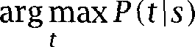 = =

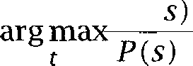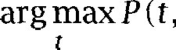

So a language model can always be used as a parsing model for the pur- pose of choosing between parses. But a language model can also be used for other purposes (for example, as a speech recognition language model, or for estimating the entropy of a language).

On the other hand, there is not a way to convert an arbitrary parsing model into a language model. Nevertheless, noticing some of the biases of PCFG parsing models that we discussed in chapter 11, a strand of work at IBM explored the idea that it might be better to build parsing models directly rather than defining them indirectly via a language model  linek et al. 1994; and directly defined parsing models have also been used by others (Collins 1996). However, in this work, although the overall probabilities calculated are conditioned on a partic- ular sentence, the atomic probabilities that the probability of a parse is decomposed into are not dependent on the individual sentence, but are still estimated from the whole training corpus. Moreover, when Collins (1997) refined his initial model (Collins 1996) so that parsing probabilities were defined via an explicit language model, this significantly increased the performance of his parser. So, while language models are not neces- sarily to be preferred to parsing models, they appear to provide a better foundation for modeling.



Weakening the independence assumptions of Context and independence assumptions

It is widely accepted in studies of language understanding that humans make wide use of the context of an utterance to disambiguate language as they listen. This use of context assumes many forms, for example the context where we are listening (to TV or in a bar), who we are listening to, and also the immediate prior context of the conversation. The prior discourse context will influence our interpretation of later sentences (this is the effect known as priming in the psychological literature). People will find semantically intuitive readings for sentences in preference to weird ones. Furthermore, much recent work shows that these many sources of

information are incorporated in real time while people parse  In our previous PCFG model, we were effectively making an independence assumption that none of these factors were relevant to the probability of a parse tree. But, in fact, all of these sources of evidence are relevant to and might be usable for disambiguating probabilistic parses. Even if we are not directly modeling the discourse context or its meaning, we can approximate these by using notions of collocation to help in more local semantic disambiguation, and the prior text as an indication of discourse context (for instance, we might detect the genre of the text, or its topic). To build a better statistical parser than a PCFG, we want to be able to incorporate at least some of these sources of information.

**Lexicalization**

There are two somewhat separable weaknesses that stem from the in- dependence assumptions of PCFGs. The most often remarked on one is

**LEXICALIZATION** their lack of In a PCFG, the chance of a VP expanding as a verb followed by two noun phrases is independent of the choice of verb involved. This is ridiculous, as this possibility is much more likely with ditransitive verbs like hand or  than with other verbs. Table 12.2 uses data from the to show how the probabilities of vari- ous common subcategorization frames differ depending on the verb that heads the  This suggests that somehow we want to include more in- formation about what the actual words in the sentence are when making decisions about the structure of the parse tree.



In other places as well, the need for lexicalization is obvious. A clear case is the issue of choosing phrasal attachment positions. As discussed at length in chapter 8, it is clear that the lexical content of phrases almost always provides enough information to decide the correct attachment site, whereas the syntactic category of the phrase normally provides very little information. One of the ways in which standard PCFGs are much

1. This last statement is not uncontroversial. Work in psycholinguistics that is influenced by a Chomskyan approach to language has long tried to argue that people construct syn- tactic parses first, and then choose between them in a disambiguation phase (e.g., Frazier 1978). But a variety of recent work (e.g., Tanenhaus and Trueswell 1995, Pearlmutter and MacDonald 1992) has argued against this and suggested that semantic and contextual information does get incorporated immediately during sentence understanding.
2. One can W help but suspect that some of the very low but non-zero entries might reveal

errors in the treebank, but note that because functional tags are being ignored, an NP can appear after an intransitive verb if it is a temporal NP like *lust week.*

*418 12 Probabilistic Parsing*

Verb

|  |  |  |  |  |
| --- | --- | --- | --- | --- |
| Local tree | *come* | *take* | *think* | *want* |
| VP-V |  | 2.6% | 4.6% | 5.7% |
| VP-VNP | 1.1% | 32.1% | 0.2% | 13.9% |
| VP v PP | 34.5% | 3.1% | 7.1% | 0.3% |
| VP V SBAR | 6.6% | 0.3% | 73.0% | 0.2% |
|  | 2.2% | 1.3% | 4.8% | 70.8% |
| VP V NP | 0.1% | 5.7% | 0.0% | 0.3% |
| VP V PRT NP | 0.3% | 5.8% | 0.0% | 0.0% |
| VP V PRT PP | 6.1% | 1.5% | 0.2% | 0.0% |

Table 12.2 Frequency of common subcategorization frames (local trees ex- panding VP) for selected verbs. The data show that the rule used to expand VP is highly dependent on the lexical identity of the verb. The counts ignore distinctions in verbal form tags. Phrase names are as in table 12.1, and tags are

tags (tables 4.5 and 4.6).



worse than n-gram models is that they totally fail to capture the lexical dependencies between words. We want to get this back, while maintain- ing a richer model than the purely linear word-level n-gram models. The most straightforward and common way to lexicalize a CFG is by having each phrasal node be marked by its head word, so that the tree in  will be lexicalized as the tree in 

(12.8) a.

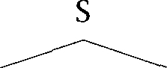

NP VP

 

NNP VBD PP

  

*Sue walked* P NP

 

*into* DT NN

*the store*

b.



*I*

 

 

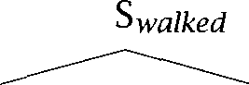*Sue walked*









 

*the store*

Central to this model of lexicalization is the idea that the strong lexi- cal dependencies are between heads and their dependents, for example between a head noun and a modifying adjective, or between a verb and



a noun phrase object, where the noun phrase object can in turn be ap- proximated by its head noun. This is normally true and hence this is an effective strategy, but it is worth pointing out that there are some depen- dencies between pairs of non-heads. For example, for the object NP in (12.9):

(12.9) I got  the easier problem [of the two] [to solve]].

both the  modifiers two and to solve are dependents of the prehead modifier easier. Their appearance is only weakly conditioned by the head of the NP ***problem.*** Here are two other examples of this sort, where the head is in bold, and the words involved in the dependency are in italics:



(12.10) a. Her approach was ***more quickly* understood than *mine.***

b. He lives in what must be the ***furthest* suburb *from the university.***

See also exercise 8.16.

**Probabilities dependent on structural context**

However, PCFGs are also deficient on purely structural grounds. Inherent to the idea of a PCFG is that probabilities are context-free: for instance, that the probability of a noun phrase expanding in a certain way is inde- pendent of where the NP is in the tree. Even if we in some way

ize PCFGs to remove the other deficiency, this assumption of structural context-freeness remains. But this grammatical assumption is actually quite wrong. For example, table 12.3 shows how the probabilities of ex- panding an NP node in the Penn differ wildly between subject position and object position. Pronouns, proper names and definite appear more commonly in subject position while containing

head modifiers and bare nouns occur more commonly in object position.

This reflects the fact that the subject normally expresses the

internal topic. As another example, table 12.4 compares the expansions for the first and second object of ditransitive verbs. The  for pronouns to be second objects is well-known, and the preference

for 1P expansions as second objects reflects the well-known ten-

dency for heavy elements to appear at the end of the clause, but it would take a more thorough corpus study to understand some of the other ef- fects. For instance, it is not immediately clear to us why bare plural

*12 Probabilistic Parsing*

|  |  |  |
| --- | --- | --- |
| Expansion | *%* as Subj | % as Obj |
| NP PRP | 13.7% | 2.1% |
| NP NNP | 3.5% | 0.9% |
| NP DT NN | 5.6% | 4.6% |
| NP NN | 1.4% | 2.8% |
| NP NP SBAR | 0.5% | 2.6% |
| NP NP PP | 5.6% | 14.1% |

Table 12.3 Selected common expansions of NP as Subject vs. Object, ordered by log odds ratio. The data show that the rule used to expand NP is highly dependent on its parent node(s), which corresponds to either a subject or an object.

|  |  |  |
| --- | --- | --- |
| Expansion | 1st Obj | % as 2nd Obj |
| NP NNS | 7.5% | 0.2% |
| NP PRP | 13.4% | 0.9% |
| NP NP PP | 12.2% | 14.4% |
| NP DT NN | 10.4% | 13.3% |
| NP NNP | 4.5% | 5.9% |
| NP NN | 3.9% | 9.2% |
| NP JJ NN | 1.1% | 10.4% |
| NP NP SBAR | 0.3% | 5.1% |

Table 12.4 Selected common expansions of NP as first and second object inside VP. The data are another example of the importance of structural context for nonterminal expansions.

nouns are so infrequent in the second object position. But at any rate, the context-dependent nature of the distribution is again manifest.

The upshot of these observations is that we should be able to build a much better probabilistic parser than one based on a PCFG by better taking into account lexical and structural context. The challenge (as so often) is to find factors that give us a lot of extra discrimination while not defeating us with a multiplicity of parameters that lead to sparse data problems. The systems in the second half of this chapter present a number of approaches along these lines.

12.1 Some Concepts ***421***

NP VP N VP

***astronomers*** VP ***astronomers*** V NP ***astronomers saw*** NP ***astronomers saw N*** astronomers saw telescopes

NP VP N VP

***astronomers*** VP ***astronomers*** V NP ***astronomers*** V N ***astronomers*** V ***telescopes*** astronomers saw telescopes

Figure 12.3 Two CFG derivations of the same tree.

* + 1. Tree probabilities and derivational probabilities

In the PCFG framework, one can work out the probability of a tree by just multiplying the probabilities of each local of the tree, where the probability of a local is given by the rule that produced it. The tree can be thought of as a compact record of a branching process where one is making a choice at each node, conditioned solely on the label of the node. As we saw in chapter 3, within generative models of  one generates sentences from a grammar, classically by starting with a start symbol, and performing a derivation which is a sequence of top-down rewrites until one has a phrase marker all of whose leaf nodes are termi- nals (that is, words). For example, figure 12.3 (a) shows the derivation of a sentence using the grammar of table 11.2, where at each stage one terminal symbol gets rewritten according to the grammar. A straightfor- ward way to make rewrite systems probabilistic is to define probability distributions over each choice point in the derivation. For instance, at the last step, we chose to rewrite the final N as ***telescopes,*** but could have chosen something else, in accord with the grammar. The linear steps of a derivational process map directly onto a standard stochastic process, where the states are productions of the grammar. Since the generative grammar can generate all sentences of the language, a derivational model is inherently a language model.

Thus a way to work out a probability for a parse tree is in terms of the probability of derivations of it. Now in general a given parse tree can have multiple derivations. For instance, the tree in (12.11) has not

1. In the original sense of Chomsky (1957); in more recent work Chomsky has suggested that Jenerative means nothing more than Iormal (Chomsky 1995: 162).

***422***

(12.11)

(12.12)

***12 Probabilistic Parsing***

***only*** the derivation in figure 12.3 (a), but also others, such as the one in figure 12.3 (b), where the second NP is rewritten before the V.



NP



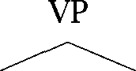N V NP I 

***astronomers saw N***



***telescopes***

So, in general, to estimate the probability of a tree, we have to calculate:

 ***= ***

**CANONICAL DERIVATION**

(12.13)

***d*** is a derivation oft)

However, in many cases, such as the PCFG case, this extra complication is unnecessary. It is fairly obvious to see (though rather more difficult to prove) that the choice of derivational order in the PCFG case makes no difference to the final probabilities. Regardless of what probability distribution we assume over the choice of which node to rewrite next in a derivation, the final probability for a tree is otherwise the same. Thus we can simplify things by finding a way of choosing a unique derivation for each tree, which we will refer to as a ***canonical derivation.*** For instance, the leftmost derivation shown in figure 12.3 (a), where at each step we expand the leftmost non-terminal can be used as a canonical derivation. When this is possible, we can say:

***= P(d)*** where ***d*** is the canonical derivation of

Whether this simplification is possible depends on the nature of the prob- abilistic conditioning in the model. It is possible in the PCFG case because probabilities depend only on the parent node, and so it doesn W matter if other nodes have been rewritten yet or not. If more context is used, or there are alternative ways to generate the same pieces of structure, then the probability of a tree might well depend on the derivation. See sections 12.2.1 and 

1. The proof depends on using the kind of derivation to tree mapping developed in (Hopcroft and Ullman 1979).
2. Even in such cases, one might choose to approximate tree probabilities by estimating

***12.1 Some Concepts* 423**

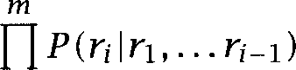Let us write for an individual rewriting step rewriting the string as To calculate the probability of a derivation, we use the chain rule, and assign a probability to each step in the derivation, con- ditioned by preceding steps. For a standard rewrite grammar, this looks like this:



(12.14) P(d) =



i = l

We can think of the conditioning terms above, that is, the rewrite rules already applied, as the history of the parse, which we will refer to as 

HISTORY-BASED S O   This is what led to the notion of ***history-based*** GRAMMARS ***grammars*** (HBGS) explored initially at IBM. Since we can never model the entire history, normally what we have to do is form equivalence classes

of the history via an equivalencing function and estimate the above as:

(12.15) P(d)

i = l

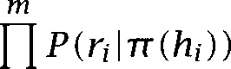

This framework includes PCFGs as a special case. The equivalencing func- tion for PCFGs simply returns the leftmost non-terminal remaining in the phrase marker. **So, = ** iff = 

* + 1. There V more than one way to do it

The way we augmented a CFG with probabilities in chapter 11 seems so natural that one might think that this is the only, or at least the only sensible, way to do it. The use of the term PCFG probabilistic

free grammar tends to give credence to this view. Hence it is impor- tant to realize that this is untrue. Unlike the case of categorical context free languages, where so many different possibilities and parsing meth- ods converge on strongly or weakly equivalent results, with probabilistic grammars, different ways of doing things normally lead to different prob- abilistic grammars. What is important from the probabilistic viewpoint is what the probabilities of different things are conditioned on (or look- ing from the other direction, what independence assumptions are made). While probabilistic grammars are sometimes equivalent for example

them according to the probabilities of a canonical derivation, but this could be expected to have a detrimental effect on performance.

*12 Probabilistic Parsing*

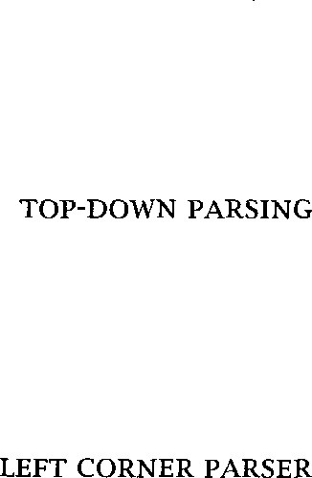an HMM working from left-to-right gives the same results as one work- ing from right-to-left, if the conditioning fundamentally changes, then there will be a different probabilistic grammar, even if it has the same categorical base. As an example of this, we will consider here another way of building a probabilistic grammar with a CFG basis, Probabilistic Left-Corner Grammars 

**Probabilistic left-corner grammars**

If we think in parsing terms, a PCFG corresponds to a probabilistic version of top-down parsing. This is because at each stage we are trying to predict the child nodes given knowledge only of the parent node. Other parsing methods suggest different models of probabilistic conditioning. Usually, such conditioning is a mixture of top-down and *bottom-up information.* One such possibility is suggested by a left-corner parsing strategy.

*Left corner parsers* (Rosenkrantz and Lewis 1970; Demers 1977) work by a combination of bottom-up and top-down processing. One begins with a goal category (the root of what is currently being constructed), and then looks at the left corner of the string (i.e., one shifts the next terminal). If the left corner is the same category as the goal category, then one can stop. Otherwise, one projects a possible local tree from the left corner, by looking for a rule in the grammar which has the left corner category as the first thing on its right hand side. The remaining children of this projected local tree then become goal categories and one recursively does left corner parsing of each. When this local tree is fin- ished, one again recursively does left-corner parsing with the as the left corner, and the same goal category as we started with. To make this description more precise, pseudocode for a simple left corner

nizer is shown in figure  This particular parser assumes that lexical material is introduced on the right-hand side of a rule, e.g., as N house, and that the top of the stack is to the left when written horizontally. The parser works in terms of a stack of found and sought constituents, the latter being represented on the stack as categories with a bar over them. We use to represent a single terminal or non-terminal (or the empty string, if we wish to accommodate empty categories in the gram- mar), and to stand for a (possibly empty) sequence of terminals and

1. The presentation here borrows from an unpublished manuscript of Mark Johnson and Ed Stabler, 1993.

**comment:** Initialization

Place the predicted start symbol  on top of the stack

3 **comment:** Parser

4 while **(an** action is possible) **do** one of the following

5 **actions**

6 [Shift] Put the next input symbol on top of the stack

7 [Attach] If is on top of the stack, remove both

8 [Project] If is on top of the stack and ***A*** replace by 



9 **endactions end**

**comment: Termination**

**if ** **A **

*1 3* **then**

*1 4* **exit success**

**15 else**

*1 6* **exit** failure

*1 7 f i*

**Figure 12.4 An LC** stack parser.

SHIFTING non-terminals. The parser has three operations, ***shifting, projecting,*** and

PROJECTING ATTACHING

***attaching.* We** will put probability distributions over these operations. When to shift is deterministic: If the thing on top of the stack is a sought category  then one must shift, and one can never successfully shift at other times. But there will be a probability distribution over what is shifted. At other times we must decide whether to attach or project. The only interesting choice here is deciding whether to attach in cases where the left corner category and the goal category are the same. Otherwise we must project. Finally we need probabilities for projecting a certain local tree given the left corner (Zc) and the goal category  Under this model, we might have probabilities for this last operation like this:

IN = IN,gc = S) = 0.25  IN  = IN,gc = S) = 0.55

To produce a language model that reflects the operation of a left corner parser, we can regard each step of the parsing operation as a step in a derivation. In other words, we can generate trees using left corner proba- bilities. Then, just as in the last section, we can express the probability of

a parse tree in terms of the probabilities of left corner derivations of that parse tree. Under left corner generation, each parse tree has a unique derivation and so we have:

 =  where is the LC derivation of

And the left corner probability of a sentence can then be calculated in the usual way:

 = 



The probability of a derivation can be expressed as a product in terms of the probabilities of each of the individual operations in the derivation. Suppose that *. . . ,* is the sequence of operations in the LC parse derivation of Then, by the chain rule, we have:

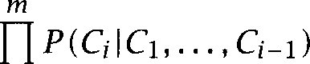

*P(t)*

i=l

In practice, we cannot condition the probability of each parse decision on the entire history. The simplest left-corner model, which is all that we will develop here, assumes that the probability of each parse decision is largely independent of the parse history, and just depends on the state of the parser. In particular, we will assume that it depends simply on the left corner and top goal categories of the parse stack.

Each elementary operation of a left corner parser is either a shift, an attach or a left corner projection. Under the independence assumptions mentioned above, the probability of a shift will simply be the probability of a certain left corner child  being shifted given the current goal cat- egory  which we will model by  When to shift is deterministic. If a goal (i.e., barred) category is on top of the stack (and hence there is no left corner category), then one must shift. Otherwise one cannot. If one is not shifting, one must choose to attach or project, which we model by  Attaching only has a non-zero probability if the left corner and the goal category are the same, but we define it for all pairs. If we do not attach, we project a constituent based on the left corner with prob- ability  Thus the probability of each elementary operation  can be expressed in terms of probability distributions and  as follows:



(12.16) = if is



*0* otherwise

(12.17) = attach) = 0



gc) if top is not gc otherwise

 



(12.18)  =   = if top is not gc



0 otherwise

Where these operations obey the following constraints:

(12.19)

(12.20)

  

*gc) = 0*



If

gc,



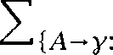        

From the above we note that the probabilities of the choice of different shifts and projections sum to one, and hence, since other probabilities are complements of each other, the probabilities of the actions available for each elementary operation sum to one. There are also no dead ends in a derivation, because unless *A* is a possible left corner constituent of  gc) = 0. Thus we have shown that these probabilities



define a language That is, *G) =* 1.



Manning and Carpenter (1997) present some initial exploration of this form of While the independence assumptions used above are still quite drastic, one nevertheless gets a slightly richer probabilistic model than a PCFG, because elementary left-corner parsing actions are condi- tioned by the goal category, rather than simply being the probability of a local tree. For instance, the probability of a certain expansion of NP can be different in subject position and object position, because the goal cat- egory is different. So the distributional differences shown in table 12.3 can be  Manning and Carpenter (1997) show how, because of this, a PLCG significantly outperforms a basic PCFG.

**Other ways of doing it**

Left-corner parsing is a particularly interesting case: left-corner parsers work incrementally from left-to-right, combine top-down and bottom-up prediction, and hold pride of place in the family of Generalized Left Cor- ner Parsing models discussed in exercise 12.6. Nevertheless it is not the

1. Subject to showing that the probability mass accumulates in finite trees, the issue discussed in chapter 11.
2. However, one might note that those in table 12.4 will not be captured.

only other possibility for making probabilistic parsers based on CFG pars- ing algorithms, and indeed other approaches were investigated earlier.

Working with bottom-up shift-reduce parsers is another obvious pos- sibility. In particular, a thread of work has looked at making probabilis- tic versions of the Generalized LR parsing approach of Tomita (1991). Briscoe and Carroll (1993) did the initial work in this area, but their model is probabilistically improper in that the LR parse tables guide a unification-based parser, and unification failures cause parse failures that are not captured by the probability distributions. A solidly probabilistic LR parser is described in (Inui et al. 1997).

**DEPENDENCY GRAMMAR**

(12.22)

Phrase structure grammars and dependency grammars

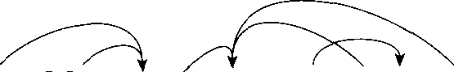The dominant tradition within modern linguistics and NLP has been to use phrase structure trees to describe the structure of sentences. But an alternative, and much older, tradition is to describe linguistic structure in terms of dependencies between words. Such a framework is referred to as a dependency grammar. In a dependency grammar, one word is the head of a sentence, and all other words are either a dependent of that word, or else dependent on some other word which connects to the headword through a sequence of dependencies. Dependencies are usually shown as curved arrows, as for example in (12.22).

The old man ate the rice slowly

Thinking in terms of dependencies is useful in Statistical NLP, but one also wants to understand the relationship between phrase structure and dependency models. In his work on disambiguating compound noun structures (see page  Lauer argues that a dependency model is better than an adjacency model. Suppose we want to



biguate a compound noun such as phrase structure model. Previous work had considered the two possible tree structures for this compound noun, as shown in (12.23) and had tried to choose between them according to whether corpus evidence showed a tighter collocational bond between *phrase-structure* or between *structure-* model.

* 1. ***Some Concepts***

(12.23) a. b.

***model phrase***

***phrase structure structure model***

Lauer argues that instead one should examine the ambiguity in terms of dependency structures, as in  and there it is clear that the dif- ference between them is whether ***phrase*** is a dependent of ***structure*** or whether it is a dependent of ***model.*** He tests this model against the ad- jacency model and shows that the dependency model outperforms the adjacency model.

(12.24) a. phrase structure model b. phrase structure model

Now Lauer is right to point out that the earlier work had been flawed, and could maintain that it is easier to see what is going on in a depen- dency model. But this result does not show a fundamental advantage of dependency grammars over phrase structure grammars. The prob- lem with the adjacency model was that in the trees, repeated annotated as (12.29, the model was only considering the nodes and  and ignoring the nodes and

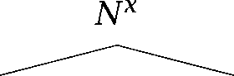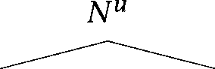(12.25) a. b.

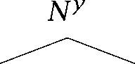 ***model phrase*** 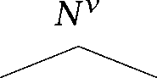

***phrase structure structure model***

If one corrects the adjacency model so that one also considers the nodes and  and does the obvious lexicalization of the phrase structure tree, so that is annotated with ***structure*** and with ***model*** (since En- glish noun compounds are right-headed), then one can easily see that the two models become equivalent. Under a lexicalized PCFG type model, we find that  =  and so the way to decide between the possibil- ities is by comparing  vs.  But this is exactly equivalent to

comparing the bond between ***phrase structure*** and ***phrase model.***

There are in fact isomorphisms between various kinds of dependency grammars and corresponding types of phrase structure grammars. A de- pendency grammar using undirected arcs is equivalent to a phrase struc- ture grammar where every rule introduces at least one terminal node. For

 Probabilistic Parsing

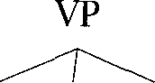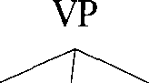

V NP PP PP V NP PP v PP PP

**Figure 12.5** Decomposing a local tree into dependencies.

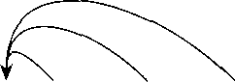

the more usual case of directed arcs, the equivalence is with l-bar level X grammars. That is, for each terminal in the grammar, there is a terminal  and the only rules in the grammar are of the form



where and  are (possibly empty) sequences of non-terminals (cf. sec- tion 32.3). Another common option in dependency grammars is for the dependencies to be labeled. This in turn is equivalent to not only labeling

**HEAD** one child of each local as the head (as was implicitly achieved by the X-bar scheme), but labeling every child node with a relationship. Providing the probabilistic conditioning is the same, these results carry over to the probabilistic versions of both kinds of 

Nevertheless, dependency grammars have their uses in probabilistic parsing, and, indeed, have become increasingly popular. There appear to be two key advantages. We argued before that lexical information is key to resolving most parsing ambiguities. Because dependency grammars work directly in terms of dependencies between words, disambiguation decisions are being made directly in terms of these word dependencies. There is no need to build a large superstructure (that is, a phrase struc- ture tree) over a sentence, and there is no need to make disambiguation decisions high up in that structure, well away from the words of the sen- tence. In particular, there is no need to worry about questions of how to lexicalize a phrase structure tree, because there simply is no structure that is divorced from the words of the sentence. Indeed, a dependency grammarian would argue that much of the superstructure of a phrase structure tree is otiose: it is not really needed for constructing an under- standing of sentences.

The second advantage of thinking in terms of dependencies is that de-

pendencies give one a way of decomposing phrase structure rules, and estimates of their probabilities. A problem with inducing parsers from the is that, because the trees are very flat, there are lots



1. Note that there is thus no way to represent within dependency grammars the two or even three level X schemata that have been widely used in modern phrase structure approaches.

of rare kinds of flat trees with many children. And in unseen data, one will encounter yet other such trees that one has never seen before. This is problematic for a PCFG which tries to estimate the probability of a local all at once. Note then how a dependency grammar decomposes

this, by estimating the probability of each head-dependent relationship separately. If we have never seen the local tree in figure 12.5 (a) before, then in a PCFG model we would at best back off to some default Xn- seen tree probability. But if we decompose the tree into dependencies, as in  then providing we had seen other trees like  and  before, then we would expect to be able to give quite a reasonable estimate for the probability of the tree in (a). This seems much more promising than simply backing off to an Xnseen tree probability, but note that we are making a further important independence assumption. For example, here we might be presuming that the probability of a PP attaching to a VP (that is, a preposition depending on a verb in dependency grammar terms) is independent of how many there are in the VP (that is, how many noun dependents the verb has). It turns out that assuming complete in- dependence of dependencies does not work very well, and we also need some system to account for the relative ordering of dependencies. To solve these problems, practical systems adopt various methods of allow- ing some conditioning between dependencies (as described below).

* + 1. Evaluation

An important question is how to evaluate the success of a statistical parser. If we are developing a language model (not just a parsing model), then one possibility is to measure the cross entropy of the model with re- spect to held out data. This would be impeccable if our goal had merely been to find some form of structure in the data that allowed us to predict the data better. But we suggested earlier that we wanted to build proba- bilistic parsers that found particular parse trees that we had in mind, and so, while perhaps of some use as an evaluation metric, ending up doing evaluation by means of measuring cross entropy is rather inconsistent with our stated objective. Cross entropy or perplexity measures only the probabilistic weak equivalence of models, and not the tree structure that we regard as important for other tasks. In particular, probabilistically weakly equivalent grammars have the same cross entropy, but if they are not strongly equivalent, we may greatly prefer one or the other for our task.

Why are we interested in particular parse trees for sentences? People are rarely interested in syntactic analysis for its own sake. Presumably our ultimate goal is to build a system for information extraction, question answering, translation, or whatever. In principle a better way to evaluate parsers is to embed them in such a larger system and to investigate the differences that the various parsers make in such a task-based evalua- tion. These are the kind of differences that someone outside the parsing community might actually care about.

However, often a desire for simplicity and modularization means that it would be convenient to have measures on which a parser can be sim- ply and easily evaluated, and which one might expect to lead to better performance on tasks. If we have good reason to believe that a certain style of parse tree is useful for further tasks, then it seems that what we could do is compare the parses found by the program with the results of hand-parsing of sentences, which we regard as a gold standard. But how should we evaluate our parsing attempts, or in other words, what is the

**CRITERION ** *criterion* that we are trying to maximize? The strictest criterion

is to award the parser 1 point if it gets the parse tree completely right, **TREEACCURACY** and 0 points if it makes any kind of mistake. This is the *tree accuracy* **EXACTMATCH or exact match** criterion. It is the toughest standard, but in many ways it is a sensible one to use. In part this is because most standard parsing

methods, such as the Viterbi algorithm for try to maximize this quantity. So, since it is generally sensible for one V objective criterion to match what one V parser is maximizing, in a way using this criterion makes sense. However, clearly, in this line of reasoning, we are putting the cart before the horse. But for many potential tasks, partly right parses are not much use, and so it is a reasonable objective criterion. For exam- ple, things will not work very well in a database query system if one gets the scope of operators wrong, and it does not help much that the system got part of the parse tree right.

On the other hand, parser designers, like students, appreciate getting part-credit for mostly right parses, and for some purposes partially right parses can be useful. At any rate, the measures that have most commonly

$RSEVAL **MEASURES** been used for parser evaluation are the *measures,* which origi- nate in an attempt to compare the performance of non-statistical parsers. These measures evaluate the component pieces of a parse. An example of a parsed tree, a gold standard tree, and the results on the PARSEVAL measures as they have usually been applied in Statistical NLP work is

**PRECISION** shown in figure 12.6. Three basic measures are proposed: *precision* **is**



ROOT

**S**

NP VP N P

I I

NNS NNS VBD VP NN **1 1**

**I I**

***Sales executives were*** VBG NP PP ***yesterday***

***examining*** DT NNS IN NP

I I I

the ***figures with*** JJ NN

I

***great care***

* + - 1. ROOT

S

NP VP

I

NNS NNS VBD VP 11

I

Sales ***executives were*** VBG NP

I

***examining*** NP PP

DT NNS IN NP

I I I 

***the figures with*** NN NN NN

I I

***great care yesterday***

Brackets in gold standard tree (a.):



Brackets in candidate parse

Precision: Recall:

Labeled Precision: Labeled Recall:

= 37.5%

= 37.5%

= 37.5%

= 37.5%

Crossing Brackets: Crossing Accuracy: Tagging Accuracy:

0

100%

1 = 90.9%

Figure 12.6 An example of the PARSEVAL measures. The PARSEVAL measures are easily calculated by extracting the ranges which are spanned by non-terminal nodes, as indicated in  and  and then calculating the intersection, either including or not including labels while doing so. The matching brackets are shown in bold. The ROOT node is ignored in all calculations, and the  nodes are used only for the tagging accuracy calculation. The starred unary node would be excluded in calculations according to the original standard, but is included here.

  

  

  

  



Figure 12.7 The idea of crossing brackets. Bracket crosses both brackets and All the other brackets are consistent. The guiding intuition is that

crossing brackets cannot be combined into a single tree structure.

**RECALL** how many brackets in the parse match those in the correct tree, measures how many of the brackets in the correct tree are in the parse,

**CROSSINGBRACKETS** and  brackets gives the average of how many constituents in one tree cross over constituent boundaries in the other tree. A picture to help understand crossing brackets is in figure 12.7. Errors of this sort have of- ten been seen as particularly dire. Rather than giving crossing brackets per tree (independent of tree size) an alternative is to report the crossing accuracy, the measure of the percentage of brackets that are not crossing brackets. The original PARSEVAL measures (because they were designed for implementations of various incompatible syntactic theories) ignored node labels, unary branching nodes, and performed various other (ad hoc) tree normalizations. However, if a parser is trying to duplicate parses being performed by hand, then it is reasonable to include node labels, and this is normally done, giving measures of labeled precision and recall. It is also reasonable to include unary nodes, except that the unary ROOT and preterminal nodes are not 

The PARSEVAL measures are not very discriminating. As we will see

1. The Penn gives all trees an unlabeled top node, here called **ROOT.** This is useful so that one can have rules rewriting the **ROOT** as the actual top node of the sentence, whether S or NP or whatever. (A surprising number of Ventences in

text are actually just noun phrases.) Including this node, and the preterminal nodes would inflate the precision and recall figures, as they are unary nodes which one could not get wrong. Including preterminal labels in the labeled measures is more defensible, but would mean that one V ability to do part of speech tagging is rolled into the performance of the parser, whereas some people feel it is best reported separately. Chains of unary nodes present some problems for these measures: the measures fail to capture the dominance ordering of the nodes, and, if multiple nodes have the same category, care must be taken in the calculation of recall. Finally we note that most evaluations of Statistical NLP parsers on the Penn have used their own ad-hoc normalizations, principally discounting

sentence-internal punctuation and the distinction between the categories ADVP and PRT.

below, Charniak (1996) shows that according to these measures, one can do surprisingly well on parsing the Penn by inducing a vanilla PCFG which ignores all lexical content. This somewhat surprising result seems to reflect that in many respects the PARSEVAL measures are quite easy ones to do well on, particularly for the kind of tree structures as- sumed by the Penn Treebank. Firstly, it is important to note that they are measuring success at the level of individual decisions and normally what makes NLP hard is that you have to make many consecutive deci- sions correctly to succeed. The overall success rate is then the  power of the individual decision success rate a number that easily becomes small.

But beyond this, there are a number of features particular to the struc- ture of the Penn that make these measures particularly easy.

Success on crossing brackets is helped by the fact that Penn

trees are quite flat. To the extent that sentences have very few brackets in them, the number of crossing brackets is likely to be small. Identi- fying troublesome brackets that would lower precision and recall mea- sures is also avoided. For example, recall that there is no disambiguation of compound noun structures within the Penn Treebank, which gives a completely flat structure to a noun compound (and any other prehead modifiers) as shown below (note that the first example also illustrates the rather questionable Penn practice of tagging hyphenated non-final portions of noun compounds as adjectives!).

(12.26) stock-index/JJ arbitrage/NN sell/NN venture/NN advertising/NN agency/NN



Another case where peculiarities of the Penn help is the non- standard adjunction structures given to post noun-head modifiers, of the general form (NP (NP the man) (PP in (NP the moon))). As we discussed in section 8.3, a frequent parsing ambiguity is whether attach to a preceding NP or VP or even to a higher preceding node and this is a situation where lexical or contextual information is more important than structural factors. Note now that the use of the above adjunction structure reduces the penalty for making this decision wrongly. For the different tree brackettings for Penn style structures and the type of N structure more commonly assumed in linguistics, as shown in figure 12.8, the errors assessed for different attachments are as shown in table 12.5. The forgivingness of the Penn scheme is manifest.

VP attach (VP saw (NP the man) (PP with (NP a telescope)))

NP attach (VP saw (NP  man) (PP with (NP a telescope)))) Another VP attach (VP saw (NP the (N man)) (PP with (NP a (N telescope))))) Another NP attach (VP saw (NP the (N man (PP with (NP a (N telescope))))))

Figure ***12.8*** Penn trees versus other trees.

Error Errors assessed Rec.

|  |  |  |  |  |
| --- | --- | --- | --- | --- |
| of NP | 0 |  | 1 | 0 |
| of VP | 1 |  | 0 | 0 |
| Another VP instead of NP 2 |  | 2 |  | 1 |
| NP instead of VP 2 |  | 2 |  | 1 |

Table 12.5 Precision and recall evaluation results for PP attachment errors for different styles of phrase structure.

One can get the attachment wrong and not have any crossing brackets, and the errors in precision and recall are 

On the other hand, there is at least one respect in which the PARSEVAL measures seem too harsh. If there is a constituent that attaches very high (in a complex right-branching sentence), but the parser by mistake attaches it very low, then every node in the right-branching complex will be wrong, seriously damaging both precision and recall, whereas arguably only a single mistake was made by the parser. This is what happened to give the very bad results in figure 12.6. While there are two attachment errors in the candidate parse, the one that causes enormous damage in the results is attaching yesterday low rather than high (the parser which generated this example didn W know about temporal nouns, to its great detriment).

This all suggests that these measures are imperfect, and one might

wonder whether something else should be introduced to replace them. One idea would be to look at dependencies, and to measure how many of the dependencies in the sentence are right or wrong. However, the difficulty in doing this is that dependency information is not shown in

1. This comparison assumes that one is including brackets. The ***general*** contrast remains even if one does not do so, but the badness of the non-Penn case is slightly reduced.

the Penn Treebank. While one can fairly successfully induce dependency relationships from the phrase structure trees given, there is no real gold standard available.

Returning to the idea of evaluating a parser with respect to a task, the correct approach is to examine whether success on the PARSEVAL mea- sures is indicative of success on real tasks. Many small parsing mistakes might not affect tasks of semantic interpretation. This is suggested by results of (Bonnema 1996; Bonnema et al. 1997). For instance, in one ex- periment, the percentage of correct semantic interpretations was  even though the tree accuracy of the parser was only 62%. The cor- relation between the PARSEVAL measures and task-based performance is briefly investigated by Hermjakob and Mooney (1997) with respect to their task of English to German translation. In general they find a quite good correlation between the PARSEVAL measures and generating accept- able translations. Labeled precision has by far the best correlation with a semantically adequate translation  whereas the correlation with the weaker measure of crossing brackets is much more modest (0.54). Whether there are other evaluation criteria that correlate better with suc- cess on final tasks, and whether different criteria better predict perfor- mance on different kinds of final tasks remain open questions. However, at the moment, people generally feel that these measures are adequate for the purpose of comparing parsers.

* + 1. Equivalent models

When comparing two probabilistic grammars, it is easy to think that they are different because they are using different surface trappings, but what is essential is to work out what information is being used to condition the prediction of what. Providing the answers to that question are the same, then the probabilistic models are equivalent.

In particular, often there are three different ways of thinking about things: in terms of remembering more of the derivational history, look- ing at a bigger context in a phrase structure tree, or by enriching the vocabulary of the tree in deterministic ways.

Let us take a simple example. Johnson (1998) demonstrates the utility of using the grandparent node  as additional contextual information when rewriting a parent non-terminal  in a PCFG. For instance, con- sider the tree in (12.27).

(12.27)

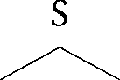

 VP

V 

When expanding the NP non-terminals in (12.2  for  we would be us- ing = NP,  = S), while for  we would use = NP,  = VP). This model can also capture the differences in the proba- bility distributions for subject and object shown in table 12.3 (while again failing to capture the distributional differences shown in table 12.4). Including information about the grandparent is surprisingly effective. Johnson shows that this simple model actually outperforms the proba- bilistic left-corner model presented earlier, and that in general it appears to be the most valuable simple enrichment of a PCFG model, short of lexicalization, and the concomitant need to handle sparse data that that introduces.



But the point that we wish to make here is that one can think of this model in three different ways: as using more of the derivational history, as using more of the parse tree context, or as enriching the category labels. The first way to think of it is in derivational terms, as in a  based grammar. There we would be saying that we are doing a finer equivalence classing of derivational histories. For two derivational histo- ries to be equivalent, not only would they have to have the same leftmost non-terminal remaining in the phrase marker, but both of these would have to have resulted from rewriting the same category. That is:

= iff = =



***. . . h A***

***.***



***: h’***

If two non-terminals were in different equivalence classes, they would be able to (and usually would) have different probabilities for rewriting.

But, instead of doing this, we could think of this new model simply in terms of the probability of tree structures, but suggest that rather than working out the probability of a local just by looking at the nodes that comprise the  we could also look at more surrounding context. One can get into trouble if one tries to look at the surrounding context in all directions at once, because then one can no longer produce a well-founded probabilistic model or parsing method there has to be a certain directionality in the use of context. But if one is thinking of the tree being built top-down, then one can certainly include as much context

from higher up in the tree as one wishes. Building equivalence classes of sequences of derivational steps is equivalent to building equivalence classes of partial trees. Just including the identity of the grandparent node is a. particularly simple example of enriching context in this way.

Or thirdly, one can do what Johnson actually did and just use a generic PCFG parser, but enrich the vocabulary of the tree labels to encode this ex- tra contextual information. Johnson simply relabeled every non-terminal with a composite label that recorded both the node V original label and its parent V label (for instance, in (12.27) was relabeled as NP-S). Two nodes in the new trees had the same label if and only if both they and their parents had the same label in the original trees. Johnson could then use a standard PCFG parser over these new trees to simulate the effect of using extra contextual information in the original trees. All three of these methods produce equivalent probabilistic models. But the third method seems a particularly good one to remember, since it is frequently easier to write a quick program to produce transformed trees than to write a new probabilistic parser.

* + 1. Building parsers: Search methods

For certain classes of probabilistic grammars, there are efficient algo- rithms that can find the highest probability parse in polynomial time. The

**TABLEAU** way such algorithms work is by maintaining some form of tableau that stores steps in a parse derivation as they are calculated in a bottom-up fashion. The tableau is organized in such a way that if two

tions are placed into one cell of the tableau, we know that both of them will be able to be extended in the same ways into larger subderivations and complete derivations. In such derivations, the lower probability one of the two will always lead to lower probability complete derivations, and

**ALGORITHM so** it may be discarded. Such algorithms are in general known as ***Viterbi algorithms,*** and we have seen a couple of examples in earlier chapters.

When using more complex statistical grammar formalisms, such algo- rithms may not be available. This can be for two reasons. There may not be (known) tabular parsing methods for these formalisms. But secondly, the above discussion assumed that by caching derivation probabilities one could efficiently find parse probabilities. Viterbi algorithms are a means of finding the highest probability derivation of a tree. They only allow us to find the highest probability parse for a tree if we can define a unique canonical derivation for each parse tree (as discussed earlier).

If there is not a one-to-one relationship between derivations and parses, then an efficient polynomial time algorithm for finding the highest prob- ability tree may not exist. We will see an example below in section 122.1. For such models, Whe decoding problem of finding the best parse be- comes exponential. We nevertheless need some efficient way of moving through a large search space. If we think of a parsing problem as a search problem in this way, we can use any of the general search methods that have been developed within AI. But we will start with the original and best-known algorithm for doing this within the Statistical NLP commu-

nity, the stack decoding algorithm.

**The stack decoding algorithm**

The stack decoding algorithm was initially developed by Jelinek (1969) for the purpose of decoding information transmissions across noisy chan- nels. However, it is a method for exploring any tree-structured search space, such as commonly occurs in Statistical NLP algorithms. For ex- ample, a derivational parsing model gives a tree-structured search space, since we start with various choices for the first step of the derivation, and each of those will lead to a (normally different) range of choices for the second step of the derivation. It is an example of what in AI is known

**UNIFORM-COST** as a uniform-cost search algorithm: one where one always expands the

**SEARCH** least-cost leaf node first.

The stack decoding algorithm can be described via a priority queue object, an ordered list of items with operations of pushing an item and popping the highest-ranked item. Priority queues can be efficiently imple- mented using a heap data structure. One starts with a priority queue that contains one item the initial state of the parser. Then one goes into a loop where at each step one takes the highest probability item off the top of the priority queue, and extends it by advancing it from an step derivation to an 1 step derivation (in general there will be multi- ple ways of doing this). These longer derivations are placed back on the priority queue ordered by probability. This process repeats until there is a complete derivation on top of the priority queue. If one assumes an infinite priority queue, then this algorithm is guaranteed to find the high- est probability parse, because a higher probability partial derivation will always be extended before a lower probability one. That is, it is complete



1. This is described in many books on algorithms, such as et al. 1990).

(guaranteed to find a solution if there is one) and ***optimal*** (guaranteed to find the best solution when there are several). If, as is common, a lim- ited priority queue size is assumed, then one is not guaranteed to find the best parse, but the method is an effective heuristic for usually

**BEAM SEARCH** ing the best parse. The term beam search is used to describe systems which only keep and extend the best partial results. A beam may either be fixed size, or keep all results whose goodness is within a factor of the goodness of the best item in the beam.

In the simplest version of the method, as described above, when one takes the highest probability item off the heap, one finds all the possible ways to extend it from an step derivation to an 1 step derivation, by seeing which next parsing steps are appropriate, and pushing the result- ing 1 step derivations back onto the heap. But Jelinek (1969) describes an optimization (which he attributes to John  where instead of do- ing that, one only applies the highest probability next step, and therefore pushes only the highest probability + 1 step derivation onto the stack, together with continuation information which can serve to point to the state at step ***n*** and the other extensions that were possible. Thereafter, if this state is popped from the stack, one not only determines and pushes on the highest probability ***n + 2*** step derivation, but one retrieves the con- tinuation, applies the second highest probability rule, and pushes on the second highest probability 1 step derivation (perhaps with its own continuation). This method of working with continuations is in practice very effective at reducing the beam size needed for effective parsing using the stack decoding algorithm.



**A* search**

Uniform-cost search can be rather inefficient, because it will expand all partial derivations (in a breadth-first-like manner) a certain distance, rather than directly considering whether they are likely to lead to a high

**T-FIRST SEARCH** probability complete derivation. There exist also best-first search algo- rithms which do the opposite, and judge which derivation to expand based on how near to a complete solution it is. But really what we want to do is find a method that combines both of these and so tries to expand the derivation that looks like it will lead to the highest probability parse, based on both the derivational steps already taken and the work still left to do. Working out the probability of the steps already taken is easy. The tricky part is working out the probability of the work still to do. It turns

**A* SEARCH**

**OPTIMALLY EFFICIENT**

out, though, that the right thing to do is to choose an optimistic estimate, meaning that the probability estimate for the steps still to be taken is al- ways equal to or higher than the actual cost will turn out to be. If we can do that, it can be shown that the resulting search algorithm is still com- plete and optimal. Search methods that work in this way are called *A* search* algorithms. search algorithms are much more efficient because they direct the parser towards the partial derivations that look nearest to leading to a complete derivation. Indeed, search is optimally efficient meaning that no other optimal algorithm can be guaranteed to explore less of the search space.

Other methods

We have merely scratched the surface of the literature on search meth- ods. More information can be found in most AI textbooks, for example (Russell and Norvig 1995: ch. 3-4).

We might end this subsection by noting that in cases where the Viterbi algorithm is inapplicable, one also usually gives up Hfficient training: one cannot use the EM algorithm any more either. But one can do other things. One approach which has been explored at **IBM** is growing a deci- sion tree to maximize the likelihood of a (see section 122.2).

Use of the geometric mean

**Any** standard probabilistic approach ends up multiplying a large num- ber of probabilities. This sequence of multiplications is justified by the chain rule, but most usually, large assumptions of conditional indepen- dence are made to make the models usable. Since these independence assumptions are often quite unjustifiable, large errors may accumulate. In particular, failing to model dependencies tends to mean that the esti- mated probability of a tree becomes far too low. Two other problems are sparse data where probability estimates for infrequent unseen constructs may also be far too low, and defective models like that are wrongly biased to give short sentences higher probabilities than long sentences. As a result of this, sentences with bigger trees, or longer derivational his- tories tend to be penalized in existing statistical parsers. To handle this, it has sometimes been suggested (Magerman and Marcus 1991; Carroll 1994) that one should rather calculate the geometric mean (or equiva- lently the average log probability) of the various derivational steps. Such

a move takes one out of the world of probabilistic approaches (however crude the assumptions) and into the world of hoc scoring functions for parsers. This approach can sometimes prove quite effective in prac- tice, but it is treating the symptoms not the cause of the problem. For the goal of speeding up chart parsing, Caraballo and Charniak (1998) show that using the geometric mean of the probability of the rules making up a constituent works much better than simply using the probability of the constituent for rating which edges to focus on extending this is both because the PCFG model is strongly biased to give higher probabilities to smaller trees, and because this measure ignores the probability of the rest of the tree. But they go on to show that one can do much better still by developing better probabilistic metrics of goodness.

* 1. **Some Approaches**

In the remainder of this chapter, we examine ways that some of the ideas presented above have been combined into statistical parsers. The pre- sentations are quite brief, but give an overview of some of the methods that are being used and the current state of the art.

* + 1. Non-lexicalized  grammars

A basic division in probabilistic parsers is between lexicalized parsers which deal with words, and those that operate over word categories. We will first describe non-lexicalized parsers. For a non-lexicalized parser, the input Ventence to parse is really just a list of word category tags, the preterminals of a normal parse tree. This obviously gives one much less information to go on than a sentence with real words, and in the second half we will discuss higher-performing lexicalized parsers. How- ever, apart from general theoretical interest, the nice thing about lexicalized parsers is that the small terminal alphabet makes them easy to build. One doesn W have to worry too much about either computational efficiency or issues of smoothing sparse data.

PCFG estimation from a Charniak (1996)

Charniak (1996) addresses the important empirical question of how well a parser can do if it ignores lexical information. He takes the Penn

bank, uses the part of speech and phrasal categories it uses (ignoring

functional tags), induces a maximum likelihood PCFG from the trees by using the relative frequency of local trees as the estimates for rules in the obvious way, makes no attempt to do any smoothing or collapsing of rules, and sets out to try to parse unseen 

The result was that this grammar performed surprisingly well. Its per- formance in terms of precision, recall, and crossing brackets is not far below that of the best lexicalized parsers (see table 12.6). It is inter- esting to consider why this is. This result is surprising because such a parser will always choose the same resolution of an attachment ambigu- ity when confronted with the same structural context and hence must often be wrong (cf. section 8.3). We feel that part of the answer is that these scoring measures are undiscerning on Penn trees, as we discussed in section 12.1.8. But it perhaps also suggests that while inter- esting parsing decisions, such as classic attachment ambiguities, clearly require semantic or lexical information, perhaps the majority of parsing decisions are mundane, and can be handled quite well by an

ized PCFG. The precision, recall, and crossing brackets measures record

average performance, and one can fare quite well on average with just a PCFG.

The other interesting point is that this result was achieved without any smoothing of the induced grammar, despite the fact that the Penn is well-known for its flat many-branching constituents, many

of which are individually rare. As Charniak shows, the grammar in- duced from the Penn ends up placing almost no categorical constraints on what part of speech can occur next in a sentence, so one can parse any sentence. While it is certainly true that some rare local trees appear in the test set that were unseen during training, it is un- likely that they would ever occur in the highest probability parse, even if smoothing were done. Thus, under these circumstances, just using maximum likelihood estimates does no harm.

**Partially unsupervised learning: Pereira and Schabes (1992)**

We have discussed how the parameter estimation space for realistic-sized is so big that the EM algorithm unaided tends to be of fairly little

use, because it always gets stuck in a local maximum. One way to try to

1. We simplify slightly. Charniak did do a couple of things: recoding auxiliary verbs via an **AUX** tag, and incorporating a Uight-branching correction, so as to get the parser to prefer right branching structures.

encourage the probabilities into a good region of the parameter space is proposed by Pereira and Schabes (1992) and Schabes et al. (1993). They begin with a Chomsky normal form grammar with 15 non-terminals over an alphabet of 45 part of speech tags as terminals, and train it not on raw sentences but on sentences, where they ignore the non-terminal labels, but use the bracketing. They employ a variant of the Inside-Outside algorithm constrained so as to only consider parses that do not cross Penn-Treebank nodes. Their parser always parses into bi- nary constituents, but it can learn from any style of bracketing, which the parser regards as a partial bracketing of the sentence. We will not present here their modified versions of the Inside-Outside algorithm equations, but the basic idea is to reduce to zero the contribution to the

tion equations of any proposed constituent which is not consistent with the bracketing. Since bracketing decreases the number of rule split points to be considered, a bracketed training corpus also speeds up the Inside-Outside algorithm.

On a small test corpus, Pereira and Schabes (1992) show the efficacy of the basic method. Interestingly, both the grammars trained on unbrack- eted and bracketed training material converge on a very similar entropy, but they differ hugely on how well their bracketings correspond to the desired bracketings present in the treebank. When the input was unbracketed, only 37% of the brackets the parser put on test sentences were correct, but when it had been trained on bracketed sentences, 90% of the brackets placed on test sentences were correct. Moreover, while EM training on the unbracketed data was successful in decreasing the cross-entropy, it was ineffective at improving the bracketing accuracy of the parser over the accuracy of the model resulting from random ini- tialization of the parameters. This result underlines the discussion at the beginning of the chapter: current learning methods are effective at finding models with low entropy, but they are insufficient to learn syn- tactic structure from raw text. Only by chance will the inferred grammar agree with the usual judgements of sentence structure. At the present time, it is an open question whether the normally assumed hierarchical structure of language is underdetermined by the raw data, or whether the evidence for it is simply too subtle to be discovered by current induction techniques.

Schabes et al. (1993) test the same method on a larger corpus including

longer sentences with similar results. They make use of one additional interesting idea, which is to impose a uniform right branching binary

structure on all flat n-ary branching local trees of the Penn in the training data so as to maximize the speed-up to the Inside-Outside algorithm that comes from bracketing being present.

**Parsing directly from trees: Data-Oriented Parsing**

**An** interesting alternative to the grammar-based models that we have considered so far is to work out statistics directly on pieces of trees in a treebank, where the is assumed to represent the body of parses that one has previously explored. Rather than deriving a grammar from the treebank, we let the parsing process use whichever fragments of trees appear to be useful. This has the apparent advantage that idiom chunks like ***take advantage of*** will be used where they are present, whereas such chunks are not straightforwardly captured in PCFG-style models. Such an approach has been explored within the Data-Oriented Parsing (DOP) framework of Rens Bod and Remko (Sima Dn et al. 1994; Bod 1995, 1996, 1998). In this section, we will look at the model.

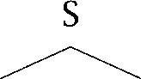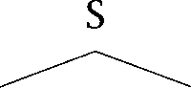Suppose we have a corpus of two sentences, as in (12.28): (12.28) a. b.

NP VP NP VP

***Sue*** V NP ***Kay*** V NP

   

***saw Jo heard Jim***

Then, to parse a new sentence like ***Sue heard Jim, we*** could do it by putting together tree fragments that we have already seen. For example we can compose these two tree fragments:

(12.29) a. S

NP VP

I

***Sue***

b. VP

V NP

I I

***heard Jim***

We can work out the probability of each tree fragment in the corpus, given that one is expanding a certain node, and, assuming independence, we can multiply these probabilities together (for instance, there are 8

(12.30)



**SIMULATION**

(12.31)

fragments with VP as the parent node fragments must include either all or none of the children of a node among which  occurs once, so its probability is  But that is only one derivation of this parse tree. In general there are many. Here is another one from our corpus, this time involving the composition of three tree fragments:

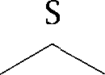a. b. V c. NP NP VP ***heard Jim***

***Sue*** V NP

Since there are multiple fundamentally distinct derivations of a single tree in this DOP model, here we have an example of a grammar where the highest probability parse cannot be found efficiently by a Viterbi algo- rithm (Sima Dn 1996) see exercise 12.8. Parsing has therefore been done using ***Carlo*** methods. This is a technique whereby the probability of an event is estimated by taking random samples. One ran- domly produces a large number of derivations and uses these to estimate the most probable parse. With a large enough sample, these estimates can be made as accurate as desired, but the parsing process becomes slow.

The DOP approach is in some ways similar to the memory-based learn- ing (MBL) approach (Zavrel and Daelemans 1997) in doing prediction di- rectly from a corpus, but differs in that whereas the MBL approach pre- dicts based on a few similar exemplars, the DOP model uses statistics over the entire corpus.

The DOP model provides a different way of thinking, but it is important to realize that it is not ***that*** different to what we have been doing with PCFGs. After all, rather than writing grammar rules like S NP VP and VP V NP, we could instead write tree fragments:

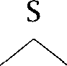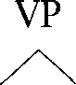

NP VP V NP

And the probabilities that we estimate for grammar rules from a

bank are exactly the same as would be assigned based on their relative frequency in the on the DOP model.

The difference between PCFGs and what we have here is that rather than only having local trees of depth 1, we can have bigger tree 

PROBABILISTIC TREE ments. The model can be formalized as a *Probabilistic Tree Substitution* SUBSTITUTION **Grammar** which has five components just like the definition of GRAMMAR a in chapter 11. However, rather than a set of rules, we have a set

of tree fragments of arbitrary depth whose top and interior nodes are nonterminals and whose leaf nodes are terminals or nonterminals, and the probability function assigns probabilities to these fragments.

are thus a generalization of and are stochastically more powerful, because one can give particular probabilities to fragments or just whole parses which cannot be generated as a multiplication of rule probabil- ities in a PCFG. Bod (1995) shows that by starting with a PCFG model of depth 1 fragments and then progressively allowing in larger fragments parsing accuracy does increase significantly (this mirrors the result of Johnson (1998) on the utility of context from higher nodes in the tree). So the DOP model provides another way to build probabilistic models that use more conditioning context.

* + 1. **Lexicalized models using derivational histories History-based grammars**

Probabilistic methods based on the history of the derivation, and in- cluding a rich supply of lexical and other information, were first ex- plored in large scale experiments at IBM, and are reported in (Black et al. 1993). This work exploited a one-to-one correspondence between left- most derivations and parse trees, to avoid summing over possible deriva- tions. The general idea was that all prior parse decisions could influence following parse decisions in the derivation, however, in the 1993 model, the only conditioning features considered were those on a path from the node currently being expanded to the root of the derivation, along with what number child of the parent a node is (from left to Black et al. (1993) used decision trees to decide which features in the



tional history were important in determining the expansion of the current node. We will cover decision trees in section 16.1, but they can be thought of just as a tool that divides up the history into highly predictive equiva- lence classes.



1. Simply using a feature of being the child of the parent seems linguistically some- what unpromising, since who knows what material may be in the other children, but this gives some handle on the varying distribution shown in table 12.4.



***12.2 Some Approaches***

Unlike most other work, this work used a custom treebank, produced by the University of Lancaster. In the 1993 experiments, they restricted themselves to sentences completely covered by the most frequent 3000 words in the corpus (which effectively avoids many sparse data issues).

Black et al. began with an existing hand-built broad-coverage

based unification grammar. This was converted into a PCFG by making equivalence classes out of certain labels (by ignoring or grouping certain features and feature-value pairs). This PCFG was then reestimated using a version of the Inside-Outside algorithm that prevents bracket crossing, as in the work of Pereira and Schabes (1992) discussed above.

Black et al. lexicalize their grammar so that phrasal nodes inherit two words, a lexical head  and a secondary head  The lexical head is the familiar syntactic head of the phrase, while the secondary head is another word that is deemed useful (for instance, in a prepositional phrase, the lexical head is the preposition, while the secondary head is the head of the complement noun phrase). Further, they define a set of about 50 each of syntactic and semantic categories,  and  to be used to classify non-terminal nodes. In the HBG parser, these two features, the two lexical heads, and the rule ***R*** to be applied at a node are predicted based on the same features of the parent node, and the index expressing what number child of the parent node is being expanded. That is, we wish to calculate:



This joint probability is decomposed via the chain rule and each of the features is estimated individually using decision trees.

The idea guiding the IBM work was that rather than having a lin- guist tinker with a grammar to improve parsing preferences, the linguist should instead just produce a parser that is capable of parsing all sen- tences. One then gets a statistical parser to learn from the information in a so that it can predict the correct parse by conditioning parsing steps on the derivation history. The HBG parser was tested on sentences of 7-l 7 words, by comparing its performance to the existing

based parser. The unification-based parser chose the correct parse for sentences about 60% of the time, while the HBG parser found the correct parse about 75% of the time, so the statistical parser was successful in producing a 37% reduction in error over the best disambiguation rules that the IBM linguist had produced by hand.

(12.32)

**SPATTER**

The HBG work was based on a language model, but work at IB M then started experimenting with building a parsing model directly. The early work reported in Jelinek et al. (1994) was developed as the SPATTER model in  (1994,  which we briefly review here.

SPATTER also works by determining probabilities over derivations, but it works in a bottom-up fashion, by starting with the words and build- ing structure over them. Decision tree models are again used to pick out features of the derivational history that are predictive for a certain parsing decision. SPATTER began the trend of decomposing local phrase structure trees into individual parsing decisions, but rather than using a variant of dependency grammar, as in most other work, it used a some- what odd technique of predicting which way the branch above a node pointed.

In SPATTER, a parse tree is encoded in terms of  part of speech tugs, non-terminal ***labels,*** and extensions, which encode the tree shape. Tagging was done as part of the parsing process. Since the grammar is fully lexicalized, the word and tag of the head child is always carried up to non-terminal nodes. If we start with some words and want to predict the they form, things look something like this:

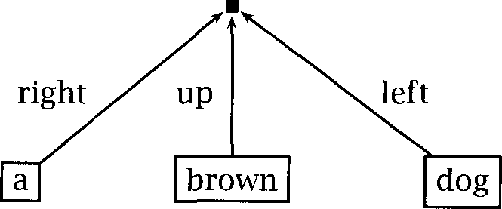

A node predicts an extension which expresses the type of the line above it connecting it to the parent node. There are five extensions: for

with two or more branches, right is assigned to the leftmost child, left is assigned to the rightmost child, and up is assigned to any children in between, while unary is assigned to an Rnly child and root is assigned to the root node of the tree. (Note that right and left are thus switched!)

These features, including the POS tags of the words, are predicted by decision-tree models. For one node, features are predicted in terms of features of surrounding and lower nodes, where these features have ready been determined. The models use the following questions (where X is one of the four features mentioned above):

* What is the X at the {current node/node  to the {left/right]]?
* What is the X at the current node V {first/second} {left/right}-most child?
* How many children does the node have? What is the span of the node in words?

[For tags:] What are the two previous POS tags?

The parser was allowed to explore different derivation sequences, so it could start working where the best predictive information was avail- able (although in practice possible derivational orders were greatly con- strained). The probability of a parse was found by summing over deriva- tions.

Some features of SPATTER, such as the extensions feature, were rather weird, and overall the result was a large and complex system that re- quired a great deal of computer power to train and run (the decision tree training and smoothing algorithms were particularly computationally in- tensive). But there was no doubting its success. SPATTER showed that one could automatically induce from data a successful statisti- cal parser which clearly outperformed any existing hand-crafted parser in its ability to handle naturally occurring text.

* + 1. Dependency-based models

**Collins (1996)**

More recently Collins (1996; 1997) has produced probabilistic parsing models from data that are simpler, more intuitive, and more quickly computable than those explored in the preceding subsection, but which perform as well or better.

Collins (1996) introduces a lexicalized generally Dependency

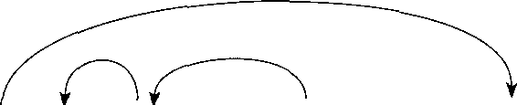like framework, except that units in the Penn are treated as chunks (using chunks in parsing in this way is reminiscent of the approach of Abney (1991)). The original model was again a parsing model. A sentence was represented as a bag of its and other words  with dependencies (D) between them:

(12.33) [The woman] in [the next row] yawned.

***4.52 12 Probabilistic Parsing***

Then:

 =  =  x 

Tagging was an independent process, and was performed by the max- imum entropy tagger of Ratnaparkhi (1996). The probability estimate for uses the idea of Church (1988) for identifying (see sec- tion 10.6.2). Each gap  between words is classified as either the start or end of an NP, between two or none of the above. Then the probability of a of length starting at is given in terms of the predicted gap features as:



***u+m***



(12.34)

where represents whether there is a Fomma between the words or not. Deleted interpolation is used to smooth this probability.

For the dependency model, Collins replaced each with its head word and removed punctuation to give a reduced sentence. But punc- tuation is used to guide parsing. Part of what is clever about Collins’ approach is that he works directly with the phrase structures of the Penn Treebank, but derives a notation for dependencies automatically from them. Dependencies are named based on the head and two child con- stituents. So if one has a as in (12.341, the dependency between the PP and verb is labeled

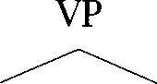

VBD PP



***lived in a shoe***

In other words, the dependency names are derived from purely  labels, but end up capturing much of the functional information that one would like to use in a parser. Nevertheless, the system does still have a few limitations for instance, these dependency labels do not capture the difference between the two objects of a ditransitive verb.

Each dependency is assumed to be independent a somewhat unre- alistic assumption. Then, each word apart from the main predicate of the sentence will be dependent on some head via a dependency

relationship Thus can be written as a set of dependencies and we have that:

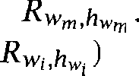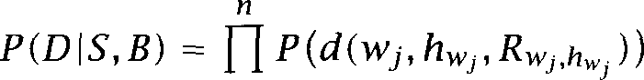

Collins calculates the probability that two word-tag pairs and appear in the same reduced sentence with relationship *R* within

the Penn in the obvious way. He counts up how common one relationship is compared to the space of all relationships:







***J***

And then he normalizes this quantity to give a probability.

This model was then complicated by adding conditioning based on the Gistance over which the dependency stretched, where distance was eval- uated by an ad hoc function that included not only the distance, but direction, whether there was an intervening verb, and how many inter- vening commas there were.

The parser used a beam search with various pruning heuristics for efficiency. The whole system can be trained in 15 minutes, and runs quickly, performing well even when a quite small beam is used. Collins’ parser slightly outperforms **SPATTER ,** but the main advance seems to be in building a much simpler and faster system that performs basically as well. Collins also evaluates his system both using and not using lexi- cal information and suggests that lexical information gives about a 10% improvement on labeled precision and recall. The odd thing about this result is that the unlexicalized version ends up performing rather worse than Charniak V **PCFG** parser. One might hypothesize that while splitting up local into independent dependencies is useful for avoiding data sparseness when dealing with a lexicalized model, it nevertheless means that one doesn W capture some (statistical) dependencies which are being profitably used in the basic **PCFG** model.

**A lexicalized dependency-based language model**

Collins (1997) redevelops the work of Collins (1996) as a generative lan- guage model (whereas the original had been a probabilistically deficient parsing model). He builds a sequence of progressively more complex

models, at each stage getting somewhat improved performance. The gen- eral approach of the language model is to start with a parent node and a head and then to model the successive generation of dependents on both the left and right side of the head. In the first model, the probability of each dependent is basically independent of other dependents (it depends on the parent and head nodes category, the head lexical item, and a fi- nal composite feature that is a function of distance, intervening words, and punctuation). Dependents continue to be generated until a special pseudo-nonterminal STOP is generated.

Collins then tries to build more complex models that do capture some of the (statistical) dependencies between different dependents of a head. What is of particular interest is that the models start bringing in a lot of traditional linguistics. The second model makes use of the ar- gument/adjunct distinction and models the subcategorization frames of heads. A subcategorization frame is predicted for each head, and the generation of dependents is additionally conditioned on the bag of subcategorized arguments predicted that have not yet been generated. A problem caused by trying to model subcategorization is that various subcategorized arguments may not be overtly present in their normal place, due to processes like the implicit object alternation (section 8.4) or In the final model Collins attempts to incorporate movement into the probabilistic model, through the use of traces and coindexed fillers (which are present in the Penn treebank). While the second model performs considerably better than the first, this final com- plication is not shown to give significantly better performance).

* + 1. Discussion

Some overall parsing performance figures for some roughly comparable systems are shown in table 12.6. At the time of writing, Collins results are the best for a broad coverage statistical parser. It remains an open research problem to see whether one can weld useful elements of the IBM work (such as using held out data to estimate model parameters, the use

1. All these systems were trained on the Penn Treebank, and tested on an unseen test set of sentences of 2-40 words, also from the Penn Treebank. However, various details of the treatment of punctuation, choosing to ignore certain non-terminal distinctions, etc., nevertheless mean that the results are usually not exactly comparable. The results for SPATTER are the results Collins (1996) gives for running SPATTER on the same test set as his own parsers, and differ slightly from the results reported in (Magerman 1995).

Sentences of 40 words

|  |  |  |  |  |  |
| --- | --- | --- | --- | --- | --- |
| %LR | | %LP | CB | %0 |  |
| Charniak (1996) PCFG 80.4 | | 78.8 | n/a |  | n/a |
| (1995) SPATTER | 84.6 | 84.9 | 1.26 | 56.6 | |
| Collins (1996) best | 85.8 | 86.3 | 1.14 | 59.9 | |
| Charniak (1997a) best | 87.5 | 87.4 | 1.00 | 62.1 | |
| Collins (1997) best | 88.1 | 88.6 | 0.91 | 66.5 | |

Table 12.6 Comparison of some statistical parsing systems. LR = labeled recall, LP = labeled precision, CB = crossing brackets, n/a means that a result is not given (Charniak (1996) gives a result of 87.7% for non-crossing accuracy).

of decision trees, and more sophisticated deleted estimation techniques) with the key ideas of Collins work to produce even better parsers. Addi- tionally, we note that there are several other systems with almost as good performance, which use quite different parsing techniques, and so there still seems plenty of room for further investigation of other techniques. For instance, Charniak (1997a) uses probability estimates for conven- tional grammar rules (suitably lexicalized). The rule by which to expand a node is predicted based on the the node V category, its parent V cate- gory, and its lexical head. The head of each child is then predicted based on the child V category and the parent node V category and lexical head. Charniak provides a particularly insightful analysis of the differences in the conditioning used in several recent state-of-the-art statistical parsers and of what are probably the main determinants of better and worse performance.

Just as in tagging, the availability of rich lexical resources (principally, the Penn treebank) and the use of statistical techniques brought new lev- els of parsing performance. However, we note that recent incremental progress, while significant, has been reasonably modest. As Charniak (1997a: 601) points out:

This seems to suggest that if our goal is to get, say, 95% average labeled precision and recall, further incremental improvements on this basic scheme may not get us there.

Qualitative breakthroughs may well require semantically richer lexical re- sources and probabilistic models.

#### 12.3 Further Reading

A variety of work on grammar induction can be found in the biennial proceedings of the International Colloquium on Grammar Inference  rasco and Oncina 1994; and de la Higuera 1996; Honavar and

1998).

The current generation of work on probabilistic parsing of unrestricted text emerged within the DARPA Speech and Natural Language community. Commonly cited early papers include (Chitrao and Grishman 1990) and (Magerman and Marcus 1991). In particular,  and Marcus make early reference to the varying structural properties of in different positions.

Another thread of early work on statistical parsing occurred at the Uni- versity of Lancaster. (1987) and Garside and Leech (1987) describe a constituent boundary finder that is similar to the NP finding of (Church 1988). A PCFG trained on a small is then used to choose between possible constituents. Some discussion of the possibilities of using sim- ulated annealing also appears. They suggest that their system could find an Dcceptable parse about 50% of the time.

Another important arena of work on statistical parsing is work within the pattern recognition community, an area pioneered by King-Sun Fu. See in particular (Fu 1974).

An approachable introduction to statistical parsing including  speech tagging appears in (Charniak  The design of the Penn

bank is discussed in (Marcus et al. 1993) and (Marcus et al. 1994). It is available from the Linguistic Data Consortium.

MEASURES The original can be found in (Black et al. 1991) or (Harrison et al. 1991). A study of various parsing evaluation metrics, their relationships, and appropriate parsing algorithms for different objective functions can be found in (Goodman 1996).



DEPENDENCY The ideas of dependency grammar stretch back into the work of

GRAMMAR dieval Arab grammarians, but received a clear formal statement in the work of (1959). Perhaps the earliest work on probabilistic de- pendency grammars was the Probabilistic Link Grammar model of Laf- ferty et al. (1992). Except for one particular quirky property where a word can be bi-linked in both directions, link grammar can be thought of as a notational variant of dependency grammar. Other work on  based statistical parsers includes Carroll and Charniak (1992).

We have discussed only a few papers from the current flurry of work

* 1. *Further Reading 457*

**T REE- ADJOINING**

**GR AMMARS**

**TR ANSFORMATION -**

**BASED LEARNING**



**SEMANTIC PARSING**

on statistical parsing. Systems with very similar performance to (Collins  but very different grammar models, are presented by Charniak (1997a) and Ratnaparkhi (1997a). See also (Eisner 1996) for another re- cent approach to dependency-based statistical parsers, quite similar to (Collins 1997).

Most of the work here represents probabilistic parsing with a

free base. There has been some work on probabilistic versions of more powerful grammatical frameworks. Probabilistic *(Tree-Adjoining Grammars)* are discussed by Resnik (1992) and Schabes (1992). Early work on probabilistic versions of unification grammars like Head-driven Phrase Structure Grammar (Pollard and Sag 1994) and Lexical-Functional Grammar (Kaplan and Bresnan  such as (Brew  used improper distributions, because the dependencies within the unification grammar were not properly accounted for. A firmer footing for such work is pro- vided in the work of Abney (1997). See also (Smith and Cleary 1997). Bod et al. (1996) and Bod and Kaplan (1998) explore a DOP approach to LFG.

*Transformation-based learning* has also been applied to parsing and grammar induction (Brill  Brill and Resnik 1994). See chapter 10 for a general introduction to the transformation-based learning approach.

Hermjakob and Mooney (1997) apply a non-probabilistic parser based on machine learning techniques (decision lists) to the problem of

bank parsing, and achieve quite good results. The main take-home mes- sage for future Statistical NLP research in their work is the value they get from features for semantic classes, whereas most existing Statistical NLP work has tended to overemphasize syntactic features (for the obvi- ous reason that they are what is most easily obtained from the currently available treebanks).

Chelba and Jelinek (1998) provide the first clear demonstration of a probabilistic parser outperforming a  model as a language model for  *recognition.* They use a lexicalized binarized grammar (essen- tially equivalent to a dependency grammar) and predict words based on the two previous heads not yet contained in a bigger constituent.

Most of the exposition in this chapter has treated parsing as an end in itself. Partly because parsers do not perform well enough yet, parsing has rarely been applied to higher-level tasks like speech recognition and language understanding. However, there is growing interest in *semantic parsing,* an approach that attempts to build a meaning representation of a sentence from its syntactic parse in a process that integrates syntactic and semantic processing. See (Ng and Zelle 1997) for a recent overview

article. A system that is statistically trained to process sentences all the way from words to discourse representations for an airline reservation application is described by Miller et al. (1996).

#### 12.4

(12.35)

(12.36)

#### Exercises

Exercise 12.1 

The second sentence in the ***Wall*** article referred to at the start of the chapter is:



The agency sees widespread use of the codes as a way of handling the rapidly growing mail volume and controlling labor costs.

Find at least five well-formed syntactic structures for this sentence. If you cannot do this exercise, you should proceed to exercise 12.2.

Exercise 12.2 

Write a context-free grammar parser, which takes a grammar of rewrite rules, and uses it to find all the parses of a sentence. Use this parser and the grammar in (12.36) to parse the sentence in exercise 12.1. (The format of this grammar is verbose and ugly because it does not use the abbreviatory conventions, such as optionality, commonly used for phrase structure grammars. On the other hand, it is particularly easy to write a parser that handles grammars in this form.) How many parses do you get? (The answer you should get is 83.)

a. S-NPVP

b. 

**C.** VPG VBG NP

d. 

e. 

f. PP-PNP

 

h. N ***agency, use, codes, way, mail, volume, labor,***

i. 

 V sees

k. A ***widespread, growing***

1. ***of; as***

1. ***VBG handling, controlling***

n. ***RB rapidly***

**0 . *CC and***

* 1. Exercises 4.59

While writing the parser, leave provision for attaching probabilities to rules, so that you will be able to use the parser for experiments of the sort discussed later in the chapter.

Exercise 12.3  In chapter 11, we suggested that have a bad bias towards using



nals with few expansions. Suppose that one has as a training corpus the

given below, where Qx indicates how many times a certain tree appears in the training corpus. What PCFG would one get from the (using MLE as dis- cussed in the text)? What is the most likely parse of the string a using that grammar. Is this a reasonable result? Was the problem of bias stated correctly in chapter 1 Discuss.

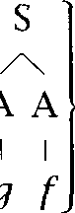



10 x B B, 95xA A, 325 x A A, 8 x  428

*I I I I*

A A

*I*

 *fa*

Exercise 12.4 

Can one combine a leftmost derivation of a with an n-gram model to produce a probabilistically sound language model that uses phrase structure? If so, what kinds of independence assumptions does one have to make? (If the approach you work out seems interesting, you could try implementing it!)

Exercise 12.5 

While a PLCG can have different probabilities for a certain expansion of NP in subject position and object position, we noted in a footnote that a PLCG could not capture the different distributions of as first and second objects of a verb that were shown in table 12.4. Explain why this is so.

Exercise 12.6  As shown by Demers  left-corner parsers, top-down parsers and

up parsers can all be fit within a large family of Generalized Left-Corner Parsers whose behavior depends on how much of the input they have looked at before undertaking various actions. This suggests other possible probabilistic models implementing other points in this space. Are there other particularly useful points in this space? What are appropriate probabilistic models for them?

Exercise 12.7 

In section 12.2.1 we pointed out that a non-lexicalized parser will always choose the same attachment in the same structural configuration. However, thinking about the issue of PP attachment discussed in section 8.3, that does not quite mean that it must always choose noun attachments or always choose verb at- tachments for Why not? Investigate in a corpus whether there is any utility in being able to distinguish the cases that a PCFG can distinguish.

Exercise 12.8 

The aim of this exercise is to appreciate why one cannot build a Viterbi algorithm for DOP parsing. For PCFG parsing, if we have built the two constituents/partial derivations shown in and and  in in then we can discard because any bigger tree built using



will have a lower probability than a tree which is otherwise identical but substitutes  But we cannot do this in the DOP model. Why not? Hint: Suppose that the tree fragment  is in the corpus.

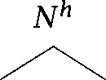(12.37) a.  b.  **C.**

**c *d a***

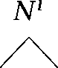

***a***

***a b b c d***

Exercise 12.9 

Build, train, and test your own statistical parser using the Penn treebank. Your results are more likely to be useful to others if you chose some clear hypothesis to explore.

**PART** IV

# Applications and Techniques



**$*lso knowing nothing official about, but having guessed and inferred considerable about, the powerful new mechanized methods in cryptography-methods which I believe succeed even when one does not know what language has been coded-one naturally wonders if the problem of translation could conceivably be treated as a problem in cryptography.***

***When I look at an article in Russian, I say:* 7*his is really written***

***in English, but it has been coded in some strange symbols. I will now proceed to decode.***

***(Weaver 1955: 18, quoting a letter he wrote in 1947)***

**7*he best way of finding out the difficulties of doing something is to try to do it, so at this point I moved to the Artificial Intelligence Laboratory at MIT.. .***

**7*he first great revelation was that the problems are difficult. Of*** course, ***these*** days ***this fact is*** a ***commonplace. But in the 1960s almost no one realized that machine vision was difficult. The field had to go through the same experience as the machine translation field did*** in ***its fiascoes of*** the 1950s before it was at last realized that here were some problems that had to be taken ***seriously.” 1982: 15)***

## Statistical Alignment and Machine Translation

13

M ACHINE TRANSLATION, the automatic translation of text or speech from one language to another, is one the most important applications of NLP. The dream of building machines that let people from different cultures talk to each other easily is one of the most appealing ideas we as NLP researchers can use to justify our profession (and to get money from funding agencies).

Unfortunately, machine translation (MT) is a hard problem. It is true that nowadays you can buy inexpensive packages that call themselves translation programs. They produce low-quality translations which are sufficient for a translator who can post-edit the output or for people who know enough about a foreign language to be able to decipher the original with the help of a buggy translation. The goal of many NLP researchers is instead to produce close to error-free output that reads fluently in the target language. Existing systems are far from this goal for all but the most restricted domains (like weather reports, Isabelle *1987).*

Why is machine translation hard? The best way to answer this question is to look at different approaches to MT that have been pursued. Some important approaches are schematically presented in figure 13.1.

FOR WORD The simplest approach is to translate word for *word* (the bottom ar-

row in figure 13.1). One obvious problem with this is that there is no one-to-one correspondence between words in different languages. Lexical ambiguity is one reason. One of the examples we discussed in chapter 7 is the English word *suit* which has different translations in French, de- pending on whether it means Oawsuit or Vet of garments. One needs to look at context larger than the individual word to choose the correct French translation for ambiguous words like suit.

Another challenge for the word-for-word approach is that languages

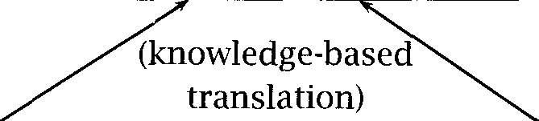464 *3 Statistical Alignment and Machine Translation*

Interlingua

(knowledge representation)

|  |  |  |
| --- | --- | --- |
| English (semantic representation) |  | French  (semantic representation) |
| semantic transfer |

|  |  |  |
| --- | --- | --- |
| English (syntactic parse) |  | French (syntactic parse) |
| syntactic transfer |

English Text (word string)

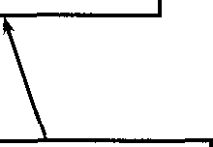

word-for-word

French Text (word string)

**Figure 13.1** Different strategies for Machine Translation. Examples are for the case of translation from English (the source) to French (the target). Word-based methods translate the source word by word. Transfer methods build a tured representation of the source (syntactic or semantic), transform it into a structured representation of the target and generate a target string from representation. Semantic methods use a richer semantic representation than

parse trees with, for example, quantifier scope disambiguated. Interlingua meth- ods translate via a language-independent knowledge representation. Adapted from (Knight 1997: figure

have different word orders. A naive word-for-word translation will us ally get the word order in the target language wrong. This problem

**TIC TRANSFER** addressed by the *transfer approach.* We first parse the so **APPROACH** text, then transform the parse tree of the source text into a syntactic in the target language (using appropriate rules), and then generate

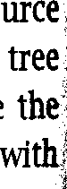

c

translation from this syntactic tree. Note that we are again faced ambiguity, syntactic ambiguity here, since we are assuming that we correctly disambiguate the source text.

The syntactic transfer approach solves problems of word order, but 

*465*

ten a syntactically correct translation has inappropriate semantics. For example, German , like to eat is a verb-adverb construction that translates literally as eat  (or *willingly, with pleasure, gladly).* There is no verb-adverb construction in English that can be used to ex- press the meaning of *like to eat. So* a syntax-based approach cannot work here.



**TRANSFER** In *semantic transfer approaches, we* represent the meaning of the **APPROACH** source sentence (presumably derived via an intermediate step of parsing as indicated by the arrows in figure  and then generate the transla-

tion from the meaning. This will fix cases of syntactic mismatch, but even this is not general enough to work for all cases. The reason is that even if the literal meaning of a translation is correct, it can still be unnatural to the point of being unintelligible. A classic example is the way that En- glish and Spanish express direction and manner of motion  1985). In Spanish, the direction is expressed using the verb and the manner is expressed with a separate phrase:

(13.1) La botella a la cueva flotando.

With some effort, English speakers may be able to understand the literal translation Whe bottle entered the cave floating. But if there are too many such literal translations in a text, then it becomes cumbersome to read. The correct English translation expresses the manner of motion using the verb and the direction using a preposition:

(13.2) The bottle floated into the cave.

An approach that does not rely on literal translations is translation via **INTERLINGUA** an  An interlingua is a knowledge representation formalism that is independent of the way particular languages express meaning.

An interlingua has the added advantage that it efficiently addresses the problem of translating for a large number of languages, as is, for exam- ple, necessary in the European Community. Instead of building  translation systems, for all possible pairs of languages, one only has to build O(n) systems to translate between each language and the

gua. Despite these advantages, there are significant practical problems with interlingua approaches due to the difficulty of designing efficient and comprehensive knowledge representation formalisms and due to the large amount of ambiguity that has to be resolved to translate from a natural language to a knowledge representation language.

Where do statistical methods come into play in this? In theory, each of the arrows in figure 13.1 can be implemented based on a probabilistic model. For example, we can implement the arrow from the box (n- glish Text (word string) to the box (nglish Text (syntactic parse) as a probabilistic parser (see chapters 11 and 12). Some components not shown in the figure could also be implemented statistically, for example, a word sense disambiguator. Such probabilistic implementation of se- lected modules is in fact the main use of statistical methods in machine translation at this point. Most systems are a mix of probabilistic and probabilistic components, However, there are a few completely statistical translation systems and we will describe one such system in section 13.3.

So why do we need a separate chapter on machine translation then, if a large part of the probabilistic work done for MT, such as probabilistic parsing and word sense disambiguation, is already covered in other chap- ters? Apart from a few specific MT problems (like probabilistic transfer, see the Further Reading), there is one task that mainly comes up in the MT context, the task of *text * Text alignment is not part of the translation process per se. Instead, text alignment is mostly used to cre- ate lexical resources such as bilingual dictionaries and parallel grammars, which then improve the quality of machine translation.

Surprisingly, there has been more work on text alignment in Statistical NLP than on machine translation proper, partly due the above-mentioned fact that many other components of MT systems like parsers and ambiguators are not MT-specific. For this reason, the bulk of this chapter will be about text alignment. We will then briefly discuss word alignment, the step necessary after text alignment for deriving a bilingual dictionary from a parallel text. The last two sections describe the best known at- tempt to construct a completely statistical MT system and conclude with some suggestions for further reading.

#### 13.1 Text Alignment

A variety of work has applied Statistical NLP methods to multilingual **PARALLELTEXTS** texts. Most of this work has involved the use of or bitexts **BITEXTS** where the same content is available in several languages, due to doc-



ument translation. The parallel texts most often used have been  **H ANSARDS** mentary proceedings  or other official documents of countries with multiple official languages, such as Canada, Switzerland and Hong

* 1. *Text Alignment 467*

Kong. One reason for using such texts is that they are easy to obtain in quantity, but we suspect that the nature of these texts has also been helpful to Statistical NLP researchers: the demands of accuracy lead the translators of this sort of material to to use very consistent, literal trans- lations. Other sources have been used (such as articles from newspapers and magazines published in several languages), and yet other sources are easily available (religious and literary works are often freely avail- able in many languages), but these not only do not provide such a large supply of text from a consistent period and genre, but they also tend to involve much less literal translation, and hence good results are harder to come by.

Given that parallel texts are available online, a first task is to perform ALIGNMENT gross large scale alignment, noting which paragraphs or sentences in one language correspond to which paragraphs or sentences in another lan-

guage. This problem has been well-studied and a number of quite suc- cessful methods have been proposed. Once this has been achieved, a second problem is to learn which words tend to be translated by which other words, which one could view as the problem of acquiring a bilin- gual dictionary from text. In this section we deal with the text alignment problem, while the next section deals with word alignment and induction of bilingual dictionaries from aligned text.

* + 1. Aligning sentences and paragraphs

Text alignment is an almost obligatory first step for making use of mul- tilingual text corpora. Text alignment can be used not only for the two tasks considered in the following sections (bilingual lexicography and ma- chine translation), but it is also a first step in using multilingual corpora as knowledge sources in other domains, such as for word sense biguation, or multilingual information retrieval. Text alignment can also be a useful practical tool for assisting translators. In many situations, such as when dealing with product manuals, documents are regularly revised and then each time translated into various languages. One can reduce the burden on human translators by first aligning the old and re- vised document to detect changes, then aligning the old document with its translation, and finally splicing in changed sections in the new docu- ment into the translation of the old document, so that a translator only has to translate the changed sections.

The reason that text alignment is not trivial is that translators do not

ways translate one sentence in the input into one sentence in the output, although, naturally, this is the most common situation. Indeed, it is

at the outset of this chapter to realize the extent to which human translators change and rearrange material so the output text will flow well in the target language, even when they are translating material from quite technical domains. As an example, consider the extract from English and French versions of a document shown in figure **13.2.** Although the ma- terial in both languages comprises two sentences, note that their content and organization in the two languages differs greatly. Not only is there a great deal of reordering (denoted imperfectly by bracketed groupings and arrows), but large pieces of material can just disappear: for exam- ple, the final English words achieved ***above-average growth rates.*** In the reordered French version, this content is just implied from the fact that we are talking about how in general sales of soft drinks were higher, in ***particular, cola drinks.***

In the sentence alignment problem one seeks to say that some group of sentences in one language corresponds in content to some group of sentences in the other language, where either group can be empty so as to allow insertions and deletions. Such a grouping is referred to as a

**BEAD** sentence alignment or ***bead.*** There is a question of how much content has to overlap between sentences in the two languages before the sentences are said to be in an alignment. In work which gives a specific criterion, normally an overlapping word or two is not taken as sufficient, but if a clause overlaps, then the sentences are said to be part of the alignment, no matter how much they otherwise differ. The commonest case of one sentence being translated as one sentence is referred to as a sentence alignment. Studies suggest around 90% of alignments are usually of this sort. But sometimes translators break up or join sentences, yielding

or  and even or sentence alignments.

Using this framework, each sentence can occur in only one bead. Thus although in figure 13.2 the whole of the first French sentence is trans- lated in the first English sentence, we cannot make this a alignment, since much of the second French sentence also occurs in the first English sentence. Thus this is an example of a alignment. If we are aligning at the sentence level, whenever translators move part of one sentence into another, we can only describe this by saying that some group of sentences in the source are parallel with some group of sentences in the

translation. An additional problem is that in real texts there are a

**CROSSING DEPENDENCIES**

prising number of cases of ***crossing dependencies,*** where the order of

With ***regard to***



***mineral waters and (the) lemonades *** ***drinks)***

***they*** encounter

***still more users***

Quant

According to

***Indeed***

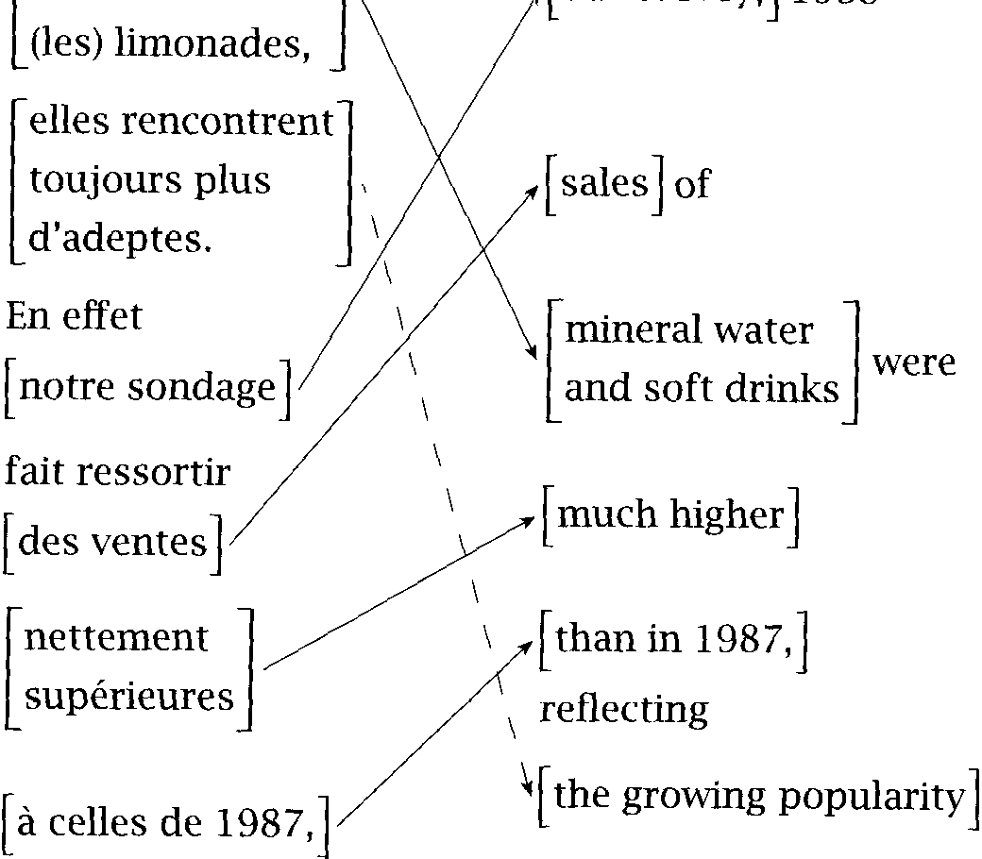

et aux

of these products.

***our survey***

***makes stand*** out

***the sales***

clearly superior

***to those in 1987***

***for cola-based drinks***

drink]

manufacturers

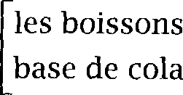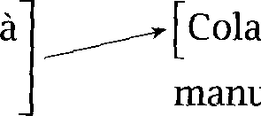

 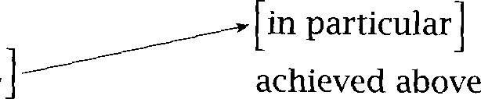

Figure 13.2 and correspondence. The middle and right columns

show the French and English versions with arrows connecting parts that can be viewed as translations of each other. The italicized text in the left column is a fairly literal translation of the French text.

Paper Brown et al.

Gale and Church (1993)

wu (1994)

Church (1993)

Fung and (1994)

Languages Corpus Basis English, French Canadian Hansard # of words

English, French, Union Bank of # of characters German Switzerland reports

English, Cantonese Hong Kong Hansard # of characters

various various (incl. Hansard) 4-gram signals English, Cantonese Hong Kong Hansard lexical signals

Kay and (1993)

Chen (1993)

Haruno and Yamazaki (1996)

English, French, German

English, French English, Japanese

Scientific American lexical (not

probabilistic:

Canadian Hansard lexical

**EEC** proceedings

newspaper, magazines lexical (incl.

dictionary)

Table 13.1 Sentence alignment papers. The table lists different techniques for text alignment, including the languages and corpora that were used as a

and (in column %asis ) the type of information that the alignment is based on.

sentences are changed in the translation (Dan 1998). The algorithms we present here are not able to handle such cases accurately. Following the statistical string matching literature we can distinguish



**ALIGNMENT** tween alignment problems and correspondence problems, by adding the **CORRESPONDENCE** restriction that alignment problems do not allow crossing dependencies. If this restriction is added, then any rearrangement in the order of sen-

tences must also be described as a many to many alignment. Given these restrictions, we find cases of and, in theory at least, even more exotic alignment configurations. Finally, either deliberately or by mistake, sentences may be deleted or added during translation, yielding 1:0 and alignments.



A considerable number of papers have examined aligning sentences in parallel texts between various languages. A selection of papers is shown in table 13.1. In general the methods can be classified along several di- mensions. On the one hand there are methods that are simply  based versus those methods that use lexical (or character string) content. Secondly, there is a contrast between methods that just give an average alignment in terms of what position in one text roughly corresponds with a certain position in the other text and those that align sentences to form

sentence beads. We outline and compare the salient features of some of these methods here. In this discussion let us refer to the parallel texts in the two languages as and where each is a succession of sentences, so

= and = If there are more than two languages, we reduce the problem to the two language case by doing align- ments. Many of the methods we consider use dynamic programming methods to find the best alignment between the texts, so the reader may wish to review an introduction of dynamic programming such as



et al. (1990: ch. 16).

* + 1. **Length-based methods**

Much of the earliest work on sentence alignment used models that just compared the lengths of units of text in the parallel corpora. While it seems strange to ignore the richer information available in the text, it turns out that such an approach can be quite effective, and its efficiency allows rapid alignment of large quantities of text. The rationale of  based methods is that short sentences will be translated as short sen- tences and long sentences as long sentences. Length usually is defined as the number of words or the number of characters.

(13.3)

(13.4)

**Gale and Church (1993)**

Statistical approaches to alignment attempt to find the alignment A with highest probability given the two parallel texts and ***T:***

***=***



***A A***

To estimate the probabilities involved here, most methods decompose the aligned texts into a sequence of aligned beads and sug- gest that the probability of a bead is independent of the probability of other beads, depending only on the sentences in the bead. Then:



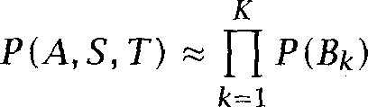

The question then is how to estimate the probability of a certain type of alignment bead (such as or given the sentences in that bead.

The method of Gale and Church (1991; 1993) depends simply on the length of source and translation sentences measured in characters. The

hypothesis is that longer sentences in one language should correspond to longer sentences in the other language. This seems uncontroversial, and turns out to be sufficient information to do alignment, at least with similar languages and literal translations.

The Union Bank of Switzerland (UBS) corpus used for their experiments provided parallel documents in English, French, and German. The texts in the corpus could be trivially aligned at a paragraph level, because para- graph structure was clearly marked in the corpus, and any confusions at this level were checked and eliminated by hand. For the experiments presented, this first step was important, since Gale and Church (1993) report that leaving it out and simply running the algorithm on whole documents tripled the number of errors. However, they suggest that the need for prior paragraph alignment can be avoided by applying the algo- rithm they discuss twice: firstly to align paragraphs within the document, and then again to align sentences within paragraphs. Shemtov (1993) de- velops this idea, producing a variant dynamic programming algorithm that is especially suited to dealing with deletions and insertions at the level of paragraphs instead of just at the sentence level.

Gale and Church V (1993) algorithm uses sentence length to evaluate

how likely an alignment of some number of sentences in is with some number of sentences in  Possible alignments in the study were lim- ited to This made it possible to easily find the most probable text alignment by using a dynamic programming al- gorithm, which tries to find the minimum possible distance between the two texts, or in other words, the best possible alignment. Let  be the lowest cost alignment between sentences and Then one can recursively define and calculate *D(i, j)* by using the obvious base cases that *D * *= 0,* etc., and then defining:



*D(i, j* 1) +  align 0, 

*D(i* 1, align 0)



*=* min *D(i* 1, j 1) cost(l:l align



 1, j 2) align

 *2, j* 1) align



 *2, j 2) + * align



For instance, one can start to calculate the cost of aligning two texts as indicated in figure 13.3. Dynamic programming allows one to ciently consider all possible alignments and find the minimum cost align- ment While the dynamic programming algorithm is quadratic,



 alignment 1  alignment 2

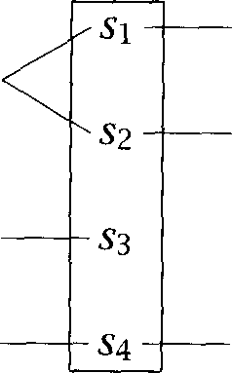

 ,





+



+



Figure 13.3 Calculating the cost of alignments. The costs of two different align- ments are computed, one in the left column (which aligns with and and aligns with and one in the right column (which aligns with the empty sentence).

since it is only run between paragraph anchors, in practice things pro- ceed quickly.

This leaves determining the cost of each type of alignment. This is done based on the length in characters of the sentences of each language in the bead,  and  One assumes that each character in one language gives rise to a random number of characters in the other language. These ran- dom variables are assumed to be independent and identically distributed, and the randomness can then be modeled by a normal distribution with mean and variance  These parameters are estimated from data about the corpus. For the authors compare the length of the respective texts. German/English = 1.1, and French/English = 1.06, so they are content to model as 1. The squares of the differences of the lengths of paragraphs are used to estimate 

The cost above is then determined in terms of a distance measure be- tween a list of sentences in one language and a list in the other. The distance measure compares the difference in the sum of the lengths of the sentences in the two lists to the mean and variance of the whole corpus: = The cost is of the form:



 =



where align is one of the allowed match types etc.). The neg- ative log is used just so one can regard this cost as a Gistance measure: the highest probability alignment will correspond to the shortest Gis- tance and one can just add Gistances.’ The above probability is calcu- lated using Bayes law in terms of align), and therefore



the first term will cause the program to give a higher a priori probability to matches, which are the most common.

So, in essence, we are trying to align beads so that the length of the sentences from the two languages in each bead are as similar as possible. The method performs well (at least on related languages like English, French and German). The basic method has a 4% error rate, and by using a method of detecting dubious alignments Gale and Church are able to produce a best 80% of the corpus on which the error rate is only 0.7%. The method works best on alignments, for which there is only a 2% error rate. Error rates are high for the more difficult alignments; in particular the program never gets a 1:0 or alignment correct.

**Brown et al. (1991c)**

The basic approach of Brown et al.  is similar to Gale and Church, but works by comparing sentence lengths in words rather than charac- ters. Gale and Church (1993) argue that this is not as good because of the greater variance in number of words than number of characters between translations. Among the salient differences between the papers is a dif- ference in goal: Brown et al. did not want to align whole articles, but just produce an aligned subset of the corpus suitable for further research. Thus for higher level section alignment, they used lexical anchors and simply rejected sections that did not align adequately. Using this method on the Canadian Hansard transcripts, they found that sometimes sec- tions appeared in different places in the two languages, and this Ead text could simply be ignored. Other differences in the model used need not overly concern us, but we note that they used the EM algorithm to auto- matically set the various parameters of the model (see section 13.3). They report very good results, at least on alignments, but note that some- times small passages were misaligned because the algorithm ignores the identity of words (just looking at sentence lengths).

wu **(1994)**

Wu (1994) begins by applying the method of Gale and Church (1993) to a corpus of parallel English and Cantonese text from the Hong Kong Hansard. He reports that some of the statistical assumptions underly ing Gale and Church V model are not as clearly met when dealing with these unrelated languages, but nevertheless, outside of certain header

passages, Wu reports results not much worse than those reported by Gale and Church. To improve accuracy, Wu explores using lexical cues, which heads this work in the direction of the lexical methods that we cover in section 13.1.4. Incidentally, it is interesting to note that Wu V 500 sentence test suite includes one each of a and alignments alignments considered too exotic to be generable by most of the methods we discuss, including Wu V.



* + 1. Offset alignment by signal processing techniques

What ties these methods together is that they do not attempt to align beads of sentences but rather just to align position offsets in the two parallel texts so as to show roughly what offset in one text aligns with what offset in the other.

**COGNATES**

**Church (1993)**

Church (1993) argues that while the above length-based methods work well on clean texts, such as the Canadian Hansard, they tend to break down in real world situations when one is dealing with noisy optical char- acter recognition (OCR) output, or files that contain unknown markup conventions. OCR programs can lose paragraph breaks and punctua- tion characters, and floating material (headers, footnotes, tables, etc.) can confuse the linear order of text to be aligned. In such texts, find- ing even paragraph and sentence boundaries can be difficult. Electronic

texts should avoid most of these problems, but may contain unknown markup conventions that need to be treated as noise. Church V approach is to induce an alignment by using cognates. Cognates are words that are similar across languages either due to borrowing or common inheritance from a linguistic ancestor, for instance, French  and English  However, rather than considering cognate words (as in Simard et al. (1992)) or finding lexical correspondences (as in the methods to

which we will turn next), the procedure works by finding cognates at the level of character sequences. The method is dependent on there be- ing an ample supply of identical character sequences between the source and target languages, but Church suggests that this happens not only in languages with many cognates but in almost any language using the Ro- man alphabet, since there are usually many proper names and numbers present. He suggests that the method can even work with non-Roman

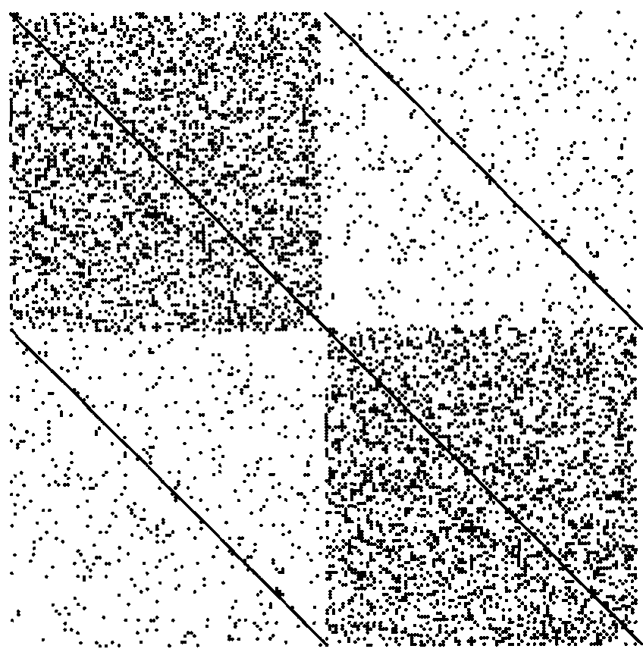

Figure 13.4 A sample dot plot. The source and the translated text are concate- nated. Each coordinate is marked with a dot iff there is a correspondence between position x and position The source text has more random corre- spondences with itself than with the translated text, which explains the darker shade of the upper left and, by analogy, the darker shade of the lower right. The diagonals are black because there is perfect correspondence of each text with itself (the diagonals in the upper left and the lower right), and because of the correspondences between the source text and its translation (diagonals in lower left and upper right).



writing systems, providing they are liberally sprinkled with names and numbers (or computer keywords!).

**DOT-PLOT** The method used is to construct a dot-plot. The source and translated texts are concatenated and then a square graph is made with this text on both axes. A dot is placed at (x,  whenever there is a match between po- sitions x and y in this concatenated text. In Church (1993) the unit that is matched is character 4-grams. Various signal processing techniques are then used to compress the resulting plot. Dot plots have a characteristic look, roughly as shown in figure 13.4. There is a straight diagonal line, since each position (x, x) has a dot. There are then two darker rectangles in the upper left and lower right. (Since the source is more similar to itself, and the translation to itself than each to the other.) But the

information for text alignment is found in the other two, lighter colored quadrants. Either of these matches between the text of the two

**BITEXT MAP** languages, and hence represents what is sometimes called a map. In these quadrants, there are two other, fainter, roughly straight, diago- nal lines. These lines result from the propensity of cognates to appear in the two languages, so that often the same character sequences appear in the source and the translation of a sentence. A heuristic search is then used to find the best path along the diagonal, and this provides an align- ment in terms of offsets in the two texts. The details of the algorithm need not concern us, but in practice various methods are used so as not to calculate the entire  and n-grams are weighted by inverse fre- quency so as to give more importance to when rare n-grams match (with common n-grams simply being ignored). Note that there is no attempt here to align whole sentences as beads, and hence one cannot provide performance figures corresponding to those for most other methods we discuss. Perhaps because of this, the paper offers no quantitative evalua- tion of performance, although it suggests that error rates are Rften very small. Moreover, while this method may often work well in practice, it can never be a fully general solution to the problem of aligning paral- lel texts, since it will fail completely when no or extremely few identical character sequences appear between the text and the translation. This problem can occur when different character sets are used, as with east- ern European or Asian languages (although even in such case there are often numbers and foreign language names that occur on both sides).

**and McKeown (1994)**

Following earlier work in Fung and Church  Fung and McKeown (1994) seek an algorithm that will work:  without having found sen- tence boundaries (as we noted above, punctuation is often lost in OCR),

(ii) in only roughly parallel texts where some sections may have no corre- sponding section in the translation or vice versa, and (iii) with unrelated language pairs. In particular, they wish to apply this technique to a par- allel corpus of English and Cantonese (Chinese). The technique is to infer a small bilingual dictionary that will give points of alignment. For each

**RIVAL VECTOR** word, a *signal* is produced, as an *vector* of integer numbers

**478** *13 Statistical Alignment and Machine Translation*

ing the number of words between each occurrence of the word at  For instance, if a word appears at word offsets (1, 263, 267, 519) then the arrival vector will be (262, 4, 252). These vectors are then compared for English and Cantonese words. If the frequency or position of occur- rence of an English and a Cantonese word differ too greatly it is assumed that they cannot match, otherwise a measure of similarity between the signals is calculated using Dynamic Time Warping a standard dynamic programming algorithm used in speech recognition for aligning signals of potentially different lengths (Rabiner and Juang 1993: sec. 4.7). For all such pairs of an English word and a Cantonese word, a few dozen pairs with very similar signals are retained to give a small bilingual dictionary with which to anchor the text alignment. In a manner similar to Church V dot plots, each occurrence of this pair of words becomes a dot in a graph of the English text versus the Cantonese text, and again one expects to see a stronger signal in a line along the diagonal (producing a figure sim- ilar to figure 13.4). This best match between the texts is again found by a dynamic programming algorithm and gives a rough correspondence in offsets between the two texts. This second phase is thus much like the previous method, but this method has the advantages that it is genuinely language independent, and that it is sensitive to lexical content.

* + 1. Lexical methods of sentence alignment

The previous methods attacked the lack of robustness of the  based methods in the face of noisy and imperfect input, but they do this by abandoning the goal of aligning sentences, and just aligning text offsets. In this section we review a number of methods which still align beads of sentences like the first methods, but are more robust because they use lexical information to guide the alignment process.

Kay and (1993)

The early proposals of Brown et al.  and Gale and Church (1993) make little or no use of the actual lexical content of the sentences. How- ever, it seems that lexical information could give a lot of confirmation of alignments, and be vital in certain cases where a string of similar length

* + - 1. Since Chinese is not written divided into words, being able to do this depends on an earlier text segmentation phase.

sentences appears in two languages (as often happens in reports when there are things like lists). Kay and (1993) thus use a partial alignment of lexical items to induce the sentence alignment. The use of lexical cues also means the method does not require a prior higher level paragraph alignment.

The method involves a process of convergence where a partial align- ment at the word level induces a maximum likelihood alignment at the sentence level, which is used in turn to refine the word level alignment and so on. Word alignment is based on the assumption that two words should correspond if their distributions are the same. The steps are ba- sically as follows:

Assume the first and last sentences of the texts align. These are the initial anchors.

 Then until most sentences are aligned:

**ENVELOPE** 1.

2.

3.

Form an envelope of possible alignments from the Cartesian prod- uct of the list of sentences in the source language and the target language. Alignments are excluded if they cross anchors or their respective distances from an anchor differ too greatly. The differ- ence is allowed to increase as distance from an anchor increases, giving a pillow shape of possible alignments, as in figure 13.5.

Choose pairs of words that tend to co-occur in these potential par- tial alignments. Choose words whose distributions are similar in the sense that most of the sentences in which one appears are alignable with sentences in which the other appears, and which are sufficiently common that alignments are not likely to be due to chance.

Find pairs of source and target sentences which contain many pos- sible lexical correspondences. The most reliable of these pairs are used to induce a set of partial alignments which will be part of the final result. We commit to these alignments, and add them to our list of anchors, and then repeat the steps above.

**SCHEDULE** The accuracy of the approach depends on the annealing schedule. If you accept many pairs as reliable in each iteration, you need fewer it- erations but the results might suffer. Typically, about 5 iterations are needed for satisfactory results. This method does not assume any lim- itations on the types of possible alignments, and is very robust, in that

|  |  |  |  |  |  |  |  |  |  |  |  |  |  |
| --- | --- | --- | --- | --- | --- | --- | --- | --- | --- | --- | --- | --- | --- |
| **1** | **1 1 1 1 1 1 1 1 1 1 2 2**  **2 3 4 5 6 7 8 9 0 1 2 3 4 5 6 7 8 9 0 1** | | | | | | | | | | | | |
| **1**  |  |  |  |  |  |  |  |  |  |  |  |  |  |
| **3** |  | **mwm** |  |  |  |  |  |  |  |  |  |  |  |
| **4** |  |    |  |  |  |  |  |  |  |  |  |  |  |
| **5** |  |   |  |  |  |  |  |  |  |  |  |  |  |
| **6** |  |  |  |  |  |  |  |  |  |  |  |  |  |
| **7** |  |  |  |  |  |  |  |  |  |  |  |  |  |
| 8 |  |  |  |  |  |  |  |  |  |  |  |  |  |
| 9 |  |  |  |  |  |  |  |  |  |  |  |  |  |
| **10** |  |  |  |  |  |  |  |  |  |  |  |  |  |
| **11** |  |  |  |  |  |  |  |  |  |  |  |  |  |
| **12** |  |  |  |  |  |  |  |  |  |  |  |  |   |
| **13** |  |  |  |  |  |  |  |  |  |  |  |  |    |
| **14** |  |  |  |  |  |  |  |  |  |  |  |  | m m 8 m |
| **15** |  |  |  |  |  |  |  |  |  |  |  |  |     |
| **16** |  |  |  |  |  |  |  |  |  |  |  |  |  |
| **17** |  |  |  |  |  |  |  |  |  |  |  |  |  |

**Figure 13.5** The pillow-shaped envelope that is searched. Sentences in the text are shown on the vertical axis  sentences in the  text are shown on the horizontal axis (1-21). There is already an anchor between the begin- ning of both texts, and between sentences  A indicates that the two corresponding sentences are in the set of alignments that are considered in the current iteration of the algorithm. Based on (Kay and Roscheisen 1993: figure 3).



Ead sentences just will not have any match in the final alignment. Re- sults are again good. On Scientific American articles, Kay and Roscheisen (1993) achieved 96% coverage after four passes, and attributed the re- mainder to 1:0 and matches. On 1000 Hansard sentences and using 5 passes, there were 7 errors, 5 of which they attribute not to the main algorithm but to the naive sentence boundary detection algorithm that they employed. On the other hand, the method is computationally inten- sive. If one begins with a large text with only the endpoints for anchors, there will be a large envelope to search. Moreover, the use of a  shaped envelope to somewhat constrain the search could cause problems if large sections of the text have been moved around or deleted, as then the correct alignments for certain sentences may lie outside the search envelope.

**Chen (1993)**

**Chen** (1993) does sentence alignment by constructing a simple

word translation model as he goes along. The best alignment is then

the one that maximizes the likelihood of generating the corpus given the translation model. This best alignment is again found by using dynamic programming. Chen argues that whereas previous length-based meth- ods lacked robustness and previous lexical methods were too slow to be practical for large tasks, his method is robust, fast enough to be practical (thanks to using a simple translation model and thresholding methods to improve the search for the best alignment), and more accurate than previous methods.

The model is essentially like that of Gale and Church  except that a translation model is used to estimate the cost of a certain alignment. So, to align two texts and  we divide them into a sequence of sentence beads  each containing zero or more sentences of each language as before, so that the sequence of beads covers the corpus:

 =



Then, assuming independence between sentence beads, the most proba- ble alignment *A =* of the corpus is determined by:



*=*



***A A k=l***

The term P(L) is the probability that one generates an alignment of beads, but Chen effectively ignores this term by suggesting that this dis- tribution is uniform up to some suitably high  greater than the number of sentences in the corpus, and zero thereafter.

The task then is to determine a translation model that gives a more accurate probability estimate, and hence cost for a certain bead than a model based only on the length of the respective sentences. Chen argues that for reasons of simplicity and efficiency one should stick to a fairly simple translation model. The model used ignores issues of word order, and the possibility of a word corresponding to more than one word in

**WORD BEADS** the translation. It makes use of word beads, and these are restricted to and word beads. The essence of the model is that if a word is commonly translated by another word, then the probability of the corresponding word bead will be high, much higher than the product of the probability of the 1:0 and word beads using the same words. We omit the details of the translation model here, since it is a close relative of the model introduced in section 13.3. For the probability of an alignment, the program does not sum over possible word beadings derived from the sentences in the bead, but just takes the best one. Indeed, it does not



even necessarily find the best one since it does a greedy search for the best word beading: the program starts with a 1:0 and beading of the putative alignment, and greedily replaces a 1:0 and a bead with the bead that produces the biggest improvement in the probability of the

alignment until no further improvement can be gained.

The parameters of Chen V model are estimated by a Viterbi version of the EM  The model is bootstrapped from a small corpus of 100 sentence pairs that have been manually aligned. It then reesti- mates parameters using an incremental version of the EM algorithm on an (unannotated) chunk of 20,000 corresponding sentences from each language. The model then finally aligns the corpora using a single pass through the data. The method of finding the best total alignment uses dynamic programming as in Gale and Church (1993). However,

olding is used for speed reasons (to give a linear search rather than the quadratic performance of dynamic programming): a beam search is used and only partial prefix alignments that are almost as good as the best partial alignment are maintained in the beam. This technique for limit- ing search is generally very effective, but it causes problems when there are large deletions or insertions in one text (vanilla dynamic program- ming should be much more robust against such events, but see Simard and Plamondon (1996)). However, Chen suggests it is easy to detect large deletions (the probability of all alignments becomes low, and so the beam becomes very wide), and a special procedure is then invoked to search for a clear alignment after the deletion, and the regular alignment process is then restarted from this point.

This method has been used for large scale alignments: several million

sentences each of English and French from both Canadian Hansard and European Economic Community proceedings. Chen has estimated the er- ror rate based on assessment of places where the proposed alignment is different from the results of Brown et al.  He estimates an er- ror rate of 0.4% over the entire text whereas others have either reported higher error rates or similar error rates over only a subset of the text. Fi- nally Chen suggests that most of the errors are apparently due to the terribly-good sentence boundary detection method used, and that further

* + - 1. In the standard EM algorithm, for each data item, one sums over all ways of doing something to get an expectation for a parameter. Sometimes, for computational reasons, people adopt the expedient of just using the probabilities of the best way of doing some- thing for each data item instead. This method is referred to as a Viterbi version of the EM algorithm. It is heuristic, but can be reasonably effective.

improvements in the translation model are unlikely to improve the align- ments, while tending to make the alignment process much slower. We note, however, that the presented work limits matches to



 and  and so it will fail to find the more exotic alignments that do sometimes occur. Extending the model to other alignment types appears straightforward, although we note that in practice Gale and Church had less success in finding unusual alignment types. Chen does not present any results broken down according to the type of alignment involved.

**Haruno and Yamazaki (1996)**

Haruno and Yamazaki (1996) argue that none of the above methods work effectively when trying to align short texts in structurally differ- ent languages. Their proposed method is essentially a variant of Kay and Roscheisen but nevertheless, the paper contains several in- teresting Firstly they suggest that for structurally very different languages like Japanese and English, including function words in lexical matching actually impedes alignment, and so the authors leave all function words out and do lexical matching on content words only. This is achieved by using part of speech taggers to classify words in the two languages. Secondly, if trying to align short texts, there are not enough repeated words for reliable alignment using the techniques Kay and (1993) describe, and so they use an online dictionary to find matching word pairs. Both these techniques mark a move from the knowledge-poor approach that characterized early Statistical NLP work to a knowledge-rich approach. For practical purposes, since knowledge sources like taggers and online dictionaries are widely available, it seems silly to avoid their use purely on ideological grounds. On the other hand, when dealing with more technical texts, Haruno and Yamazaki point out that finding word correspondences in the text is still important using a dictionary is not a substitute for this. Thus, using a combination of methods they are able to achieve quite good results on even short texts between very different languages.



* + - 1. On the other hand some of the details of their method are questionable: use of mutual information to evaluate word matching (see the discussion in section 5.4 adding use of a score to filter the unreliability of mutual information when counts are low is only a partial solution) and the use of an ad hoc scoring function to combine knowledge from the dictionary with corpus statistics.
    1. Summary

The upshot seems to be that if you have clean texts from a controlled translation environment, sentence alignment does not seem that difficult a problem, and there are now many methods that perform well. On the other hand, real world problems and less literal translations, or languages with few cognates and different writing systems can pose considerable problems. Methods that model relationships between lexical items in one way or another are much more general and robust in circumstances of this sort. Both signal processing techniques and whole sentence align- ment techniques are crude approximations to the fine-grained structure of a match between a sentence and its translation (compare, again, the elaborate microstructure of the match shown in figure  but they have somewhat different natures. The choice of which to use should be determined by the languages of interest, the required accuracy, and the intended application of the text alignment.

* + 1. Exercises

Exercise *13.1*

For two languages you know, find an example where the basic assumption of the length-based approach breaks down, that is a short and a long sentence are translations of each other. It is easier to find examples if length is defined as number of words.

Exercise 13.2

Gale and Church (1993) argue that measuring length in number of characters is preferable because the variance in number of words is greater. Do you agree that word-based length is more variable? Why?

Exercise *13.3*

The  figure is actually incorrect: it is not symmetric with respect to the main diagonal. (Verify this!) It should be. Why?

* 1. Word Alignment

**BILINGUAL** A common use of aligned texts is the derivation of bilingual dictionaries

**DICTIONARIES TERMINOLOGY DATABASES**

and terminology databases. This is usually done in two steps. First the text alignment is extended to a word alignment (unless we are dealing with an approach in which word and text alignment are induced simulta- neously). Then some criterion such as frequency is used to select aligned

* 1. ***Word Alignment 485***

pairs for which there is enough evidence to include them in the bilin- gual dictionary. For example, if there is just one instance of the word alignment  ***products*** (an alignment that might be derived from figure  then we will probably not include it in a dictionary (which is the right decision here since ***adeptes*** means Xsers in the context, not Sroducts ).

One approach to word alignment was briefly discussed in section 5.3.3: **ASSOCIATION** word alignment based on measures of association. Association measures such as the  measure used by Church and Gale  are an efficient

way of computing word alignments from a bitext. In many cases, they are sufficient, especially if a high confidence threshold is used. However, association measures can be misled in situations where a word in  fre- quently occurs with more than one word in  This was the example of ***house*** being incorrectly translated as ***communes*** instead of ***chambre*** be- cause, in the Hansard, ***House*** most often occurs with both French words in the phrase ***de Communes.***

Pairs like ***chambre- house*** can be identified if we take into account a

source of information that is ignored by pure association measures: the fact that, on average, a given word is the translation of only one other word in the second language. Of course, this is true for only part of the words in an aligned text, but assuming one-to-one correspondence has been shown to give highly accurate results  1997b). Most algo- rithms that incorporate this type of information are implementations of the EM algorithm or involve a similar back-and-forth between a hypoth- esized dictionary of word correspondences and an alignment of word tokens in the aligned corpus. Examples include Chen (1993) as described in the previous section, Brown et al. (1990) as described in the next sec- tion, Dagan et al.  Kupiec  and Vogel et al. (1996). Most of these approaches involve several iterations of recomputing word cor- respondences from aligned tokens and then recomputing the alignment of tokens based on the improved word correspondences. Other authors address the additional complexity of deriving correspondences between

**PHRASES *phrases*** since in many cases the desired output is a database of

nological expressions, many of which can be quite complex (Wu 1995; Gaussier 1998; Hull 1998). The need for several iterations makes all of these algorithms somewhat less efficient than pure association methods.

As a final remark, we note that future work is likely to make signifi- cant use of the prior knowledge present in existing bilingual dictionaries rather than attempting to derive everything from the aligned text. See

  z

|  |  |  |  |  |  |
| --- | --- | --- | --- | --- | --- |
| Language Model | e | Translation Model | *f* | Decoder  ***=*** argmax,  I |  |
|  |  |  |

 

Figure 13.6 The noisy channel model in machine translation. The Language Model generates an English sentence e. The Translation Model transmits e as the French sentence  The decoder finds the English sentence which is most likely to have given rise to 

Klavans and Tzoukermann (1995) for one example of such an approach.

#### Statistical Machine Translation

NOISY CHANNEL In section 22.4, we introduced the *noisy channel model.* One of its  MODEL cations in NLP is machine translation as shown in figure 13.6. In order to translate from French to English, we set up a noisy channel that receives

as input an English sentence e, transforms it into a French sentence  and sends the French sentence *f* to a decoder. The decoder then deter- mines the English sentence that *f* is most likely to have arisen from (and which is not necessarily identical to e).

We thus have to build three components for translation from French to English: a language model, a translation model, and a decoder. We also have to estimate the parameters of the model, the *probabili- ties.*

**Language model.** The language model gives us the probability *P(e)* of the English sentence. We already know how to build language models based on n-grams (chapter 6) or probabilistic grammars (chapter 11 and chapter  so we just assume here that we have an appropriate language model.

**Translation model.** Here is a simple translation model based on word alignment:

(13.5)  *=*

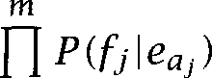

We use the notation of Brown et al. (1993): e is the English sentence; is the length of e in words; *f* is the French sentence; *m* is the length of

word j in *f;* is the position in e that is aligned with; is the



**TRANSLATIO N**word in e that  is aligned with; is the translation probability,



**PROBABILITY** the probability that we will see in the French sentence given that we see in the English sentence; and Z is a normalization constant.

The basic idea of this formula is fairly straightforward. The sums   sum over all possible alignments of French words to En- glish words. The meaning of = 0 for an is that word j in the French

**EMPTY CEPT** sentence is aligned with the *empty* that is, it has no (overt) trans- lation. Note that an English word can be aligned with multiple French words, but that each French word is aligned with at most one English word.

For a particular alignment, we multiply the translation probabilities, assuming independence of the individual translations (see below for how to estimate the translation probabilities). So for example, if we want to compute:

P (Jean *loves *



for the alignment (Jean, John), *loves),* and then we multiply the three corresponding translation probabilities.



x *x *



To summarize, we compute *P * by summing the probabilities of all alignments. For each alignment, we make two (rather drastic) simplifying assumptions: Each French word is generated by exactly one English word (or the empty  and the generation of each French word is indepen- dent of the generation of all other French words in the

Decoder. We saw examples of decoders in section and this one does the same kind of maximization, based on the observation that we can omit *P(f)* from the maximization since *f* is fixed:

= = *=* e



The problem is that the search space is infinite, so we need a heuris- tic search algorithm. One possibility is to use stack search (see sec- tion The basic idea is that we build an English sentence in- crementally. We keep a stack of partial translation hypotheses. At each

4. Going in the other direction, note that one English word can correspond to multiple French words.

point, we extend these hypotheses with a small number of words and alignments and then prune the stack to its previous size by discarding the least likely extended hypotheses. This algorithm is not guaranteed to find the best translation, but can be implemented efficiently.

**Translation probabilities.** The translation probabilities are estimated using the EM algorithm (see section 14.2.2 for a general introduction to EM). We assume that we have a corpus of aligned sentences.

As we discussed in the previous section on word alignment, one way to guess at which words correspond to each other is to compute an associ- ation measure like  But that will generate many spurious correspon- dences because a source word is not penalized for being associated with more than one target word (recall the example



*chamber).*

**CREDIT ASSIGNMENT** The basic idea of the EM algorithm is that it solves the credit *assign- ment* problem. If a word in the source is strongly aligned with a word in the target, then it is not available anymore to be aligned with other words in the target. This avoids cases of double and triple alignment on the one hand, and an excessive number of unaligned words on the other hand.

We start with a random initialization of the translation probabilities In the E step, we compute the expected number of times we



will find in the French sentence given that we have in the English sentence.

**Z =**



where the summation ranges over all pairs of aligned sentences such that the English sentence contains and the French sentence contains (We have simplified slightly here since we ignore cases where words

occur more than once in a sentence.)

The M step reestimates the translation probabilities from these expec- tations:



where the summation ranges over all English words v.

What we have described is a very simple version of the algorithms de- scribed by Brown et al. (1990) and Brown et al. (1993) (see also Kupiec  for a clear statement of EM for alignment). The main part we

have simplified is that, in these models, implausible alignments are pe- nalized. For example, if an English word at the beginning of the English sentence is aligned with a French word at the end of the French sentence,

**DISTORTION** then this *distortion* in the positions of the two aligned words will decrease the probability of the alignment.

**FERTILITY** Similarly, a notion of fertility is introduced for each English word which tells us how many French words it usually generates. In the uncon- strained model, we do not distinguish the case where each French word is generated by a different English word, or at least approximately so (which somehow seems the normal case) from the case where all French words are generated by a single English word. The notion of fertility allows us to capture the tendency of word alignments to be one-to-one and

two in most cases (and one-to-zero is another possibility in this model). For example, the most likely fertility of *farmers* in the corpus that the models were tested on is 2 because it is most often translated as two words: For most English words, the most likely fertility is 1 since they tend to be translated by a single French word.



An evaluation of the model on the aligned Hansard corpus found that only about 48% of French sentences were decoded (or translated) cor- rectly. The errors were either incorrect decodings as in (13.7) or ungram- matical decodings as in (13.8) (Brown et al. 1990: 84).

(13.7) a. **Source sentence.** Permettez que je un example a la chambre.

b. **Correct translation.** Let me give the House one example.

**C. Incorrect decoding.** Let me give an example in the **House.**

(13.8) a. **Source sentence.** Vous avez besoin de toute l Dide disponible.

b. **Correct translation. You** need all the help you can get.

**C. Ungrammatical decoding. You** need of the whole benefits available.

A detailed analysis in (Brown et al. 1990) and (Brown et al. 1993) reveals several problems with the model.

**Fertility is asymmetric. Often** a single French word corresponds to several English words. For example, *to go* is translated as There is no way to capture this generalization in the formalization proposed. The model can get individual sentences with *to go* right by translating

*to* as the empty set and go as  but this is done in an error-prone way on a case by case basis instead of noting the general correspon- dence of the two expressions.

Note that there is an asymmetry here since we can formalize the fact that a single English word corresponds to several French words. This is the example of farmers which has fertility 2 and produces two words

and 

**Independence assumptions.** As so often in Statistical NLP, many inde- pendence assumptions are made in developing the probabilistic model that don W strictly hold. As a result, the model gives an unfair advan- tage to short sentences because, simply put, fewer probabilities are multiplied and therefore the resulting likelihood is a larger number. One can fix this by multiplying the final likelihood with a constant  that increases with the length of the sentence, but a more principled solution would be to develop a more sophisticated model in which in- appropriate independence assumptions need not be made. See Brown et al. (1993:  and also the discussion in section 12.1.11.

**Sensitivity to training data.** Small changes in the model and the training data (e.g., taking the training data from different parts of the Hansard) can cause large changes in the estimates of the parameters. For example, the 1990 model has a translation probability  the) of 0.610, the 1993 model has 0.497 instead (Brown et al. 1993: 286). It does not necessarily follow that such discrepancies would impact translation performance negatively, but they certainly raise questions about how close the training text and the text of application need to be in order to get acceptable results. See section 10.3.2 for a discussion of the effect of divergence between training and application corpora in the case of part-of-speech tagging.

**Efficiency.** Sentences of more than 30 words had to be eliminated from the training set presumably because decoding them took too long (Brown et al. 1993: 282).

On the surface, these are problems of the model, but they are all related to the lack of linguistic knowledge in the model. For example, syntactic analysis would make it possible to relate subparts of the sentence to each other instead of simulating such relations inadequately using the notion of fertility. And a stronger model would make fewer independence

assumptions, make better use of the training data (since a higher bias reduces variance in parameter estimates) and reduce the search space with potential benefits for efficiency in decoding.

Other problems found by Brown et al. (1990) and Brown et al. (1993) show directly that the lack of linguistic knowledge encoded in the system causes many translation failures.

 **No notion of phrases.** The model relates only individual words. As the examples of words with high fertility show, one should really model relationships between phrases, for example, the relationship between to go and and between  and



**. Non-local dependencies.** Non-local dependencies are hard to capture with Oocal models like  (see page 98 in chapter 3). So even if the translation model generates the right set of words, the language model will not assemble them correctly (or will give the re- assembled sentence a low probability) if a long-distance dependency occurs. In later work that builds on the two models we discuss here, sentences are preprocessed to reduce the number of long-distance de- pendencies in order to address this problem (Brown et al.  For example, *is she a mathematician* would be transformed to she *is a mathematician* in a preprocessing step.

**Morphology.** Morphologically related words are treated as separate symbols. For example, the fact that each of the 39 forms of the French verb *diriger* can be translated as to conduct and to *direct* in appropriate contexts has to be learned separately for each form.

**Sparse data problems.** Since parameters are solely estimated from the training corpus without any help from other sources of informa- tion about words, estimates for rare words are unreliable. Sentences with rare words were excluded from the evaluation in (Brown et al. 1990) because of the difficulty of deriving a good characterization of infrequent words automatically.

In summary, the main problem with the noisy channel model that we have described here is that it incorporates very little domain knowledge about natural language. This is an argument that is made in both (Brown et al. 1990) and (Brown et al. 1993). All subsequent work on statisti- cal machine translation (starting with Brown et al. (1992a)) has therefore

on building models that formalize the linguistic regularities in- herent in language.

Non-linguistic models are fairly successful for word alignment as shown by Brown et al. (1993) among others. The research results we have discussed in this section suggest that they fail for machine translation.

Exercise 13.4

The model V task is to find an English sentence given a French input sentence. Why don W we just estimate  and do without a language model? What would happen to ungrammatical French sentences if we relied on  What happens with ungrammatical French sentences in the model described above that relies on  These questions are answered by (Brown et al. 1993: 265).

Exercise 13.5 

Translation and fertility probabilities tell us which words to generate, but not where to put them. Why do the generated words end up in the right places in the decoded sentence, at least most of the time?

Exercise 13.6 

**V ITERBI TRANSLATION** The *Viterbi translation* is defined as the translation resulting from the maximum likelihood alignment. In other words, we don W sum over all possible alignments as in the translation model in equation (13.5). Would you expect there to be significant differences between the Viterbi translation and the best translation according to equation 

Exercise 13.7  Construct a small training example for EM and compute at least two iterations.

Exercise 13.8 

For the purposes of machine translation, n-gram models are reasonable language models for short sentences. However, with increasing sentence length it becomes more likely that there are several (semantically distinct) ways of ordering the words into a grammatical sentence. Find a set of (a) 4 English words, (b) 10 English words that can be turned into two semantically distinct and grammatical sequences.

#### Further Reading

For more background on statistical methods in MT, we recommend the overview article by Knight (1997). Readers interested in efficient decod- ing algorithms (in practice one of the hardest problems in statistical MT) should consult Wu  Wang and Waibel  and et al. (1998). Alshawi et al.  Wang and Waibel  and Wu and Wong

*13.4 Further Reading 493*

(1998) attempt to replace the statistical word-for-word approach with a statistical transfer approach (in the terminology of figure 13.1). An al- gorithm for statistical generation is proposed by Knight and

siloglou (1995).

An Hmpirical approach to MT that is different from the noisy channel **EXAMPLE-BASED** model we have covered here is example-based translation. In  based translation, one translates a sentence by using the closest match in

an aligned corpus as a template. If there is an exact match in the aligned corpus, one can just retrieve the previous translation and be done. Oth- erwise, the previous translation needs to be modified appropriately. See Nagao (1984) and Sato (1992) for descriptions of example-based MT sys- tems.

One purpose of word correspondences is to use them in translating unknown words. However, even with automatic acquisition from aligned corpora, there will still be unknown words in any new text, in particular names. This is a particular problem when translating between languages with different writing systems since one cannot use the unknown string verbatim in the translation of, say, Japanese to English. Knight and Graehl (1997) show how many proper names can be handled by a transliteration system that infers the written form of the name in the target language directly from the written form in the source language. Since the man alphabet is transliterated fairly systematically into character sets like Cyrillic, the original Roman form can often be completely recovered.

Finding word correspondences can be seen as a special case of the more general problem of knowledge acquisition for machine translation. See Knight et al. (1995) for a more high-level view of acquisition in the MT context that goes beyond the specific problems we have discussed here.

Using parallel texts as a knowledge source for word sense  tion is described in Brown et al.  and Gale et al.  (see also section 7.2.2). The example of the use of text alignment as an aid for translators revising product literature is taken from Shemtov (1993). The alignment example at the beginning of the chapter is drawn from an ex- ample text from the UBS data considered by Gale and Church  although they do not discuss the word level alignment. Note that the text in both languages is actually a translation from a German original. A search interface to examples of aligned French and English Canadian Hansard sentences is available on the web; see the

**BEAD** The term bead was introduced by Brown et al.  The notion

**BITEXT** of a is from (Harris and the term *bitext map* comes from

**BITEXTMAP**

 1997a). Further work on signal-processing-based approaches to parallel text alignment appears in  1997a) and (Chang and Chen 1997). A recent evaluation of a number of alignment systems is available on the web (see website). Particularly interesting is the very divergent performance of the systems on different parallel corpora pre- senting different degrees of difficulty in alignment.

## Clustering

**CLUSTERING ALGORITHMS** partition a set of objects into groups or **CLUSTERS clusters.** Figure 14.1 gives an example of a clustering of 22 high-frequency **DENDROGRAM** words from the Brown corpus. The figure is an example of a  a branching diagram where the apparent similarity between nodes at the

bottom is shown by the height of the connection which joins them. Each node in the tree represents a cluster that was created by merging two child nodes. For example, in and **on** form a cluster and so do with and *for.* These two subclusters are then merged into one cluster with four ob- jects. The Keight of the node corresponds to the decreasing similarity of the two clusters that are being merged (or, equivalently, to the order in which the merges were executed). The greatest similarity between any two clusters is the similarity between *in* and on corresponding to the lowest horizontal line in the figure. The least similarity is between *be* and the cluster with the 21 other words corresponding to the highest horizontal line in the figure.

While the objects in the clustering are all distinct as tokens, normally objects are described and clustered using a set of features and values

**DATA** ten known as the model), and multiple objects may



**MODEL** have the same representation in this model, so we will define our

**BAGS** tering algorithms to work over *bags* objects like sets except that they allow multiple identical items. The goal is to place similar objects in the same group and to assign dissimilar objects to different groups.

What is the notion of Vimilarity between words being used here? First, the left and right neighbors of tokens of each word in the Brown cor- pus were tallied. These distributions give a fairly true implementation of Firth V idea that one can categorize a word by the words that occur

around it. But now, rather than looking for distinctive collocations, as in

14 Clustering

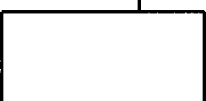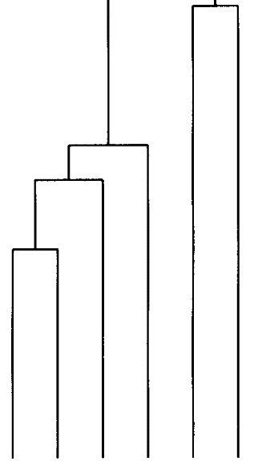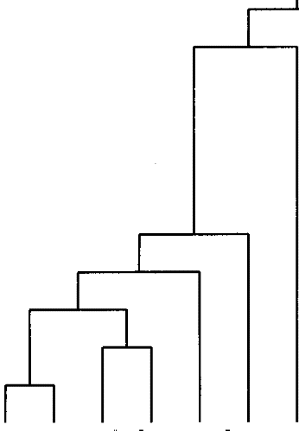

h

**1** 1

be not he I it this the his

and but in on with for at from

to as is was

Figure 14.1 A single-link clustering of 22 frequent English words represented as a dendrogram.

chapter 5, we are capturing and using the whole distributional pattern of the word. Word similarity was then measured as the degree of overlap in the distributions of these neighbors for the two words in question. For example, the similarity between in and on is large because both words oc- cur with similar left and right neighbors (both are prepositions and tend to be followed by articles or other words that begin noun phrases, for instance). The similarity between *is* and *he* is small because they share fewer immediate neighbors due to their different grammatical functions. Initially, each word formed its own cluster, and then at each step in the

clustering, the two clusters that are closest to each other are merged into a new cluster.

There are two main uses for clustering in Statistical NLP. The figure **XPLORATORY DATA** demonstrates the use of clustering for  data analysis  **ANALYSIS** Somebody who does not know English would be able to derive a crude grouping of words into parts of speech from figure 14.1 and this insight

may make subsequent analysis easier. Or we can use the figure to evalu- ate neighbor overlap as a measure of part-of-speech similarity, assuming we know what the correct parts of speech are. The clustering makes apparent both strengths and weaknesses of a neighbor-based represen- tation. It works well for prepositions (which are all grouped together), but seems inappropriate for other words such as this and which are not grouped together with grammatically similar words.

Exploratory data analysis is an important activity in any pursuit that deals with quantitative data. Whenever we are faced with a new problem and want to develop a probabilistic model or just understand the basic characteristics of the phenomenon, is the first step. It is always a mistake to not first spend some time getting a feel for what the data at hand look like. Clustering is a particularly important technique for **in** Statistical NLP because there is often no direct pictorial visualization for linguistic objects. Other fields, in particular those dealing with numeri- cal or geographic data, often have an obvious visualization, for example, maps of the incidence of a particular disease in epidemiology. Any tech- nique that lets one visualize the data better is likely to bring to the fore new generalizations and to stop one from making wrong assumptions about the data.

There are other well-known techniques for displaying a set of objects in a two-dimensional plane (such as pages of books); see section 14.3 for references. When used for clustering is thus only one of a number of techniques that one might employ, but it has the advantage that it can produce a richer hierarchical structure. It may also be more convenient to work with since visual displays are more complex. One has to worry about how to label objects shown on the display, and, in contrast to clus- tering, cannot give a comprehensive description of the object next to its visual representation.

**GENERALIZATION** The other main use of clustering in NLP is for  We re- ferred to this as *forming bins* or equivalence classes in section 6.1. But there we grouped data points in certain predetermined ways, whereas here we induce the bins from data.

*Clustering*

As an example, suppose we want to determine the correct preposition to use with the noun Friday for translating a text from French into En- glish. Suppose also that we have an English training text that contains the phrases on Sunday, on Monday, and on *Thursday,* but not on *Friday.* That *on* is the correct preposition to use with *Friday* can be inferred as follows. If we cluster English nouns into groups with similar syntactic and semantic environments, then the days of the week will end up in the same cluster. This is because they share environments like X *ntil*

day-of-the-week, day-of-the-week, and Gay-of-the-week *morning.”*



Under the assumption that an environment that is correct for one mem- ber of the cluster is also correct for the other members of the cluster, we can infer the correctness of *on Friday* from the presence of *on*

**LEARNING** *day, on Monday* and *on Thursday. So* clustering is a way of  We group objects into clusters and generalize from what we know about some members of the cluster (like the appropriateness of the preposition *on)* to others.

**CLASSIFICATION** Another way of partitioning objects into groups is *classification,* which is the subject of chapter **16.** The difference is that classification is su- *pervised* and requires a set of labeled training instances for each group. Clustering does not require training data and is hence called *unsuper- vised* because there is no Weacher who provides a training set with class labels. The result of clustering only depends on natural divisions in the data, for example the different neighbors of prepositions, articles and pronouns in the above dendrogram, not on any pre-existing categoriza- tion scheme. Clustering is sometimes called automatic or unsupervised classification, but we will not use these terms in order to avoid confusion. There are many different clustering algorithms, but they can be clas-

sified into a few basic types. There are two types of structures

**HIERARCHICAL** by clustering algorithms, *clusterings* and  or

**FLAT NON-HIERARCHICAL**

*hierarchical * Flat clusterings simply consist of a certain

ber of clusters and the relation between clusters is often undetermined.

**ITERATIVE** Most algorithms that produce flat clusterings are *iterative.* They start with a set of initial clusters and improve them by iterating a reallocation operation that reassigns objects.

A hierarchical clustering is a hierarchy with the usual interpretation that each node stands for a subclass of its mother V node. The leaves of the tree are the single objects of the clustered set. Each node represents the cluster that contains all the objects of its descendants. Figure 14.1 is an example of a hierarchical cluster structure.

Another important distinction between clustering algorithms is

**SOFT CLUSTERING** ther they perform a *soft clustering* or *clustering.* In a hard

**IARD CLUSTERING** ment, each object is assigned to one and only one cluster. Soft assign- ments allow degrees of membership and membership in multiple clus- ters. In a probabilistic framework, an object has a probability distribu- tion over clusters where  is the probability that is a member of In a vector space model, degree of membership in multiple clusters can be formalized as the similarity of a vector tc the center of each cluster. In a vector space, the center of the points in a cluster c,

**CENTROID** otherwise known as the centroid or center *of* gravity is the point:

**JTER OF GRAVITY**

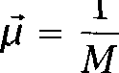

(14.1)

In other words, each component of the centroid vector  is simply the average of the values for that component in the points in c.

In hierarchical clustering, assignment is usually Kard. In non-hierarch-

ical clustering, both types of assignment are common. Even most soft assignment models assume that an object is assigned to only one cluster. The difference from hard clustering is that there is uncertainty about which cluster is the correct one. There are also true multiple assignment

**DISJUNCTIVE** models, so-called *disjunctive clustering* models, in which an object can **CLUSTERING** truly belong to several clusters. For example, there may be a mix of syntactic and semantic categories in word clustering and book would fully

belong to both the semantic Rbject and the syntactic Qoun category.

We will not cover disjunctive clustering models here. See (Saund 1994) for an example of a disjunctive clustering model.

Nevertheless, it is worth mentioning at the beginning the limitations that follow from the assumptions of most clustering algorithms. A hard clustering algorithm has to choose one cluster to which to assign ev- ery item. This is rather unappealing for many problems in NLP. It is a commonplace that many words have more than one part of speech. For instance  can be a noun or a verb, and fast can be an adjective or an adverb. And many larger units also show mixed behavior. Nominalized clauses show some verb-like (clausal) behavior and some noun-like  inalization) behavior. And we suggested in chapter 7 that several senses of a word were often simultaneously activated. Within a hard clustering framework, the best we can do in such cases is to define additional clus- ters corresponding to words that can be either nouns or verbs, and so on. Soft clustering is therefore somewhat more appropriate for many 



Hierarchical clustering:

Preferable for detailed data anal- ysis

Provides more information than flat clustering

No single best algorithm (each of the algorithms we describe has been found to be optimal for some application)

Less efficient than flat clustering (for objects, one minimally has to compute an x matrix of similarity coefficients, and then update this matrix as one pro- ceeds)

14 ***Clustering***

Non-hierarchical clustering:

Preferable if efficiency is a con- sideration or data sets are very large

K-means is the conceptually sim- plest method and should proba- bly be used first on a new **data** set because its results are often sufficient

K-means assumes a simple Eucli- dean representation space, and so cannot be used for many data sets, for example, nominal data like colors

In such cases, the EM algorithm is the method of choice. It can ac- commodate definition of clusters and allocation of objects based on complex probabilistic models.

Table 14.1 A summary of the attributes of different clustering algorithms.

lems in NLP, since a soft clustering algorithm can assign an ambiguous word like  partly to the cluster of verbs and partly to the cluster of nouns.

The remainder of the chapter looks in turn at various hierarchical and non-hierarchical clustering methods, and some of their applications in NLP. In table 14.1, we briefly characterize some of the features of cluster- ing algorithms for the reader who is just looking for a quick solution to an immediate clustering need.

For a discussion of the pros and cons of different clustering algorithms see Kaufman and Rousseeuw (1990). The main notations that we will use in this chapter are summarized in table 14.2.

* 1. **Hierarchical Clustering**

The tree of a hierarchical clustering can be produced either bottom-up, by starting with the individual objects and grouping the most similar

Notation X =



.



m







Meaning

the set of n objects to be clustered

the set of clusters (or cluster hypotheses) (set of subsets) of X

similarity function

group average similarity function Dimensionality of vector space Number of points in cluster

Vector sum of vectors in cluster **Cj** number of word tokens in training corpus tokens ***i*** through of the training corpus function assigning words to clusters number of occurrences of string  number of occurrences of string



 = =



Centroid for cluster

Covariance matrix for cluster **Cj**

Table **14.2** Symbols used in the clustering chapter.

ones, or top-down, whereby one starts with all the objects and divides them into groups so as to maximize within-group similarity. Figure 14.2

**AGGLOMERATIVE** describes the bottom-up algorithm, also called agglomerative clustering. **CLUSTERING** Agglomerative clustering is a greedy algorithm that starts with a separate cluster for each object  In each step, the two most similar clusters

are determined  and merged into a new cluster (9). The algorithm terminates when one large cluster containing all objects of has been formed, which then is the only remaining cluster in C (7).

Let us flag one possibly confusing issue. We have phrased the clus- tering algorithm in terms of similarity between clusters, and therefore we join things with ***maximum*** similarity (8). Sometimes people think in terms of distances between clusters, and then you want to join things that are the minimum distance apart. So it is easy to get confused between whether you Ue taking maximums or minimums. It is straightforward to produce a similarity measure from a distance measure ***d,*** for example by  =  

**VE CLUSTERING** Figure 14.3 describes top-down hierarchical clustering, also called ***divi-***

sive clustering (Jain and Dubes 1988: 57). Like agglomerative clustering

Given: a set X = of objects



**2** a function sim:  x



**3 ** 

**4 := end 5 c:= {Cl,...**



8  := 

9 Cj **U**



**10 U **

**11**

Figure 14.2 Bottom-up hierarchical clustering.

Given: a set X = of objects



**2** a function



a function split: P(X) x P(X)



c:=   

**5 j:=** 1

6 **while** *C* > 1



**7 ** 



**:=**

*j:=*

**8**

**9**

*10*

Figure 14.3 Top-down hierarchical clustering.

it is a greedy algorithm. Starting from a cluster with all objects  each iteration determines which cluster is least coherent (7) and splits this cluster (8). Clusters with similar objects are more coherent than clus- ters with dissimilar objects. For example, a cluster with several identical members is maximally coherent.

Hierarchical clustering only makes sense if the similarity function is

**MONOTONIC** *monotonic:*

(14.2) **Monotonicity.**

**c , c** c ), c )) c u c )



In other words, the operation of merging is guaranteed to not increase similarity. A similarity function that does not obey this condition makes

Function Definition

single link similarity of two most similar members complete link similarity of two least similar members group-average average similarity between members

**Table 14.3** Similarity functions used in clustering. Note that for group-average clustering, we average over all pairs, including pairs from the same cluster. For single-link and complete-link clustering, we quantify over the subset of pairs from different clusters.

the hierarchy uninterpretable since dissimilar clusters, which are placed far apart in the tree, can become similar in subsequent merging so that Floseness in the tree does not correspond to conceptual similarity any- more.

Most hierarchical clustering algorithms follow the schemes outlined in figures 14.2 and 14.3. The following sections discuss specific instances of these algorithms.

* + 1. Single-link and complete-link clustering

Table 14.3 shows three similarity functions that are commonly used in in- formation retrieval (van Rijsbergen 1979: 36ff). Recall that the similarity function determines which clusters are merged in each step in bottom-up clustering. In single-link clustering the similarity between two clusters is the similarity of the two closest objects in the clusters. We search over all pairs of objects that are from the two different clusters and select the pair with the greatest similarity.

COHERENCE Single-link clusterings have clusters with good local coherence since the similarity function is locally defined. However, clusters can be elongated or Vtraggly as shown in figure 14.6. To see why single-link clustering produces such elongated clusters, observe first that the best moves in figure 14.4 are to merge the two top pairs of points and then the two bottom pairs of points, since the similarities a/b, c/d,  and g/h are the largest for any pair of objects. This gives us the clusters in figure 14.5. The next two steps are to first merge the top two clusters, and then the bottom two clusters, since the pairs *b/c* and  are closer than all others that are not in the same cluster (e.g., closer than ***b/f*** and  After doing these two merges we get figure 14.6. We end up with two clusters that



*4*

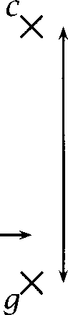

*d***X**

*--*

*--*

*--*

--

*3*

*2*

1



*0* 1 *2 3 4 5 6 7 8*

**Figure 14.4** A cloud of points in a plane.

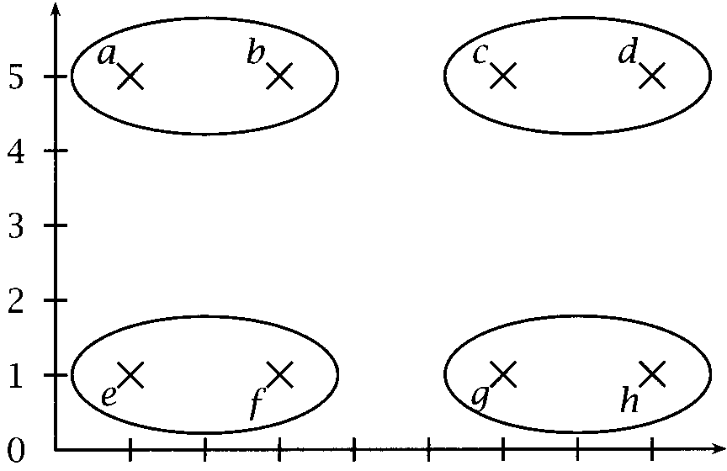

*0* 1 *2 3 4 5 6 7 8*

**Figure 14.5** Intermediate clustering of the points in figure 14.4.

are locally coherent (meaning that close objects are in the same cluster), but which can be regarded as being of bad global quality. An example of bad global quality is that a is much closer to than to *d,* yet and *d are* in the same cluster whereas and e are not.

The tendency of single-link clustering to produce this type of elongated

**CHAINING EFFECT** cluster is sometimes called the *chaining effect* since we follow a chain of large similarities without taking into account the global context.

**MINIMUM SPANNING** Single-link clustering is closely related to the *minimum spanning tree* (MST) of a set of points. The MST is the tree that connects all objects with edges that have the largest similarities. That is, of all trees connecting the set of objects the sum of the length of the edges of the MST is

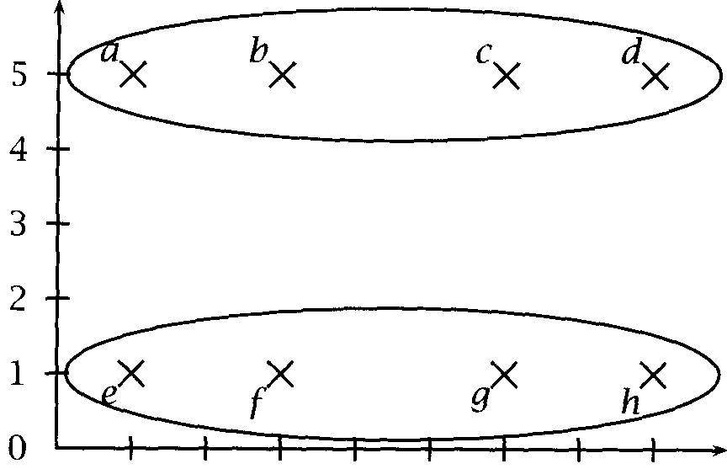

0 1 2 3 4 5 6 7 8

Figure 14.6 Single-link clustering of the points in figure 14.4.

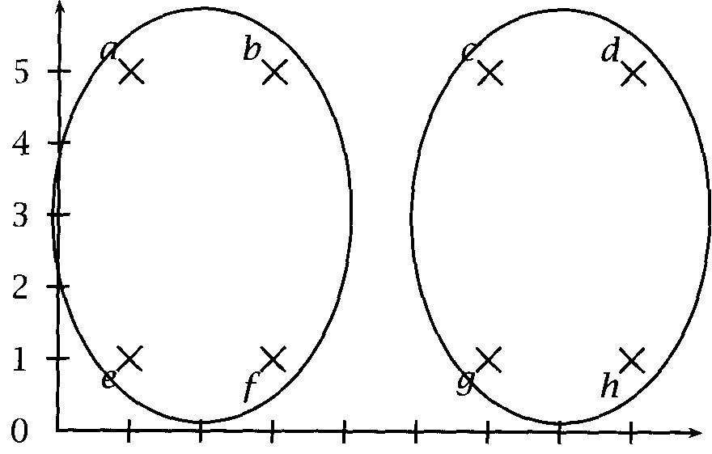

0 1 2 3 4 5 6 7 8

Figure 14.7 Complete-link clustering of the points in figure 14.4.

mal. A single-link hierarchy can be top-down from an MST by removing the longest edge in the MST so that two unconnected compo- nents are created, corresponding to two subclusters. The same operation is then recursively applied to these two subclusters (which are also  Complete-link clustering has a similarity function that focuses on glo- bal cluster quality (as opposed to  coherent clusters as in the case of single-link clustering). The similarity of two clusters is the similarity of their two most dissimilar members. Complete-link clustering avoids elongated clusters. For example, in complete-link clustering the two best merges in figure 14.5 are to merge the two left clusters, and then the

two right clusters, resulting in the clusters in figure 14.7. Here, the min- imally similar pair for the left clusters (a/f or is Wighter than the minimally similar pair of the two top clusters *(u/d).*

*So* far we have made the assumption that Wight clusters are better than Vtraggly clusters. This reflects an intuition that a cluster is a group of objects centered around a central point, and so compact clusters are to be preferred. Such an intuition corresponds to a model like the Gaussian dis- tribution (section  which gives rise to sphere-like clusters. But this

is only one possible underlying model of what a good cluster is. It is really a question of our prior knowledge about and model of the data which de- termines what a good cluster is. For example, the Hawai Lan islands were produced (and are being produced) by a volcanic process which moves along a straight line and creates new volcanoes at more or less regular intervals. Single-link is a very appropriate clustering model here since local coherence is what counts and elongated clusters are what we would expect (say, if we wanted to group several chains of volcanic islands). It is important to remember that the different clustering algorithms that we discuss will generally produce different results which incorporate the somewhat ad hoc biases of the different algorithms. Nevertheless, in most NLP applications, the sphere-shaped clusters of complete-link clus- tering are preferable to the elongated clusters of single-link clustering.

The disadvantage of complete-link clustering is that it has time com-

plexity  since there are merging steps and each step requires  comparisons to find the smallest similarity between any two ob- jects for each cluster pair (where is the number of objects to be  In contrast, single-link clustering has complexity  Once the x similarity matrix for all objects has been computed, it can be updated after each merge in O(n): if clusters and are merged into

= then the similarity of the merge with another cluster is simply the maximum of the two individual similarities:







Each of the 1 merges requires at most constant-time updates. Both merging and similarity computation thus have complexity 

is an instance of %ig Oh notation for algorithmic complexity. We assume that the reader is familiar with it, or else is willing to skip issues of algorithmic complexity. It is defined in most books on algorithms, including  et al. 1990). The notation describes just the basic dependence of an algorithm on certain parameters, while ignoring constant factors.



*1.*

in single-link clustering, which corresponds to an overall complexity of

Single-link and complete-link clustering can be graph-theoretically in- terpreted as finding a maximally connected and maximally complete graph (or clique), respectively, hence the term Fomplete link the latter. See (Jain and Dubes 1988: 64).

* + 1. **Group-average agglomerative clustering**

Group-average agglomerative clustering is a compromise between  link and complete-link clustering. Instead of the greatest similarity be- tween elements of clusters (single-link) or the least similarity (complete link), the criterion for merges is average similarity. We will see presently that average similarity can be computed efficiently in some cases so that the complexity of the algorithm is only  The group-average strat- egy is thus an efficient alternative to complete-link clustering while avoid- ing the elongated and straggly clusters that occur in single-link cluster- ing.

Some care has to be taken in implementing group-average agglomera- tive clustering. The complexity of computing average similarity directly is  So if the average similarities are computed from scratch each time a new group is formed, that is, in each of the merging steps, then the algorithm would be 0 However, if the objects are represented as length-normalized vectors in an m-dimensional real-valued space and if



COSINE the similarity measure is the *cosine,* defined as in (8.401, then we have:



then there exists an algorithm that computes the average similarity of a cluster in constant time from the average similarity of its two children. Given the constant-time for an individual merging operation, the overall time complexity is 0

We write X for the set of objects to be clustered, each represented by a m-dimensional vector:





For a cluster X, the average similarity between vectors in is



*14 Clustering*

defined as follows. (The factor 1) calculates the number of (non-zero) similarities added up in the double summation.)



1



1)

Let C be the set of current clusters. In each iteration, we identify the two clusters and which maximize  u c,). This corresponds to step 8 in figure 14.2. A new, smaller, partition C is then constructed by merging and (step 10 in figure 14.2):

C = (C



For cosine as the similarity measure, the inner maximization can be done in linear time (Cutting et al. 1992: 328). One can compute the av- erage similarity between the elements of a candidate pair of clusters in constant time by  for each cluster the sum of its members



(14.5)

The sum vector  is defined in such a way that:  it can be easily updated after a merge (namely by simply summing the of the clusters that are being merged), and (ii) the average similarity of a cluster can be easily computed from them. This is so because the following relationship between  and  holds:





=





     

Thus, .





Therefore, if  is known for two groups and then the average similarity of their union can be computed in constant time as follows:

 



**+**

**+**

1)

Given this result, this approach to group-average agglomerative clus- tering has complexity  reflecting the fact that initially all  similarities have to be computed. The following step that performs mergers (each in linear time) has linear  that overall com- plexity is quadratic.

This form of group-average agglomerative clustering is efficient enough to deal with a large number of features (corresponding to the dimensions of the vector space) and a large number of objects. Unfortunately, the constant time computation for merging two groups (by making use of the quantities  depends on the properties of vector spaces. There is no general algorithm for group-average clustering that would be efficient independent of the representation of the objects that are to be clustered.

* + 1. An application: Improving a language model

Now that we have introduced some of the best known hierarchical clus- tering algorithms, it is time to look at an example of how clustering can

**ANGUAGE MODEL** be used for an application. The application is building a better language Recall that language models are useful in speech recognition

and machine translation for choosing among several candidate hypothe- ses. For example, a speech  may find that President Kennedy and precedent Kennedy are equally likely to have produced the acous- tic observations. However, a language model can tell us what are ***pri- ori*** likely phrases of English. Here it tell us that ***President Kennedy*** is much more likely than ***precedent Kennedy,*** and so we conclude that Pres- ***ident Kennedy*** is probably what was actually said. This reasoning can be formalized by the equation for the noisy channel model, which we introduced in section 2.2.4. It says that we should choose the hypothe- sis that maximizes the product of the probability given by the language model, P(H), and the conditional probability of observing the speech signal ***D*** (or the foreign language text in machine translation) given the hypothesis, 

 =  = argmax ***= ***



***H H H***

Clustering can play an important role in improving the language model (the computation of ***P(H))*** by way of ***generalization.*** As we saw in chap- ter 6, there are many rare events for which we do not have enough train- ing data for accurate probabilistic modeling. If we mediate probabilistic

inference through clusters, for which we have more evidence in the train- ing set, then our predictions for rare events are likely to be more accurate. This approach was taken by Brown et al. We first describe the formalization of the language model and then the clustering algorithm.

**The language model**

The language model under discussion is a  model that makes a first order Markov assumption that a word depends only on the previous

**CROSS ENTROPY** word. The criterion that we optimize is a decrease in entropy or, **PERPLEXITY** equivalently, *perplexity* (section the amount by which the language model reduces the uncertainty about the next word. Our aim is to find

a function that assigns words to clusters which decreases perplexity compared to a simple word  model.

We first approximate the cross entropy of the corpus =



for the cluster assignment function by making the Markov assumption that a word V occurrence only depends on its predecessor:

(14.7) =

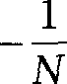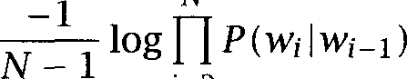

**N**

(14.8)

(14.9)

(14.10)



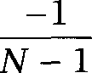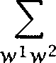



Now we make the basic assumption of cluster-based generalization that the occurrence of a word from cluster only depends on the cluster of the preceding



Formula (14.10) can be simplified as follows:

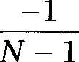

(14.11) **+ **



1. One can observe that this equation is very similar to the probabilistic models used in tagging, which we discuss in chapter 10, except that we induce the word classes from corpus evidence instead of taking them from our linguistic knowledge about parts of speech.



(14.12)

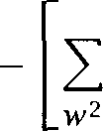

N - l





log

|  |  |  |  |
| --- | --- | --- | --- |
|  | **I** |  |  |
| (14.13) | ***+***  ***W*** | ***log*** |
| (14.14) | = H(w) |  |  |
|  | In (14.13) we rely on the approximations |  | and |

**N-l** which hold for large n. In =

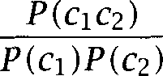



addition,



= holds since  =

Equation (14.14) shows that we can minimize the cross entropy by choosing the cluster assignment function such that the mutual infor- mation between adjacent clusters is maximized. Thus we should get the optimal language model by choosing clusters that maximize this mutual information measure.



(14.15)

**Clustering**

The clustering algorithm is bottom-up with the following merge criterion which maximizes the mutual information between adjacent classes:





In each step, we select the two clusters whose merge causes the smallest loss in mutual information. In the description of bottom-up clustering in figure 14.2, this would correspond to the following selection criterion for the pair of clusters that is to be merged next:



**:=** argmin

The clustering is stopped when a pre-determined number of clusters has been reached  = 1000 in (Brown et al. 1992c)). Several shortcuts are necessary to make the computation of the MI-loss function and the clus- tering of a large vocabulary efficient. In addition, the greedy algorithm

( Go the merge with the smallest MI-loss ) does not guarantee an optimal clustering result. The clusters can be (and were) improved by moving in- dividual words between clusters. The interested reader can look up the specifics of the algorithm in (Brown et al. 1992c).

Here are three of the 1000 clusters found by Brown et al. (1992c): plan, letter, request, memo, case, question, charge, statement, draft day, year, week, month, quarter, half

evaluation, assessment, analysis, understanding, opinion, conversa- tion, discussion

We observe that these clusters are characterized by both syntactic and semantic properties, for example, nouns that refer to time periods.

The perplexity for the cluster-based language model was 277 compared to a perplexity of 244 for a word-based model (Brown et al.



so no direct improvement was achieved by clustering. However, a linear interpolation (see section 6.3.1) between the word-based and the cluster- based model had a perplexity of 236, which is an improvement over the word-based model (Brown et al. 1992c: 476). This example demonstrates the utility of clustering for the purpose of generalization.

We conclude our discussion by pointing out that clustering and cluster- based inference are integrated here. The criterion we optimize on in clustering, the minimization of = is at the same time a measure of the quality of the language model, the ultimate goal of the clustering. Other researchers first induce clusters and then use these clusters for generalization in a second, independent step. An integrated approach to clustering and cluster-based inference is preferable because it guarantees that the induced clusters are optimal for the particular type of generalization that we intend to use the clustering for.



* + 1. Top-down clustering

Hierarchical top down clustering as described in figure 14.3 starts out with one cluster that contains all objects. The algorithm then selects the least coherent cluster in each iteration and splits it. The functions we introduced in table 14.3 for selecting the best pair of clusters to merge in bottom-up clustering can also serve as measures of cluster coherence in top-down clustering. According to the single-link measure, the coher- ence of a cluster is the smallest similarity in the minimum spanning tree

**KULLBACK - LEIBLER**

**DIVERGENCE**

(14.16)

**DISTRIBUTIONAL JOUN CLUSTERING**

for the cluster; according to the complete-link measure, the coherence is the smallest similarity between any two objects in the cluster; and ac- cording to the group-average measure, coherence is the average similarity between objects in the cluster. All three measures can be used to select the least coherent cluster in each iteration of top-down clustering.

Splitting a cluster is also a clustering task, the task of finding two clusters of the cluster. Any clustering algorithm can be used for the splitting operation, including the bottom-up algorithms described above and non-hierarchical clustering. Perhaps because of this recursive need for a second clustering algorithm, top-down clustering is less often used than bottom-up clustering.

However, there are tasks for which top-down clustering is the more nat- ural choice. An example is the clustering of probability distributions us- ing the ***divergence.*** Recall that KL divergence which we introduced in section is defined as follows:



 **=**



This Gissimilarity measure is not defined for p(x) 0 and q(x) = 0. In cases where individual objects have probability distributions with many zeros, one cannot compute the matrix of similarity coefficients for all objects that is required for bottom-up clustering.

An example of such a constellation is the approach to distributional clustering of nouns proposed by (Pereira et al. 1993). Object nouns are represented as probability distributions over verbs, where q,(v) is esti- mated as the relative frequency that, given the object noun n, the verb v is its predicate. So for example, for the noun ***apple*** and the verb ***eat, we*** will have q,(v) = 0.2 if one fifth of all occurrences of ***apple*** as an object noun are with the verb ***eat. Any*** given noun only occurs with a limited number of verbs, so we have the above-mentioned problem with singu- larities in computing KL divergence here, which prevents us from using bottom-up clustering.

To address this problem, ***distributional noun clustering*** instead per- forms top-down clustering. Cluster centroids are computed as (weighted and normalized) sums of the probability distributions of the member nouns. This leads to cluster centroid distributions with few zeros that have a defined KL divergence with all their members. See Pereira et al. (1993) for a complete description of the algorithm.

#### Non-Hierarchical Clustering

Non-hierarchical algorithms often start out with a partition based on ran domly selected seeds (one seed per cluster), and then refine this initial

**REALLOCATING** partition. Most non-hierarchical algorithms employ several passes of allocating objects to the currently best cluster whereas hierarchical algo- rithms need only one pass. However, reallocation of objects from one cluster to another can improve hierarchical clusterings too. We saw an example in section 14.1.3, where after each merge objects were moved around to improve global mutual information.

If the non-hierarchical algorithm has multiple passes, then the ques- tion arises when to stop. This can be determined based on a measure of goodness or cluster quality. We have already seen candidates of such a measure, for example, group-average similarity and mutual informa- tion between adjacent clusters. Probably the most important stopping criterion is the likelihood of the data given the clustering model which we will introduce below. Whichever measure we choose, we simply con- tinue clustering as long as the measure of goodness improves enough in each iteration. We stop when the curve of improvement flattens or when goodness starts decreasing.

The measure of goodness can address another problem: how to deter- mine the right number of clusters. In some cases, we may have some prior knowledge about the right number of clusters (for example, the right number of parts of speech in part-of-speech clustering). If this is not the case, we can cluster the data into clusters for different values of Often the goodness measure improves with *n.* For example, the more clusters the higher the maximum mutual information that can be attained for a given data set. However, if the data naturally fall into a certain number of clusters, then one can often observe a substantial increase in goodness in the transition from 1 to clusters and a small increase in the transition from to 1. In order to automatically deter- mine the number of clusters, we can look for a with this property and then settle on the resulting clusters.



A more principled approach to finding an optimal number of clusters **M INIMUM** is the Minimum *Description Length* (MDL) approach in the *AUTOCLASS* system (Cheeseman et al. 1988). The basic idea is that the measure of

AUTOCLASS goodness captures both how well the objects fit into the clusters (which

is what the other measures we have seen do) and how many clusters there are. A high number of clusters will be penalized, leading to a lower 

value. In the framework of MDL, both the clusters and the objects are specified by code words whose length is measured in bits. The more clusters there are, the fewer bits are necessary to encode the objects. In order to encode an object, we only encode the difference between it and the cluster it belongs to. If there are more clusters, the clusters describe objects better, and we need fewer bits to describe the difference between objects and clusters. However, more clusters obviously take more bits to encode. Since the cost function captures the length of the code for both data and clusters, minimizing this function (which maximizes the goodness of the clustering) will determine both the number of clusters and how to assign objects to 

It may appear that it is an advantage of hierarchical clustering that the number of clusters need not be determined. But the full cluster hierarchy of a set of objects does not define a particular clustering since the tree can be cut in many different ways. For a usable set of clusters in hier- archical clustering one often needs to determine a desirable number of clusters or, alternatively, a value of the similarity measure at which links of the tree are cut. So there is not really a difference between hierarchical and non-hierarchical clustering in this respect. For some non-hierarchical clustering algorithms, an advantage is their speed.

We cover two non-hierarchical clustering algorithms in this section, means and the EM algorithm. K-means clustering is probably the simplest clustering algorithm and, despite its limitations, it works sufficiently well in many applications. The EM algorithm is a general template for a family of algorithms. We describe its incarnation as a clustering algorithm first and then relate it to the various instantiations that have been used in Statistical NLP, some of which like the inside-outside algorithm and the forward-backward algorithm are more fully treated in other chapters of this book.

* + 1. K-means

K -MEANS K-means is a hard clustering algorithm that defines clusters by the cen- ter of mass of their members. We need a set of initial cluster centers in the beginning. Then we go through several iterations of assigning each object to the cluster whose center is closest. After all objects have been assigned, we recompute the center of each cluster as the centroid or *mean*

1. can be downloaded from the internet. See the 

***1*** Given:asetX=



***2*** a distance measure *d : x*



***3*** a function for computing the mean



***4*** Select ***k*** initial centers



***5* while** stopping criterion is not true **do**

***6* for** all clusters **do**



***7 ***  

***8* end**

***9* for** all means  **do**

 



***11***

***12* end**

**end**

**Figure** 14.8 The K-means clustering algorithm.

 of its members (see figure  that is  = The dis- tance function is Euclidean distance.



A variant of K-means is to use the  norm instead (section 



This norm is less sensitive to outliers. K-means clustering in Euclidean space often creates singleton clusters for outliers. Clustering in  space will pay less attention to outliers so that there is higher likelihood of getting a clustering that partitions objects into clusters of similar size.

**MEDOIDS** The norm is often used in conjunction with *medoids* as cluster centers. The difference between medoids and centroids is that a medoid is one of the objects in the cluster a prototypical class member. A centroid, the average of a cluster V members, is in most cases not identical to any of the objects.

The time complexity of K-means is  since both steps of the itera- tion are  and only a constant number of iterations is computed.

Figure 14.9 shows an example of one iteration of the K-means algo- rithm. First, objects are assigned to the cluster whose mean is closest. Then the means are recomputed. In this case, any further iterations will not change the clustering since an assignment to the closest center does not change the cluster membership of any object, which in turn means that no center will be changed in the recomputation step. But this is

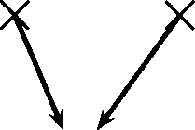

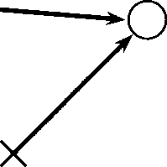

*7 --*

*6 - -*

*6 - -*

*5 --*

0

*5 --*

*4 -- 4 --*

*3 - - x*

*2 --*

*2 --*

0

1 --

*0*

1 --

*X*

II

II

II

II

I

II

II

I

II

I

*I*I

*0* 1 *2 3 4 5 6 0* 1 *2 3 4 5 6*

assignment recomputation of means

Figure 14.9 One iteration of the K-means algorithm. The first step assigns objects to the closest cluster mean. Cluster means are shown as circles. The second step recomputes cluster means as the center of mass of the set of objects that are members of the cluster.

not the case in general. Usually several iterations are required before the algorithm converges.

One implementation problem that the description in figure 14.8 does not address is how to break ties in cases where there are several centers with the same distance from an object. In such cases, one can either assign objects randomly to one of the candidate clusters (which has the disadvantage that the algorithm may not converge) or perturb objects slightly so that their new positions do not give rise to ties.

Here is an example of how to use K-means clustering. Consider these twenty words from the New *York Times* corpus in chapter 5.

Barbara, Edward, Gov, Mary, **NFL,** Reds, Scott, Sox, ballot, finance, inning, payments, polls, profit, quarterback, researchers, science, score, scored, seats

**518 14 *Clustering***

Cluster Members

1 ballot  polls (0.281, (0.301, seats (0.32)

1. profit  finance (0.211, payments (0.22)
2. ***NFL Reds Sox inning quarterback scored score (0.33)***
3. ***researchers science (0.23)***
4. ***Scott Barbara Edward (0.29)***



**Table 14.4** An example of K-means clustering. Twenty words represented as vectors of co-occurrence counts were clustered into 5 clusters using K-means. The distance from the cluster centroid is after each word.

Table 14.4 shows the result of clustering these words using K-means with

= 5. We used the data representation from chapter 8 that is also the basis of table 8.8 on page 302. The first four clusters correspond to the topics Jovernment, Iinance, Vports, and Uesearch, respectively. The last cluster contains names. The benefit of clustering is obvious here. The clustered display of the words makes it easier to understand what types of words occur in the sample and what their relationships are.

Initial cluster centers for K-means are usually picked at random. It de- pends on the structure of the set of objects to be clustered whether the choice of initial centers is important or not. Many sets are well-behaved and most initializations will result in clusterings of about the same qual- ity.

For ill-behaved sets, one can compute good cluster centers by first run- ning a hierarchical clustering algorithm on a subset of the objects. This

**B UCKSHOT** is the basic idea of the ***Buckshot*** algorithm. Buckshot first applies average agglomerative clustering  to a random sample of the data that has size square root of the complete set. GAAC has quadratic time complexity, but since  = applying to this sample results in overall linear complexity of the algorithm. The K-means reassignment step is also linear, so that the overall complexity is 0 

* + 1. **The EM algorithm**

One way to introduce the EM algorithm is as a Voft version of K-means clustering. Figure 14.10 shows an example. As before, we start with a set of random cluster centers, and In K-means clustering we would



0 1 *2 3*

initial state

X X





*2 --*

8

1 --

X X

I I

I

I

I

I

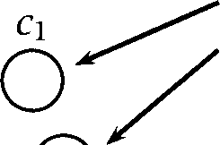

*0* 1 *2 3*

after iteration 1

0 1 *2 3*

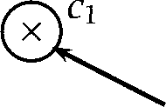

I

, I

I

I

after iteration 2

Figure **14.10** An example of using the EM algorithm for soft clustering.

arrive at the final centers shown on the right side in one iteration. The EM algorithm instead does a soft assignment, which, for example, makes the lower right point mostly a member of but also partly a member of As a result, both cluster centers move towards the centroid of all three objects in the first iteration. Only after the second iteration do we reach the stable final state.

An alternative way of thinking of the EM algorithm is as a way of es- timating the values of the hidden parameters of a model. We have seen some data X, and can estimate the probability of the data according to some model p with parameters But how do we find the model which maximizes the likelihood of the data? This point will be a maximum in the parameter space, and therefore we know that the prob- ability surface will be flat there. So for each model parameter  we want to set .  = 0 and solve for the  Unfortunately this (in gen- eral) gives a non-linear set of equations for which no analytical methods of solution are known. But we can hope to find the maximum using the EM algorithm.



In this section, we will first introduce the EM algorithm for the estima- tion of Gaussian mixtures, the soft clustering algorithm that figure 14.10 is an example of. Then we will describe the EM algorithm in its most general form and relate the general form to specific instances like the inside-outside algorithm and the forward-backward algorithm.

**EM for Gaussian mixtures**

In applying EM to clustering, we view clustering as estimating a mixture of probability distributions. The idea is that the observed data are gener- ated by several underlying causes. Each cause contributes independently to the generation process, but we only see the final mixture without in- formation about which cause contributed what. We formalize this notion

**OBSERVABLE** by representing the data as a pair. There is the data X =  where each  = is simply the vector that corresponds to



**UNOBSERVABLE** the  data point. And then there is the *unobservable* data = 

where within each  = the component is 1 if object *i* is a member of cluster  (that is, it is assumed to be generated by that underlying cause) and 0 otherwise.

We can cluster with the EM algorithm if we know the type of distribu- tion of the individual clusters (or causes). When estimating a Gaussian mixture, we make the assumption that each cluster is a Gaussian. The EM algorithm then determines the most likely estimates for the parameters of the distributions (in our case, the mean and variance of each Gaussian), and the prior probability (or relative prominence or weight) of the indi- vidual causes. So in sum, we are supposing that the data to be clustered consists of *n* m-dimensional objects = generated by Gaussians



Once the mixture has been estimated we can view the result as a clus- tering by interpreting each cause as a cluster. For each object  we can compute the probability that cluster  generated *i. An* object can belong to several clusters, with varying degrees of confidence.



**Multivariate normal distributions.** The (multivariate) m-dimensional

**G AUSSIAN** *Gaussian* family is parameterized by a mean or center and an *m x*



**COVARIANCEMATRIX** invertible positive definite symmetric matrix, the *matrix *

The probability density function for a Gaussian is given by:

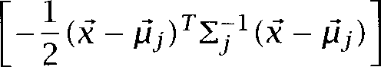(14.17)

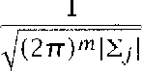

Since we are assuming that the data is generated by we wish to find the maximum likelihood model of the form:



*k*

(14.18)





|  |  |  |  |  |  |  |
| --- | --- | --- | --- | --- | --- | --- |
| Main  cluster | Word | 1 | 2 | 3 | 4 | 5 |
| 1 | ***ballot*** | 0.63 | 0.12 | 0.04 | 0.09 | 0.11 |
| 1 | ***polls*** | 0.58 | 0.11 | 0.06 | 0.10 | 0.14 |
| 1 | ***Gov*** | 0.58 | 0.12 | 0.03 | 0.10 | 0.17 |
| 1 | ***seats*** | 0.55 | 0.14 | 0.08 | 0.08 | 0.15 |
| 2 | profit | 0.11 | 0.59 | 0.02 | 0.14 | 0.15 |
| 2 | finance | 0.15 | 0.55 | 0.01 | 0.13 | 0.16 |
| 2 |  | 0.12 | 0.66 | 0.01 | 0.09 | 0.11 |
| 3 | ***NFL*** | 0.13 | 0.05 | 0.58 | 0.09 | 0.16 |
| 3 | ***Reds*** | 0.05 | 0.01 | 0.86 | 0.02 | 0.06 |
| 3 | ***sox*** | 0.05 | 0.01 | 0.86 | 0.02 | 0.06 |
| 3 | ***inning*** | 0.03 | 0.01 | 0.93 | 0.01 | 0.02 |
| 3 | ***quarterback*** | 0.06 | 0.02 | 0.82 | 0.03 | 0.07 |
| 3 | ***score*** | 0.12 | 0.04 | 0.65 | 0.06 | 0.13 |
| 3 | ***scored*** | 0.08 | 0.03 | 0.79 | 0.03 | 0.07 |
| 4 | ***researchers*** | 0.08 | 0.12 | 0.02 | 0.68 | 0.10 |
| 4 | ***science*** | 0.12 | 0.12 | 0.03 | 0.54 | 0.19 |
| 5 | ***Scott*** | 0.12 | 0.12 | 0.11 | 0.11 | 0.54 |
| 5 |  | 0.10 | 0.10 | 0.05 | 0.15 | 0.59 |
| 5 | Barbara | 0.15 | 0.11 | 0.04 | 0.12 | 0.57 |
|  | Edward | 0.16 | 0.18 | 0.02 | 0.12 | 0.51 |

Table 14.5 An example of a Gaussian mixture. The five cluster centroids from table 14.4 are the means  of the five clusters. A uniform diagonal

matrix = 0.05 and uniform priors = 0.2 were used. The posterior

probabilities can be interpreted as cluster membership probabilities.



In this model, we need to assume a prior or weight for each Gaussian, so that the integral of the combined Gaussians over the whole space is 1. Table 14.5 gives an example of a Gaussian mixture, using the centroids from the K-means clustering in table 14.4 as cluster centroids  (this is a common way of initializing EM for Gaussian mixtures). For each word, the cluster from table 14.4 is still the dominating cluster. For example, ***ballot***

has a higher membership probability in cluster 1 (its cluster from the means clustering) than in other clusters. But each word also has some non-zero membership in all other clusters. This is useful for assessing the strength of association between a word and a topic. Comparing two

members of the Vports cluster, *inning* and we can see that *inning* is strongly associated with Vports  = 0.93) whereas score has some affinity with other clusters as well (e.g., *p =* 0.12 with the Jovernment’ cluster). This is a good example of the utility of soft clustering.

We now develop the EM algorithm for estimating the parameters of a Gaussian mixture. Let us write = Then, for the parameters of the model, we end up with = The log likelihood of the data X given the parameters is:



(14.19) 

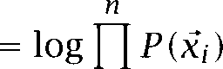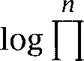





***k***

**i = l**

The set of parameters with the maximum likelihood gives us the best model of the data (assuming that it was generated by a mixture of Gaussians). So our goal is to find parameters that maximize the log likelihood given in the equation above. Here, we have to fiddle with all the parameters so as to try to make the likelihood of each data point a maximum, while still observing various constraints on the values of the parameters (so that the area under the pdf remains 1, for instance). This is a nasty problem in constrained optimization. We cannot calculate the maximum directly since it involves the log of a sum. Instead, we approximate the solution by iteration using the EM algorithm.

The EM algorithm is an iterative solution to the following circular state- ments:

**Estimate:** If we knew the value of we could compute the expected val- ues of the hidden structure of the model.

**Maximize:** If we knew the expected values of the hidden structure of the model, then we could compute the maximum likelihood value of

We break the circularity by beginning with a guess for and iterating **EXPECTATION STEP** back and forth between an *expectation step* and a *maximization step,* **MAXIMIZATION STEP** hence the name EM algorithm. In the expectation step, we compute ex- pected values for the hidden variables which can be interpreted as

cluster membership probabilities. Given the current parameters, we com- pute how likely it is that an object belongs to any of the clusters. The maximization step computes the most likely parameters of the model

14.2 Clustering *523*

given the cluster membership probabilities. This procedure improves our estimates of the parameters so that the parameters of a cluster better re- flect the properties of objects with high probability of membership in it.

A key property of the EM algorithm is monotonicity: With each iteration of E and M steps, the likelihood of the model given the data increases. This guarantees that each iteration produces model parameters that are more likely given the data we see. However, while the algorithm will eventually move to a local maximum, it will often not find the globally best solution. This is an important difference from least-squares methods like SVD (covered in chapter  which are guaranteed to find the global optimum.

In what follows we describe the EM algorithm for estimating a Gaussian mixture. We follow here the discussion in (Dempster et al.  (Mitchell 1997: ch.  and (Ghahramani 1994). See also  and Hart 1973: 193).

To begin, we **initialize** all the parameters. Here, it would be appropriate to initialize the covariance matrices  of each Gaussian as an identity matrix, each of the weights as  and the *k* means  are each chosen to be a random perturbation away from a data point randomly selected from X.

The **E-step** is the computation of parameters is the expectation of the hidden variable which is 1 if generated and 0 otherwise.



(14.20)

    



The **M-step** is to recompute the parameters (mean, variance, and prior for each Gaussian) as maximum likelihood estimates given expected values 

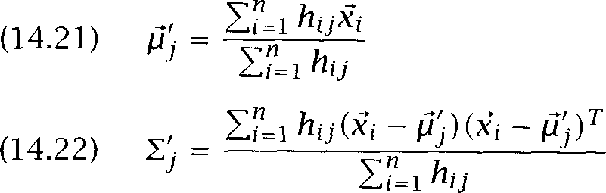

These are the maximum-likelihood estimates for the mean and variance of a Gaussian  and Hart 1973: 23).

The weights of the Gaussians are recomputed as:

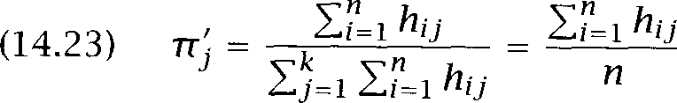

Once means, variances, and priors have been recomputed, we **repeat,** by performing the next iteration of the E and M steps. We keep iterating as long as the log likelihood keeps improving significantly at each step.

EM **and its applications Statistical** NLP

This description of the EM algorithm has been for clustering and Gaus- sian mixtures, but the reader should be able to recognize other applica- tions of EM as instantiations of the same general scheme, for example, the forward-backward algorithm and the inside-outside algorithm, which we covered in earlier chapters. Here is the most general formulation of EM (Dempster et al. 1977: 6).

Define a function Q as follows:

 = 

Here, the z are the hidden variables (the vectors above), the x are the observed data (the vectors  above). are the parameters of the model, the mean, variances and priors in the case of Gaussian mixtures. I( is (the log of) the joint probability distribution of observable and unobservable data given the parameters



Then the E and M step take the following form:

E-step: Compute 

 M-step: Choose  to be a value of that maximizes 

For the Gaussian mixture case, computing Q corresponds to computing the  the expected values of the hidden variable z. The M step chooses the parameters that maximize 

This general formulation of EM is not literally an algorithm. We are not told how to compute the M-step in general. (There are cases where it cannot be computed.) However, for a large class of problems there exist such algorithms, for example, for all distributions of the exponential family, of which the Gaussian distribution is an example. The remainder of this section briefly discusses how certain other algorithms covered in this book are instances of the EM algorithm.

**Baum-Welch reestimation.** In the Baum-Welch or forward-backward al- gorithm (see section  the E step computes  for each state  the expected number of transitions from the observed data; (ii) for each



* 1. *Non-Hierarchical Clustering* **525**

pair  of states, the expected number of transitions from state *i* to state j. The unobservable data here are the unobservable state transi- tions. In the E step, we compute expected values for these unobservables given the current parameters of the model.

The M step computes new maximum likelihood estimates of the param- eters given the expected values for the unobservables. For Baum-Welch, these parameters are the initial state probabilities the state transition probabilities and the symbol emission probabilities 

**Inside-outside algorithm.** The unobservable data in this algorithm (see section 11.3.4) are whether a particular rule is used to generate a particular subsequence of words or not. The E step computes expec- tations over these data, corresponding to the expected number of times that a particular rule will be used. We use the symbols *r, * and for these expectations in section 11.3.4. (The difference between the and the is that the are for rules that produce



minals and the are for rules that produce preterminals. The subscript refers to sentence in the training set.)

The M step then computes maximum-likelihood estimates of the pa- rameters based on the  and The parameters here are the rule proba- bilities and maximum-likelihood simply consists of summing and  the  or for a particular nonterminal.

**Unsupervised word sense disambiguation.** The unsupervised word sense disambiguation algorithm in section 7.4 is a clustering algorithm very similar to EM estimation of Gaussian mixtures, except that the prob- ability model is different. The E step again computes expectations of hidden binary variables that record cluster memberships, but the probabilities are computed based on the Bayesian independence model described in that section, not a Gaussian mixture. The probability that a cluster (or sense, which is what we interpret each cluster as) gener- ates a particular word is then recomputed in the M step as a

likelihood estimate given the expectation values.

**K-means.** K-means can be interpreted as a special case of estimating a Gaussian mixture with EM. To see this, assume that we only recompute the mean of each Gaussian in each iteration of the algorithm. Priors and variances are fixed. If we fix the variances to be very small, then the shape

***14 Clustering***

of the Gaussian will be that of a sharp peak that falls off steeply from the center. As a result, if we look at the probability  of the Eest’ cluster j and the probability of the next best cluster j , then the first will be much larger than the second.



This means that based on the posterior probabilities computed in the E step, each object will be a member of one cluster with probability very close to 1.0. In other words, we have an assignment that is a hard assign- ment for the purpose of recomputing the means since the contributions of objects with a very small membership probability will have a negligible influence on the computation of the means.

So an EM estimation of a Gaussian mixture with fixed small variances is very similar to K-means. However, there is a difference for ties. Even in the case of small variances, tied objects will have equal probabilities of membership for two clusters. In contrast, K-means makes a hard choice for ties.

**Summary.** The EM algorithm is very useful, and is currently very popu- lar, but it is sensible to also be aware of its deficiencies. On the down-side, the algorithm is very sensitive to the initialization of the parameters, and unless parameters are initialized well, the algorithm usually gets stuck in one of the many local maxima that exist in the space. One possibility that is sometimes used is to use the results of another clustering algo- rithm to initialize the parameters for the EM algorithm. For instance, the K-means algorithm is an effective way of finding initial estimates for the cluster centers for EM of Gaussian mixtures. The rate of convergence of the EM algorithm can also be very slow. While reestimation via the EM algorithm is guaranteed to improve (or at least to not have a detrimen- tal effect on) the likelihood of the data according to the model, it is also important to remember that it isn W guaranteed to improve other things that aren W actually in the model, such as the ability of a system to assign part of speech tags according to some external set of rules. Here there is a mismatch between what the EM algorithm is maximizing and the objec- tive function on which the performance of the system is being evaluated, and, not surprisingly, in such circumstances the EM algorithm might have deleterious effects. Finally, it is perhaps worth pointing out that the EM algorithm is only really called for when there isn W a more straightforward way of solving the constrained optimization problem at hand. In simple cases where there is an algebraic solution or the solution can be found

* 1. ***Further Reading 527***

by a simple iterative equation solver such as Newton V method, then one may as well do that.

#### Further Reading

General introductions to clustering are (Kaufman and Rousseeuw 1990) and (Jain and Dubes 1988). Overviews of work on clustering in informa- tion retrieval can be found in (van Rijsbergen  (Rasmussen 1992) and (Willett 1988).

**SPANNING**

**TREE**

**PRINCIPAL**

**2 NENT ANALYSIS**

Algorithms for constructing minimum ***spanning trees*** can be found in  et al. 1990: ch. 24). For the general case, these algorithms run in

0  log  where is the number of nodes in the graph.

To the extent that clustering is used for data analysis and compre- hension, it is closely related to visualization techniques that project a high-dimensional space onto (usually) two or three dimensions. Three commonly used techniques are ***principal component analysis*** (PCA) (see (Biber et al. 1998) for its application to corpora), Multi-Dimensional Scaling (MDS) (Kruskal  and Kohonen maps or Self-Organizing Maps (SOM) (Kohonen 1997). These spatial representations of a multi- dimensional space are alternatives to the dendrogram in figure 14.1.

Clustering can also be viewed as a form of category induction in cog- nitive modeling. Many researchers have attempted to induce syntactic categories by clustering corpus-derived word representations (Brill et al. 1990; Finch 1993). We used the clustering method proposed by

(1995) for figure 14.1. Waterman (1995) attempts to find clusters of se- mantically related words based on syntactic evidence.

An early influential paper in which object nouns are clustered on the basis of verbs in a way similar to (Pereira et al. 1993) is (Hindle 1990). Li and Abe (1998) develop a symmetric model of verb-object pair clustering in which clusters generate both nouns and verbs. A pure verb cluster- ing approach is adopted by et al. (1996). An example of adjective clustering can be found in (Hatzivassiloglou and 1993).

The efficiency of clustering algorithms is becoming more important as text collections and NLP data sets increase in size. The Buckshot algo- rithm was proposed by Cutting et al. (1992). Even more efficient

time algorithms (based on  of a cluster hierarchy) are de- scribed by Cutting et al. (1993) and Silverstein and Pedersen (1997).

528 *14 Clustering*

* 1. Exercises

**Exercise 14.1**

Retrieve the word space data from the and do a single-link,  link, and group-average clustering of a subset.

Exercise 14.2 

Construct an example data set for which the K-means algorithm takes more than one iteration to converge.

**Exercise 14.3**

Create a data set with 10 points in a plane where each point is a distance of 1 or less from the origin. Place an eleventh point (the outlier) in turn at distance

* + 1. 2,  4, (c) 8, and (d) 16 from the origin. For each of these cases run K-means clustering with two clusters (i) in Euclidean space and (ii) in  space. (Pick the initial two centers from the 10 points near the origin.) Do the two distance measures give different results? What are the implications for data sets with outliers?

Exercise 14.4 

Since the EM algorithm only finds a local minimum, different starting conditions will lead to different clusterings. Run the EM algorithm 10 times with different initial seeds on the 1000 most frequent words from the and analyze the differences. Compute the percentage of pairs of words that are in the same cluster in all 10 clusterings, in 9 clusterings, etc.

Exercise 14.5 

Discuss the trade-off between time and the quality of clustering that needs to be made when choosing one of the three agglomerative algorithms or K-means.

**Exercise 14.6**

The model proposed by Brown et al.  is optimal in that it finds clusters that improve the evaluation measure directly. But it actually did not improve the measure in their experiment, or only after linear interpolation. What are possible reasons?

Exercise 14.7 

Show that K-means converges if there are no ties. Compute as a goodness mea- sure of the clustering the sum squared error that is incurred when each object is replaced by its cluster V center. Then show that this goodness measure decreases (or stays the same) in both the reassignment and the recomputation steps.

## Topics in In formation

**I NFORMATION R ETRIEVAL RESEARCH** is

oping algorithms and models for retrieving information from document repositories. **IR** might be regarded as a natural subfield of **NLP** because it deals with a particular application of natural language processing. (Tra- ditional IR research deals with text although retrieval of speech, images and video are becoming increasingly common.) But in actuality, inter- actions between the fields have been limited, partly because the special demands of IR were not seen as interesting problems in **NLP,** partly be- cause statistical methods, the dominant approach in IR, were out of favor in **NLP.**

With the resurgence of quantitative methods in **NLP,** the connections

between the fields have increased. We have selected four examples of recent interaction between the fields: probabilistic models of term dis- tribution in documents, a problem that has received attention in both Statistical **NLP** and IR; discourse segmentation, an **NLP** technique that has been used for more effective document retrieval; and the Vector Space Model and Latent Semantic Indexing  two IR techniques that have been used in Statistical NLP. Latent Semantic Indexing will also serve as an example of  *reduction,* an important statistical tech- nique in itself. Our selection is quite subjective and we refer the reader to the IR literature for coverage of other topics (see section 15.6). In the following section, we give some basic background on IR, and then discuss the four topics in turn.

*15 Topics* ***in Information Retrieval***

#### Some Background on Information Retrieval

**AD-HOC RETRIEVAL**

**PROBLEM**

**EXACT MATCH B OOLEAN QUERIES**

**FEEDBACK DATABASE MERGING**

**TEXT CATEGORIZATION**

**FILTERING ROUTING**

The goal of IR research is to develop models and algorithms for retrieving information from document repositories, in particular, textual informa- tion. The classical problem in IR is the ad-hoc *retrieval problem.* In ad-hoc retrieval, the user enters a query describing the desired information. The system then returns a list of documents. There are two main models. *Exact match* systems return documents that precisely satisfy some struc- tured query expression, of which the best known type is Boolean queries, which are still widely used in commercial information systems. But for large and heterogeneous document collections, the result sets of exact match systems usually are either empty or huge and unwieldy, and so most recent work has concentrated on systems which rank documents according to their estimated relevance to the query. It is within such an approach that probabilistic methods are useful, and so we restrict our attention to such systems henceforth.

An example of ad-hoc retrieval is shown in figure 15.1. The query is

Jlass pyramid Pei Louvre, entered on the search engine Vista. The user is looking for web pages about I. M. Pei V glass pyramid over the Louvre entrance in Paris. The search engine returns several rele- vant pages, but also some non-relevant ones a result that is typical for ad-hoc searches due to the difficulty of the problem.

Some of the aspects of ad-hoc retrieval that are addressed in IR re- search are how users can improve the original formulation of a query interactively, by way of *relevance feedback;* how results from several text databases can be merged into one result list *(database merging);* which models are appropriate for partially corrupted data, for example, documents; and how the special problems that languages other than En- glish pose can be addressed in IR.

Some subfields of information retrieval rely on a training corpus of documents that have been classified as either relevant or non-relevant to a particular query. In *text categorization,* one attempts to assign docu- ments to two or more pre-defined categories. An example is the subject codes assigned by Reuters to its news stories (Lewis 1992). Codes like CORP-NEWS (corporate news), CRUDE (crude oil) or ACQ (acquisitions) make it easier for subscribers to find stories of interest to them. A finan- cial analyst interested in acquisitions can request a customized

that only delivers documents tagged with ACQ.

*Filtering* and *routing* are special cases of text categorization with only

Advanced Query]  Simple Query]  Private Products]  Help with Query]



Search the **Web**

Display results **Compact Detailed**

When in doubt use lower-case. Check Help for better matches.

pyramid: a b o u t

**Documents of about 10000 matching the query, best matches first.**

**Paris, France**

Paris, France. Practical Info.-A Brief Overview. Layout: One of the most densely populated cities in Europe, Paris is also one of the most accessible,...

29 *Sep* 9 5

**Culture**

Culture. French culture is an integral part of France V image, as foreign tourists are the first to acknowledge by thronging to the Louvre and the Centre..



**Travel World Science Education Tour of Europe**

-size 48K 20 96

Science Education Tour of Europe. B E M I D J 1 S T A T E U N I V E R I T Y Science Education Tour of EUROPE July 1,



*size*

*. size* ***May*** 95

**FRANCE REAL ESTATE RENTAL**

LOIRE VALLEY RENTAL. ANCIENT STONE HOME FOR RENT. Available to rent is a

furnished, country decorated, two bedroom, small stone home, built in the..



*Jun*

**LINKS**

PAUL 6 LINKS. Click here to view CNN interactive and CNET. Click here to make your own web site. Click here to manage your cash. Interested in...

 *size* 9K 19 96

**Digital Design Media, Chapter 9: Lines in Space**

Construction planes... Glass-sheet models... Three-dimensional geometric transformations...

Sweeping points... Space curves... Structuring wireframe...

**No Title**

36K 22 

Boston Update 94: A VISION FOR BOSTON 6 FUTURE. Ian Menzies. Senior Fellow, Institute. University of Massachusetts Boston. April 1994. Prepared..



25K 31 *Jan* 96

**Paris Photograph**

The Arc de Triomphe du neatly frames IM Pei V glass pyramid, Paris 1996



Richard Nebesky.

Figure 15.1 Results of the search Jlass pyramid Pei Louvre on an search engine.

532

**INFORMATION NEED**

15.1.1

**INVERTED INDEX**

**POSTINGS**

**POSITION INFORMATION**

**PHRASES**

*Topics in Information Retrieval*

*two* categories: relevant and non-relevant to a particular query (or  need). In routing, the desired output is a ranking of documents according to estimated relevance, similar to the ranking shown in fig- ure 15.1 for the ad-hoc problem. The difference between routing and ad-hoc is that training information in the form of relevance labels is available in routing, but not in ad-hoc retrieval. In filtering, an estima- tion of relevance has to be made for each document, typically in the form of a probability estimate. Filtering is harder than routing because an absolute ( 'ocument is relevant ) rather than a relative assessment of relevance ( 'ocument  is more relevant than  is required. In many practical applications, an absolute assessment of relevance for each indi- vidual document is necessary. For example, when a news group is filtered for stories about a particular company, users do not want to wait for a month, and then receive a ranked list of all stories about the company in the past month, with the most relevant shown at the top. Instead, it

is desirable to deliver relevant stories as soon as they come in without knowledge about subsequent postings. As special cases of classification, filtering and routing can be accomplished using any of the classification algorithms described in chapter 16 or elsewhere in this book.

Common design features of IR systems

Most IR systems have as their primary data structure an inverted index. An inverted index is a data structure that lists for each word in the col- lection all documents that contain it (the postings) and the frequency of occurrence in each document. An inverted index makes it easy to search for Kits of a query word. One just goes to the part of the inverted index that corresponds to the query word and retrieves the documents listed there.

A more sophisticated version of the inverted index also contains posi- *tion information.* Instead of just listing the documents that a word oc- curs in, the positions of all occurrences in the document are also listed. A position of occurrence can be encoded as a byte offset relative to the beginning of the document. An inverted index with position information lets us search for phrases. For example, to search for Far insurance,’ we simultaneously work through the entries for and in the inverted index. First, we intersect the two sets so that we only have documents in which both words occur. Then we look at the position in- formation and keep only those hits for which the position information



|  |  |  |  |  |  |  |
| --- | --- | --- | --- | --- | --- | --- |
| a | also | an | and | as | at | be but by |
| can  have | could  he | do  her | for  here | from | go  how |  |
| i | if | in | into | it | its |  |
| my | of | on | or | our | say | she |
| that | the | their | there | therefore | they |  |
| this | these | those | through | to | until |  |
| we | what | when | where | which | while | who with would |
|  | your |  |  |  |  |  |

Table 15.1 A small stop list for English. Stop words are function words that can be ignored in keyword-oriented information retrieval without a significant effect on retrieval accuracy.

indicates that occurs immediately after This is much more efficient than having to read in and process all documents of the collec- tion sequentially.

The notion of phrase used here is a fairly primitive one. We can only search for fixed phrases. For example, a search for Far insurance rates’ would not find documents talking about *rates for cur insurance.* This is an area in which future Statistical NLP research can make important contributions to information retrieval. Most recent research on phrases in IR has taken the approach of designing a separate phrase identification module and then indexing documents for identified phrases as well as words. In such a system, a phrase is treated as no different from an ordinary word. The simplest approach to phrase identification, which is anathema to NLP researchers, but often performs surprisingly well, is to just select the most frequent  as phrases, for example, those that occur at least 25 times.

In cases where phrase identification is a separate module, it is very similar to the problem of discovering collocations. Many of the tech- niques in chapter 5 for finding collocations can therefore also be applied to identifying good phrases for indexing and searching.

In some IR systems, not all words are represented in the inverted index. **STOP LIST** A ***stop list*** of Jrammatical or *function words* lists those words that are **WORDS** deemed unlikely to be useful for searching. Common stop words are *the, from* and ***could.*** These words have important semantic functions in

English, but they rarely contribute information if the search criterion is

*534*

**STEMMING**



**P ORTERSTEMMER**

15.1.2

***Topics in information Retrieval***

a simple word-by-word match. A small stop list for English is shown in table 15.1.

A stop list has the advantage that it reduces the size of the inverted index. According to Zipf V law (see section  a stop list that covers a few dozen words can reduce the size of the inverted index by half. However, it is impossible to search for phrases that contain stop words once the stop list has been applied note that some occasionally used phrases like *when and where* consist *entirely* of words in the stop list in table 15.1. For this reason, many retrieval engines do not make use of a stop list for indexing.

Another common feature of IR systems is stemming, which we briefly discussed in section 4.2.3. In IR, stemming usually refers to a simplified form of morphological analysis consisting simply of truncating a word. For example, *laughing,* and *laughed* are all stemmed to laugh-. Common stemmers are the and *Porter* stemmers, which differ in the actual algorithms used for determining where to truncate words (Lovins 1968; Porter 1980). Two problems with truncation stem- mers are that they conflate semantically different words (for example, gallery and  may both be stemmed to  and that the truncated stems can be unintelligible to users (for example, if *gallery* is presented as *gull-).* They are also much harder to make work well for  rich languages.



Evaluation measures

Since the quality of many retrieval systems depends on how well they manage to rank relevant documents before non-relevant ones, IR resear- chers have developed evaluation measures specifically designed to eval- uate rankings. Most of these measures combine precision and recall in a way that takes account of the ranking. As we explained in section 8.1, precision is the percentage of relevant items in the returned set and re- call is the percentage of all relevant documents in the collection that is in the returned set.

Figure 15.2 demonstrates why the ranking of documents is important. All three retrieved sets have the same number of relevant and not rele- vant documents. A simple measure of precision (50% correct) would not distinguish between them. But ranking 1 is clearly better than ranking 2 for a user who scans a returned list of documents from top to bottom

Evaluation Ranking 1 Ranking 2 Ranking 3 dl: x d6: x



d2: x dl:

d3: d8: x d2:

d4: d7: x x

d5: d6: x x

d6: x dl: d3:

d7: x d2: d5:

x d3: d4:

x d4: d7: x

x d5: x

precision at 5 1.0 0.0 0.4

precision at 10 0.5 0.5 0.5

uninterpolated av. 1.0 0.3544 0.5726

interpolated av. (1 l-point) 1.0 0.5 0.6440

Table 15.2 An example of the evaluation of rankings. The columns show three different rankings of ten documents, where a indicates a relevant document and a x indicates a non-relevant document. The rankings are evaluated accord- ing to four measures: precision at 5 documents, precision at 10 documents, uninterpolated average precision, and interpolated average precision over 11

points.

(which is what users do in many practical situations, for example, when web searching).

**CUTOFF** One measure used is precision at a particular cutoff, for example 5 or 10 documents (other typical cutoffs are 20 and 100). By looking at precision for several initial segments of the ranked list, one can gain a good impression of how well a method ranks relevant documents before non-relevant documents.

 *average precision* aggregates many precision numbers **PRECISION** into one evaluation figure. Precision is computed for each point in the list where we find a relevant document and these precision numbers are

then averaged. For example, for ranking 1 precision is 1.0 for dl,  d3, d4 and d5 since for each of these documents there are only relevant documents up to that point in the list. The uninterpolated average is therefore also 1.0. For ranking 3, we get the following precision numbers for the relevant documents:



 which averages to 0.5726.

If there are other relevant documents further down the list then these also have to be taken into account in computing uninterpolated average precision. Precision at relevant documents that are not in the returned set is assumed to be zero. This shows that average precision indirectly mea- sures *recall,* the percentage of relevant documents that were returned in the retrieved set (since omitted documents are entered as zero precision).

**INTERPOLATED** *Interpolated average precision* is more directly based on recall.



**AVERAGE PRECISION LEVELS OF RECALL**

sion numbers are computed for various levels of *recall,* for example for the levels 0%, SO%, SO%,  and 100% in the case of an 1 l-point average (the most widely used measure). At recall level precision  is computed at the point of the ranked list where the proportion of retrieved relevant documents reaches However, if 

**INTERPOLATE** sion goes up again while we are moving down the list, then we *interpolate* and take the highest value of precision anywhere beyond the point where recall level was first reached. For example, for ranking 3 in figure 15.2 interpolated precision for recall level 60% is not  the precision at the point where 60% recall is first reached as shown in the top diagram of figure 15.2. Instead, it is as shown in the bottom diagram of figure 15.2. (We are assuming that the five relevant documents shown are the only relevant documents.) The thinking here is that the user will be willing to look at more documents if the precision goes up. The two



**PRECISION-RECALL** graphs in figure 15.2 are so-called *precision-recall curves,* with 

**CURVES** lated and uninterpolated values for 0%, and 100% recall for ranking 3 in table 15.2.



There is an obvious trade-off between precision and recall. If the whole collection is retrieved, then recall is  but precision is low. On the other hand, if only a few documents are retrieved, then the most

seeming documents will be returned, resulting in high precision, but re- call will be low.

Average precision is one way of computing a measure that captures

***F* MEASURE** both precision and recall. Another way is the *measure,* which we intro- duced in section 8.1:

(15.1) *F =* 1

 

where is the precision, *R* is the recall and determines the weighting of precision and recall. The *F* measure can be used for evaluation at fixed cutoffs if both recall and precision are important.

* 1. ***Some Background on Information Retrieval*** 537

1

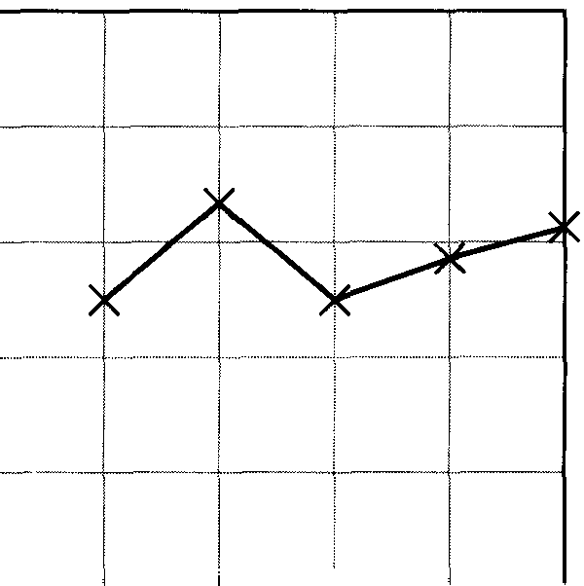

recall

1

precision

**0**

interpolated precision

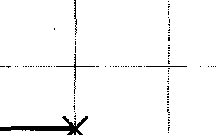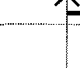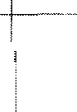

X

0

0 recall 1

Figure 15.2 Two examples of precision-recall curves. The two curves are for ranking 3 in table 15.2: uninterpolated (above) and interpolated (below).

Any of the measures discussed above can be used to compare the per- formance of information retrieval systems. One common approach is to run the systems on a corpus and a set of queries and average the perfor- mance measure over queries. If the average of system 1 is better than the average of system 2, then that is evidence that system 1 is better than system 2.

Unfortunately, there are several problems with this experimental de- sign. The difference in averages could be due to chance. Or it could be due to one query on which system 1 outperforms system 2 by a large margin with performance on all other queries being about the same. It is therefore advisable to use a statistical test like the test for system com- parison (as shown in section 6.2.3).

15.1.3 The probability ranking principle

Ranking documents is intuitively plausible since it gives the user some control over the tradeoff between precision and recall. If recall for the first page of results is low and the desired information is not found, then the user can look at the next page, which in most cases trades higher recall for lower precision.

The following principle is a guideline which is one way to make the assumptions explicit that underlie the design of retrieval by ranking. We present it in a form simplified from (van Rijsbergen 1979: 113):

Probability Ranking Principle (PRP). Ranking documents in order of decreasing probability of relevance is optimal.

The basic idea is that we view retrieval as a greedy search that aims to identify the most valuable document at any given time. The document that is most likely to be valuable is the one with the highest estimated probability of relevance (where we consider all documents that haven W been retrieved yet), that is, with a maximum value for  Id). After mak- ing many consecutive decisions like this, we arrive at a list of documents

that is ranked in order of decreasing probability of relevance.

Many retrieval systems are based on the PRP, so it is important to be clear about the assumptions that are made when it is accepted.

One assumption of the PRP is that documents are independent. The clearest counterexamples are duplicates. If we have two duplicates  and  then the estimated probability of relevance of  does not change after we have presented  further up in the list. But  does not give

the user any information that is not already contained in  Clearly, a better design is to show only one of the set of identical documents, but that violates the PRP.

Another simplification made by the PRP is to break up a complex in- formation need into a number of queries which are each optimized in isolation. In practice, a document can be highly relevant to the complex information need as a whole even if it is not the optimal one for an in- termediate step. An example here is an information need that the user initially expresses using ambiguous words, for example, the query  to search for information on the animal (as opposed to the car). The op- timal response to this query may be the presentation of documents that make the user aware of the ambiguity and permit disambiguation of the query. In contrast, the PRP would mandate the presentation of documents that are highly relevant to either the car or the animal.

A third important caveat is that the probability of relevance is only es- timated. Given the many simplifying assumptions we make in designing probabilistic models for IR, we cannot completely trust the probability

**VARIANCE** estimates. One aspect of this problem is that the variance of the esti- mate of probability of relevance may be an important piece of evidence in some retrieval contexts. For example, a user may prefer a document that we are certain is probably relevant (low variance of probability esti- mate) to one whose estimated probability of relevance is higher, but that also has a higher variance of the estimate.

* 1. The Vector Space Model

**SPACE MODEL** The vector space model is one of the most widely used models for ad-hoc retrieval, mainly because of its conceptual simplicity and the appeal of the underlying metaphor of using spatial proximity for semantic proxim- ity. Documents and queries are represented in a high-dimensional space, in which each dimension of the space corresponds to a word in the doc- ument collection. The most relevant documents for a query are expected to be those represented by the vectors closest to the query, that is, doc- uments that use similar words to the query. Rather than considering the magnitude of the vectors, closeness is often calculated by just looking at angles and choosing documents that enclose the smallest angle with the query vector.

In figure 15.3, we show a vector space with two dimensions,

**540 *15 Topics*** *in Information Retrieval*

***car***

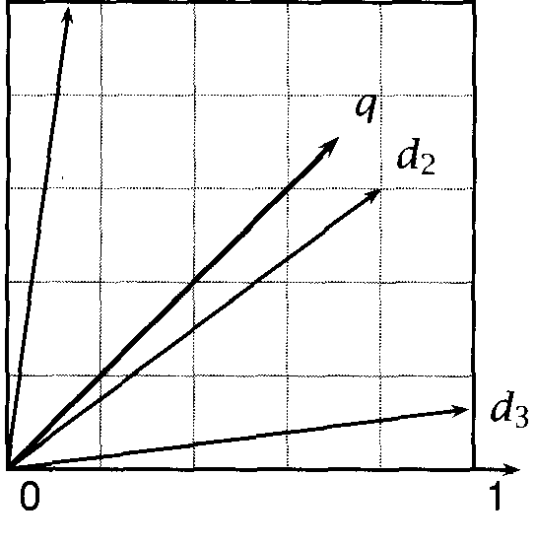

**0**

***insurance***

**Figure 15.3** A vector space with two dimensions. The two dimensions corre- spond to the terms *car* and *insurance.* One query and three documents are represented in the space.

sponding to the words and ***insurance.*** The entities represented in the space are the query represented by the vector  and three documents and  with the following coordinates: 



**TERM WEIGHTS** and The coordinates or term ***weights*** are derived from occurrence counts as we will see below. For example, ***insurance*** may have only a passing reference in  while there are several occurrences of ***car*** hence the low weight for ***insurance*** and the high weight for ***car.***

**TERM** (In the context of information retrieval, the word ***term*** is used for both words and phrases. We say ***term weights*** rather than ***word weights*** be- cause dimensions in the vector space model can correspond to phrases as well as words.)

In the figure, document  has the smallest angle with so it will be the top-ranked document in response to the query ***car insurance.*** This is because both Foncepts (car and insurance) are salient in  and there-

fore have high weights. The other two documents also mention both terms, but in each case one of them is not a centrally important term in the document.

* + 1. **Vector similarity**

To do retrieval in the vector space model, documents are ranked

**COSINE** ing to similarity with the query as measured by the ***cosine*** measure or

NORMALIZED ***normalized correlation coefficient.*** We introduced the cosine as a measure CORRELATION of vector similarity in section 8.5.1 and repeat its definition here: COEFFICIENT

(15.2) = 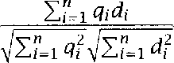

where  and dare n-dimensional vectors in a real-valued space, the space of all terms in the case of the vector space model. We compute how well the occurrence of term (measured by and  correlates in query and document and then divide by the Euclidean length of the two vectors to scale for the magnitude of the individual and 

Recall also from section 8.5.1 that cosine and Euclidean distance give rise to the same ranking for normalized vectors:

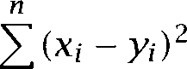( 1 5 . 3 ) 

i=l



 2

i=l i=l i=l



**1** 2 + 1

i=l



So for a particular query  and any two documents  and  we have: ( 1 5 . 4 )    

which implies that the rankings are the same. (We again assume normal- ized vectors here.)

If the vectors are normalized, we can compute the cosine as a simple dot product. Normalization is generally seen as a good thing otherwise longer vectors (corresponding to longer documents) would have an unfair advantage and get ranked higher than shorter ones. (We leave it as an exercise to show that the vectors in figure 15.3 are normalized, that is,

 

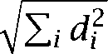

* + 1. Term weighting

We now turn to the question of how to weight words in the vector space model. One could just use the count of a word in a document as its term

Quantitv Svmbol Definition

term frequency



document frequency collection frequency 

number of occurrences of in

number of documents in the collection that occurs in total number of occurrences of in the collection

**Table 15.3** Three quantities that are commonly used in term weighting in in- formation retrieval.

Word Collection Frequency Document Frequency insurance 10440 3997

try 10422 8760

**Table 15.4** Term and document frequencies of two words in an example cor- pus.

**TERM FREQUENCY**

**DOCUMENT FREQUENCY COLLECTION FREQUENCY**

weight, but there are more effective methods of term weighting. The basic information used in term weighting is term *frequency, document frequency,* and sometimes collection frequency as defined in table 15.3. Note that and that =  It is also important to note that document frequency and collection frequency can only be used if there is a collection. This assumption is not always true, for example if collections are created dynamically by selecting several databases from a large set (as may be the case on one of the large on-line information services), and joining them into a temporary collection.

The information that is captured by term frequency is how salient a word is within a given document. The higher the term frequency (the more often the word occurs) the more likely it is that the word is a good description of the content of the document. Term frequency is usually dampened by a function like  =  or  = 1 tf 0 be- cause more occurrences of a word indicate higher importance, but not as much relative importance as the undampened count would suggest. For example,  or 1 +log 3 better reflect the importance of a word with three occurrences than the count 3 itself. The document is somewhat more im- portant than a document with one occurrence, but not three times as important.



The second quantity, document frequency, can be interpreted as an in- dicator of informativeness. A semantically word will often occur several times in a document if it occurs at all. Semantically

words are spread out homogeneously over all documents. An example

from a corpus of New ***York Times*** articles is the words ***insurance*** and

in table 15.4. The two words have about the same collection frequency, the total number of occurrences in the document collection. But ***insur-*** ance occurs in only half as many documents as This is because the word can be used when talking about almost any topic since one can to do something in any context. In contrast, insurance refers to a

narrowly defined concept that is only relevant to a small set of topics. Another property of semantically words is that, if they come up once in a document, they often occur several times. ***Insurance*** occurs about three times per document, averaged over documents it occurs in at least once. This is simply due to the fact that most articles about health insurance, car insurance or similar topics will refer multiple times to the concept of insurance.

One way to combine a word V term frequency  and document fre-

quency  into a single weight is as follows:

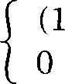(15.5) weight(i,j) = if 1



if ***0***

where is the total number of documents. The first clause applies for words occurring in the document, whereas for words that do not appear  = 0), we set  = 0.

Document frequency is also scaled logarithmically. The formula log  = log gives full weight to words that occur in 1 doc- ument  log  =  log 1 =  A word that occurred in all documents would get zero weight  log  = = 0).



**DOCUMENT** This form of document frequency weighting is often called ***inverse***

**FREQUENCY *ument frequency*** or idf weighting. More generally, the weighting scheme

**IDF TF.IDF**

in (15.5) is an example of a larger family of so-called  weighting schemes. Each such scheme can be characterized by its term occurrence weighting, its document frequency weighting and its normalization. In one description scheme, we assign a letter code to each component of the tf.idf scheme. The scheme in (15.5) can then be described as Otn” for logarithmic occurrence count weighting  logarithmic document fre- quency weighting (t), and no normalization (n). Other weighting possi- bilities are listed in table 15.5. For example, is augmented term occurrence weighting, no document frequency weighting and no normal- ization. We refer to vector length normalization as cosine normalization because the inner product between two length-normalized vectors (the query-document similarity measure used in the vector space model) is

Term occurrence n (natural)

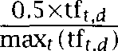

1 (logarithm)

a (augmented) 0.5

Document frequency n (natural)

Normalization

1. (no normalization)

*c* (cosine)

**Table** 15.5 Components of weighting schemes.  is the frequency of term in document ***d,*** is the number of documents occurs in, N is the total number of documents, and is the weight of term ***i.***

their cosine. Different weighting schemes can be applied to queries and documents. In the name  the halves refer to document and query weighting, respectively.

The family of weighting schemes shown in table 15.5 is sometimes crit- icized as Dd-hoc because it is not directly derived from a mathematical model of term distributions or relevancy. However, these schemes are effective in practice and work robustly in a broad range of applications. For this reason, they are often used in situations where a rough measure of similarity between vectors of counts is needed.

#### Term Distribution Models

An alternative to tf.idf weighting is to develop a model for the distribu- tion of a word and to use this model to characterize its importance for retrieval. That is, we wish to estimate  the proportion of times that word appears ***k*** times in a document. In the simplest case, the dis- tribution model is used for deriving a probabilistically motivated term weighting scheme for the vector space model. But models of term distri- bution can also be embedded in other information retrieval frameworks. Apart from its importance for term weighting, a precise characteriza- tion of the occurrence patterns of words in text is arguably at least as

**LAW** important a topic in Statistical NLP as ***Zipf* V** Zipf V law describes word behavior in an ***entire corpus.*** In contrast, term distribution mod-

els capture regularities of word occurrence in ***subunits corpus (e.g.,*** documents or chapters of a book). In addition to information retrieval, a good understanding of distribution patterns is useful wherever we want to assess the likelihood of a certain number of occurrences of a specific word in a unit of text. For example, it is also important for author



cation where one compares the likelihood that different writers produced a text of unknown authorship.

Most term distribution models try to characterize how informative a word is, which is also the information that inverse document frequency is getting at. One could cast the problem as one of distinguishing con- tent words from non-content (or function) words, but most models have a graded notion of how informative a word is. In this section, we intro- duce several models that formalize notions of informativeness. Three are based on the Poisson distribution, one motivates inverse document fre- quency as a weight optimal for Bayesian classification and the final one, *residual inverse document frequency,* can be interpreted as a combination of idf and the Poisson distribution.

* + 1. The Poisson distribution

The standard probabilistic model for the distribution of a certain type of event over units of a fixed size (such as periods of time or volumes of

**POISSON DISTRIBUTION**

liquid) is the *Poisson distribution.* Classical examples of Poisson distribu- tions are the number of items that will be returned as defects in a given period of time, the number of typing mistakes on a page, and the number of microbes that occur in a given volume of water.

The definition of the Poisson distribution is as follows.

***k***

**Poisson Distribution.** =  for some 0



In the most common model of the Poisson distribution in IR, the parame- ter 0 is the average number of occurrences of per document, that is,  = where  is the collection frequency and is the total number of documents in the collection. Both the mean and the variance of the Poisson distribution are equal to 



E(p) =  = 

Figure 15.4 shows two examples of the Poisson distribution.

In our case, the event we are interested in is the occurrence of a partic- ular word and the fixed unit is the document. We can use the Poisson distribution to estimate an answer to the question: What is the probabil- ity that a word occurs a particular number of times in a document. We might say that  = is the probability of a document having exactly *k* occurrences of where  is appropriately estimated for each word.



*546* Topics in

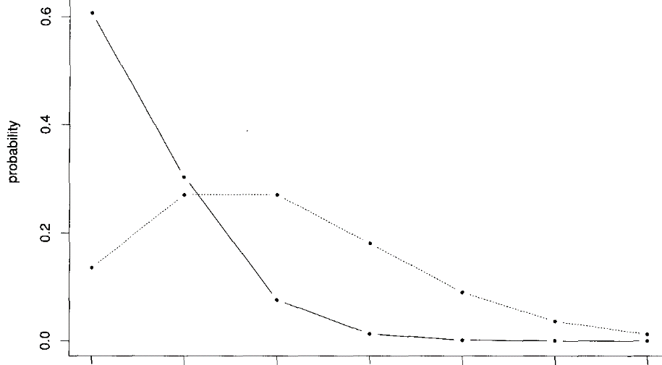

**0 1** 2 3 4 5 6

count

Figure 15.4 The Poisson distribution. The graph shows  0.5) (solid line) and  2.0) (dotted line) for 0 *k* 6. In the most common use of this distribution in IR, *k* is the number of occurrences of term *i* in a document, and

is the probability of a document with that many occurrences.



The Poisson distribution is a limit of the binomial distribution. For the binomial distribution p), if we let and *p 0* in such a way that np remains fixed at value 0, then Assuming a Poisson distribution for a term is appropriate if the following conditions hold.



The probability of one occurrence of the term in a (short) piece of text is proportional to the length of the text.

The probability of more than one occurrence of a term in a short piece of text is negligible compared to the probability of one occurrence.

Occurrence events in non-overlapping intervals of text are indepen- dent.

We will discuss problems with these assumptions for modeling the tribution of terms shortly. Let us first look at some examples.

|  |  |  |  |  |  |
| --- | --- | --- | --- | --- | --- |
| Word |  | |  | | Overestimation |
| follows | 21744 | 23533 | 0.2968 | 20363 | 0.94 |
| transformed | 807 | 840 | 0.0106 | 835 | 1.03 |
| soviet | 8204 | 35337 | 0.4457 | 28515 | 3.48 |
| students | 4953 | 15925 | 0.2008 | 14425 | 2.91 |
| james | 9191 | 11175 | 0.1409 | 10421 | 1.13 |
| freshly | 395 | 611 | 0.0077 | 609 | 1.54 |

**Table 15.6** Document frequency and collection frequency (cf) for 6 words in the New *York Times* corpus. Computing according to the Poisson distribution is a reasonable estimator of df for non-content words (like follows), but severely overestimates df for content words (like *soviet).* The pa- rameter of the Poisson distribution is the average number of occurrences of term *i* per document. The corpus has N = 79291 documents.



Table 15.6 shows for six terms in the New York Times how well the Poisson distribution predicts document frequency. For each word, we show document frequency  collection frequency  the es- timate of A (collection frequency divided by total number of documents  the predicted df, and the ratio of predicted df and actual df.

Examining document frequency is the easiest way to check whether a term is Poisson distributed. The number of documents predicted to have at least one occurrence of a term can be computed as the complement of the predicted number with no occurrences. Thus, the Poisson predicts that the document frequency is  = 1 -Pi (0)) where is the number of documents in the corpus. A better way to check the fit of the Poisson is to look at the complete distribution: the number of documents with 0, 1, 2, 3, etc. occurrences. We will do this below.

In table 15.6, we can see that the Poisson estimates are good for content words like *follows* and *transformed.* We use the term non-content *word* loosely to refer to words that taken in isolation (which is what most IR systems do) do not give much information about the contents of the document. But the estimates for content words are much too high, by a factor of about 3 (3.48 and 2.91).

This result is not surprising since the Poisson distribution assumes independence between term occurrences. This assumption holds approx- imately for non-content words, but most content words are much more likely to occur again in a text once they have occurred once, a property

**548** *15 Topics in Information Retrieval*

**BURSTINESS** that is sometimes called or term clustering. However, there **TERM CLUSTERING** are some subtleties in the behavior of words as we can see for the last two words in the table. The distribution of  is surprisingly close to

Poisson, probably because in many cases a person V full name is given at

first mention in a newspaper article, but following mentions only use the last name or a pronoun. On the other hand, freshly is surprisingly Poisson. Here we get strong dependence because of the genre of recipes in the New York *Times* in which freshly frequently occurs several times. So non-Poisson-ness can also be a sign of clustered term occurrences in a particular genre like recipes.

The tendency of content word occurrences to cluster is the main prob- lem with using the Poisson for words. But there is also the opposite effect. We are taught in school to avoid repetitive writing. In many cases, the probability of reusing a word immediately after its first occurrence in a text is lower than in general. A final problem with the Poisson is that documents in many collections differ widely in size. So documents are not a uniform unit of measurement as the second is for time or the kilogram is for mass. But that is one of the assumptions of the Poisson distribution.

The two-Poisson model

A better fit to the frequency distribution of content words is provided by **T W O- POISSON M ODEL** the *two-Poisson Model* (Bookstein and Swanson  a mixture of two Poissons. The model assumes that there are two classes of documents

associated with a term, one class with a low average number of occur- (the non-privileged class) and one with a high average number of

occurrences (the privileged class):

  (1

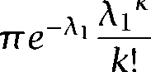

***k***

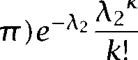

*k*

where is the probability of a document being in the privileged class, **(1** is the probability of a document being in the non-privileged class, and  and  are the average number of occurrences of word in the privileged and non-privileged classes, respectively.



The two-Poisson model postulates that a content word plays two dif- ferent roles in documents. In the non-privileged class, its occurrence is accidental and it should therefore not be used as an index term, just as a non-content word. The average number of occurrences of the word in

* 1. *Term Distribution Models* 549

this class is low. In the privileged class, the word is a central content word. The average number of occurrences of the word in this class is high and it is a good index term.

Empirical tests of the two-Poisson model have found a spurious Gip at

frequency 2. The model incorrectly predicts that documents with 2 occur- rences of a term are less likely than documents with 3 or 4 occurrences. In reality, the distribution for most terms is monotonically decreasing. If  is the proportion of times that word appears times in a doc- ument, . .



**GATIVE BINOMIAL** use more than two Poisson distributions. The  *binomial* is one such mixture of an infinite number of Poissons (Mosteller and Wallace  but there are many others (Church and Gale 1995). The negative binomial fits term distributions better than one or two Poissons, but it can be hard to work with in practice because it involves the computation of large binomial coefficients.

15.3.3 The mixture

A simpler distribution that fits empirical word distributions about as well as the negative binomial is Katz V K mixture:

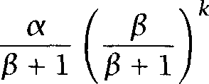

where  = 1 iff 0 and  = 0 otherwise and and  are parame- ters that can be fit using the observed mean and the observed inverse document frequency IDF as follows.



IDF = log, 

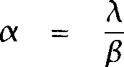        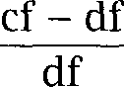

The parameter  is the number of Hxtra terms per document in which the term occurs (compared to the case where a term has only one occur- rence per document). The decay factor = (extra terms per term

occurrence) determines the ratio For example, if there are as





|  |  |  |  |  |  |  |  |  |  |  |  |
| --- | --- | --- | --- | --- | --- | --- | --- | --- | --- | --- | --- |
| Word | | 0 | 1 | ***2*** | ***3*** | k  ***4*** | ***5*** | ***6*** | ***7*** | ***8*** | |
| follows | act. | 57552.0 | 20142.0 | 1435.0 | 148.0 | 18.0 | 1.0 |  |  |  |  |
|  | est. | 57552.0 | 20091.0 | 1527.3 | 116.1 | 8.8 | 0.7 | 0.1 | 0.0 | 0.0 | 0.0 |
| trans- | act. | 78489.0 | 776.0 | 29.0 | 2.0 |  |  |  |  |  |  |
| formed | est. | 78489.0 | 775.3 | 30.5 | 1.2 | 0.0 | 0.0 | 0.0 | 0.0 | 0.0 | 0.0 |
| soviet | act. | 71092.0 | 3038.0 | 1277.0 | 784.0 | 544.0 | 400.0 | 356.0 | 302.0 | 255.0 | 1248.0 |
|  | est. | 71092.0 | 1904.7 | 1462.5 | 1122.9 | 862.2 | 662.1 | 508.3 | 390.3 | 299.7 | 230.1 |
| students | act. | 74343.0 | 2523.0 | 761.0 | 413.0 | 265.0 | 178.0 | 143.0’ | 112.0 | 96.0 | 462.0 |
|  | est. | 74343.0 | 1540.5 | 1061.4 | 731.3 | 503.8 | 347.1 | 239.2 | 164.8 | 113.5 | 78.2 |
| james act. | | 70105.0 | 7953.0 | 922.0 | 183.0 | 52.0 | 24.0 | 19.0 | 9.0 | 7.0 | 22.0 |
| est. | | 70105.0 | 7559.2 | 1342.1 | 238.3 | 42.3 | 7.5 | 1.3 | 0.2 | 0.0 | 0.0 |
| freshly | act. | 78901.0 | 267.0 | 66.0 | 47.0 | 8.0 | 4.0 | 2.0 | 1.0 |  |  |
|  | est. | 78901.0 | 255.4 | 90.3 | 31.9 | 11.3 | 4.0 | 1.4 | 0.5 | 0.2 | 0.1 |

Table 15.7 Actual and estimated number of documents with k occurrences for six terms. For example, there were 1435 documents with 2 occurrences of  ***lows.*** The K mixture estimate is 1527.3.

many extra terms as term occurrences, then there will be ten times as many documents with 1 occurrence as with 2 occurrences and ten times as many with 2 occurrences as with *3* occurrences. If there are no extra

terms (cf = df  = 0), then we predict that there are no documents with more than 1 occurrence.

The parameter captures the absolute frequency of the term. Two terms with the same  have identical ratios of collection frequency to doc- ument frequency, but different values for if their collection frequencies are different.

Table 15.7 shows the number of documents with *k* occurrences in the New *York Times* corpus for the six words that we looked at earlier. We observe that the fit is always perfect for *k = 0.* It is easy to show that this is a general property of the K mixture (see exercise 15.3).

The K mixture is a fairly good approximation of term distribution, espe- cially for non-content words. However, it is apparent from the empirical numbers in table 15.7 that the assumption:



1)



does not hold perfectly for content words. As in the case of the Poisson mixture we are making a distinction between low base rate of occurrence and another class of documents that have clusters of occur- rences. The K mixture assumes = c for *k* 1, which concedes

that *k = 0* is a special case due to a low base rate of occurrence for many words. But the ratio  seems to decline for content words even for *k* 1. For example, for soviet we have:

71092



|  |  |  |
| --- | --- | --- |
| 23.4 | 3038  1277 | 2.38 |
| 1.63 | 544 | 1.44 |
| 1.36 |  |  |

P,(O)





3038

 



544



In other words, each occurrence of a content word we find in a text de- creases the probability of finding an additional term, but the decreases become consecutively smaller. The reason is that occurrences of content words tend to cluster in documents whose core topic is associated with the content word. A large number of occurrences indicates that the con- tent word describes a central concept of the document. Such a central concept is likely to be mentioned more often than a Fonstant decay” model would predict.

We have introduced Katz V K mixture here as an example of a term dis-

tribution model that is more accurate than the Poisson distribution and the two-Poisson model. The interested reader can find more discussion of the characteristics of content words in text and of several probabilistic models with a better fit to empirical distributions in (Katz 1996).

* + 1. Inverse document frequency

We motivated inverse document frequency  heuristically in section 15.2.2, but we can also derive it from a term distribution model. In the derivation we present here, we only use  occurrence information and do not take into account term frequency.

To derive IDF, we view ad-hoc retrieval as the task of ranking

**RELEVANCE** ments according to the odds of relevance:



=

where  is the probability of relevance of *d* and  is the probability of non-relevance. We then take logs to compute the log odds, and apply Bayes formula:

log = log

log



*= *  

Let us assume that the query Q is the set of words  and let the indicator random variables  be 1 or 0, corresponding to occurrence and non-occurrence of word in ***d.*** If we then make the conditional independence assumption discussed in section 7.2.1, we can write:



Since we are only interested in ranking, we can create a new rank- ing function ***g(d)*** which drops the constant term



With the abbreviations =  ***=*** 1 (word occurring in a rele- vant document) and = ***= 11-R)*** (word occurring in a relevant document), we can write ***g(d)*** as follows. (In the second line, we make use of ***=*** = y = =   and =  = 1 y = = so that we can write the equation more compactly.)





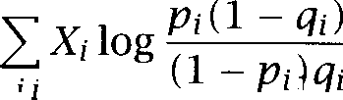

***I***

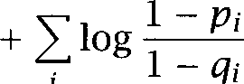

***i***

*= Xi*

C l o g -

*9i i 9i*

In the last equation above, log  is another constant term which does not affect the ranking of documents, and so we can drop it as well giving the final ranking function:



*i*



(15.6) ***g* (*d) =***

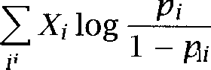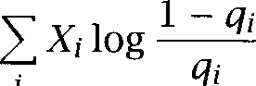

*i*

If we have a set of documents that is categorized according to relevance to the query, we can estimate the and directly. However, in ad-hoc retrieval we do not have such relevance information. That means we

have to make some simplifying assumptions in order to be able to rank documents in a meaningful way.

First, we assume that is small and constant for all terms. The first term of then becomes log  = ***c*** Xi, a simple count of the number of matches between query and document, weighted by



The fraction in the second term can be approximated by assuming that most documents are not relevant ***SO =*** = =  which is the maximum likelihood estimate of  the probability of occurrence of not conditioned on relevance.







***N***

The last approximation,  holds for most words since most words are relatively rare. After applying the logarithm, we have now arrived at the IDF weight we introduced earlier. Substituting it back into



N

N



the formula for g we get:

(15.7) Q (d)



This derivation may not satisfy everyone since we weight the term ac- cording to the Rpposite of the probability of non-relevance rather than directly according to the probability of relevance. But the probability of relevance is impossible to estimate in ad-hoc retrieval. As in many other cases in Statistical NLP, we take a somewhat circuitous route to get to a desired quantity from others that can be more easily estimated.

* + 1. Residual inverse document frequency

**INVERSE An** alternative to IDF is ***residual inverse document frequency*** or ***RIDF.* DOCUMENT** Residual IDF is defined as the difference between the logs of actual **FREQUENCY** verse document frequency and inverse document frequency predicted by

Poisson:



_

1



= log,



IDF  (1 hi))

where IDF = log,  and p is the Poisson distribution with parameter =  the average number of occurrences of per document. 1



is the Poisson probability of a document with at least one occurrence. So, for example, RIDF for insurance and in table 15.4 would be 1.29 and 0.16, respectively (with N = 79291 verify this!).

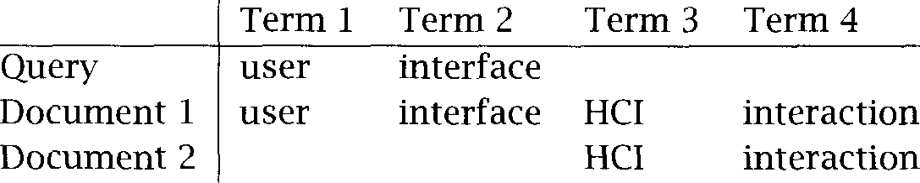

Table 15.8 Example for exploiting co-occurrence in computing content similar- ity. For the query and the two documents, the terms they contain are listed in their respective rows.

As we saw above, the Poisson distribution only fits the distribution of non-content words well. Therefore, the deviation from Poisson is a good predictor of the degree to which a word is a content word.

#### 15.4

**CO-OCCURRENCE**



**I NDEXING**

**Usage of term distribution models**

We can exploit term distribution models in information retrieval by using the parameters of the model fit for a particular term as indicators of relevance. For example, we could use RIDF or the  in the K mixture as a replacement for IDF weights (since content words have large  and large RIDF, non-content words have smaller  and smaller RIDF).

Better models of term distribution than IDF have the potential of as- sessing a term V properties more accurately, leading to a better model of query-document similarity. Although there has been little work on employing term distribution models different from IDF in IR, it is to be hoped that such models will eventually lead to better measures of content similarity.

#### Latent Semantic Indexing

In the previous section, we looked at the occurrence patterns of individ- ual words. A different source of information about terms that can be exploited in information retrieval is co-occurrence: the fact that two or more terms occur in the same documents more often than chance. Con- sider the example in table 15.8. Document 1 is likely to be relevant to the query since it contains all the terms in the query. But document 2 is also a good candidate for retrieval. Its terms *HCI* and *interaction co-occur* with and *interface,* which can be evidence for semantic relatedness. *Latent Semantic Indexing * is a technique that projects queries and

* 1. *Latent Semantic Indexing*

*A =*

|  |  |
| --- | --- |
|  |  |
| cosmonaut astronaut moon  car  truck | 1 0 1 0 0 0  1 0 0 0 0  1 1 0 0 0 0  1 0 0 1 1 0 |
| 0 0 0 1 0 1 |

Figure 15.5 An example of a term-by-document matrix *A.*

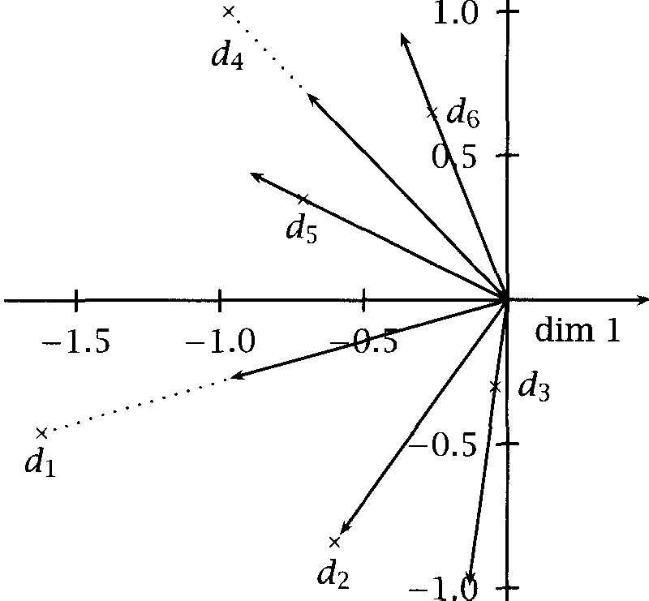

Figure 15.6 Dimensionality reduction. The documents in matrix 15.5 are shown after the five-dimensional term space has been reduced to two dimen- sions. The reduced document representations are taken from figure 15.11. In addition to the document representations  , *we* also show their  normalized vectors, which show more directly the similarity measure of cosine that is used after **LSI** is applied.



documents into a space with Oatent semantic dimensions. Co-occurring terms are projected onto the same dimensions, non-co-occurring terms are projected onto different dimensions. In the latent semantic space, a query and a document can have high cosine similarity even if they do not share any terms as long as their terms are semantically similar accord- ing to the co-occurrence analysis. We can look at LSI as a similarity metric that is an alternative to word overlap measures like tf.idf.

The latent semantic space that we project into has fewer dimensions than the original space (which has as many dimensions as terms). LSI is

**DIMENSIONALITY** thus a method for  *reduction.* A dimensionality reduction **REDUCTION** technique takes a set of objects that exist in a high-dimensional space and represents them in a low-dimensional space, often in a two-dimensional

or three-dimensional space for the purposes of visualization. The exam- ple in figure 15.5 may demonstrate the basic idea. This matrix defines a five-dimensional space (whose dimensions are the five words *astronaut, cosmonaut, moon, cur* and truck) and six objects in the space, the

Figure 15.6 shows how the six objects can be displayed in a two-dimensional space after the application of SVD (dimension 1 and dimension 2 are taken from figure 15.11, to be explained later). The visu- alization shows some of the relations between the documents, in partic- ular the similarity between  and documents) and  and (space exploration documents). These relationships are not as clear in figure 15.5. For example,  and  have no terms in common.



There are many different mappings from high-dimensional spaces to low-dimensional spaces. Latent Semantic Indexing chooses the mapping that, for a given dimensionality of the reduced space, is optimal in a sense to be explained presently. This setup has the consequence that the dimensions of the reduced space correspond to the axes



Consider the case of reducing dimensionality to 1 dimension. In order to get the best possible representation in 1 dimension, we will look for the axis in the original space that captures as much of the variation in the data as possible. The second dimension corresponds to the axis that best captures the variation remaining after subtracting out what the first axis explains and so on. This reasoning shows that Latent Semantic

**P RINCIPAL** dexing is closely related to *Principal Analysis* (PCA), another **ANALYSIS** technique for dimensionality reduction. One difference between the two techniques is that PCA can only be applied to a square matrix whereas LSI



can be applied to any matrix.

Latent semantic indexing is the application of a particular

technique, Falled Singular Value Decomposition or SVD, to a

by-document matrix. SVD (and hence LSI) is a least-squares method. The projection into the latent semantic space is chosen such that the repre- sentations in the original space are changed as little as possible when measured by the sum of the squares of the differences. We first give a simple example of a least-squares method and then introduce SVD.

* + 1. Least-squares methods

Before defining the particular least-squares method used in LSI, it is in- structive to study the most common least-squares approximation: fitting

[NEAR REGRESSION

a line to a set of points in the plane by way of linear regression. Consider the following problem. We have a set of points:

 . . . . We would like to find the line:



f(x) =



with parameters and that fits these points best. In a least-squares ap- proximation, the best fit is the one that minimizes the sum of the squares of the differences:



(15.8)

     



i=l



We compute by solving  = 0,the value of for which reaches its minimum:



**0**

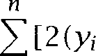

  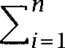   

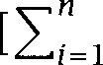

(15.9)

 



respectively.

are the means of the x and y coordinates,

We now substitute (15.9) for ***b*** in (15.8) and solve  = 0 for





***+***

 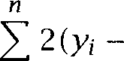  

i=l

**558** *15 Topics in Information Retrieval*

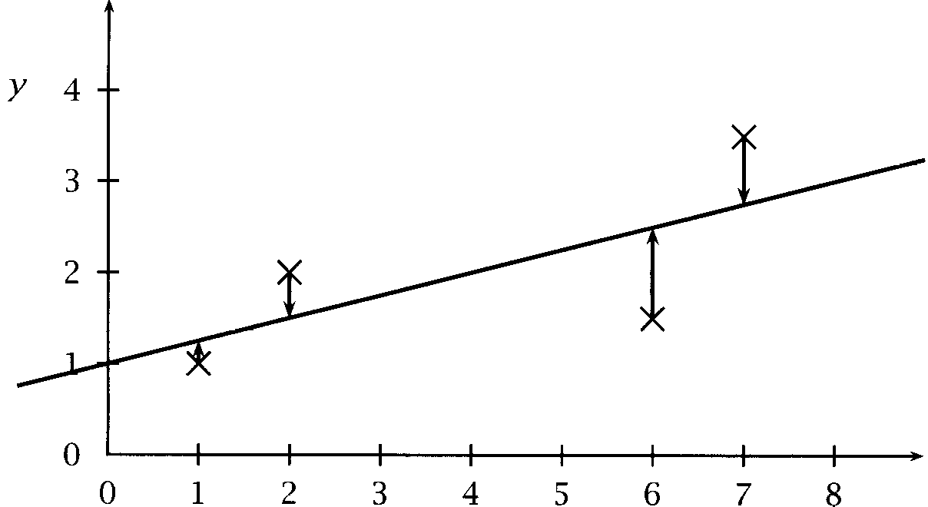

*X*

**Figure 15.7** An example of linear regression. The line y = + 1 is the best least-squares fit for the four points Arrows show which points on the line the original points are projected to.





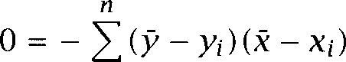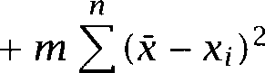

(15.10)



*- X i )*

Figure 15.7 shows an example of a least square fit for the four points (1, We have:







(X

26



and



* + 1. Singular Value Decomposition

As we have said, we can view Singular Value Decomposition or SVD as a method of word co-occurrence analysis. Instead of using a simple word overlap measure like the cosine, we instead use a more sophisticated sim- ilarity measure that makes better similarity judgements based on word

co-occurrence. Equivalently, we can view SVD as a method for

ality reduction. The relation between these two viewpoints is that in the process of dimensionality reduction, co-occurring terms are mapped onto the same dimensions of the reduced space, thus increasing similarity in the representation of semantically similar documents.

Co-occurrence analysis and dimensionality reduction are two Iunc-

tional ways of understanding We now look at the formal definition of LSI. LSI is the application of Singular Value Decomposition (SVD) to document-by-term matrices in information retrieval. SVD takes a ma- trix ***A*** and represents it as  in a lower dimensional space such that

the Gistance between the two matrices as measured by the 2-norm is

minimized:

(15.11) A =



The 2-norm for matrices is the equivalent of Euclidean distance for vec- tors. SVD is in fact very similar to fitting a line, a one-dimensional object, to a set of points, which exists in the two-dimensional plane. Figure 15.7 shows which point on the one-dimensional line each of the original points corresponds to (see arrows).

Just as the linear regression in figure 15.7 can be interpreted as pro- jecting a two-dimensional space onto a one-dimensional line, so does SVD project an n-dimensional space onto a k-dimensional space where



In our application (word-document matrices), is the number of word types in the collection. Values of that are frequently chosen are 100 and

150. The projection transforms a document V vector in n-dimensional

word space into a vector in the k-dimensional reduced space.

One possible source of confusion is that equation (15.11) compares the original matrix and a lower-dimensional approximation. Shouldn W the second matrix have fewer rows and columns, which would make equa- tion (15.11) ill-defined? The analogy with line fitting is again helpful here. The fitted line exists in two dimensions, but it is a one-dimensional ob- ject. The same is true for  it is a matrix of lower rank, that is, it could be represented in a lower-dimensional space by transforming the axes of the space. But for the particular axes chosen it has the same number of rows and columns as ***A.***

The SVD projection is computed by decomposing the  term matrix  into the product of three matrices, and 







***T =***

|  |  |  |  |  |  |
| --- | --- | --- | --- | --- | --- |
|  | Dim. 1 | Dim. 2 | Dim. 3 | Dim.4 | Dim. 5 |
| cosmonaut | -0.44 | -0.30 | 0.57 | 0.58 | 0.25 |
| astronaut | -0.13 | -0.33 | -0.59 | 0.00 | 0.73 |
| moon | -0.48 | -0.51 | -0.37 | 0.00 | -0.61 |
| car | -0.70 | 0.35 | 0.15 | -0.58 | 0.16 |
|  | -0.26 | 0.65 | -0.41 | 0.58 | -0.09 |



Figure **15.8** The matrix ***T*** of the SVD decomposition of the matrix in figure ***15.5.***

Values are rounded.

S =



0.000.000.000.002.16 0.000.000.000.001.59 0.000.000.000.001.28 0.000.000.000.001.00 0.000.390.000.000.00

Figure **15.9** The matrix of singular values of the SVD decomposition of the matrix in figure 15.5. Values are rounded.

where = We indicate dimensionality by subscripts: ***A*** has rows and columns, ***T*** has rows and columns and so on. is the transpose of ***D,*** the matrix ***D*** rotated around its diagonal:  ***= ***



Examples of A, ***T, S,*** and D are given in figure 15.5 and figures 15.8

through 15.10. Figure 15.5 shows an example of ***A. A*** contains the docu- ment vectors with each column corresponding to one document. In other words, element of the matrix records how often term i occurs in doc- ument j. The counts should be appropriately weighted (as discussed in section 15.2). For simplicity of exposition, we have not applied weighting and assumed term frequencies of 1.

Figures 15.8 and 15.10 show ***T*** and ***D,*** respectively. These matrices

**ORTHONORMAL** have columns. This means that the column vectors have unit length and are all orthogonal to each other. (If a matrix C has thonormal columns, then  = I, where I is the diagonal matrix with a diagonal of l V, and zeroes elsewhere. So we have  ***= *** ***= I.)***

We can view SVD as a method for rotating the axes of the n-dimensional space such that the first axis runs along the direction of largest variation

     

 

|  |  |  |  |  |  |  |  |  |
| --- | --- | --- | --- | --- | --- | --- | --- | --- |
| Dimension | 1 | -0.75 |  | -0.28 | - 0.20 | -0.45 | -0.33 | -0.12 |
| Dimension | 2 | -0.29 |  | -0.53 | -0.19 | 0.63 | 0.22 | 0.41 |
| Dimension | 3 | 0.28 |  | -0.75 | 0.45 | -0.20 | 0.12 | -0.33 |
| Dimension | 4 | 0.00 |  | 0.00 | 0.58 | 0.00 | -0.58 | 0.58 |
| Dimension | 5 | -0.53 |  | 0.29 | 0.63 | 0.19 | 0.41 | -0.22, |

Figure ***15.10*** The matrix of ure 15.5. Values are rounded.

the SVD decomposition of the matrix in 

among the documents, the second dimension runs along the direction with the second largest variation and so forth. The matrices and ***D*** represent terms and documents in this new space. For example, the first column of ***T*** corresponds to the first row of ***A,*** and the first column of ***D*** corresponds to the first column of ***A.***

The diagonal matrix contains the singular values of ***A in*** descending order (as in figure 15.9). The  singular value indicates the amount of variation along the  axis. By restricting the matrices ***T, S,*** and ***D*** to their first columns one obtains the matrices and  Their product  is the best least square approximation of ***A*** by a matrix of rank ***k*** in the sense defined in equation (15.11). One can also prove that is unique, that is, there is only one possible decomposition of a given matrix. See Golub and van Loan (1989) for an extensive treatment of SVD including a proof of the optimality property.



That SVD finds the optimal projection to a low-dimensional space is the key property for exploiting word co-occurrence patterns. SVD represents terms and documents in the lower dimensional space as well as possible. In the process, some words that have similar co-occurrence patterns are projected (or collapsed) onto the same dimension. As a consequence, the similarity metric will make topically similar documents and queries come out as similar even if different words are used for describing the topic. If we restrict the matrix in figure 15.8 to the first two dimensions, we end up with two groups of terms: space exploration terms (cosmonaut, as- and ***moon)*** which have negative values on the second dimension

1. SVD is unique up to sign flips. If we flip all signs in the matrices ***D*** and we get a second solution.

     

|  |  |  |  |  |  |  |
| --- | --- | --- | --- | --- | --- | --- |
| Dimension 1 | -1.62 | -0.60 | -0.04 | -0.97 | -0.71 | -0.26 |
| Dimension 2 | -0.46 | -0.84 | -0.30 | 1.00 | 0.35 | 0.65 |

Figure **15.11** The matrix = of documents after  with sin- gular values and reduction to two dimensions. Values are rounded.

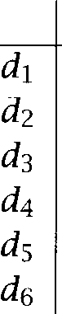



|  |  |  |  |  |
| --- | --- | --- | --- | --- |
| 1.00 |  |  |  | |
| 0.78 | 1.00 |  |
| 0.40 | 0.88 | 1.00 |
| 0.47 | -0.18 | -0.62 | 1.00 |  |
| 0.74 | 0.16 | -0.32 | 0.94 | 1.00 |
| 0.10 | -0.54 | -0.87 | 0.93 | 0.74 1.00 |

Table 15.9 The matrix of document correlations For example, the nor- malized correlation coefficient of documents and (when represented as in figure 15.11) is 0.88. Values are rounded.

and automobile terms (car and *truck)* which have positive values on the second dimension. The second dimension directly reflects the different co-occurrence patterns of these two groups: space exploration terms only co-occur with other space exploration terms, automobile terms only occur with other automobile terms (with one exception: the occurrence of in  In some cases, we will be misled by such co-occurrences patterns and wrongly infer semantic similarity. However, in most cases co-occurrence is a valid indicator of topical relatedness.

These term similarities have a direct impact on document similarity. Let us assume a reduction to two dimensions. After  with the singular values, we get the matrix =  shown in figure 15.11 where  is restricted to two dimensions (with the diagonal elements 2.16, 1.59). Matrix is a dimensionality reduction of the original matrix ***A*** and is what was shown in figure 15.6.

Table 15.9 shows the similarities between documents when they are represented in this new space. Not surprisingly, there is high similarity between  and  (0.78) and and  ***(0.94, 0.93,*** 0.74). These document similarities are about the same in the original space (i.e. when we compute correlations for the original document vectors in figure 15.5). The key change is that and whose similarity is 0.00 in the original



space, are now highly similar (0.88). Although  and  have no common terms, they are now recognized as being topically similar because of the co-occurrence patterns in the corpus.

Notice that we get the same similarity as in the original space (that is, zero similarity) if we compute similarity in the transformed space without any dimensionality reduction. Using the full vectors from figure 15.10 and  them with the appropriate singular values we get:

-0.28 x -0.20 x 2.16 -0.53 x -0.19 x 

-0.75 x 0.45 x 1.28 0.00 x 0.58 x 1.00 + 0.29 x 0.63 x 0.39 0.00

(If you actually compute this expression, you will find that the answer is not quite zero, but this is only because of rounding errors. But this is as good a point as any to observe that many matrix computations are quite sensitive to rounding errors.)

We have computed document similarity in the reduced space using the product of and The correctness of this procedure can be seen by looking at  which is the matrix of all document correlations for the original space:

(15.13) ***= *** ***= = ***

Because has orthonormal columns, we have ***= I.*** Furthermore, since is diagonal, =  Term similarities are computed analogously since one observes that the term correlations are given by:

(15.14) ***= *** ***= = ***

One remaining problem for a practical application is how to fold que- ries and new documents into the reduced space. The SVD computation only gives us reduced representations for the document vectors in ma- trix ***A.*** We do not want to do a completely new SVD every time a new query is launched. In addition, in order to handle large corpora efficiently we may want to do for only a sample of the documents (for example a third or a fourth). The remaining documents would then be folded in.

The equation for folding documents into the space can again be derived from the basic equation:

(15.15) ***A =***

 ***= ***

***=***

*i64 15 Topics in Information Retrieval*

*So we* just multiply the query or document vector with the transpose of the term matrix (after it has been truncated to the desired

ity). For example, for a query vector  and a reduction to dimensionality  the query representation in the reduced space is 

* + 1. Latent Semantic Indexing in IR

The application of SVD to information retrieval was originally proposed by a group of researchers at (Deerwester et al. 1990) and called *Latent Semantic Indexing* (LSI) in this context. LSI has been compared

**INDEXING** to standard vector space search on several document collections. It was found that LSI performs better than vector space search in many cases, especially for high-recall searches (Deerwester et al. 1990; Dumais 1995). strength in high-recall searches is not surprising since a method that

takes co-occurrence into account is expected to achieve higher recall. On the other hand, due to the noise added by spurious co-occurrence data one sometimes finds a decrease in precision.

The appropriateness of LSI also depends on the document collection. Recall the example of the vocabulary problem in figure **15.8.** In a hetero- geneous collection, documents may use different words to refer to the same topic like and *interface* in the figure. Here, LSI can help identify the underlying semantic similarity between seemingly dissimilar documents. However, in a collection with homogeneous vocabulary, LSI is less likely to be useful.

The application of SVD to information retrieval is called *Latent*

*tic Indexing* because the document representations in the original term space are transformed to representations in a new reduced space. The dimensions in the reduced space are linear combinations of the original dimensions (this is so since matrix multiplications as in equation (15.16) are linear operations). The assumption here (and similarly for other forms of dimensionality reduction like principal component analysis) is that these new dimensions are a better representation of documents and queries. The metaphor underlying the term Oatent is that these new di- mensions are the true representation. This true representation was then obscured by a generation process that expressed a particular dimension with one set of words in some documents and a different set of words in another document. LSI analysis recovers the original semantic structure of the space and its original dimensions. The process of assigning dif- ferent words to the same underlying dimension is sometimes interpreted

as a form of soft term clustering since it groups terms according to the dimensions that they are represented on in the reduced space.

One could also argue that the representation is not only better (since it is based on the 'true' dimensions), but also more compact. Many documents have more than 150 unique terms. So the sparse vector rep- resentation will take up more storage space than the compact rep- resentation if we reduce to 150 dimensions. However, the efficiency gain due to more compact representations is often outweighed by the addi- tional cost of having to go through a  matrix multiplica- tion whenever we map a query or a new document to the reduced space. Another problem is that an inverted index cannot be constructed for representations. If we have to compute the similarity between the query and every single document, then an SVD-based system can be slower than a term-based system that searches an inverted index.

The actual computation of is quadratic in the rank of the document by term matrix (the rank is (bounded by) the smaller of the number of documents and the number of terms) and cubic in the number of singular values that are computed (Deerwester et al. 1990:  For very large collections subsampling of documents and selection of terms according to frequency is often employed in order to reduce the cost of computing the Singular Value Decomposition.

One objection to SVD is that, along with all other least-squares meth- NORMALITY ods, it really designed for normally-distributed data. But, as can be seen from the discussion earlier in this chapter, such a distribution is inappropriate for count data, and count data is, after all, what a 

document matrix consists of. The link between least squares and normal distribution can be easily seen by  at the definition of the normal distribution (section 2.1.9):

o)=

1

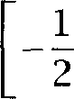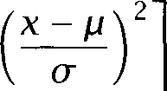exp



where is the mean and o the covariance. The smaller the squared de- viation from the mean -  the higher the probability n ( *a) .*So the least squares solution is the maximum likelihood solution. But this is only true if the underlying data distribution is normal. Other

~ ;



1. However, others have suggested that given the particular characteristics of the matri- ces that is applied to in information retrieval the complexity is linear in the number of documents and (approximately)quadratic in the number of singular values. See (Oard and (Berryet al. and (Berry and Young 1995) for discussion.

*i66 15 Topics in Information Retrieval*

like Poisson or negative binomial are more appropriate for term counts. One problematic feature of SVD is that, since the reconstruction  of the term-by-document matrix *A* is based on a normal distribution, it can have negative entries, clearly an inappropriate approximation for counts. A dimensionality reduction based on Poisson would not predict such impossible negative counts.

In defense of LSI (and the vector space model in general which can also be argued to assume a normal distribution), one can say that the matrix entries are not counts, but weights. Although this is not an issue that has been investigated systematically, the normal distribution could be appropriate for the weighted vectors even if it is not for count vectors.

From a practical point of view, LSI has been criticized for being tationally more expensive than other word co-occurrence methods while not being more effective. Another method that also uses co-occurrence

**PSEUDO-FEEDBACK** is *pseudo-feedback* (also called pseudo *relevance feedback* and two-stage retrieval, Buckley et al. 1996; Kwok and Chan 1998). In pseudo-feedback, the top documents (typically the top 10 or 20) returned by an ad-hoc query are assumed to be relevant and added to the query. Some of these top *n* documents will not actually be relevant, but a large enough pro- portion usually is to improve the quality of the query. Words that occur frequently with query words will be among the most frequent in the top *n. So* pseudo-feedback can be viewed as a cheap query-specific way of doing co-occurrence analysis and co-occurrence-based query modification.

Still, in contrast to many heuristic methods that incorporate term occurrence into information retrieval, LSI has a clean formal framework and a clearly defined optimization criterion (least squares) with one glo- bal optimum that can be efficiently computed. This conceptual simplicity and clarity make LSI one of the most interesting IR approaches that go beyond query-document term matching.

#### Discourse Segmentation

Text collections are increasingly heterogeneous. An important aspect of heterogeneity is length. On the world wide web, document sizes range from home pages with just one sentence to server logs of half a megabyte. The weighting schemes discussed in section 152.2 take account of dif- ferent lengths by applying cosine normalization. However, cosine nor- malization and other forms of normalization that discount term weights

15.5 *Discourse Segmentation 567*

according to document length ignore the distribution of terms within a document. Suppose that you are looking for a short description of  plasty. You would probably prefer a document in which the occurrences of angioplasty are concentrated in one or two paragraphs since such a concentration is most likely to contain a definition of what angioplasty is. On the other hand, a document of the same length in which the occur- rences of angioplasty are scattered uniformly is less likely to be helpful.

We can exploit the structure of documents and search over structurally defined units like sections and paragraphs instead of full documents. However, the best subpart of a document to be returned to the user often encompasses several paragraphs. For example, in response to a query on angioplasty we may want to return the first two paragraphs of a subsec- tion on angioplasty, which introduce the term and its definition, but not the rest of the subsection that goes into technical detail.

Some documents are not structured into paragraphs and sections. Or, in the case of documents structured by means of a markup language like HTML, it is not obvious how to break them apart into units that would be suitable for retrieval.

These considerations motivate an approach that breaks documents into topically coherent multi-paragraph subparts. In the rest of this sub- section we will describe one approach to multiparagraph segmentation, the  algorithm (Hearst and Plaunt 1993; Hearst 1994, 1997).

15.5.1 

The basic idea of this algorithm is to search for parts of a text where the

**SUBTOPIC** vocabulary shifts from one subtopic to another. These points are then interpreted as the boundaries of multi-paragraph units.

Sentence length can vary considerably. Therefore, the text is first

**SEQUENCES** vided into small fixed size units, the *token sequences.* Hearst suggests a size of 20 words for token sequences. We refer to the points between

**GAPS** token sequences as The  algorithm has three main com- ponents: the *cohesion scorer,* the *depth scorer* and the *boundary selector.*

**SCORER** The *cohesion scorer* measures the amount of Wopic continuity or cohe-

sion at each gap, that is, the amount of evidence that the same subtopic is prevalent on both sides of the gap. Intuitively, we want to consider gaps with low cohesion as possible segmentation points.

**DEPTH SCORER** The *depth scorer* assigns a depth score to each gap depending on how low its cohesion score is compared to the surrounding gaps. If cohesion

**BOUNDARY SELECTOR**

at the gap is lower than at surrounding gaps, then the depth score is high. Conversely, if cohesion is about the same at surrounding gaps, then the depth score is low. The intuition here is that cohesion is relative. One part of the text (say, the introduction) may have many successive shifts in vocabulary. Here we want to be cautious in selecting subtopic boundaries and only choose those points with the lowest cohesion scores compared to their neighbors. Another part of the text may have only slight shifts for several pages. Here it is reasonable to be more sensitive to topic changes and change points that have relatively high cohesion scores, but scores that are low compared to their neighbors.

The boundary selector is the module that looks at the depth scores and selects the gaps that are the best segmentation points.

Several methods of cohesion scoring have been proposed.

* *Vector Space Scoring.* We can form one artificial document out of the token sequences to the left of the gap (the  block) and another artificial document to the right of the gap (the right  (Hearst suggests a length of two token sequences for each block.) These two blocks are then compared by computing the correlation coefficient of their term vectors, using the weighting schemes that were described earlier in this chapter for the vector space model. The idea is that the more terms two blocks share the higher their cohesion score and the less likely they will be classified as a segment boundary. Vector Space Scoring was used by Hearst and Plaunt (1993) and and Allen (1993).
* Block *comparison.* The block comparison algorithm also computes the correlation coefficient of the gap V left block and right block, but it only uses within-block term frequency without taking into account (inverse) document frequency.
* *Vocabulary introduction.* A gap V cohesion score in this algorithm is the negative of the number of new terms that occur in left and right block, that is terms that have not occurred up to this point in the text. The idea is that subtopic changes are often signaled by the use of new vocabulary  1991). (In order to make the score a cohesion score we multiply the count of new terms by -1 so that larger scores (fewer new terms) correspond to higher cohesion and smaller scores (more new terms) correspond to lower cohesion.)

The experimental evidence in (Hearst 1997) suggests that Block Compar- ison is the best performing of these three algorithms.

* 1. *Discourse Segmentation*

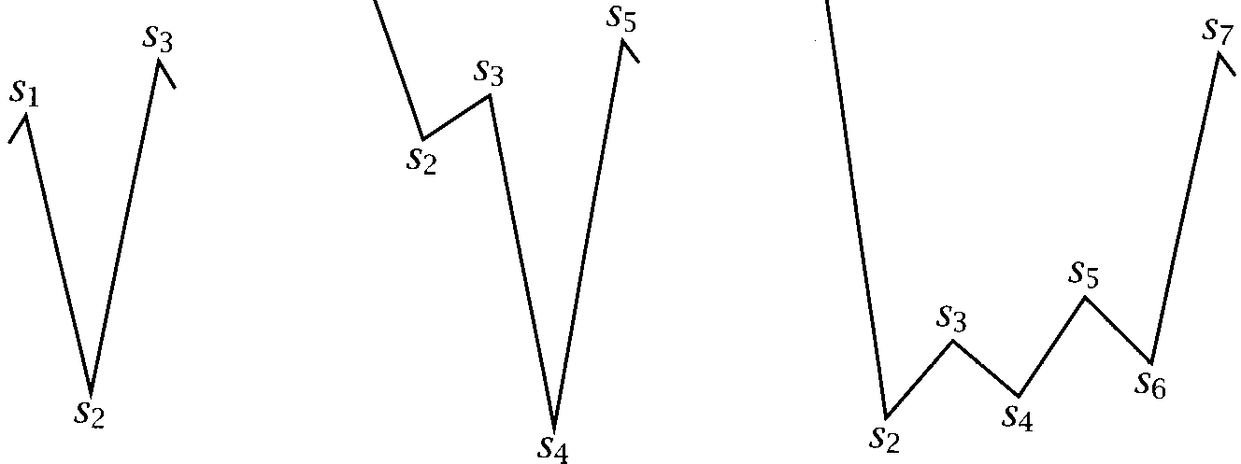

cohesion

**91**

text2

texts

Figure *15.12* Three constellations of cohesion scores in topic boundary identi- fication.

The second step in  is the transformation of cohesion scores into depth scores. We compute the depth score for a gap by summing the heights of the two sides of the valley it is located in, for example



for in text 1 in figure 15.12. Note that high absolute values of the cohesion scores by themselves will not result in the creation of a segment boundary.  views subtopic changes and segmentation as relative. In a text with rapid fluctuations of topic or vocabulary from paragraph to paragraph only the most radical changes will be accorded the status of segment boundaries. In a text with only subtle subtopic changes the algorithm will be more discriminating.



For a practical implementation, several enhancements of the basic al- gorithm are needed. First, we need to smooth cohesion scores to address situations like the one in text 2 in figure 15.12. Intuitively, the difference should contribute to the depth score of gap This is achieved by



*smoothing* scores using a low pass filter. For example, the depth score for is replaced by +  This procedure effectively takes into consideration the cohesion scores of gaps at a distance of two from the central gap. If they are as high as or higher than the two immediately surrounding gaps, they will increase the score of the central gap.



We also need to add heuristics to avoid a sequence of many small segments (this type of segmentation is rarely chosen by human judges when they segment text into coherent units). Finally, the parameters of the methods for computing cohesion and depth scores (size of token sequence, size of block, smoothing method) may have to be adjusted de- pending on the text sort we are working with. For example, a corpus with long sentences will require longer token sequences.

The third component of  is the boundary selector. It esti- mates average and standard deviation of the depth scores and selects all gaps as boundaries that have a depth score higher than for some constant c (for example, c = 0.5 or c = 1.0). We again try to avoid using absolute scores. This method selects gaps that have Vignificantly’ low depth scores, where significant is defined with respect to the average and the variance of scores.



In an evaluation, Hearst (1997) found good agreement between seg- ments found by  and segments demarcated by human judges. It remains an open question to what degree segment retrieval leads to better information retrieval performance than document retrieval when evaluated on precision and recall. However, many users prefer to see a hit in the context of a natural segment which makes it easier to quickly understand the context of the hit (Egan et al. 1989).

Text segmentation could also have important applications in other ar- eas of Natural Language Processing. For example, in word sense biguation segmentation could be used to find the natural units that are most informative for determining the correct sense of a usage. Given the increasing diversity of document collections, discourse segmentation is guaranteed to remain an important topic of research in Statistical NLP and IR.

#### Further Reading

Two major venues for publication of current research in IR are the TREC proceedings  1996, see also the links on the website), which re- port results of competitions sponsored by the US government, and the ACM SIGIR proceedings series. Prominent journals are Information Pro- ***cessing &Management,*** the ***Journal of the American Society for Informa- tion Science,*** and ***Information Retrieval.***

The best known textbooks on information retrieval are books by van

* 1. *Further Reading 571*

Rijsbergen and McGill (1983) and Frakes and Baeza-Yates (1992). See also  1998) and (Korfhage 1997). A collection of seminal papers was recently edited by Sparck Jones and Willett (1998). Smeaton (1992) and Lewis and Jones (1996) discuss the role of NLP in informa- tion retrieval. Evaluation of IR systems is discussed in (Cleverdon and Mills  (Tague-Sutcliffe  and (Hull 1996). Inverse document frequency as a term weighting method was proposed by Sparck Jones (1972). Different forms of tf.idf weighting were extensively investigated within the SMART project at Cornell University, led by Gerard



 1971b; and McGill 1983). Two recent studies are  et al. 1996) and (Moffat and Zobel1998).

The Poisson distribution is further discussed in most introductions to probability theory, e.g., (Mood et al. 1974: 95). See (Harter 1975) for a way of estimating the parameters and  of the two-Poisson model without having to assume a set of documents labeled as to their class membership. Our derivation of IDF is based on (Croft and Harper 1979)). RIDF was introduced by Church (1995).



Apart from work on better phrase extraction, the impact of NLP on IR in recent decades has been surprisingly small, with most IR researchers fo- cusing on shallow analysis techniques. Some exceptions are  1987; Bonzi and Liddy 1988; Sheridan and Smeaton 1992; Strzalkowski 1995; Klavans and Kan 1998). However, recently there has been much more interest in tasks such as automatically summarizing documents rather than just returning them as is  et al. 1994; Kupiec et al.  and such trends may tend to increase the usefulness of NLP in IR applications. One task that has benefited from the application of NLP techniques is

**CROSS-LANGUAGE ** *information retrieval* or *CLIR* (Hull and Grefenstette 1998;

**INFORMATION** Grefenstette 1998). The idea is to help a user who has enough knowledge

**RETRIEVAL**

CLIR

of a foreign language to understand texts, but not enough fluency to for- mulate a query. In CLIR, such a user can type in a query in her native language, the system then translates the query into the target language and retrieves documents in the target language. Recent work includes (Sheridan et al. 1997; Nie et al. 1998) and the Notes of the AAAI sympo- sium on cross-language text and speech retrieval (Hull and Oard 1997). Littman et al. (1998b) and Littman et al. (1998a) use Latent Semantic In- dexing for CLIR.

We have only presented a small selection of work on modeling term distributions in IR. See (van Rijsbergen 1979: ch. 6) for a more systema- tic introduction. (Robertson and Sparck Jones 1976) and (Bookstein and

*Topics in Information Retrieval*

Swanson 1975) are other important papers (the latter is a decision theo- retic approach). Information theory has also been used to motivate **IDF** (Wong and Yao 1992). An application of residual inverse document fre- quency to the characterization of index terms is described by Yamamoto and Church (1998).

The example in table 15.8 is adapted from (Deerwester et al. 1990). The term-by-document matrix we used as an example for is small. It can easily be decomposed using one of the standard statistical packages (we used S-plus). For a large corpus, we have to deal with several hundred thousand terms and documents. Special algorithms have been developed for this purpose. See (Berry 1992) and on the world wide web for a description and implementation of several such algorithms.

Apart from term-by-document matrices, SVD has been applied to

by-word matrices by and Pedersen (1997) and to discourse seg- mentation (Kaufmann 1998). Dolin (1998) uses LSI for query categoriza- tion and distributed search, using automated classification for collection summarization.

Latent Semantic Indexing has also been proposed as a cognitive model for human memory. Landauer and Dumais (1997) argue that it can ex- plain the rapid vocabulary growth found in school-age children.

**SEGMENTATION** Text segmentation is an active area of research. Other work on the problem includes  and Buckley 19911, (Beeferman et al. 1997) and (Berber Sardinha 1997). Kan et al. (1998) make an implementation of their segmentation algorithm publicly available (see website). An information source that is different from the word overlap measure used in 

**LEXICAL CHAINS** is so-called *lexical chains:* chains of usages of one or more semantically related words throughout a text. By observing starts, interruptions, and terminations of such chains, one can derive a different type of description of the subtopic structure of text (Morris and Hirst 1991).

Text segmentation is a rather crude treatment of the complexity of written texts and spoken dialogues which often have a hierarchical and non-linear structure. Trying to do justice to this complex structure is a much harder task than merely detecting topic changes. Finding the best approach to this problem is an active area of research in Statistical

**ANALYSIS** NLP. The special issue of Computational Linguistics on empirical *dis- course analysis,* edited by Walker and Moore  is a good starting point for interested readers.

When Statistical NLP methods became popular again in the early  discourse modeling was initially an area with a low proportion of

* 1. ***Exercises***

cal work, but there has been a recent surge in the application of quantita- tive methods. For some examples, see (Stolcke et al.  (Walker et al.

**MODELING** 1998) and (Samuel et al. 1998) for probabilistic approaches to ***dialog mod- eling*** and (Kehler 1997) and (Ge et al. 1998) for probabilistic approaches

**ANAPHORA** to ***anaphora resolution.***

**RESOLUTION**

#### 15.7 Exercises

Exercise 15.1 

Try to find out the characteristics of various search engines. Do they use a stop list? Try to search for stop words. Can you search for the phrase ***the the?*** Do the engines use stemming? Do they normalize words to lowercase? For example, does a search for  return anything?

Exercise 15.2 

The simplest way to process phrases in the vector space model is to add them as separate terms. For example, the query ***car insurance rates*** might be translated into an internal representation that contains the terms car, insurance, ***rates, car insurance, insurance rates.*** This means that phrases and their constituent words are treated as independent sources of evidence. Discuss why this is problematic.

Exercise 15.3  Show that Katz V K mixture satisfies:



That is, the fit of the estimate to the actual count is always perfect for the num- ber of documents with zero occurrences.

Exercise 15.4 

Compute Residual **IDF** for the words in table 15.7. Are content words and content words well separated?

Exercise **15.5 **

Select a non-content word, a content word and a word which you are not sure how to classify and compute the following quantities for them: (a) document frequency and collection frequency, (b) **(c) RIDF,** and (d) and  of the K mixture. (You can use any reasonable size corpus of your choice.)

Exercise 15.6 

Depending on  the Poisson distribution is either monotonically falling or has the shape of a curve that first rises, and then falls. Find examples of each. What is the property of that determines the shape of the graph?

***574 15 Topics in Information Retrieval***

Exercise 15.7 

Compute the SVD decomposition of the term-by-document matrix in figure 15.5 using S-Plus or another software package.

Exercise 15.8 

In this exercise, we look at two assumptions about subtopic structure that are made in 

First,  performs a ***linear*** segmentation, that is, a text is divided into a sequence of segments. No attempt is made to impose further structure. One example where the assumption of linearity is not justified is noted by Hearst: a sequence of three paragraphs that is then summarized in a fourth paragraph. Since the summary paragraph has vocabulary from paragraphs 1 and 2 that does not occur in paragraph 3 a segment boundary between 3 and 4 is inferred. Pro- pose a modification of  that would recognize paragraphs l-4 as a unit.

Another assumption that  relies on is that most segment boundaries are characterized by pronounced valleys like the one in text 1 in figure 15.12. But sometimes there is a longer flat region between two segments. Why is this a problem for the formulation of the algorithm described above? How could one fix it?

## 16 Text Categorization





**CLASSES CATEGORIES**

**THIS CHAPTER** both introduces an important **NLP** problem, text cat- egorization, and provides a more general perspective on classification, including coverage of a number of important classification techniques that are not covered elsewhere in the book.  or  is the task of assigning objects from a universe to two or more classes

or *categories.* Some examples are shown in table 16.1. Many of the tasks that we have already studied in detail, such as tagging, word sense biguation, and prepositional phrase attachment are classification tasks. In tagging and disambiguation, we look at a word in context and classify it as being an instance of one of its possible part of speech tags or an in- stance of one of its senses. In PP attachment, the two classes are the two different attachments. Two other **NLP** classification tasks are author and language identification. Determining whether a newly discovered poem was written by Shakespeare or by a different author is an example of au- thor identification. A language identifier tries to pick the language that a document of unknown origin is written in (see exercise 16.6).

In this chapter, we will concentrate on another classification problem,

**TEXT** *text categorization.* The goal in text categorization is to classify the topic **TEGORIZATION** or theme of a document. A typical set of topic categories is the one used in the Reuters text collection, which we will introduce shortly. Some of its

topics are Pergers and acquisitions, Zheat, Frude oil, and Harnings

reports. One application of text categorization is to filter a stream of news for a particular interest group. For example, a financial journalist may only want to see documents that have been assigned the category Pergers and acquisitions.”

In general, the problem of statistical classification can be characterized

**TRAINING SET** as follows. We have a *training set* of objects, each labeled with one or

16 *Text Categorization*

Problem Object

tagging context of a word

disambiguation context of a word

PP attachment sentence author identification document language identification document text categorization document

Categories

the word V tags the word V senses parse trees

authors languages topics

**Table 16.1** Some examples of classification tasks in NLP. For each example, the table gives the type of object that is being classified and the set of possible categories.

**DATA REPRESENTATION**

**MODEL**

**MODEL CLASS TRAINING PROCEDURE**

**GRADIENT DESCENT HILL CLIMBING**

more classes, which we encode via a data representation model. Typically each object in the training set is represented in the form where is a vector of measurements and c is the class label. For text categorization, the information retrieval vector space model is frequently used as the data representation. That is, each document is represented as a vector of (possibly weighted) word counts (see section 15.2). Finally, we define a class and a *training* procedure. The model class is a parameterized family of classifiers and the training procedure selects one classifier from this  An example of such a family for binary

classification is linear classifiers which take the following form:





where we choose class for 0 and class for 0. This family is parameterized by the vector and the threshold

We can think of training procedures as algorithms for function fitting, which search for a good set of parameter values, where Joodness is determined by an optimization criterion such as misclassification rate or entropy. Some training procedures are guaranteed to find the optimal set of parameters. However, many iterative training procedures are only guaranteed to find a better set in each iteration. If they start out in the wrong part of the search space, they may get stuck in a local optimum without ever finding the global optimum. An example of such a training procedure for linear classifiers is *gradient descent* or *climbing* which we will introduce below in the section on



1. Note however that some classifiers like nearest-neighbor classifiers are non-parametric and are harder to characterize in terms of a model class.

*577*

YES is correct NO is correct

YES was assigned a *b*

*NO* was assigned c ***d***

Table 16.2 Contingency table for evaluating a binary classifier. For example, a

is the number of objects in the category of interest that were correctly assigned to the category.

Once we have chosen the parameters of the classifier (or, as we usually say, the classifier), it is a good idea to see how well it is doing on

**TEST SET** a *test set.* This test set should consist of data that was not used during

training. It is trivial to do well on data that the classifier was trained on. The real test is an evaluation on a representative sample of unseen data since that is the only measure that will tell us about actual performance in an application.

For binary classification, classifiers are typically evaluated using a table **ACCURACY** of counts like table 16.2. An important measure is classification accu- racy which is defined as  the proportion of correctly classified

objects. Other measures are precision,  recall,  and fallout,  See section 8.1.

In classification tasks with more than two categories, one begins by making a 2 x 2 contingency table for each category separately (evaluat- ing versus  There are then two ways to proceed. One can compute an evaluation measure like accuracy for each contingency table separately and then average the evaluation measure over categories to get an overall

**RO-AVERAGING** measure of performance. This process is called  Or one **IO-AVERAGING** can do micro-averaging, in which one first makes a single contingency ta- ble for all the data by summing the scores in each cell for all categories.

The evaluation measure is then computed for this large table. averaging gives equal weight to each category whereas micro-averaging gives equal weight to each object. The two types of averaging can give divergent results when precision is averaged over categories with differ- ent sizes. Micro-averaged precision is dominated by the large categories whereas macro-averaged precision will give a better sense of the quality of classification across all categories.

In this chapter we describe four classification techniques: decision trees, maximum entropy modeling, and *k* nearest neigh- bor classification. These are either important classification techniques



node 5

1704 articles

**node** 1

***7681*** articles

***= 0.300***

split: cts value: 2

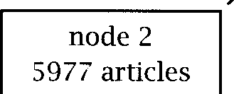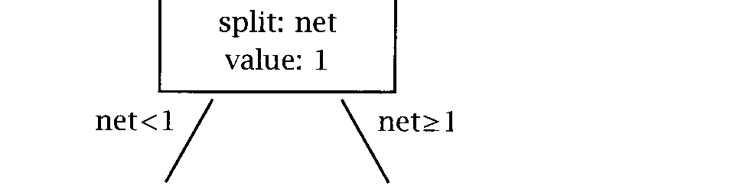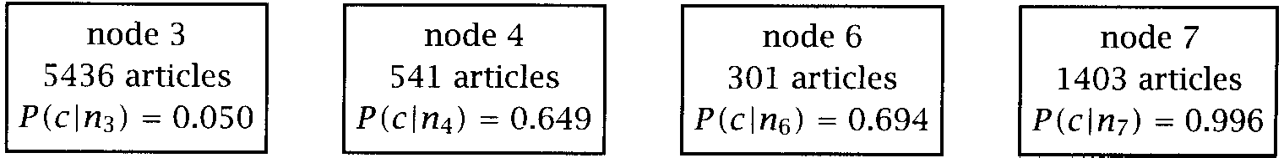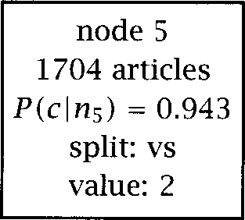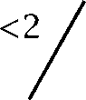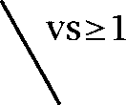

***= 0.116***

***= 0.943***

split: vs value: 2

Figure 16.1 A decision tree. This tree determines whether a document is part of the topic category Harnings or not. ***P*** is the probability of a document at node to belong to the Harnings category c.



in their own right, or, in the case of the perceptron, are the simplest ex- ample of an important class of techniques, neural networks. We conclude with some pointers to further reading.

#### Decision Trees

**DECISION TREES** As the first class of classification models, we introduce *decision trees.* An example of a decision tree is shown in figure 16.1. This tree de- cides whether to assign documents to the Reuters category Harnings.” We classify a document by starting at the top node, testing its question, branching to the appropriate node, and then repeating this process until we reach a leaf node. For example, a document with weight 1 for *cts* and weight 3 for *net* takes the left branch at the top node and then the right branch at the child node. Its probability of being in the category Harnings given that it belongs to node 4 is then estimated as 0.649. At each node, we show the number of articles in the training set that belong



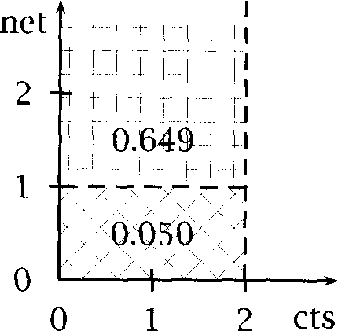

**Figure 16.2** Geometric interpretation of part of the tree in figure 16.1.

to the node, the probability of a member of the node being in the cate- gory Harnings, the word (or dimension) we split on at this node, and the weight of the word we split on.

Another way to visualize the tree is shown in figure 16.2. The horizon- tal axis corresponds to the weight for the vertical axis to the weight for *net.* Questions ask whether the value of some feature is less than some value or not. The top node in figure 16.1 defines a decision bound- ary corresponding to the vertical line *=* 2 in figure 16.2. The left child node subdivides the left region into two regions above and below

Q*et =* 1.” The upper subregion (marked with  *= 0.649)* corre-

sponds to node 4, the lower subregion to node 4. Note that the region to the right of the decision boundary Fts = 2 is not further subdivided be- cause node 5 splits on not on *net* We would need a three-dimensional graph to also show the effect of node 5.

The text categorization task that we use as an example in this chapter is to build  that distinguish the Harnings category in the *Reuters* collection. The Reuters collection is currently the most popular database for evaluating text categorization research. The version we use (based on the so-called Modified Apte Split,  et al. 1994) consists of 9603 training articles and 3299 test articles that were sent over the Reuters in 1987. The articles are categorized with more than

100 topics such as Pergers and acquisitions and Lnterest rates. An

example of an article in this category is shown in figure 16.3. See the for references to the Reuters collection.

The first task in text categorization is to find an appropriate data

**<REUTERS**



**<TEXT>**

**<TITLE>COBANCO INC &lt;CBCO> YEAR NET</TITLE>**

**<DATELINE> SANTA CRUZ, Feb 26 </DATELINE>**

**34 cts 1.19 dlrs Net 807,000 vs **

**Assets 510.2 mln vs 479.7 mln**

**Deposits 472.3 mln vs 440.3 mln**

**Loans 299.2 mln vs 327.2 mln**

**Note: 4th qtr not available. Year includes 1985 extraordinary gain from tax carry forward of 132,000 dlrs, or five cts per shr.**

**Reuter**

**</BODY></TEXT>**

**</REUTERS>**

Figure 16.3 An example of a Reuters news story in the topic category Harn ings. Parts of the original have been omitted for brevity.

**(16.1)**

**resentation** model. This is an art in itself, and usually depends on the particular categorization method used, but to simplify things, we will use a single data representation throughout this chapter. It is based on the 20 words whose  score with the category Harnings in the train- ing set was highest (see section 5.3.3 for the  measure). The words loss, *profit,* and *cts* (for Fents ), all three of which seem obvious as good indicators for an earnings report, are some of the 20 words that were selected. Each document was then represented as a vector of *K =* 20 integers,  **= ** **. . . , ** where was computed as the following quantity:

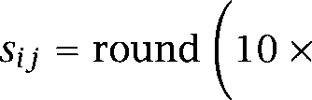Here,  is the number of occurrences of term *i* in document and  is the length of document j. The score is set to 0 for no occurrences of the term. So for example, if profit occurs 6 times in a document of length 89 words, then the score for *profit* would be = 10 **x** 5.09



**+**

1 +



Word  Term weight Classification



 

cts 3

3

6 3

000 4

loss 0

0

0

3 4

profit 0

dlrs 3

1 2

0

is 0

S 0

that 0

net 3

2

at 0

Table 16.3 The representation of document **11, shown** in figure 16.3. This illustrates the data representation model which we use for classification in this chapter.

which would be rounded to 5. This weighting scheme does log weighting similar to the schemes discussed in chapter 15, while at the same time incorporating weight normalization. We round values to make it easier to present and inspect data for pedagogical reasons.

The representation of the document in figure 16.3 is shown in ta- ble 16.3. As tends to happen when using an automatic feature selection method, some of the selected words don W seem promising as indicators of Harnings, for example, that and The three symbols  Ot , and  were selected because of a formatting peculiarity in the publicly available Reuters collection: a large proportion of articles in the category Harn- ings have a company tag like in the title line whose left angle bracket was converted to an SGML character entity. We can think of this

*16 Text Categorization*

|  |  |  |
| --- | --- | --- |
| entropy at node 1, | = 0.300 | 0.611 |
| entropy at node 2, | = 0.116 | 0.359 |
| entropy at node 5, | = 0.943 | 0.219 |
| weighted sum of 2 and 5 |  | x 0.359 + x 0.219 = 0.328 |
| information gain |  | 0.611 0.328 = 0.283 |

Table 16.4 An example of information gain as a splitting criterion. The table shows the entropies for nodes 1, 2, and 5 in figure 16.1, the weighted sum of the child nodes and the information gain for splitting 1 into 2 and 5.

left angle bracket as indicating: 7his document is about a particular company.” We will see that this Peta-tag is very helpful for classifica- tion. The title line of the document in figure 16.3 has an example of the

Now that we have a model class (decision trees) and a representation for the data  vectors), we need to define the training proce- dure. Decision trees are usually built by first growing a large tree and

**PRUNING** then pruning it back to a reasonable size. The pruning step is necessary **OVERFITTING** because very large trees  the training set. Overfitting occurs when classifiers make decisions based on accidental properties of the training

set that will lead to errors on the test set (or any new data). For exam- ple, if there is only one document in the training set that contains both the words and (for Gollars and Sercent ) and this document happens to be in the earnings category, then the training procedure may grow a large tree that categorizes all documents with this property as being in this category. But if there is only one such document in the training set, this is probably just a coincidence. When the tree is pruned back, then the part that makes the corresponding inference (assign to Harnings if one finds both and  will be cut off, thus leading to better performance on the test set.

**SPLITTING CRITERION** For growing the tree, we need a *splitting criterion* for finding the

**STOPPING CRITERION** ture and its value that we will split on and a *stopping criterion* which determines when to stop splitting. The stopping criterion can trivially be that all elements at a node have an identical representation or the same category so that splitting would not further distinguish them.

The splitting criterion which we will use here is to split the objects at a

1. The string should really have been tokenized as a unit, but it can serve as an example of the low-level data problems that occur frequently in text categorization.

**ORMATION GAIN**

node into two piles in the way that gives us maximum information gain.

***Information gain*** (Breiman et al. 1984: 25, Quinlan 1986: section 4,

lan 1993) is an information-theoretic measure defined as the difference of the entropy of the mother node and the weighted sum of the entropies of the child nodes:

(16.2) = =  

where a is the attribute we split on, y is the value of a we split on, t is the distribution of the node that we split, and are the proportion of elements that are passed on to the left and right nodes, and and are the distributions of the left and right nodes. As an example, we show the values of these variables and the resulting information gain in table 16.4 for the top node of the decision tree in figure 16.1.

Information gain is intuitively appealing because it can be interpreted as measuring the reduction of uncertainty. If we make the split that max- imizes information gain, then we reduce the uncertainty in the resulting classification as much as possible. There are no general algorithms for finding the optimal splitting value efficiently. In practice, one uses heuris- tic algorithms that find a near-optimal 

A node that is not split by the algorithm because of the stopping cri-

**LEAF NODE**

terion is a ***leaf node.*** The prediction we make at a leaf node is based on its members. We can compute maximum likelihood estimates, but smoothing is often appropriate. For example, if a leaf node has 6 mem- bers in the category Harnings and 2 other members, then we would estimate the category membership probability of a new document in the node as  =  = 0.7 if we use add-one smoothing (section 6.2.2).

Once the tree has been fully grown, we prune it to avoid overfitting and to optimize performance on new data. At each step, we select the re- maining leaf node that we expect by some criterion to be least helpful (or even harmful) for accurate classification. One common pruning criterion is to compute a measure of confidence that indicates how much evidence there is that the node is Kelpful (Quinlan 1993). We repeat the pruning process until no node is left. Each step in the process (from the full tree to the empty tree) defines a classifier the classifier that corresponds to the decision tree with the nodes remaining at this point. One way to

1. We could afford an exhaustive search for the optimal splitting value here because the are integers in a small interval.

the best of these trees (where *n* is the number of internal nodes of

**VALIDATION** the full tree) is by *validation* on held out data.

**VALIDATION SET** Validation evaluates a classifier on a held-out data set, the *validation* set to assess its accuracy. For the same reason as needing independent test data, in order to evaluate how much to prune a decision tree we need to look at a new set of data which is what evaluation on the valida- tion set does. (See section 6.2.3 for the same basic technique used in smoothing.)

An alternative to pruning a decision tree is to keep the whole tree, but to make the classifier probability estimates a function of internal as well as leaf nodes. This is a means of getting at the more reliable probability distributions of higher nodes without actually pruning away the nodes below them. For each leaf node, we can read out the sequence of nodes and associated probability distributions from that node to the root of the decision tree. Rather than using held out data for pruning, held out data can be used to train the parameters of a linear interpolation (sec- tion 6.3.1) of all these distributions for each leaf node, and these interpo- lated distributions can then be used as the final classification functions.  (1994) that this gives superior performance to pruning, at least for the statistical parsing problem on which he was working (see section 12.2.2).

Figure 16.4 shows how performance of a decision tree depends on pruning. The x-axis corresponds to number of nodes pruned, the y-axis to classification accuracy. In order to produce the graph we grew the tree on 80% of the training set (7681 documents) and set 20% (1922 doc- uments) aside as the validation set. The pruning of the top node is not shown in the 

The pattern we find is standard: performance on the training set is maximum for the full tree and then falls off continuously. Since we op- timize the initial construction of the full tree on the training set, larger trees will fit the properties of the training set better than pruned trees, hence the decrease in performance on the training set as we go from left to right.

Accuracy for validation and test sets peaks somewhere in the middle. When performance peaks we have reached the point where parts of the tree that fit accidental properties of the training set have been pruned

1. The pruning criterion was to select the leaf node with the lowest information gain on the validation set.



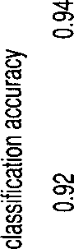**8 0 0 8 5 0 9 0 0 9 5 0 1 0 0 0**

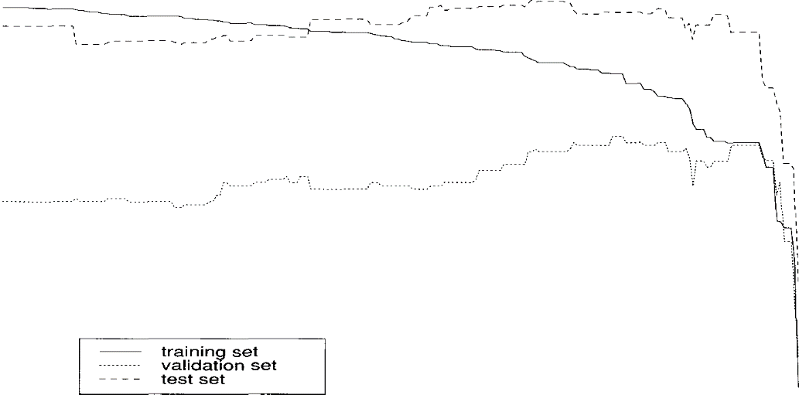

**number of nodes pruned**

Figure 16.4 Pruning a decision tree. The graph shows how classification accu- racy of a decision tree depends on pruning. Optimal performance on the test set (96.21% accuracy) is reached for 951 nodes pruned. Optimal performance on the validation set (93.91% accuracy) is reached for 974-977 nodes pruned. For these four pruned trees, performance on the test set is  close to optimal performance. Performance on the training set is monotonically decreasing.

away. Oversimplifying a little bit, any further pruning will delete nodes that capture correct generalizations about the Harnings category, hence the decrease in performance.

One strategy for selecting a tree is to pick the one that performs best for the validation set. As we can see in the picture it does not perfectly coincide with the peak for the test set, but it is close enough. The tree that performs best on the validation set will often be slightly overtrained or slightly undertrained, but usually it will be close to optimal performance. Table 16.5 evaluates performance of the tree with 50 internal nodes on the test set. This is the smallest tree with the optimal performance of

93.91% accuracy on the validation set.

A problem with setting aside a validation set is that a relatively large part of the full training set is wasted. A better method is to use n-fold

**X%-VALIDATION *cross-validation*** (cf. section 62.4) to estimate a good size for the pruned

|  |  |  |
| --- | --- | --- |
| Harnings” | Harnings | correct? |
| assigned? | YES | NO |
|  | *1024* | 69 |
| **NO** | *63* | *2143* |

Table 16.5 Contingency table for a decision tree for the Reuters category Harn- ings. Classification accuracy on the test set is 96.0%.

decision tree. For example, in 5-fold cross-validation we split the data into five parts. We reserve one part as a validation set, train the tree on the other four parts and then prune it back based on the held-out part. This process is repeated four times using each of the other four parts as a validation set. We then determine the average size of an optimally per- forming pruned tree. Finally, a new tree is grown for the *entire* training set and pruned back to what we have calculated to be the optimal size.

The interdependence of complexity of the learning device and accuracy on the training set is an important characteristic of many classification methods. If the device is too complex (or has too many parameters), then we risk overfitting and low accuracy on new data. If the device is not complex enough, it is not able to make maximum use of the training data, which again leads to lower than optimal accuracy on new data. The trick is to find just the right balance and cross-validation is one approach to doing that.

Another common property of classification methods is shown in fig- ure 16.5, the dependence of classification accuracy on the amount of training data available. Not surprisingly, the more training data, the bet- ter up to a point where performance improvement levels off. Sometimes one gets lucky with a small set (hence the fluctuations), but one cannot be sure that a tree trained on a small data set will perform well.

**LEARNING CURVES** Computing *learning curves* like those in figure 16.5 is important to de- termine the size of an appropriate training set. Many training procedures are computationally expensive, so it is advantageous to avoid overly large training sets. But on the other hand, insufficient training data will result in suboptimal classification accuracy. Looking at the curve lets one de- cide how much data is enough for optimal performance. (Of course, there are many cases in which one has no control over the amount of training data available and has to live with a small training set even though a larger one would give much better performance.)

|  |  |  |  |  |  |
| --- | --- | --- | --- | --- | --- |
|  |  |  |  |  |  |
| **0** | **2 0 0 0** | **4 0 0 0**  **number of** | **6 0 0 0 6 0 0 0**  **articles in training set** | **10000** | **12000** |

Figure 16.5 Classification accuracy depends on the amount of training data available. The x axis corresponds to the number of training documents the deci- sion tree was trained on. The y axis corresponds to accuracy on the test set for a decision tree selected based on a constant size validation set. Classification accuracy is highly variable for small training set sizes and increases and levels off for larger sets.

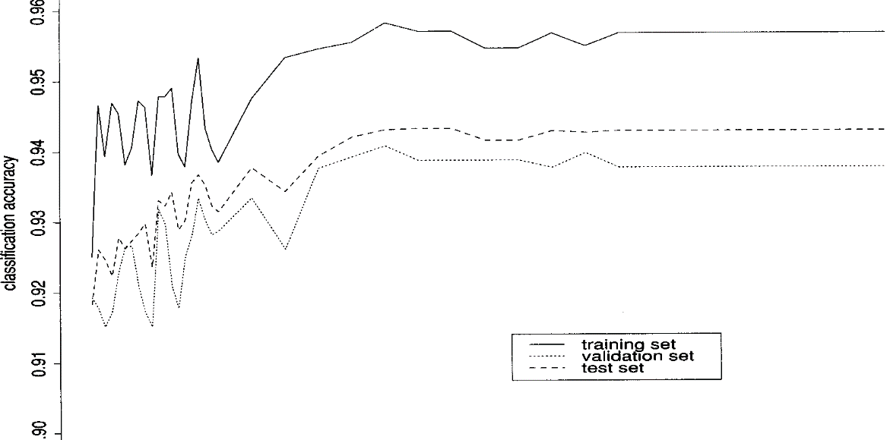

When are decision trees appropriate for a classification task in NLP? Decision trees are more complex than classifiers like Naive Bayes (sec- tion  linear regression (section  and logistic regression. If the classification problem is simple (in particular, if it is ***linearly***

 ***see*** below), then these simpler methods are often preferable. Decision trees also split the training set into smaller and smaller subsets. This makes correct generalization harder, since there may not be enough data for reliable prediction, and incorrect generalization easier, since smaller sets have accidental regularities that don W generalize. Figure 16.6 gives a simple example of this problem from the domain of learning phono- logical rules. Pruning addresses this problem to some extent, but some learning problems are better handled by methods that look at all features simultaneously. The other three methods we introduce in this chapter all

have this property.

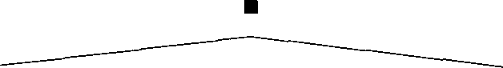

**-VOICED**

 



**-COR +COR -COR** *d*

 

*t* **-ANT +ANT** *d* **-ANT +ANT**

 **I I **

*t ad d ad*

Figure 16.6 An example of how decision trees use data inefficiently from the domain of phonological rule learning. The regular rule for the English past tense is that one gets after a voiceless sound, and after a voiced sound, except after sounds (i.e., where one gets /ad/. Because the voicing feature has the greatest information gain, the tree splits on that feature first, but that makes the remaining conditioning harder to learn because the relevant data has been subdivided into different bins within which learning is attempted independently.



The greatest advantage of decision trees is that they can be interpreted so easily. It is easy to trace the path from the root to a leaf node for a couple of articles and to develop an intuition as to how the decision tree works. **This** is not only invaluable in debugging one V own code and understanding a new problem domain, but it also allows one to explain the classifier to researchers and laymen alike, an important property in research collaboration and practical applications.

Exercise 16.1 [*I

What is the classification accuracy of the trivial tree with one leaf node for the

Harnings category?

Exercise 16.2

In section 7.1, we introduced upper and lower bounds as a way to assess how hard a particular classification problem is. What are upper and lower bounds for the Harnings category?

Exercise 16.3 

An important application of text categorization is the detection of spam (also known as unsolicited bulk Try to collect at least a hundred spam mes- sages and non-spam messages, divide them into training and test sets and build

a decision tree that detects spam. Finding the right features is paramount for this task, so design your feature set carefully.

Exercise 16.4 

Another important application of text categorization is the detection of Ddult’ content, that is, content that is not appropriate for children because it is sexually explicit. Collect training and test sets of adult and non-adult material from the World Wide Web and build a decision tree that can block access to adult material.

Exercise 16.5 

Collect a reasonable amount of text written by yourself and by a friend. You may want to break up individual texts (e.g., term papers) into smaller pieces to get a large enough set. Build a decision tree that automatically determines whether you are the author of a piece of text. Note that it is often the Oittle words that give an author away (for example, the relative frequencies of words like because or 

Exercise 16.6 

Download a set of English and non-English texts from the World Wide Web or use some other multilingual source. Build a decision tree that can distinguish between English and non-English texts. (See also exercise 6.10.)

#### Maximum Entropy Modeling

Maximum entropy modeling is a framework for integrating information from many heterogeneous information sources for classification. The data for a classification problem is described as a (potentially large) num- ber of features. These features can be quite complex and allow the exper- imenter to make use of prior knowledge about what types of information are expected to be important for classification. Each feature corresponds to a constraint on the model. We then compute the entropy ***model,*** the model with maximum entropy of all the models that satisfy the constraints. This term may initially seem perverse, since we have spent most of the book trying to minimize the (cross) entropy of mod- els, but the idea is that we do not want to go beyond the data. If we chose a model with less entropy, we would add Lnformation constraints to the model that are not justified by the empirical evidence available to us. Choosing the maximum entropy model is motivated by the desire to preserve as much uncertainty as possible.

We have simplified matters in this chapter by neglecting the problem of

feature selection (we use the same 20 features throughout). In maximum entropy modeling, feature selection and training are usually integrated.

Ideally, this enables us to specify all potentially relevant information at the beginning, and then to let the training procedure worry about how to come up with the best model for classification. We will only introduce the basic method here and refer the reader to the Further Reading for feature selection.

For a given set of features, we first compute the expectation of each fea- ture based on the training set. Each feature then defines the constraint

**EMPIRICAL** that this  ***expectation*** be the same as the expectation the feature **EXPECTATION** has in our final maximum entropy model. Of all probability distributions **MAXIMUM ENTROPY** that obey these constraints, we attempt to find the maximum ***entropy***

**DISTRIBUTION** distribution, the one with the highest entropy. One can show that there

is a unique such maximum entropy distribution and there exists an al- gorithm, generalized iterative scaling, which is guaranteed to converge to it.

The features  are binary functions that can be used to characterize any property of a pair (2,  where is a vector representing an input element (in our case the vector of word weights repre- senting an article as in table  and c is the class label (1 if the article is in the Harnings category, 0 otherwise). For text categorization, we define features as follows:



1

Recall that is the term weight for word ***i*** in Reuters article  Note that the use of binary features is different from the rest of this chapter: The other classifiers use the magnitude of the weight, not just the presence or absence of a 

The model class for the particular variety of maximum entropy

**LOGLINEAR MODELS** ing that we introduce here is  ***models*** of the following form: (16.4)  



where ***K*** is the number of features, is the weight for feature  and Z is

a normalizing constant, used to ensure that a probability distribution results. To use the model for text categorization, we compute  0) and

1. While the maximum entropy approach is not in principle limited to binary features, known reasonably efficient solution procedures such as generalized iterative scaling, which we introduce below, do only work for binary features.

**FEATURES**

**(16.5)**

 1) and, in the simplest case, choose the class label with the greater probability.

Note that, in this section,  contain information about the class of the object in addition to the of the object we want to classify. Here, we are following most publications on maximum entropy modeling in defining feature in this sense. The more common use of the term Ieature (which we have adopted for the rest of the book) is that it only refers to some characteristic of the object, independent of the class the object is a member of.

Equation (16.4) defines a loglinear model because, if we take logs on both sides, then logp is a linear combination of the logs of the weights:





Loglinear models are an important class of models for classification. Other examples of the class are logistic regression  and Nelder 1989) and decomposable models (Bruce and Wiebe 1999). We introduce the maximum entropy modeling approach here because maximum en- tropy models have been the most widely used loglinear models in Sta- tistical **NLP** and because it is an application of the important maximum entropy principle.

16.21 Generalized iterative scaling

**GENERALIZED RATIVE SCALING**

**(16.6)**

**(16.7)**

*iterative scaling* is a procedure for finding the maximum en- tropy distribution  of form (16.4) that obeys the following set of con- straints:



In other words, the expected value of  for  is the same as the expected value for the empirical distribution (in other words, the training set).

The algorithm requires that the sum of the features for each possible be equal to a constant 



C 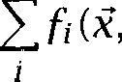 C) **C**

1. ***See*** Berger et al. (1996) for Improved Iterative a variant of generalized iterative scaling that does not impose this constraint.

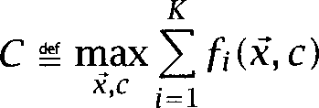In order to fulfil this requirement, we define C as the greatest possible feature sum:

and add a feature  that is defined as follows:

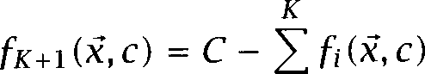

i=l

Note that this feature is not binary, in contrast to the others. is defined as follows:



where the sum is over the event space, that is, all possible vectors and class labels c. The empirical expectation is easy to compute:

(16.9)

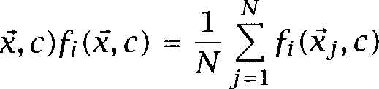

where is the number of elements in the training set and we use the fact that the empirical probability for a pair that doesn W occur in the training set is 0.

In general, the maximum entropy distribution cannot be computed efficiently since it would involve summing over all possible combinations of and c, a potentially infinite set. Instead, we use the following approx- imation (Lau 1994: 2 5):





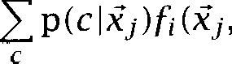

where c ranges over all possible classes, in our case c 1).



Now we have all the pieces to state the generalized iterative algorithm:

* 1. Initialize  Any initialization will do, but usually we 1, + 1. Compute as shown above. Set



scaling

choose 1.

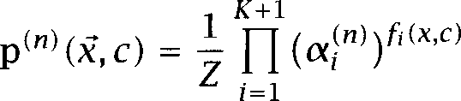(16.11)

* 1. Compute c) for the distribution  given by the  for each element in the training set:

|  |  |  |  |  |  |
| --- | --- | --- | --- | --- | --- |
|  | **C** |  | | | |
| ***profit*** |  |
|  |  | 0 | 1 | 1 | 2 |
|  |  | 0 | 1 | 1 | 2 |
| (1) |  | 0 | 1 | 1 | 2 |
| (1) |  | 1 | 0 | 2 | 4 |

**Table 16.6 An** example of a maximum entropy distribution in the form of equa- tion (16.4). The vector consists of a single element, indicating the presence or absence of the word ***profit*** in the article. There are two classes (member of Harnings or not). Feature is 1 if and if the article is in Harnings” and ***profit*** occurs. is the Iiller feature For one particular choice of the parameters, namely  = 2.0 and = 1.0, we get after normal- ization (Z = 2 2 2 + 4 = 10) the following maximum entropy distribution:  = = 2/Z = 0.2 and = 4/Z = 0.4. An example of a data set with the same empirical is (0, (1,



(16.12)

* 1. Compute for all 1 ***i K +*** 1 according to equation (16.10).
  2. Update the parameters



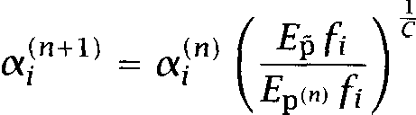

* 1. If the parameters of the procedure have converged, stop, otherwise increment and go to 2.

We present the algorithm in this form for readability. In an actual im- plementation, it is more convenient to do the computations using loga- rithms.

One can show that this procedure converges to a distribution  that obeys the constraints  and that of all such distributions it is the one that maximizes the entropy H(p) and the likelihood of the data. Darroch and (1972) show that this distribution always exists and is unique. A toy example of a maximum entropy distribution that generalized it-

erative scaling will converge to is shown in table 16.6.

**Exercise 16.7**

What are the classification decisions for the distribution in table Compute

Harnings ***profit)*** and ***profit).***



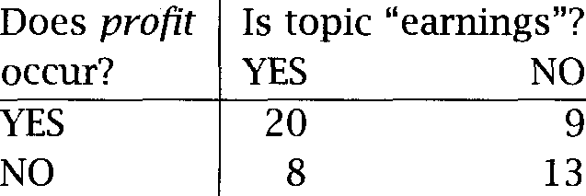

**Table 16.7** An empirical distribution whose corresponding maximum entropy distribution is the one in table 16.6.

**Exercise 16.8**

Show that the distribution in table 16.6 is a fixed point for iterative general- ized scaling. That is, computing one iteration should leave the distribution unchanged.

**Exercise 16.9 **

Consider the distribution in table 16.7. Show that for the features defined in table 16.6, this distribution has the same feature expectations  as the one table 16.6.

**Exercise 16.10 **

Compute a number of iterations of generalized iterative scaling for the data in table 16.7 (using the features defined in table 16.6). The procedure should converge towards the distribution in table 16.6.

**Exercise 16.11 **

Select one of exercises 16.3 through 16.6 and build a maximum entropy model for the corresponding text categorization task.

16.2.2 Application to text categorization

We have already suggested how to define appropriate features for text categorization in equation (16.3). For the task of identifying Reuters Harnings articles we end up 20 features, each corresponding to one of the selected words, and the feature introduced at the start of the last subsection.



Table 16.8 shows the weights found by generalized iterative scaling after convergence (500 iterations). We trained on the 9603 articles in the training set. The features with the highest weights are *cts, profit* and It. If we use as our decision rule, we get



the classification results in table 16.9. Classification accuracy is 88.6%. An important question in an implementation is when to stop the iter-

ation. One way to test for convergence is to compute the log difference

* 1. ***Maximum Entropy Modeling***

|  |  |
| --- | --- |
| Word | Feature weight log |
| vs | 0.613 |
|  | -0.110 |
| cts | 1.298 |
|  | -0.432 |
|  | -0.429 |
|  | -0.413 |
| loss | -0.332 |
|  | -0.085 |
|  | 0.202 |
| 3 | -0.463 |
| profit | 0.360 |
| dlrs | -0.202 |
| 1 | -0.211 |
|  | -0.260 |
| is | -0.546 |
| ***S*** | -0.490 |
| that | -0.285 |
| net | -0.300 |
| It | 1.016 |
| at | -0.465 |
|  | 0.009 |

Table 16.8 Feature weights in maximum entropy modeling for the category

Harnings in Reuters.

Harnings” Harnings correct? assigned? YES NO

YES 735 24

NO 352 2188

Table 16.9 Classification results for the distribution corresponding to ta- ble 16.8 on the test set. Classification accuracy is 88.6%.

between empirical and estimated feature expectations (log  log  which should approach zero. Ristad (1996) recommends to also look at the largest when doing iterative scaling. If the largest weight becomes too large, then this indicates a problem with either the data representa- tion or the implementation.

When is the maximum entropy framework presented in this section ap- propriate as a classification method? The somewhat lower performance on the Harnings task compared to some of the other methods indicates one characteristic that is a shortcoming in some situations: the restric- tion to binary features seems to have led to lower performance. In text categorization, we often need a notion of Vtrength of evidence which goes beyond a simple binary feature recording presence or absence of ev- idence. The feature-based representation we use for maximum entropy modeling is not optimal for this purpose.

Generalized iterative scaling can also be computationally expensive due to slow convergence (but see (Lau 1994) for suggestions for speeding up convergence). For binary classification, the loglinear model defines a

ear separator that is in principle no more powerful than Naive  or **LINEARREGRESSION** linear regression, classifiers that can be trained more efficiently. How- ever, it is important to stress that, apart from the theoretical power of

a classification method, the training procedure is crucial. Generalized iterative scaling takes dependence between features into account in con- trast to Naive Bayes and other linear classifiers. If feature dependence is not expected to a be a problem, then Naive Bayes is a better choice than maximum entropy modeling.

Finally, the lack of smoothing can also cause problems. For example, if we have a feature that always predicts a certain class, then this fea- ture may get an excessively high weight. One way to deal with this is to Vmooth the empirical data by adding events that did not occur. In practice, features that occur less than five times are usually eliminated.

One of the strengths of maximum entropy modeling is that it offers a framework for specifying all possibly relevant information. The attrac- tion of the method lies in the fact that arbitrarily complex features can be defined if the experimenter believes that these features may contribute useful information for the classification decision. For example, Berger et al. (1996: 57) define a feature for the translation of the preposition *in* from English to French that is 1 if and only if in is translated as pen- dant and in is followed by the word weeks within three words. There is also no need to worry about heterogeneity of features or weighting

* 1. *Perceptrons 597*

tures, two problems that often cause difficulty in other classification ap- proaches. Model selection is well-founded in the maximum entropy prin- ciple: we should not add any information over and above what we find in the empirical evidence. Maximum entropy modeling thus provides a well-motivated probabilistic framework for integrating information from heterogeneous sources.

We could only allude here to another strength of the method: an inte- grated framework for feature selection and classification. (The fact that we have not done maximum entropy feature selection here is perhaps the main reason for the lower classification accuracy.) Most classifica- tion methods cannot deal with a very large number of features. If there are too many features initially, an (often ad-hoc) method has to be used to winnow the feature set down to a manageable size. This is what we have done here, using the  test for words. In maximum entropy mod- eling one can instead specify all potentially relevant features and use extensions of the basic method such as those described by Berger et al. (1996) to simultaneously select features and fit the classification model. Since the two are integrated, there is a clear probabilistic interpretation (in terms of maximum entropy and maximum likelihood) of the result- ing classification model. Such an interpretation is less clear for other methods such as perceptrons and nearest neighbors.

In this section we have only attempted to give enough information to

help the reader to decide whether maximum entropy modeling is an ap- propriate framework for their classification task when compared to other classification methods. More detailed treatments of maximum entropy modeling are mentioned in the Further Reading.

#### 16.3 Perceptrons

We present perceptrons here as a simple example of a gradient descent **HILL CLIMBING** (or reversing the direction of goodness, *hill climbing)* algorithm, an im- portant class of iterative learning algorithms. In gradient descent, we

attempt to optimize a function of the data that computes a goodness criterion like squared error or likelihood. In each step, we compute the derivative of the function and change the parameters of the model in the direction of the steepest gradient (steepest ascent or descent, depending on the optimality function). This is a good idea because the direction of

comment: Categorization Decision

*2* funct



*3* if then



*4* return yes

*5* else

*6* return no

*7* fi.

*9* comment: Initialization

*1 0 *

*1 1 *

*1 2* comment: Perceptron Learning Algorithm

*1 3* while not converged yet do



*1 4*

*1 5*

*1 6*

*1 7*

*1 8*

*1 9*

*2 0*

*2 1*

*2 2*

*2 3*

*2 4*

*2 5*

*2 6* end

for all elements the training set do

***d =***

if = *d* then

continue

elsif  = yes and *d =* **no** then





elsif  = no and ***d = yes*** then





**fi**

end

Figure 16.7 The Perceptron Learning Algorithm. The perceptron decides \es” if the inner product of weight vector and data vector is greater than and Qo” otherwise. The learning algorithm cycles through all examples. If the current weight vector makes the right decision for an instance, it is left unchanged. Otherwise, the data vector is added to or subtracted from the weight vector, depending on the direction of the error.

steepest gradient is the direction where we can expect the most improve- ment in the goodness criterion.

Without further ado, we introduce the perceptron learning algorithm in figure 16.7. As before, text documents are represented as term vectors. Our goal is to learn a weight vector and a threshold  such that com- paring the dot product of the weight vector and the term vector against the threshold provides the categorization decision. We decide \es (the article is in the Harnings category) if the inner product of weight vector and document vector is greater than the threshold and Qo otherwise:

*K*

Decide \es iff *. = >*



where ***K*** is the number of features ***=*** 20 for our example as before) and is component i of vector 

The basic idea of the perceptron learning algorithm is simple. If the weight vector makes a mistake, we move it (and  in the direction of greatest change for our optimality criterion To see that the changes to and in figure 16.8 are made in the direction of greatest change, we first define an optimality criterion  that incorporates into the weight vector:



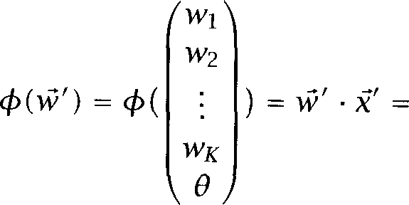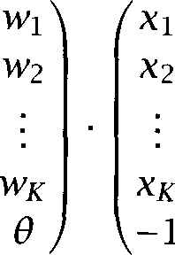

The gradient of  (which is the direction of greatest change) is the vec- tor



Of all vectors of a given length that we can add to is the one that will change  the most. So that is the direction we want to take for gradient descent; and it is indeed the change that is implemented in figure 16.7.

Figure 16.8 shows one error-correcting step of the algorithm for a dimensional problem. The figure also illustrates the class of models that can be learned by linear separators. Each weight vector de- fines an orthogonal line (or a plane or hyperplane in higher dimensions) that separates the vector space into two halves, one with positive values,

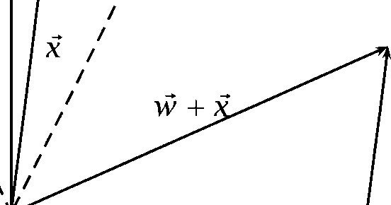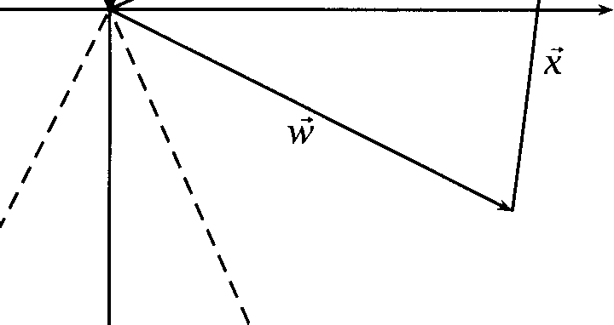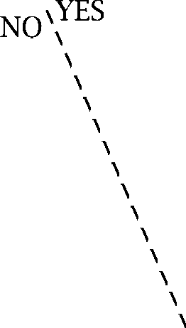

**NO**

YES

**S’**

**Figure 16.8** One error-correcting step of the perceptron learning algorithm. Data vector is misclassified by the current weight vector since it lies on the Qo –side of the decision boundary S. The correction step adds to and (in this case) corrects the decision since now lies on the \es -side of S , the decision boundary of the new weight vector



**LINEARLY SEPARABLE**

**PERCEPTRON CONVERGENCE**

**THEOREM**

one with negative values. In figure 16.8, the separator is S, defined by Classification tasks in which the elements of two classes can be perfectly separated by such a hyperplane are called *linearly separable.*

One can show that the perceptron learning algorithm always converges towards a separating hyperplane when applied to a linearly separable problem. This is the *perceptron convergence theorem.* It might seem plausible that the perceptron learning algorithm will eventually find a solution if there is one, since it keeps adjusting the weights for misclassi- fied elements, but since an adjustment for one element will often reverse classification decisions for others, the proof is not trivial.

Word  Weight 11

mln



loss



3

profit dlrs

1

is

**S**

that net It

at



6

24

2

12

- 4

19

-2

7

- 7

31

1

3

- 4

- 8

-12

-1

8

11

- 6

37

Table 16.10 Perceptron for the Harnings category. The weight vector and of a perceptron learned by the perceptron learning algorithm for the category Harnings in Reuters.

Table 16.10 shows the weights learned by the perceptron learning algo- rithm for the Harnings category after about 1000 iterations. As with the model parameters in maximum entropy modeling we get high weights for ***profit*** and Table 16.11 shows the classification results on the test set. Overall accuracy is 83%. This suggests that the problem is not linearly separable. See the exercises.

A perceptron in 20 dimensions is hard to visualize, so we reran the algorithm with just two dimensions, and ***cts.*** The weight vector and the linear separator defined by it are shown in figure 16.9.

The perceptron learning algorithm is guaranteed to learn a linearly

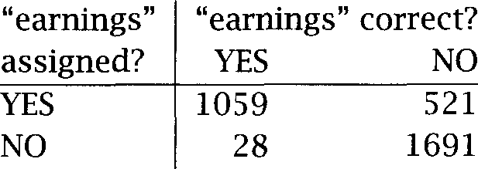

**Table 16.11** Classification results for the perceptron in table 16.10 on the test set. Classification accuracy is 83.3%.

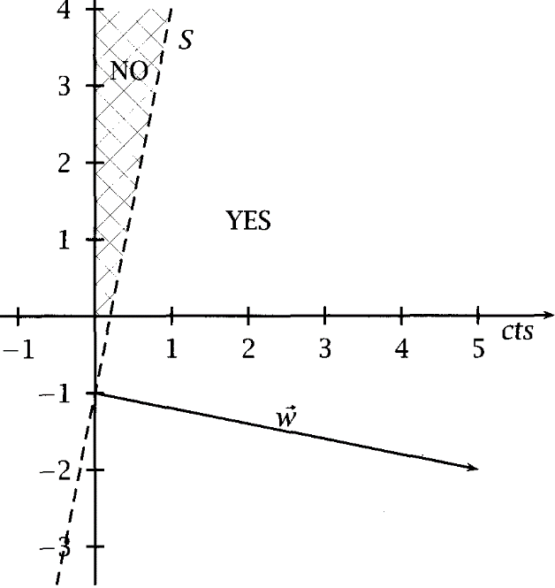

***mln***

**Figure 16.9** Geometric interpretation of a perceptron. The weight for ***cts*** is 5, the weight for is -1, and the threshold is 1. The linear separator divides the upper right quadrant into a NO and a YES region. Only documents with many more occurrences of ***mln*** than are categorized as not belonging to Harnings.”

* 1. *Perceptrons* 603

**LOCAL OPTIMUM**

**GLOBAL OPTIMUM**



**NETWORKS CONNECTIONIST**

**MODELS**

arable problem. There are similar convergence theorems for some other gradient descent algorithms, but in most cases convergence will only be to a local optimum, locations in the weight space that are locally opti- mal, but inferior to the globally optimal solution. Perceptrons converge to a global *optimum* because they select a classifier from a class of sim- ple models, the linear separators. There are many important problems that are not linearly separable, the most famous being the prob- lem. The XOR (i.e., exclusive OR) problem involves a classifier with two features and  where the answer should be \es if is true and  false or vice versa. A decision tree can easily learn such a problem, whereas a perceptron cannot. After some initial enthusiasm about ceptrons (Rosenblatt 19621, researchers realized these limitations. As a consequence, interest in perceptrons and related learning algorithms faded quickly and remained low for decades. The publication of (Minsky and  1969) is often seen as the point at which the interest in this genre of learning algorithms started to wane. See Rumelhart and Zipser (1985) for a historical summary.

If the perceptron learning algorithm is run on a problem that is not lin- early separable, the linear separator will sometimes move back and forth erratically while the algorithm tries in vain to find a perfectly separating plane. This is in fact what happened when we ran the algorithm on the Harnings data. Classification accuracy fluctuated between 72% and 93%. We picked a state that lies in the middle of this spectrum of accuracy for tables 16.10 and 16.11. Perceptrons have not been used much in NLP be- cause most NLP problems are not linearly separable and the perceptron learning algorithm does not find a good approximate separator in such cases. However, in cases where a problem is linearly separable,

trons can be an appropriate classification method due to their simplicity and ease of implementation.

A resurgence of work on gradient descent learning algorithms occurred in the eighties when several learning algorithms were proposed that over- came the limitations of perceptrons, most notably the *backpropagation* algorithm which is used to train *multi-layer perceptrons * otherwise known as *neural networks* or *connectionist* Backpropagation ap- plied to can in principle learn any classification function including XOR. But it converges more slowly than the perceptron learning algo- rithm and it can get caught in local *optima.* Pointers to uses of neural networks in NLP appear in the Further Reading.

*16 Text* Categorization

Exercise 16.12 

Build an animated visualization that shows how the perceptron V decision boundary moves during training and run it for a two-dimensional classification problem.

Exercise 16.13 

Select a subset of 10 Harnings and 10 non- Harnings documents. Select two words, one for the x axis, one for the y axis and plot the 20 documents with class labels. Is the set linearly separable?

Exercise 16.14 

How can one show that a set of data points from two classes is not linearly separable?

Exercise 16.15  Show that the Harnings data set is not linearly separable.

Exercise 16.16 

Suppose a problem is linearly separable and we train a perceptron to conver- gence. In such a case, classification accuracy will often not be 100%. Why?

Exercise 16.17 

Select one of exercises 16.3 through 16.6 and build a perceptron for the corre- sponding text categorization task.

#### *k* Nearest Neighbor Classification

**NEAREST NEIGHBOR** The rationale for the nearest neighbor *classification rule* is remarkably

**RULE** simple. To classify a new object, find the object in the training set that is most similar. Then assign the category of this nearest neighbor.

The basic idea is that if there is an identical article in the training set (or at least one with the same representation), then the obvious decision is to assign the same category. If there is no identical article, then the most similar one is our best bet.

**NEAREST NEIGHBOR** A generalization of the nearest neighbor rule is nearest neighbor or *KNN* classification. Instead of using only one nearest neighbor as the basis for our decision, we consult nearest neighbors. KNN for 1 is more robust than the 1 nearest neighbor method.



The complexity of KNN is in finding a good measure of similarity. As an example of what can go Wrong consider the task of deciding whether there is an eagle in an image. If we have a drawing of an eagle that we want to classify and all exemplars in the database are photographs of

* 1. *k Nearest Neighbor Classification 605*

eagles, then KNN will classify the drawing as non-eagle because according to any low-level similarity metric based on image features drawings and photographs will come out as very different no matter what their content (and how to implement high-level similarity is an unsolved problem). If one doesn W have a good similarity metric, one can W use KNN.

Fortunately, many NLP tasks have simple similarity metrics that are quite effective. For the Harnings data, we implemented cosine similarity (see section  and chose = 1. This algorithm for binary categorization can be stated as follows.

Goal: categorize  based on the training set X.

 Determine the largest similarity with any element in the training set:

 =



(16.13)

 Collect the subset of X that has highest similarity with 

*A = * = 



Let and be the number of elements in *A* that belong to the two classes and respectively. Then we estimate the conditional prob- abilities of membership as follows:



Decide if otherwise.



This version deals with the case where there is a single nearest neighbor (in which case we simply adopt its category) as well as with cases of ties. For the Reuters data, 2310 of the 3299 articles in the test set have one nearest neighbor. The other 989 have neighborhoods with more than 1 element (the largest neighborhood has 247 articles with identical representation). Also, 697 articles of the 3299 have a nearest neighbor with identical representation. The reason is not that there are that many duplicates in the test set. Rather, this is a consequence of the feature representation which can give identical representations to two different documents.

It should be obvious how this algorithm generalizes for the case 1: one simply chooses the nearest neighbors, again with suitable provi- sions for ties, and decides based on the majority class of these neigh- bors. It is often desirable to weight neighbors according to their similar- ity, so that the nearest neighbor gets more weight than the farthest.



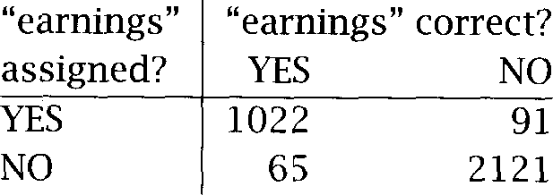

Table 16.12 Classification results for an for the Harnings” category. Classification accuracy is 95.3%.



One can show that for large enough training sets, the error rate of KNN BAYESERRORRATE approaches twice the Bayes error rate. The Bayes is the optimal error rate that is achieved if the true distribution of the data is known and



we use the decision rule  if otherwise and Hart 1973: 98).



The results of applying to the Harnings category in Reuters are

shown in table 16.12. Overall accuracy is 95.3%.

As alluded to above, the main difficulty with KNN is that its perfor- mance is very dependent on the right similarity metric. Much work in implementing KNN for a problem often goes into tuning the similarity metric (and to a lesser extent  the number of nearest neighbors used). Another potential problem is efficiency. Computing similarity with all training exemplars takes more time than computing a linear classification function or determining the appropriate path of a decision tree.

However, there are ways of implementing KNN search efficiently, and often there is an obvious choice for a similarity metric (as in our case). In such cases, KNN is a robust and conceptually simple method that often performs remarkably well.

Exercise 16.18 

Two of the classifiers we have introduced in this chapter have a linear decision boundary. Which?

Exercise 16.19 

If a classifier V decision boundary is linear, then it cannot achieve perfect ac- curacy on a problem that is not linearly separable. Does this necessarily mean that it will perform worse on a classification task than a classifier with a more complex decision boundary? Why not? (See Roth (1998) for discussion.)

Exercise 16.20 

Select one of exercises 16.3 through 16.6 and build a nearest neighbors classifier for the corresponding text categorization task.

* 1. ***Further Reading 607***

#### 16.5 Further Reading

The purpose of this chapter is to give the student interested in classifi- cation for NLP some orientation points. A recent in-depth introduction to machine learning is (Mitchell 1997). Comparisons of several learning algorithms applied to text categorization can be found in (Yang  (Lewis et al.  and  et al. 1995).

The features and the data representation based on the features used in this chapter can be downloaded from the book V

Some important classification techniques which we have not covered are: logistic regression and linear discriminant analysis  et al. 1995); decision lists, where an ordered list of rules that change the clas- sification is learned (Yarowsky 1994); winnow, a mistake-driven online linear threshold learning algorithm (Dagan et al. 1997a); and the Rocchio algorithm (Rocchio 1971; Schapire et al. 1998).

**N AIVE** Another important classification technique, Naive  was intro- duced in section 7.2.1. See (Domingos and Pazzani 1997) for a discussion of its properties, in particular the fact that it often does surprisingly well even when the feature independence assumed by Naive Bayes does not hold.

Other examples of the application of decision trees to NLP tasks are parsing (Magerman 1994) and tagging  1994). The idea of using held out training data to train a linear interpolation over all the distri- butions between a leaf node and the root was used both by  (1994) and earlier work at IBM. Rather than simply using cross-validation to determine an optimal tree size, an alternative is to grow multiple de- cision trees and then to average the judgements of the individual trees.

**BAGGING** Such techniques go under names like bagging and boosting, and have

**BOOSTING ** been widely explored and found to be quite successful (Breiman 1994; Quinlan 1996). One of the first papers to apply decision trees to text categorization is (Lewis and Ringuette 1994).

**ENTROPY** Jelinek (1997: ch. 13-14) provides an in-depth introduction to

mum entropy modeling. See also (Lau 1994) and (Ratnaparkhi 199713). Darroch and (197.2) introduced the generalized iterative scaling procedure, and showed its convergence properties. Feature selection algorithms are described by Berger et al. (1996) and Della Pietra et al. (1997).

Maximum entropy modeling has been used for tagging (Ratnaparkhi  text segmentation (Reynar and Ratnaparkhi  prepositional

phrase attachment (Ratnaparkhi  sentence boundary detection (Mikheev  determining coreference (Kehler  named entity recognition (Borthwick et al. 1998) and partial parsing (Skut and Brants 1998). Another important application is language modeling for speech recognition (Lau et al. 1993; Rosenfeld  Iterative proportional fitting, a technique related to generalized iterative scaling, was used by Franz (1996, 1997) to fit loglinear models for tagging and prepositional phrase attachment.

**NEURAL NETWORKS** Neural networks or multi-layer were one of the statistical

techniques that revived interest in Statistical NLP in the eighties based on work by Rumelhart and McClelland (1986) on learning the past tense of English verbs and (1990) paper )inding Structure in Time,” an attempt to come up with an alternative framework for the conceptu- alization and acquisition of hierarchical structure in language. Introduc- tions to neural networks and backpropagation are (Rumelhart et al.  (McClelland et al.  and (Hertz et al. 1991). Other neural network re- search on NLP problems includes tagging (Benello et al. 1989;

 sentence boundary detection (Palmer and Hearst  and pars- ing (Henderson and Lane 1998). Examples of neural networks used for text categorization are (Wiener et al. 1995) and (Schiitze et al. 1995). ikkulainen (1993) develops a general neural network framework for NLP.

The Perceptron Learning Algorithm in figure 16.7 is adapted from  tlestone 1995). A proof of the perceptron convergence theorem appears in (Minsky and  1988) and  and Hart 1973: 142).

KNN, or as it is sometimes called, has also been applied to a wide range of different NLP problems, including pronuncia- tion (Daelemans and van den Bosch  tagging (Daelemans et al. 1996; van et al.  prepositional phrase attachment (Zavrel et al.  shallow parsing (Argamon et al.  word sense  tion (Ng and Lee 1996) and smoothing of estimates (Zavrel and



mans 1997). For KNN-based text categorization see (Yang  (Yang (Stanfill and Waltz 1986; et al.  and (Hull et al. 1996). Yang (1994, 1995) suggests methods for weighting neighbors according to their similarity. We used cosine as the similarity measure. Other com- mon metrics are Euclidean distance (which is different only if vectors are not normalized, as discussed in section 8.5.1) and the Value Difference Metric (Stanfill and Waltz 1986).

**T HESE TINY TABLES** are not a substitute for a decent statistics text- book or computer software, but they give the key values most  needed in Statistical **NLP** applications.

**Standard normal distribution.** Entries give the proportion of the area under a standard normal curve from to z for selected values of z.

|  |  |
| --- | --- |
| **Z** | **-3 -2** -1 0 1 **2 3** |
| Froaortion | 0.0013 0.023 0.159 0.5 0.841 0.977 0.9987 |

**(Student V) test critical values.** A distribution with d.f. degrees of freedom has percentage C of the area under the curve between and (two-tailed), and proportion of the area under the curve between

and (one tailed). The values with infinite degrees of freedom are the same as critical values for the z test.

|  |  |  |  |  |  |  |
| --- | --- | --- | --- | --- | --- | --- |
| ***P***  C | 0.05  90% | 0.025  95% | 0.01  98% | 0.005  99% | 0.001  99.8% | 0.0005  99.9% |
| d.f. 1 | 6.314 | 12.71 | 31.82 | 63.66 | 318.3 | 636.6 |
| 10 | 1.812 | 2.228 | 2.764 | 3.169 | 4.144 | 4.587 |
| 20 | 1.725 | 2.086 | 2.528 | 2.845 | 3.552 | 3.850 |
|  | 1.645 | 1.960 | 2.326 | 2.576 | 3.091 | 3.291 |

 **critical values.** A table entry is the point  with proportion of the area under the curve being in the right-hand tail from  to of a  curve with d.f. degrees of freedom. (When using an x c table, there are 1) degrees of freedom.)



*6 1 0* Tiny Statistical ***Tables***

|  |  |  |  |  |  |  |  |
| --- | --- | --- | --- | --- | --- | --- | --- |
| *P* | 0.10 | | | 0.05 | 0.01 | 0.005 | 0.001 |
| d.f. 1 | 0.00016 | 0.0039 | 2.71 | 3.84 | 6.63 | 7.88 | 10.83 |
| 2 | 0.020 | 0.10 | 4.60 | 5.99 | 9.21 | 10.60 | 13.82 |
| 3 | 0.115 | 0.35 | 6.25 | 7.81 | 11.34 | 12.84 | 16.27 |
| 4 | 0.297 | 0.71 | 7.78 | 9.49 | 13.28 | 14.86 | 18.47 |
| 100 | 70.06 | 77.93 | 118.5 | 124.3 | 135.8 | 140.2 | 149.4 |